
毕 业 论 文（设 计）外 文 参 考 资 料 及 译 文

译文题目：Building a Network Design and Implementation Framework of a Campus Area Network for the Mariano Marcos State University
构建网络设计与实施框架马亚诺马科斯州立大学校区域网络
学生姓名： 学 号：
专 业：
所在学院：
指导教师：
职 称：
2025 年 12 月 31 日
说明
要求学生结合毕业论文（设计）课题参阅一篇以上的外文资料（开题报告涉及参考文献中的一篇），并翻译至少一万印刷符（或译出3千汉字）以上的译文。
译文原则上要求打印（如手写，一律用400字方格稿纸书写），连同学校提供的统一封面及英文原文装订，于毕业论文（设计）工作开始后2周内完成，作为成绩考核的一部分

Building a Network Design and Implementation Framework of a Campus Area Network for the Mariano Marcos State University
Milagros B. Barruga, Thelma D. Palaoag
Department of Information Technology and Computer Science, University of the Cordilleras, Gov.
Pack Rd., Baguio City
DOI: https://doi.org/10.51244/IJRSI.2024.1104023
Received: 26 March 2024; Accepted: 01 April 2024; Published: 04 May 202

ABSTRACT
A framework for network design and implementation is imperative to ensure value in the delivery of network services. Frameworks serve as guides in identifying value propositions to address the changing demands of the organization’s stakeholders. Frameworks prescribe efficient methods and appropriate tools that can be used to ensure that the implementation of a technological innovation addresses the demands, regardless of the changing IT landscape.
The demand to deliver an efficient network service requires that the network have optimized levels of scalability, availability, performance, security, and other desirable network goals. These goals have to be prioritized depending on the goals of the organization. A framework for identifying priority service delivery components must be in place in order for the governing body and IT managers of the organization to objectively prescribe appropriate technological solutions to employ.
The development of the proposed framework is patterned on Plan Design Implement Operate Optimize network life cycle, anchored on the principles of the service value chain of ITIL and the principles of IT governance using the goals cascade of COBIT. A review of existing studies was carried out to determine the prevailing technical goals and technology enablers that are peculiar to IT service management in a campus environment, specifically the delivery of computer network service.
A framework was drawn to serve as a guide to achieving network design goals that are aligned with business goals, compliant with standards, and provide value to customers of state universities and colleges like Mariano Marcos State University.

Keywords: network design and implementation, campus area network, IT governance, goals cascade, IT service, system value chain

INTRODUCTION
The accelerating changes in the internetworking industry compels network designers to develop continually changing state-of-the-art networks. These changes are evident with increasing requirements for remote access, security, bandwidth, scalability, reliability, and vendors and standards bodies introducing new protocols and technologies [1]. Furthermore, the peculiarities of the volatile, uncertain, complex and ambiguous world [2] overwhelm managers who may pursue drastic actions to cope. Drivers of innovation creates apparent needs and some managers resort to quick fix-solutions that are eventually short-lived and inefficient as these solutions may not align to the business requirements of the organization.
Developing a framework for network design and implementation necessitates careful consideration of the business and technical goals of the organization and the value that it intends to deliver to its internal and external customers. This prerequisite is often overlooked by state-run organizations like state universities and colleges (SUC), especially if their strategic directions are not inclined to digital transformation and no definite funding source is in place. In such cases, the computer network system is implemented as temporary support structures and not as crucial tools and key drivers for achieving the organization’s strategic, functional and operational goals and as leverage for creating value for the organization’s stakeholder.
The value requirement from the network service is on the network’s efficiency. There are eight network design goals that IT managers may take into consideration to build an efficient network system. These are scalability, availability, performance, security, manageability, usability, adaptability, and affordability [1]. Some organizations are inclined to satisfy on just a few of these design goals, and depending on

the business goals, a tradeoff among these goals is performed. Literatures prescribe various mechanism and approaches to ensure that certain network design goals are addressed. Case studies highlight the need for greater reliability (fault-tolerance), scalability, QoS and security [3], strike a balance on security, availability, scalability and performance [4], satisfy QoS requirements and better availability on converged service network [5], and greater efficiency, scalability and robustness [6]. Some studies focus on problem-specific solutions when proposing and acquiring network infrastructure. An agent-oriented implementation that considers an intelligent shell that adapts to various changes in the computer network provides flexibility in the system [7]. Network shaping methods were also employed and tested to improve the network performance [8]. Dealing with increasing amount of heterogenous information exchange between and among various physical and virtual entities calls for the inception of model-driven interoperability mechanisms [9]. Setting-up a converge network and recommending VOIP for optimal infrastructure utilization, and campus-cloud for data recovery and network agility are now also considered mitigating intervention for mobility and resilience among others [6]. To some extent, the setting-up of a computer network was related most to budget, such is over provisioned to the extent that the budget allows [10]. Planned usage, and intelligent upgrades depends on the availability of funds. Taking into consideration the issue on affordability, Hernandez [4] posits that networks can eliminate repetitive operations, innovate minimum processes, generate added value and increase strength of the organization, thus affordability. In doing so however, the network performance must be well calculated to avoid wasteful cost [8]. Investing on single integrated network [5], a converged network that supports effective data sharing [6] can reduce investment and maintenance cost. The issue on affordability is critical for state-run schools as they are dependent on the availability of budget allocation that the government provides. Because SUCs are subsidized by the national government, how they efficiently utilize allotted funds is closely monitored and carefully scrutinized [11]. A careful consideration on the network design goals and constraints must therefore be put into a perspective so that campus administrators and their network managers may be able to allocate their scarce resources to achieve their goals.
Apart from achieving their strategic goals, SUCs are also expected to adhere to institutional standards in their processes. Compliance to technical requirements is crucial as various accrediting bodies impose stringent requirements to ensure quality management systems, and procedures and processes that are compliant to national and international standards. Schools consider as bragging rights to qualify to certain level of accreditation, certification, or rankings [12].
The pursuit to digital transformation and the desire to employ new technologies requires systems implementations that stresses on the use of computer network technology as backbone for operations [10]. The efficient operations of computerized systems and automated processes whether outsourced or developed in-house, rely on a robust computer network infrastructure, and the delivery of network support.
The challenge therefore for achieving an efficient network system as a value provision to customers lies on

the identification of specific factors that are indicative of a network’s ideal status as it is aligned with the organization’s goals and objectives, compliance to standards, and adherence to emerging technologies while considering the cost of its implementation.
A framework for network design and implementation is imperative to ensure value in the delivery of network services. Frameworks serve as guide in identifying value propositions to address the changing demands of the organization’s stakeholders. Frameworks prescribe efficient methods and appropriate tools that can be used to ensure that the implementation of a technological innovation addresses the demands regardless of the changing IT landscape. IT frameworks lay out guidelines, best practices and operating principles to help organizations achieve their institutional objectives and motivations for improvement. These ensure alignment between the way IT services are delivered and the value they enable [1]. With a framework, only the factors that are critical in the achievement of the organization’s mandate and visions are mapped in the overall roadmap to successful computer network system implementation. These can be laid out objectively based on the motivations, resources and financial capability of the SUC.
An IT governance framework can be a useful guide to ensure the alignment of IT solutions to the organization’s goals. As leverage to value creation, the computer network system facilitates the achievement of outcomes that the organization aims to achieve. Established standards and measures or tools can be employed to objectively determine the performance and conformance of the successful implementation of a solution, thus ensure value creation.
The top-down network design approach includes exploring organizational and group structures to find the people for whom the network will provide services and from whom the designer should get valuable information to make the network design succeed [1]. This information will serve as basis in the logical and then the physical design of the network. While this approach is specific to computer network implementation, a more systematic and holistic approach to the adoption of innovation or delivering IT services can be employed to ensure that all important factors in identifying and prioritizing business and technical goals are considered. The rudiments of IT governance using the COBIT toolkit is helpful in assessing the maturity of the organization in its capabilities to deliver its IT services. The goals cascades process provides measures that ensures the alignment of IT governance and management objectives with the stakeholders’ drivers and needs [13]. Being able to quantitatively identify the alignment goals of the organization means that the cost allocation and value proposition for the IT service is optimized.
Stakeholders’ drivers and needs are requirements that can be translated as the demand component of the ITIL service value chain (SVC). The fulfillment of this demand translates to value creation to the customers and other stakeholders. The SVC serves as guide to create value streams for designing and implementing IT services like the design and implementation of a network system [18].

This work proposes a framework that maps the three approaches: top-down network design, COBIT IT governance, and ITIL service value chain to design and implement an efficient network system.

Section 2.1 of this work discusses the groundwork concepts to describe efficiency in computer network system. An efficient network is the value proposition for the IT service delivery. Section 2.2 presents system concepts behind the formulation of the proposed framework. This includes issues in the mapping and integration of the three related approaches. Section 2.3 is the discussion of the proposed framework.

RESULTS AND DISCUSSION
Efficiency in Computer Communication System
An efficient network design addresses the prescribed network design goals. Scalable networks are able to

provide support as the network grows. It must adapt to increases in the network usage and scope. High availability suggests 99.999% uptime. This requires that the network must be resilient that it can to rescore operations after a disaster. Network users complain if the network does not work on certain performance levels. High performance network must satisfy certain levels of capacity, utilization, throughput, and response time, among others. Efficiency in the network performance shows effectivity in comparison with cost in time, money, and effort. It should entail low overhead, or less wastage to produce the required output. Security affects efficiency. Threats disrupts the business operations. Manageable networks establish a documented monitoring and maintenance of the network infrastructure which facilitates new network design and upgrades. This is useful for network managers. Usability points to the network’s ease of use to include support to mobility, and configurations that support dynamic configurations. Highly adaptable networks are easy to implement with new technologies. If it cannot be adaptable, it will negatively affect availability. Cost-effectiveness or affordability requires that it carries the maximum amount of traffic for a given financial cost. The budget for technology adaption must be considered as it will dictate the best possible infrastructure to acquire [1]. Table 1 summarizes the network design goals using the top-down design. Each of these goals can be measured with the identified variables for operationalization. These variables were defined by Oppenheimer and other researchers in the domain.

Table 1. Design goals for an efficient network management

Technical Goals | Variables for operationalization | Related works
Scalability | Percent of supported network usage and scope | [1] [3]
Availability (includes reliability, redundancy, resiliency) | Percent uptime | [1] [3]
 | Cost of downtime
 | Mean Time Between Failure (MTBF) and Mean Time to Repair (MTTR)
Network Performance (includes QoS) | Capacity (bandwidth) | [1] [3] [14] [5] [8]
 | Utilization (percentage of capacity)
 | Optimum utilization
 | Throughput (pps, goodput, application layer throughput)
 | Offered load
 | Accuracy (BER)
 | Latency (delays, jitter)
 | Response time
 | Data loss, Jitter, ping
 | Optical power loss
Security | Number of network assets that are damaged | [1] [6]
 | Number of network assets accessed inappropriately
Manageability |  | [1]
Usability | Level of user-friendliness | [1]
Adaptability | Cost of recording/simulation of number of bytes each router receives and sends at certain point in time | [7] [15]
Affordability | Amount of traffic for a given financial cost | [1] [4] [6]
 | Cost of shared resources
 | Cost of maintaining legacy systems
There is not much literature that objectively describe how should the tradeoff be performed among the desired network design goals. The network designer has to decide as a result of identifying customer needs and goals as to which of the network design goals must be prioritized. Since customers are not always knowledgeable on the technicalities of the network design goals, the tradeoff analysis may not necessarily reflect the actual need of the customers, much less to ensure that the network design goals are aligned with the business goals.
Approaches in Development of the Proposed Network Design and Implementation Framework
There are a number of approaches that the organization can employ when trying to map its business goals with its network design goals.

Structured systems approach
Specific to network design, the Systems Development Life Cycle (SDLC) and the Plan Design Implement Operate Optimize (PDIOO) network life cycle are the common methods. The SDLC for network design is described with six sequential steps that runs as a cycle. The PDIOO works in parallel with the SDLC (Figure 1). The idea is always following the structured systems approach which is characterized by designing top-down sequence wherein specifications of the network design are derived from the requirements gathered at the beginning of the sequence. Although it does not prescribe a specific technique or model, the structured systems analysis specifies that during the design project, several techniques and models can be used to characterize the existing system, determine new user requirements, and propose a structure for future system.
Figure 1. Structured systems analysis approaches to network design and implementation
In analyzing requirements for the SDLC, the network analyst interviews users and technical personnel to gain an understanding of the business and technical goals for a new and enhanced system. After which, the analyst shall characterize the existing network capabilities, from which he/she will be able to analyze current and future traffic. This phase is in parallel with the PDIOO’s planning phase. It involves identification of network requirements including analysis of areas where the network will be installed and who will be the users requiring the network service. Both the Analyze requirements and Plan stages aim to develop recommendations for the network design options that correlates with business and technical goals. It is expected that at this stage, the network designer has already identified the critical and less critical goals and therefore is now able to recommend network design options.
Organizations are unique due to their specific priority goals. Inefficient decision-making and lack of accurate information can shatter the efforts of an organization towards the achievement of their goals and objectives. The lack of appropriate IT governance framework is also one of the reasons why initiatives or propositions for improvement simply stopped at the proposal level because of the lack of alignment to the overall goals and objectives of the organization. The ITIL’s guiding principle of focusing on the value [16] and COBIT’s principle on meeting the stakeholders’ needs purports the need for IT governance to align the processes or activities with the organization’s objectives, such that the governing body continuously look into the performance and compliance of the services for continual improvement (Figure 2).
Figure 2. Mapping COBIT and ITIL principles of IT Governance
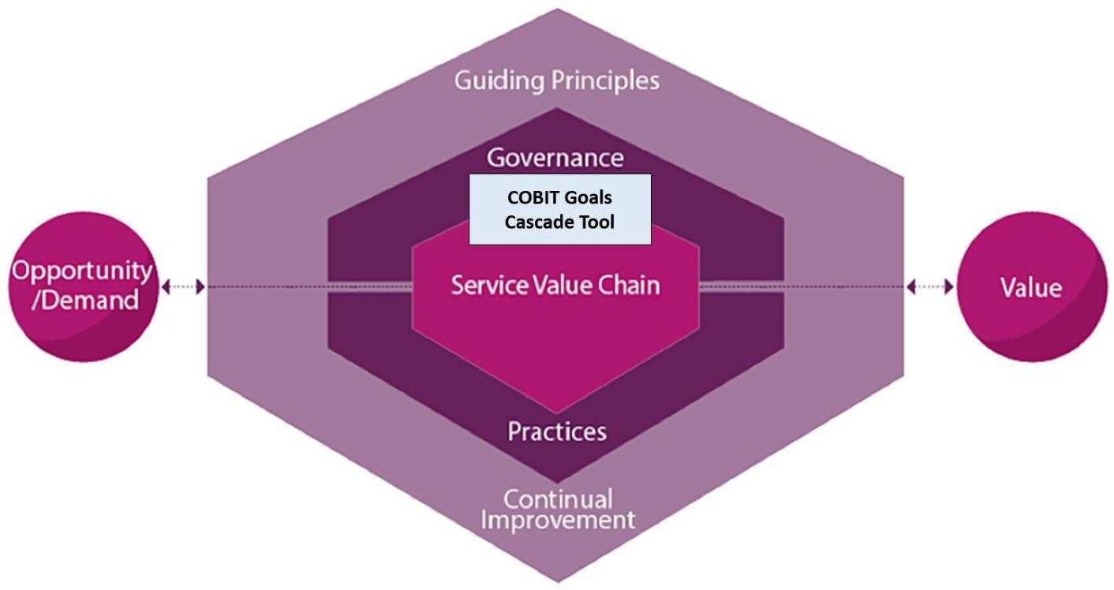

IT Governance approach
Gaining an understanding of the business and technical goals can be holistically employed using the COBIT IT governance guide. This tool is necessary to ensure the alignment of business goals to its technical goals, specifically on prioritizing the objectives that it needs to tackle first. This idea is especially useful for organizations which have limited resources so that they can prioritize where their scarce resource can be allotted first in the course of project implementation. The COBIT IT governance toolkit provide automated tools that guides governing bodies in determining their priority objectives based from their specific goals. Established metrics and conventions are embedded in the COBIT canvass to determine the priority objectives from the design factors that the organization wishes to satisfy. Besides the design factors as reference, COBIT also provides another guide that leverages on the organization’s specific goals, denoted in Figure 3 as stakeholder needs. These needs generally entail benefit realization, risk optimization, and resources optimization. These needs are inputs from which the governing body of the organization can automatically generate a list of priority goals. Balance score cards are utilized to automatically analyze the cascading of these goals: first, map the organization’s specific goals with the enterprise goals, then enterprise goals with alignment goals, then the alignment goals with prioritized enabler goals (governance and management goals) [17].

Figure 3. Goals cascade

The organization’s specific goals can vary due to change in organizational strategies, change in business or regulatory environment, or triggered by the introduction of new technologies. These specific goals are arbitrary at any point in time due to inevitable changes or as a requirement for continual improvement. Table 2 is a sample checklist of specific goals which can be used as input to the goals cascade. These are actually a set of typical business goals defined by Oppenheimer.
Table 2. Business goals checklist

Business goal
Increase revenue and profit
Increase market share
Expand into new markets
Increase competitive advantages over companies in the same market
Reduce costs
Increase employee productivity
Shorten product-development cycles
Use just-in-time manufacturing
Plan around component shortages
Offer new customer services
Offer better customer support
Open the network to key constituents (prospects, investors, customers, business partners, suppliers, and employees)
Avoid business disruption caused by network security problems
Avoid business disruption caused by natural and unnatural disasters
Modernize outdated technologies
Reduce telecommunications and network costs, including overhead associated with separate networks for voice, data, and video
Make data centers more efficient in their usage of power, cabling, racks, storage, and WAN circuits

With the use of COBIT goals cascade canvass tool, a balance scorecard can be generated when mapping stakeholder needs with enterprise goals (Table 3), and mapping enterprise goals with alignment goals (Table 4).

Table 3. Enterprise goals checklist

Enterprise goal
Portfolio of competitive products and services
Managed business risk
Compliance with external laws and regulations
Quality of financial information
Customer-oriented service culture
Business service continuity and availability
Quality of management information
Optimization of internal business process functionality
Optimization of business process cost
Staff skills motivation and productivity
Compliance with internal policies
Manages digital transformation program
Product and business innovation
Table 4. Alignment goals checklist

Alignment goal
IT compliance and support for business compliance with external law and regulations
Managed information and technology-related risks
Realized benefits from information and technology-enabled investments and services portfolio
Quality of technology-related financial information
Delivery of I&T services in line with business requirements
Agility to turn business requirements into operational solutions
Security of information, processing infrastructure and applications, and privacy
Enabling and supporting business processes by integrating applications and technology
Delivery of program on time, on budget and meeting requirements and quality standards
Quality of IT management information
IT compliance with internal policies
Competent and motivated staff with mutual understanding of technology and business
Knowledge, expertise and initiatives for business innovation

The resulting matrix is finally mapped with the enable goals or the 40 governance and management objectives (Figure 3). Each of these goals have assigned processes, practices and activities. This final mapping will generate the priority governance and management objectives where the governing body can refer from in identifying the activities that the organization needs to prioritize. COBIT has a complete reference for specific activities that needs to be undertaken for each of the practices of each of the processes defined in the enabler goals. By being able to identify the most important governance and management goals, the organization can focus its efforts on the specific activities of the priority process to address its business goals. The prioritization that is established here can then be a basis for the tradeoff analysis for the specific network design goals. The same principle of goals cascading can be employed for the enabler goals with the network design goals.

Figure 4. Governance and Management objectives

Service value stream for creating value from network service
The overall layout of the proposed framework is patterned from the service value system of the ITIL framework with the service value chain as its core component. Value propositions always look into the demand of developing the service whether to deliver service, to improve existing capabilities, or to introduce an innovation. The demands are the priority business goals which was generated from the results of the goals cascade. “Engage” is the stage in the ITIL framework that investigates specific stakeholder needs, which are inputs to the organizations strategic planning and portfolio management. Value propositions in developing specific service or product can be developed with the SVC as the organization carry out the stages to design and transform, obtain and build, or design and support [18].
Figure 5. Service value stream for the network service

The design and development of a network system constitutes one service value stream in the ITIL SVC, wherein the stakeholder requirements constitute the Demand of the value chain. To Engage is to employ analysis on the network design goals and constraints. Following the SDLC network life cycle, the value stream shall provide a computer network service after Testing, Optimization,

Documentation. By employing the necessary conventions in each of these essential value-adding steps, an efficient network service shall be delivered to the service customers.
The Proposed Network Management Framework
Figure 5 shows the mapping of the various approaches that were utilized to derive the proposed framework. It shows here the component activities of the PPDIO, SDLC, ITIL Service Value Chain, and the COBIT Goals Cascade tool. The broken lines show the parallel activities from among the related approaches. With emphasis in this investigation is the Goals Cascade which serves as intermediary between the Demand and Engage activities of the ITIL SVC. By employing this orchestration of activities, the proposed framework was developed.
Figure 6. Mapping the Different Approaches
Figure 6 shows that the proposed framework. As an IT service, the network design and implementation define its Demands, translated here in the figure as Stakeholder drivers. These drivers emanate from any change in the organizational strategies, business and regulatory environment and new technologies for adaption. These drivers influence the organization’s business goals.
The Engage stage in this framework is now comprised of two approaches. First is the use of the COBIT template for goals cascade, then, the tradeoff analysis of the network design goals. This is a critical stage of ensuring that the IT service aligns with the business and enterprise goals.
Figure 7. Proposed Network Design and Implementation Framework
The proposed framework constitutes as one value stream in the ITIL SVC, the stakeholder drivers constitute the demands of the value chain. To engage is to employ analysis thru goals cascade and tradeoff analysis. Following the top-down network design approach completes the value stream for the computer network implementation.
For SUCs, the following items entail the Stakeholder drivers as illustrated in Figure 7. Strategic planning is carried out to lay down a 3-5-year plan for the organization. The development of the strategic plan subsumes issues on corporate politics, change management and changes in the strategic directions, as the organization looks into the areas for improvement using the current performance evaluation results as baseline [19]. The Business and Regulatory Environment outlines the legal bases for operation of the SUC.These include policies and guidelines in the execution of university’s functions in instruction, research, and extension. These legal bass include CHED

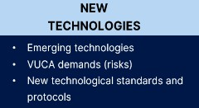
Memorandum Orders, and PSGs for each of the degree program offerings, and other regulatory requirements set by the Civil Service Commission, Department of Budget and Management, Commission on Audit, National Economic and Development Authority, and other agencies including partner agencies. Subjecting the organization to evaluation for delivering quality management to its stakeholders also requires its compliance to AACCUP, and if so desired by the top management, subjecting the organization to national and international certification and rankings like Philippine Quality Assurance (PQA), International Standards for Operation (ISO), World Universities with Real Impact (WURI), Times Higher Education (THE), and the like. Proactive leadership in SUCs consider novel priorities beyond the regular strategies should funding allows. Futures thinking and strategic foresights sees beyond the regular undertaking and pursue new developments next to other priorities, seeking solutions to problems that is yet to encounter. This is imperative in the VUCA world. SUCs also delve into adopting emerging trends that can transform existing initiatives into digitalized status. These are the drivers that are arbitrarily considered that changes the business priorities. Once these business priorities are in place, the design and implementation of innovations can be ascertained to give value to the organization.
Figure 8. Stakeholder Drivers for State Universities and Colleges

The Goals Cascade tool will take the business goals as its input. After processing, the priority programs, projects and activities will be identified. This priority activities will be the concrete reference to objectively perform the tradeoff analysis for the network design goals. This stage will ensure that prioritizing network design goals is objectively determined.

After determining the priority goals, the tradeoff analysis on the desired network goals may now be mapped with the objectives derived from the goals cascade. In doing so, the prioritization of the network design goals ensures that the right combination of network resources is taken into consideration when developing the network designs. This is with reference to the existing capabilities or design constraints. However, these design constraints are secondary considerations in the logical design after the priority design goals are already satisfied.

CONCLUSION
The proposed framework employs the conventions of structure systems approach in network design and implementation as it is anchored on the ITIL service value chain and COBIT IT governance goals cascade. Employing these principles and tools ensures that the network service is a value proposition that addresses the priority goals of the organization as it objectively aligns the network goals with the business goals. The business goals of an SUC are always depended on the funding source. However, with careful consideration of the other key factors, the organization may be able to maximize its scarce resources by addressing their priority goals. These goals are objectively determined with the proposed framework for design and implementation.

ACKNOWLEDGMENTS

My thanks to the MMSU Seamless Campus Network project team and the Fourth Industrial Revolution ad hoc group for the insights.

REFERENCES
- P. Oppenheimer, Top-Down Network Design Third Edition, Indianapolis: Cisco Systems, Inc., 2011.
- D. Sinha and S. Sinha, “Managing in a VUCA World: Possibilities and Pitfalls.,” Journal of Technology Management for Growing Economies., vol. 11, no. 1, pp. 17-21, 2020.
- M. F. Kadhin, N. S. Ali and S. Al-Khammasi, “Multi-Phase Methodology for Proposing a High Performance Switcched Campus Network: University of Kufa Case Study,” Journal of Engineering and Applied Sciences, vol. 13, no. 16, pp. 6700-6707, 2018.
- L. Hernandez, H. Villanueva and S. Estrada, “Proposal for the Design of a new Technological Infrastructure for the Efficient Management of Netwrok Serices and Applications in a High Complexity Clinic in Colombia,” in Advances in Intelligent Systems and Computing, 2018.
- Giovanni and N. Surantha, “Design and Evaluation of Enterprise Network with Converged Services,”Procedia Computer Science, vol. 135, pp. 526-533, 2018.
- A. A. Ojugo and A. Eboka, “Mitigating Technical Challenges via Redesigning Campus Network for Greater Efficiency, Scalabilty and Robustness: A Logical View,” I.J. Modern Education and Computer Science, vol. 6, no. 2020, pp. 29-45, 2020.
- N. Shiratori, T. Suganuma, S. Suguira, G. Chakraborty, K. Sugawara, T. Kinoshita and E. Lee, “Framework of a flexible computer communication network,” Computer Comunications, vol. 19, no. 1996, pp. 1268-1275, 1996.
- M. Wairisal and N. Surantha, “Design and Evaluation of Efficient Bandwidth Management for a Corporate Network,” in 2018 International Conference on Information Management and Technology, 2018.
- G. Zacharewicz, N. Daclin, G. Doumeingths and H. Haidar, “Model Driven Interoperability for System Engineering,” Modelling, vol. 1, pp. 94-121, 2020.
- J. Wynekoop and J. Finan, “Enterprise Network Design: How is it done?,” in IFIP International Federation for Information Processing, 2001.
- M. I. P. Conchada and I. G. C. Zamudio, “The cost efficiency of state universities and colleges in the Philippines,” The Philippine review of Economics, vol. L, no. 2, pp. 83-104, 2013.
- H. A.-H. Ibrahim, “Quality Assurance and Accreditation in Education,” Open Journal of Education,vol. 2, 2014.
- O. Z. Olorunojowon, “ISACA Drive Transparent and Measurable Value With COBIT 5 Process Metrics,” ISACA, 12 December 2017. [Online]. Available: https://www.isaca.org/resources/news-and- trends/industry-news/2017/drive-transparent-and-measurable-value-with-cobit-5-process- metrics#:~:text=COBIT%205%20combines%20the%20goals,and%20priorities%20of%20the%20organi zation [Accessed 10 August 2022].
- Z. Abdellaoui, Y. Dieudonne and A. Aleya, “Design, implementation and evaluation of a FIber To The Homw (FTTH) access network based on a Giga Passive Optical Netwrok (GPON),” Array, vol. 10, 2021.
- J. HIllenbrand, P. Gonnheimer, E. Gerlitz and J. Fleischer, “Design and implementation of holistic framewrok for data integration in industrial machine and sensor networks,” Procedia CIRP, vol. 104,
- M. A.-S. H. H. Yahya Al-Ashmoery, “Impact of IT Service Management and ITIL Framework on the Businesses,” in 2021 International Conference of Modern Trends in Information and Communication Technology Industry (MTICTI), 2021.

- T. H. Anant Joshi, “COBIT as a Framework for Enterprise Governance of IT,” in Enterprise Governance of Information Technology, Switzerland, SpringerNature Switzerland AG, 2020, pp. 125- 162.
- S. B. A. S. Abdelaali Himi, “The IT Service Management according to the ITIL framework,”IJCSI International Journal of Computer Science Issues, vol. 8, no. 3, pp. 515-522, 2011.
- Mariano Marcos State University, “Mariano Marcos State University Updated Stratgeic Plan 2019- 2022,” Mariano Marcos State University, Batac, Ilocos Norte, 2019.

构建网络设计与实施框架马亚诺·马科斯州立大学校园区域网络
科迪勒拉大学信息技术与计算机科学系碧瑶市帕克路
DOI： https://doi.org/10.51244/IJRSI.2024.1104023
收稿日期：2024年 3月26日；接受日期：2024年 4月1日；出版日期：2024年 5月4日

摘要
建立网络设计和实施框架对于确保交付价值至关重要。网络服务框架旨在指导企业识别价值主张，以满足组织利益相关者不断变化的需求。框架规定了高效的方法和合适的工具，确保技术创新的实施能够满足需求，无论IT环境如何变化。
要提供高效的网络服务，网络必须具备优化的可扩展性、可用性、性能、安全性以及其他必要的网络目标。这些目标必须根据组织的具体目标进行优先级排序。为了使组织的管理机构和IT经理能够客观地选择合适的技术解决方案，必须建立一个用于识别优先服务交付组件的框架。
所提出的框架的开发以“计划、设计、实施、运营、优化”网络生命周期为模式并以ITIL的服务价值链原则和COBIT的目标级联IT治理原则为基础。
校园环境中 IT 服务管理特有的技术目标和技术推动因素，特别是计算机网络服务的交付。
制定了一个框架，旨在指导实现与业务目标一致、符合标准并为马亚诺·马科斯州立大学等州立大学和学院的客户创造价值的网络设计目标。

关键词：网络设计与实现、校园网、IT治理、目标级联、IT服务、系统价值链

引言
互联网络行业的加速变革迫使网络设计人员不断开发最先进的网络。这些变革体现在对远程访问、安全性、带宽、可扩展性和可靠性日益增长的需求上，以及供应商和标准组织不断推出新的协议和技术[1]。此外，瞬息万变、充满不确定性、复杂且模糊不清的世界[2]也令管理者感到压力巨大，他们可能会采取激进的应对措施。创新驱动力催生了显而易见的需求，一些管理者转而寻求快速有效的解决方案，但这些方案最终往往效率低下且难以持久，因为它们可能并不符合组织的业务需求。
制定网络设计和实施框架需要仔细考虑组织的业务和技术目标，以及其希望为内部和外部客户创造的价值。而像州立大学这样的公立机构往往忽视了这一前提条件。
尤其是一些高校（州立大学），如果其战略方向并未倾向于数字化转型，且没有明确的资金来源，那么计算机网络系统往往被用作临时支持结构，而非实现组织战略、职能和运营目标的关键工具和驱动力，也并非为组织利益相关者创造价值的杠杆。
网络服务的价值需求在于网络的效率。IT 管理人员在构建高效的网络系统时，可以考虑八个网络设计目标，分别是可扩展性、可用性、性能、安全性、可管理性、易用性、适应性和经济性[1]。
有些组织倾向于只满足其中几个设计目标，并根据业务目标在这些目标之间进行权衡。文献中提出了各种机制和方法。
为了确保实现某些网络设计目标。案例研究强调了提高可靠性（容错性）、可扩展性、服务质量 (QoS) 和安全性的必要性 [3]，需要在安全性、可用性、可扩展性和性能之间取得Ť衡 [4]，满足融合服务网络的 QoS 要求并提高可用性 [5]，以及提高效率、可扩展性和鲁棒性 [6]。一些研究在提出和获取网络基础设施时，侧重于针对特定问题的解决方案。一种面向代理的实现方案，考虑了一个能够适应计算机网络各种变化的智能外壳，从而为系统提供了灵活性 [7]。网络整形方法也被用于提高网络性能并进行了测试 [8]。处理日益增长的异构信息交换量
各种物理和虚拟实体之间的交互需要建立模型驱动的互操作性机制[9]。构建融合网络并推荐使用 VoIP 以实现最佳基础设施 利用率，以及使用园区云进行数据恢复和提升网络敏捷性，这些措施现在也被视为提高移动性和弹性等方面的缓解措施[6]。在某种程度上，计算机网络的构建与预算密切相关，因此通常会在预算允许的范围内进行超额配置[10]。
计划性使用和智能升级取决于资金的可用性。考虑到可负担性问题，Hernandez [4] 认为网络可以消除重复性操作，创新最低流程，创造附加值并增强组织实力，从而降低成本。然而，这样做必须对网络性能进行精确计算，以避免浪费成本 [8]。投资于单一集成网络 [5] 或支持有效数据共享的融合网络 [6] 可以降低投资和维护成本。对于公立学校而言，可负担性问题至关重要，因为它们依赖于政府提供的预算拨款。由于公立高等院校 (SUC) 由国家政府补贴，因此它们如何高效利用拨款受到密切监控和严格审查 [11]。必须认真考虑网络设计目标和限制条件。
因此，应该从宏观角度看待这个问题，以便校园管理人员及其网络管理员能够合理分配有限的资源，实现他们的目标。
除了实现其战略目标外，高等院校还应遵守机构标准。
他们的流程。遵守技术要求至关重要，因为各种认证机构都提出了严格的要求，以确保质量管理体系、程序和流程符合国家和国际标准。学校将获得特定级别的认证、证书或排名视为一种荣誉[12]。
追求数字化转型和采用新技术的愿望要求系统实施强调使用计算机网络技术作为运营的骨ţ[10]。
无论是外包还是内部开发的计算机系统和自动化流程的高效运行，都依赖于强大的计算机网络基础设施和网络支持的交付。因此，实现高效的网络系统并为客户提供价值的挑战在于：
确定能够表明网络理想状态的具体因素，即网络与组织的目标和宗旨保持一致，符合标准，并遵循新兴技术，同时考虑其实施成本。
建立网络设计和实施框架对于确保交付价值至关重要。
网络服务框架旨在指导识别价值主张，以满足组织利益相关者不断变化的需求。框架规定了高效的方法和合适的工具，以确保技术创新的实施能够满足需求，无论IT环境如何变化。IT框架阐述了指导原则、最佳实践和操作原则，以帮助组织实现其机构目标 和改进动力。
这些措施确保了IT服务的交付方式与其所创造的价值保持一致[1]。通过框架，只会考虑对实现组织使命和愿景至关重要的因素。
这些内容都已纳入成功实施计算机网络系统的总体路线图中。这些内容可以根据高等教育机构的动机、资源和财务能力进行客观制定。
IT治理框架可以作为有效指南，确保IT解决方案与组织目标保持一致。作为价值创造的杠杆，计算机网络系统有助于实现组织预期目标。可采用既定的标准、衡量指标或工具来客观地评估解决方案成功实施的绩效和合规性，从而确保价值创造。
自顶向下的网络设计方法包括探索组织和群体结构，以确定网络将为其提供服务的人员，以及设计者应从中获取的、对网络设计成功至关重要的信息[1]。这些信息将作为网络逻辑设计和物理设计的基础。虽然这种方法专门针对计算机网络实施，但对于创新应用或IT服务交付，可以采用更系统、更全面的方法，以确保在识别和确定业务及技术目标的优先级时，所有重要因素都得到 考虑。使用COBIT工具包进行IT治理的基础知识有助于评估组织在交付IT服务方面的能力成熟度。目标级联流程提供了一些措施，确保IT治理和管理目标与利益相关者的驱动因素和需求保持一致[13]。能够量化地识别组织的协调目标意味着可以优化IT服务的成本分配和价值主张。
利益相关者的驱动因素和需求是可以转化为需求组成部分的要求。
ITIL 服务价值链 (SVC)。满足这一需求将转化为为客户和其他利益相关者创造价值。SVC 可作为创建价值流的指南，用于设计和实施 IT 服务，例如网络系统的设计和实施 [18]。
这项工作提出了一种框架，该框架映射了三种方法：自顶向下的网络设计、COBIT IT 治理和 ITIL 服务价值链，以设计和实施高效的网络系统。
本文第 2.1 节讨论了描述计算机网络系统效率的基础概念。高效的网络是 IT 服务交付的价值所在。第 2.2 节介绍了所提出框架背后的系统概念，包括三种相关方法的映射和集成问题。第 2.3 节讨论了所提出的框架。

结果与讨论
计算机通信系统的效率
随着网络规模的增长，它必须提供支持。它必须适应网络使用量和范围的增长。高可用性意味着 99.999% 的正常运行时间。这要求网络必须具有弹 性，以便在灾难发生后恢复运行。如果网络无法达到特定的性能水Ť，网络用户就会抱怨。高性能网络必须满足一定的容量、利用率、吞吐量和响应时间等指标。网络性能的效率体现在与时间、金钱和精力成本的比较中。它应该以较低的开销或更少的浪费来实现所需的功能。
产出。安全性影响效率。威胁会扰乱业务运营。可管理的网络建立了一套有据可查的网络基础设施监控和维护机制，从而有助于新网络的设计和升级。这对网络管理员来说非常有用。易用性体现了网络的便捷性。
其用途包括支持移动性以及支持动态配置的配置。高度适应性的网络易于利用新技术进行部署。如果网络不具备适应性，则会对可用性产生负面影 响。成本效益或可负担性要求网络在给定成本下承载最大流量。必须考虑技术适应的预算，因为它将决定需要购置的最佳基础设施[1]。表1总结了采用自顶向下设计方法的网络设计目标。每个目标都可以通过已确定的运行变量进行衡量。这些变量由Oppenheimer和该领域的其他研究人员定义。
表1. 高效网络管理的设计目标

技术目标 | 可操作化变量 | 相关研究
可扩展性 | 受支持的网络使用率及范围占比 | [1] [3]
可用性（含可靠性、冗余性、弹性） | 正常运行时间占比故障成本平均故障间隔时间（MTBF）与平均修复时间（MTTR） | [1] [3]
网络性能（含服务质量） | 容量（带宽）利用率（容量占比）最优利用率吞吐量（每秒分组数、实际吞吐量、应用层吞吐量）提供负载准确率（误码率）延迟（时延、抖动）响应时间数据丢失、抖动、ping 值光功率损耗 | [1] [3] [14] [5] [8]
安全性 | 受损的网络资产数量被不当访问的网络资产数量 | [1] [6]
可管理性 | - | [1]
易用性 | 用户友好度水平 | [1]
适应性 | 特定时间点每个路由器收发字节数的记录 / 仿真成本给定财务成本下的流量规模 | [7] [15]
经济性 | 共享资源成本遗留系统维护成本 | [1] [4] [6]

网络设计人员需要根据客户的需求和目标，决定哪些网络设计目标应该优先考虑。由于客户并非总是了解网络设计目标的具体技术细节，因此权衡分析未必能反映客户的实际需求，更遑论确保网络设计目标与业务目标保持一致。拟议网络设计与实施框架的开发方法组织在尝试将业务目标与其网络设计目标相匹配时，可以采用多种方法。
结构化系统方法
针对网络设计，系统开发生命周期（SDLC）和规划‑设计‑实施‑运行‑优化（PDIOO）网络生命周期是常用的方法。网络设计的SDLC是：
PDIOO 由六个顺序步骤组成，这些步骤循环运行。PDIOO 与 SDLC 并行工作。
（图 1）。其思路始终遵循结构化系统方法，该方法的特点是：
采用自顶向下的设计顺序，其中网络设计的规范是从⋯⋯推导出来的
需求收集在流程的初始阶段。虽然结构化系统分析并未规定具体的技术或模型，但它指出，在设计项目中，可以使用多种技术和模型来描述现有系统、确定新的用户需求，并为未来的系统提出结构。
图 1. 网络设计与实现中的结构化系统分析方法
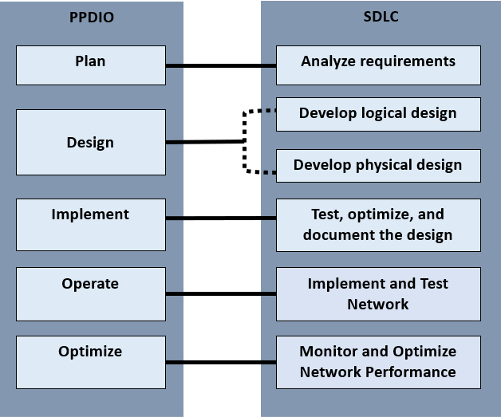

在分析软件开发生命周期（SDLC）的需求时，网络分析师会采访用户和技术人员。
了解新系统和增强系统的业务和技术目标。之后，分析师应描述现有网络能力，以便分析当前和未来的流量。此阶段与 PDIOO 的规划阶段并行。它包括识别网络需求，分析网络部署区域以及需要网络服务的用户。需求分析和规划阶段的目标都是针对与业务和技术目标相关的网络设计方案提出建议。
准确的信息可能会阻碍组织为实现其目标所做的努力。缺乏合适的IT治理框架也是导致改进方案或建议因与组织的整体目标不符而止步于提案阶段的原因之一。ITIL的指导原则是关注价值[16]，COBIT的原则是满足利益相关者的需求，这些原则都强调了IT治理的必要性，即确保流程或活动与组织的目标保持一致，从而使管理机构能够持续关注组织的目标。进入服务绩效和合规性评估，以持续改进（图 2）。图 2. COBIT 和 ITIL IT 治理原则的映射
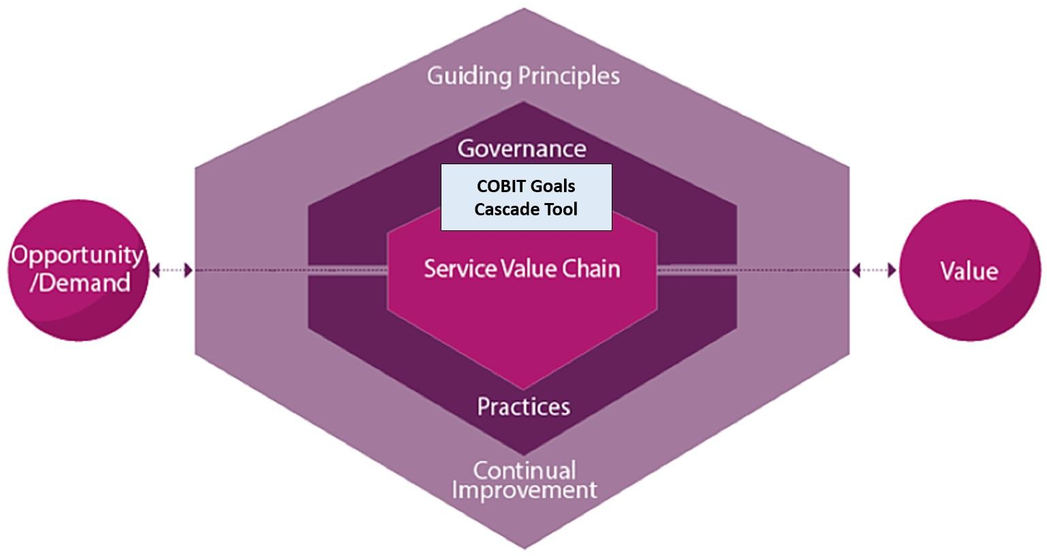

IT 治理方法
利用 COBIT IT 治理指南，可以全面理解业务和技术目标。该工具对于确保业务目标与技术目标保持一致至关重要，尤其是在确定需要优先解决的目标方面。对于资源有限的组织而言，这一理念尤为重要，因为它可以帮助他们在项目实施过程中优先分配有限的资源。COBIT IT 治理工具包提供了一系列自动化工具，指导管理机构根据自身具体目标确定优先级目标。
COBIT画布中嵌入了既定的指标和惯例，用于确定优先级。
组织希望满足的设计因素所设定的目标。除了设计因素作为参考外，COBIT 还提供了另一项指导原则，即利用组织的具体目标（如图 3 所示，称为利益相关者需求）。这些需求通常包括收益实现、风险优化和资源优化。组织管理机构可以根据这些需求自动生成优先目标列表。Ť衡计分卡用于自动分析这些目标的层级关系：首先，将组织的具体目标与企业目标进行映射；然 后，
企业目标与协调目标，然后协调目标与优先实现目标（治理和管理目标）[17]。

图 3. 目标级联
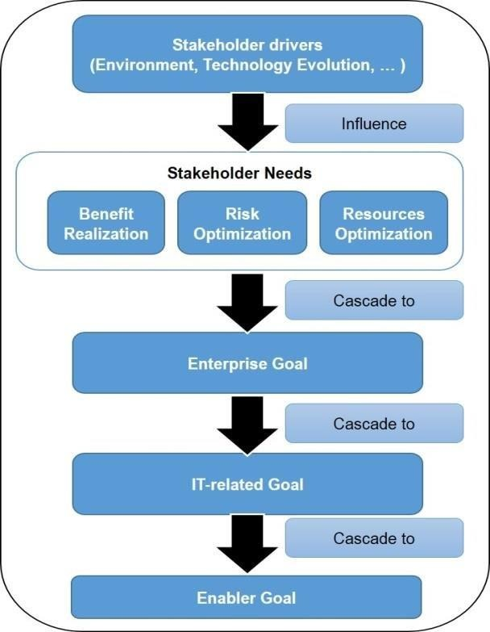

组织的具体目标可能会因组织战略的改变、商业或监管环境的变化，或新技术的引入而有所不同。由于不可避免的变化或持续改进的需要，这些具体目标在任何时间点都具有一定的任意性。
表2是一个具体目标的示例清单，可作为目标层级分解的输入。这些目标实际上是奥本海默定义的一系列典型的业务目标。
表 2. 业务目标清单
表 2. 业务目标清单
业务目标
增加收入与利润
扩大市场份额
拓展新市场
提升相对于同行业企业的竞争优势
降低成本
提高员工生产力
缩短产品开发周期
采用准时制生产模式
应对组件短缺问题进行规划
提供新的客户服务
提供更优质的客户支持
向关键主体（潜在客户、投资者、客户、业务合作伙伴、供应商及员工）开放网络
避免因网络安全问题导致的业务中断
避免因自然及人为灾害导致的业务中断
对过时技术进行现代化升级
降低电信与网络成本（包括语音、数据、视频独立网络相关的管理费用）
提升数据中心在电力、布线、机架、存储及广域网线路方面的使用效率

借助 COBIT 目标级联画布工具，可以将利益相关者的需求与企业目标进行映射（表 3），并将企业目标与一致性目标进行映射（表 4），从而生成Ť衡计分卡。
表 3. 企业目标清单
表 3. 企业目标清单
企业目标
具备竞争力的产品与服务组合
管理业务风险
遵守外部法律法规
财务信息质量
以客户为导向的服务文化
业务服务的连续性与可用性
管理信息质量
优化内部业务流程功能
优化业务流程成本
员工技能、积极性与生产力
遵守内部政策
管理数字化转型项目
产品与业务创新

表 4. 目标一致性检查表
对齐目标
IT 合规性及对业务遵守外部法律法规的支持
管理与信息及技术相关的风险
从信息化、技术赋能的投资及服务组合中实现收益
技术相关财务信息的质量
交付符合业务需求的信息技术（I&T）服务
将业务需求转化为运营解决方案的敏捷性
信息、处理基础设施与应用程序的安全性，以及隐私保护
通过整合应用程序与技术，赋能并支持业务流程
按时、按预算交付项目，并满足需求与质量标准
IT 管理信息的质量
IT 对内部政策的合规性
具备专业能力、积极性且能理解技术与业务的员工
用于业务创新的知识、专业技能与举措

最终得到的矩阵与赋能目标或40个治理和管理目标进行映射（图3）。每个目标都对应着相应的流程、实践和活动。最终的映射将生成优先的治理和管理目标，供管理机构参考，以确定组织需要优先考虑的活动。COBIT 为赋能目标中定义的每个流程的每项实践都提供了完整的具体活动参考。通过识别最重要的治理和管理目标，组织可以将精力集中在优先流程的特定活动上，从而实现其业务目标。此处建立的优先级排序可以作为特定网络设计目标权衡分析的基础。同样的目标级联原则也适用于赋能目标。符合网络设计目标。
图 4. 治理和管理
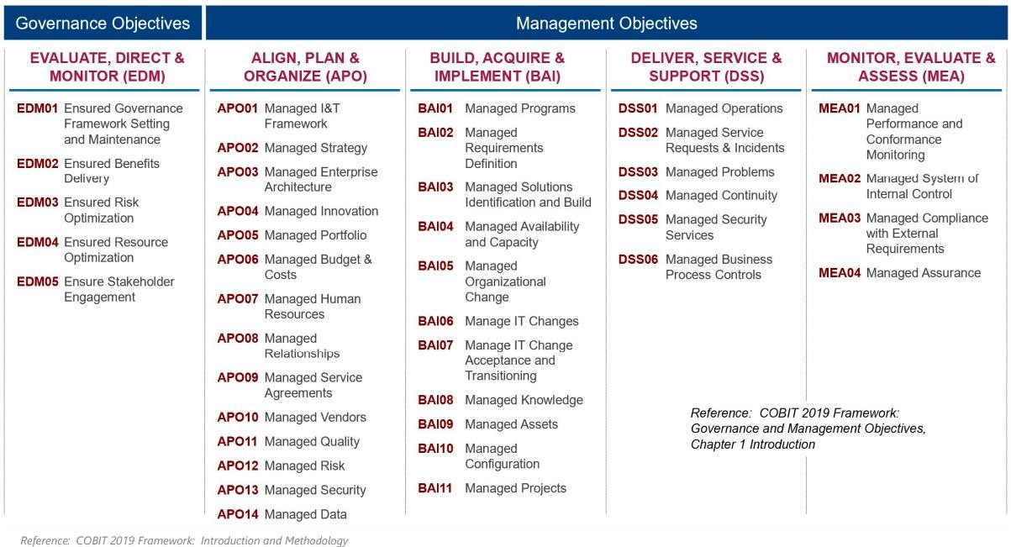

网络服务创造价值的服务价值流
所提出的框架的整体布局借鉴了 ITIL 框架的服务价值体系，并以服务价值链为核心组成部分。价值主张始终着眼于服务开发的需求，无论是交付服务、改进现有能力，还是其他目的。
引入一项创新。这些需求是优先业务目标，它们源于目标级联的结果。“参与”是 ITIL 框架中的一个阶段，该阶段旨在调查特定利益相关者的需求，这些需求是组织战略规划和组合管理的输入。在组织执行设计和转型、获取和构建或设计和支持等阶段时，可以通过 SVC 制定特定服务或产品开发的价 值主张 [18]。
图 5. 网络服务的服务价值流
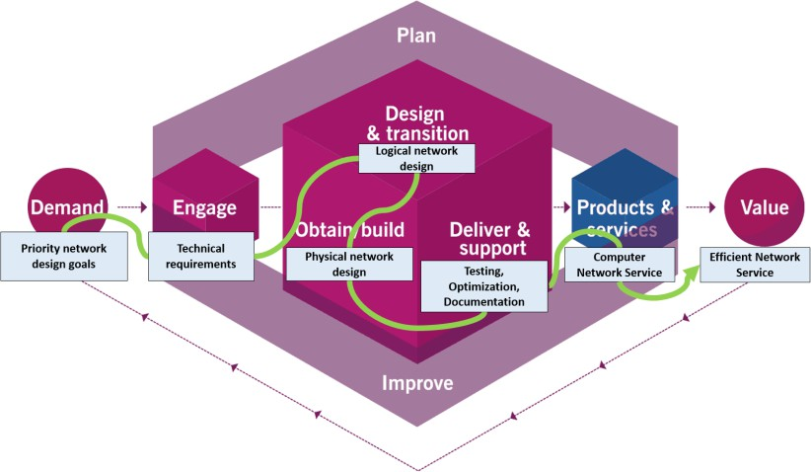

网络系统的设计与开发构成 ITIL SVC 中的一个服务价值流，其中利益相关者的需求构成价值链的需求。参与是指对网络设计目标和约束进行分析。遵循 SDLC 网络生命周期，该价值流应在测试、优化和文档编制之后提供计算机网络服务。通过在每个关键的增值步骤中采用必要的规范，可以向服务客户提供高效的网络服务。
图中展示了PPDIO、SDLC、ITIL服务价值链以及COBIT目标级联工具的组成活动。虚线表示相关方法之间的并行活动。本研究重点关注目标级联，它作为ITIL服务价值链中需求和参与活动的桥梁。通过对活动的协调，我们开发了所提出的框架。
图 6. 不同方法的分布图

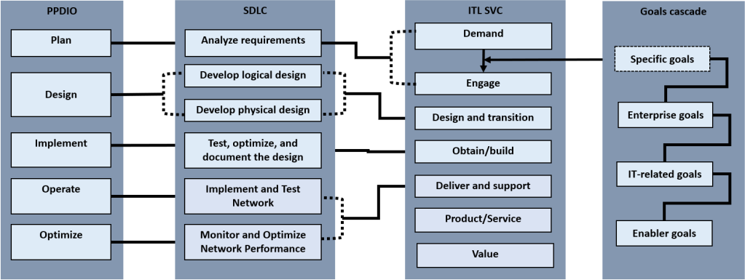
图 6 展示了所提出的框架。作为一项 IT 服务，网络设计和实施定义了其需求，图中将其转化为利益相关者驱动因素。这些驱动因素源于组织战略、业务和监管环境的任何变化以及需要适应的新技术。这些驱动因素会影响组织的业务目标。
该框架中的“参与”阶段现在包含两种方法。首先是使用 COBIT 模板进行目标分解，然后是对网络设计目标进行权衡分析。这是确保 IT 服务与业务和企业目标保持一致的关键阶段。
图 7. 拟议的网络设计和实施框架
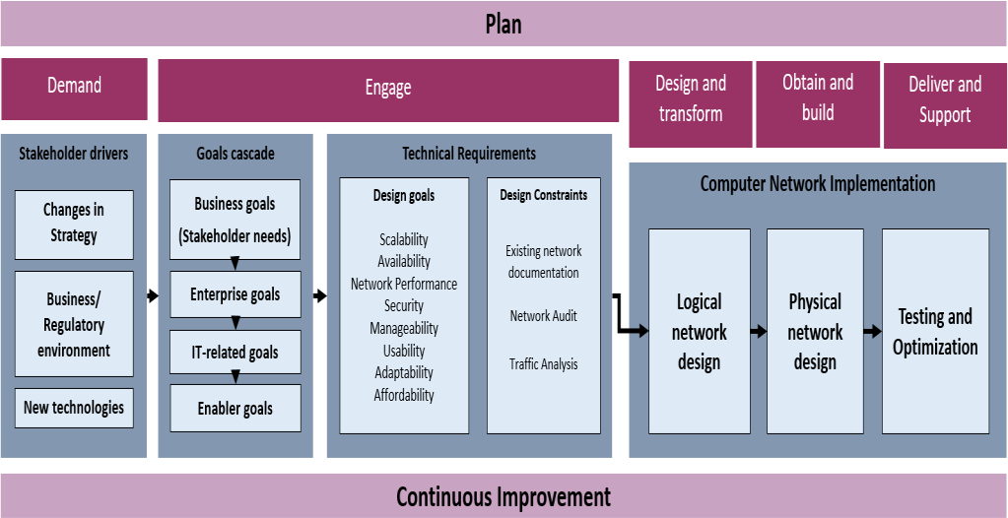
所提出的框架构成ITIL SVC中的一个价值流，利益相关者的驱动因素构成了价值链的需求。参与其中需要运用目标级联分析和权衡分析。
采用自顶向下的网络设计方法，即可完成计算机网络实现的价值流。
对于高等院校而言，以下项目涉及图 7 所示的利益相关者驱动因素。战略规划旨在制定组织未来 3‑5 年的发展计划。战略规划的制定涵盖了企业政治、变革管理以及战略方向调整等问题，因为组织会以当前的绩效评估结果为基准，审视需要改进的领域 [19]。
《商业和监管环境》概述了州立大学运营的法律基础。这些法律基础包括大学在教学、研究和推广等职能执行过程中所制定的政策和指导方针。
这些法律依据包括高等教育委员会（CHED）的备忘录命令、各学位课程的课程标准（PSG），以及公务员委员会、预算与管理部、审计委员会、国家经济发展署和其他机构（包括合作机构）制定的其他监管要求。对机构进行质量管理评估，使其能够为利益相关者提供优质服务，还要求其遵守菲律宾大学认证委员会（AACCUP）的规定；如果高层管理人员愿意，机构还可以获得国家和国际认证及排名，例如菲律宾质量保证（PQA）、国际标准化组织（ISO）、世界大学联盟（WURI）、泰晤士高等教育
（THE）等。高等教育机构的积极领导层正在考虑创新举措。
如果资金允许，应优先考虑常规战略之外的事项。前瞻性思维和战略远见超越了常规工作，在优先考虑其他事项的同时，追求新的发展，寻求解决尚未遇到的问题的方案。这在VUCA时代至关重要。高等院校也致力于采用新兴趋势，将现有举措数字化。这些驱动因素会影响业务优先事项的调整。一旦确定了这些业务优先事项，就可以着手设计和实施创新，从而为组织创造价值。

图 8. 州立大学和学院的利益相关者驱动因素

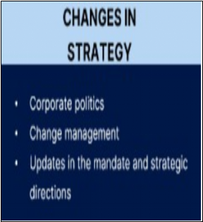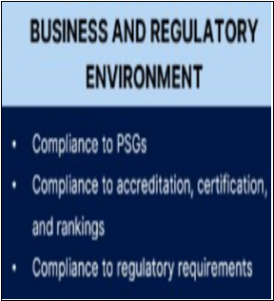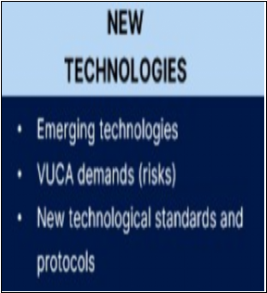

目标级联工具将以业务目标作为输入。经过处理后，工具将识别出优先级较高的项目、计划和活动。这些优先级较高的活动将作为客观进行网络设计目标权衡分析的具体参考依据。此阶段旨在确保网络设计目标的优先级排序是客观确定的。
确定优先目标后，即可将所需网络目标的权衡分析与从目标级联中得出的目标进行映射。通过这种方式，可以确定网络设计的优先级。
目标确保在开发过程中考虑到网络资源的正确组合。

网络设计。这是参照现有能力或设计约束进行的。然而，在优先设计目标得到满足后，这些设计约束在逻辑设计中是次要考虑因素。

结论
所提出的框架采用了网络设计和实施中的结构系统方法的惯例，因为它以 ITIL 服务价值链和 COBIT IT 治理目标级联为基础。运用这些原则和工具，可以确保网络服务成为一项价值主张，满足组织的优先目标，因为它客观地将网络目标与业务目标保持一致。
公立大学的业务目标始终取决于资金来源。然而，通过仔细考虑其他关键因素，该机构可以通过优先实现其目标，最大限度地利用其有限的资源。这些目标将根据所提出的设计和实施框架进行客观确定

致谢
感谢MMSU无缝校园网络项目团队

参考文献
- P. Oppenheimer, Top-Down Network Design Third Edition, Indianapolis: Cisco Systems, Inc., 2011.
- D. Sinha and S. Sinha, “Managing in a VUCA World: Possibilities and Pitfalls.,” Journal of Technology Management for Growing Economies., vol. 11, no. 1, pp. 17-21, 2020.
- M. F. Kadhin, N. S. Ali and S. Al-Khammasi, “Multi-Phase Methodology for Proposing a High Performance Switcched Campus Network: University of Kufa Case Study,” Journal of Engineering and Applied Sciences, vol. 13, no. 16, pp. 6700-6707, 2018.
- L. Hernandez, H. Villanueva and S. Estrada, “Proposal for the Design of a new Technological Infrastructure for the Efficient Management of Netwrok Serices and Applications in a High Complexity Clinic in Colombia,” in Advances in Intelligent Systems and Computing, 2018.
- Giovanni and N. Surantha, “Design and Evaluation of Enterprise Network with Converged Services,”Procedia Computer Science, vol. 135, pp. 526-533, 2018.
- A. A. Ojugo and A. Eboka, “Mitigating Technical Challenges via Redesigning Campus Network for Greater Efficiency, Scalabilty and Robustness: A Logical View,” I.J. Modern Education and Computer Science, vol. 6, no. 2020, pp. 29-45, 2020.
- N. Shiratori, T. Suganuma, S. Suguira, G. Chakraborty, K. Sugawara, T. Kinoshita and E. Lee, “Framework of a flexible computer communication network,” Computer Comunications, vol. 19, no. 1996, pp. 1268-1275, 1996.
- M. Wairisal and N. Surantha, “Design and Evaluation of Efficient Bandwidth Management for a Corporate Network,” in 2018 International Conference on Information Management and Technology, 2018.
- G. Zacharewicz, N. Daclin, G. Doumeingths and H. Haidar, “Model Driven Interoperability for System Engineering,” Modelling, vol. 1, pp. 94-121, 2020.
- J. Wynekoop and J. Finan, “Enterprise Network Design: How is it done?,” in IFIP International Federation for Information Processing, 2001.
- M. I. P. Conchada and I. G. C. Zamudio, “The cost efficiency of state universities and colleges in the Philippines,” The Philippine review of Economics, vol. L, no. 2, pp. 83-104, 2013.
- H. A.-H. Ibrahim, “Quality Assurance and Accreditation in Education,” Open Journal of Education,vol. 2, 2014.
- O. Z. Olorunojowon, “ISACA Drive Transparent and Measurable Value With COBIT 5 Process Metrics,” ISACA, 12 December 2017. [Online]. Available: https://www.isaca.org/resources/news-and- trends/industry-news/2017/drive-transparent-and-measurable-value-with-cobit-5-process- metrics#:~:text=COBIT%205%20combines%20the%20goals,and%20priorities%20of%20the%20organi zation [Accessed 10 August 2022].
- Z. Abdellaoui, Y. Dieudonne and A. Aleya, “Design, implementation and evaluation of a FIber To The Homw (FTTH) access network based on a Giga Passive Optical Netwrok (GPON),” Array, vol. 10, 2021.
- J. HIllenbrand, P. Gonnheimer, E. Gerlitz and J. Fleischer, “Design and implementation of holistic framewrok for data integration in industrial machine and sensor networks,” Procedia CIRP, vol. 104,pp. 1771-1776, 2021.
- M. A.-S. H. H. Yahya Al-Ashmoery, “Impact of IT Service Management and ITIL Framework on the Businesses,” in 2021 International Conference of Modern Trends in Information and Communication Technology Industry (MTICTI), 2021.
- T. H. Anant Joshi, “COBIT as a Framework for Enterprise Governance of IT,” in Enterprise Governance of Information Technology, Switzerland, SpringerNature Switzerland AG, 2020, pp. 125- 162.
- S. B. A. S. Abdelaali Himi, “The IT Service Management according to the ITIL framework,”IJCSI International Journal of Computer Science Issues, vol. 8, no. 3, pp. 515-522, 2011.
- Mariano Marcos State University, “Mariano Marcos State University Updated Stratgeic Plan 2019- 2022,” Mariano Marcos State University, Batac, Ilocos Norte, 2019.

