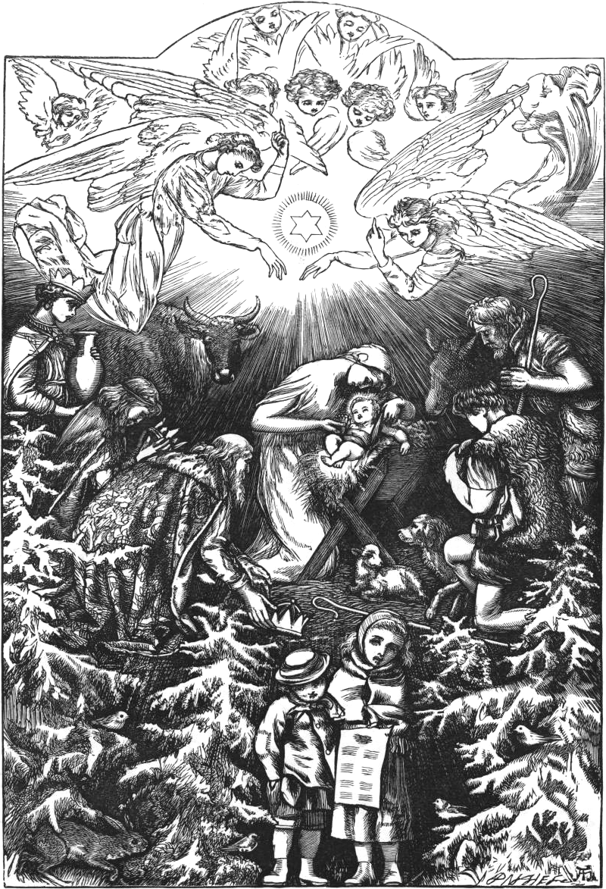

A C
of
C C

, ,  
by
 

th edition,  
This work is free of known copyright restrictions.
Cover artwork, Song of the Angels, painted in  by William-Andolphe Bouguereau; downloaded from wikipaintings.org
Inside cover artwork illustrated by Arthur Hughes, as found in Christmas Carols, New and Old; downloaded from http://www.ccel.org/b/bramley/carols/jpg-hires/0001=i.jpg

Several years ago, I found an old collection of Christmas carols on the Internet, originally published in the late s and called Christmas Carols, New and Old, the music edited by Sir John Stainer and the words by Henrey Ramsden Bramley. I had no way at the time of looking at a PDF while seated at the piano, so I had it printed as a book through Lulu.com. I did this slightly before Christmas , and I enjoyed some of the more obscure carols in the book enough that I thought they should be more readily available. So in early , I set about creating a new collection, which would simply be pages taken directly from a couple of old books that I had, in addition to the Bramley and Stainer, and would probably be only for my own use. I thought briefly of taking the trouble of making new engravings of all the music, but at the time, it seemed an enormous task, beyond my ability: though I had used a program called Lilypond to engrave music in the past, the amount of music I wanted to include would take many days of transcribing.
I had this collection ready (and in its third edition, the first edition having been merely a draft, and the second edition lacking Gaudete) in time for Christmas , but after giving a few away as Christmas gifts, I decided that the low quality scanned pages and the lack of uniformity resulting from pages that had been copied straight out of several different books was such that, though perhaps good enough for my personal use, too much of a slipshod affair to be given away, and if I was going to make a book of Christmas music, I ought to do the thing properly. Thus, I have spent many hours transcribing all the music into Lilypond and proofreading it for this new edition. In this way, I have also been able to add nearly  new songs to the collection, including a handful of Advent hymns and two songs, Ring Out Wild Bells and Auld Lang Syne, which may be sung in celebration of the new calendar year.
In selecting the songs, I have tried to include all the public domain carols that are well-known, as well as those which I have found appealing. Some songs I sought out specifically, and others I had never heard before finding them in older collections, having looked through several such books, including The Cowley Carol Book (), The Cambridge Carol Book (), the aforementioned Christmas Carols, New and Old (), as well as the several Christmas carols found in Favorite Songs and Hymns for School and Home (). In a few cases I have slightly edited the music from the source arrangement, and in rarer cases I have slightly modified the text. In perhaps the rarest of cases, I have anonymously arranged the song into parts myself.
In ordering the songs, I have attempted to interleave the more well-known songs with those tending toward obscurity, but as my goal was to err on the side of including too many songs, rather than too few, I ran out of well-known carols before the end, such that there is a short series of carols that will probably be quite obscure near the end. This is followed by a handful of carols of foreign origin, which are followed by carols and part songs of greater difficulty. In order to keep two-page songs free of page turns, some songs may be slightly out of place.
In some cases I have included the original Latin or German words as well as an English translation, but in other cases this was impossible, for Bramley and Stainer, while noting which texts were translations, were not so thoughtful as to include the names of the original texts, and I have only been able to find the source texts for a few of them. There are also a few foreign-language carols for which I have not included any English translation.
I must also express my gratitude to the authors of the free music engraving software Lilypond, which I have used to engrave all of the music.
Benjamin Bloomfield
Cincinnati, 

Ad cantum leticie 
Adeste Fideles 
All my heart this night rejoices 
All this night bright angels sing 
Although at Yule it Bloweth Cool 
Angel Gabriel 
Angels from the Realms of Glory 
Angels We Have Heard on High 
Angelus ad Virginem 
As Jacob with travel was weary one day 
As Lately We Watched 
As With Gladness Men of Old 
Auld Lang Syne 
Ave Jesu Deus 
Away in a Manger , 
The Babe of Bethlehem 
Behould a sely tender babe 
Blessed be that Maid Marie 
The Boar’s Head Carol 
Bring a Torch, Jeannette, Isabella! 
Carol for Christmas Day 
Carol for Christmas Eve 
A Carol for Christmas Eve 
Carol of the Bells 
Carol of the Birds 
Carol of the Shepherds 
A Child this day is born 
Christ Was Born on Christmas Day 
Christians, Awake, Salute the Happy Morn 
Christmas Bells 
Christmas Day 
Christmas is Coming , 
A Christmas Round 
Christmas Song 
Christmas Time is Come Again 
Chrystmasse of Olde 
Come All Ye Shepherds 
Come Thou Long Expected Jesus 
Come, tune your heart 
Come, ye lofty 
Conditor alme siderum 
Congaudeat turba fidelium 
Corde Natus 
The Coventry Carol , 
A Cradle-Song of the Blessed Virgin 
Creator alme siderum 
Dashing through the snow 
A day, a day of glory 
Deck the Hall 
Ding dong ding. 
Ding Dong Merrily on High 
Earth today rejoices 
Es Ist Ein Ros Entsprungen 
The first good joy that Mary had 
The First Noël 
Flos de radice Jesse 
The Friendly Beasts 
From Church to Church 
From far away 
From Heaven High I Come to You 
Fum Fum Fum 
Gaudete 
Glad Christmas Bells 
Glorious, beauteous, golden-bright 
Gloucestershire Wassail 
God loved the world 
God rest you Chrysten gentilmen 
God Rest You Merry, Gentlemen 
God's dear Son 
The Golden Carol 
Good Christian Men, Rejoice 
Good King Wenceslas , 
Good people all, this Christmas time 
The Great God of Heaven is come down to earth 
Hacia Belén va una burra 
Hail! Holy Child, Lain In An Oxen Manger 
Hark! A Herald Voice is Calling 
Hark! how the bells 
Hark! The Herald Angels Sing 
Here we come a wassailing 
Ho! Steward Bid my servants 
Hodie Christus natus est 
The Holly and the Ivy , 
How Great Our Joy 
Hymn for Christmas Day 
I Heard the Bells on Christmas Day 
I saw a fair Mayden syttin and sing 
I Saw Three Ships 
If angels sung a Savior's birth 
Il est né le divin Enfant 
In Bethlehem, that noble place 
In Dulci Jubilo , , 
In natali Domini 
In terra Pax 
In The Bleak Midwinter , 
The Incarnation 
Infant Holy Infant Lowly 
Infant of days, yet Lord of Life 
It Came Upon the Midnight Clear 
It was the very noon of night 
Jacob's Ladder 
Jesu, hail! O God most holy 
Jesus in the Manger 
Jesus our brother kind and good 
Jesus the Light of the World 
Jingle Bells 
Jolly Old Saint Nicholas 
Joseph, O Dear Joseph Mine 
Joy to the World 
Kling Glöckchen 
Lætentur Cœli 
Like silver lamps in a distant shrine 
Listen Lordings unto me 
Lo, How a Rose E'er Blooming 
The Lord at first had Adam made 
Lullay, Thou Little Tiny Child ,
Make we joy now in this fest 
The Manger Throne 
Masters in This Hall 
Methinks I see an heav’nly Host 
Milford 
The moon shines bright 
Myn Lyking 
New Prince, New Pompe 
Noel Nouvelet 
Now the Holly bears a berry 
O Christmas Tree 
O Come Divine Messiah 
O Come, All Ye Faithful 
O Come, Little Children 
O Come, O Come, Emmanuel 
O Du Frohliche 
O Holy Night 
O Little Town of Bethlehem 
O Tannenbaum 
Of the Father's Love Begotten 
Oh how lovely is the evening 
On Christmas Night all Christians Sing 
On Jordan's Bank 
On the Birthday of the Lord 
On yesternight I saw a sight 
Once again O blessed time 
Once in Royal David's City 
Orientis Partibus 
Past Three A Clock 
Pat-a-Pan 
Personent Hodie , 
Puer Natus in Bethlehem 
Puer nobis nascitur 
Quem Pastores 
Ring out Wild Bells , 
Rise Up, Shepherds, An' Foller 
Riu Riu Chiu 
The Sans Day Carol 
Saw ye never in the twilight 
See Amid the Winter's Snow 
The Seven Joys of Mary 
Shepherds! Shake Off Your Drowsy Sleep 
Shiloh 
Should auld acquaintance be forgot 
Silent Night 
Sleep, Holy Babe 
The Son of God is born for all 
Still Still Still 
Stille Nacht 
The Story of the Shepherd 
The Stranger Star 
Sussex Carol 
Sweet was the song the Virgin sung 
There's a Song in the Air 
There’s a star in the east 
This Endris Night 
This is the truth sent from above , 
To us is born a little Child 
To Us This Morn a Child is Born 
Tollite Hostias 
The Truth from Above , 
Twas in a Cave on Christmas Morn 
Twas in the winter cold 
The Twelve Days of Christmas 
Unto us is born a Son (Puer nobis nascitur) 
Up Good Christen Folk and Listen 
Veni, Veni, Emmanuel 
The Virgin and Child 
The virgin stills the crying 
A Virgin Unspotted 
The Waits' Song 
Wake all music's magic powers 
Wake O Wake with Tidings Thrilling 
The Wassail Song 
Wassail, Wassail 
Watchman, Tell Us of the Night 
We saw a light shine out afar 
We Three Kings of Orient Are 
We Wish You a Merry Christmas 
The Wexford Carol 
What Child is This? 
When Angelick Host Entuned 
When Christ Was Born of Mary Free 
Whence Comes This Rush of Wings? 
While by the sheep we watched at night 
While Shepherds Watched Their Flocks 
Why Most Highest art Thou lying 
Willie, get your little drum 

