Vidyut Prajna (Electric Intelligence)
  - Theme 9: AI for EV Charging Optimization & Infrastructure Planning by BESCOM
Team: Adil Farooq (Lead), Aashrith Reddy, Meher Praveen

1. Executive Summary
As Bengaluru accelerates its Electric Vehicle (EV) transition, BESCOM faces the Coincident Peak Challenge: the high-probability overlap of vehicle charging with existing residential/commercial peak windows. Unmanaged charging creates localized thermal stress on distribution transformers (DTRs), threatening grid stability.
Vidyut Prajna is a non-invasive "sidecar" decision-support layer. It treats the city as a living energy organism, using Graph-based Neural Networks to predict demand and Lagrangian Optimization to balance load. Our solution ensures that the EV revolution supports, rather than stresses, the Bengaluru grid.

2. Problem Understanding & Constraints
- Grid failures often occur at the 11kV/440V transformer level even when city-wide load is stable.
- Demand is non-uniform; evening residential spikes in HSR Layout differ fundamentally from daytime logistics surges in Peenya.
- The system operates as a data-driven overlay with zero modification to existing SCADA or hardware systems.
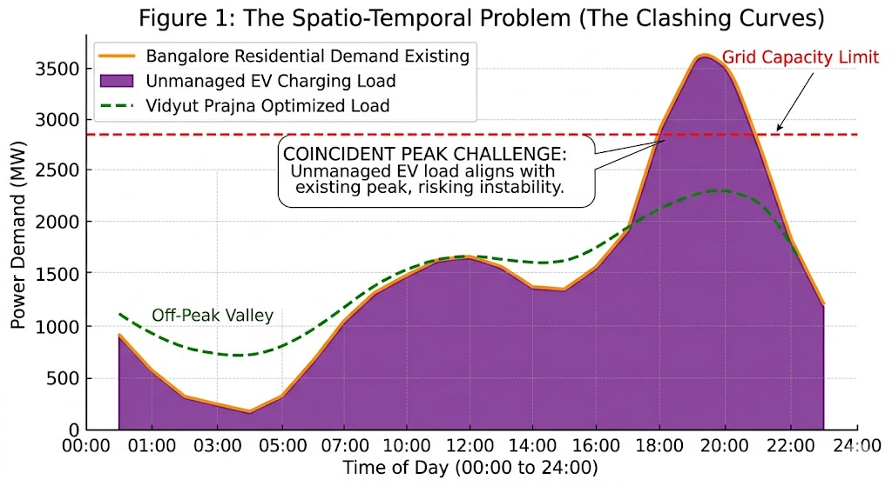
Figure 1 Impact of Vidyut Prajna: Shifting coincident unmanaged EV demand (solid orange) to the optimized night-time valley (dashed green).

3. Methodology: The Technical Engine

3.1 Spatio-Temporal Graph Convolutional Networks (STGCN)
We partition Bengaluru into hexagonal cells using Uber’s H3 Index (Level 9).
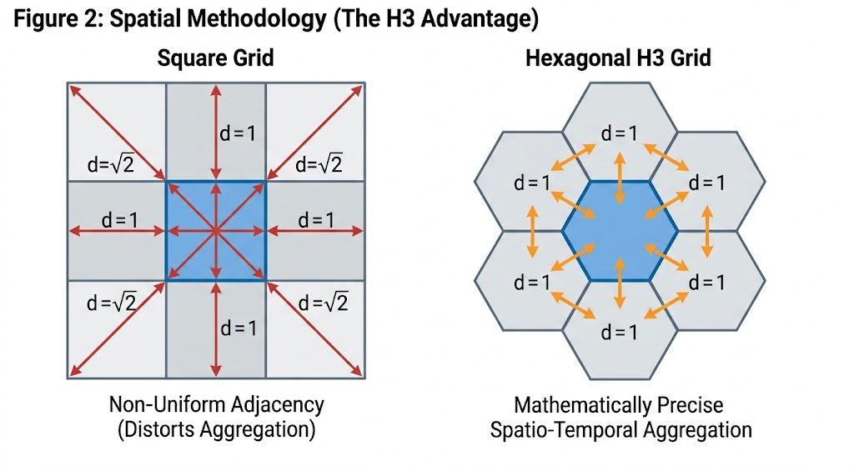
Figure 2 The Isotropic Advantage: Unlike square grids with varying diagonal distances, H3 hexagons guarantee uniform neighbor distances, crucial for accurate Kernel Density Estimation (KDE).
- Standard models ignore city topology. STGCN learns how a traffic bottleneck on the Outer Ring Road acts as a leading indicator for a charging spike in an adjacent cell 20 minutes later.
- Unlike square grids, hexagons have equal distances between all neighbours, which is mathematically vital for accurate Kernel Density Estimation (KDE) of vehicle arrivals.

3.2 Constraint-Aware Scheduling (The Optimizer)
We implement a Lagrangian-based Multi-Criteria Decision Making (MCDM) engine.
- We minimize the global grid variance
$$J = α⋅∑_{t}{\left(P_{grid\left(t\right)}- P_{avg}\right)}^{2}+ β⋅∑_{i}\left(ω_{i}⋅ΔSoC_{i}\right)$$
Where α minimizes load variance and β ensures high-priority vehicles $ω_{i}$ meet their State of Charge $ΔSoC_{i}$ targets.
- The system searches for the "Point of Minimum Regret" balancing grid health against user service levels.

4. Infrastructure Siting Logic
Our siting engine identifies "Future-Proof" corridors by fusing three critical data layers:
- Mapping congregation points for 2W/3W delivery fleets (Swiggy/Zomato) the primary drivers of near-term demand.
- Real-time and historical spare capacity in local transformers.
- Hexagonal cells where demand growth outpaces current charger density within a 500m radius.

5. System Architecture: The Isolation Layer
The architecture is designed for Zero-Risk deployment.
- Ingests telemetry (OCPP, traffic, weather, grid) using Apache Kafka with K-anonymity masking for privacy.
- Processes data through the STGCN and Lagrangian optimizer.
- Surfaces actionable insights (ranked zones, suggested windows, and feeder impact summaries) to the Planner Dashboard.
- No direct commands are sent to distribution hardware, satisfying the safety-first constraint.
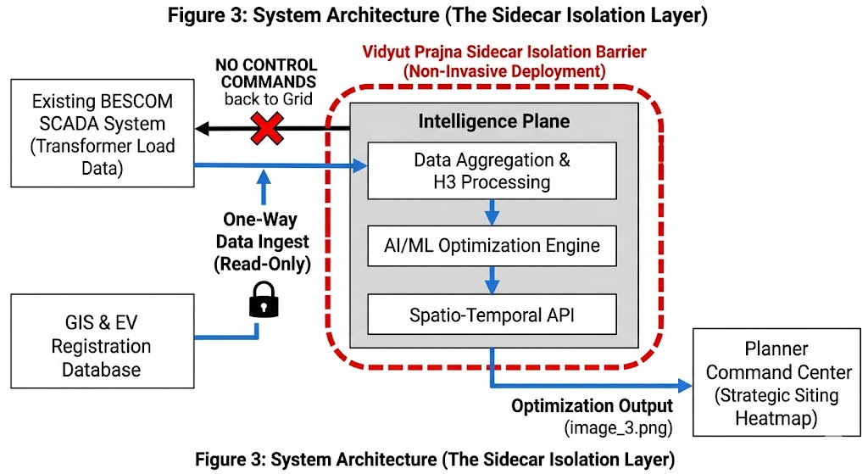
Figure 3 Non-Invasive Sidecar Architecture: A dashed isolation layer separates the Apache Kafka data stream and Lagrangian optimizer from BESCOM's grid control systems.

6. Implementation Roadmap
We move from a "Codebase" to a "City-scale" solution through a staged rollout.
Phase 1: Concept | Graph & Logic | Finalize the mathematical "Shadow Pricing" for load shifting.
Phase 2: Prototype | Digital Twin | Launch a single-ward (e.g., Whitefield) twin using Shadow Mode to stress-test the optimizer.
Phase 3: Pilot | Planner Command Center | Full-scale deployment of the dashboard for BESCOM planners to identify 2027 infrastructure needs.

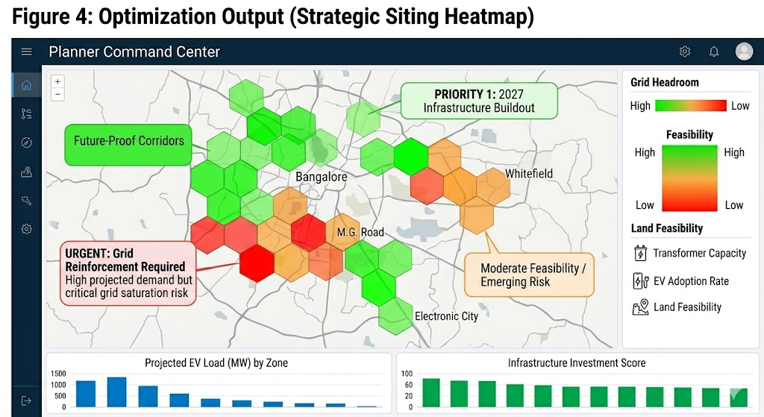
Figure 4 The Strategic Planner Dashboard: A GIS-scale command center visualizing optimized siting recommendations, highlighting high Feeder Headroom (green) and Siting Risk (red).

7. Evaluation & Baselines
Success is measured by the Delta against unmanaged systems:
- Targeted 15-20% reduction in predicted transformer overload events.
- Lower Peak-to-Average Ratio (PAR), reducing the need for expensive "peaker-plant" power procurement.
- Improvement in charger utilization rates compared to Uniform Placement strategies.

8. Conclusion
Vidyut Prajna treats EV charging as a strategic planning problem, not just a technical feature. By providing an explainable, non-invasive intelligence layer, we empower BESCOM to lead the national transition to green mobility without compromising the reliability of the city's power grid.

