

***Multivariate analysis of a late-stage restoration thinning experiment at RNP: 0, 5, & 10-year outcomes***

**2019 Grant Proposal**

|  |  |
| --- | --- |
| Project start date: | Summer 2020 |
| Project end date: | Spring 2022 |
| Funds requested: | $25,000 |

|  |  |
| --- | --- |
| Primary investigator: | Christa Dagley |
| Position/Title: | Research Assistant |
| Mailing Address: | 260A Nutting Hall, Orono, ME 04469-5755 |
| Telephone: | (707) 601-7826 |
| Email address: | christadagley@gmail.com |
| Institution: | University of Maine |

|  |  |
| --- | --- |
| Co-investigator: | Pascal Berrill |
| Position/Title: | Professor |
| Mailing Address: | 201 Nutting Hall, Orono, ME 04469-5755 |
| Telephone: | (207) 581-2836 |
| Email address: | pascal.berrill@maine.edu |
| Institution: | University of Maine |

|  |  |
| --- | --- |
| Co-investigator: | Jason Teraoka |
| Position/Title: | Forester |
| Mailing Address: | PO Box 7, 121200 US Hwy 101, Orick, CA 95555 |
| Telephone: | (707) 465-7783 |
| Email address: | Jason_Teraoka@nps.gov |
| Institution: | Redwood National Park |

**Additional Collaborators:**

|  |  |
| --- | --- |
| **Name** | **Title and Affiliation** |
| Scott Powell | Biological Science Technician, Redwood Nat’l Park |
|  |  |

**Is this proposal a continuation of a project previously funded by Save the Redwoods League?**

|  |  |
| --- | --- |
| No  Yes | If yes, please list grant # and title: |
|  |

1. Research questions

* How do different late-stage restoration thinning treatments modify stand structure and structural complexity when compared against unthinned plots in a replicated experiment, and how does this change over time?
* How do these different restoration thinning treatments alter tree growth, species composition, understory vegetation, tree regeneration, and bear damage, and how do these ecosystem attributes change over time?

1. Purpose and Need

Restoration thinning has been studied, but knowledge gaps remain: how do alternate thinning methods influence structural diversity and various other ecosystem attributes? Specifically, how do different thinning methods (i.e., crown thinning versus low thinning), by virtue of removing and retaining different numbers of trees and tree size assortments, alter the structure, composition, and development of redwood stands. Another gap in our knowledge relates to ecosystem responses when thinning must be applied in stands of advanced ages (i.e., >25 years old) following long periods of competition and suppression of redwood. Finally, repeat-measures data from replicated experiments showing initial responses to thinning and later changes has not been available for restoration thinning in older stands, until now.

Forest managers of the National and State Parks in the redwood region are charged with managing thousands of acres of second-growth forests, many of which are overstocked and contain disproportionately high densities of Douglas-fir. Management objectives on these public lands are focused on creating late-successional forest structures. Thus, methods of enhancing late-successional forest structure have become an important area of research, with field experiments being established using a variety of thinning methods. Early results in young stands (<25 years old) show how variable-density thinning enhances tree growth and promotes development of some late-successional stand attributes (O’Hara et al. 2012, Dagley et al. 2018). Most other thinning studies have focused on thinning-from-below (low thinning) to different densities, usually practiced for timber production objectives (Chittick & Keyes 2007, Oliver et al. 1994, O’Hara et al. 2015; Webb et al. 2017). In the proposed study, we will analyze multiple ecosystem response variables after two intensities of low thinning and crown thinning in an older stand. Havinglow thinning treatments will allow for direct comparison of our results with published studies. Low thinning will also be compared against the efficient, restoration-focused crown thinning method which instantly enhances structural diversity via removal of unwanted mid-sized trees to release larger trees and smaller trees of desired species.

The ability to quantitatively describe forest structures and their modifications from forest management activities is central to sustainable management of complex forest ecosystems. For this purpose, forest managers are in need of measures that describe more completely the structure and complexity to complement the conventional variables such as the distribution of dbh, height, and basal area by size class. This is especially important because different thinning methods can reduce or enhance variability in tree diameter, canopy stratification, change species composition, and modify the arrangement or trees and tree crowns in 3D space. These changes in forest structure may or may not be desirable in meeting restoration objectives, now and into the future. In this study, we will quantitatively characterize the horizontal and vertical structure, and quantify multiple dimensions of diversity resulting from different experimental restoration thinning treatments.

Thinning to achieve restoration objectives has led to increased bear damage by promoting faster tree growth (O’Hara et al. 2010, Perry et al. 2016, Dagley et al. 2018). Bears strip off large pieces of bark and eat the inner bark, phloem, cambium, and outer sapwood, wounding all or part of a stem’s circumference. Damage to trees typically occurs in the spring and is often concentrated near logging roads, skid trails or other openings (Giusti 1988; Perry et al. 2016). Damage is often concentrated on the more vigorous trees (Kimball et al. 2008; Berrill et al. 2017, Dagley et al. 2018) and thought to occur in younger stands soon after thinning has occurred (Hosack & Fulgham 1998). Recommendations from these studies have included testing postponement of thinning until trees are older/larger, but it is unknown whether bears are less likely to damage older trees. In the proposed study, bear damage in stands thinned at 40-years of age has been recorded and will be analyzed.

1. Methods

The A-972 study area is located within Redwood National Park approximately 4 km south of Orick, CA and 2 km from the Pacific Ocean (Figure 1). The stand was clearcut in 1968 (prior to park acquisition), followed by broadcast burning and aerial seeding. The regenerating second-growth stand comprised Douglas-fir, redwood, Sitka spruce (*Picea sitchensis*), western hemlock (*Tsuga heterophylla*), and red alder (*Alnus rubra*). Understory vegetation was nearly absent, but small pockets of ferns, rubus, and ericaceous species occurred before treatment, in 2007, throughout the study site (Teraoka et al. 2017).

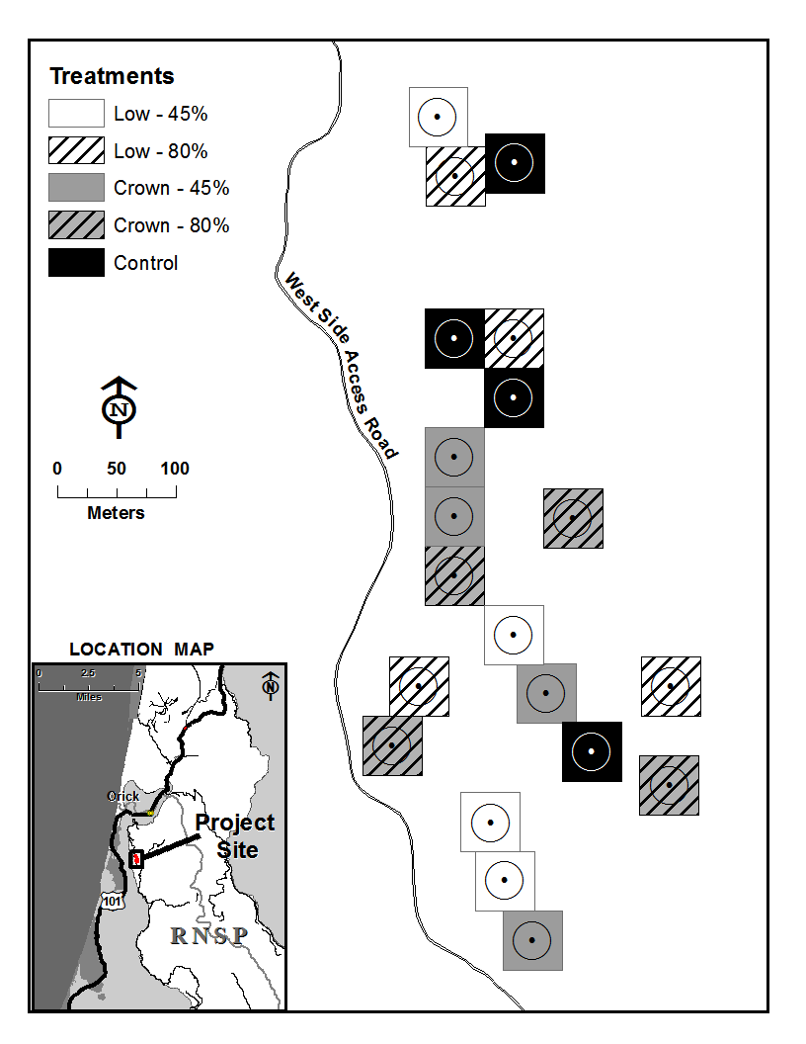

Figure 1—Location map and arrangement of treatment units and plots in the

A-972 Study Area. Circles within the square units represent 0.08-ha monitoring plots.

In fall of 2007, 20 square treatment units (0.25 ha) were established in the 40-year-old stand. Five treatments were randomly assigned and replicated four times: low and crown thinning with 80% retention of basal area, low and crown thinning with 45% retention of basal area, and an unthinned control. Within each treatment unit a circular fixed-radius monitoring plot (0.08 ha) was established at the center of each unit. Species, tree location, diameter at breast height (dbh), height, and live crown base height were recorded for all stems greater than 10 cm dbh. Instances of damage or health problems were recorded. Dominant understory species were identified and percent cover of understory vegetation recorded. Tree regeneration (<10 cm dbh) and understory vegetation was assessed using a 0.004 ha subplot centrally located inside the monitoring plot. Plots were re-measured immediately after treatment in 2008, and again in 2013, and 2018.

We propose to evaluate 10-year temporal and spatial variability in growth and structure following implementation of two thinning methods of two intensities. We will also assess understory vegetation attributes, and the amount of bear damage to each tree species and how this varies among treatments. Data analysis will include multiple linear regression analysis of growth rates (e.g., Berrill & O’Hara 2014, Dagley et al. 2018) and structural complexity (e.g., Calderon et al. 2006, Teraoka & Keyes 2011, Kuehne et al. 2018). The regression analyses will test for significant treatment effects and influential covariates including tree size variables, tree health and damage, and stand variables such as density, composition, and multiple indicators of structural complexity. Multivariate discriminant analysis will attribute differences among thinning treatments to suites of influential variables. Simulation modeling of future growth and stand development will also be performed to support adaptive management in light of longer-term goals of restoring late-successional structural features (e.g., Berrill et al. 2013).

1. Expected Outcomes

Already available are repeat measures of stem-mapped field data for this restoration experiment. Analysis of this valuable data set will help guide adaptive management for Redwood Rising and other restoration efforts. This study will be the first in the redwood region to evaluate 10-year temporal and spatial variability in structure and growth among contrasting thinning treatments and intensities. This will allow for side by side comparison of multiple ecosystem attributes representative of forest structure: tree growth and vigor, species composition, structural complexity, understory vegetation, and bear damage among treatments. We will be able to determine if the increase in tree growth rates from thinning treatments is maintained long-term, via comparison of immediate response and longer-term response (i.e., 0-5 and 5-10 year post-treatment periods). Then, the 10-year data will be used as starting data for model simulations of stand growth to identify time taken to reach late successional forest structure reference conditions.

1. Relevance to Conservation

This study directly informs restoration of redwood stands towards the old-growth reference condition. Old-growth forests are characterized as having greater structural diversity compared to stands with a history of logging. This project focusses on structural diversity and other ecosystem attributes that serve as indicators of old-growth forest. . This will be the first study in the redwood region to quantify the effects of thinning intensity and thinning method on forest structure and composition over a longer time horizon (10 years). Knowledge of outcomes from thinning at advanced ages can be applied to restoration of older stands where this potential to offset costs of restoration by harvesting and selling cut trees. Rigorous results from analysis of this replicated experiment will quickly be available to guide restoration in to the future, including restoration at Redwood National Park where the experiment is located.

1. Deliverables

We propose the following activities/products to increase public awareness about our findings and their application to forest restoration (planned completion Spring 2022):

* Organize and host outreach field tour upon peer-review acceptance of manuscript
* Produce brochure summarizing key findings for visitors to Redwood National Park
* Post manuscript and brochure as .pdf on website

1. Budget

|  |  |
| --- | --- |
| **Budget Item** | **Total** |
| a. Personnel (time allocations and salary/wages) |  |
| **PI**: 50 hours /yr in year 1 and 2 | 3,888 |
| **Co-PI**: 20 hours in year 2 | 1,186 |
| **Grad student**: $16/hr at 20 hrs/week for 48 weeks | 15,360 |
| b. Benefits | 1,964 |
| c. Supplies & Publication Costs | 658 |
| d. Total Direct Costs | 25,000 |
| e. **Total** | 25,000 |

**Amount requested from Save the Redwoods League: $25,000**

*Budget Narrative:*

a. PI: leading reporting tasks; Co-PI: advising graduate student; Grad-student; analyzing data

b. Fringe benefits for California employees currently assessed at 14%

c. Open-access publication page charges; minor stationary and consumables, as needed

d. Total direct costs exclusive of indirect costs.

e. Total project cost is sum of direct costs. Indirect costs are not allowed by Save the Redwoods League.

*Additional contributions:*

Primary Investigator, Jason Teraoka, and collaborator, Scott Powell, employed by Redwood National Parks contribute non-reimbursed time to project for data preparation and cleaning, guidance during data analysis, and reporting.

1. References

Berrill, J-P.; Beal, C.B.; LaFever, D.H.; Dagley, C.M. 2013. Modeling young stand development towards the old-growth reference condition in evergreen mixed-conifer stands at Headwaters Forest Reserve, California. Forests 4(2): 455-470.

Berrill, J-P.; O’Hara, K.L. 2014. Estimating site productivity in irregular stand structures by indexing basal area or volume increment of the dominant species. Canadian Journal of Forest Research 44(1): 92-100.

Berrill, J-P; Perry, D.W.; Breshears, L.W.; Gradillas, G.E. 2017. Tree size, growth, and anatomical factors associated with bear damage in young coast redwood. Pp. 326-328 in: Standiford, R.B.; Valachovic, Y., tech cords. 2017. Proc. of Coast redwood science symposium—2016: Past successes and future direction. USDA Forest Service Gen. Tech. Rep. PSW-GTR-258. Albany, CA. 446 p.

Calderón, O.A.A.; Pérez, J.J.; Kramer, H. 2006. Assessment and monitoring of forest ecosystem structure. In Assessment and Monitoring of Forest Ecosystem Structure; Aguirre-Bravo, C., Pellicane, P.J., Burns, D.P., Draggan, S., Eds.; Monitoring Science and Technology Symposium: Unifying Knowledge for Sustainability in the Western Hemisphere Proceedings RMRS-P-42CD; US Department of Agriculture, Forest Service, Rocky Mountain Research Station: Fort Collins, CO, USA. 990 p.

Chittick, A.J.; Keyes, C.R. 2007. Holter Ridge Thinning Study, Redwood National Park: Preliminary results of a 25-year retrospective. In: Standiford, R.B.; Giusti, G.A.; Valachovic, Y.; Zielinski, W.J.; Furniss, M.J., technical editors. Proceedings of the Redwood Science Symposium: What does the future hold? Gen. Tech. Rep. PSW-GTR-194. Albany, CA: U.S. Department of Agriculture, Forest Service, Pacific Southwest Research Station: 533 p.

Dagley, C.M.; Berrill, J-P.; Leonard, L.P.; Kim. Y.G. 2018. Restoration thinning enhances growth and diversity in mixed redwood/Douglas-fir stands in northern California, USA. Restoration Ecology 26(6): 1170-1179.

Giusti, G.A. 1988. Recognizing black bear damage to second growth redwoods. 13th vertebrate pest conference. University of California-Davis, CA.

Hosack, D.A.; Fulgham, K.O. 1998. Black bear damage to regenerating conifers in Northwestern California. Journal of Wildlife Research 1:32-37

Kimball, B.A.; Nolte, D.L.; Engeman, R.M.; Johnston, J.J.; Frank, R. 2008. Chemically mediated foraging preference of black bears (*Ursus americanus*). Journal of Mammalogy 79: 448-456

Kuehne, C.; Weiskittel, A.; Pommerening, A.; Wagner, R.G. 2018 Evaluation of 10-year temporal and spatial variability in structure and growth across contrasting commercial thinning treatments in spruce-fir forests of northern Maine, USA. Annals of Forest Science 75:20

O’Hara, K.L.; Nesmith, J.C.B.; Leonard, L.; Porter, D.J. 2010 Restoration of old forest features in coast redwood forests using early‐stage variable‐density thinning. Restoration Ecology 18:125-135

O’Hara, K.L.; Leonard, l.; Keyes, C.R. 2012. Variable-density thinning and a marking paradox: Comparing prescription protocols to attain stand variability in coast redwood. Western Journal of Applied Forestry 27(3): 143-149

O’Hara, K.L.; Narayan, L.; Cahill, K.G. 2015. Twelve-year response of coast redwood to precommercial thinning treatments. Forest Science 61(4):780-789.

Oliver, W.W.; Lindquist, J.L.; Strothmann, R.O. 1994. Young-growth redwood stands respond well to various thinning intensities. Western Journal of Applied Forestry 9(4):106-112

Perry, D.W.; Breshears, L.W.; Gradillas, G.E.; Berrill, J-P. 2016 Thinning intensity and ease-of-access increase probability of bear damage in a young coast redwood forest. Journal of Biodiversity Management and Forestry 5:1-7

Teraoka, J.R.; Keyes, C.R. 2011 Low thinning as a forest restoration tool at Redwood National Park. Western Journal of Applied Forestry 26:91-93

Teraoka, J.R.; van Mantgem, P.J.; Keyes, C.R. 2017. Low Thinning and Crown Thinning of Two Severities as Restoration Tools at Redwood National Park. P. 259-266 in Standiford, R.B., and Valachovic, Y. tech cords. Proc. of Coast redwood science symposium—2016: Past successes and future direction. USDA Forest Service Gen. Tech. Rep. PSW-GTR-258. Albany, CA. 446 p.

Webb, L.; Berrill, J-P.; Lindquist, J. 2017. Long Term Results of Early Density Management of a Third Growth Redwood Stand. P. 267-278 in Standiford, R.B., and Valachovic, Y. tech cords. Proc. of Coast redwood science symposium—2016: Past successes and future direction. USDA Forest Service Gen. Tech. Rep. PSW-GTR-258. Albany, CA. 446 p.