Fisher Ankney

October 25th, 2018

Statistics 5193

#### Question 1

fra <- data.frame()  
fra <- edit(fra)  
  
?row.names()  
  
row.names(fra) <- c("Jim", "Sam", "Sally")  
fra

## Exam.1 Exam.2  
## Jim 80 75  
## Sam 88 90  
## Sally 40 100

#### Question 2

head(read.csv("~/Downloads/DJIA.csv", header=T), n=3)  
plot(read.table("clipboard", header = T))  
ls()

## DATE DJIA  
## 1 2018-09-04 25952.48  
## 2 2018-09-05 25974.99  
## 3 2018-09-06 25995.87

## [1] "Exam 1" "Exam 2" "fra"

#### Question 3

“14,376 distinct words appeared once each in the canon, 4343 distinct words twice each; The canon has 884,647 total words, counting repeats.”

plot(  
 read.csv(  
 url("https://web.stanford.edu/~hastie/CASI_files/DATA/shakespeare.txt"),  
 sep = " ",   
 header=T)  
 )

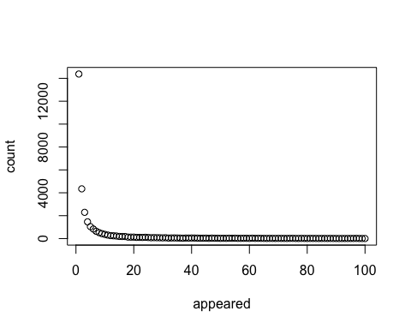

#### Question 4

library(readxl)  
StudentData <- read_excel("~/Downloads/StudentData.xlsx")  
StudentData[1:3,]

## # A tibble: 3 x 9  
## Gender Class HSClass TxtSent TxtRec Fbtime Pinterest Snapchat Introvert  
## <chr> <chr> <dbl> <dbl> <dbl> <dbl> <chr> <chr> <dbl>  
## 1 M STAT2… 1 1 1 30 N Y 8  
## 2 M STAT2… 15 10 15 20 N Y 8  
## 3 M STAT2… 65 150 150 80 N Y 1

DNA <- read.csv("~/Downloads/OrganicNitrogenDNA.csv", row.names=1)  
colnames(DNA) <- c(1:9)  
DNA[1:2,]

## 1 2 3 4 5 6 7 8 9  
## Otu00001 1402 967 1596 995 2078 1239 1108 1569 607  
## Otu00002 1265 786 730 615 1729 1078 854 1045 462

?write.csv  
write.csv(summary(DNA), file = "~/Documents/DNA_summary.txt")