**FINAL REPORT**

NIA Lab: FINAL PROJECT – GUI-based Prisoners Dilemma algorithm for 2/N players.

Authors: Jakub Mikuła, Damian Urbański.

# GUI description

Whole GUI:

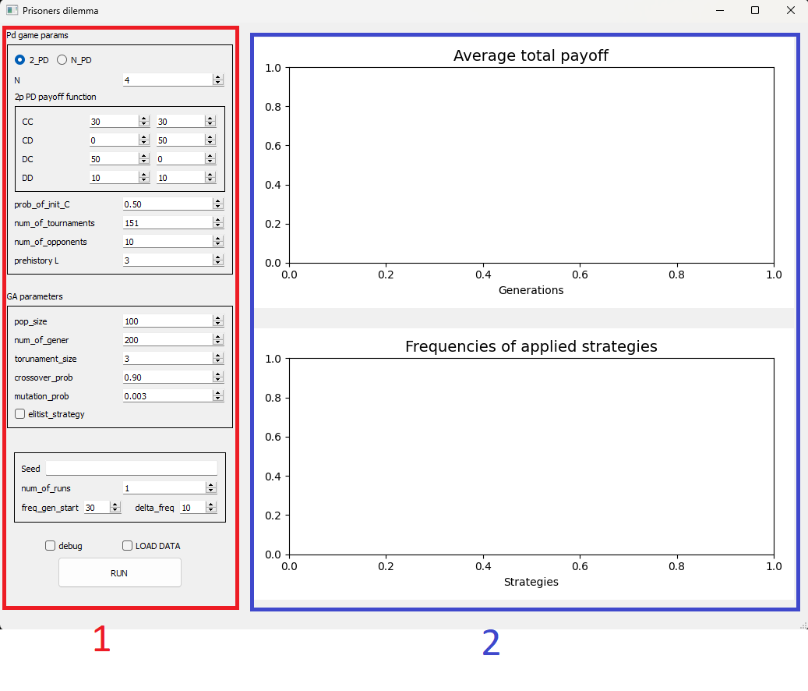

Gui consists of Parameters settings [1] and Result plots display [2] areas.

Parameters settings:

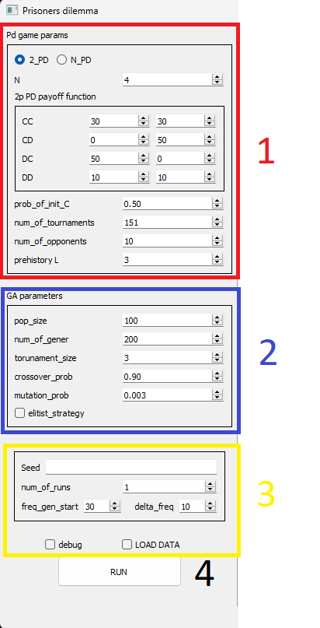

1. PD game params – parameters used in Prisoners Dilemma game.

1. 2_PD/N_PD – two-player game / N player game
2. N – how many players (used for N player game only)
3. 2p PD payoff function – whole payoff function for two-player game
4. Prob_of_init_C –
5. Num_of_tournaments –
6. Num_of_opponents –
7. Prehistory L – Size of prehistory per player

2. GA parameters – parameters used in Genetic algorithms.

1. Pop_size – size of population
2. Num_of_gener – how many generations should be created
3. Tournament_size –
4. Crossover_prob – probability of crossover
5. Mutation_prob – probability of mutation
6. Elitist_strategy – perform/do not perform elitist strategy

3. Other parameters – parameters defining what application should do/show.

1. Seed – setting for custom seed
2. Num_of_runs – how many times game should run
3. Freq_gen_start – first generation to show results for
4. Delta_freq – how many generations to wait before showing next results
5. Debug – should debug be performed
6. LOAD DATA – should data be loaded

4. Run button – button used to run game

Result plots display:

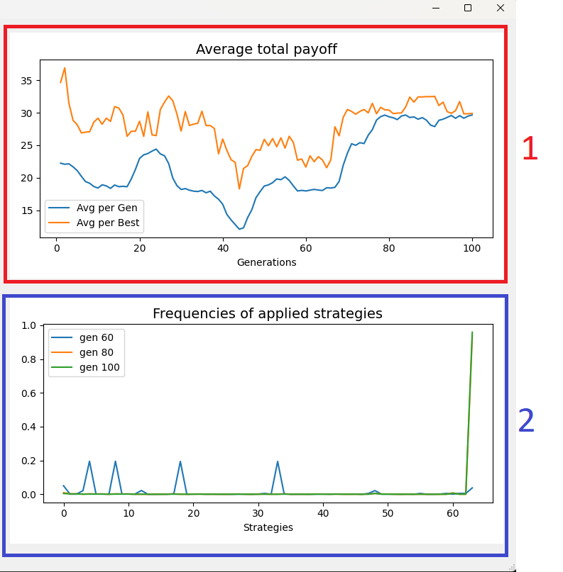

1. Average total payoff for best and for whole generation.

2. Frequencies of applied strategies (start with generation = Freq_gen_start and show next after Delta_freq generations)

Load data window:

Load data window shows only if ‘LOAD DATA’ check box is checked.

1. Strategies – where strategies file can be chosen, and its path will be shown

a. Place for chosen file path to be shown

b. Choose file – button used to choose txt file with strategies in it

2. Prehistory – where prehistory file can be chosen, and its path will be shown

a. Place for chosen file path to be shown

b. Choose file – button used to choose txt file with prehistory in it

3. Cancel button

4. Run button

# Example use

1. Open Exe file with double click
2. Set desired parameters in ‘Parameters Settings’ area and hit RUN button

1. Choose appropriate txt files for strategies and prehistory and hit RUN button

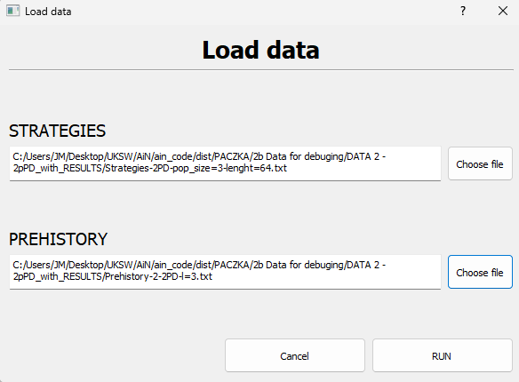

1. Now you can see plots in ‘Result plots display’ area, debug file* and result files** in RESULTS directory

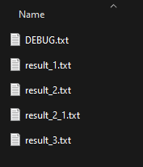

*Debug file is only created if debug check box is checked

**Result files may be different based on given parameters and may not be created

# RESULTS OF EXPERIMENTAL STUDY

## Experiment 1:

Simulation by hand according to pseudocode from Moodle

MAIN

Print_11:

Strategies

[[0 1 0 1 0 1 0 1 0 1 0 1 0 1 0 1 0 1 0 1 0 1 0 1 0 1 0 1 0 1 0 1 0 1 0 1 0 1 0 1 0 1 0 1 0 1 0 1 0 1 0 1 0 1 0 1 0 1 0 1 0 1 0 1],

[0 0 0 0 0 1 1 1 1 1 0 0 0 0 0 1 1 1 1 1 0 0 0 0 0 1 1 1 1 1 0 0 0 0 0 1 1 1 1 1 0 0 0 0 0 1 1 1 1 1 0 0 0 0 0 1 1 1 1 1 0 0 0 0]]

Prehistory

[0 1 1 0 0 0]

Print_12:

P1_start

[0 1 0 1 0 1 0 1 0 1 0 1 0 1 0 1 0 1 0 1 0 1 0 1 0 1 0 1 0 1 0 1 0 1 0 1 0 1 0 1 0 1 0 1 0 1 0 1 0 1 0 1 0 1 0 1 0 1 0 1 0 1 0 1]

P2_strat

[0 0 0 0 0 1 1 1 1 1 0 0 0 0 0 1 1 1 1 1 0 0 0 0 0 1 1 1 1 1 0 0 0 0 0 1 1 1 1 1 0 0 0 0 0 1 1 1 1 1 0 0 0 0 0 1 1 1 1 1 0 0 0 0]

Strat_id_1 = 24

Strat_id_2 = 36

Print_13:

C_opponents

[1,1]

Gener_history_freq

[0 0 0 0 0 0 0 0 0 0 0 0 0 0 0 0 0 0 0 0 0 0 0 0 1 0 0 0 0 0 0 0 0 0 0 0 1 0 0 0 0 0 0 0 0 0 0 0 0 0 0

0 0 0 0 0 0 0 0 0 0 0 0 0]

TOURNAMENT_2PLAYERS

print_14:

Tournament - 2 players

Gra = 1

curr_action_P1 = 0

curr_action_P2 = 1

payoff_P1 = 50

payoff_P2 = 0

SUM_with_opponents

[50, 0]

Prehistory

[0 1 0 1 1 0]

P1_preh

[0 1 0 1 1 0]

P2_preh

[1 0 1 0 0 1]

strat_id_1 = 22

strat_id_2 = 41

gener_history_freq

[0 0 0 0 0 0 0 0 0 0 0 0 0 0 0 0 0 0 0 0 0 0 1 0 1 0 0 0 0 0 0 0 0 0 0 0 1 0 0 0 0 1 0 0 0 0 0 0 0 0 0

0 0 0 0 0 0 0 0 0 0 0 0 0]

print_14:

Tournament - 2 players

Gra = 2

curr_action_P1 = 0

curr_action_P2 = 0

payoff_P1 = 10

payoff_P2 = 10

SUM_with_opponents

[60, 10]

Prehistory

[0 0 0 1 0 1]

P1_preh

[0 0 0 1 0 1]

P2_preh

[0 0 1 0 1 0]

strat_id_1 = 5

strat_id_2 = 10

gener_history_freq

[0 0 0 0 0 1 0 0 0 0 1 0 0 0 0 0 0 0 0 0 0 0 1 0 1 0 0 0 0 0 0 0 0 0 0 0 1 0 0 0 0 1 0 0 0 0 0 0 0 0 0

0 0 0 0 0 0 0 0 0 0 0 0 0]

print_14:

Tournament - 2 players

Gra = 3

curr_action_P1 = 1

curr_action_P2 = 0

payoff_P1 = 0

payoff_P2 = 50

SUM_with_opponents

[60, 60]

Prehistory

[1 0 0 0 0 1]

P1_preh

[1 0 0 0 0 1]

P2_preh

[0 1 0 0 1 0]

strat_id_1 = 33

strat_id_2 = 18

gener_history_freq

[0 0 0 0 0 1 0 0 0 0 1 0 0 0 0 0 0 0 1 0 0 0 1 0 1 0 0 0 0 0 0 0 0 1 0 0 1 0 0 0 0 1 0 0 0 0 0 0 0 0 0

0 0 0 0 0 0 0 0 0 0 0 0 0]

print_14:

Tournament - 2 players

Gra = 4

curr_action_P1 = 1

curr_action_P2 = 1

payoff_P1 = 30

payoff_P2 = 30

SUM_with_opponents

[90, 90]

Prehistory

[1 1 1 0 0 0]

P1_preh

[1 1 1 0 0 0]

P2_preh

[1 1 0 1 0 0]

strat_id_1 = 56

strat_id_2 = 52

gener_history_freq

[0 0 0 0 0 1 0 0 0 0 1 0 0 0 0 0 0 0 1 0 0 0 1 0 1 0 0 0 0 0 0 0 0 1 0 0 1 0 0 0 0 1 0 0 0 0 0 0 0 0 0

0 1 0 0 0 1 0 0 0 0 0 0 0]

print_14:

Tournament - 2 players

Gra = 5

curr_action_P1 = 0

curr_action_P2 = 0

payoff_P1 = 10

payoff_P2 = 10

SUM_with_opponents

[100, 100]

Prehistory

[0 0 1 1 1 0]

P1_preh

[0 0 1 1 1 0]

P2_preh

[0 0 1 1 0 1]

strat_id_1 = 14

strat_id_2 = 13

gener_history_freq

[0 0 0 0 0 1 0 0 0 0 1 0 0 1 1 0 0 0 1 0 0 0 1 0 1 0 0 0 0 0 0 0 0 1 0 0 1 0 0 0 0 1 0 0 0 0 0 0 0 0 0

0 1 0 0 0 1 0 0 0 0 0 0 0]

FITNESS & STATISTICS

GO TO STOP

## Experiment 2

You will run the program with the following data:

GUI:2pPD

GUI: num_of_tournaments=5

GUI: num_of_opponents=2

GUI: prehistory_l=3

GUI: pop_size=3

GUI:num_of_generations=2

GUI:freq_gen_start=0

GUI:delta_freq=1

GUI: debug

Remaining GUI parameters – like in GUI.

Use data from the directory: 2b Data for debugging/DATA 2 – 2pPD

STEP 1: Make on a list of a paper a simulation by hand, and show which values are expected to be printed for the above parameters.

STEP 2: Run the program and show values printed by the program.

SUBMIT results by email.

print_11

Strategies

0101010101010101010101010101010101010101010101010101010101010101

0000011111000001111100000111110000011111000001111100000111110000

0000000000000000000000000000000011111111111111111111111111111111

Prehistory

001001

print_12

P1_start

0101010101010101010101010101010101010101010101010101010101010101

P2_strat

0000011111000001111100000111110000011111000001111100000111110000

strat_id_1 = 9

strat_id_2 = 6

print_13

c_opponents

[1, 1, 0]

gener_history_freq

[0, 0, 0, 0, 0, 0, 1, 0, 0, 1, 0, 0, 0, 0, 0, 0, 0, 0, 0, 0, 0, 0, 0, 0, 0, 0, 0, 0, 0, 0, 0, 0, 0, 0, 0, 0, 0, 0, 0, 0, 0, 0, 0, 0, 0, 0, 0, 0, 0, 0, 0, 0, 0, 0, 0, 0, 0, 0, 0, 0, 0, 0, 0, 0]

print_14

Tournament - 2 players

Gra = 1

curr_action_P1 = 1

curr_action_P2 = 1

payoff_P1 = 30

payoff_P2 = 30

SUM_with_opponents

[30, 30, 0]

Prehistory

[[1, 1], [0, 0], [1, 0]]

P1_preh

[[1, 1], [0, 0], [1, 0]]

P2_preh

[[1, 1], [0, 0], [0, 1]]

strat_id_1 = 50

strat_id_2 = 49

gener_history_freq

[0, 0, 0, 0, 0, 0, 1, 0, 0, 1, 0, 0, 0, 0, 0, 0, 0, 0, 0, 0, 0, 0, 0, 0, 0, 0, 0, 0, 0, 0, 0, 0, 0, 0, 0, 0, 0, 0, 0, 0, 0, 0, 0, 0, 0, 0, 0, 0, 0, 1, 1, 0, 0, 0, 0, 0, 0, 0, 0, 0, 0, 0, 0, 0]

print_14

Tournament - 2 players

Gra = 2

curr_action_P1 = 0

curr_action_P2 = 1

payoff_P1 = 50

payoff_P2 = 0

SUM_with_opponents

[80, 30, 0]

Prehistory

[[0, 1], [1, 1], [0, 0]]

P1_preh

[[0, 1], [1, 1], [0, 0]]

P2_preh

[[1, 0], [1, 1], [0, 0]]

strat_id_1 = 28

strat_id_2 = 44

gener_history_freq

[0, 0, 0, 0, 0, 0, 1, 0, 0, 1, 0, 0, 0, 0, 0, 0, 0, 0, 0, 0, 0, 0, 0, 0, 0, 0, 0, 0, 1, 0, 0, 0, 0, 0, 0, 0, 0, 0, 0, 0, 0, 0, 0, 0, 1, 0, 0, 0, 0, 1, 1, 0, 0, 0, 0, 0, 0, 0, 0, 0, 0, 0, 0, 0]

print_14

Tournament - 2 players

Gra = 3

curr_action_P1 = 0

curr_action_P2 = 0

payoff_P1 = 10

payoff_P2 = 10

SUM_with_opponents

[90, 40, 0]

Prehistory

[[0, 0], [0, 1], [1, 1]]

P1_preh

[[0, 0], [0, 1], [1, 1]]

P2_preh

[[0, 0], [1, 0], [1, 1]]

strat_id_1 = 7

strat_id_2 = 11

gener_history_freq

[0, 0, 0, 0, 0, 0, 1, 1, 0, 1, 0, 1, 0, 0, 0, 0, 0, 0, 0, 0, 0, 0, 0, 0, 0, 0, 0, 0, 1, 0, 0, 0, 0, 0, 0, 0, 0, 0, 0, 0, 0, 0, 0, 0, 1, 0, 0, 0, 0, 1, 1, 0, 0, 0, 0, 0, 0, 0, 0, 0, 0, 0, 0, 0]

print_14

Tournament - 2 players

Gra = 4

curr_action_P1 = 1

curr_action_P2 = 0

payoff_P1 = 0

payoff_P2 = 50

SUM_with_opponents

[90, 90, 0]

Prehistory

[[1, 0], [0, 0], [0, 1]]

P1_preh

[[1, 0], [0, 0], [0, 1]]

P2_preh

[[0, 1], [0, 0], [1, 0]]

strat_id_1 = 33

strat_id_2 = 18

gener_history_freq

[0, 0, 0, 0, 0, 0, 1, 1, 0, 1, 0, 1, 0, 0, 0, 0, 0, 0, 1, 0, 0, 0, 0, 0, 0, 0, 0, 0, 1, 0, 0, 0, 0, 1, 0, 0, 0, 0, 0, 0, 0, 0, 0, 0, 1, 0, 0, 0, 0, 1, 1, 0, 0, 0, 0, 0, 0, 0, 0, 0, 0, 0, 0, 0]

print_14

Tournament - 2 players

Gra = 5

curr_action_P1 = 1

curr_action_P2 = 1

payoff_P1 = 30

payoff_P2 = 30

SUM_with_opponents

[120, 120, 0]

Prehistory

[[1, 1], [1, 0], [0, 0]]

P1_preh

[[1, 1], [1, 0], [0, 0]]

P2_preh

[[1, 1], [0, 1], [0, 0]]

strat_id_1 = 56

strat_id_2 = 52

gener_history_freq

[0, 0, 0, 0, 0, 0, 1, 1, 0, 1, 0, 1, 0, 0, 0, 0, 0, 0, 1, 0, 0, 0, 0, 0, 0, 0, 0, 0, 1, 0, 0, 0, 0, 1, 0, 0, 0, 0, 0, 0, 0, 0, 0, 0, 1, 0, 0, 0, 0, 1, 1, 0, 1, 0, 0, 0, 1, 0, 0, 0, 0, 0, 0, 0]

print_12

P1_start

0000000000000000000000000000000011111111111111111111111111111111

P2_strat

0101010101010101010101010101010101010101010101010101010101010101

strat_id_1 = 50

strat_id_2 = 49

print_13

c_opponents

[2, 1, 1]

gener_history_freq

[0, 0, 0, 0, 0, 0, 1, 1, 0, 1, 0, 1, 0, 0, 0, 0, 0, 0, 1, 0, 0, 0, 0, 0, 0, 0, 0, 0, 1, 0, 0, 0, 0, 1, 0, 0, 0, 0, 0, 0, 0, 0, 0, 0, 1, 0, 0, 0, 0, 2, 2, 0, 1, 0, 0, 0, 1, 0, 0, 0, 0, 0, 0, 0]

print_14

Tournament - 2 players

Gra = 1

curr_action_P1 = 1

curr_action_P2 = 1

payoff_P1 = 30

payoff_P2 = 30

SUM_with_opponents

[150, 120, 30]

Prehistory

[[1, 1], [1, 1], [0, 0]]

P1_preh

[[1, 1], [1, 1], [0, 0]]

P2_preh

[[1, 1], [1, 1], [0, 0]]

strat_id_1 = 60

strat_id_2 = 60

gener_history_freq

[0, 0, 0, 0, 0, 0, 1, 1, 0, 1, 0, 1, 0, 0, 0, 0, 0, 0, 1, 0, 0, 0, 0, 0, 0, 0, 0, 0, 1, 0, 0, 0, 0, 1, 0, 0, 0, 0, 0, 0, 0, 0, 0, 0, 1, 0, 0, 0, 0, 2, 2, 0, 1, 0, 0, 0, 1, 0, 0, 0, 2, 0, 0, 0]

print_14

Tournament - 2 players

Gra = 2

curr_action_P1 = 1

curr_action_P2 = 0

payoff_P1 = 0

payoff_P2 = 50

SUM_with_opponents

[200, 120, 30]

Prehistory

[[1, 0], [1, 1], [1, 1]]

P1_preh

[[1, 0], [1, 1], [1, 1]]

P2_preh

[[0, 1], [1, 1], [1, 1]]

strat_id_1 = 47

strat_id_2 = 31

gener_history_freq

[0, 0, 0, 0, 0, 0, 1, 1, 0, 1, 0, 1, 0, 0, 0, 0, 0, 0, 1, 0, 0, 0, 0, 0, 0, 0, 0, 0, 1, 0, 0, 1, 0, 1, 0, 0, 0, 0, 0, 0, 0, 0, 0, 0, 1, 0, 0, 1, 0, 2, 2, 0, 1, 0, 0, 0, 1, 0, 0, 0, 2, 0, 0, 0]

print_14

Tournament - 2 players

Gra = 3

curr_action_P1 = 1

curr_action_P2 = 1

payoff_P1 = 30

payoff_P2 = 30

SUM_with_opponents

[230, 120, 60]

Prehistory

[[1, 1], [1, 0], [1, 1]]

P1_preh

[[1, 1], [1, 0], [1, 1]]

P2_preh

[[1, 1], [0, 1], [1, 1]]

strat_id_1 = 59

strat_id_2 = 55

gener_history_freq

[0, 0, 0, 0, 0, 0, 1, 1, 0, 1, 0, 1, 0, 0, 0, 0, 0, 0, 1, 0, 0, 0, 0, 0, 0, 0, 0, 0, 1, 0, 0, 1, 0, 1, 0, 0, 0, 0, 0, 0, 0, 0, 0, 0, 1, 0, 0, 1, 0, 2, 2, 0, 1, 0, 0, 1, 1, 0, 0, 1, 2, 0, 0, 0]

print_14

Tournament - 2 players

Gra = 4

curr_action_P1 = 1

curr_action_P2 = 1

payoff_P1 = 30

payoff_P2 = 30

SUM_with_opponents

[260, 120, 90]

Prehistory

[[1, 1], [1, 1], [1, 0]]

P1_preh

[[1, 1], [1, 1], [1, 0]]

P2_preh

[[1, 1], [1, 1], [0, 1]]

strat_id_1 = 62

strat_id_2 = 61

gener_history_freq

[0, 0, 0, 0, 0, 0, 1, 1, 0, 1, 0, 1, 0, 0, 0, 0, 0, 0, 1, 0, 0, 0, 0, 0, 0, 0, 0, 0, 1, 0, 0, 1, 0, 1, 0, 0, 0, 0, 0, 0, 0, 0, 0, 0, 1, 0, 0, 1, 0, 2, 2, 0, 1, 0, 0, 1, 1, 0, 0, 1, 2, 1, 1, 0]

print_14

Tournament - 2 players

Gra = 5

curr_action_P1 = 1

curr_action_P2 = 1

payoff_P1 = 30

payoff_P2 = 30

SUM_with_opponents

[290, 120, 120]

Prehistory

[[1, 1], [1, 1], [1, 1]]

P1_preh

[[1, 1], [1, 1], [1, 1]]

P2_preh

[[1, 1], [1, 1], [1, 1]]

strat_id_1 = 63

strat_id_2 = 63

gener_history_freq

[0, 0, 0, 0, 0, 0, 1, 1, 0, 1, 0, 1, 0, 0, 0, 0, 0, 0, 1, 0, 0, 0, 0, 0, 0, 0, 0, 0, 1, 0, 0, 1, 0, 1, 0, 0, 0, 0, 0, 0, 0, 0, 0, 0, 1, 0, 0, 1, 0, 2, 2, 0, 1, 0, 0, 1, 1, 0, 0, 1, 2, 1, 1, 2]

print_12

P1_start

0000011111000001111100000111110000011111000001111100000111110000

P2_strat

0000000000000000000000000000000011111111111111111111111111111111

strat_id_1 = 37

strat_id_2 = 26

print_13

c_opponents

[2, 2, 2]

gener_history_freq

[0, 0, 0, 0, 0, 0, 1, 1, 0, 1, 0, 1, 0, 0, 0, 0, 0, 0, 1, 0, 0, 0, 0, 0, 0, 0, 1, 0, 1, 0, 0, 1, 0, 1, 0, 0, 0, 1, 0, 0, 0, 0, 0, 0, 1, 0, 0, 1, 0, 2, 2, 0, 1, 0, 0, 1, 1, 0, 0, 1, 2, 1, 1, 2]

print_14

Tournament - 2 players

Gra = 1

curr_action_P1 = 1

curr_action_P2 = 0

payoff_P1 = 0

payoff_P2 = 50

SUM_with_opponents

[290, 120, 170]

Prehistory

[[1, 0], [1, 0], [0, 1]]

P1_preh

[[1, 0], [1, 0], [0, 1]]

P2_preh

[[0, 1], [0, 1], [1, 0]]

strat_id_1 = 41

strat_id_2 = 22

gener_history_freq

[0, 0, 0, 0, 0, 0, 1, 1, 0, 1, 0, 1, 0, 0, 0, 0, 0, 0, 1, 0, 0, 0, 1, 0, 0, 0, 1, 0, 1, 0, 0, 1, 0, 1, 0, 0, 0, 1, 0, 0, 0, 1, 0, 0, 1, 0, 0, 1, 0, 2, 2, 0, 1, 0, 0, 1, 1, 0, 0, 1, 2, 1, 1, 2]

print_14

Tournament - 2 players

Gra = 2

curr_action_P1 = 0

curr_action_P2 = 0

payoff_P1 = 10

payoff_P2 = 10

SUM_with_opponents

[290, 130, 180]

Prehistory

[[0, 0], [1, 0], [1, 0]]

P1_preh

[[0, 0], [1, 0], [1, 0]]

P2_preh

[[0, 0], [0, 1], [0, 1]]

strat_id_1 = 10

strat_id_2 = 5

gener_history_freq

[0, 0, 0, 0, 0, 1, 1, 1, 0, 1, 1, 1, 0, 0, 0, 0, 0, 0, 1, 0, 0, 0, 1, 0, 0, 0, 1, 0, 1, 0, 0, 1, 0, 1, 0, 0, 0, 1, 0, 0, 0, 1, 0, 0, 1, 0, 0, 1, 0, 2, 2, 0, 1, 0, 0, 1, 1, 0, 0, 1, 2, 1, 1, 2]

print_14

Tournament - 2 players

Gra = 3

curr_action_P1 = 0

curr_action_P2 = 0

payoff_P1 = 10

payoff_P2 = 10

SUM_with_opponents

[290, 140, 190]

Prehistory

[[0, 0], [0, 0], [1, 0]]

P1_preh

[[0, 0], [0, 0], [1, 0]]

P2_preh

[[0, 0], [0, 0], [0, 1]]

strat_id_1 = 2

strat_id_2 = 1

gener_history_freq

[0, 1, 1, 0, 0, 1, 1, 1, 0, 1, 1, 1, 0, 0, 0, 0, 0, 0, 1, 0, 0, 0, 1, 0, 0, 0, 1, 0, 1, 0, 0, 1, 0, 1, 0, 0, 0, 1, 0, 0, 0, 1, 0, 0, 1, 0, 0, 1, 0, 2, 2, 0, 1, 0, 0, 1, 1, 0, 0, 1, 2, 1, 1, 2]

print_14

Tournament - 2 players

Gra = 4

curr_action_P1 = 0

curr_action_P2 = 0

payoff_P1 = 10

payoff_P2 = 10

SUM_with_opponents

[290, 150, 200]

Prehistory

[[0, 0], [0, 0], [0, 0]]

P1_preh

[[0, 0], [0, 0], [0, 0]]

P2_preh

[[0, 0], [0, 0], [0, 0]]

strat_id_1 = 0

strat_id_2 = 0

gener_history_freq

[2, 1, 1, 0, 0, 1, 1, 1, 0, 1, 1, 1, 0, 0, 0, 0, 0, 0, 1, 0, 0, 0, 1, 0, 0, 0, 1, 0, 1, 0, 0, 1, 0, 1, 0, 0, 0, 1, 0, 0, 0, 1, 0, 0, 1, 0, 0, 1, 0, 2, 2, 0, 1, 0, 0, 1, 1, 0, 0, 1, 2, 1, 1, 2]

print_14

Tournament - 2 players

Gra = 5

curr_action_P1 = 0

curr_action_P2 = 0

payoff_P1 = 10

payoff_P2 = 10

SUM_with_opponents

[290, 160, 210]

Prehistory

[[0, 0], [0, 0], [0, 0]]

P1_preh

[[0, 0], [0, 0], [0, 0]]

P2_preh

[[0, 0], [0, 0], [0, 0]]

strat_id_1 = 0

strat_id_2 = 0

gener_history_freq

[4, 1, 1, 0, 0, 1, 1, 1, 0, 1, 1, 1, 0, 0, 0, 0, 0, 0, 1, 0, 0, 0, 1, 0, 0, 0, 1, 0, 1, 0, 0, 1, 0, 1, 0, 0, 0, 1, 0, 0, 0, 1, 0, 0, 1, 0, 0, 1, 0, 2, 2, 0, 1, 0, 0, 1, 1, 0, 0, 1, 2, 1, 1, 2]

print_12

P1_start

0000011111000001111100000111110000011111000001111100000111110000

P2_strat

0000000000000000000000000000000011111111111111111111111111111111

strat_id_1 = 0

strat_id_2 = 0

print_13

c_opponents

[2, 2, 2]

gener_history_freq

[4, 1, 1, 0, 0, 1, 1, 1, 0, 1, 1, 1, 0, 0, 0, 0, 0, 0, 1, 0, 0, 0, 1, 0, 0, 0, 1, 0, 1, 0, 0, 1, 0, 1, 0, 0, 0, 1, 0, 0, 0, 1, 0, 0, 1, 0, 0, 1, 0, 2, 2, 0, 1, 0, 0, 1, 1, 0, 0, 1, 2, 1, 1, 2]

print_31

After GA operators

temp_Strategies

['0101010101010101010101010101010101010101010101010101010101010101', '0000000000000000000000000000000011111111111111111111111111111111', '0101010101010101010101010101010101010101010101010101010101010101']

parent_Strategies

[1, 1, 1]

child_Strategies

['0100000000000000000000000000000011111111111111111111111111111111', '0001010101010101010101010101010101010101010101010101010101010101', '0101010101010101010101010101010101010101010101010101010101010101']

Strategies

['0100000000000000000000000000000011111111111111111111111111111111', '0001010101010101010101010101010101010101010101010101010101010101', '0101010101010101010101010101010101010101010101010101010101010101']

print_12

P1_start

0100000000000000000000000000000011111111111111111111111111111111

P2_strat

0001010101010101010101010101010101010101010101010101010101010101

strat_id_1 = 26

strat_id_2 = 37

print_13

c_opponents

[1, 1, 0]

gener_history_freq

[0, 0, 0, 0, 0, 0, 0, 0, 0, 0, 0, 0, 0, 0, 0, 0, 0, 0, 0, 0, 0, 0, 0, 0, 0, 0, 1, 0, 0, 0, 0, 0, 0, 0, 0, 0, 0, 1, 0, 0, 0, 0, 0, 0, 0, 0, 0, 0, 0, 0, 0, 0, 0, 0, 0, 0, 0, 0, 0, 0, 0, 0, 0, 0]

print_14

Tournament - 2 players

Gra = 1

curr_action_P1 = 0

curr_action_P2 = 1

payoff_P1 = 50

payoff_P2 = 0

SUM_with_opponents

[50, 0, 0]

Prehistory

[[0, 1], [0, 1], [1, 0]]

P1_preh

[[0, 1], [0, 1], [1, 0]]

P2_preh

[[1, 0], [1, 0], [0, 1]]

strat_id_1 = 22

strat_id_2 = 41

gener_history_freq

[0, 0, 0, 0, 0, 0, 0, 0, 0, 0, 0, 0, 0, 0, 0, 0, 0, 0, 0, 0, 0, 0, 1, 0, 0, 0, 1, 0, 0, 0, 0, 0, 0, 0, 0, 0, 0, 1, 0, 0, 0, 1, 0, 0, 0, 0, 0, 0, 0, 0, 0, 0, 0, 0, 0, 0, 0, 0, 0, 0, 0, 0, 0, 0]

print_14

Tournament - 2 players

Gra = 2

curr_action_P1 = 0

curr_action_P2 = 1

payoff_P1 = 50

payoff_P2 = 0

SUM_with_opponents

[100, 0, 0]

Prehistory

[[0, 1], [0, 1], [0, 1]]

P1_preh

[[0, 1], [0, 1], [0, 1]]

P2_preh

[[1, 0], [1, 0], [1, 0]]

strat_id_1 = 21

strat_id_2 = 42

gener_history_freq

[0, 0, 0, 0, 0, 0, 0, 0, 0, 0, 0, 0, 0, 0, 0, 0, 0, 0, 0, 0, 0, 1, 1, 0, 0, 0, 1, 0, 0, 0, 0, 0, 0, 0, 0, 0, 0, 1, 0, 0, 0, 1, 1, 0, 0, 0, 0, 0, 0, 0, 0, 0, 0, 0, 0, 0, 0, 0, 0, 0, 0, 0, 0, 0]

print_14

Tournament - 2 players

Gra = 3

curr_action_P1 = 0

curr_action_P2 = 0

payoff_P1 = 10

payoff_P2 = 10

SUM_with_opponents

[110, 10, 0]

Prehistory

[[0, 0], [0, 1], [0, 1]]

P1_preh

[[0, 0], [0, 1], [0, 1]]

P2_preh

[[0, 0], [1, 0], [1, 0]]

strat_id_1 = 5

strat_id_2 = 10

gener_history_freq

[0, 0, 0, 0, 0, 1, 0, 0, 0, 0, 1, 0, 0, 0, 0, 0, 0, 0, 0, 0, 0, 1, 1, 0, 0, 0, 1, 0, 0, 0, 0, 0, 0, 0, 0, 0, 0, 1, 0, 0, 0, 1, 1, 0, 0, 0, 0, 0, 0, 0, 0, 0, 0, 0, 0, 0, 0, 0, 0, 0, 0, 0, 0, 0]

print_14

Tournament - 2 players

Gra = 4

curr_action_P1 = 0

curr_action_P2 = 0

payoff_P1 = 10

payoff_P2 = 10

SUM_with_opponents

[120, 20, 0]

Prehistory

[[0, 0], [0, 0], [0, 1]]

P1_preh

[[0, 0], [0, 0], [0, 1]]

P2_preh

[[0, 0], [0, 0], [1, 0]]

strat_id_1 = 1

strat_id_2 = 2

gener_history_freq

[0, 1, 1, 0, 0, 1, 0, 0, 0, 0, 1, 0, 0, 0, 0, 0, 0, 0, 0, 0, 0, 1, 1, 0, 0, 0, 1, 0, 0, 0, 0, 0, 0, 0, 0, 0, 0, 1, 0, 0, 0, 1, 1, 0, 0, 0, 0, 0, 0, 0, 0, 0, 0, 0, 0, 0, 0, 0, 0, 0, 0, 0, 0, 0]

print_14

Tournament - 2 players

Gra = 5

curr_action_P1 = 1

curr_action_P2 = 0

payoff_P1 = 0

payoff_P2 = 50

SUM_with_opponents

[120, 70, 0]

Prehistory

[[1, 0], [0, 0], [0, 0]]

P1_preh

[[1, 0], [0, 0], [0, 0]]

P2_preh

[[0, 1], [0, 0], [0, 0]]

strat_id_1 = 32

strat_id_2 = 16

gener_history_freq

[0, 1, 1, 0, 0, 1, 0, 0, 0, 0, 1, 0, 0, 0, 0, 0, 1, 0, 0, 0, 0, 1, 1, 0, 0, 0, 1, 0, 0, 0, 0, 0, 1, 0, 0, 0, 0, 1, 0, 0, 0, 1, 1, 0, 0, 0, 0, 0, 0, 0, 0, 0, 0, 0, 0, 0, 0, 0, 0, 0, 0, 0, 0, 0]

print_12

P1_start

0101010101010101010101010101010101010101010101010101010101010101

P2_strat

0100000000000000000000000000000011111111111111111111111111111111

strat_id_1 = 11

strat_id_2 = 7

print_13

c_opponents

[2, 1, 1]

gener_history_freq

[0, 1, 1, 0, 0, 1, 0, 1, 0, 0, 1, 1, 0, 0, 0, 0, 1, 0, 0, 0, 0, 1, 1, 0, 0, 0, 1, 0, 0, 0, 0, 0, 1, 0, 0, 0, 0, 1, 0, 0, 0, 1, 1, 0, 0, 0, 0, 0, 0, 0, 0, 0, 0, 0, 0, 0, 0, 0, 0, 0, 0, 0, 0, 0]

print_14

Tournament - 2 players

Gra = 1

curr_action_P1 = 1

curr_action_P2 = 0

payoff_P1 = 0

payoff_P2 = 50

SUM_with_opponents

[170, 70, 0]

Prehistory

[[1, 0], [0, 0], [1, 0]]

P1_preh

[[1, 0], [0, 0], [1, 0]]

P2_preh

[[0, 1], [0, 0], [0, 1]]

strat_id_1 = 34

strat_id_2 = 17

gener_history_freq

[0, 1, 1, 0, 0, 1, 0, 1, 0, 0, 1, 1, 0, 0, 0, 0, 1, 1, 0, 0, 0, 1, 1, 0, 0, 0, 1, 0, 0, 0, 0, 0, 1, 0, 1, 0, 0, 1, 0, 0, 0, 1, 1, 0, 0, 0, 0, 0, 0, 0, 0, 0, 0, 0, 0, 0, 0, 0, 0, 0, 0, 0, 0, 0]

print_14

Tournament - 2 players

Gra = 2

curr_action_P1 = 0

curr_action_P2 = 0

payoff_P1 = 10

payoff_P2 = 10

SUM_with_opponents

[180, 70, 10]

Prehistory

[[0, 0], [1, 0], [0, 0]]

P1_preh

[[0, 0], [1, 0], [0, 0]]

P2_preh

[[0, 0], [0, 1], [0, 0]]

strat_id_1 = 8

strat_id_2 = 4

gener_history_freq

[0, 1, 1, 0, 1, 1, 0, 1, 1, 0, 1, 1, 0, 0, 0, 0, 1, 1, 0, 0, 0, 1, 1, 0, 0, 0, 1, 0, 0, 0, 0, 0, 1, 0, 1, 0, 0, 1, 0, 0, 0, 1, 1, 0, 0, 0, 0, 0, 0, 0, 0, 0, 0, 0, 0, 0, 0, 0, 0, 0, 0, 0, 0, 0]

print_14

Tournament - 2 players

Gra = 3

curr_action_P1 = 0

curr_action_P2 = 0

payoff_P1 = 10

payoff_P2 = 10

SUM_with_opponents

[190, 70, 20]

Prehistory

[[0, 0], [0, 0], [1, 0]]

P1_preh

[[0, 0], [0, 0], [1, 0]]

P2_preh

[[0, 0], [0, 0], [0, 1]]

strat_id_1 = 2

strat_id_2 = 1

gener_history_freq

[0, 2, 2, 0, 1, 1, 0, 1, 1, 0, 1, 1, 0, 0, 0, 0, 1, 1, 0, 0, 0, 1, 1, 0, 0, 0, 1, 0, 0, 0, 0, 0, 1, 0, 1, 0, 0, 1, 0, 0, 0, 1, 1, 0, 0, 0, 0, 0, 0, 0, 0, 0, 0, 0, 0, 0, 0, 0, 0, 0, 0, 0, 0, 0]

print_14

Tournament - 2 players

Gra = 4

curr_action_P1 = 0

curr_action_P2 = 1

payoff_P1 = 50

payoff_P2 = 0

SUM_with_opponents

[190, 70, 70]

Prehistory

[[0, 1], [0, 0], [0, 0]]

P1_preh

[[0, 1], [0, 0], [0, 0]]

P2_preh

[[1, 0], [0, 0], [0, 0]]

strat_id_1 = 16

strat_id_2 = 32

gener_history_freq

[0, 2, 2, 0, 1, 1, 0, 1, 1, 0, 1, 1, 0, 0, 0, 0, 2, 1, 0, 0, 0, 1, 1, 0, 0, 0, 1, 0, 0, 0, 0, 0, 2, 0, 1, 0, 0, 1, 0, 0, 0, 1, 1, 0, 0, 0, 0, 0, 0, 0, 0, 0, 0, 0, 0, 0, 0, 0, 0, 0, 0, 0, 0, 0]

print_14

Tournament - 2 players

Gra = 5

curr_action_P1 = 0

curr_action_P2 = 1

payoff_P1 = 50

payoff_P2 = 0

SUM_with_opponents

[190, 70, 120]

Prehistory

[[0, 1], [0, 1], [0, 0]]

P1_preh

[[0, 1], [0, 1], [0, 0]]

P2_preh

[[1, 0], [1, 0], [0, 0]]

strat_id_1 = 20

strat_id_2 = 40

gener_history_freq

[0, 2, 2, 0, 1, 1, 0, 1, 1, 0, 1, 1, 0, 0, 0, 0, 2, 1, 0, 0, 1, 1, 1, 0, 0, 0, 1, 0, 0, 0, 0, 0, 2, 0, 1, 0, 0, 1, 0, 0, 1, 1, 1, 0, 0, 0, 0, 0, 0, 0, 0, 0, 0, 0, 0, 0, 0, 0, 0, 0, 0, 0, 0, 0]

print_12

P1_start

0001010101010101010101010101010101010101010101010101010101010101

P2_strat

0101010101010101010101010101010101010101010101010101010101010101

strat_id_1 = 7

strat_id_2 = 11

print_13

c_opponents

[2, 2, 2]

gener_history_freq

[0, 2, 2, 0, 1, 1, 0, 2, 1, 0, 1, 2, 0, 0, 0, 0, 2, 1, 0, 0, 1, 1, 1, 0, 0, 0, 1, 0, 0, 0, 0, 0, 2, 0, 1, 0, 0, 1, 0, 0, 1, 1, 1, 0, 0, 0, 0, 0, 0, 0, 0, 0, 0, 0, 0, 0, 0, 0, 0, 0, 0, 0, 0, 0]

print_14

Tournament - 2 players

Gra = 1

curr_action_P1 = 1

curr_action_P2 = 1

payoff_P1 = 30

payoff_P2 = 30

SUM_with_opponents

[190, 100, 150]

Prehistory

[[1, 1], [0, 0], [0, 1]]

P1_preh

[[1, 1], [0, 0], [0, 1]]

P2_preh

[[1, 1], [0, 0], [1, 0]]

strat_id_1 = 49

strat_id_2 = 50

gener_history_freq

[0, 2, 2, 0, 1, 1, 0, 2, 1, 0, 1, 2, 0, 0, 0, 0, 2, 1, 0, 0, 1, 1, 1, 0, 0, 0, 1, 0, 0, 0, 0, 0, 2, 0, 1, 0, 0, 1, 0, 0, 1, 1, 1, 0, 0, 0, 0, 0, 0, 1, 1, 0, 0, 0, 0, 0, 0, 0, 0, 0, 0, 0, 0, 0]

print_14

Tournament - 2 players

Gra = 2

curr_action_P1 = 1

curr_action_P2 = 0

payoff_P1 = 0

payoff_P2 = 50

SUM_with_opponents

[190, 100, 200]

Prehistory

[[1, 0], [1, 1], [0, 0]]

P1_preh

[[1, 0], [1, 1], [0, 0]]

P2_preh

[[0, 1], [1, 1], [0, 0]]

strat_id_1 = 44

strat_id_2 = 28

gener_history_freq

[0, 2, 2, 0, 1, 1, 0, 2, 1, 0, 1, 2, 0, 0, 0, 0, 2, 1, 0, 0, 1, 1, 1, 0, 0, 0, 1, 0, 1, 0, 0, 0, 2, 0, 1, 0, 0, 1, 0, 0, 1, 1, 1, 0, 1, 0, 0, 0, 0, 1, 1, 0, 0, 0, 0, 0, 0, 0, 0, 0, 0, 0, 0, 0]

print_14

Tournament - 2 players

Gra = 3

curr_action_P1 = 0

curr_action_P2 = 0

payoff_P1 = 10

payoff_P2 = 10

SUM_with_opponents

[190, 110, 210]

Prehistory

[[0, 0], [1, 0], [1, 1]]

P1_preh

[[0, 0], [1, 0], [1, 1]]

P2_preh

[[0, 0], [0, 1], [1, 1]]

strat_id_1 = 11

strat_id_2 = 7

gener_history_freq

[0, 2, 2, 0, 1, 1, 0, 3, 1, 0, 1, 3, 0, 0, 0, 0, 2, 1, 0, 0, 1, 1, 1, 0, 0, 0, 1, 0, 1, 0, 0, 0, 2, 0, 1, 0, 0, 1, 0, 0, 1, 1, 1, 0, 1, 0, 0, 0, 0, 1, 1, 0, 0, 0, 0, 0, 0, 0, 0, 0, 0, 0, 0, 0]

print_14

Tournament - 2 players

Gra = 4

curr_action_P1 = 1

curr_action_P2 = 1

payoff_P1 = 30

payoff_P2 = 30

SUM_with_opponents

[190, 140, 240]

Prehistory

[[1, 1], [0, 0], [1, 0]]

P1_preh

[[1, 1], [0, 0], [1, 0]]

P2_preh

[[1, 1], [0, 0], [0, 1]]

strat_id_1 = 50

strat_id_2 = 49

gener_history_freq

[0, 2, 2, 0, 1, 1, 0, 3, 1, 0, 1, 3, 0, 0, 0, 0, 2, 1, 0, 0, 1, 1, 1, 0, 0, 0, 1, 0, 1, 0, 0, 0, 2, 0, 1, 0, 0, 1, 0, 0, 1, 1, 1, 0, 1, 0, 0, 0, 0, 2, 2, 0, 0, 0, 0, 0, 0, 0, 0, 0, 0, 0, 0, 0]

print_14

Tournament - 2 players

Gra = 5

curr_action_P1 = 0

curr_action_P2 = 1

payoff_P1 = 50

payoff_P2 = 0

SUM_with_opponents

[190, 190, 240]

Prehistory

[[0, 1], [1, 1], [0, 0]]

P1_preh

[[0, 1], [1, 1], [0, 0]]

P2_preh

[[1, 0], [1, 1], [0, 0]]

strat_id_1 = 28

strat_id_2 = 44

gener_history_freq

[0, 2, 2, 0, 1, 1, 0, 3, 1, 0, 1, 3, 0, 0, 0, 0, 2, 1, 0, 0, 1, 1, 1, 0, 0, 0, 1, 0, 2, 0, 0, 0, 2, 0, 1, 0, 0, 1, 0, 0, 1, 1, 1, 0, 2, 0, 0, 0, 0, 2, 2, 0, 0, 0, 0, 0, 0, 0, 0, 0, 0, 0, 0, 0]

print_12

P1_start

0001010101010101010101010101010101010101010101010101010101010101

P2_strat

0101010101010101010101010101010101010101010101010101010101010101

strat_id_1 = 28

strat_id_2 = 44

print_13

c_opponents

[2, 2, 2]

gener_history_freq

[0, 2, 2, 0, 1, 1, 0, 3, 1, 0, 1, 3, 0, 0, 0, 0, 2, 1, 0, 0, 1, 1, 1, 0, 0, 0, 1, 0, 2, 0, 0, 0, 2, 0, 1, 0, 0, 1, 0, 0, 1, 1, 1, 0, 2, 0, 0, 0, 0, 2, 2, 0, 0, 0, 0, 0, 0, 0, 0, 0, 0, 0, 0, 0]

print_31

After GA operators

temp_Strategies

['0001010101010101010101010101010101010101010101010101010101010101', '0101010101010101010101010101010101010101010101010101010101010101', '0001010101010101010101010101010101010101010101010101010101010101']

parent_Strategies

[1, 1, 1]

child_Strategies

['0001010101010101010101010101010101010101010101010101010101010101', '0101010101010101010101010101010101010101010101010101010101010101', '0001010101010101010101010101010101010101010101010101010101010101']

Strategies

['0001010101010101010101010101010101010101010101010101010101010101', '0101010101010101010101010101010101010101010101010101010101010101', '0001010101010101010101010101010101010101010101010101010101010101']

## Experiment 3