Learning the Interface 界面学习
Unity Manual > User Guide > Unity Basics > Learning the Interface
Unity 手册->用户指南->Unity基础->界面学习

First Launch 第一次启动
Let's begin learning Unity. If you have not yet opened Unity, you can find it inside Applications->Unity on Mac, or Start->Programs->Unity on Windows. When it launches for the first time, the Unity Editor will appear:
让我们开始学习Unity。如果你还没有打开Unity，你可以发现它在Mac 操作系统上的Applications->Unity或在windows系统的 Start->Programs->Unity。当它第一次启动时，Unity编辑器将显示：
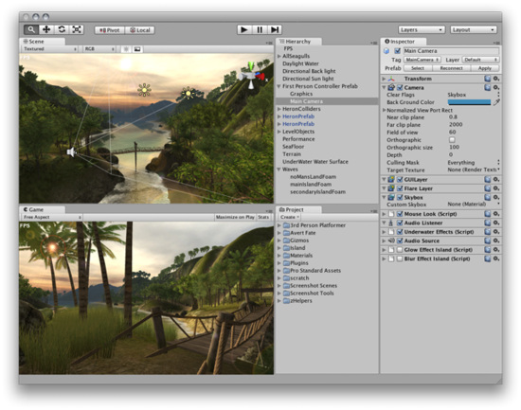
By default, the "Islands" scene of the Tropical Paradise project will appear 默认，热带天堂群岛项目将出现
Take your time to look over the Unity Editor interface and familiarize yourself with it. The Main Editor Window is made up of several Tabbed Windows, called Views. There are several types of Views in Unity, each with a specific purpose.
花费你的一点时间查看Unity编辑器的界面并熟悉它。主编辑器窗口有几个选项卡式的窗口组成，称为视图。在Unity中有几个视图类型，每个带有特定的目的。
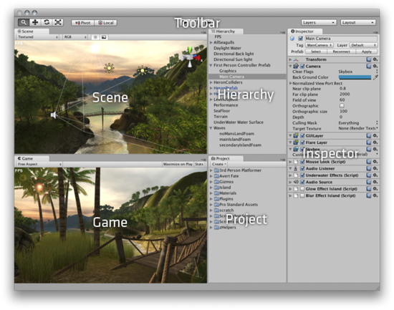
Now we'll look at each View in detail. 现在，我们详细查看每个视图。

Project View 项目视图（个人认为翻译为项目面板比较合适）
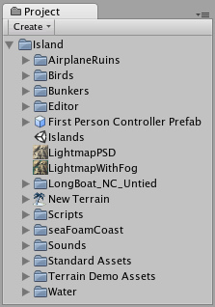
Every Unity project contains an Assets folder. The contents of this folder are presented in the Project View. This is where you store all the assets that make up your game, like scenes, scripts, 3D models, textures, audio files, and Prefabs. If you right-click on any asset in the Project View, you can choose Reveal in Finder (Reveal in Explorer on Windows) to actually see the asset itself in your file system.
每一个Unity项目包含一个资产文件夹。这个文件夹的内容呈现在项目面板中（项目视图）。这是编辑你的游戏的所有资产存储的地方，像场景、脚本、3D模型、纹理、音频文件以及预制品。在项目面板（项目视图）里的任何资产上点击鼠标右键，你可以选择显示定位程序（文件）（在windows上定位资源管理器）在你的文件系统中去查看资产本身。
Important Note: You should never move project assets around using the OS since this will break any metadata associated with the asset. Always use the Project View to organize your assets.
重要提示：你应该从不使用系统到处移动项目资产，因为这将断开任何元数据与资产的关联。总是使用项目面板（项目视图）去组织你的资产。
To add assets to your project, you can drag any file from your OS into the Project View, or use Assets->Import New Asset. Your asset is now ready to be used in your game. For more information about working with assets, skip ahead to the Asset Workflow section of the manual.
添加资产到你的项目，你可以从你的系统中拖拽任何文件到项目面板（项目视图）里，或使用Assets->Import New Asset.（资产 ->引入新资产）。你的资产现在准备好了被应用在你的游戏里。更多关于资产工作的信息，向前跳至本手册的资产工作流部分。
Scenes are also stored in the Project View. Think of these as individual levels. For example, the Islands Scene loads by default when Unity first launches. To create a new Scene, use Command-N (Control-N on Windows). To save the current Scene into the Project View, use Command-S (Control-S on Windows).
场景也存储在项目面板（视图）里。作为单独的层次思考这些。（独立层次思考这些）。例如，当Unity第一次启动时，默认岛屿场景装入。去建立一个新场景，使用Command-N（在windows上使用 Ctrl +N）,保存当前的场景到项目面板（视图），使用Command-S（在windows上使用Ctrl+S）.
Some game assets need to be created from within Unity. To do this, use the Create drop-down, or right click->Create.
有些游戏资产必须从Unity内部创建，要这样做，使用创建下拉框，或right click->Create（鼠标右键->创建）。
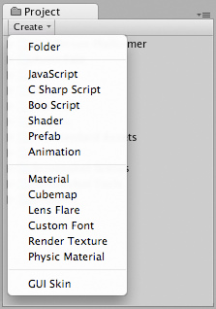
The Create drop-down 创建下拉框
This will allow you to add scripts, Prefabs, or folders to keep your project organized. You can rename any asset/folder by pressing Enter on Mac, or F2 on Windows, or with two paced clicks on the asset name. If you hold the Alt key while you expand or contract a directory, all subdirectories will also be expanded or contracted.
这将允许你去添加脚本、预制品、或文件夹去保持你的项目组织（去组织你的项目）。你可以在MAC上按回车键或在windows上按F2键重命名任意资产/文件夹，或在资产名称上两步单击（注意不是连续单击）。如果你按住ALT键在你展开或收缩一个目录，所有的自目录将也被展开或收缩。

Hierarchy 层次
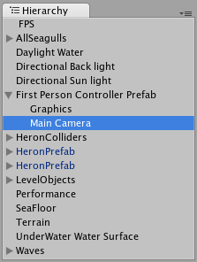
The Hierarchy contains every GameObject in the current Scene. Some of these are direct instances of asset files like 3D models, and others are instances of Prefabs -- custom objects that will make up much of your game. You can select and Parent objects in the Hierarchy. As objects are added and removed from the scene, they will appear and disappear from the Hierarchy as well.
在当前场景里，层次包含全部的游戏对象（翻译成游戏物体好？）。这些中的某些游戏对象是在资产文件里直接实例化，像3D模型、以及其它实例化的预制品—自定义对象将弥补许多你的游戏。在层次里，你可以选取和父类化对象。当对象被添加及从场景里移除时，它们将也从层次里显示及消失。

Parenting 父类化
Unity uses a concept called Parenting. To make any GameObject the child of another, drag the desired child onto the desired parent in the Hierarchy. A child will inherit the movement and rotation of its parent. You can now expand and contract the parent to see its children in the Hierarchy without affecting your game.
Unity使用一个称为父类化的概念。去处理任意游戏对象成为另一个游戏对象的子游戏对象，在层次里拖拽想要的子对象到想要的父对象。一个子对象将继承它的父对象的动作和旋转。在层次里你可以现在展开及收缩父对象去查看子对象，不会影响你的游戏。
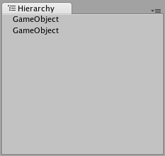
Two unparented objects 两个非父对象
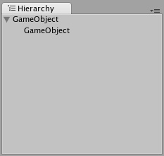
One object parented to another 对另一个来讲的一个父对象
To learn more about Parenting, please review the Parenting section of the Transform Component page.
去学习更多的关于父类化，请详阅变换组件页的父类化章节。

Toolbar 工具条
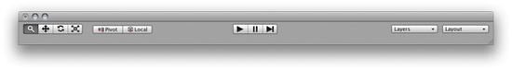
The Toolbar consists of five basic controls. Each relate to different parts of the Editor.
工具条由五个基本控制组成。每个涉及不同的编辑器部分。
Transform Tools -- used with the Scene View 变换工具—与场景视图一起使用
Transform Gizmo Toggles -- affect the Scene View display 变换辅助工具切换—影响
场景视图显示
Play/Pause/Step Buttons -- used with the Game View
播放/占停/步进 按钮—与游戏视图一起使用
Layers Drop-down -- controls which objects are displayed in Scene View
阶层下拉框—在场景视图里控制每个对象的显示
Layout Drop-down -- controls arrangement of all Views
版面布置下拉框—控制所有的视图排列

Scene View 场景视图
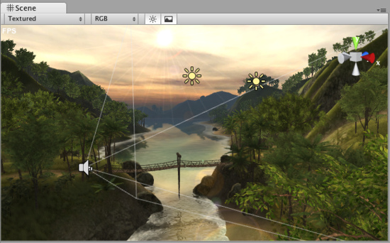
The Scene View 场景视图
Scene View is your interactive sandbox. You will use the Scene View to select and position environments, the player, the camera, enemies, and all other GameObjects. Maneuvering and manipulating objects within the Scene View are some of the most important functions in Unity, so it's important to be able to do them quickly. Here's how:
场景视图是你的交互式的沙箱。你将使用场景视图去选取和定位工作环境，播放器、摄像机、敌人以及其它的所有游戏对象（物体）。在场景视图内部操纵和操作对象是Unity里一些十分重要的功能。重要的是能够快速的使用它们。方法是：
Hold the right mouse button to enter Flythrough mode. This turns your mouse and WASD keys into quick first-person view navigation.
按住鼠标右键进入飞越模式。这让你的鼠标和W A S D键进入快速第一人称视图导航。（在场景视图里）
Select any GameObject and press the F key. This will center the Scene View and pivot point on the selection.
选取任意游戏对象（物体）并按F键，依选取的坐标定为场景视图的中心。
Hold Alt and click-drag to orbit the camera around the current pivot point. If you're using three-button mouse you can also:
按住Alt键和点击拖拽以摄像机当前的区轴坐标旋转。如果你使用三键鼠标，你也可以：
Hold Alt and middle click-drag to drag the Scene View camera around.
按住Alt键与按住鼠标中间键围绕摄像机拖拽场景视图旋转。
Hold Alt and right click-drag to zoom the Scene View. This is the same as scrolling with your mouse wheel.
按住Alt键和鼠标邮件拖拽去伸缩场景视图。这与你的鼠标滚轮滚动相同。
If you are using a one-button mouse, you might find more use in the Hand Tool (shortcut: Q). 如果你使用一键鼠标，你可能发现更多的使用手形工具（快捷键：Q）
Hold Alt and click-drag to orbit. 按住Alt键及点击拖拽去旋转。
Hold Command (Control on Windows) and click-drag to zoom.按住Command键（windows log键在windows上）及点击拖拽去伸缩。（注：在windows上不如滚动鼠标滚轮）

Positioning GameObjects 定位游戏对象
When building your games, you'll place lots of different objects in your game world. To do this use the Transform Tools in the Toolbar to Translate, Rotate, and Scale individual GameObjects. Each has a corresponding Gizmo that appears around the selected GameObject in the Scene View. You can use the mouse and manipulate any Gizmo axis to alter the Transform Component of the GameObject, or you can type values directly into the number fields of the Transform Component in the Inspector.
当你构建你的游戏时，你将在你的游戏世界里放置许多不同的对象。要做到这一点，使用工具栏里的变换工具去平移、旋转以及缩放单个的游戏对象。每个关联的辅助工具（Gizmo）显示在已选取场景视图里的游戏对象周围。你可以使用鼠标及操作任意辅助工具的轴去改变游戏对象的变换组件，或你可以直接输入在检视器面板里的变换组件的数字字段的值。
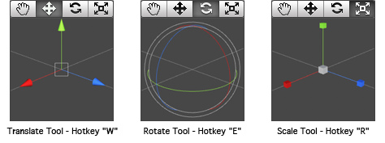
While dragging any Gizmo Axis, you can hold the Command key (Control on Windows) to snap to increments defined in the Snap Settings.
当拖动任意辅助工具（Gizmo）的轴时，你可以按住Command键（Ctrl在windows上）来捕捉到捕捉设置定义的增量。
You can change the Snap Settings from Edit->Snap Settings...
你可以从Edit->Snap Settings...（编辑->捕捉设置…）修改捕捉设置。
Click and drag in the center of the Gizmo to manipulate the object on all axes at once.
在辅助工具（Gizmo）的中心点击和拖动去立即操作对象的所有轴。
While dragging in the center, you can hold Command (Control on Windows) to snap the object to the intersection of any Collider. This makes precise positioning of objects incredibly fast.
当在拖动中心时，你可以按住Command键（Ctrl键在windows上）去捕捉对象与任何碰撞器的交集。这使准确定位对象不可思议的迅速。
If you have a three button mouse, you can click the middle button to adjust the last-adjusted axis (which turns yellow) without clicking directly on it.
如果你有一个三个按钮的鼠标，你可以点击鼠标的中间按钮去调整最后一次调整轴（那个变为黄颜色）而不用直接在上面点击它。
Be careful when using the scaling tool, as non-uniform scales (e.g. 1,2,1) can cause unusual scaling of child objects.
当使用缩放工具时要小心，因为不均匀的缩放比例（例如 1，2，1）可以引起子对象不寻常的缩放。
For more information on transforming GameObjects, please view the Transform Component page.
更多的信息在变换游戏对象（物体）章节，请查看变换组件页。
The Gizmo Display Toggles are used to define the location of any Transform Gizmo.
辅助工具（Gizmo）显示切换被用于定义任何变换的辅助工具位置
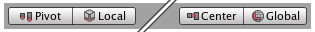
Gizmo Display Toggles辅助工具显示切换
- Position: 位置
  - Center will position the Gizmo at the center of the object's rendered bounds.
  - 中心将定位辅助工具在对象渲染范围的中心。
  - Pivot will position the Gizmo at the actual pivot point of a Mesh.
  - 枢轴支点将定位辅助工具在网格实际的枢轴点。
- Rotation: 旋转
  - Local will keep the Gizmo's rotation relative to the object's.
  - 本地将保持相对于对象的辅助工具的旋转。
  - Global will clamp the Gizmo to world space orientation.
  - 全局将钳住辅助工具对整个空间定位。

Scene Gizmo 场景辅助工具
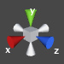
In the upper-right corner of the Scene View is the Scene Gizmo. This displays the Scene Camera's current orientation, and allows you to quickly modify the viewing angle. You can click on any of the arms to snap the Scene Camera to that direction and change it to Isometric Mode. While in Isometric Mode, you can right-click drag to orbit, and Alt-click drag to pan. To exit this mode, click the middle of the Scene Gizmo. You can also Shift-click the middle of the Scene Gizmo any time to toggle Isometric Mode.
在场景视图的右上角里是场景辅助工具。显示场景摄像机的当前方向，以及允许你做快速的变换视角。你可以在任意的（辅助工具）机械臂上点击去捕获场景摄像机方向以及更改它到等距模式。当在等距模式里时，你可以点击鼠标右键拖动做轨道旋转，以及按住Alt键拖动平移。（注意，在单键鼠标下与上述说明有差异，按Alt键加鼠标左键旋转；先按一下Q键，点击鼠标左键拖动平移）。退出等距模式，在场景辅助工具的中心点击一下即可。你可以在任意时间按Shift键在场景辅助工具中间点击去切换等距模式。
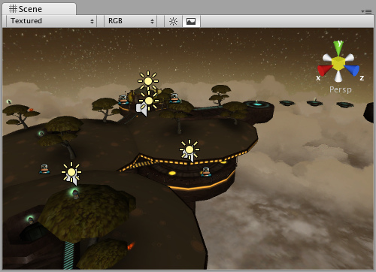
Perspective mode. 透视模式
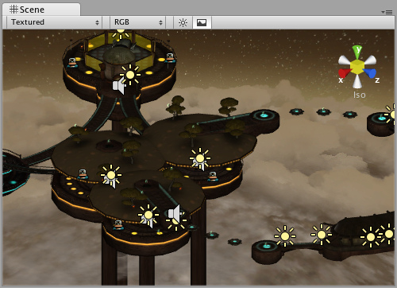
Isometric mode. Objects do not get smaller with distance here! 等距模式，这里对象不获得小的距离。

Scene View Control Bar 场景视图控制条
The first drop-down is for choosing a Draw Mode. You can choose to view the entire scene Textured, Wireframe, or Textured with Wireframe overlay. This has no effect on your game when it is published.
第一个下拉框是选择绘图模式。你可以选择去查看整个场景纹理，线框架，或纹理与线框架覆盖。在游戏发布时，它不对你的游戏有影响。
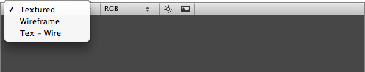
Draw Mode drop-down 绘制模式下拉框
The next drop-down is for choosing one of four Render Modes. You can choose to fill the Scene View with RGB, Alpha, Overdraw, or Mipmaps. Again, this will not affect your published game.
下一个下拉框是四选一的渲染模式。你可以选择用RGB、阿尔法、重绘、或管道映射去填充场景视图。另外，这将不影响你发布的游戏。
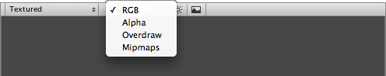
Render Mode drop-down 渲染模式下拉框
RGB is simply all the colors of your game rendered as normal.
RGB仅是作为正常渲染你游戏的所有颜色。
Alpha will render all alpha values for fine-tuning transparency or fullscreen effects that make use of alpha values.
阿尔法将渲染所有阿尔法值为了利用阿尔法值去精度调谐透明度或全屏效果。
Overdraw will indicate how much of the screen is consuming overdraw time.
重绘将表明屏幕被强制绘制多少次。
Mipmaps shows ideal texture sizes -- red means the particular texture is too large, and blue means the texture could be larger. Of course ideal texture sizes depend on the resolution the game will run.
管道映射显示理想纹理大小-红色意味着特殊的纹理太大，蓝色意味着这个纹理可能大一些。当然，理想纹理的大小依靠游戏运行时的分辨率。
Next, we have two buttons: Scene Lighting and Game Overlay.
接下来，我们有两个按钮：场景照明和游戏覆盖。
Enabling Scene Lighting will override the default Scene View lighting with whatever lights you have positioned to create your final light setup. Game Overlay will enable items like Skyboxes and GUI Elements in the Scene View.
启用场景照明将替代你拥有任何位置的灯在默认场景视图照明去创建你最最终的灯光设置。游戏覆盖将启用对象像天空盒以及GUI元素在场景视图里。

Game View 游戏视图
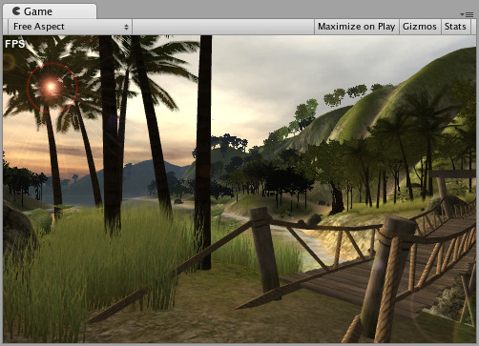
The Game View is rendered from the Camera(s) in your game. It is representative of your final, published game. You will need to use one or more Cameras to control what the player actually sees when they are playing your game. For more information about Cameras, please view the Camera Component page.
游戏视图是从你的游戏的摄像机里呈现。它是你最终发布游戏的代表。你将需要使用一个或多个摄像机去控制当他们玩你的游戏的时候玩家实际看到的东西。更多关于摄像机的信息，请查看摄像机组件页。

Play Mode 播放模式
Use the buttons in the Toolbar to control the Editor Play Mode and see how your published game will play. While in Play mode, any changes you make are temporary, and will be reset when you exit Play mode. The Editor UI will darken to remind you of this.
使用工具条的按钮去控制编辑器播放模式以及查看你发布的游戏将如何扮演。当在播放模式里，你所作的任何改变都是临时的，在你退出播放模式时将被复位。编辑器用户将变暗来提醒你在播放模式下。

Game View Control Bar 游戏视图控制条
The first drop-down on the Game View control bar is the Aspect Drop-down. Here, you can force the aspect ratio of the Game View window to different values. It can be used to test how your game will look on monitors with different aspect ratios.
在游戏视图控制条上的第一下拉框是界面比例下拉框。这里，你可以强制游戏视图窗口的界面比率到不同的数值。它可以被用于测试在显示器宽度不同界面比率观看你的游戏如何。
Further to the right is the Maximize on Play toggle. While enabled, the Game View will maximize itself to 100% of your Editor Window for a nice full-screen preview when you enter Play mode.
往右一点的是播放时最大化开关。当启用时，游戏视图将最大化你的编辑器窗口到100%，为了更好的全屏预览当你进入播放模式时。
Continuing to the right is the Gizmos toggle. While enabled, all Gizmos that appear in Scene View will also be drawn in Game View. This includes Gizmos drawn using any of the Gizmos class functions.
继续右边的是辅助工具切换器。当启用时，所有在场景视图里显示的辅助工具将也在游戏视图里被绘制。这个绘制的辅助工具包括类函数利用辅助工具。
Finally we have the Stats button. This shows Rendering Statistics window that is very useful for Optimizing Graphics Performance.
最后我们有一个统计按钮。这个展示渲染统计窗口为优化图形性能是非常有用的。
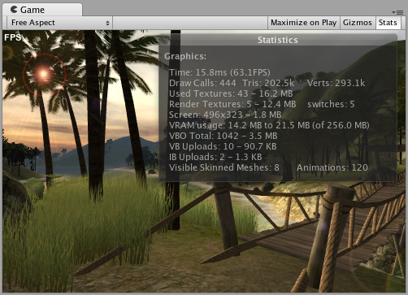

Inspector 检视器面板（属性检视器?）
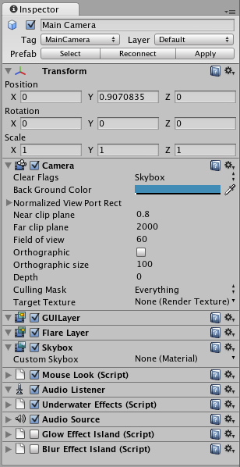
Games in Unity are made up of multiple GameObjects that contain meshes, scripts, sounds, or other graphical elements like Lights. The Inspector displays detailed information about your currently selected GameObject, including all attached Components and their properties. Here, you modify the functionality of GameObjects in your scene. You can read more about the GameObject-Component relationship, as it is very important to understand.
在Unity里的游戏由多个的游戏对象（物体）组成，包括网格、脚本、声音或其它图形元素如光。检视器面板显示关于你当前选取的游戏对象的详细信息，包括所有的附加组件以及它们的属性。这里，你修改游戏对象（物体）的功能在你的场景里。你可以阅读更多关于游戏对象（物体）-组件关系，因为了解它是非常重要的。
Any property that is displayed in the Inspector can be directly modified. Even script variables can be changed without modifying the script itself. You can use the Inspector to change variables at runtime to experiment and find the magic gameplay for your game. In a script, if you define a public variable of an object type (like GameObject or Transform), you can drag and drop a GameObject or Prefab into the Inspector to make the assignment.
在检视器面板里显示的任何属性可以被直接修改。甚至脚本变量可以被修改而不通过脚本它自身。你可以使用检视器面板修改在运行时的变量去试验和为你的游戏发现魔法可玩性。在脚本里，如果你定义了一个对象类型的公共变量（如GameObject 或Transform），你可以拖动并放下一个游戏对象或预制品到检视器面板构成一个赋值分配。
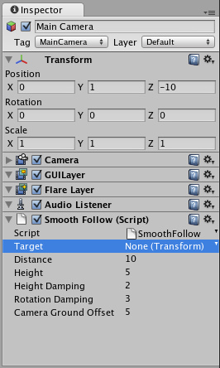
Click the question mark beside any Component name in the Inspector to load its Component Reference page. Please view the Component Reference for a complete and detailed guide to all of Unity's Components.
在检视器面板里点击任何组件名称旁边的问号去装载该组件引用页。请查看Unity为所有组件提供的完整和详细的组件指南。
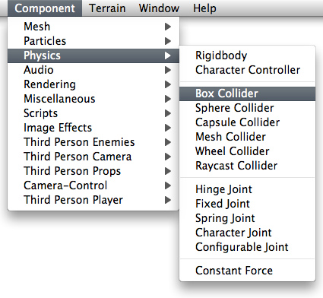
Add Components from the Component menu从组件菜单添加组件
You can click the tiny gear icon (or right-click the Component name) to bring up a context menu for the specific Component.
你可以按一下小齿轮图标（或右键单击组件名称）去提出一个指定组件上下文菜单。
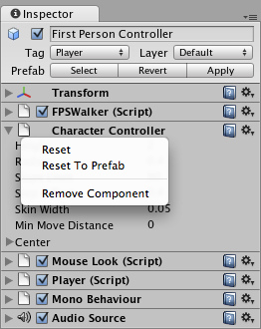
The Inspector will also show any Import Settings for a selected asset file.
检视器面板将为选择的资产文件显示所有的引入设置。（注意：这个可能有差异，使用的2.5 要在项目面板的文件点击一下，才可出现）
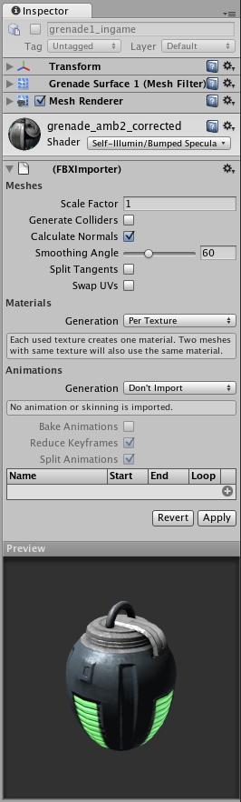
Click Apply to reimport your asset. 点击应用重新引入你的资产
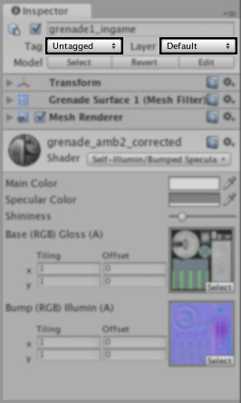
Use the Layer drop-down to assign a rendering Layer to the GameObject. Use the Tag drop-down to assign a Tag to this GameObject.
对游戏对象使用阶层下来框来指定一个渲染阶层。对这个游戏对象使用标签下来框来指定一个标签。

Prefabs 预制品
If you have a Prefab selected, some additional buttons will be available in the Inspector. For more information about Prefabs, please view the Prefab manual page.
如何你有一个选取的与制品，一些额外的按钮将在检视器面板里可用。更多关于预制品的信息，请查看预制品指南页。

Status Bar 状态栏
The Status Bar at the bottom of the Editor serves multiple purposes. It will display any compile errors or Debug log output. If there is a problem with your game, keeping an eye on the Status Bar is the best way to find the error. You can double-click on the Status Bar to bring up the Console window, which has all script or run-time errors visible.
在编辑器底部的状态栏提供多个用途。它将显示任何编译错误或调试日志输出。如果你的游戏有一个问题，密切注视状态栏是最好的方法找到错误。你可以在状态栏上双击去弹出控制台窗口，它所有的脚本或运行错误可见。

Console 控制台
Double-clicking an error in the Status Bar or choosing Window->Console will bring up the Console.
在状态栏里双击一个错误，或选择Window->Console（窗口->控制台）将弹出控制台。
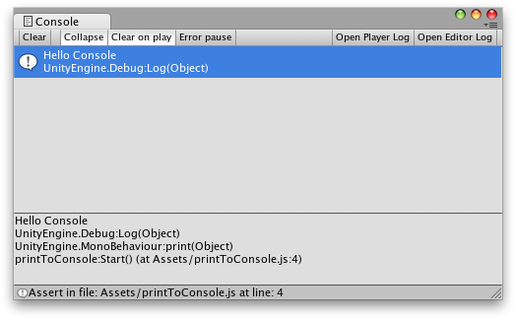
The Console shows messages, warnings, errors, or debug output from your game. You can define your own messages to be sent to the Console using either Debug.Log() or Debug.Error(). You can double-click any message to be taken to the script that caused the message. You also have a number of options on the Console Toolbar.
控制台从你的游戏里展示消息、警告、错误、或调试输出。你可以使用Debug.Log()与 Debug.Error()的任何一个定义你自己的消息发送到控制台。你可以双击任意消息到达那个引起消息的脚本。你也有一个在控制台工具栏的选项。
Most of the options in the Console Toolbar are self-explanatory, but one thing should be made clear. When Error Pause is enabled, Debug.Error() will cause the pause to occur but Debug.Log() will not.
大多数的控制台工具栏选项是自说明的（注意：这是一个新的编程用语，指的是通过名称就可以知道其含义），但有一点必须明确。当错误占停是启用的，Debug.Error()将引起占停出现，而Debug.Log()将不会。

Customizing Your Workspace 定制你工作空间
You can customize your Layout of Views by click-dragging the Tab of any View to one of several locations. Dropping a Tab in the Tab Area of an existing window will add the Tab beside any existing Tabs. Alternatively, dropping a Tab in any Dock Zone will add the View in a new window.
你可以定制你的视图布局，通过点击拖动任意视图的选项卡到几个地点之一。拖动一个现有窗口的选项卡区域里的选项卡将添加在任何以存在选项卡的旁边。拖动一个在任意停放区域的选项卡将添加视图，在一个新窗口里。
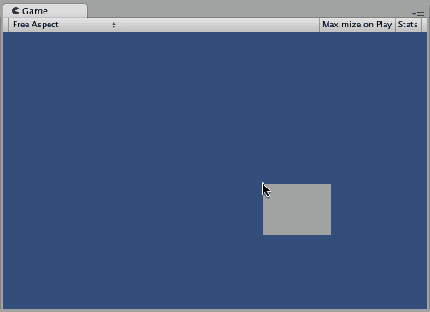
Views can be docked to the sides or bottom of any existing window
视图可以停放在一侧或任意存在窗口里的按钮
Tabs can also be detached from the Main Editor Window and arranged into their own floating Editor Windows. Floating Windows can contain arrangements of Views and Tabs just like the Main Editor Window.
选项卡也可以从主编辑窗口里分离并排列到它们自己浮动器窗口里。浮动窗口可以包含视图的排列和选项卡就像主编辑器窗口。
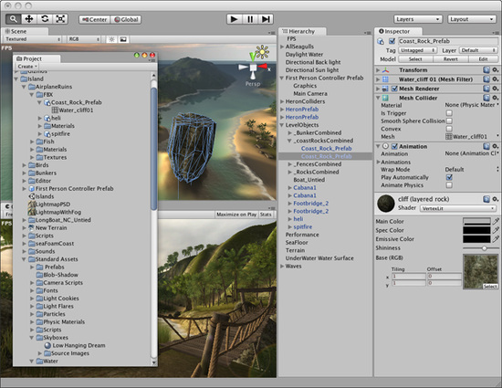
Floating Editor Windows are the same as the Main Editor Window, except there is no Toolbar
浮动编辑器窗口是和主编器窗口一模一样的。除非它没有工具栏。
When you've created a Layout of Editor Windows, you can Save the layout and restore it any time. You do this by expanding the Layout drop-down (found on the Toolbar) and choosing Save Layout.... Name your new layout and save it, then restore it by simply choosing it from the Layout drop-down.
当你已经创建了一个编辑器窗口布局，你任何时间可以保存布局和恢复它。你通过扩展布局下拉框（在工具栏上发现）和选择保存布局…做这个。命名你的新布局并保存它，然后通过从布局下拉框里简单的选择它恢复它。
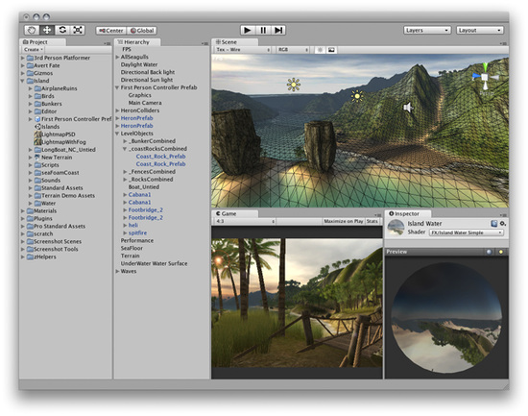
A completely custom Layout 一个完成的定制布局
At any time, you can right-click the tab of any view to view additional options like Maximize or add a new tab to the same window.
在任意时间，你可以右键点击任意视图的选项卡去查看附件选项像最大化或增加新的选项卡到同一窗口。（注意：也可以点击图标“”做同样的功能）
