·Tutorials 教程
Unity Manual > User Guide > Unity Basics > Tutorials
Unity 手册- > 用户指南-> Unity 基础->教程
These tutorials will let you work with Unity while you follow along. They will give you hands-on experience with building real projects. For new users, it is recommended that you follow the GUI Essentials and Scripting Essentials tutorials first. After that, you can follow any of them. They are all in PDF format, so you can print them out and follow along or read them alongside Unity.
这些教程将让你与Unity一起工作，跟随下面的内容。它们将给你利用真实的项目的内行经验。对于新用户，强烈的建议你首先跟随精华的GUI和教程教程。在此之后，你可以沿它们任何而行。它们都是PDF格式，因此可以打印出它们并跟随或在Unity旁边阅读它们。

在线资源

我们有许多在线教程。点击这里去我们最后更新的网站

（注意，此教程请在网上查看，翻译省略）

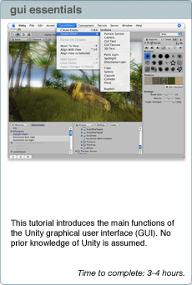
经典GUI（教程）

本教程介绍Unity图形用户接口（GUI）的主要功能。假定你没有Unity的知识。
完成时间：3-4个小时

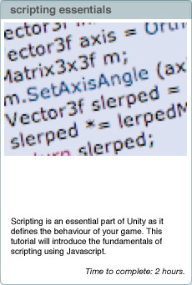
经典脚本（教程）

脚本是unity中的精华部分，定义你游戏的行为。本教程将介绍使用Javascript脚本的基本原理。
完成时间：2个小时。

Introduction to the Unity Interface Unity 界面入门
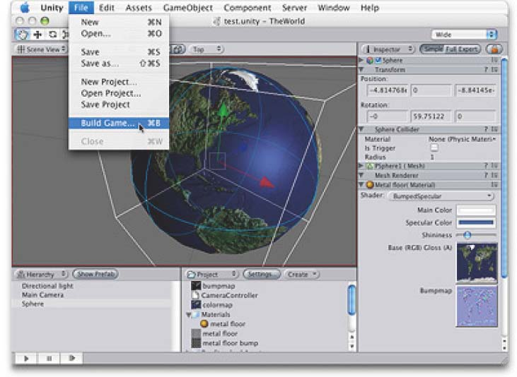
This tutorial will introduce the Unity graphical user interface(GUI).
本教程将介绍Unity的图形用户界面（GUI）
No prior knowledge of Unity isassumed.
假定没有Unity预先知识
Time to complete: 1 hour. 时间 1小时
Author: Graham McAllister
作者：Graham McAllister

Contents 目录
- Aims of the tutorial本教程的目标
- Screen layout 屏幕布局
- Finding game objects 发现游戏对象
- Creating game objects 创建游戏对象
- Navigating the Scene View 定位场景视图
- Moving game objects 移动游戏对象
- Game View 游戏视图
- Resizing game objects 伸缩游戏对象
- Using assets 使用资产
- Adding Components 添加组件
- Duplicate 复制（对象）
1. Aims of this tutorial 教程目标
If you are new to Unity this should be the ﬁrst tutorial that you read. It will explain the key sections of the interface and describe how to create basic game objects and position them in 3D space.
如果你对Unity的不熟悉，这应该是你个阅读的第一个教程。它将讲解界面的关键章节和描述如何创建基本游戏对象和在3D空间定位它们。
To demonstrate the Unity interface essentials, we’ll create a simple scene which will allow a character to walk around on a surface.
示范Unity经典界面，我们将建立一个简单的场景，允许一个角色在表面行走。
Note: any text that requires the user to take an action begins with a ‘-’.
注意：需要用户创建的一个动作以“_”开始的任意字符串。
2. Screen Layout 场景布局
Before we start, let’s make sure our screen layout is in 2 Split mode.
-To ensure it is, select Window->Layouts->2 Split. Your view is now split into 5 main regions:
在我们开始之前，让我们确保我们的屏幕布局在2个分割的模式。确保它是，选择Window->Layouts->2 Split（窗口->布局->2个分割模式，注意：在2.5 for windows版本里没有这个布局选项）。你的视图现在是分割成5个主要区域。
- Scene View - for placing game objects 场景视图—用于放置游戏对象
- Game View - this is how the game will look when run. 游戏视图—它是当游戏运行时将看到外观如何。
- Hierarchy View -this is a list of all game objects currently in the scene. 层次视图（面板）--场景里所有当前游戏对象的列表（清单）
- Project View -this view shows all assets that are available for use (like a palette) 项目视图（面板）--这个视图显示被应用到的可利用的所有资产（像一个选项板）。
- Inspector View -this shows the properties of the currently selected game object. 检视视图（面板，翻译成属性监视器比较合适）--它显示当前选取的游戏对象的属性。

3. Finding game objects in 3D space 在3D空间查找游戏对象
-Start Unity. We’ll begin by creating a new project.
启动Unity，我们将通过创建一个新的项目开始。
-Select File->New Project from the main menu and give the project a name such as “GUI Tutorial” and click Create Project. Unity will now import assets (e.g. audio, textures, 3D models) so they are available for use.
从主菜单选择File->New Project（文件->新项目）并给项目一个名称例如“GUI Tutorial” 然后点击创建项目。Unity将引入资产（例如 音频、纹理、3D模型），以便它们成为使用可利用的。
Once importing is complete you will be presented with your game world. At present the world only contains a Main Camera (this is default), you can see this listed as the only item in the Hierarchy view.
你一旦引入完成，在你的游戏世界将被呈现。目前，这个（游戏）世界仅包含一个主摄像机（这是默认的），你可以查看作为仅有的项目这个清单，在层次视图里。
-If you can’t see the camera in your Scene View, click on the Main Camera in the Hierarchy View, move your cursor so that it’s inside the Scene View, then type F (frame select) on the keyboard. The Main Camera should now be at the centre of the Scene View. This technique can be used to ﬁnd any game object.
如果你在你的场景视图里不能看到这个摄像机，在层次视图里点击主摄像机，移动你的鼠标以至它是在场景视图里，然后在键盘上按F键（帧选择）。主摄像机现在应该在场景视图的中央。
-Any game object can be selected by either clicking on it in the Scene View or selecting it in the Hierarchy View. If you click on an object in the Scene View, you can conﬁrm that you’ve selected the correct object as it will also be highlighted in the Hierarchy view.
任意的游戏对象可以被选取通过任一方法，在场景视图点击它或在层次视图里选取它
4. Creating game objects 创建游戏对象
Let’s add some game objects to our world.
让我们添加一些游戏对象到我们的世界。
-Select Game Object->Create Other->Plane, this will create a plane (a 2D surface) to allow our character to walk on.
选择Game Object->Create Other->Plane,这将创建一个平面（一个2D表面），允许我们的角色在上面行走。
-Add a cube to the game world by selecting Game Object->Create Other->Cube.
添加一个方块对到游戏世界通过选择Game Object->Create Other->Cube.
-Add a point light by selecting Game Object->Create Other->Point Light.
添加一个点光源通过Game Object->Create Other->Point Light.
5. Navigating the Scene View 定位场景视图
You can look around your 3D objects from any angle by using the following:
你可以在任意角度（角落）查看你的3D对象通过使用下列的方法：
- Rotating (Option+LMB) 旋转 （Option +鼠标左键）
- Panning (Option+MMB) 平移 （Option +鼠标中键）
- Zooming (Option+RMB) 缩放 （Option +鼠标右键）

NB: The Option key is beside the Command key (the one with the Apple logo on it) on the Mac keyboard, L/M/R MB is Left/Middle/Right Mouse Button. It is recommended that you have a 3 button mouse.
注意：选项键是在MAC键盘上Command旁边（上面带苹果标志的键），L/M/R MB是左/中/右鼠标按钮。强烈建议你有一个3按钮的鼠标。（以上苹果机器上的操作，下面的说明可以在windows平台上使用）
If you only have a one-button mouse, or are using a laptop, you can still navigate easily. Firstly, click on the hand-shaped tool in the upper left hand corner of the Unity GUI, then the following can be used:
如果你只有一个按钮的鼠标（注：我没有见过这样的鼠标）或使用一个膝上型电脑（笔记本电脑），你可以仍旧容易的定位。首先，在Unity GUI（图形用户界面）的左上角工具栏里点击手型按钮，然后使用下面的说明：
- Rotating (Option+LMB) 旋转(Option+鼠标左键)（在windows上 按Alt+鼠标左键）
- Panning (LMB) 平移 （鼠标左键）
- Zooming (Command+LMB) -Try this now. 缩放（Command+鼠标左键）（在windows上 按windows旗标键+鼠标左键，或使用鼠标的滚轮，或先按R键，点击辅助工具（GIZMO）进行缩放），现在尝试。

6. Moving game objects 移动游戏对象
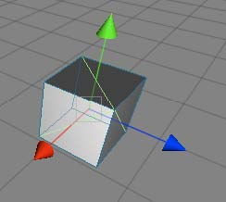
You can position any game object in 3D space by using one of the following:
你可以在3D空间定位任意游戏对象，通过使用下列之一。
1. Move tool (W on the keyboard). Selecting any game object then typing W will display three arrowheads, one for each axis of 3D space. Red is the x-axis, green is the y-axis, blue is the z-axis, i.e. r,g,b, maps to x,y,z. To move an object, click the LMB on the arrowhead that represents the axis you want to move in and move the mouse as much as appropriate. As you drag the arrowheads notice the object’s position values in the Inspector Panel change also. You can enter values directly into these boxes also (3 boxes, 1 each for x,y,z values).
移动工具（在键盘上按W键）。选取任意游戏对象然后按W键，将显示三个箭头，一个3D空间轴的每个轴。红色是X轴，绿色是Y轴，蓝色是Z轴，也就是RGB映射到X,Y,Z。去移动一个对象，在箭头上鼠标左键点击表示这个轴你想去移动并恰当的移东鼠标。当你拖动箭头，注意在检视面板里这个对象的坐标值也改变。你也可以直接键入值到这些框中（3个框，1个框是各自的x，y，z值）。
You can also re-position a game object by ﬁrstly clicking on it, then move the camera to point towards the general direction of where the want the object to move to, then select Game Object->Align with View. The selected game object will move to where the camera now points.
你也可以重新配置一个游戏对象通过第一个单击，然后移动摄像机去朝向对象移动到希望地方的大体方向 。然后选择Game Object->Align with View.（游戏对象->对齐视图），选取的游戏对象将移动到摄像机新坐标的地方。
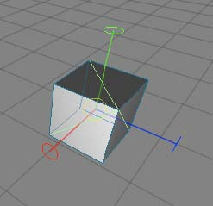
2. Rotate tool (E on the keyboard). Selecting any game object then typing E will display the rotate tool. To rotate around an axis, click the LMB on the axis of choice then move the mouse to rotate the game object. As you rotate the object notice the object’s rotation values in the Inspector Panel change also. You can enter values directly into these boxes also.
旋转工具（在键盘上按E键）。选取任意游戏对象然后按E键将显示缩放工具。围绕一个轴旋转，在选择的轴上按鼠标左键然后移动鼠标去旋转游戏对象。在你旋转对象注意在检视面板里该对象的旋转值也改变。你也可以直接键入值到这些框中。
-Let’s try a small exercise. Move the cube (move tool) so that it is outside of the Scene View. Use the Frame Select feature (click Cube in the Hierarchy View then press the F key) to ﬁnd the cube again. Finally move the cube back so it’s close to the plane.
让我们做一个小练习。移动方块（移动工具）致使它处于场景视图的外面。使用帧选择特性（在层次视图（面板）里点击方块，然后按F键）重新找到这个方块。最后，向后移动方块使它接近于平板。
-Move the point light so that it’s above the cube and the plane. 移动点光源使它处于方块和平板的上方。
7. Game View 游戏视图
The Game View shows how the game will look when run (complete with textures, lighting etc). If you cannot see your game world in the Game View, it’s because your camera is not looking in the right direction.
游戏视图显示当游戏运行时外观如何（连通纹理、灯光等）。如果在游戏视图里，你不能看到你的游戏世界，是因为你的摄像机不在正确的方向探测。
-Click on the Main Camera, you will notice an inverted yellow pyramid wireframe coming out from it. This is known as the camera’s viewport (what it can see). If the viewport is not pointing in the direction of your game objects, navigate in the scene view so that you are looking at your game objects, select the Main Camera then select Game Object->Align With View. Your Game View should now match your Scene View.
在主摄像机上点击，你将注意到一个倒置的黄色倒置的金字塔线框出现。这是摄像机的视口（它看到的程度）。如果视口没有指向你的游戏对象的方向，在场景视图里定位它使你看到你的游戏对象，选取主摄像机然后选取Game Object->Align With View（游戏对象->对齐视图）。你的游戏窗口现在应该匹配你的场景视图。
You can also manually adjust your camera’s settings by either using the move and rotate tools, or changing its transform values in the Inspector View.
你也可以手工调整你的摄像机的设置，通过任一的：使用移动和旋转工具或在检视视图（面板）里更改它的变换值。
You may also want to move your light to give better aesthetics.
你也同样应该移动你的灯光以提供更佳的美感。
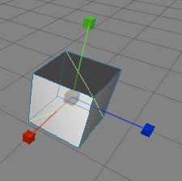
8. Resizing game objects 伸缩游戏对象
To resize an object ﬁrstly select it then press R on the keyboard (resize or scale tool). You can visually scale an object by dragging the square block at the end of the each axis, or use the Inspector View to type a precise value in.
伸缩一个游戏对象首先选取它然后在键盘上按R键（调整大小或缩放工具）。你可以直观的缩放一个对象通过拖动每个轴末端的四方块，或使用检视器视图（面板）去键入一个精确值。
We’ll now resize some objects in our game world.
我们现在将伸缩一些对象在我们的游戏世界里。
-Select the plane and set its x and z scale values to 10 in the Inspector view (the ﬁrst and third box, as the second box is for the y value).
选取平板并设置它的X和Z刻度值为10在检视器视图里。（第一个和第三个方框，对于第二个方框是Y的值）。
-Select the cube, resize it along the y-axis visually (press R and drag the green square upwards). the cube should now look like a pillar.
选取立方体，伸缩它沿着直观的Y轴（按R键向前拖动绿色的方块）。立方体现在应看起来像一个柱子。
-Rename the cube Pillar. Do this by selecting it in the Hierarchy View and pressing return to enter the new name. Remember it’s best to ensure game objects begin with a capital letter.
重命名这个立方柱。做这一点通过在层次视图（面板）里选取它并按回车键输入新的名称（在windows上，按F2键）。记住，带一个“_”首字符（名称）是一个最好确保游戏对象的名称。
9. Using Assets 使用资产
Computer games are created from 3D models, textures, sound ﬁles, game code etc., these are called the game’s assets. Unity comes with many assets shipped as standard assets (even more in the Pro version).
以3D模型、纹理、声音文件、游戏代码等创建的计算机游戏，这些被称为游戏的资产。Unity附带有许多的资产被当作标准的资产（在专业版里甚至更多）。
We’ll now add a character to our game world from the built-in assets. In the Project View expand the Standard Assets folder, then expand Prefabs. A prefab is collection of game objects that have been pre-assembled into a logical grouping. You should see the First Person Controller (FPS Controller) inside the Prefabs folder.
从内置的资产里，我们将现在添加一个角色到我们的游戏世界里。在项目视图（面板）里展开标准资产文件夹，然后展开预制品。一个预制品是已经被预先安装到一个逻辑组里的游戏对象集合。你应当在预制品文件夹里看到一个第一人称控制器（FPS 控制器）。
-Drag the FPS Controller prefab into the Scene View. Notice how the Game View has changed, this is because the FPS Controller prefab comes with its own camera which takes precedent over the existing Main Camera. Make sure the FPS Controller is not caught in the plane, move it so that it is above the plane.
拖动FPS控制器预制品到场景视图里。注意游戏视图如何变化的，这是因为FPS控制器预制品带有它自己的摄像机取代了先前存在的主摄像机。在平板里确保FPS控制器没有被捕获，移动它使它在平板之上。
-Delete the Main Camera as we’ll not need it now (Command+delete). The Game View is now what the player can see in-game.
现在，作为我们将不再需要的主摄像机删除（Command+delete，windows上的Delete键）。游戏视图现在是玩家可以在游戏里看到的样子。
-Start the game by clicking the Play button in the lower left hand side of the Unity GUI. Notice the screen stays the same, so you can see the game in the Scene View and the Game View. Use the cursor keys to move the character around (or W,S,A,D), the mouse to look around and space to jump.
开始游戏通过点击在Uniy GUI左下手边里的播放按钮（2.5版本里的播放工具条里播放按钮）。注意到屏幕同时停在使你看到在场景视图里和游戏视图里的游戏。使用箭头键移动角色（或 按W、S、A、D），鼠标旋转查看和空格键跳跃。
-Stop the game at any time by clicking on the Play button again.
在任何时间停止游戏通过再次点击播放按钮。
NB: By pressing the space bar while the mouse cursor is inside any of the views (Game View, Scene View etc), this makes that particular view expand to full screen. This is useful when making adjustments in the Scene View, or playing the game (Game View). Pressing space inside the full screen view returns to the previous layout mode. Note that this feature does not work if the game is currently running, either stop or pause the game ﬁrst.
注意：通过按空格键当鼠标光标在任何视图里（游戏视图，场景视图等）时，这使特定视图展开至全屏。当在场景视图里做调整时或播放游戏（游戏视图）是有用的。在全屏视图里按空格键返回以前的布局模式。注这个特性不工作，如果游戏当前正在运行，首先停止或占停游戏。
10. Adding Components 添加组件
Game objects can have a number of components (or behaviours) attached to them. By clicking on any game object, you can see the attached components in the Inspector View (e.g. Transform, Box Collider).
游戏对象可以有几个组件（行为）附加到它们。在任意游戏对象上点击，你可以看到附在的组件在检视器视图里（例如，Transform变换组件, Box Collider 碰撞盒组件）。
-Click on Pillar and look at its components in the Inspector View.
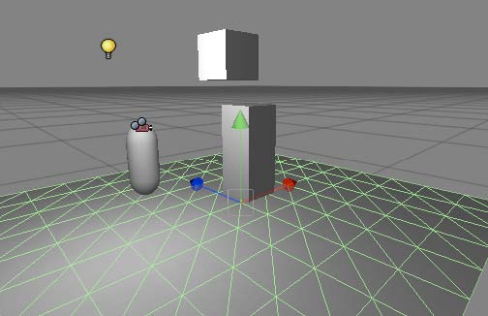
在柱子上点击并在检视器视图里查看它的组件。
Let’s add another cube and add an extra component.
让我们添加另外一个立方体并添加额外的组件。
-Add another cube to the scene (Game Object->Create Other->Cube). Rename it PhysicsCube in the Hierarchy view.
添加另外一个立方体到场景里（Game Object->Create Other->Cube）。重命名它为PhysicsCube 在层次视图里。
Figure 1 - demonstrating Rigidbody
图1-示范碰撞体
Now we’re going to add a Rigidbody component to this cube. The RigidBody component allows the game object to behave as if it’s in a world with gravity, i.e. the object will fall downwards until it hits a surface with a collider component attached.
现在，我们去添加一个碰撞体组件到这个立方体。碰撞体组件允许游戏对象带有重力的行为在一个世界里。也就是对象将快速下降直到它碰撞一个带着附有碰撞组件表面。
-Making sure PhysicsCube is selected, select Component->Physics->Rigidbody. This adds the Rigidbody component to the currently selected game object. Notice that in the Inspector View the Rigidbody component has been added.
确保PhysicsCube被选取，选取Component->Physics->Rigidbody。添加碰撞体组件到当前选取的游戏对象上。注意，在检视器视图里这个碰撞体组件已经被添加。
-Move PhysicsCube so that it is above Pillar but slightly offset (see Figure 1). We want to set the scene up so that when we press play, PhysicsCube will collide with Pillar and fall to the ground.
移动PhysicsCube使它在柱子的上方，但有些偏移（看图1）。我们应该设置场景抬高以便当我们按播放时，PhysicsCube将与柱子碰撞并落在地上。
-Press Play, PhysicsCube should collide with Pillar and land on the plane.
按播放，PhysicsCube应该与柱子碰撞并降落在地上。

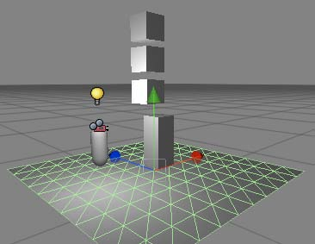
11. Duplicate 复制
Duplicating a game object is one of the most powerful features of Unity. When duplicating an object, all features and behaviours of the object are also copied. It’s a very fast way to create complex scenes. We’ll now add more PhysicsCubes to our scene.
复制一个游戏对象是Unity许多强大的功能之一。当复制一个游戏对象，这个游戏对象的所有功能和行为也被复制。它是一个非常快速的完成场景创建的方法。我们现在将添加更多的PhysicsCube到我们的场景。
图2-使用复制
-Click on PhysicsCube and press Command+D (or do this from the Edit menu). Notice an extra PhysicsCube entry has appeared in the Hierarchy menu, however you cannot see it as it has been created at the same position as the ﬁrst PhysicsCube.
在PhysicsCube上点击并按Command+D（windows上按Ctrl+D）（或从编辑菜单做这个）。注意到一个额外的PhysicsCube条目已经出现在层次菜单里。然而，你不能看到它（在场景视图里）因为它被创建在与第一个PhysicsCube相同的坐标点。
-Move the new PhysicsCube by selecting the move tool (W) and move it upwards (y-axis).
移动新建立的PhysicsCube通过选取移动工具（或按W键）并向上移动它（y轴）。
-Repeat this process so there are now 3 PhysicsCube game objects (see Figure 2).
重复这个处理以至现在有3个PhysicsCube 游戏对象（看图2）
-Run the game and all 3 PhysicsCube game objects should interact and behave naturally.
运行游戏，所有3个PhysicsCube游戏对象将自然的相互影响行为。
This tutorial has introduced the fundamentals of the Unity GUI. You should now try the scripting tutorial to look beneath the surface of Unity.
本教程已经介绍了Unity GUI的基本原理。你应该现在尝试在Unity界面下查看脚本指南。

Introduction to scripting with Unity Unity脚本入门
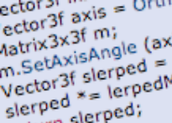
Scripting is an essential part of Unity as it defines the behaviour of your game. This
tutorial will introduce the fundamentals of scripting using Javascript. No prior knowledge
of Javascript or Unity is required.
脚本是Unity的经典部分。它定义你游戏的行为。本教程将使用Javascript介绍脚本的基本原理。不需要Javascript或Unity的预先知识。
Time to complete: 2 hours. 完成时间：2个小似乎
Author: Graham McAllister 作者：Graham McAllister
Contents 目录
1. Aims of this tutorial 本教程的目标
2. Prerequisites 先决条件
3. Naming conventions 命名约定
4. Player Input 玩家输入
5. Connecting variables 连接变量
6. Accessing components 访问组件
7. Instantiate 实例创建
8. Debugging 调试
9. Common Script Types 公共脚本类型
1. Aims of this tutorial
Scripting is how the user defines a game’s behaviour (orrules) in Unity. The recommended programming
language for Unity is Javascript, however C# or Boo can also be used. This tutorial will cover the fundamentals of scripting in Unity and also introduce key elements of the Application Programming Interface (API).You can think of the API as code that has already been written for you which lets you concentrate on your game design and also speeds up development time.
脚本是用户定义一个游戏的行为（规则）的方法在Unity里。建议Unity（脚本）的程序语言是Javascript，然而，C#或Boo也可以被使用。本教程将覆盖Unity的脚本基本原理也同样介绍应用程序接口（API）的关键元素。你可以认为API是已经为你编写好代码让你集中于你的游戏设计以及加速开发时间。
A good understanding of these basic principles is essential in order to harness the full power of Unity.
这些基本原理的一个好的解释是为了利用Unity的全部功能的精华。
2. Prerequisites 先决条件
This tutorial focuses on the scripting element of Unity, it is assumed you are already familiar with Unity’s interface(if not you should read the Unity GUI tutorial).
本手册关注在Unity的脚本元素，它假定你已经熟悉了Unity的界面（如果不熟悉，你应该阅读Unity GUI教程）。
In order to make scripting easier to understand, it is preferable to have a code editor that has syntax highlighting support for Javascript. This means that reserved words (syntax used by Javascript itself) are coloured differently than user defined words. One such editor is SubEthaEdit.
为了使脚本更容易的理解，一个优越的编辑器拥有语法高亮支持 Javascript。这意味着保留字（语法用Javascript它自己的）是不同的着色与用户定义的字比较。一个这样的编译器是SubEthaEdit.
NB: any text that requires the user to take an action begins with a ‘-’. 注意：需要用户去采取行动的任何字符串应以“_”开头。
3. Naming Conventions 命名约定
Before we begin, it is worth mentioning some conventions in Unity.
我们开始之前，一些Unity里的命名约定是值得提及。
Variables - begin with a lowercase letter. Variables are used to store information about any aspects of a game’s state.
变量-以一个小写字母开始。变量被用于存储关于许多游戏状态的信息。
Functions - begin with an uppercase letter. Functions are blocks of code which are written once and can then be reused as often as needed.
函数-以大写字母开头。函数是编写一次和可以重复使用的代码块。
Classes - begin with an uppercase letter. These can be thought of as collections of functions.
类-以大写字母开头。这些可以认为是函数的集合。
Tip: When reading example code or the Unity API, pay close attention to the first letter of words. This will help you better understand the relationship between objects.
技巧：当阅读示例代码或Unit API时，注意字符串的首字符。这将帮组你更好的理解对象之间的关系。
4. Player Input 玩家输入
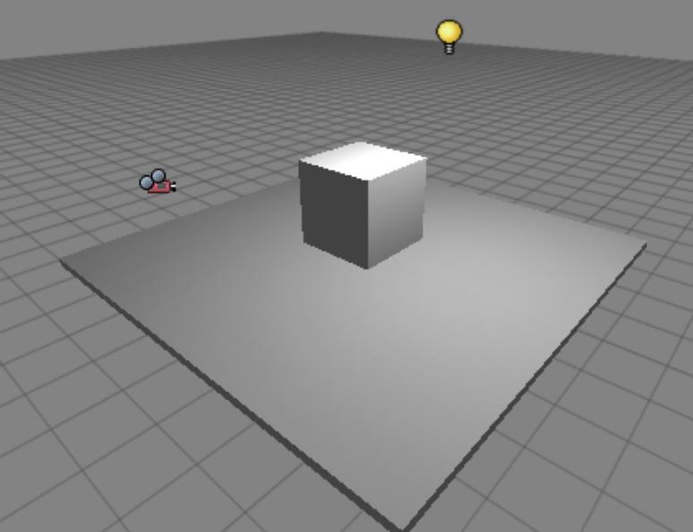
For our first program we’re going to allow the user to move around in a simple game world.
对于我们的第一个程序，我们将允许用户在一个简易的游戏世界里来回行走。
Setting the scene 设置场景
- Start Unity. 启动Unity
Firstly, let’s create a surface for the user to walk on. The surface we’re going to use is a flattened cube shape.
首先，让我们创建一个使用户在上面行走的表面。
- Create a cube and scale its x,y,z dimensions to 5, 0.1, 5 respectively, it should now resemble a large flat plane. Rename this object ‘Plane’ in the Hierarchy View.
创建一个立方体并分别缩放它的x，y，z的尺寸为5，0.1，5。它现在应该像一个巨大的平台。
- Create a 2nd cube and place it at the centre of this plane. If you can’t see the objects in your Game View, alter the main camera so they’re visible. Rename the object to Cube1.
创建第二个立方体并把它放置在这个平台的中心。如果你不能看到这个对象（物体）在你的游戏视图里，改变主摄像机以使它们可见。重命名这个对象为Cube1。
- You should also create a point light and place it above the cubes so that they’re more easily visible.
你应该同样创建一个点光源并放置它在立方体的上方使它们更容易的可见。
- Save the scene by selecting File->Save As and give the game a name.
保存场景 通过选取 File->Save As 并指定一个游戏的名称。
Our first script 我们第一个脚本
We’re now ready to start game programming. We’re going to allow the player to move around the game world by controlling the position of the main camera. To do this we’re going to write a script which will read input from the keyboard, then we attach (associate) the script with the main camera (more on that in the next section).
我们现在准备好了开始游戏编程。我们将允许玩家在游戏世界里来回走动通过控制主摄像机的位置。做到这一点，我们将编写一个脚本从键盘里读取输入，然后我们把这个脚本和主摄像机（更多的在下一节）连接（关联）。
- Begin by creating an empty script. Select Assets->Create->Javascript and rename this script to Move1 in the Project Panel.
开始创建一个空白脚本。选取 Assets->Create->Javascript 并重名这个脚本为Move1 在项目面板里。
- Double-click on the Move1 script and it will open with the Update() function already inserted (this is default behaviour), we’re going to insert our code inside this function.
在Move1脚本上双击，它将带着已经插入Update()函数（这是一个默认的行为）被打开，我们将插入我们的代码在这个函数里。
Any code you insert inside the Update() function will be executed every frame.
你在Update()函数里插入的任何代码将被每个的帧执行。
In order to move a game object in Unity we need to alter the position property of its transform, the Translate function belonging to the transform will let us do this. The Translate function takes 3 parameters, x, y and z movement. As we want to control the main camera game object with the cursor keys, we simply attach code to determine if the cursor keys are being pressed for the respective parameters:
为了在Unity里移动一个游戏对象我们只需要改变它的transform的坐标属性，隶属于transform的这个Translate函数 将让我们做这件事。
function Update () {
transform.Translate(Input.GetAxis("Horizontal"), 0, Input.GetAxis("Vertical"));
}
The Input.GetAxis() function returns a value between -1 and 1, e.g. on the horizontal axis, the left cursor key maps to -1, the right cursor key maps to 1. Notice the 0 parameter for the y-axis as we’re not interested in moving the camera upwards. The Horizontal and Vertical axis are pre-defined in the Input Settings, the names and keys mapped to them can be easily changed in Edit->Project Settings->Input.
函数Input.GetAxis()返回一个在-1与1之间的值，举例来说，在水平轴左箭头映射为-1，右箭头映射为1（注：左右箭头是指键盘上左右方向键），注意到0参数对应的y轴对我们向前移动摄像机没有兴趣。水平和垂直轴是在输入设置里预定义的，名称和键映射到它们可以容易更改在Edit->Project Settings->Input.里。
- Open the Move1 Javascript and type in the above code, pay close attention to capital letters.
打开Move1 Javascript 脚本并键入上面的代码，注意字符的大小写。
Attaching the script 连接脚本
Now that our first script is written, how do we tell Unity which game object should have this behaviour? All we have to do is to attach the script to the game object which we want to exhibit this behaviour.
现在我们第一个脚本已经编写，我们如何告诉Unity 哪个游戏对象应该有这个行为？我们必须使这个脚本到关联那个我们想展示这个行为的游戏对象上。
- To do this, first click on the game object that you wish to have the behaviour as defined in the script. In our case, this is the Main Camera, and you can select it from either the Hierarchy View or the Scene View.
做到这一点，首先在那个你希望拥有这个行为的游戏对象上点击当作在脚本里的定义。在我们的示例里，这是主摄像机，你可以从层次视图或场景视图里选取它。
- Next select Components->Scripts->Move1 from the main menu. This attaches the script to the camera, you should notice that the Move1 component now appears in the Inspector View for the main camera.
接下来，从主菜单中选取Components->Scripts->Move1。关联脚本到摄像机，你应该注意到这个主摄像机的Move1组件现在显示在检视器视图里。
Tip: You can also assign a script to an game object by dragging the script from the Project View onto the object in the Scene View.
技巧：你也可以分配一个脚本给一个游戏对象，通过从项目视图里拖动这个脚本到一个在场景视图里的对象。
- Run the game (press the play icon at the lower left hand corner), you should be able to move the main camera with the cursor keys or W,S,A,D. You probably noticed that the camera moved a little too fast, let’s look at a better way to control the camera speed.
运行这个游戏（按播放图标在左手角落的底部，2.5 版本 windows上的播放条上的播放按钮），你应能够利用方向键或W,S,A,D键移动主摄像机。你也许注意到摄像机移动的有点快，让我们找到一个更好的方法去控制摄像机的速度。
Delta time 时间延迟
As the previous code was inside the Update() function, the camera was moving at a velocity measured in meters per frame. It is better however to ensure that your game objects move at the more predictable rate of meters per second. To achieve this we multiply the value returned from the Input.GetAxis() function by Time.deltaTime and also by the velocity we want to move per second:
作为在Update()里的先前的代码，摄像机以标准的速率移动在仪表里，每帧。一个更好的无论如何确保你的游戏对象移动在超过可预定的米每秒速率，完成这个目标，我们从Input.GetAxis()函数里返回大值通过Time.deltaTime和通过我们每秒应该移动的速率。
var speed = 5.0;
function Update () {
var x = Input.GetAxis("Horizontal") * Time.deltaTime * speed;
var z = Input.GetAxis("Vertical") * Time.deltaTime * speed;
transform.Translate(x, 0, z);
}
- Update the Move1 script with the above code. Notice here that the variable speed is declared outside of the function Update(), this is called an exposed variable, as this variable will appear in the Inspector View for whatever game object the script is attached to (the variable gets exposed to the Unity GUI).
利用上面的代码更新Move1脚本。注意，这里在函数Update()外面声明了一个speed变量，这被称为外部变量，无论什么游戏对象脚本被关联上（变量接触到Unity GUI）该变量将显示在检视器视图里。
Exposing variables are useful when the value needs to be tweaked to get the desired effect, this is much easier than changing code.
暴露的变量是有用的当变量值需要被修改去获得想得到的效果，这是比更改代码容易的操作。
5. Connecting Variables 连接变量
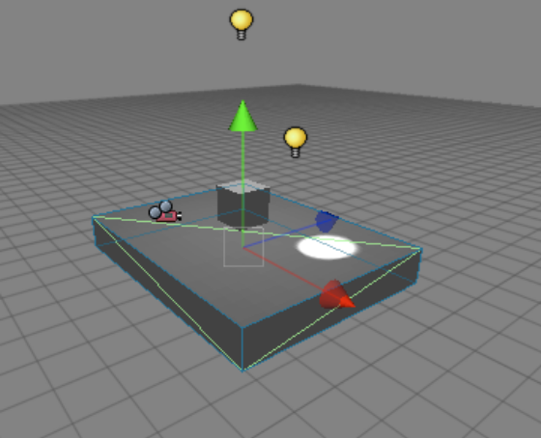
Connecting variables via the GUI is a very powerful feature of Unity. It allows variables which would normally be assigned in code to be done via drag and drop in the Unity GUI. This allows for quick and easy prototyping of ideas. As connecting variables is done via the Unity GUI, we know we always need to expose a variable in our script code so that we can assign the parameter in the Inspector View.
经由GUI连接变量是Unity的强大功能。它允许在代码里去做正常关联的那个变量，经由在Unity GUI里拖放完成。这涉及敏捷的概念原型。作为连接变量经由Unity GUI完成，我们知道我们总要需要暴露一个变量在我们的脚本代码里，因此，我们可以链接这个参数在检视器视图里。
We’ll demonstrate the connecting variables concept by creating a spotlight which will follow the player
(Main Camera) around as they move.
我们将示范连接变量概念通过创建一个聚光灯将跟随摄像机（主摄像机）周围当它们移动时。
- Add a spotlight to the Scene View. Move it if necessary so it’s close to the other game objects.
添加一个聚光灯到场景视图。如果必要的话移动它使它接近于其它游戏对象。
- Create a new Javascript and rename it to Follow.
建立一个新的Javascript脚本并重命名为Follow。
Let’s think what we want to do. We want our new spotlight to look at wherever the main camera is. As it happens, there’s a built in function in Unity to do this, transform.LookAt(). If you were beginning to think ‘how do I do this?’ and were already imagining a lot of code, then it’s worth remembering to always check the Unity API for a function that already exists. We could also make a good guess at looking in the ‘transform’ section of the API as we’re interested in altering the position or rotation of a game object. Now we come to the connecting variables section; what do we use as a parameter for LookAt()? Well we could hardcode a game object, however we know we want to assign the variable via the GUI, so we’ll just use an exposed variable (of type Transform).
让我们思考我们应该做什么。我们想要我们的新聚光灯去查看主摄像机在哪里。恰好出现，有一个在Unity里的现成函数去做到这一点，它是 transform.LookAt()。如果你已经开始思考“我如何处理它?”，以及已经设想了许多代码，那么一个值得记住是总要检查Unity API，查看是否已经存在这样的一个函数。我们同样实现一个好的猜测是在API 的‘transform’ 章节里查找，我们感兴趣修改坐标位置或旋转一个对象。 现在，我们继续连接变量章节；我们为LookAt()提供什么参数？那么，我们能硬编码一个游戏对象，然而，我们知道我们想连接变量经由GUI，因此我们正好使用暴露变量（类型是Transform）
Our Follow.js script should look like this:
我们Follow.js脚本看起来应像这个样子：
var target : Transform;
function Update () {
transform.LookAt(target);
}
- Attach the script to the spotlight and notice when the component gets added, the “target” variable is exposed.
连接这个脚本到聚光灯并注意当组件获得添加，“target”变量是暴露的。
- With the spotlight still selected, drag the Main Camera from the Hierarchy View onto the “target” variable in the Inspector View. This assigns the target variable, i.e. the spotlight will now follow the Main Camera. If we wanted the spotlight to follow a different game object we could just drag in a different object (as long as it was of type Transform of course).
仍旧选取聚光灯,从层次视图拖动主摄像机到在检视器视图里的“target”变量上。这就连接了“target”变量。也就是聚光灯现在将跟随主摄像机。如果我们想这个聚光灯去跟随一个不同的游戏对象，我们可以只需拖动一个不同的对象（当然只要它是Transform类型）。
- Play the game. If you watch the Scene View you should see the spotlight following the Main Camera around. You may want to change the position of the spotlight to improve the effect.
播放游戏，如果你观看场景视图，你应该看到聚光灯跟随在主摄像机周围。你也需想改变聚光灯的位置（坐标）改进效果。
6. Accessing Components 访问组件
As a game object can have multiple scripts (or other components) attached, it is often necessary to access other component’s functions or variables. Unity allows this via the GetComponent() function. We’re now going to add another script to our spotlight which will make it look at Cube1 whenever the jump button (spacebar by default) is pressed. Let’s think about this first, what do we want to do:
作为一个游戏对象可以有多个连接的脚本（或其它的组件），是常常必要的去访问其它的组件的功能或变量。Unity允许这样做，经由GetComponent()函数。我们现在将要添加另外的脚本到我们的聚光灯，无论何时只要按跳跃按钮（默认空白键）将使它看到Cube1。让我们首先思考一下，我们想要做什么：
1. Detect when the jump button has been pressed.
检测，当跳跃键已经被按下时。
2. When jump has been pressed make the spotlight look at Cube1. How do we do this?
当跳跃键已经被按下，使聚光灯看到Cube1，我们如何做到？
Well, the Follow script contains a variable “target” whose value determines which game object the spotlight should look at. We need to set a new value for this parameter. We could hardcode the value for the cube (see the section ‘Doing it with code’ later), however we know that exposing the variable and assigning this via the GUI is a better way of doing this.
好，Follow脚本包含一个“target”变量-求出聚光灯应该看到哪个游戏对象是谁的值。我们需要设置一个新的值为这个参数。我们能硬编码这个值为cube（稍后看本节“利用代码”），然而，我们知道那个暴露的变量和分配它，经由GUI是一个好的方法做这个。
- Create a new Javascript and name it Switch. Add the following code to Switch.js:
创建一个新的Javascript脚本并命名它为Switch，添加如下的代码到Switch.js:
var switchToTarget : Transform;
function Update () {
if (Input.GetButtonDown("Jump"))
GetComponent(Follow).target = switchToTarget;
}
Notice in particular how Follow is the parameter to GetComponent(), this returns a reference to the Follow script which we can then use to access its “target” variable.
特别注意Follow是如何使用参数给GetComponent()，它返回一个引用到Follow脚本那个我们能使用访问它的“target”变量。
- Add the Switch script to the spotlight and assign Cube1 to the switchToTarget parameter in the Inspector View.
添加Switch 脚本到聚光灯并链接Cube1到switchToTarget参数在检视器视图里。
- Run the game. Move around and verify that the spotlight follows you as usual, then hit the spacebar and the spotlight should focus on the Cube1.
运行游戏，来回走到和核对那个聚光灯正常跟随你，然后，敲击空白键，聚光灯应该聚焦在Cube1上。
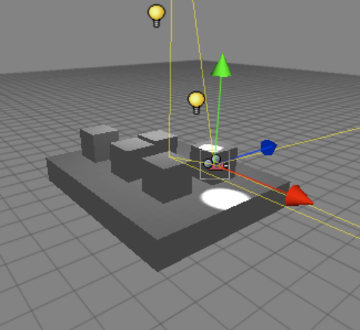
Doing it with code 使用代码
Earlier in the tutorial we mentioned that it would be possible to assign the variables via code (as opposed to the Unity GUI), let’s take a look at how you would do that.
早先在手册里，我们提及它将可能连接变量经由代码（反对Unity GUI），让我们看看你将如何做。
Remember this is only for comparison, assigning variables via the GUI is the recommended approach.
记住，这仅仅是一个对比，分配变量经由GUI是推荐的途径。
The problem we were interested in earlier was how do we tell the spotlight to look at Cube1 when the jump button was pressed. Our solution was to expose a variable in the Switch script which we could then assign by dropping Cube1 onto it from the Unity GUI. There are two main ways to do this in code:
早期我们比较感兴趣的问题是我们如何告诉聚光灯看到Cube1 当跳跃键被按下时。我们的方案是暴露一个变量在Switch脚本里，我们可以通过拖动Cube1到它上面从Unity GUI里。有两种主要方法做到这一点在代码里：
1. Use the name of the game object.
使用游戏对象的名称
2. Use the tag of the game object.
使用游戏对象的标志
1. Game object name 游戏对象名称
A game object’s name can be seen in the Hierarchy View. To use this name with code we use it as a parameter in the GameObject.Find() function. So if we want the jump button to switch the spotlight from Main Camera to Cube1, the code is as follows:
一个游戏对象的名称可以在层次视图里被看到。使用名称和代码，我们用它作为参数在GameObject.Find()函数里。因此，如果我们想按跳跃键去切换聚光灯从主摄像机到Cube1，代码如下：
function Update () {
if (Input.GetButtonDown("Jump"))
{
var newTarget = GameObject.Find("Cube").transform;
GetComponent(Follow).target = newTarget;
}
}
Notice how no variable is exposed as we name it directly in code. Check the API for more options using Find().
注意，没有变量是暴露的而是我们直接在代码里命名它。检查API更多选项，使用Find()
2. Game object tag 游戏对象标签
A game object’s tag is a string which can be used to identify a component. To see the built-in tags click on the Tag button in the Inspector View, notice you can also create your own. The function for finding a component with a specific tag is GameObject.FindWithTag () and takes a string as a parameter. Our complete code to do this is:
一个游戏对象的标签是一个字符串，那个可以被使用于识别一个组件。查看内置的标签，在检视器视图里标签按钮上点击，注意你也可以创建你自己的标签。发现一个带有指定标签的组件的函数是GameObject.FindWithTag ()并带有一个字符串作为参数。我们完成的代码做到这一点：
function Update () {
if (Input.GetButtonDown("Jump"))
{
var newTarget = GameObject.FindWithTag("Cube").transform;
GetComponent(Follow).target = newTarget;
}
}
7. Instantiate 实例创建
It is often desirable to create objects during run-time (as the game is being played). To do this, we use the Instantiate function. Let’s show how this works by instantiating (creating) a new game object every time the
user presses the fire button (either the left mouse button or left ctrl on the keyboard by default). So what do we want to do? We want the user to move around as usual, and when they hit the fire button, instantiate a new object. A few things to think about:
这是经常令人愉快的去创建对象在运行期间（当游戏正在播放），做到这一点，我们使用Instantiate功能。让我们展示如何工作，通过实例创建一个新的游戏对象每次用户按发射按钮（任一的方法：鼠标左键或默认的键盘上的左Ctrl键）。因此，我们应该做什么？我们想用户通常来回走动，当它们点击发射按钮，实例创建和一个新的对象。有几件事情要考虑：
1. Which object do we instantiate?
我们实例创建哪个对象？
2. Where do we instantiate it?
在哪里我们实例创建它？
Regarding which object to instantiate, the best way of solving this is to expose a variable. This means we can state which object to instantiate by using drag and drop to assign a game object to this variable. As for where to instantiate it, for now we’ll just create the new game object wherever the user (Main Camera) is currently located whenever the fire button is pressed. The Instantiate function takes three parameters; (1) the object we want to create, (2) the 3D position of the object and (3) the rotation of the object.
The complete code to do this is as follows (Create.js):
关于哪个对象去实例创建，最好的解决方是暴露一个变量。这意味着我们可以规定哪个对象去实例创建通过使用拖放去连接一个游戏对象到这个变量上。作为在哪里实例创建它，现在，我们将正确的创建一个新的游戏对象无论用户（主摄像机）的当前位置在哪里，无论发射键在哪里被按下。实例创建函数需要三个参数：（1）我们想要创建的对象，（2）对象的3D坐标以及（3）对象的旋转。
完成的代码如下所示：（Create.js）
var newObject : Transform;
function Update () {
if (Input.GetButtonDown("Fire1")) {
Instantiate(newObject, transform.position, transform.rotation);
}
}
Don’t forget that transform.position and transform.rotation are the position and rotation of the transform that the script is attached to, in our case this will be the Main Camera. However, when an object is instantiated, it is usual for that object to be a prefab. We’ll now turn the Cube1 game object into a prefab.
不要忘记transform.position和transform.rotation 是变换组件的坐标与旋转 那个脚本连接的，在我们的方案里，它将是主摄像机。然而，当一个对象是实例创建的，它通常是一个预制品的对象。我们现在将转换Cube1游戏对象到一个预制品。
- Firstly, let’s create an empty prefab. Select Assets->Create->Prefab. Rename this prefab to Cube.
首先，让我们建立一个空的预制品，选取 t Assets->Create->Prefab，重命名这个预制品为Cube.
- Drag the Cube1 game object from the Hierarchy View onto the Cube prefab in the Project view. Notice the prefab icon changes.
从层次视图里拖动Cube1游戏对象到Cube预制品里在项目视图里。注意预制品图标的变化。
Now we can create our Javascript code.
现在，我们建立我们的Javascript代码
- Create a new Javascript and name it Create. Insert the above code.
建立一个新的Javascript脚本 并命名它为Create，插入上面的代码。
- Attach this script to the Main Camera and assign the Cube prefab to the newObject variable of Main Camera.
关联这个脚本到主摄像机和关联Cube预制品到主摄像机的newObject变量
- Play the game and move around as usual. Each time the fire button is clicked (LMB or left ctrl) and you should notice a new cube appearing.
播放游戏并正常来回走动。每次发射按钮被点击（鼠标左键，或键盘左Ctrl键）你应当注意到一个新立方体出现。
8. Debugging 调试
Debugging is the skill of finding and fixing human errors in your code (ok let’s call them mistakes!). Unity provides help via the Debug class, we’ll now look at the Debug.Log() function.
调试是发现和修复人为错误的技能在你的代码里（好，让我们称它们错误吧！）。Unity支持帮组经由Debug类，我们现在将看到Debug.Log()函数。
Log 记录
The Log() function allows the user to send a message to the Unity Console. Reasons for doing this might include:
Log()函数允许用户发送一个消息个Unity控制台，这样做的理由包括：
1. To prove that a certain part of the code is being reached during run-time.
证明代码的某一部分在运行期间存在。
2. To report the status of a variable.
报告变量的状态。
We’ll now use the Log() function to send a message to the Unity Console when the user clicks the fire button.
我们现在将使用 Log()函数去发送一个消息给Unity控制台当用户点击发射按钮时。
- Open the Create script and add the following line after the ‘Instantiate’ code inside the ‘if’ block:
打开Create脚本并添加下面一行在‘Instantiate’代码里的‘if’块之后：
Debug.Log("Cube created");
- Run the game and click the fire button, you should see a line appear at the bottom of the Unity GUI saying “Cube created”, you can click on this to examine the Unity Console.
运行游戏并点击发射按钮，你应该看到一行显示在Unity GUI底部说明“Cube created”，你可以在这个上面点击去控制台检验。
Watch 监视
Another useful feature for debugging is exposing a private variable. This makes the variable visible in the Inspector View when the Debug mode is selected, but it cannot be edited.
另外有用的特性为调式暴露一个私有变量。这使变量可见在检视器视图里当在调试模式被选取，但不能被编辑。
To demonstrate this, we’ll expose a private variable to count the number of cubes that we instantiate.
去示范它，我们将暴露一个私有变量去计算我们实例创建立方体的数量。
- Open the Create script again and add two lines:
再次打开Create脚本并添加两行：
(1) Add a private variable called cubeCount
添加一个私有变量称为cubeCount
(2) Increment this variable whenever a cube is instantiated.
无论何时一个立方体被实例创建，这个变量增加1.
The complete code is a follows (Create.js):
完成的代码如下：
var newObject : Transform;
private var cubeCount = 0;
function Update () {
if (Input.GetButtonDown("Fire1")) {
Instantiate(newObject, transform.position, transform.rotation);
Debug.Log("Cube created");
cubeCount++;
}
}

- Run the game and click the fire button to create some cubes. Notice in the Inspector View how the cubeCount variable is incremented whenever a new cube is instantiated.
运行游戏并点击发射按钮去建立一些立方体。注意到在检视器视图里cubeCount变量如何增加无论何时一个新的立方体被实例创建.
Notice also how the number appears greyed out, this denotes that it’s a read-only variable (cannot be edited).
也要注意到数值显示为灰色，这不能修改，它是一个只读的变量（不能被编辑）。
9. Common script types 公共脚本类型
Whenever a new Javascript is created, by default it contains an Update() function. This section will discuss other common options available, simply replace the name of the Update() function with one from the list below.
FixedUpdate() Code placed inside this function is executed at regular intervals (a fixed framerate). It is
common to use this function type when applying forces to a Rigidbody.
无论何时，一个新的Javascript被建立，它默认包括一个Update()函数。本节将讨论其它公共可用的选项，利用从下面列表里之一完全替代Update()函数的名称。
// Apply a upwards force to the rigid body every frame 每一帧允许一个向上力去固定物体 function FixedUpdate () {
rigidbody.AddForce (Vector3.up);
}
Awake()
Code inside here is called when the script is initialized.
代码在这里被条用当脚本被初始化时。
Start()
This is called before any Update() function, but after Awake(). The difference between the Start () and Awake() functions is that the Start() function is only called if the script is enabled (if its checkbox is enabled in the Inspector View).
在任何Update()函数之前被调用，但在Awake()之后。在Start () 和 Awake()函数之间的差别是指Start()是单独调用，如果脚本启用。（如果它的检验框是启用的，在检视器视图里）
OnCollisionEnter()
Code inside here is executed when the game object the script belongs to collides with another game object.
代码在这里被执行当游戏对象脚本隶属于与其它游戏对象碰撞时
OnMouseDown()
Code inside here is executed when the mouse hovers over a game object which contains a GUIElement or a Collider.
代码在这里被执行当鼠标盘旋在一个包含GUIElement或碰撞体的游戏对象的顶部时
// Loads the level named "SomeLevel" as a response 装载"SomeLevel"级别作为用户在对象上
// to the user clicking on the object 点击的一个应答
function OnMouseDown () {
Application.LoadLevel ("SomeLevel");
}
OnMouseOver()
Code inside here is executed when the mouse hovers over a game object which contains a GUIElement or a Collider.
代码在这里被执行当鼠标盘旋在一个包含GUIElement或碰撞体的游戏对象的顶部时
// Fades the red component of the material to zero 使材质的红色成分
// while the mouse is over the mesh
function OnMouseOver () {
renderer.material.color.r -= 0.1 * Time.deltaTime;
}
Check the Unity API for more information on all of these functions.
检查Unity API 获得所有这些函数上的更多信息。

Summary 结束语
This tutorial has introduced the essential scripting concepts in Unity. You should now read other Unity tutorials or try experimenting yourself!
这个教程已经介绍了必要的脚本概念在Unity里。你应该现在阅读其它Unity教程或你自己做实验！

