Cameras 摄像机
Unity Manual > User Guide > Building Scenes > Cameras
Unity手册->用户指南->创建场景->摄像机
Just as cameras are used in films to display the story to the audience, Cameras in Unity are used to display the game world to the player. You will always have at least one camera in a scene, but you can have more than one. Multiple cameras can give you a two-player splitscreen or create advanced custom effects. You can animate cameras, or control them with physics. Practically anything you can imagine is possible with cameras, and you can use typical or unique cameras to fit your game's style.
正如摄像机用于电影显示故事给观众，在Unity里摄像机用于显示游戏世界给玩家。在一个场景里，你总是拥有至少一个摄像机，但你可以拥有超过一个的摄像机。多个摄像机可以给你两个玩家分屏或建立高级的客户效果。你可以动画摄像机，或物理控制它们。你可以设想几乎任何事情是摄像机发生的已经你可以使用典型的或独特的摄像机以适合你的游戏的风格。
The remaining text is from the Camera Component reference page.
剩余的文本来自于摄像机组件引用页。

Camera 摄像机
Cameras are the devices that capture and display the world to the player. By customizing and manipulating cameras, you can make the presentation of your game truly unique. You can have an unlimited number of cameras in a scene. They can be set to render in any order, at any place on the screen, or only certain parts of the screen.
摄像机是捕获和展示世界该玩家的设备。通过定制和操纵摄像机，你可以使你的游戏真正独一无二的展示。在场景里你可以拥有不限数量的摄像机。它们可以被设置为任何顺序渲染、在屏幕的任何地方或仅是屏幕的以部分。
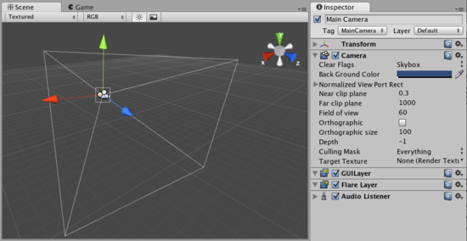
Unity's flexible Camera object Unity的灵活的设计摄像机对象。

Properties 属性
Clear Flags  清除标志 | Determines which parts of the screen will be cleared. This is handy when using multiple Cameras to draw different game elements.  确定屏幕的哪些部分将被清除。这是方便的当使用多个摄像机去绘制不同游戏元素时。
Background color  背景颜色 | Color applied to the remaining screen after all elements in view have been drawn and there is no skybox.  颜色应用于在所有在视图里的元素已经被绘制和没有天空盒之后的屏幕的剩余部分。
Normalized View Port Rect  标准视口矩形 | Four values that indicate where on the screen this camera view will be drawn, in Screen Coordinates (values 0-1).  四个值在屏幕上指定哪里，摄像机视图将被绘制，在场景里相配（值 0-1）
X | The beginning horizontal position that the camera view will be drawn.  摄像机视图开始的水平位置将被会绘制。
Y | The beginning vertical position that the camera view will be drawn.  摄像机视图开始的垂直位置将被会绘制。
Width 宽度 | Width of the camera output on the screen.摄像机输出到屏幕上的宽度
Height 高度 | Height of the camera output on the screen.摄像机输出到屏幕上高度
Near clip plane近剪辑平面 | The closest point relative to the camera that drawing will occur.  相对于摄像机的最近点绘制将出现。
Far clip plane 远剪辑平面 | The furthest point relative to the camera that drawing will occur.  相对于摄像机的最远点绘制将出现。
Field of view 视界 | Width of the Camera's view angle, measured in degrees along the local Y axis.摄像机视角的宽度，沿本地y轴度量。
Orthographic 正交投影 | Toggles the camera's capability to simulate perspective.切换摄像机的性能去模拟远景
Orthographic size 正交投影大小 | The viewport size of the Camera when it is Orthographic.  当它是正交投影时，摄像机的视口大小。
Depth 深度 | The camera's position in the draw order. Cameras with a higher depth will be drawn on top of cameras with a lower depth value.  在绘制顺序里的摄像机的位置。拥有一个高深度的摄像机将紧接着所有低深度值的摄像机被绘制。
Culling Mask 剔除面具 | Include or omit layers of objects to be rendered by the Camera. Assign layers to your objects in the Inspector.  通过摄像机渲染包含或剔除对象的层。 在检视器里指定层到你的对象。
Render Target (Unity Pro only) 渲染目标（Unity专业版仅有） | Reference to a Render Texture that will contain the output of the Camera view. Making this reference will disable this Camera's capability to render to the screen.  引用一个包含摄像机视图输出的渲染纹理。使这个纹理将停用这个摄像机的性能去渲染屏幕。

Details 详细资料
Cameras are essential for displaying your game to the player. They can be customized, scripted, or parented to achieve just about any kind of effect imaginable. For a puzzle game, you might keep the Camera static for a full view of the puzzle. For a first-person shooter, you would parent the Camera to the player character, and place it at the character's eye level. For a racing game, you'd likely want to have the Camera follow your player's vehicle.
给玩家显示你的游戏摄像机是必需的。它们可以被定制、脚本或父类化取得恰当的任何可想象效果类型。对于一个益智游戏，你也许保持益智游戏全景视图的静态摄像机。对于一个第一人称射击，你将父类化摄像机给玩家角色以代替角色的视觉水平。对于赛车游戏，你可能希望有摄像机根须你的玩家的汽车。
You can create multiple Cameras and assign each one to a different Depth. Cameras are drawn from low Depth to high Depth. In other words, a Camera with a Depth of 2 will be drawn on top of a Camera with a depth of 1. You can adjust the values of the Normalized View Port Rectangle property to resize and position the Camera's view onscreen. This can create multiple mini-views like missile cams, map views, rear-view mirrors, etc.
你可以创建多个摄像机并指定每个摄像机不同的深度。摄像机从低深度到高深度绘制。换句话说，一个拥有深度2的将紧接着深度为1的被绘制。你可以调整水平视口矩形属性的值去调整大小和摄像机的视图在屏幕上的位置。这可以创建多个小视图就像发射物齿轮、地图窗口，后视镜等等。

Clear Flags 清除标志
Each Camera stores color and depth information when it renders its view. The portions of the screen that are not drawn in are empty, and will display the skybox by default. When you are using multiple Cameras, each one stores its own color and depth information in buffers, accumulating more data as each Camera renders. As any particular Camera in your scene renders its view, you can set the Clear Flags to clear different collections of the buffer information. This is done by choosing one of the four options:
当摄像机渲染它的视图时，每个摄像机存储颜色和深度信息。 屏幕的一部分是不绘制是空的，将默认被显示为天空。当你使用多个摄像机，每个摄像机存储它自己颜色和深度信息在缓存里、积累多的数据做个每个摄像机渲染。做为任一特殊的摄像机在你的场景里渲染它自己的视图，你可以设置清除标志去清除不同缓存信息的集合。这样做通过四个选项之一：

Skybox 天空盒
This is the default setting. Any empty portions of the screen will display the current Camera's skybox. If the current Camera has no skybox set, it will default to the skybox chosen in the Render Settings (found in Edit->Render Settings). It will then fall back to the Background Color.
这是默认设置。任何场景的空白部分将先显示当前摄像机的天空盒。如果当前摄像机没有天空盒设置，它将默认为在渲染设置里（在Edit->Render Settings里找到）选择的天空盒。此后，它将回退到背景颜色。

Solid Color 纯色
Any empty portions of the screen will display the current Camera's Background Color.
屏幕的任何空白部分将显示当前摄像机的背景颜色。

Depth Only 独立深度
If you wanted to draw a player's gun without letting it get clipped inside the environment, you would set one Camera at Depth 0 to draw the environment, and another Camera at Depth 1 to draw the weapon alone. The weapon Camera's Clear Flags should be set to to depth only. This will keep the graphical display of the environment on the screen, but discard all information about where each object exists in 3-D space. When the gun is drawn, the opaque parts will completely cover anything drawn, regardless of how close the gun is to the wall.
如果你想去绘制一个玩家的枪 没有让它获得环境内侧剪辑，你应该设置摄像机在深度0绘制环境，其它摄相象在深度1绘制独立武器。武器摄像机的清除标志应该被设置为唯一深度。这将保持屏幕上环境图片显示，但是丢弃所有有关的每个对象存在于3D空间的地点信息。当枪被绘制时，不透明部分将完全覆盖任何事物绘制，不管抢是如何接近墙。
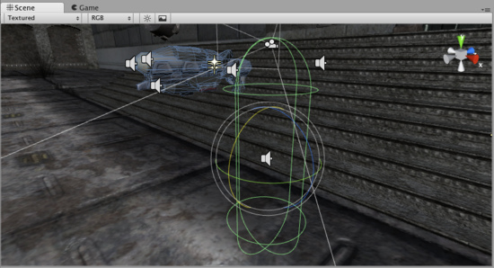
The gun is drawn last, after clearing the depth buffer of the cameras before it
抢被最后一次绘制，在摄像机的深度缓存清除前后。

Don't Clear 不清除
This mode does not clear either the color or the depth buffer. The result is that each frame is drawn over the next, resulting in a smear-looking effect. This isn't typically used in games, and would likely be best used with a custom shader.
这个模式不清除任一的颜色或深度缓存。其结果是每帧被绘制在下一个之上，造成在一抹黑里的效果。在游戏里这不经常使用，有可能最好使用一个定制的阴影。

Clip Planes 剪辑平面
The Near and Far Clip Plane properties determine where the Camera's view begins and ends. The planes are laid out perpendicular to the Camera's direction and are measured from the its position. The Near plane is the closest location that will be rendered, and the Far plane is the furthest.
近处和远处剪辑面属性决定摄像机视图开始与结束的地方。平面是垂直布局于摄像机的方向并从它自己的位置来衡量。近处剪辑是接近渲染的本地，远处剪辑是最远的。
The clipping planes also determine how depth buffer precision is distributed over the scene. In general, to get better precision you should move the Near plane as far as possible.
剪辑的平面同样确认缓存精度如何分布在场景上。一般而言，去获得较好的精度你应该移动近处剪辑尽可能的远。

Culling Mask 剔除面具
The Culling Mask is used for selectively rendering groups of objects using Layers. More information on using layers can be found here.
剔除面具被用于选择性的渲染对象组使用的层。使用层的更多信息在这里。
Commonly, it is good practice to put your User Interface on a different layer, then render it by itself with a separate Camera set to render the UI layer by itself.
一般地，一个良好的做法是把你的用户界面放置一个不同的层，然后渲染它它，利用各自摄像机设渲染它自己的UI层。
In order for the UI to display on top of the other Camera views, you'll also need to set the Clear Flags to Depth only and make sure that the UI Camera's Depth is higher than the other Cameras.
为了用户界面（UI）显示在其它摄像机的上面，你应该同样需要设置清除标志为单独深度并确定UI摄像机的深度是比其它摄像机高的高度。

Normalized Viewport Rectangle 标准视口矩形
Normalized Viewport Rectangles are specifically for defining a certain portion of the screen that the current camera view will be drawn upon. You can put a map view in the lower-right hand corner of the screen, or a missile-tip view in the upper-left corner. With a bit of design work, you can use Viewport Rectangle to create some unique behaviors.
标准视口矩形是特定定义一个屏幕的某一部分，当前摄像机视图将被绘制在上面。你可以放置一个地图视图在屏幕右手下角落里，或一个导弹提示视图在左上角。就设计工作的一点，你可以使用视口矩形去创建一些独特的行为。
It's easy to create a two-player split screen effect using Normalized Viewport Rectangle. After you have created your two cameras, change player one's Ymin value to 0.5, and player two's Ymax: value to 0.5. This will make player one's camera display from halfway up the screen to the top, and player two's camera will start at the bottom and stop halfway up the screen.
使用标准视口矩形很容易创建两个玩家分屏效果。在你已经建立两个摄像机之后，更改两个玩家之一的Ymin（y最小值）值为0.5，已经两个玩家的Ymax（y最大值）为0.5。这将使玩家之一的摄像机从屏幕的中部向上到顶部显示，以及第二个玩家的摄像机将开始在底部及停止在屏幕的中部。
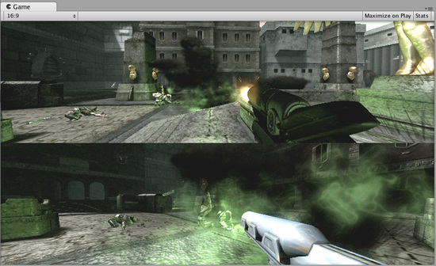
Two-player display created with Normalized Viewport Rectangle 两个玩家显示利用标准视口矩形创建的。

Orthographic 正交投影
Marking a Camera as Orthographic removes all perspective from the Camera's view. This is mostly useful for making isometric or 2D games.
使一个摄像机作为正交投影从摄像机的视图里删除所有透视。这是通常用于做等角（正交）或2D游戏。
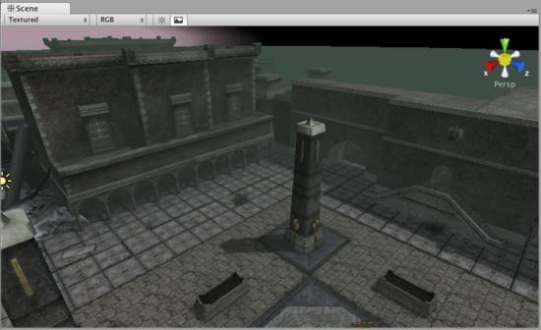
Perspective camera 透视摄像机.
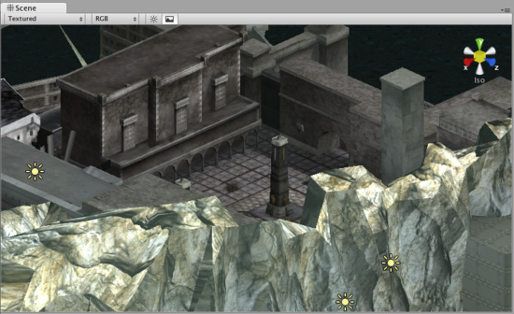
Orthographic camera. Objects do not get smaller with distance here! 正交摄像机，对象不再获得小的位距这里！

Render Texture 渲染纹理
This feature is only available for Unity Pro licenses (not applicable to any version of Unity iPhone). It will place the camera's view onto a Texture that can then be applied to another object. This makes it easy to create sports arena video monitors, surveillance cameras, reflections etc.
这个特性仅是Unity 专业版本据有的许可（不适用于Unity iPhone的任何版本）。它将放置摄像机视图在一个纹理上，然后可以被用于其它对象。这很容易的去创建体育场检视器，检视摄像机，反射等。
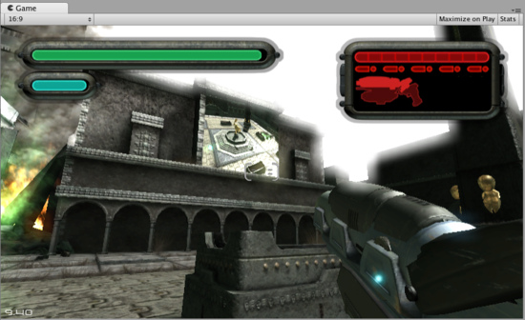
A Render Texture used to create a live arena-cam 一个渲染纹理被用于创建一个实况转播体育场

Hints 提示
Cameras can be instantiated, parented, and scripted just like any other GameObject.
摄像机可以被实例化、父类化、以及脚本化就像任何其它GameObject（游戏物体）。
To increase the sense of speed in a racing game, use a high Field of View.
为增加场景的速度感在一个赛车游戏里，使用高可视区。
Cameras can be used in physics simulation if you add a Rigidbody Component.
摄像机可以被用于物理仿真里如果你添加一个刚体组件。
There is no limit to the number of Cameras you can have in your scenes.
没有限制你拥有的摄像机的数量在你的场景里。
Orthographic cameras are great for making 3D user interfaces
正交投影摄像机可以制作3D用户界面。
If you are experiencing depth artifacts (surfaces close to each other flickering), try setting Near Plane to as large as possible.
如果你遇到史前古物深度技巧（表面接近的彼此闪烁），尝试设置近处平面尽可能的大。
Cameras cannot render to the Game Screen and a Render Texture at the same time, only one or the other.
摄像机不能渲染游戏场景和一个渲染纹理在同一时间，统一时间只能一个。
Pro license holders have the option of rendering a Camera's view to a texture, called Render-to-Texture, for even more unique effects.
专业版许可者拥有渲染的一个摄像机视图的渲染选项对一个纹理，称为渲染到纹理，为了更独特的效果。
Unity comes with pre-installed Camera scripts, found in Components->Camera Control. Experiment with them to get a taste of what's possible.
Unity配置了预安装摄像机脚本，在Components->Camera Control里找到。实验它们去获得可能发生的什么体验。

