Unity Manual —> User Guide > Building Scenes > Particle Systems

Unity手册—>用户手册—>建立场景—>粒子系统

Particle Systems

粒子系统
Particles are essentially 2D images rendered in 3D space. They are primarily used for effects such as smoke, fire, water droplets, or leaves. A Particle System is made up of three separate Components: Particle Emitter, Particle Animator, and a Particle Renderer. You can use a Particle Emitter and Renderer together if you want static particles. The Particle Animator will move particles in different directions and change colors. You also have access to each individual particle in a particle system via scripting, so you can create your own unique behaviors that way if you choose.
粒子本质上是2D图象在3D空间的渲染。它们主要用于诸如烟，火，水飞沫，或树叶的装饰。一个 粒子系统由三个独立的组件组成： 粒子发射器， 粒子动画，以及 粒子渲染。如果你想建一个静态粒子，你可以使用一个粒子发射器和渲染结合处理。动画的粒子会移动不同的方向的粒子和改变颜色的粒子。你还可以在粒子系统中通过脚本访问每个粒子，因此，你可以选择创建自己独特的行为方式。
Please view the Particle Scripting Reference here.
粒子脚本参考 请查看这里。
The remainder of this page's text is from the Particle Component Reference pages.
此网页的文本的其余部分是来之 粒子组件参考 页。

Particle Components

粒子组件

Particle Systems 粒子系统
Particle Systems in Unity are used to make clouds of smoke, steam, fire and other atmospheric effects. Particle Systems work by using one or two Textures & drawing them many times, creating a chaotic effect.
在Unity中，粒子系统通常用来制造烟雾，蒸气，火及其他大气的效果。粒子系统通过使用一个或两个纹理的多次绘制的操作，建立一个混乱的效果。
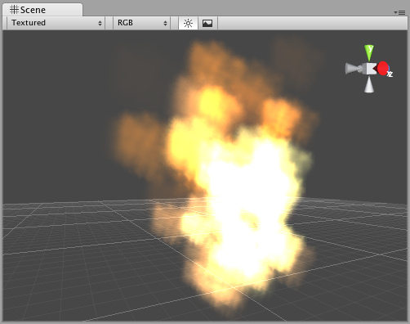
A Particle System included in the Standard Assets 标准资产包含的一个粒子系统
A typical Particle System in Unity is an object that contains a Particle Emitter, a Particle Animator and a Particle Renderer. The Particle Emitter generates the particles, the Particle Animator moves them over time, and the Particle Renderer draws them on the screen.
在Unity中，一个典型的粒子系统是一个对象，它包含一个粒子发射器、一个粒子动画和一个粒子渲染。粒子发射器产生所有的粒子，粒子动画随着时间移动它们，粒子渲染在屏幕上绘制它们。
If you want your particles to interact with the world, add a Particle Collider Component to the GameObject.
如果你希望你的粒子与游戏结合，添加一个粒子对撞机组件到一个GameObject。（游戏对象）

Ellipsoid Particle Emitter 椭圆体的粒子发射器
The Ellipsoid Particle Emitter spawns particles inside a sphere. Use the Ellipsoid property below to scale & stretch the sphere.
椭圆体的粒子发射器在一个球面范围内产生粒子。使用椭圆体的伸展刻度属性在球面范围内进行伸展（放大或缩小）。
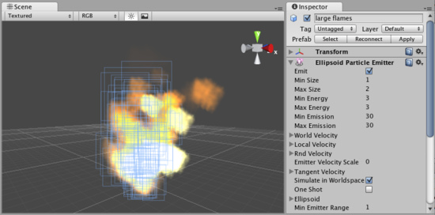
The Ellipsoid Particle Emitter Inspector 椭圆体粒子发射器检视板

Properties 属性

Properties
Emit  发射 | If enabled, the emitter will emit particles.  如勾选，发射器发射粒子
Min Size  最小尺寸 | The minimum size each particle can be at the time when it is spawned.  产生粒子时的每个粒子的最小尺寸
Max Size  最大尺寸 | The maximum size each particle can be at the time when it is spawned.  产生粒子时的每个粒子的最大尺寸
Min Energy  最小能量 | The minimum lifetime of each particle, measured in seconds.  以秒计算，每个粒子最小生存期
Max Energy  最大能量 | The maximum lifetime of each particle, measured in seconds.  以秒计算，每个粒子最大生存期
Min Emission  最小发射 | The minimum number of particles that will be spawned every second.  每秒钟产生粒子的最小数量
Max Emission  最大发射 | The maximum number of particles that will be spawned every second.  每秒钟产生粒子的最大数量
World Velocity  全局速度 | The starting speed of particles in world space, along X, Y, and Z.  沿x,y,z轴粒子在全局空间的开始速度
Local Velocity  本地速度 | The starting speed of particles along X, Y, and Z, measured in the object's orientation.  以物体的方向沿x，y，z轴的粒子开始速度
Rnd Velocity  随即速度 | A random speed along X, Y, and Z that is added to the velocity.  沿x，y，z轴增量的随即速度
Emitter Velocity Scale  发射速度缩放 | The amount of the emitter's speed that the particles inherit.  这个发射器速度数量继承至这些粒子（这个翻译的不明白）
Tangent Velocity  切线速度 | The starting speed of particles along X, Y, and Z, across the Emitter's surface.  交叉发射器的表面，沿x，y，z轴的粒子开始速度
Simulate In World Space  在全局空间模拟 | If enabled, the particles don't move when the emitter moves. If false, when you move the emitter, the particles follow it around.  如勾选，当发射器移动时，粒子不移动。如不勾选，当移动发射器时，粒子跟随移动。
One Shot  一次射击 | If enabled, the particle numbers specified by min & max emission is spawned all at once. If disabled, the particles are generated in a long stream.  如勾选，根据指定的粒子最小与最大数立即全部产生。如不勾选，粒子生成一个长的流。
Ellipsoid  椭圆体 | Scale of the sphere along X, Y, and Z that the particles are spawned inside.  粒子产生在沿x，y，z轴伸缩球体的内部。
Min Emitter Range  最小发射器范围 | Determines an empty area in the center of the sphere - use this to make particles appear on the edge of the sphere.  在球体中心确定一个空的区域，这个区域做为粒子出现的球体边界

Details 详细说明
Ellipsoid Particle Emitters (EPEs) are the basic emitter, and are included when you choose to add a Particle System to your scene from Components->Particles->Particle System. You can define the boundaries for the particles to be spawned, and give the particles an initial velocity. From here, use the Particle Animator to manipulate how your particles will change over time to achieve interesting effects.
椭圆体粒子发射器（EPEs）是基本发射器，当你从Components->Particles->Particle System菜单选择增加一个粒子系统到你的场景时已经包含在其中。
Particle Emitters work in conjunction with Particle Animators and Particle Renderers to create, manipulate, and display Particle Systems. All three Components must be present on an object before the particles will behave correctly. When particles are being emitted, all different velocities are added together to create the final velocity.
粒子发射器与 粒子动画师、粒子渲染协同去创建，处理和显示粒子系统。在粒子正常运转之前，这三个组件必须存在于一个对象上。当粒子被发射，所有不同的速度相加形成粒子最终的速度。

Spawning Properties （粒子）产生属性
Spawning properties like Size, Energy, Emission, and Velocity will give your particle system distinct personality when trying to achieve different effects. Having a small Size could simulate fireflies or stars in the sky. A large Size could simulate dust clouds in a musky old building.
当努力达到不同的效果时，产生粒子的属性，像大小、能量、发射和速度将给你的粒子系统独特的特性。一个小的尺寸可以模拟萤火虫或天空中的星星。一个大的尺寸可以模拟古色古香旧建筑物的尘埃。
Energy and Emission will control how long your particles remain onscreen and how many particles can appear at any one time. For example, a rocket might have high Emission to simulate density of smoke, and high Energy to simulate the slow dispersion of smoke into the air.
能量和发射将控制你的粒子在任何时间、任意数量的粒子在屏幕上显示多长的时间。例如：一个火箭有高的发射模拟烟雾，和高的能量模拟烟雾在空气中缓慢分散。
Velocity will control how your particles move. You might want to change your Velocity in scripting to achieve interesting effects, or if you want to simulate a constant effect like wind, set your X and Z Velocity to make your particles blow away.
速度将控制你的粒子如何移动。你或许想在脚本中更改速度实现有趣的效果，或则，你想模拟像风一样的恒定效果，设置你的X和Z轴的速度吹走你的粒子

Simulate in World Space全局空间模拟
If this is disabled, the position of each individual particle will always translate relative to the Position of the emitter. When the emitter moves, the particles will move along with it. If you have Simulate in World Space enabled, particles will not be affected by the translation of the emitter. For example, if you have a fireball that is spurting flames that rise, the flames will be spawned and float up in space as the fireball gets further away. If Simulate in World Space is disabled, those same flames will move across the screen along with the fireball.
如这项是禁用的，每个个体粒子的坐标（位置）总转化为相对与该发射器的相对坐标。当发射器移动，粒子将随着该发射器移动。若Simulate in World Space选项是启用的，粒子将不受到发射器变换的影响。例如，你有一个火焰溅射上升的火球，作为火球的火焰将分散并悬浮在空间更远。若Simulate in World Space项是禁用的，这些相同火焰将随着火球在屏幕上一起移动。

Emitter Velocity Scale 发射器速度缩放
This property will only apply if Simulate in World Space is enabled.
这个属性仅适用于Simulate in World Space选项已启动。
If this property is set to 1, the particles will inherit the exact translation of the emitter at the time they are spawned. If it is set to 2, the particles will inherit double the emitter's translation when they are spawned. 3 is triple the translation, etc.
若该属性设置为1，这些粒子将在它们产生时原样继承发射器的变化。若设置为2，这些粒子将在它们产生时两倍继承发射器的变化。若设置为2，这些粒子将在它们产生时三倍继承发射器的变化，等等。

One Shot 一次射击
One Shot emitters will create all particles within the Emission property all at once, and cease to emit particles over time. Here are some examples of different particle system uses with One Shot Enabled or Disabled:
在发射属性内部，一次射击发射将立即建立全部粒子、时间过后发射粒子停止。这里有一些One Shot Enabled 启用 或Disabled禁止的不同粒子系统的例子：
Enabled: 启用
- Explosion 爆炸
- Water splash 水溅
- Magic spell 魔法
Disabled: 禁用
- Gun barrel smoke 枪管烟
- Wind effect 风效果
- Waterfall 瀑布

Min Emitter Range 最小发射范围
The Min Emitter Range determines the depth within the ellipsoid that particles can be spawned. Setting it to 0 will allow particles to spawn anywhere from the center core of the ellipsoid to the outer-most range. Setting it to 1 will restrict spawn locations to the outer-most range of the ellipsoid.
这个最小发射范围确定粒子产生在椭圆体内的深度。设置为0，将允许粒子在从球体的外部边缘到中心的范围内
任何地方产生 ，设置为1，将限制在球体的边缘范围位置产生粒子。
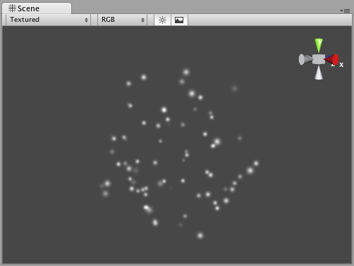
Min Emitter Range of 0 最小范围为0
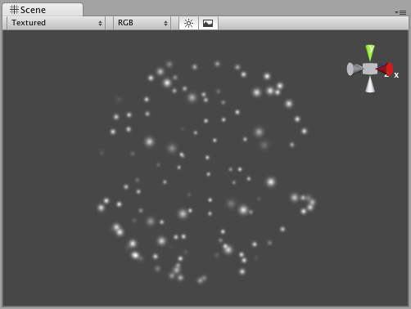
Min Emitter Range of 1最小范围为1

Hints 提示
- Be careful of using many large particles. This can seriously hinder performance on low-level machines. Always try to use the minimum number of particles to attain an effect.
- 小心使用多的大粒子。这可能会严重妨碍低级别机器的性能。 总是试着用最小粒子数目达到效果
- The Emit property works in conjunction with the AutoDestruct property of the Particle Animator. Through scripting, you can cease the emitter from emitting, and then AutoDestruct will automatically destroy the Particle System and the GameObject it is attached to.
- 发射属性总是与粒子动画的自动毁坏属性一起工作。通过脚本，你可以停止发射器发射，然后自动毁坏属性将自动销毁粒子系统和它所附加游戏对象。

Mesh Particle Emitter 网格粒子发射器
The Mesh Particle Emitter emits particles around a mesh. Particles are spawned from the surface of the mesh, which can be necessary when you want to make your particles interact in a complex way with objects.
网格粒子发射器发射网格状的粒子。当你想让你的粒子与物体一起相互影响时是必要的从网格的表面产生粒子。
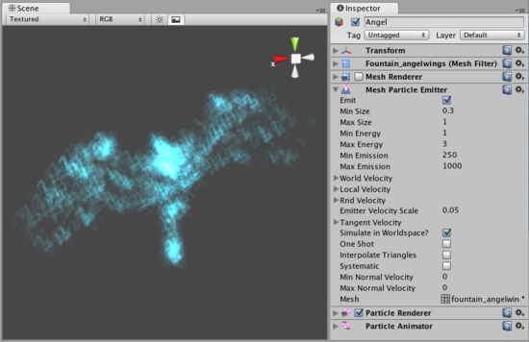
The Mesh Particle Emitter Inspector 网格粒子发射器检视面板

Properties 属性
Emit  发射 | If enabled, the emitter will emit particles.  若启用，发射器将发射粒子
Min Size  最小尺寸 | The minimum size each particle can be at the time when it is spawned.  每个粒子在产生时的最小尺寸
Max Size  最大尺寸 | The maximum size each particle can be at the time when it is spawned.  每个粒子在产生时的最大尺寸
Min Energy  最小能量 | The minimum lifetime of each particle, measured in seconds.  以每秒钟计，每个粒子最小生存周期
Max Energy  最大能量 | The maximum lifetime of each particle, measured in seconds.  以每秒钟计，每个粒子最大生存周期
Min Emission  最小发射 | The minimum number of particles that will be spawned every second.  每秒钟将产生粒子的最小数量
Max Emission  最大发射 | The maximum number of particles that will be spawned every second.  每秒钟将产生粒子的最大数量
World Velocity  全局速度 | The starting speed of particles in world space, along X, Y, and Z.  沿X,Y,Z轴在全局空间的开始速度
Local Velocity  局部速度 | The starting speed of particles along X, Y, and Z, measured in the object's orientation.  以物体的方向，沿X,Y,Z轴粒子的开始速度
Rnd Velocity  随即速度 | A random speed along X, Y, and Z that is added to the velocity.  沿X,Y,Z轴随即增加的速度
Emitter Velocity Scale  发射器速度伸缩 | The amount of the emitter's speed that the particles inherit.  从粒子继承的发射器的速度数量
Tangent Velocity  切线速度 | The starting speed of particles along X, Y, and Z, across the Emitter's surface.  交叉通过发射器的表面沿X,Y,Z轴的粒子开始速度
Simulate In World Space  空间模拟 | If enabled, the particles don't move when the emitter moves. If false, when you move the emitter, the particles follow it around.  若启用，当发射器移动，粒子不移动。若禁用，等发射器移动，粒子随着一起移动
One Shot  一次射击 | If enabled, the particle numbers specified by min & max emission is spawned all at once. If disabled, the particles are generated in a long stream.  若启用，根据最小与最大属性指定的粒子数量立即产生粒子。若禁用，则产生一个粒子流
Interpolate Triangles  插入三角形 | If enabled, particles are spawned all over the mesh's surface. If disabled, particles are only spawned from the mesh's vertrices.  若启用，粒子从网格表面的产生，若禁用，则只从网格的顶部产生
Systematic  系统性 | If enabled, particles are spawned in the order of the vertices defined in the mesh. Although you seldom have direct control over vertex order in meshes, most 3D modelling applications have a very systematic setup when using primitives. It is important that the mesh contains no faces in order for this to work.  若启用，粒子在网管的顶部定义顺序产生，尽管你很少直接在网格顶部控制，多数的3D模型程序在使用一个系统的建立元素。重要的是这些网格包括不表面的顺序工作
Min Normal Velocity  最小正常速度 | Minimum amount that particles are thrown away from the mesh.  粒子远离网格的最小数量
Max Normal Velocity  最大正常速度 | Maximum amount that particles are thrown away from the mesh.  粒子远离网格的最大数量

Details 详细说明
Mesh Particle Emitters (MPEs) are used when you want more precise control over the spawn position & directions than the simpler Ellipsoid Particle Emitter gives you. They can be used for making advanced effects.
当你想在更精确控制粒子产生位置与流向而简单的Ellipsoid Particle Emitte 不能提供时，使用网格粒子发射器（MPEs）。它们能够创造高级的效果。
MPEs work by emitting particles at the vertices of the attached mesh. Therefore, the areas of your mesh that are more dense with polygons will be more dense with particle emission.
MPEs发射粒子工作在所附网格的顶部。因此，你的网格区域是更密集的与多边的密集粒子发射区域。
Particle Emitters work in conjunction with Particle Animators and Particle Renderers to create, manipulate, and display Particle Systems. All three Components must be present on an object before the particles will behave correctly. When particles are being emitted, all different velocities are added together to create the final velocity.
粒子发射器与粒子动画、粒子渲染协同工作去创建、处理和显示粒子系统。在粒子正常运转前，三个组件必须一同存在于一个物体上。当粒子开始发射，所有不同的速度相加形成最终的速度。

Spawning Properties （与上面的含义相同）
Spawning properties like Size, Energy, Emission, and Velocity will give your particle system distinct personality when trying to achieve different effects. Having a small Size could simulate fireflies or stars in the sky. A large Size could simulate dust clouds in a musky old building.
Energy and Emission will control how long your particles remain onscreen and how many particles can appear at any one time. For example, a rocket might have high Emission to simulate density of smoke, and high Energy to simulate the slow dispersion of smoke into the air.
Velocity will control how your particles move. You might want to change your Velocity in scripting to achieve interesting effects, or if you want to simulate a constant effect like wind, set your X and Z Velocity to make your particles blow away.

Simulate in World Space （与上面的含义相同）
If this is disabled, the position of each individual particle will always translate relative to the Position of the emitter. When the emitter moves, the particles will move along with it. If you have Simulate in World Space enabled, particles will not be affected by the translation of the emitter. For example, if you have a fireball that is spurting flames that rise, the flames will be spawned and float up in space as the fireball gets further away. If Simulate in World Space is disabled, those same flames will move across the screen along with the fireball.

Emitter Velocity Scale （与上面的含义相同）
This property will only apply if Simulate in World Space is enabled.
If this property is set to 1, the particles will inherit the exact translation of the emitter at the time they are spawned. If it is set to 2, the particles will inherit double the emitter's translation when they are spawned. 3 is triple the translation, etc.

One Shot （与上面的含义相同）
One Shot emitters will create all particles within the Emission property all at once, and cease to emit particles over time. Here are some examples of different particle system uses with One Shot Enabled or Disabled:
Enabled:
- Explosion
- Water splash
- Magic spell
Disabled:
- Gun barrel smoke
- Wind effect
- Waterfall

Interpolate Triangles 插入三角形
Enabling your emitter to Interpolate Triangles will allow particles to be spawned between the mesh's vertices. This option is off by default, so particles will only be spawned at the vertices.
启动你的发射器的插入三角形将允许粒子在网格顶部产生。这个选项默认是关闭的。因此，粒子只在在顶部产生。
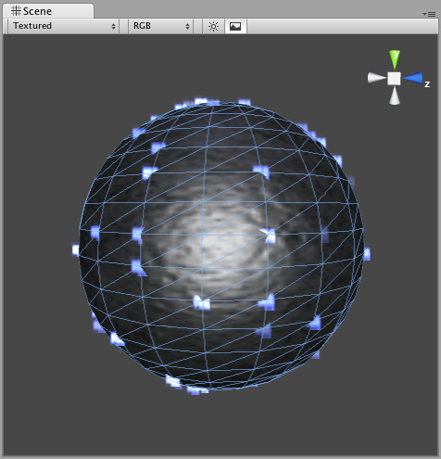
A sphere with Interpolate Triangles off (the default) 一个带插入三角形关闭的球体（默认）
Enabling this option will spawn particles on and in-between vertices, essentially all over the mesh's surface (seen below).
启动该选项，将在网格表面顶部产生粒子。（看下面）
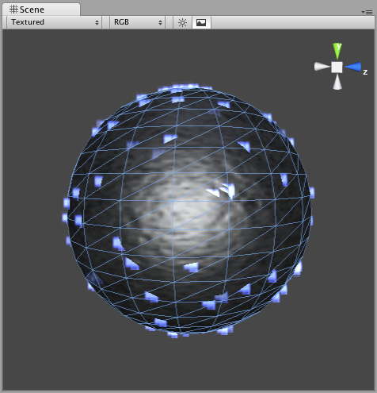
A sphere with Interpolate Triangles on 一个带打开插入三角形的球体
It bears repeating that even with Interpolate Triangles enabled, particles will still be denser in areas of your mesh that are more dense with polygons.
值得重申的是，即使插入三角形启动，粒子仍然在你的网格区域密集多边型。

Systematic
系统性
Enabling Systematic will cause your particles to be spawned in your mesh's vertex order. The vertex order is set by your 3D modeling application.
开启系统性，将导致你的粒子在你的网格顶点顺序产生。顶点顺序的设置有你的3D模型程序设置。
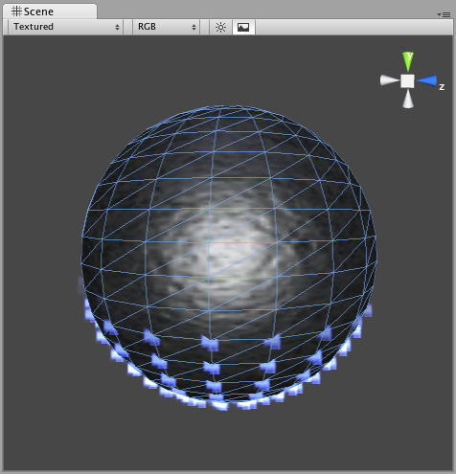
An MPE attached to a sphere with Systematic enabled 一个MPE附在一个开启系统性的球体上

Normal Velocity 正常速度
Normal Velocity controls the speed at which particles are emitted along the normal from where they are spawned.
正常速度控制哪个粒子从它们产生的地方沿正常发射速度来到。
For example, create a Mesh Particle System, use a cube mesh as the emitter, enable Interpolate Triangles, and set Normal Velocity Min and Max to 1. You will now see the particles emit from the faces of the cube in a straight line.
例如，建立一个网格粒子系统，使用一个立方体的网格作为发射器，启用插入三角形，设置正常最小速度与最大速度为1.你将看到粒子从立方体表面成一个直线发射。

See Also 参阅
- How to make a Mesh Particle Emitter
- 如何构造一个网格发射器

Hints （与上面相同）
- Be careful of using many large particles. This can seriously hinder performance on low-level machines. Always try to use the minimum number of particles to attain an effect.
- The Emit property works in conjunction with the AutoDestruct property of the Particle Animator. Through scripting, you can cease the emitter from emitting, and then AutoDestruct will automatically destroy the Particle System and the GameObject it is attached to.
- MPEs can also be used to make glow from a lot of lamps placed in a scene. Simply make a mesh with one vertex in the center of each lamp, and build an MPE from that with a halo material. Great for evil sci-fi worlds.

Particle Animator 粒子动画
Particle Animators move your particles over time, you use them to apply wind, drag & color cycling to your particle systems.
粒子动画随着时间移动你的粒子，你使用它们引用到风上，拖动你的颜色板到你的粒子系统。
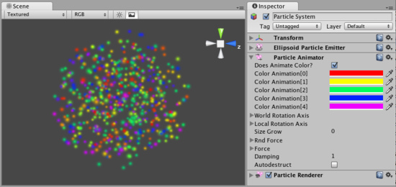
The Particle Animator Inspector 粒子动画检视面板

Properties 属性
Does Animate Color  做动画颜色 | If enabled, particles cycle their color over their lifetime.  若启用，粒子循环它们的颜色超过它们的生命周期
Color Animation  颜色动画 | The 5 colors particles go through. All particles cycle over this - if some have a shorter life span than others, they will animate faster.  5种颜色粒子通过。所有粒子循环- 若有一些粒子生命比其它的短，它们的动画更快。
World Rotation Axis  全局旋转轴 | An optional world-space axis the particles rotate around. Use this to make advanced spell effects or give caustic bubbles some life.  粒子围绕一个可选的全局空间轴旋转。使用这个可以制造高级的魅力效果或给予一个腐蚀性的生命气泡。
Local Rotation Axis  本地旋转轴 | An optional local-space axis the particles rotate around. Use this to make advanced spell effects or give caustic bubbles some life.  粒子围绕一个可选的本地空间轴旋转。使用这个可以制造高级的魅力效果或给予一个腐蚀性的生命气泡。
Size Grow  尺寸增长 | Use this to make particles grow in size over their lifetime. As randomized forces will spread your particles out, it is often nice to make them grow in size so they don't fall apart. Use this to make smoke rise upwards, to simulate wind, etc.  使用这个制造粒子增长大小超过它们的生命周期。作为随即力量将向外伸展你的粒子，通常使它们很好的增长尺寸不至于使它们下落崩溃。应用这个处理烟幕的上升，模拟风 等等。
Rnd Force  随即强制 | A random force added to particles every frame. Use this to make smoke become more alive.  一个随即强制增加粒子每个帧。使用它处理烟雾更生动。
Force  强制 | The force being applied every frame to the particles, measure relative to the world.  相对于全局的数量，强制对粒子每帧起作用
Damping  衰减 | How much particles are slowed every frame. A value of 1 gives no damping, while less makes them slow down.  许多的粒子每帧变慢。在它们放慢过程中衰减值没有设为1
Auto destruct  自动销毁 | If enabled, the GameObject attached to the Particle Animator will be destroyed when all particles disappear.  若启动，当所有的粒子消失时附加在动画粒子的游戏物体将销毁

Details 详细信息
Particle Animators allow your particle systems to be dynamic. They allow you to change the color of your particles, apply forces and rotation, and choose to destroy them when they are finished emitting. For more information about Particle Systems, reference Mesh Particle Emitters, Ellipsoid Particle Emitters, and Particle Renderers.
粒子动画允许你的粒子系统是动态的。它们允许你更改你的粒子的颜色，应用强制和旋转，和选择当它们发射完毕销毁它们。更多的关于粒子系统的信息，参见 网格粒子发射器，椭球粒子发射器和 粒子渲染。

Animating Color 动画颜色
If you would like your particles to change colors or fade in/out, enable them to Animate Color and specify the colors for the cycle. Any particle system that animates color will cycle through the 5 colors you choose. The speed at which they cycle will be determined by the Emitter's Energy value.
若你希望你的粒子更改颜色或渐显/淡出，启用它们的Animate Color 并指定颜色的循环周期。任何的粒子系统使用你所选择的5种颜色进行动画颜色的循环。它们的循环速度由发射器的Energy值决定。
If you want your particles to fade in rather than instantly appear, set your first or last color to have a low Alpha value.
若你想你的粒子渐显而不理解显示，设置你的第一或最后一个颜色为Alpha值
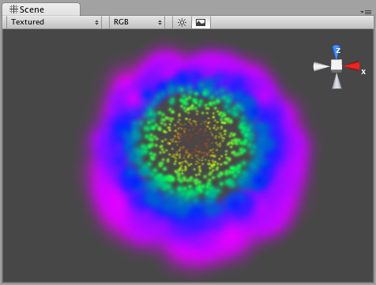
An Animating Color Particle System 一个动画颜色粒子系统

Rotation Axes 旋转轴（坐标）
Setting values in either the Local or World Rotation Axes will cause all spawned particles to rotate around the indicated axis (with the Transform's position as the center). The greater the value is entered on one of these axes, the faster the rotation will be.
无论设置本地或全局旋转坐标将导致所有产生粒子围绕坐标旋转（以Transform的中心坐标）值越大进入这些坐标的粒子旋转越快。
Setting values in the Local Axes will cause the rotating particles to adjust their rotation as the Transform's rotation changes, to match its local axes.
设置本地值将导致旋转粒子以Transform的旋转改变排列一适应本地的坐标。
Setting values in the World Axes will cause the particles' rotation to be consistent, regardless of the Transform's rotation.
设置全局值将导致粒子的旋转的一致，不管以Transform的旋转。

Forces & Damping 强制与衰减
You use force to make particles accelerate in the direction specified by the force.
你使用强制去处理粒子加速由强制指定的方向。
Damping can be used to decelerate or accelerate without changing their direction:
衰减用于处理加速或减速而不改变它们的方向
- A value of 1 means no Damping is applied, the particles will not slow down or accelerate.
- 值为1表示无衰减使用，这些粒子将不会减慢或加速
- A value of 0 means particles will stop immediately.
- 设为0表示粒子将立即停止
- A value of 2 means particles will double their speed every second.
- 设为2表示粒子将在每秒钟获得两倍的速度

Destroying GameObjects attached to Particles
销毁附加粒子的游戏物体
You can destroy the Particle System and any attached GameObject by enabling the AutoDestruct property. For example, if you have an oil drum, you can attach a Particle System that has Emit disabled and AutoDestruct enabled. On collision, you enable the Particle Emitter. The explosion will occur and after it is over, the Particle System and the oil drum will be destroyed and removed from the scene.
你可以销毁通过启用AutoDestruct属性的粒子系统和任何附加的游戏物体。例如，若你有一个油桶，你可以附加一个发射禁止和自动销毁启用的粒子系统。在碰撞时，你启动粒子发射器。当爆炸发生结束后，粒子系统和油桶将销毁并从场景中移除。
。Note that automatic destruction takes effect only after some particles have been emitted. The precise rules for when the object is destroyed when AutoDestruct is on:
注意当一些粒子发射后自动销毁的效果就生效。这个精确规则为：当AutoDestruct 开启，物体就销毁
If there have been some particles emitted already, but all of them are dead now, or
If the emitter did have Emit on at some point, but now Emit is off.
如有一些粒子已经发射，但它们现在都死了或这个发射器在一些其它位置在发射，就关闭现在的发射。

Hints 提示
- Use the Color Animation to make your particles fade in & out over their lifetime - otherwise, you will get nasty-looking pops.
- 使用颜色动画让你的粒子进行渐显和对它们的生命周期处理，否则，你将持久性的污染投影
- Use the Rotation Axes to make whirlpool-like swirly motions.
- 使用旋转坐标去处理旋窝般的动作。

Particle Collider 粒子碰撞
The World Particle Collider is used to collide particles against other Colliders in the scene.
全局粒子碰撞通常用于在场景中与其它粒子碰撞。
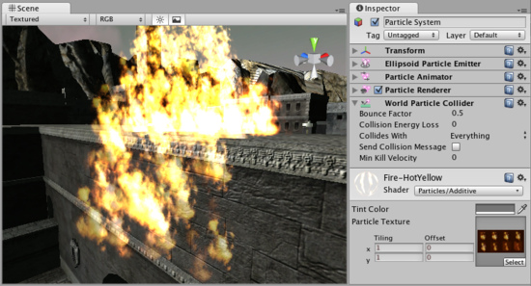
A Particle System colliding with a Mesh Collider 一个粒子系统碰撞的网格碰撞

Properties 属性
Bounce Factor  弹跳因子 | Particles can be accelerated or slowed down when they collide against other objects. This factor is similar to the Particle Animator's Damping property.  当它们与其它物体碰撞时，这些粒子可以加速或放慢速度。这一因素与 Particle Animator's Damping 属性相似
Collision Energy Loss  碰撞能量损失 | Amount of energy (in seconds) a particle should lose when colliding. If the energy goes below 0, the particle is killed.  当碰撞是，这些碰撞的粒子应失去能量（以秒计），若能力低于0的粒子就被杀死
Min Kill Velocity  最小杀死速度 | If a particle's Velocity drops below Min Kill Velocity because of a collision, it will be eliminated.  若一个粒子的速度减低到最小杀死速度，因碰撞的原因，它将被淘汰
Collides with  与碰撞 | Which Layers the particle will collide against.  每个阶层的俩字会相互碰撞
Send Collision Message  发送碰撞消息 | If enabled, every particle sends out a collision message that you can catch through scripting.  若启用，每个粒子向外发送一个碰撞消息，你可以通过脚本抓取

Details 详细资料
To create a Particle System with Particle Collider:
建立一个粒子碰撞系统：
- Create a Particle System using GameObject->Create Other->Particle System
建立一个粒子系统，使用菜单 游戏物体—>建立其它 —>粒子系统
- Add the Particle Collider using Component->Particles->World Particle Collider
添加碰撞粒子，使用菜单 组件—>粒子 —>全局粒子碰撞

Messaging 消息
If Send Collision Message is enabled, any particles that are in a collision will send the message OnParticleCollision() to both the particle's GameObject and the GameObject the particle collided with.
若发送碰撞消息以启用，任何粒子碰撞都将发送消息，OnParticleCollision() 无论对于粒子的游戏物体还是游戏物体粒子碰撞。

Hints 提示
Send Collision Message can be used to simulate bullets and apply damage on impact.
- 发送碰撞消息可以使用模拟子弹和应用损坏击打
- Particle Collision Detection is slow when used with a lot of particles. Use Particle Collision Detection wisely.
- 当使用大量的粒子粒子碰撞检测变慢。使用单个粒子碰撞检测明智
- Message sending introduces a large overhead and shouldn't be used for normal Particle Systems.
- 消息发送是一个大的开销，使用应不影响正常粒子系统

Particle Renderer 粒子渲染
The Particle Renderer renders the Particle System on screen.
粒子渲染渲染粒子系统屏幕显示
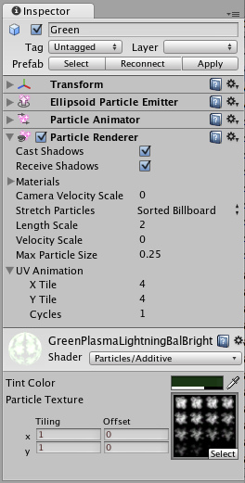
The Particle Renderer Inspector 粒子渲染检视面板

Properties 属性
Materials  材料 | Reference to a list of Materials that will be displayed in the position of each individual particle.  参考材料列表，每一个粒子的位置将显示
Camera Velocity Scale  摄像机速度伸展 | The amount of stretching that is applied to the Particles based on Camera movement.  在摄像机移动基础上应用于粒子的伸展数量
Stretch Particles  伸展粒子 | Determines how the particles are rendered.  确定如何渲染粒子
Billboard  揭示栏 | The particles are rendered as if facing the camera.  面对摄像机粒子渲染
Stretched  伸展 | The particles are facing the direction they are moving.  面对方向移动粒子渲染
Sorted Billboard  排序揭示栏 | The particles are sorted by depth. Use this when using a blending material.  粒子深度排序。当使用混合材料时使用它
Vertical Billboard  垂直揭示栏 | All particles are aligned flat along the X/Z axes.  所有粒子以X/Z轴平面排列
Horizontal Billboard  垂直揭示栏 | All particles are aligned flat along the X/Y axes.  所有粒子以X/Y轴平面排列
Length Scale  长度拉伸 | If Stretch Particles is set to Stretched, this value determines how long the particles are in their direction of motion.  若粒子拉伸设置为拉伸，则个值确定粒子在此方向上多长
Velocity Scale  速度拉伸 | If Stretch Particles is set to Stretched, this value determines the rate at which particles will be stretched, based on their movement speed.  若粒子拉伸设置为拉伸，该值确定在粒子拉伸速度，以它们移动速度为基础
UV Animation  紫外线动画 | If either of these are set, the UV coordinates of the particles will be generated for use with a tile animated texture. See the section on Animated Textures below.  如任一的或这些设置，紫外线与之相配的粒子将使用与动画材质一致并列产生。见下一结动画材质
X Tile  X 排列 | Number of frames located across the X axis.  通过X轴定位帧的数量
Y Tile  Y 排列 | Number of frames located across the Y axis.  通过Y轴定位帧的数量
Cycles  循环 | How many times to loop the animation sequence.  多次循环动画序列

Details 详细信息
Particle Renderers are required for any Particle Systems to be displayed on the screen.
粒子渲染所需要任何粒子系统将展现在屏幕上
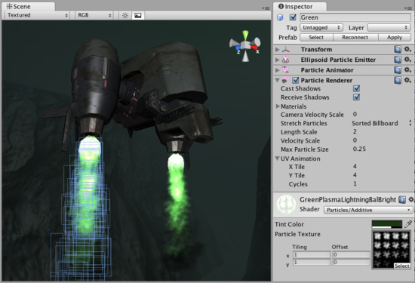
A Particle Renderer makes the Gunship's engine exhaust appear on the screen
粒子渲染使得炮艇的发动机排气出现在屏幕上

Choosing a Material 选择材料
When setting up a Particle Renderer it is very important to use an appropriate material and shader. Most of the time you want to use a Material with one of the built-in Particle Shaders. There are some premade materials in the Standard Assets->Particles->Sources folder.
当建立一个粒子渲染器非常重要的是使用适当的材料与着色。多数的时候，你想使用一个内置的材料对粒子着色。它们在Standard Assets->Particles->Sources文件夹中
Creating a new material is easy:
建立一个新的材料非常简单：
- Select Assets->Create Other->Material from the menu bar.
- 从菜单中选择 Assets->Create Other->Materia
- The Material has a shader popup, choose one of the shaders in the Particles group. Eg. Particles->Multiply.
- 材料着色弹出，在粒子群中选择一个着色，然后使用 Particles->Multiply.
- Now assign a Texture. The different shaders use the alpha channel of the textures slightly differently, but most of the time a value of black will make it invisible and white in the alpha channel will display it on screen.
- 现在分配一个纹理。同的着色器使用alpha通道的纹理略有不同，但大部分时间是将不可见的黑色和白色的alpha通道作将显示在屏幕上的值。

Distorting particles 扭曲粒子
By default particles are rendered billboarded. That is simple square sprites. This is good for smoke and explosions and most other particle effects.
默认情况下，粒子billboarded用渲染，这是简单的平方单色画面。对烟雾和爆炸以及其它粒子是好的效果。
Particles can be made to either stretch with the velocity. This is useful for sparks, lightning or laser beams. Length Scale and Velocity Scale affects how long the stretched particle will be.
粒子可以与速度一起拉伸。通常用于火花、闪电或激光束。长度和速度拉伸影响粒子延伸的长度。
Sorted Billboard can be used to make all particles sort by depth. Sometimes this is necessary, mostly when using Alpha Blended particle shaders. This can be expensive and should only be used if it really makes a quality difference when rendering.
排序揭示栏可以用于所有粒子深度排序。有时这是必须的。主要当使用Alpha Blended混合粒子着色。这可能是昂贵的，当真的作出质量方面的差别时渲染使用。

Animated textures 动画纹理
Particle Systems can be rendered with an animated tile texture. To use this feature, make the texture out of a grid of images. As the particles go through their life cycle, they will cycle through the images. This is good for adding more life to your particles, or making small rotating debris pieces.
粒子系统可以与动画材质一起渲染。使用此功能，使用网格图像纹理处理。作为通过粒子生命周期循环，它们将通过图片循环。这是一个好的增加你的粒子生命，或处理小的部分残骸的旋转。

Hints 提示
- Use Particle Shaders with the Particle Renderer.
使用粒子着色与粒子渲染

