Unity Manual —> User Guide—> Building Scenes —> Terrains
Unity手册—>用户指南—>建立场景—>地形

Terrain Engine Guide 地形引擎指南
This section will explain how to use the Terrain Engine. It will cover creation, technical details, and other considerations. It is broken into the following sections:
本节将讲述如何使用地形引擎。这将包括创建，技术细节，和其他因素。 它分为以下部分：

（1）Using Terrains 使用地形
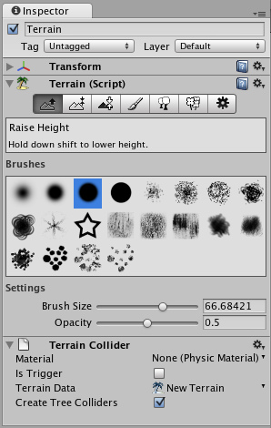
This section covers the most basic information about using Terrains. This includes creating Terrains and how to use the new Terrain tools & brushes.
本节包括有关使用地形最基本的资料。这包括建立地形，以及如何使用新的地形工具和刷子。

（2）Height 高度
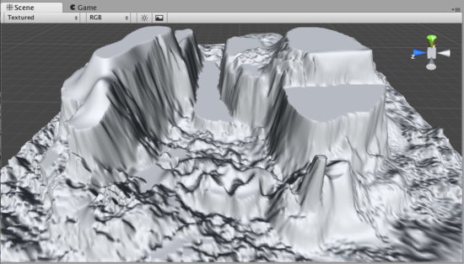
This section explains how to use the different tools and brushes that alter the Height of the Terrain.
本节讲解如何使用不同的工具和笔刷，改变地形高度。

（3）Terrain Textures 地形纹理
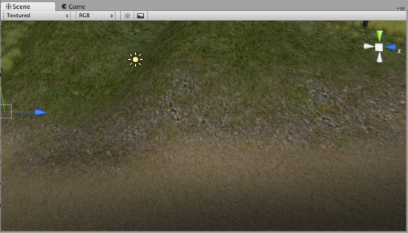
This section explains how to add, paint and blend Terrain Textures using different brushes.
本节讲解如何添加、描绘和地形纹理混合使用不同的刷子

（4）Trees 树
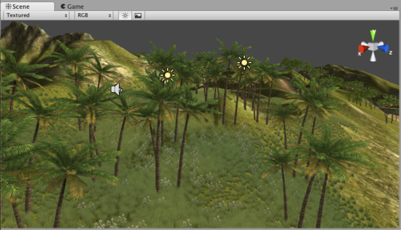
This section contains important information for creating your own tree assets. It also covers adding and painting trees on your Terrain.
本节包含用于创建你自己树资产的重要信息。它包括增加和绘画树木在你的地形上。

（5）Grass 草
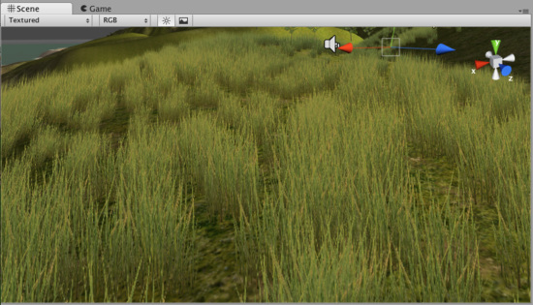
This section explains how grass works, and how to use it.
本节讲解草如何工作，以及如何使用它。

（6）Detail Meshes元件网格
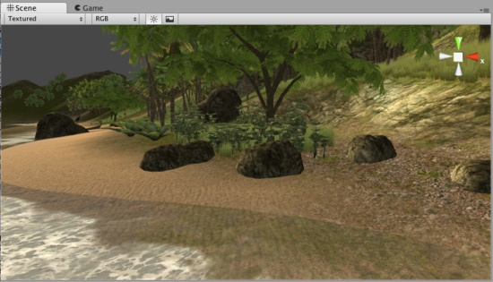
This section explains practical usage for detail meshes like rocks, haystacks, vegetation, etc.
本节讲解元件网格的实际应用，像岩石、草堆、植被等等。

（7）Lightmaps光照映射
（解释：光照映射(lightmaps)把预先计算好的纹理混合在基本纹理上方，用于模拟真实的光影效果，在目前的3D游戏中对画质影响非常大。）
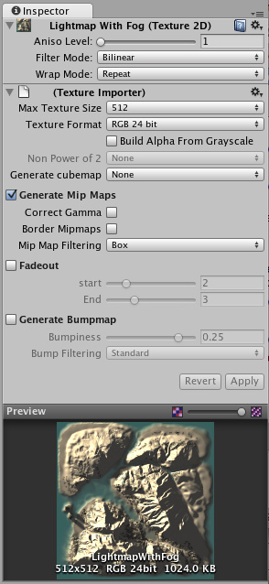
This section explains the advantages of using Lightmaps, how to create them, and technical information.
本节讲解使用光照映射的优势，如何建立它们以及它们的技术信息

（8）Other Settings 其它设置
This section covers all the other settings associated with Terrains.
本节涵盖了所有与地形有关的其他设置。

1）Using Terrains 使用地形
Reference Manual > Terrain Engine Guide > Using Terrains
参考手册—>地形引擎指南—>使用地形

Creating a new Terrain 建立一个新的地形
A new Terrain can be created from Terrain->Create Terrain. This will add a Terrain to your Project and Hierarchy Views.
从菜单 Terrain->Create Terrain 建立一个新的地形。这将添加一个地形到你的项目中以及在层次面板中显示。
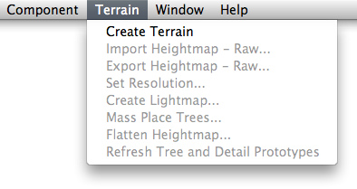
Your new Terrain will look like this in the Scene View:
你的新地形在场景中看起来向这个样子：
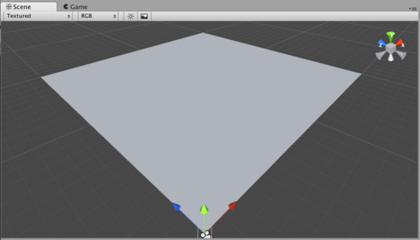
A new Terrain in Scene View 一个新地形在场景视图中。
If you would like a differently sized Terrain, choose Terrain->Set Resolution from the menu bar. There are a number of settings that related to Terrain size which you can change from this dialog.
如果你项一个大小不同的地形，从菜单栏选择Terrain->Set Resolution。在该对话框中，有很多有关地形大小的设置，在此可以设置地形的数据。

Navigating the Terrain 地形导航（定位地形）
Terrains work a bit differently than other GameObjects. Most notably, there is no Transform Gizmo that allows you to position the Terrain. Instead, you use Brushes to paint and manipulate your Terrain. If you do want to reposition a Terrain, you can modify its Transform Position values in the Inspector. This allows you to move your Terrain around, but you cannot rotate or scale it.
地形操作与其它游戏物体有一个不同点。特别显著的是它没有变换的辅助工具（Gizmo）允许你定位地形。相反，你使用画刷去画和操作你的地形。如果你想重新定位你的地形，你可以在检视面板（Inspector）修改它的 Transform Position 值。这允许你移动你的地形，但你不能旋转或缩放它。
While your Terrain is selected in the Hierarchy, you can gracefully navigate the terrain with the F (focus) key. When you press F, wherever your mouse is positioned will be moved to the center of the Scene View. This allows you to touch up an area, and quickly zoom over to a different area and change something else. If your mouse is not hovering over an area of the Terrain when you press the F key, the entire Terrain will be centered in your Scene View.
当你在层次面板（Hierarchy）中选择你的地形，你可以使用F键导航（定位）你的地形。当你按F键，无论你的鼠标位置在何处，它将移动到场景的中心。（提示，前提是你的鼠标在场景视图中）。这允许你到一个区域，并快速变焦到不同区域以及改变一些其它的东西。若你的鼠标位置没有停在地形中一个区域上面，当你按F键时，整个地形将显示在场景视图的中心。（提示，当地形有多个区域时，按F键可以测试一下结果）

Editing the Terrain 编辑地形
With the Terrain selected, you can look at the Inspector to see some incredible new Terrain editing tools.
选择地形，你可以在检视面板看到一些难以置信新的地形编辑工具。（这句话好像是对老的Unity用户说的）
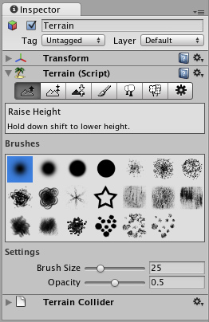
Terrain Editing Tools appear in the Inspector 地形编辑工具显示在检视面板中。
Each rectangular button is a different Terrain tool. There are tools to change the height, paint splat maps, or attach details like trees or rocks. To use a specific tool, click on it. You will then see a short description of the tool appear in text below the tool buttons.
每一个长方形按钮就是一个不同的地形工具。有些工具是改变高度、画长条木板地图，或则是类似对树、岩石附加细节工具。使用此特定工具，就点击它。你将看到这个工具一个小的描述文本显示在该功能工具按钮的下面。
Most of the tools make use of a brush. Many different brushes are displayed for any tool that uses a brush. To select a brush, just click on it.
大多数的工具利用一个刷子。多数不同的刷子显示为任何工具使用一个刷子。选择一个刷子，只要点击一下它。（这句话的意识是使用一把刷子，根据选择不同类型变成不同的刷子使用）
You will use all of these brushes in the Scene View to paint directly onto your Terrain. Simply choose the tool and brush you want, then click & drag on the Terrain to alter it in real-time. To paint height, textures, or decorations, you must have the Terrain selected in the Hierarchy View.
你将使用所有的这些刷子在Scene View（场景视图）中直接画你的地形。简单的选择你想还要的工具和刷子，然后在地形上点击和拖拽就能实时改变。你必须在层次视图Hierarchy View中选择地形，去画高、纹理或修饰。
Note: When you have a brush selected, move your mouse over the Terrain in the Scene View and press F. This will center the Scene View over the mouse pointer position and automatically zoom in to the Brush Size distance. This is the quickest & easiest way to navigate around your Terrain while creating it.
注意：当你有一个选择的刷子，在场景的地形上移动你的鼠标和按F键，这将把鼠标指针位置显示在场景中心和自动放大画刷大小距离。在创建地形时，这是最快与最简单的方法去浏览你的地形。

2）Height 高度
Reference Manual > Terrain Engine Guide > Height
参考手册—>地形引擎指南—>高度
Using any of the Terrain editing tools is very simple. You will literally paint the Terrain from within the Scene View. For the height tools and all others, you just have to select the tool, and click the Terrain in Scene View to manipulate it in real-time.
使用任何地形编辑工具是非常简单的。从场景视图内部你将照字面意义画地形。对于高度工具和其它的工具，你只要选择工具，然后在场景视图中的地形里点击就可以实时操作生成。

Raising & Lowering Height 升高和降低高度
The first tool on the left is the Raise Height tool .
左边第一个工具是提高高度工具。
With this tool, you paint brush strokes that will raise the height of the Terrain. Clicking the mouse once will increment the height. Keeping the mouse button depressed and moving the mouse will continually raise the height until the maximum height is reached.
用这个工具，你的笔触将提高地形的高度。点击鼠标一次将增高高度。保持按住鼠标左键，移动鼠标将不断提高高度，直到达到最大高度。
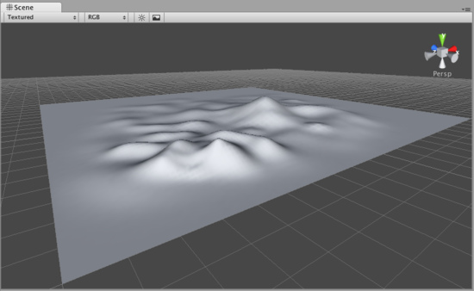
You can use any of the brushes to achieve different results 你可以使用任何刷子取得不同的结果。
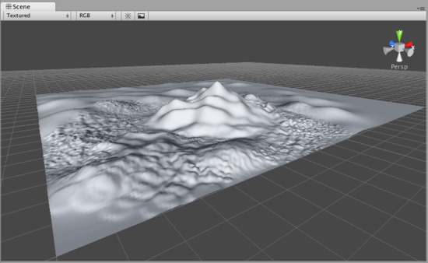
If you want to lower the height when you click, hold the Shift key. 如果你想降低高度，按住Shift键点击。
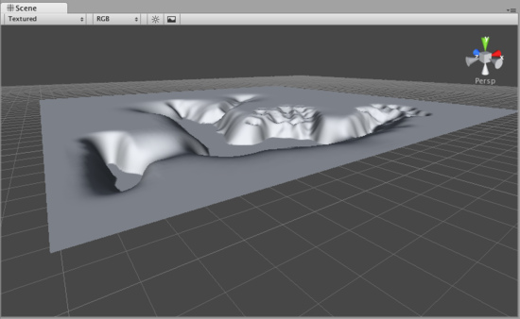
Note:When you have a brush selected, move your mouse over the Terrain in the Scene View and press F. This will center the Scene View over the mouse pointer position and automatically zoom in to the Brush Size distance. This is the quickest & easiest way to navigate around your Terrain while creating it.
注意：当你有一个选择的刷子，在场景视图的地形上移动你的鼠标并按F键。This will center the Scene View over the mouse pointer position and automatically zoom in to the distance.这将把鼠标指针的位置移动到场景中心显示，并自动放大的画笔大小的距离。 在创建地形时，This is the quickest & easiest way to navigate around your Terrain while creating it.这是最快和最简单的方法来浏览你的地形。

Paint Height 画高度
The second tool from the left is the Paint Height tool .
左边第二个工具是画高工具。
This tool allows you to specify a target height, and move any part of the terrain toward that height. Once the terrain reaches the target height, it will stop moving and rest at that height.
这个工具允许你指定目标高度，地形的任何一部分向这个高度移动。一旦这个地形达到目标高度，它将停止移动并在停那个高度。
To specify the target height, hold Shift and click on the terrain at the height you desire. You can also manually adjust the Height slider in the Inspector.
指定目标高度，按住Shift键，然后在地形上点击你希望高度的地方。在检视面板中你也可以手工调整高度滑块。
Now you've specified the target height, and any clicks you make on the terrain will move the terrain up or down to reach that height.
现在，你已经指定了目标高度，然后在地形上任意点击将移动地形上涨或下跌达到那个指定的高度。
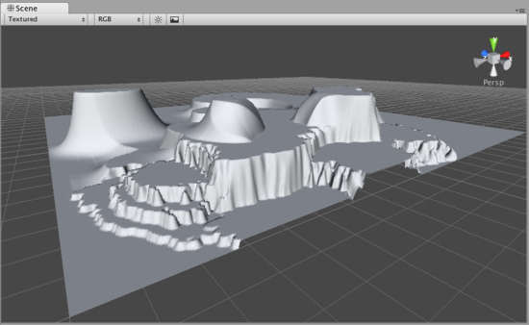

Smoothing Height 平滑高度
The third tool from the left is the Smoothing Height tool .
左边第三个工具是平滑高度工具。
This tool allows you to soften any height differences within the area you're painting. Like the other brushes, paint the areas you want to smooth in the Scene View.
这个工具允许你在你画的区域内软化任意高度差。像其它画刷，在场景视图中画你想平滑的区域。
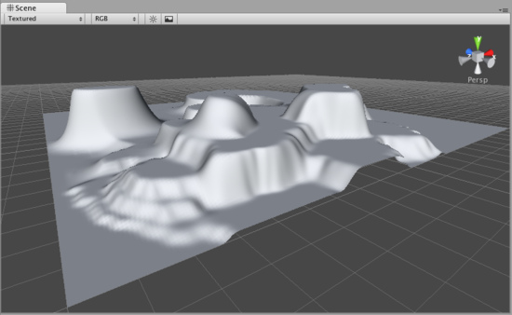

Working with Heightmaps 与高度图合作
If you like, you can import a greyscale Heightmap created in Photoshop, or from real-world geography data and apply it to your Terrain. To do this, choose Terrain->Import Heightmap - Raw..., then select the desired RAW file. You'll then see some import settings. These will be set for you, but you have the option of changing the size of your Terrain from this dialog if you like. When you're ready, click the Import button. Once the Heightmap has been applied to the Terrain, you can edit it normally with all the Tools described above. Note that the Unity Heightmap importer can only import grayscale raw files. Thus you can't create a raw heightmap using RGB channels, you must use grayscale.
如果你愿意，你可以导入在Photoshop中建立的灰度高度图，或从真实世界地理数据应用到你的地形。要做到这一点，选择 Terrain->Import Heightmap - Raw...（地形>“导入高度图-原始...），然后选择所需的RAW文件。 You'll then see some import settings.然后，你将会看到一些导入设置。 These will be set for you, but you have the option of changing the size of your Terrain from this dialog if you like.这些将为你设置，但是你必须从这个对话框改变选项至你喜欢的地形的大小。 When you're ready, click the button.当你准备好，点击Import（导入）按钮。 Once the Heightmap has been applied to the Terrain, you can edit it normally with all the Tools described above. Note that the Unity Heightmap importer can only import grayscale raw files.一旦高度图已应用于地形，你可以使用上面描述的所有功能工具正常的编辑它。注意，Unity引入的高度图只能引入灰度原始文件。 Thus you can't create a raw heightmap using RGB channels, you must use grayscale.因此，你不能创建一个使用RGB通道的原始高度图，你必须使用灰度。
Unity works with RAW files which make use of full 16-bit resolution. Any other heightmap editing application like Bryce, Terragen, or Photoshop can work with a Unity Heightmap at full resolution.
Unity与RAW文件一起利用完整的16位分辨率的使用。 任何其它的Any other heightmap editing application like Bryce, Terragen, or Photoshop can work with a Unity Heightmap at full resolution.高度图编辑程序如Bryce，Terragen，或Photoshop都可以与Unity的高度图的全分辨率一起使用。
You also have the option of exporting your Heightmap to RAW format. Choose Terrain-> Export Heightmap - Raw... and you'll see a export settings dialog. Make any changes you like, and click Export to save your new Heightmap.
你同样有个选项把你的高度图导出到RAW格式。Choose and you'll see a export settings dialog.选择 Terrain-> Export Heightmap - Raw...（地形>“导出高度图-原始...），你会看到一个导出设置对话框。 Make any changes you like, and click to save your new Heightmap.做你喜欢的任意更改，然后点击导出按钮，保存你的新高度图。
Unity also provides an easy way to flatten your terrain. Choose Terrain->Flatten.... This lets you flatten your terrain to a height you specify in the wizard.
Unity还提供了一个简单的方法来平坦你的地形。 选择Terrain->Flatten...（地形-> 平坦...）。 这使你平坦你的地形到你在向导中指定的高度。

3）Textures 纹理
Reference Manual > Terrain Engine Guide > Textures
参考手册—>地形引擎指南—>纹理
Decorate the landscape of your terrain by tiling Terrain Textures across the entire terrain. You can blend and combine Terrain Textures to make smooth transitions from one map to another, or to keep the surroundings varied.
在整个地形上平铺Terrain Textures（地形纹理）来美化你的地形。你可以混合并结合地形纹理去平滑变化从一个映射到另一个映射，或保持各种各样的环境。
Terrain Textures are also called splat maps. What this means is you can define several repeating high resolution textures and blend between them arbitrarily, using alpha maps which you paint directly onto the Terrain. Because the textures are not large compared to the size of the terrain, the distribution size of the Textures is very small.
地形纹理也称为长条木板地图。 这意味着你可以定义多个重复的高分辨率纹理和它们之间的任意混合，使用alpha（阿尔法）地图直接在你的地形上画图。 由于纹理与地形的大小相比不大，分布的纹理尺寸非常小。
Note: Using an amount of textures in a multiple of four provides the greatest benefit for performance and storage of the Terrain alpha maps.
注意：最好的有益处理和存储地阿尔法地图地形是使用四个提供在一个管道多数量的纹理。
To being working with textures, click on the Paint Textures button in the Inspector.
处理纹理，在检视面板中点击Paint Textures（绘制纹理）按钮。

Adding a Terrain Texture 添加一个地形纹理
Before you can begin painting Terrain Textures, you will add at least one to the Terrain from your Project folder. Click the Options Button->Add Texture....
在你开始绘制地形纹理之前，你至少应添加加一个地形从你的项目文件夹中。点击 Options Button->Add Texture....（选项按钮->添加纹理...）
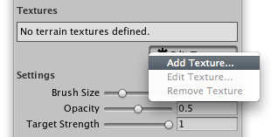
This will bring up the Add Terrain Texture dialog. 这将弹出一个添加纹理的对话框
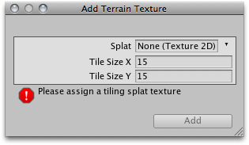
The Add Terrain Texture dialog 添加地形纹理对话框
From here, select a tileable texture in the Splat property. You can either drag a texture to the property from the Project View, or choose one from the drop-down.
从这里，在长条木板属性中选择一个平铺的纹理，你也可以从项目面板视图中拖拽一个纹理到该属性中，或从下来单中选择一个。
Now, set the Tile Size X and Tile Size Y properties. The larger the number, the larger each "tile" of the texture will be scaled. Textures with large Tile Sizes will be repeated fewer times across the entire Terrain. Smaller numbers will repeat the texture more often with smaller tiles.
现在，设置平铺X和平铺Y的属性。数字越大，每个平铺的纹理就对应的按比例放大。大的平铺尺寸的纹理将在整个地形中重复少的次数。通常少数的平铺尺寸小的纹理将重复纹理多次。
Click the Add Button and you'll see your first Terrain Texture tile across the entire Terrain.
点击 增加 按钮，你将看到第一个地形纹理平铺到整个地形。
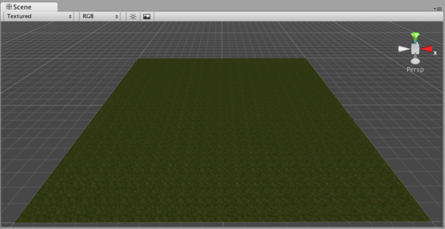
Repeat this process for as many Terrain Textures as you like. 多地形纹理的重复处理直到你满意为止。

Painting Terrain Textures 绘制地形纹理
Once you've added at least two Terrain Textures, you can blend them together in various ways. This part gets really fun, so let's jump right to the good stuff.
一旦你至少增加了两个地形纹理，你可以以不同的方式把它们混合在一起。这部分很有趣，让我们马上进入主题。
Select the Terrain Texture you want to use. The currently selected Terrain Texture will be highlighted in blue.
选择你想用的地形纹理。当前选择的地形纹理将以蓝框线高亮显示。
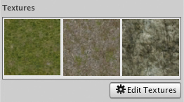
Select the Brush you want to use. The currently selected Brush will be highlighted in blue.
选择你想用的画刷。当前选择的画刷将以蓝框线高亮显示。
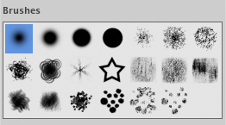
Select the Brush Size, Opacity, and Target Strength.
选择画刷的大小，不透明度，和目标强度
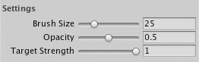
Click and drag on the terrain to draw the Terrain Texture.
在地形上点击和拖动去绘制地形纹理
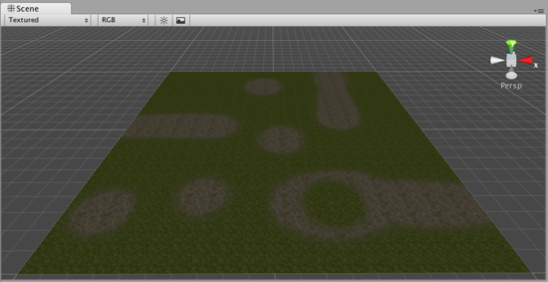
Use a variety of Textures, Brushes, Sizes, and Opacities to create a great variety of blended styles.
使用多种的纹理，画刷，大小和不透明度去建立一个多种有趣的混合风格。
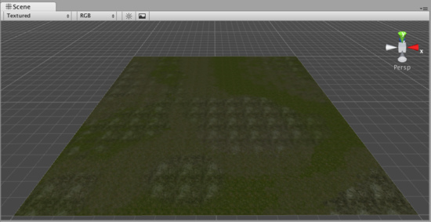
Note:When you have a brush selected, move your mouse over the Terrain in the Scene View and press F. This will center the Scene View over the mouse pointer position and automatically zoom in to the Brush Size distance. This is the quickest & easiest way to navigate around your Terrain while creating it.
注意：当你有一个选择的画刷，在场景视图中的地形上移动你的鼠标并按F键。这将把鼠标指针的位置移动到场景中心显示，并自动放大的画刷大小的距离。 在创建地形时，这是最快和最简单的方法来浏览你的地形。

4）Trees 树
Reference Manual > Terrain Engine Guide > Trees
参考手册—>地形引擎指南—>树
Unity's Terrain Engine has special support for Trees. You can put thousands of trees onto a Terrain, and render them in-game with a practical frame rate. This works by rendering trees near the camera in full 3D, and transitioning far-away trees to 2D billboards. Billboards in the distance will automatically update to orient themselves correctly as they are viewed from different angles. This transition system makes a detailed tree environment very simple for performance. You have complete control over tweaking the parameters of the mesh-to-billboard transition so you can get the best performance you need.
Unity的地形引擎有特别为树的支持。You can put thousands of trees onto a Terrain, and render them in-game with a practical frame rate.你可以在一个地形上放置数千棵树，并用一个实际的帧速渲染它们。在一个全3D的摄像机附近进行树的重绘工作，并且把远的树变换成2D揭示牌。在远处的揭示牌它们自己将自动更正到恰当的方向以符合它们从不同的角度展示。这个变换系统处理一个元件树环境是非常简单特性。 你可以完全控制网格的参数到揭示牌的转换，以便你达到你需要的最佳性能。
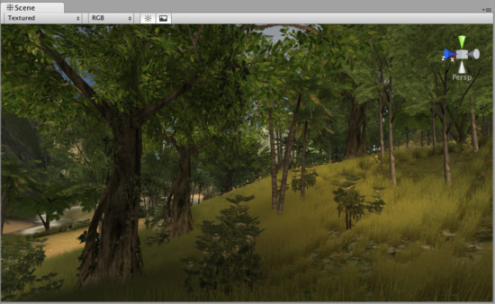
You can easily paint lots of trees for beautiful environments like this 你可以轻松的绘制出像这个美丽的多树环境。

Adding Trees 添加树
Select the Place Trees button in the Inspector.
在检视面板选择Place Trees（种树）按钮
Before you can place trees on your terrain, you have to add them to the library of available trees. To do this, click the Edit Trees button->Add Tree. You'll see the Add Tree dialog appear.
在你的地形上种树之前，你必须添加它们到可以使用的树木库。为此，点击 Edit Trees button->Add Tree（编辑树木按钮->添加树）。你将看到添加树木的对话框显示。
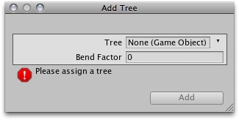
The Add Tree dialog 添加树木对话框
Select the tree from your Project View and drag it to the Tree variable. You can also edit the Bend Factor if you want to add an additional bit of animated "bending in the wind" effect to the trees. When you're ready, click Add. The tree will now appear selected in the Inspector.
从你的项目面板视图中选择树木，然后拖拽它到这个树变量。如果你想增加额外的“风中的弯曲效应”效果动画给这些树木，你可以编辑Bend Factor（弯曲因子）。当你准备好，点击 添加 按钮，这个选定的树木将在检视面板中显示。
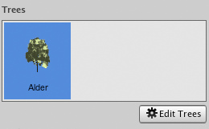
The newly added tree appears selected in the Inspector 在检视面板中显示新添加选择的树木
You can add as many trees as you like. Each one will be selectable in the Inspector for you to place on your Terrain.
你可以添加许多你喜欢的树木。检视面板里被选择的每一个树木可以种在你的地形上。
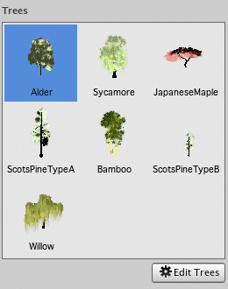
The currently selected tree will always be highlighted in blue 当前选定的树总是以蓝色突出显示

Painting Trees 画树
While still using the Place Trees tool, click anywhere on the Terrain to place your trees. To erase trees, hold the Shift button and click on the Terrain.
仍旧使用种树工具，在地形上任意地点栽种你的树木。清除树木，按住Shift键，然后在地形上点击。
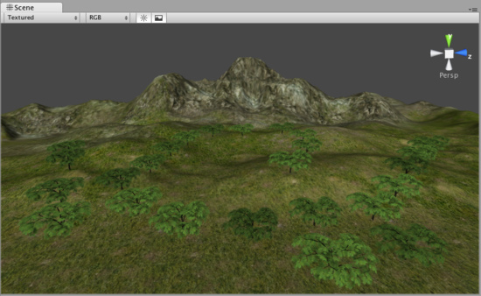
Painting trees is as easy as using a paintbrush tool 绘制树木与使用画刷工具一样容易
There are a number of options at your disposal when placing trees.
当种植树木是，这有几个选项由你支配。
Brush Size  画刷大小 | Radius in meters of the tree placing brush.  树木刷子的米半径
Tree Spacing  树间距 | Percentage of tree width between trees.  树木之间间距宽度的百分比
Color Variation  颜色变化 | Allowed amount of color difference between each tree.  每棵树之间的颜色差异的允许量
Tree Height  树高 | Height adjustment of each tree compared to the asset.  每棵树的高度调整相比于其它资产
Height Variation  高度差 | Allowed amount of difference in height between each tree.  每一个树的高度差的允许量
Tree Width  树宽 | Width adjustment of each tree compared to the asset.  每棵树的宽度调整相比于其它资产
Width Variation  宽度变化 | Allowed amount of difference in width between each tree.  每一个树宽度差的允许量

Tree Painting Tips 树绘制技巧
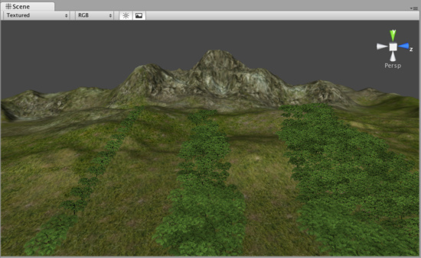
Different Brush sizes cover different area sizes 不同的画刷大小覆盖不同区域的大小
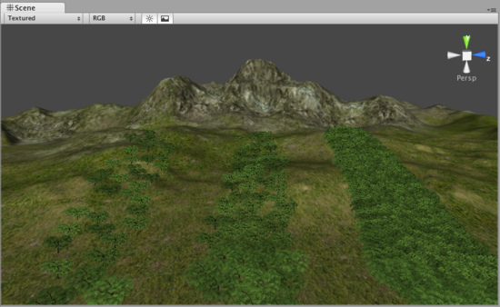
Adjust Tree Spacing to change the density of the trees you're painting 在你绘制时，调整树间距改变树木的密度

Editing Trees 编辑树
To change any import parameters for an added tree, select the detail and choose Edit Trees button->Edit Detail. Or double-click the tree you want to edit. You will then see the Edit Tree dialog, and you can change any of the settings.
为添加树木更改任何重要的参数，选取元件并选择Edit Trees button->Edit Detail.（编辑树木按钮 ->编辑元件）。或双击你想要编辑的树。你将看到编辑树对话框，然后，你可以任意更改设置。

Mass Placement 大规模种植
If you don't want to paint your trees and you just want a whole forest created, you can use Terrain->Mass Place Trees. Here, you will see the Mass Place Trees dialog. You can set the number of trees you want placed, and they'll be instantly positioned. All the trees added to your Terrain will be used in this mass placement.
如果你不想画你的树木有想快速的建立整个森林，你可以使用Terrain->Mass Place Trees（地形->大规模种树）.
这里，你将看到大规模种树对话框，你可以设置你想种植树的数，然后，它们将立即栽种。所有树木将被用于整体布置添加到你的地形。
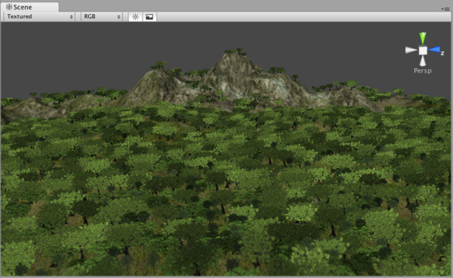
10,000 Trees placed at once 10000棵树木立即种植

Refreshing Source Assets 更新源资产
If you make any updates to your tree asset source file, it must be manually re-imported into the Terrain. To do this, use Terrain->Refresh Tree and Detail Prototypes. This is done after you've changed your source asset and saved it, and will refresh the trees in your Terrain immediately.
如果你进行任意更改你的树木资产源文件，它必须要手工重新引入到地形。要做到这一点，使用Terrain->Refresh Tree and Detail Prototypes（地形->刷新树和元件原型）。这样做完后，你已经更新了你的源资产并保持它，而且，将立即刷新在你地形里的树。

Creating Trees 创建树
Every tree should consist of a single mesh with two Materials. One for the trunk and one for the leaves. For performance reasons, triangle count should be kept below 2000 for an average tree. The fewer triangles the better. The pivot point of the tree mesh must be exactly at the root of the tree, that is at the point where the tree should meet the surface it is placed on. This makes it the easiest to import into Unity and other modelling applications.
每个树应当由一个简单的网格和两个材料组成。一个树干和一个树叶。由于性能的原因，三角形应保持低于2000的一个平均树。三角形越少越好，树网格的支点坐标必须正确的在树的根部，这是个坐标在那个地方遇到表面，它才能栽种上。这使它成为最容易导入到Uinty中和其它模型的应用。
Trees must use the Nature/Soft Occlusion Leaves and Nature/Soft Occlusion Bark shader. In order to use those shaders you also have to place the tree in a special folder that contains the name "Ambient-Occlusion". When you place a model in that folder and reimport it, Unity will calculate soft ambient occlusion specialized for trees. The "Nature/Soft Occlusion" shaders need this information. If you don't follow the naming conventions the tree will look weird with completely black parts.
树必须使用自然/软闭塞树叶和自然/软闭塞树皮着色。为使用这些着色器，你也必须同样在一个指定的文件夹名称中含"Ambient-Occlusion"的文件夹中放置树。当你放置一个模型在那个文件夹中并重新引入它，Unity将计算软环境闭塞专有的树木，这个"Nature/Soft Occlusion"（自然/软闭塞）着色器需要这个信息。如果你不遵循这个命名约定，这个树看起来是完全怪异的黑色。
Unity also ships with several high quality trees in the "Terrain Demo.unitypackage". You can use those trees readily in your game. Even if you don't want to use the builtin trees, we strongly recommend that you take a look at those trees as an example on how to model trees.
Unity也附带了几个高品质的树木在"Terrain Demo.unitypackage"中。你可以在你的游戏里容易的使用这些树。即使你不想使用内置的树，但我们强烈的建议你把这些树作为模型例子看看。

Using Low Poly Trees 使用低聚树
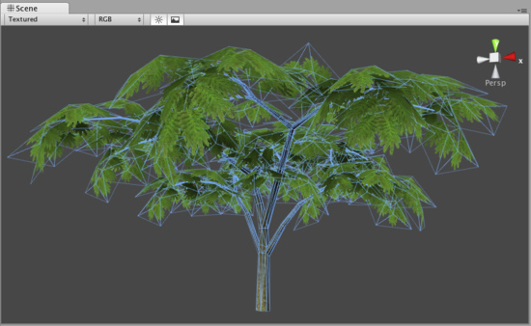
One branch with leaves is done with only six triangles and shows quite a bit of curvature. You can add more triangles for even more curvature. But the main point is: When making trees, work with triangles not with quads. If you use quads you basically need twice as many triangles to get the same curvature on branches.
一个叶分支，完成只有6个三角形和显示相当多的曲率。你可以为每个曲率添加更多的三角形。但是主要问题是：当处理树木时，三角形不能与四方形联合使用。如果你使用四方形，你基本上需要一样多三角形两次来取得分支同样的曲率。
The tree itself wastes a lot of fillrate by having large polygons but almost everything is invisible due to the alpha. This should be avoided for performance reasons and of course because the goal is to make dense trees. This is one of the things that makes Oblivion's trees look great. They are so dense you cant even see through the leaves.
树本身损耗庞大的供应速率由巨大的无形阿尔法大量填充率的多边形提供。这应该是性能避免的原因，当然，目标为茂密树林也是其原因。This should be avoided for performance reasons and of course because the goal is to make dense trees. This is one of the things that makes Oblivion's trees look great.这是湮没的树木更好看事物的其中之一。 它们They are so dense you cant even see through the leaves.它们它们它们是如此密集，甚至你看穿叶子。

Setting up Tree Collisions Setting up Tree Collisions设置树碰撞
If you'd like your trees to make use of colliders, it's very easy. When you've imported your Tree asset file, all you need to do is instantiate it in the Scene View, add a Capsule Collider and tweak it, and make the GameObject into a new Prefab. Then when you're adding trees to your Terrain, you add the tree Prefab with the Capsule Collider attached. You can only use Capsule Colliders when adding collisions with trees.
如果你希望你的树木使用碰撞器，这很容易。当你引入你的树资产文件，所有你需要做的是场景视图中实例化它们，添加一个Capsule Collider和调整它，使它成为一个新的预制游戏物体。然后，当你添加树木到你的地形时，你添加带有附着Capsule Collider预制的树。你也可以在添加带有碰撞的树时单独使用Capsule Colliders。

5）Grass 草
Reference Manual > Terrain Engine Guide > Grass
参考手册—>地形引擎指南—>草
The Paint Foliage button allows you to paint grass, rocks, or other decorations around the Terrain. To paint grass, choose Edit Details button->Add Grass Texture. You don't need to create a mesh for grass, just a texture.
画枝叶按钮允许你在地形上绘制草、岩石或其它装饰。绘制草，选择Edit Details button->Add Grass Texture（编辑元件按钮->添加草纹理）.你不需要为草建立网格，仅是一个纹理。
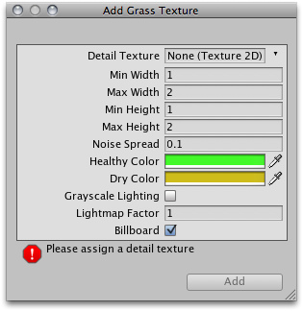
The Add Grass Texture dialog 添加草纹理对话框
At this dialog, you can fine-tune the appearance of the grass with the following options:
在这个对话框中，你可以根据下面的选项调整草的外观：
Detail Texture 细节纹理 | The texture to be used for the grass. 纹理用来做草
Min Width 最小宽度 | Minimum width of each grass section in meters. 在米的每个草区域内最小宽度
Max Width 最大宽度 | Maximum width of each grass section in meters.在米的每个草区域内最大宽度
Min Height 最小高度 | Minimum height of each grass section in meters. 在米的每个草区域内最小高度
Max Height 最大高度 | Maximum height of each grass section in meters. 在米的每个草区域内最大高度
Noise Spread  噪声传播 | The size of noise-generated clusters of grass. Lower numbers mean less noise.  草丛产生的噪音大小。低数字意味着少的噪音
Healthy Color  健康颜色 | Color of healthy grass, prominent in the center of Noise Spread clusters.  健康草的颜色，突出在噪音传播群的中心
Dry Color  干草颜色 | Color of dry grass, prominent on the outer edges of Noise Spread clusters.  干草的颜色，突出在噪音传播群的边缘
Grayscale Lighting  灰度灯光 | If enabled, grass textures will not be tinted by any colored light shining on the Terrain.  如果启动，在地形上草纹理不会受到任何彩色光的照射色彩。
Lightmap Factor  光照映射因子 | How much the grass will be influenced by the Lightmap.  许多的草将被光映射影响
Billboard  揭示牌 | If checked, this grass will always rotate to face the main Camera.  如选择，这个草将总是面对主摄像机旋转
After you've clicked the Add button, you'll see the grass appear selectable in the Inspector.
在你已经点击添加按钮之后，你将在检视面板中看到选择的草出现。
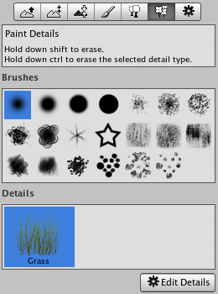
The added grass appears in the Inspector 添加的草出现在检视面板中

Painting Grass 画草
Painting grass works the same as painting textures or trees. Select the grass you want to paint, and paint right onto the Terrain in the Scene View
绘制草的工作与绘制纹理或树木相同。选择你想绘制的草，在场景视图里的地形上正确绘制。
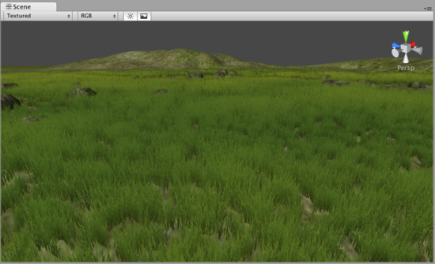
Painting grass is easy as pie 绘制草饼是容易的
Note:When you have a brush selected, move your mouse over the Terrain in the Scene View and press F. This will center the Scene View over the mouse pointer position and automatically zoom in to the Brush Size distance. This is the quickest & easiest way to navigate around your Terrain while creating it.
注意：当你有一个选择的画刷，在场景视图中的地形上移动你的鼠标并按F键。这将把鼠标指针的位置移动到场景中心显示，并自动放大的画刷大小的距离。 在创建地形时，这是最快和最简单的方法来浏览你的地形。

Editing Grass 编辑草
To change any import parameters for a particular Grass Texture, select it choose Edit Details button->Edit. You can also double-click it. You will then see the Edit Grass dialog appear, and be able to adjust the parameters described above.
更改特定草纹理任意重要参数，选取它，选择Edit Details button->Edit.（编辑元件按钮->编辑），你也可以双击它，你将看到编辑草的对话框出现，然后调整上述的参数。
You'll find that changing a few parameters can make a world of difference. Even changing the Max/Min Width and Height parameters can vastly change the way the grass looks, even with the same number of grass objects painted on the Terrain.
你会发现，改变一些参数可以实现天差之别。甚至更改高度和宽度的最大/最小参数可以广大改变草的外观，甚至是绘制在地形上的相同数量草的对象。
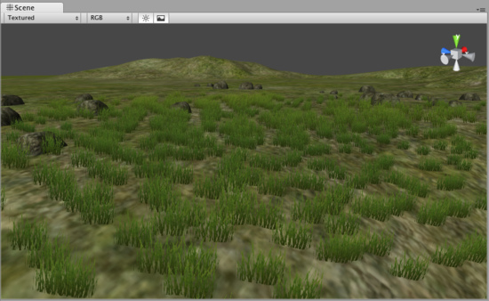
Grass created with the default parameters 以默认参数建立的草
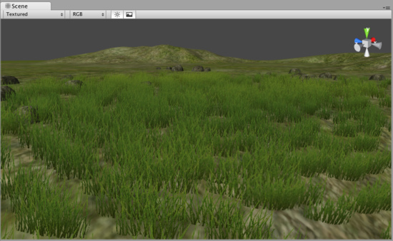
The same number of painted grass objects, now wider and taller 相同数量绘制的草对象，现在宽和高相同。

6）Detail Meshes 元件网格
Reference Manual > Terrain Engine Guide > Detail Meshes
参考手册—>地形引擎指南—>元件网格
Any Terrain decoration that is not trees or grass should be created as a Detail Mesh. This is perfect for things like rocks, 3D shrubbery, or other static items. To add these, use the Paint Foliage button
任何没有树或草的地形装饰被作为一个元件网格创建。这是理想的事情，像岩石，三维灌木丛，或其它静态的东西。要添加这些，使用Paint Foliage（画树叶按钮）
. Then choose Edit Details button->Add Detail Mesh. You will see the Add Detail Mesh dialog appear.
然后选择Edit Details button->Add Detail Mesh（编辑元件按钮->添加元件网格）。你将看到添加元件网格对话框出现。
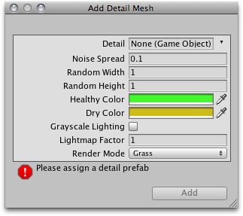
The Add Detail Mesh dialog 添加元件网格对话框
Detail 原件 | The mesh to be used for the detail. 网格被用于元件
Noise Spread  噪音传播 | The size of noise-generated clusters of the Detail. Lower numbers mean less noise.  元件群产生噪音的大小。低数字意味着少的噪音
Random Width 随机宽度 | Limit for the amount of width variance between all detail objects. 限制所有元件对象之间宽度数值的差异
Random Height随机高度 | Limit for the amount of height variance between all detail objects.限制所有元件对象之间高度数值的差异
Healthy Color健康颜色 | Color of healthy detail objects, prominent in the center of Noise Spread clusters.  元件对象的健康颜色，突出在噪音传播群中心
Dry Color干颜色 | Color of dry detail objects, prominent on the outer edges of Noise Spread clusters.  元件对象的干颜色，突出在噪音传播群的边缘
Grayscale Lighting灰度灯光 | If enabled, detail objects will not be tinted by any colored light shining on the Terrain  如果启动，在地形上元件对象不会受到任何彩色光的照射色彩。.
Lightmap Factor光照映射因子 | How much the detail objects will be influenced by the Lightmap.许多元件对象将被灯光映射影响
Render Mode 渲染模式 | Select whether this type of detail object will be lit using Grass lighting or normal Vertex lighting. Detail objects like rocks should use Vertex lighting.  是否选取这个类型将决定被使用草灯光或正常顶点等光。向岩石的元件对象应使用顶点灯光。
After you've clicked the Add button, you'll see the Detail mesh appear in the Inspector. Detail meshes and grass will appear next to each other.
在你已经点击添加按钮之后，你将看到元件网格显示在检视面板里。元件网格和草将互相显示在一起。
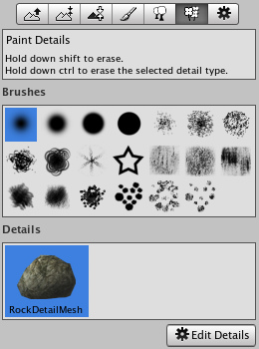
The added Detail mesh appears in the Inspector, beside any Grass objects 添加的元件网格显示在检视面板，在其它的草对象旁边。

Painting Detail Meshes 画元件网格
Painting a Detail mesh works the same as painting textures, trees, or grass. Select the Detail you want to paint, and paint right onto the Terrain in the Scene View.
绘制一个元件网格的工作与绘制纹理、树木、或草一样。选取你想要绘制的元件，在场景视图中的地形上正确绘制。
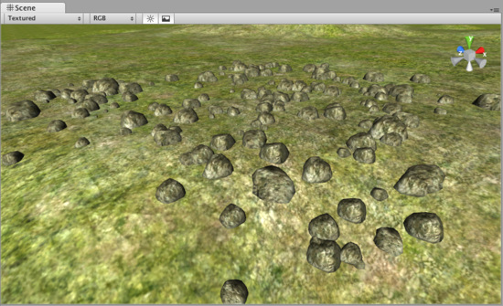
Painting Detail meshes is very simple 绘制元件网格非常容易
Note: When you have a brush selected, move your mouse over the Terrain in the Scene View and press F. This will center the Scene View over the mouse pointer position and automatically zoom in to the Brush Size distance. This is the quickest & easiest way to navigate around your Terrain while creating it.
注意：当你有一个选择的画刷，在场景视图中的地形上移动你的鼠标并按F键。这将把鼠标指针的位置移动到场景中心显示，并自动放大的画刷大小的距离。 在创建地形时，这是最快和最简单的方法来浏览你的地形。

Editing Details 编辑元件
To change any import parameters for a Detail Mesh, select it and choose Edit Details button->Edit. You will then see the Edit Detail Mesh dialog appear, and be able to adjust the parameters described above.
更改一个元件任意重要参数，选取它，选择Edit Details button->Edit.（编辑元件按钮->编辑），你将看到编辑草的对话框出现，然后调整上述的参数。

Refreshing Source Assets 更新源资产
If you make any updates to your Detail Mesh asset source file, it must be manually re-imported into the Terrain. To do this, use Terrain->Refresh Tree and Detail Prototypes. This is done after you've changed your source asset and saved it, and will refresh the Detail Meshes in your Terrain immediately.
如果你进行更新任何你的元件网格资产源文件，它必须手动重新引入到地形里。要做到这一点，使用Terrain->Refresh Tree and Detail Prototypes（地形->更新树和元件原型）。做完这一点后，你已经更改了你的源资产并保存了它，它将立即在你的地形中刷新元件网格。

7）Lightmaps 光照映射
Reference Manual > Terrain Engine Guide > Lightmaps
参考手册—>地形引擎指南—>光照映射
You can create and use a Lightmap, based on the Lights in your Scene. You should almost always use Lightmaps. A Lightmapped terrain looks substantially better than Vertex lit. On top of that a Lightmapped terrain also runs faster than a Vertex lit terrain!
在你的场景灯光的基础上，你可以创建和使用光照映射。你应该总是使用光照映射。一个光照映射地形看起来大大好过顶点照射。另外一个光照映射地形运行速度也比顶点照射地形快。
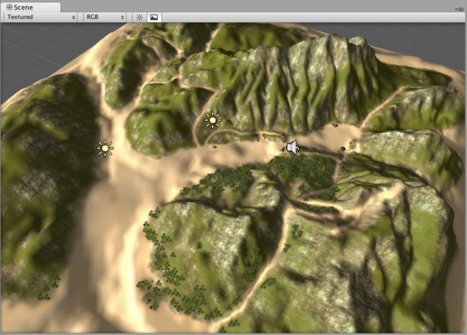
A mountain view without a Lightmap 没有光照映射的山脉视图
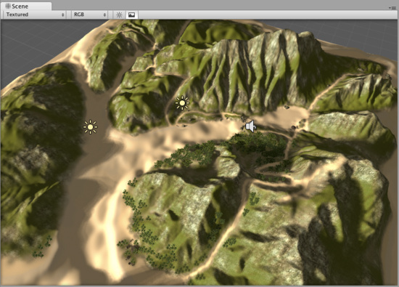
The same mountain, now using a Lightmap. Much better! 同样的山脉，使用光照映射，好多了！

Creating a Lightmap 建立一个光照映射
To create a Lightmap, make sure you have at least one Directional Light in your scene. Then choose Terrain->Create Lightmap from the menu. Here you can set various options like the Resolution of the Lightmap, choose the Lights used in the Lightmap, Shadows, and Shadow Sampling.
创建一个光照映射，在你的场景中确认至少已经有一个方向光（Directional Light）。然后，从菜单选择Terrain->Create Lightmap（地形->建立光照映射）。这里你可以设置不同的选项，如光照映射分斌率、选择光照映射使用的灯光，阴影和阴影取样。

Toggling Lightmap 切换光照映射
To enable or disable the active Lightmap, select your Terrain and click the Terrain Settings tab. In Lighting popup, choose Lightmap or Pixel lighting mode.
启动或禁止激活光照映射，选取你的地形并点击地形设置选项卡，在照明弹出里，选择光照映射或像素照射模式。
Note: You must use a Directional Light to create the lightmap. Point and Spot Lights will not be taken into account when creating the lightmap.
注意：你必须使用一个方向光去建立一个光照映射。当建立光照映射，点光源和聚光灯将不被考虑。

8）Other Settings
Reference Manual > Terrain Engine Guide > Other Settings
参考手册—>地形引擎指南—>其它设置
There are a number of options under the Terrain Settings button in the Terrain Inspector.
检视面板中的地形设置按钮里有许多的选项。
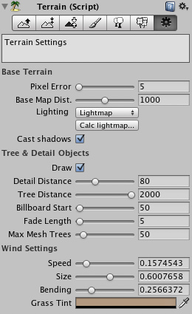
All additional Terrain Settings 所有附加的地形设置
Base Terrain 基本地形
Pixel Error  像素差错 | Amount of allowable errors in the display of Terrain Geometry. This is essentially a LOD setting.  地形几何显示允许的错误数。它本质上是一个LOD设置
Base Map Dist.  基本映射距离 | The distance that Terrain Textures will be displayed in high-resolution.  地形纹理距离被用于高分辨率显示
Lighting 灯光 | Terrain lighting mode: 地形灯光模式
Vertex 顶点 | Terrain is lit by lights in vertex lit mode. 地形被顶点灯光模式照亮
Lightmap 光照映射 | Terrain uses lightmap and is not affected by lights. 地形使用光照映射并不被灯光影响
Pixel 像素 | Terrain is lit by pixel & vertex lights up close, and fades out to lightmap in the distance. Close by it can also receive shadows.  地形被像素或关闭顶点灯光照亮，并在远处淡出到灯光映射。关闭它能够获得阴影。
Cast Shadows 阴影造型 | Should terrain cast shadows? 地形是否设置阴影？
Tree & Detail Settings 树木和元件设置
Draw 绘制 | If enabled, all trees, grass, and detail meshes will be drawn.  如果开始，所有的树木、草、和元件网格将被绘制
Detail Distance  元件距离 | Distance from the camera that details will stop being displayed.  那些距离摄像机远的元件将被停止显示。
Tree Distance  树木距离 | Distance from the camera that trees will stop being displayed. The higher this is, the further-distance trees can be seen.  那些距离摄像机远的树木将被停止显示。这是指较高的树木，更远距离的树木可以被看见。
Billboard Start  揭示牌开始 | Distance from the camera that trees will start appearing as Billboards instead of Meshes.  那些距离摄像机距离远的树木将被网格揭示牌代替开始显示
Fade Length  淡出长度 | Total distance delta that trees will use to transition from Billboard orientation to Mesh orientation.  那些全距离元件树木将从揭示牌方向转换到网格方向
Max Mesh Trees  最大网格树木 | Total number of allowed mesh trees to be capped in the Terrain.  在地形里，网格树木允许数量被并行处理
Wind Settings 风设置
Speed 速度 | The speed that wind blows through grass. 风吹过草的速度
Size 大小 | The areas of grass that are affected by wind all at once. 立即被风影响的草的区域
Bending 弯曲 | Amount that grass will bend due to wind. 由于风，草的弯曲数值
Grass Tint 草色 | Overall tint amount for all Grass and Detail Meshes.所有草和元件网格整体色彩数值

