Using Scripts 使用脚本

Unity Manual > User Guide > Working with Assets > Using Scripts

Unity手册-> 用户指南 ->与资产合作->使用脚本
This is a short introduction on how to create and utilize scripts in a project. For detailed information about the Scripting API, please view the Scripting Reference. For detailed information about creating game play through scripting, please view the Creating Gameplay page of this manual.
这是一个小的介绍如何在一个项目里建立和使用脚本。关于脚本API的详细信息，请查看脚本引用。关于通过脚本建立游戏玩家的详细信息，请查看本手册的建立游戏玩家页。
Scripting inside Unity is done by writing simple behaviour scripts in JavaScript, Boo or C#. You can use one or all scripting languages in a single project, there is no penalty for using more than one. Unless stated otherwise, all the scripting examples are in JavaScript.
在Unity里的脚本的完成通过编写简单行为脚本在JavaScript, Boo 或 C#之内。你可以使用一个或所有简本语言在一个独立的项目中，使用多于一个没有损失。除非另有说明，所有的脚本例子是JavaScript的。

Creating new scripts 建立新脚本
Unlike other assets like Meshes or Textures, Script files can be created from within Unity. To create a new script, open the Assets->Create->JavaScript (or Assets->Create->C Sharp Script or Assets->Create->Boo Script) from the main menu. This will create a new script called NewBehaviourScript and place it in the selected folder in Project View. If no folder is selected in Project View, the script will be created at the root level.
和其它资产不同，像网格或纹理，脚本文件可以Unity内部被建立。建立一个新的脚本，从主菜单打开Assets->Create->JavaScript（或Assets->Create->C Sharp Scrip 或Assets->Create->Boo Script）。这将建立一个新脚本称为NewBehaviourScript并放置它在项目视图里选择的文件夹里。如果在项目视图里没有文件夹选取，脚本将被建立在根层次。
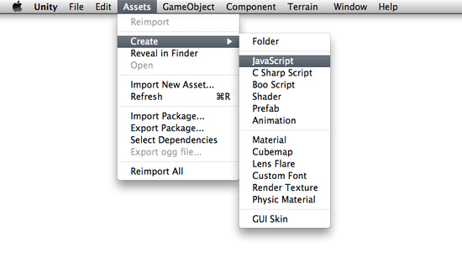
You can edit the script by double-clicking on it in the Project View. This will launch Unitron, the script editor for Unity. You do all your scripting in an external text editor like Unitron, and not in Unity directly. To set the default script editor, change the drop-down item in Unity->Preferences->External Script editor.
你可以在项目视图里通过在脚本上双击编辑它。这将启动Unitron，Unity的脚本编辑器。在外部文本编辑器里你处理所有你脚本像Unitron一样，但不如在Unity里直接。设置默认的脚本编辑器，在Unity->Preferences->External Script editor里（在windows上是 Eidt->Preferences->External Script editor）更改下拉框的项目
These are the contents of a new, empty behaviour script: 这些是新的内容，空白行为脚本：
function Update () {
}
A new, empty script does not do a lot on its own, so let's add some functionality. Change the script to read the following: 一个新的，空白脚本不做它自身的任何事情，因此让我们添加一些功能。修改脚本阅读如下：
function Update () {
print("Hello World");
}
When executed, this code will print "Hello World" to the console. But there is nothing that causes the code to be executed yet. We have to attach the script to an active GameObject in the Scene before it will be executed.
当执行，这个代码将打印"Hello World"到控制台里。但什么也没有导致代码的执行。在它执行之前，在场景里，我们必须附加脚本到一个活动的GameObject。

Attaching scripts to objects 附加脚本到对象
Save the above script and create a new object in the Scene by selecting GameObject->Create Other->Cube. This will create a new GameObject called "Cube" in the current Scene.
保存上面的脚本并建立一个新的对象在场景里通过选取GameObject->Create Other->Cube。这将建立一个新的游戏物体称为"Cube”在当前场景里。
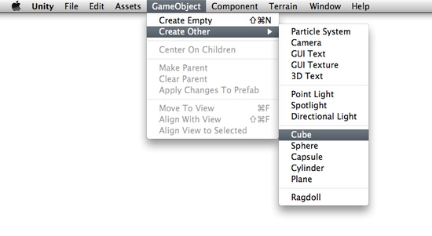
Now drag the script from the Project View to the Cube (in the Scene or Hierarchy View, it doesn't matter). You can also select the Cube and choose Component->Scripts->New Behaviour Script. Either of these methods will attach the script to the Cube. Every script you create will appear in the Component->Scripts menu. If you have changed the name of your script, you will that name instead.
现在从项目视图里拖拽脚本到这个立方体（Cube）（在场景里或层次视图里，这无关紧要）。你也可以选取这这个Cube并选择Component->Scripts->New Behaviour Script。这些方法的编辑器将附加这个脚本到Cube。你建立的每个脚本将显示在Component->Scripts菜单里。如果你已经修改了你的脚本的名称，你将代替那个名称。
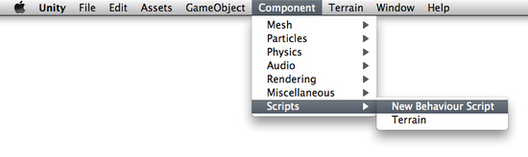
If you select the Cube and look at the Inspector, you will see that the script is now visible. This means it has been attached.
如果你选取里Cube并查看检视器，你将看到脚本是现在可见。这意味着它已经被附加了。
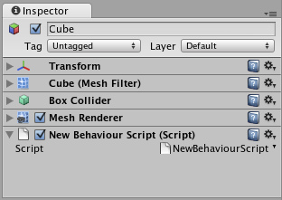
Press Play to test your creation. You should see the text "Hello World" appear beside the Play/Pause/Step buttons. Exit play mode when you see it.
按播放按钮去测试你的创造。你应该看到"Hello World"文本显示Play/Pause/Step按钮旁边 （在2.5的windows 版的里，显示在底部状态栏）。当你看到它退出播放模式。

Manipulating the object 操作对象
A print() statement can be very handy when debugging your script, but it does not manipulate the GameObject it is attached to. Let's change the script to add some functionality:
一个print()语句可以非常便利的当调试你的脚本时，但它不能操作被附属于的GameObject（游戏物体）。让我们修改脚本添加一些功能：
function Update () {
transform.Rotate(0, 5*Time.deltaTime, 0);
}
If you're new to scripting, it's okay if this looks confusing. These are the important concepts to understand:
如果你是新的脚本，它看起来有些凌乱。这些是重要的概念理解：
- function Update () {} is a container for code that Unity executes multiple times per second (once per frame). function Update () {}是Unity多个时间每秒钟执行代码的容器（一次每帧）。
- transform is a reference to the GameObject's Transform Component. Transform是一个对象物体的变换组件的引用。
- Rotate() is a function contained in the Transform Component. Rotate()是在变换组件里的功能容器。
- The numbers in-between the commas represent the degrees of rotation around each axis of 3D space: X, Y, and Z. 在逗号之间的数字表示环绕每个3D空间空间轴：x，y和z 的旋转的角度。
- Time.deltaTime is a member of the Time class that evens out movement over one second, so the cube will rotate at the same speed no matter how many frames per second your machine is rendering. Therefore, 5 * Time.deltaTime means 5 degrees per second.
Time.deltaTime是Time类的一个成员，使每秒移动平坦，因此这个Cube将以同样的速度旋转而不管你机器的每秒的多少帧被绘制。所以，5 * Time.deltaTime意味着每秒5度。
With all this in mind, we can read this code as "every frame, rotate this GameObject's Transform component a small amount so that it will equal five degrees around the Y axis each second."
所有在这一点，我们可以阅读这个代码作为“每一个帧，旋转这个GameObject的变换组件一个小的数量因此它将等于5度环绕Y轴每秒”
You can access lots of different Components the same way as we accessed transform already. You have to add Components to the GameObject using the Component menu. All the Components you can easily access are listed under Variables on the GameObject Scripting Reference Page.
同样的方法你可以访问许多不同组件是与我们已经访问了transform的一样方法。你必须添加组件到GameObject使用组件菜单。所有组件你可以容易访问被在GameObject脚本引用页的变量下列出。
For more information about the relationship between GameObjects, Scripts, and Components, please jump ahead to the GameObjects page or Using Components page of this manual.
关于GameObjects, Scripts和Components间的关系的更多信息，请跳到前面的GameObjects页或本手册的Using Components页。

The Power of Variables 变量的功能
Our script so far will always rotate the Cube 5 degrees each second. We might want it to rotate a different number of degrees per second. We could change the number and save, but then we have to wait for the script to be recompiled and we have to enter Play mode before we see the results. There is a much faster way to do it. We can experiment with the speed of rotation in real-time during Play mode, and it's easy to do.
我们的脚本到目前为止将总每秒选择Cube 5度。我们也许想要它每秒选择不同数量的角度。我们可以改变数据并保存它，但我们必须等待脚本被从新编译以及我们必须进入播放模式在我们看到结果之前。有一个非常快速的方法去做它。在实时播放模式过程中，我们可以利用旋转速度实验，而且它是容易去做到。
Instead of typing 5 into the Rotate() function, we will declare a speed variable and use that in the function. Change the script to the following code and save it:
替代在Rotate()函数输入5，我们将定义一个speed 变量并在函数里使用它。修改脚本到如下的代码并保存它。
var speed = 5.0;

function Update () {
transform.Rotate(0, speed*Time.deltaTime, 0);
}
Now select the Cube and look at the Inspector. Notice how our speed variable appears.
现在，选取这个Cube并在检视器里查看。注意我们的speed变量如何显示。
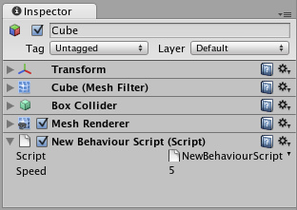
This variable can now be modified directly in the Inspector, just like renaming a file in the file explorer. Select it, press Return and change the value. You can also right- or option-click on the value and drag the mouse up or down. You can change the variable at any time, even while the game is running.
在检视器里的这个变量现在可以被直接修改，就像在文件资源管理器里重命名一个文件一样。选取它，按回车键并修改它的值。你也可以恰当的点击选项并左右拖动鼠标（修改值）。你可以在任何时间更改变量，甚至当游戏在运行的过程中。
Hit Play and try modifying the speed value. The Cube's rotation speed will change instantly. When you exit Play mode, you'll see that your changes are reverted back to their value before entering Play mode. This way you can play, adjust, and experiment to find the best value, then apply that value permanently.
击播放按钮并尝试修改speed变量的值。这个Cube的旋转速度将立即改变。等你退出播放模式时，你将看到你的更改回复到进入播放模式之前的它们值。这个方法你可以播放、调整以及实验去找打最优的值，然后应用不变的引用那个值。
Using this method of changing a variable's value in the Inspector means that you can re-use one script on many objects, each with a different variable value. If you attach the script to multiple Cubes, and change the speed of each cube, they will all rotate at different speeds even though they use the same script.
在检视器里使用这个方法修改变量的值意味着你可以重复使用一个脚本在多个对象上，每次用一个不同的变量值。如果你附加这个脚本到多个Cube，并更改每个Cube的speed，它们将全部用不同的速度旋转甚至是它们使用同样的脚本。

Where to go from here 从这里走到哪里
This was just a short introduction on how to use scripts inside the Editor. For more examples, check out the Tutorials that come with Unity. You should also read through Scripting Overview inside the Script Reference, which contains a more thorough introduction into scripting with Unity plus pointers into the reference itself for in-depth information. If you're really stuck, be sure to visit the Unity Forums and ask questions there. Someone is always willing to help.
这仅是一个短小的介绍如何使用脚本在编辑器里。更多的例子，检查Unity带来的手册。你也应该通过阅读脚本概述在脚本引用里，它包含了一个脚本到自己的参考指针与Unity加更详细的介绍深入的信息。如果你真的坚持，一定要访问Unity论坛并要求咨询，有人总是愿意提供帮助。

