Input 输入

Unity Manual > User Guide > Creating Gameplay > Input

Unity手册->用户指南->建立可玩性游戏->输入
Unity supports Keyboard, Joystick and Gamepad input. Unity支持键盘、操纵杆及游戏键盘输入。
Virtual axes and buttons can be created in the Input Manager and end users can configure Keyboard input in a nice screen configuration dialog. 虚拟坐标轴和按钮可以在输入管理里被创建以及最终用户可以在一个美好的屏幕配置对话框里配置键盘输入。
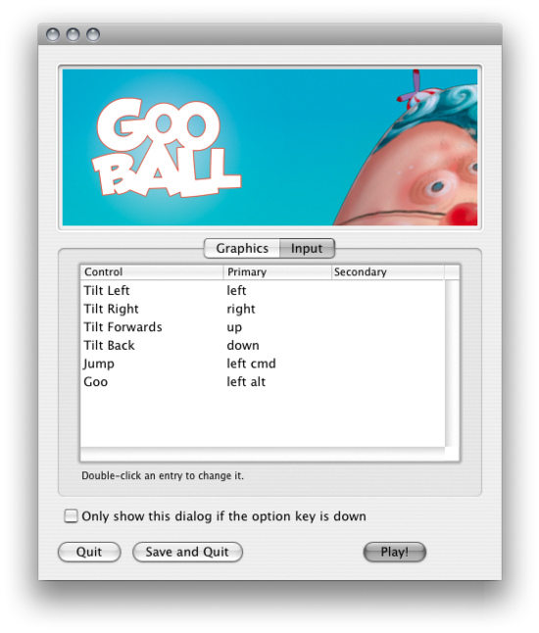
You can setup Joysticks, Gamepads, Keyboard, and Mouse, then access them all through one simple scripting interface. 你可以配置操纵杆、小键盘、键盘和鼠标，然后通过一个简单的脚本界面访问它们。
From scripts, all virtual axes are accessed by their name. 从脚本里，所有虚拟轴是通过它们的名称访问的。
Every project has the following default input axes when it's created: 每个项目拥有下面默认的输入轴当它们被创建时：
- Horizontal and Vertical are mapped to w, a, s, d and the arrow keys.
- 水平和垂直被映射到w、a、s、d以及方向键。
- Fire1, Fire2, Fire3 are mapped to Control, Option (Alt), and Command, respectively.
- 开火1、开火2、开火3被映射到Control、Option（Alt）以及各个的指令。
- Mouse X and Mouse Y are mapped to the delta of mouse movement.
- 所标的左和右键被映射鼠标移动的增量。
- Window Shake X and Window Shake Y is mapped to the movement of the window.
- 窗口摇动X和Y被映射窗口的移动。

Adding new Input Axes添加新的输入坐标轴
If you want to add new virtual axes go to the Edit->Project Settings->Input menu. Here you can also change the settings of each axis.
如果你想添加新的虚拟轴就到Edit->Project Settings->Inpu菜单。这里你也可以更改每个轴的设置。
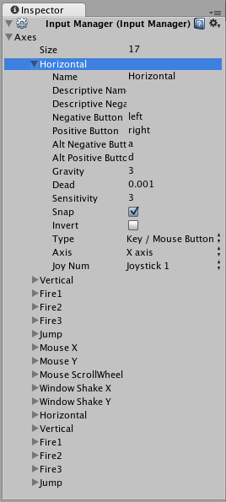
You map each Axis to two buttons either on a Joystick, Mouse, or Keyboard keys.
你映射每个轴到两个按钮其中一个是操纵杆或键盘的键。
Name  名称 | The name of the string used to check this Axis from a script.  字符串名称被用于确认轴从脚本里
Descriptive Name  描述名称 | Positive value name displayed in the Input tab of the Configuration dialog for standalone builds.  正向值的名称显示在输入配置对话框为独立建立。
Descriptive Negative Name  描述反向名称 | Negative value name displayed in the Input tab of the Configuration dialog for standalone builds.  反向值的名称显示在输入配置对话框为独立建立
Negative Button  反向按钮 | The button used to push the Axis in the negative direction.  本按钮被用于推动轴在反向的方向上
Positive Button  正向按钮 | The button used to push the Axis in the positive direction.  本按钮用于推动轴在正向方向上
Alt Negative Button  Alt反向按钮 | Alternative button used to push the Axis in the negative direction.  交错按钮被用于推动轴在反向的方向上。
Alt Positive Button  Alt 正向按钮 | Alternative button used to push the Axis in the positive direction.  交错按钮被用于推动轴在正向方向上。
Gravity  重力 | Speed in units per second that the Axis falls toward neutral when no buttons are pressed.  每秒单位内的速度轴线下落到中轴当没有按钮被按下时。
Dead  停用 | Size of the analog dead zone. All analog device values within this range result map to neutral.  模拟停用区域的大小。所有的模拟设备值在这个范围内的结果映射到中枢。
Sensitivity  灵敏度 | Speed in units per second that the the Axis will move toward the target value. This is for digital devices only.  每秒单位内的速度，轴将向前移动到目标的值。这是仅为数字设备。
Snap  捕获 | If enabled, the Axis value will reset to zero when pressing a button of the opposite direction.  如果启用，轴值将重设为零当按下相对位置按钮时。
Invert  反转 | If enabled, the Negative Buttons provide a positive value, and vice-versa.  如果启用，反向按钮提供一个正向值，反之依然。
Type  类型 | The type of inputs that will control this Axis.  输入类型，控制这个轴的
Axis  轴 | The axis of a connected device that will control this Axis.  连接设备的轴控制这个轴
Joy Num  操纵杆编号 | The connected Joystick that will control this Axis.  连接操纵杆控制的轴。
Use these settings to fine tune the look and feel of input. They are all documented with tooltips in the Editor as well. 使用这些设置去细微调整外观和输入的感觉。它们所有在编辑器里的提示文本也将说明。

Using Input Axes from Scripts 从脚本使用输入轴
You can query the current state from a script like this:
你可以查询当前状态从一个脚本里，像这样：
value = Input.GetAxis ("Horizontal");
An axis has a value between -1 and 1. The neutral position is 0. This is the case for Joystick input and Keyboard input.
一个轴拥有一个在-1到1之间的值。中间位置是0。这是一个选择为操纵杆输入和键盘输入。
However, Mouse delta and Window Shake delta are how much the mouse or window moved during the last frame. This means it can be larger than 1 or smaller than -1 when the user moves the mouse quickly.
然而，鼠标增量和窗口摇动增量是在最近的帧期间内鼠标或窗口移动多少。
It is possible to create multiple Axes with the same name. When getting the input axis, the axis with the largest absolute value will be returned. This makes it possible to assign more than one input device to one Axis name. For example, create one axis for keyboard input and one axis for joystick input with the same name. If the user is using the joystick, input will come from the joystick, otherwise input will come from the keyboard. This way you don't have to think at all about from where the input comes when writing scripts.
它可以创建具有相同名称的多个轴。当输入轴获取，拥有最大绝对值的轴线将返回。这使得分配多个输入设备，以一轴的名称。例如，创建一个键盘输入和一个摇杆具有相同名称的输入轴轴。如果用户正在使用操纵杆，输入来自操纵杆，否则将来自输入键盘。这样，你就不必为在所有关于从那里输入正值编写脚本。

Button names 按钮名称
To map a key to an axis, you have to enter the key's name in the Positive Button or Negative Button property in the Inspector.
映射到一个轴键，在检视器属性里，你必须在正向按钮或负向按钮里输入键的名称。
The names of keys follow this convention: 键的名称符合下面的约定：
- Normal keys: "a", "b", "c" ... 正常键 a，b，c…
- Number keys: "1", "2", "3", ... 数字键 1，2，3，
- Arrow keys: "up", "down", "left", "right" 方向键 "up", "down", "left", "right"
- Keypad keys: "[1]", "[2]", "[3]", "[+]", "[equals]" 小键盘键"[1]", "[2]", "[3]", "[+]", "[equals]"
- Modifier keys: "right shift", "left shift", "right ctrl", "left ctrl", "right alt", "left alt", "right cmd", "left cmd"
- 修改键"right shift", "left shift", "right ctrl", "left ctrl", "right alt", "left alt", "right cmd", "left cmd"

- Mouse Buttons: "mouse 0", "mouse 1", "mouse 2", ... 鼠标键"mouse 0", "mouse 1", "mouse 2", ...

- Joystick Buttons (from any joystick): "joystick button 0", "joystick button 1", "joystick button 2", ...
- 操纵杆键（任何操纵杆）："joystick button 0", "joystick button 1", "joystick button 2", ...
- Joystick Buttons (from a specific joystick): "joystick 0 button 0", "joystick 0 button 1", "joystick 1 button 0", ...
- 操纵杆键（指定操纵杆）："joystick 0 button 0", "joystick 0 button 1", "joystick 1 button 0", ...
- Special keys: "backspace", "tab", "return", "escape", "space", "delete", "enter", "insert", "home", "end", "page up", "page down"
- 专用键backspace", "tab", "return", "escape", "space", "delete", "enter", "insert", "home", "end", "page up", "page down"
- Function keys: "f1", "f2", "f3", ... 功能键 "f1", "f2", "f3", ...
The names used to identify the keys are the same in the scripting interface and the Inspector.
名称用来识别键是相同的在脚本接口里和在检视器里。
value = Input.GetKey ("a");

