Transforms 变换

Unity Manual > User Guide > Creating Gameplay > Transforms

Unity手册->用户指南->建立可玩性游戏->变化
Transforms are a key Component in every GameObject. They dictate where the GameObject is positioned, how it is rotated, and its scale. It is impossible to have a GameObject without a Transform. You can adjust the Transform of any GameObject from the Scene View, the Inspector, or through Scripting.
Transforms是一个关键组件在每个GameObject里。它们指定GameObject的位置是哪里，如何旋转，以及如何缩放。一个没有Transform的GameObject是可能的。从场景视图里、检视器里户或通过脚本你可以调整任何GaomeObject的Transform。
The remainder of this page's text is from the Transform Component Reference page.
本页剩余部分的文本是来自Transform 组件引用页。

Transform 变换
The Transform Component determines the actual Position, Rotation, and Scale of all objects in the scene. Every object has a Transform.
在场景里，Transform组件确定所有对象的实际的位置、旋转和缩放。每个对象有一个Transform。
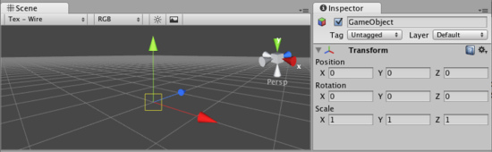
The Transform Component is viewable and editable in the Inspector
在检视器里，Transform组件是可视与可编辑的。

Properties 属性
Position  位置 | Position of the Transform in X, Y, and Z coordinates.  与x，y，z相配配的Transform的位置
Rotation  旋转 | Rotation of the Transform around the X, Y, and Z axes, measured in degrees.  Transform围绕x，y，z轴旋转，使用角度规则。
Scale  缩放 | Scale of the Transform along X, Y, and Z axes. Value "1" is the original size (size at which the object was imported).沿x，y，z轴变换伸缩。值为1是原始大小（在该对象导入时的大小）
All properties of a Transform are measured relative to the Transform's parent. If the Transform has no parent, the properties are measured relative to World Space.
所有变换组件的属性的测量是相对于变换组件的父。若这个变换组件没有父，这些属性的测量相对于整个空间。

Using Transforms 使用变换组件
Transforms are always manipulated in 3D space using X, Y, and Z axes. In Unity, these axes are represented by the colors red, green, and blue respectively. Remember: XYZ = RGB.
变换组件总是在3D空间使用x，y，z轴生成。在Unity里，这些轴通过红、绿、蓝三种颜色分别展现。记住：XYZ=RGB.
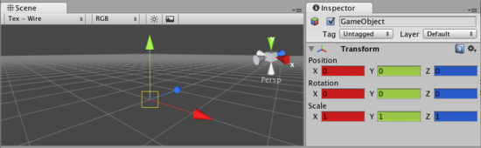
Color-coded relationship between 3 axes and Transform properties 色标3个轴与变换组件之间的关系。
Transform Components can be directly manipulated using the Scene View or the Inspector. The Inspector will list the properties stated above for easy editing. You can also modify Transforms in your Scene by interacting with them, using the Move, Rotate, and Scale tools. These tools are located in the upper left-hand corner of the Unity Editor.
Transform（变换）组件可以直接操作使用场景视图或检视器面板。检视器面板将列出容易编辑的属性状态。你也可以在你的场景里通过使用移动、旋转和伸缩互动修改变化组件。这些工具定位在Unity编辑器的左手上角。
The View, Translate, Rotate, and Scale tools 查看，变换，旋转机伸缩工具。
The tools will be usable on any object in your scene. Click on the object, and you will see the tool gizmo appear around it. Depending on the current tool, the gizmo will look slightly different. Clicking the object will also cause the Transform component to become visible in the Inspector. If the Inspector does not display the Transform component or its properties, then you do not have an object highlighted in the Scene View.
在你的场景里，这个工具可用在任何对象上。在对象上点击，然后你将看到小发明（gizmo翻译成装置/辅助？）工具显示在对象的周围。利用当前工具，小发明将看起来稍微不同。点击对象也将导致变换组件在检视器面板了变为可见。如果检视器面板里没有显示变换组件或它的属性，在场景视图里你不能拥有一个高亮显示的对象。
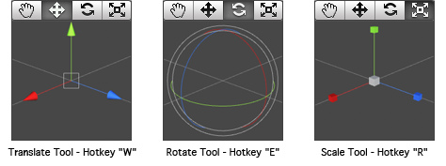
平移工具-快捷键 W 旋转工具-快捷键 E 缩放工具-快捷键 R
All three Gizmos can be directly edited in Scene View. 所有三个小发明可以直接在场景视图里编辑。
To manipulate the Transform, click and drag on one of the 3 gizmo axes, you'll notice its color changes. As you drag the mouse, you will see the object translate, rotate, or scale along the axis. When you release the mouse button, you'll notice that the axis remains selected. You can click the middle mouse button and drag the mouse to manipulate the Transform along the selected axis. To access all 3 axes at once click and drag the center point of all 3 gizmos.
操作变换，在小发明3个轴的一个轴上点击并拖动，你将注意到它的颜色改变。在你拖动鼠标，你将看到对象平移、旋转、或沿轴伸缩。当你释放鼠标按钮，你将注意到这个轴仍然被选取。你可以点击鼠标的中间键并拖动鼠标去操作变换沿选取的轴。一起访问所有的3个轴，点击并拖动3个小发明的中心。
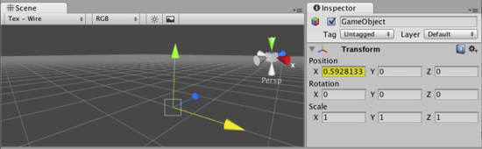
Any individual axis will become selected when you click on it 任何个体的轴将变为选取状态当你在它上面点击时。

Parenting 父类化
Parenting is one of the most important concepts to understand when using Unity. When a GameObject is a Parent of another GameObject, the Child GameObject will move, rotate, and scale exactly as its Parent does. Just like your arms are attached to your body, when you turn your body, your arms move because they're attached. Any object can have multiple children, but only one parent.
当使用Unity时，理解父类化是一个非常重要的概念。当一个GameObject（游戏物体）是另外一个GameObject的一个父时，子GameObject将移动、旋转和正确的伸缩当它的父在做这些改变时。就像你的胳膊被附加到你的身体，当你转动你的身体时，你的胳膊因为它们被附加而移动。任何对象可以拥有多个子，但是只有一个父。
You can create a Parent by dragging any GameObject in the Hierarchy View onto another. This will create a Parent-Child relationship between the two GameObjects.
你可以在层次视图里通过拖动任何对象到其它对象上创建一个父。这将在两个GameObject之间建立一个父-子关系。
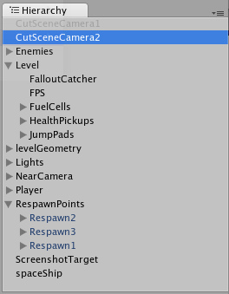
A real-world example of a Parent-Child hierarchy. All the GameObjects with arrows to the left are Parents.
父-子层次的一个真实世界的例子。所有的GameObject利用箭头指向左边的父。
In the above example, we say that the arms are parented to the body, and the hands are parented to the arms. The scenes you make in Unity will contain collections of these Transform hierarchies. The topmost parent object is called the Root object. When you move, scale, or rotate a parent, all the changes in its Transform are applied to its children as well.
在上面的例子里，我们说胳膊是身体的父，以及手是胳膊的父。在Unity里你创造的场景将包含这些变换层次的集合。最顶层父对象被称为根对象。当你移动，伸缩或旋转一个父对象，所有的改变在它的变化里也被应用于它的子孙。
It is worth pointing out that the Transform values in the Inspector of any Child GameObject are displayed relative to the Parent's Transform values. These are also called the Local Coordinates. Through scripting, you can access the Global Coordinates as well as the Local Coordinates.
值得指出的是在检视器里的任何子GameObject的变化值是相对于父的变化值显示。这些也被称为局部坐标。通过脚本，你可以访问全局坐标与局部坐标。
You can build compound objects by parenting multiple separate objects together, like the skeletal structure of a human ragdoll. You can also create small yet effective objects with single parents. For example, if you have a horror game that takes place at night, you can create an effective atmosphere with a flashlight. To create this object, you would parent a spotlight Transform to the flashlight Transform. Then, any alteration of the flashlight Transform will affect the spotlight, creating a convincing flashlight effect.
通过父类化多重的对象结合在一起，你可以创建复合对象，像一个人的骨骼结构。你也可以建立单亲的小有效对象。例如，如果你一个发生在夜间的恐怖游戏，你可以创建一个手电筒的有效气氛。创建这个对象，你将父类一个聚光灯变换组件到一个手电筒变换组件。然后，任何手电筒变换组件的改变会影响关注的焦点，创造一个有说服力的闪光效果。

Importance of Scale 缩放的重要性
The scale of the Transform determines the difference between the size of your mesh in your modeling application, and the size of your mesh in Unity. The mesh's size in Unity (and therefore the Transform's scale) is very important, especially during physics simulation. There are 3 factors that can determine the Scale of your object:
转换的伸缩确定你的模型程序里的网格大小与Unity里的网格大小之间的不同。在Unity里的网格大小（因此变换组件的伸缩）是非常重要的，尤其在物理模式时。有3种因素可以确定你的对象伸缩：
- The size of your mesh in your 3D modeling application. 在你的3D模型程序里你的网格大小
- The Mesh Scale Factor setting in the object's Import Settings. 网格伸缩比率设置在对象导入设置里。
- The Scale values of your Transform Component. 你变换组件的伸缩值。
Ideally, you should not adjust the Scale of your object in the Transform Component. The best option is to create your models at real-life scale, so you won't have to change your Transform's scale. The second-best option is to adjust the scale at which your mesh is imported in the Import Settings for your individual mesh. Certain optimizations occur based on the import size, and instantiating an object that has an adjusted scale value can decrease performance. For more information, read through the Rigidbody component's section on optimizing scale.
理想地，你不应该在变换组件中调整你的对象的伸缩。最好的选项是在现实的数值产生的你的模型，因此你将不必改变你的变换数值。第二个好的选项是调整伸缩在导入设定中设置你的个体网格的导入。特定的最佳化出现基于导入的大小，而且对象初始化有一个调整数值可以减少处理性能。更多的信息，通读刚体组件的优化伸缩部分。

Hints 提示
- When parenting Transforms, put the parent's location at 0,0,0 before applying the child. This will save you many headaches later.
- 当父类化变换时，设置父的位置为0，0，0在应用子之前。这将保存你以后许多头疼的事情。
- Particle Systems are not affected by the Transforms Scale. In order to scale a Particle System, you need to modify the properties in the System's Particle Emitter, Animator and Renderer.
- 粒子系统不受变化伸缩的影响。为了伸缩一个粒子系统，你需要修改属性在粒子系统的发射器里，动画以及渲染器里。
- If you are using Rigidbodies for physics simulation, there is some important information about the Scale property to be read on the Rigidbody page.
- 如果你使用刚体为物理模拟，在刚体页，有一些重要的关于伸缩属性的信息阅读。
- You can change the colors of the Transform axes (and other UI elements) from the Unity Menu->Preferences->Colors & keys.
- 你可以更改 变化轴的演示（其它UI元素）从Unity Menu->Preferences->Colors & keys（在windows上是 Edit Preferences->Colors & keys）
- If you can avoid scaling, do so. Try to have the scales of your object finalized in your 3D modeling application, or in the Import Settings of your mesh.
- 如果你能避免伸缩，如此做。尝试在你的3D模型应用程序中确定你最终的对象伸缩，或在你的网格导入设置里设置。

