Animation 动画

Unity Manual > User Guide > Creating Gameplay > Animation

Unity手册->用户指南->建立可玩性游戏->动画

Animation View Guide 动画视图指南
The Animation View in Unity 2.6 allows you create and modify Animation Clips directly inside Unity. It is meant to be a powerful and easy tool that can supplement external 3D animation programs or even be used instead. It is great for creating simple Animation Clips, and has the added benefits of being able to animate variables of materials and components, and add Animation Events to Animation Clips that can call script functions at specific points in time.
动画视图在Unity2.6里允许你创建和直接在Unity里修改动画剪辑。这就意味着功能强大和易用的工具可以填补外界的3D动画程序或甚至被替代使用。它是擅长于创建简单动画剪辑，以及拥有添加益处能够用来制作动画的材料和组件的变量，并添加动画的动画剪辑事件，可以调用脚本函数在指定的时间点。
For information about animating characters or importing animations see the Character Animation section.
有关动画角色和导入动画的信息查看角色动画章节。
This Animation View Guide is broken up into different pages that focus on different areas of the Animation View itself. Please visit the following pages to build comprehensive knowledge about using the Animation View.
这个动画视图指南是分成不同的网页，重点对动画视图本身不同的领域。请访问以下网页去建立有关使用动画视图的综合知识。

Using the Animation View 使用动画视图
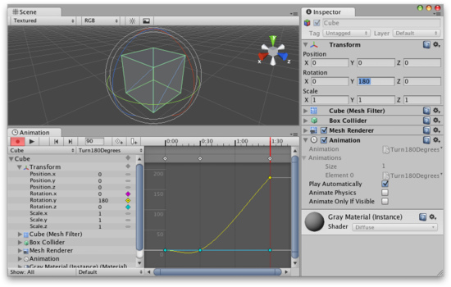
This section covers the most basic information about using the Animation View. This includes creating Animations Clips and how to edit them using the Animation Mode. 本节包括有关使用动画视图最基本的资料。这包括创建动画剪辑和编辑他们如何使用动画模式。

Editing Animation Curves 编辑动画曲线
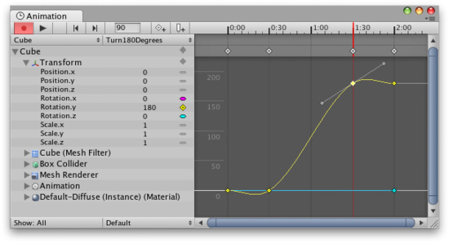
This section covers how to add and edit Animation Curves directly in the Animation View. This includes creating Animation Curves, creating and moving keys and keyframes, and editing tangents and tangent types.
这一节介绍如何添加和直接编辑动画曲线在动画视图里。这包括创建动画曲线，创建和移动键和关键帧，并编辑切线和切线类型。

Objects with Multiple Moving Parts 对象的多个移动部件
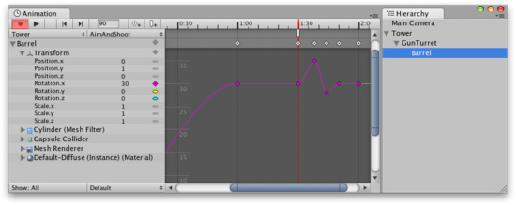
This section covers how to animate Game Objects with multiple moving parts and how to handle cases where there is more than one Animation Component that can control the selected Game Object. 本节介绍如何动画游戏对象的多个运动部件，以及在有一个以上的动画组件可以控制选定的游戏对象的情况下如何处理。

Using Animation Events 使用动画事件
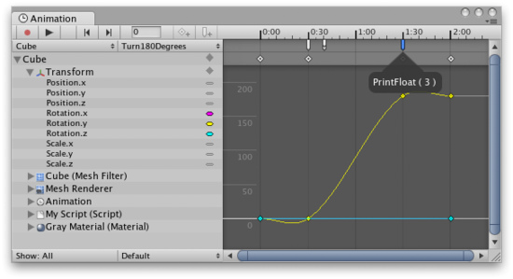
This section covers how to add Animation Events to an Animation Clip. Animation Events lets you call a script function similar to SendMessage as part of playing back an animation.
本节介绍如何添加一个动画事件到一个动画剪辑上。动画事件让你调用相似于SendMessage的脚本函数作为物理播放动画的一部分。

