Sound 声音

Unity Manual > User Guide > Creating Gameplay > Sound

Unity手册->用户指南->建立可玩性游戏->声音

Audio Listener 音频侦听器
The Audio Listener acts as a microphone-like device. It receives input from any given Audio Source in the scene and plays sounds through the computer speakers. It is traditionally attached to the Main Camera.
音频侦听器充当麦克风这样的设备。在场景里它接收受任音频源输入并通过计算机扬声器 播放。这是传统上附加到主照相机的。
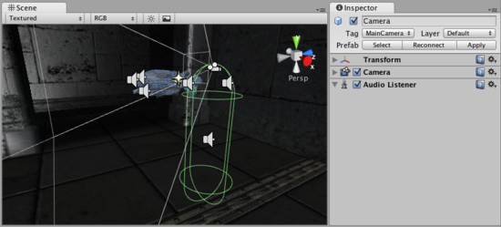
The Audio Listener, attached to the Main Camera 一个音频侦听器， 被附加到主摄像机

Properties 属性
The Audio Listener has no properties. It simply must be added to work. It is always added to the Main Camera by default. 音频侦听器没有属性。它仅必须被添加到工作。它总是被默认的添加到主摄像机。

Details 详细资料
The Audio Listener works in conjunction with Audio Sources, allowing you to create the aural experience for your games. When the Audio Listener is attached to a GameObject in your scene, any Sources that are close enough to the Listener will be picked up and output to the computer's speakers. Each scene can only have 1 Audio Listener to work properly. 音频侦听器与音源协同工作，允许你创建你的游戏听觉体验。当音频侦听器是连接到一个在你场景里的GameObject时，任何足够接近侦听器的源将将被捡起并输出到计算机的扬声器。每个场景只能有1音频监听器去正常的工作。
As long as the Sources are in mono format, the Listener will automatically position the sound correctly in the stereo field, at the correct volume. Stereo Sources will automatically play in both speakers. For example, if your character walks off a street into a night club, the night club's music should probably be stereo, while the individual voices of characters in the club should be mono with their realistic positioning being handled by Unity.
只要来源是单声道格式，侦听器会自动正确的定位声音在立体声区段里，调整正确的音量。立体声源将自动发挥两个扬声器。例如，如果你的角色离开街道到一家夜总会里，在夜总会的音乐应该是立体声，而角色在俱乐部里的个人的声音应该是单声道，与它们当时的实际位置单被Unity处理。
You should attach the Audio Listener to either the Main Camera or to the GameObject that represents the player. Try both to find what suits your game best. 你应该附加音频侦听器到任何一个的主摄像机或GameObject代表的玩家。尝试发现适合你游戏的最好的方式。

Hints 提示
- Each scene can only have one Audio Listener. 每个场景只能有一个音频侦听器。
- You access the project-wide audio settings using the Audio Manager, found in the Edit->Project Settings->Audio menu. 你访问的音频设置项目范围使用音频管理器，发现在Edit->Project Settings->Audio 菜单里。
- View the Audio Clip Component page for more information about Mono vs Stereo sounds.
- 查看音频剪辑组件页获得更多关于单声道与立体声。

Audio Source 音频源
The Audio Source takes an Audio Clip and plays it from a position in the world. 音频源携带一个音频剪辑并从世界的一个位置播放它。
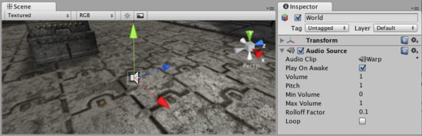
The Audio Source in the Scene View and Inspector音频源在场景里和检视器

Properties 属性
Audio Clip  音频剪辑 | Reference to the sound clip file that will be played  引用将被播放的声音剪辑文件。
Play On Awake  播放唤醒 | If enabled, the sound will start playing the moment the scene launches. If disabled, you need to start it using the Play() command from scripting.  如果启用，声音将开始播放在场景启动的那一刻。如果禁止，你需要去开始它从脚本使用Play()命令。
Volume  音量大小 | How loud the sound is at a distance of 1 world unit (1 meter) from the Audio Listener.  从音频监听器声音如何响亮是在世界的1单位（1米）的远处。
Pitch  音调 | Amount of change in pitch due to slowdown/speed up of the Audio Clip. Value 1 is normal playback speed. 在音调里的变化量由于放缓/加快音频剪辑。值1是正常的播放速度。
Min Volume  最小音量 | The minimum value of the sound. No matter how far away you get, the sound will not get softer than this value.  声音的最低值。无论距离多远你的声音不会得到比这个值柔和。
Max Volume  最大音量 | How loud the sound gets at the loudest. No matter how close you get, the sound will never get louder than this value.  如何响亮的声音得到最响亮。无论你如何接近，声音将永远不会得到超过此值。
Rolloff Factor  滚降系数 | How fast the sound fades. The higher the value, the closer the Listener has to be before hearing the sound.  如何快速声音淡出。数值越高，必须先听到这种声音之前越接近监听器。
Loop  循环 | Enable this to make the Audio Clip loop when it reaches the end.  启用这个使音频剪辑循环当它到达时结束。

Creating Audio Sources 建立音频源
Audio Sources don't do anything without an assigned Audio Clip. The Clip is the actual sound file that will be played back. The Source is like a controller for starting and stopping playback of that clip, and modifying other audio properties. 音源不这样做没有任何指定的音频剪辑。剪辑是实际的声音文件将被播放。源就像是音频剪辑启动和停止播放的控制器以及修改其他音频属性。
To create a new Audio Source: 建立一个新的音源：
- Import your audio files into your Unity Project. These are now Audio Clips. 导入你的音频文件到你Unity项目了。有些新的音频剪辑。
- Go to GameObject->Create Empty from the menubar. 从菜单条执行GameObject->Create Empty
- With the new GameObject selected, select Component->Audio->Audio Source. 选取新的GameObjext，选择Component->Audio->Audio Source
- Assign the Audio Clip property of the Audio Source Component in the Inspector. 在检视器里指定音频源组件的音频剪辑属性

Hints 提示
- The key to a nice sound environment is tweaking the Rolloff Factor.良好声音环境的关键是调整的滚降系数。
- 3D audio effects will only work for mono Audio Clips. Stereo Audio Clips will be mixed as-is into the sound output. 3D音频效果只对单声道音频剪辑工作。立体声音频剪辑将混入到声音输出。

Audio Clip 音频剪辑
Audio Clips are used by Audio Sources to represent the audio asset imported into Unity. Unity supports both Mono and Stereo audio assets. Unity supports importing the following audio file formats: .aif, .wav, .mp3, and .ogg. 音频剪辑所使用的音源代表音频资产导入到Unity里。Unity同时支持单声道和立体声音频资产。Unity支持导入以下音频文件格式：.AIF、.Wav、.MP3和 .ogg。
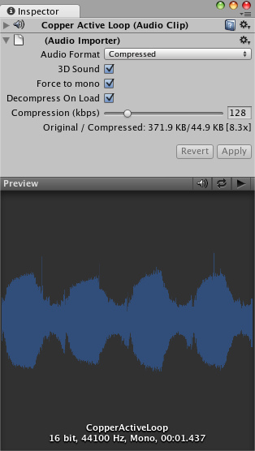
The Audio Clip Inspector 音频剪辑检视器

Properties 属性
Audio Format  音频格式 | The specific format that will be used for the sound at runtime.  具体格式将声音在运行时使用。
Native  原始的 | Larger file size, higher quality. Best for very short sound effects.  较大的文件大小，质量更高。很短的最佳音响效果。
Compressed  压缩的 | Smaller file size, lower/variable quality. Best for medium length sound effects and music.  较小的文件尺寸，降低/质量参差不齐。中等长度的最佳音效和音乐。
3D Sound  3D声音 | If enabled, the sound will play back in 3D space. In Unity 2.6, both Mono and Stereo sounds can be played in 3D  如果启用，将播放声音在三维空间里。在Unity2.6里，单声道和立体声都可以播放的声音在三维里。
Force to mono  强制单声道 | If enabled, the stereo audio clip will be condensed to a single channel mono sound.  如果启用，立体声音频剪辑将简化为单一通道单声道。
Decompress On Load  本地解压 | If enabled, this clip will be loaded into memory as soon as the scene containing it is loaded. It is suggested that you leave this on, otherwise your game may have reduced performance as the sound is decompressed real-time at runtime.  如果启用，这个剪辑将被加载到内存中只要场景里含有它就被加载。它建议你留下这个，否则，你的游戏可能减少的性能，声音是在运行时实时解压缩。
Compression  压缩 | Amount of Compression to be applied to a Compressed clip. Statistics about file size can be seen beneath the slider. It is suggested to drag the slider to a place that leaves the playback "good enough" but still at a small enough size to meet your file size/distribution needs.  压缩量将适用于压缩剪辑。统计有关文件的大小可以看到下面的滑块。它建议拖动滑块到一个地方，离开播放“足够好”，但在一个足够小的尺寸仍然以满足你的文件大小/分配需要。

Importing Audio Assets 导入音频资产
Unity supports both Compressed and Uncompressed Audio. Any type of file except .mp3 will be initially imported as Uncompressed. MP3 and Compressed audio files must be decompressed by the CPU while the game is running, but are smaller in file size. Native formats have the benefit of being higher fidelity without increasing CPU taxation, but create much larger files. Unity同时支持压缩和非压缩音频。任何类型的文件处除了.MP3播放将作为压缩导入.MP3和压缩的音频文件必须由CPU解压在游戏运行中，但文件小。本机格式在被高保真没有增加负担的CPU，而是建立更大的文件。
As a general rule of thumb, Compressed audio is best for long files like background music or dialog, and uncompressed is better for short sound effects that are under two seconds. However...
作为一般原则，压缩音频是对长文件最好的就像背景音乐或对话框，解压是对在两秒钟短音乐效果是好的。然而...
If you are creating a web player game, you should Compress as much of your audio as possible. This will help you attain the smallest file size for webplayer downloads. If you tweak the amount of Compression, the difference in sound quality won't be noticeable. 如果你要创建一个网络游戏的玩家，你应该为你的压缩尽可能多的音频。这将帮助你实现最小的WEPPLAYER下载文件的大小。如果你修改的压缩量，音质的差异不会明显。

Using 3D Audio 使用3D音频
If an audio clip is marked as a 3D Sound then it will be played back to simulate its position in the game world's 3D space. 3D sounds simulate distance and location of sounds by fading volume and panning across speakers. Unity supports 3D audio, and any stereo or mono clip can be played back in 3D space. However, mono 3D sounds are the most common. 如果音频剪辑是明显的3D声音，然后将播放到模拟其在游戏世界的三维空间位置。三维模拟远处和本地的声音通过衰减量和交叉移动麦克风。Unity支持3D音频，任何剪辑立体声或单声道可以被播放在三维空间里。不过，单声道3D声音是最常见的。

Loading Compressed Audio装入压缩音频
Compressed audio files have an option to choose when the Clip will be decompressed. The option is set in the Import Settings: 压缩音频文件有一个选项去选择当剪辑被解压缩时。该选项在导入设置里被设置：
Decompress On Load enabled 在装入时启用解压 | Decompress and load the Clip into RAM when the player is loading. 解压并装入剪辑到内存当玩家被装载时。
Decompress On Load disabled (Live decompression) 在装入时禁用解压（现场解压） | Decompress and play the Clip real-time when the Clip is triggered to start. 解压并实时播放解压当剪辑被触发去启动时
Decompressing on load is the most commonly used option, and shouldn't really be disabled unless you have a special case. It means that the levels containing the Clip will take longer to load initially, and it will use up more of the end-user's RAM. Live decompression does not load the Clip data into RAM at level load. Instead, it requires the CPU to decompress the sound real-time. This means it is more CPU intensive rather than RAM intensive. 在装入时解压缩是最常用的选项，实际上不应被禁用，除非你有特殊情况。这意味着，最初各级包含的剪辑将需要更长的时间来加载，它会使用更多最终用户的内存。现场解压不加载剪辑数据到内存在装入级别。相反，它需要CPU来实时解压缩声音。这意味着它是要更多加强的CPU这样与其倒不如密集的内存型。
To summarize, enable decompression on load as much as possible, and definitely for all short Clips. Pick live decompression for longer Clips like music tracks. All Ogg Vorbis Clips using live decompression will increase CPU usage. It can use a substantial amount of CPU to live decompress multiple Clips at once, so you should avoid playing more than 2 live decompression Clips at once. 总之，尽可能的在加载时启用解压，并明确所有短剪辑。挑选喜欢的音乐曲目长剪辑现场解压。 所有的Ogg Vorbis的剪辑使用现场解压会增加CPU使用率。它可以使用大量的CPU去现场一次解压缩多个剪辑，所以你应该避免播放一次超过2个现场解压剪辑。

