Game Interface Elements 游戏界面元素

Unity Manual > User Guide > Creating Gameplay > Game Interface Elements

Unity手册->用户指南->建立可玩性游戏->游戏界面元素
To create interface elements for your game, you have some options to choose from. You can use GUI Text and GUI Texture objects, or you can use UnityGUI. UnityGUI is the Interface Scripting system introduced in Unity 2.0. 建立界面元素为你的游戏，你有一些选项可供选择。你可以使用GUI文本和GUI的纹理对象，或也可以使用Unity GUI。 UnityGUI是界面脚本系统引入到Unity2.0里。
The rest of this page contains a detailed guide for getting up and running with UnityGUI.
本页面的其余部分包含一个详细指南为学习和运行UnityGUI。

GUI Scripting Guide GUI脚本指南

Overview 概述
GUI stands for Graphical User Interface. Unity's GUI system is called UnityGUI. UnityGUI allows you to create a huge variety of GUIs complete with functionality very quickly and easily. Rather than creating a GUI object, manually positioning it, and then writing a script that handles its functionality, you do all of this at once in a small amount of code. This works by creating GUI Controls, which are instantiated, positioned, and defined all at once.
GUI（图形用户界面）代表图形用户界面。Unity的GUI系统被称为UnityGUI。 UnityGUI允许你非常快捷方便创建一个完整的功能的种类繁多图形用户界面。而不是创建一个GUI对象，手动定位它，然后编写一个脚本来处理它的功能，你能一次做这一切在一个少量的代码里。通过创建图形用户界面控制，这是实例化，并立即定义所有。
For example, the following code will create a fully functional button from scratch:
例如，下面的代码将从零开始创建一个完整的功能按钮：
function OnGUI () {
if (GUI.Button (Rect (10,10,150,100), "I am a button")) {
print ("You clicked the button!");
}
}
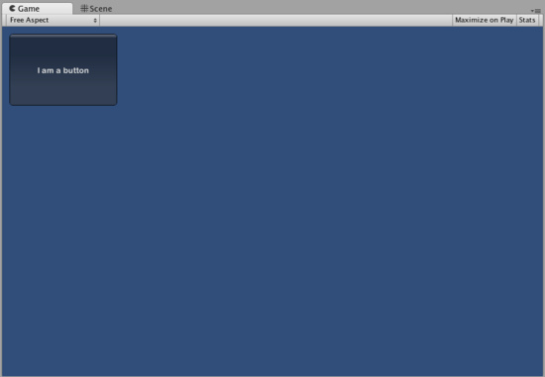
This is the button created by the code above 通过上面的代码创建的按钮。
Although this example is very simple, there are very powerful and complex techniques available for use in UnityGUI. It is a broad subject, and the following sections will help you get up to speed as quickly as possible. This guide can be read straight through, or used as reference material. 虽然这个例子很简单，有非常强大和复杂的技术，在UnityGUI里使用。这是一个广泛的主题，以下各节将帮助你尽快加快速度。本指南可以直接通过阅读，或作为参考材料。

UnityGUI Basics UnityGUI基础
This section covers the important concepts of UnityGUI, giving you an overview as well as a bunch of working examples you can paste into your own projects. UnityGUI is very friendly to play with, so this is a good place to get started. 本节涵盖UnityGUI的重要概念，为你提供的概述以及一堆的工作的例子，你可以粘贴到自己的项目里。 UnityGUI是非常友好的处理，所以这是一个好地方开始。

Controls 控制
This section lists every available Control in UnityGUI. It is complete with code examples and images.
本节列出每一个可用的控制在UnityGUI里。这是完整的代码实例和图片。

Customization 定制
Creating functional GUI controls would not be as useful if their appearances couldn't be customized. Thankfully, we've thought of this. All controls in UnityGUI can be customized with GUIStyles and GUISkins. This section explains how to use them.
创建GUI控制的功能将不会被视为有用的，如果他们的外表不能定制。谢天谢地，我们已经想到了这一点。在UnityGUI里的所有控制可定做GUIStyles和GUISkins。本节说明如何使用它们。

Layout Modes 布局模型
UnityGUI features two ways to arrange your GUIs. You can manually place each control on the screen, or you can use an Automatic Layout system which works a lot like HTML tables. Using one system or the other is as simple as using a different class, and you can mix the two together. This section explains the functional differences between the two systems, including examples.
UnityGUI的特性两种方式来安排你的图形用户界面。你可以手动地在屏幕上放置每个控制，也可以使用很多像HTML表格自动布局系统的工作方式。使用一个系统或其他很简单的使用不同的类，并且可以将两者混为一谈。本节说明两个系统之间包括实例性能上的差异。

Extending UnityGUI 扩展UnityGUI
UnityGUI is very easy to extend with new Control types. This chapter shows you how to make simple compound controls, then goes on to show you how to make a custom control - complete with integration into Unity's event system.
UnityGUI很容易扩展至新的控制类型。本章告诉你如何使简单的复合控制，然后向你展示如何使一个自定义控制-配套的集成到Unity的事件系统里。

Extending Unity Editor 扩充Unity 编辑器
The main Unity editor is written using UnityGUI. It is completely extensible using the same code as you would use for in-game GUI. In addition, there are a bunch of Editor specific GUI widgets to help you out when creating custom editor GUI.
主要的Unity编辑器是使用UnityGUI。这是完全可扩展使用相同的代码，你会利用游戏中的图形用户界面。此外，有一些特定的GUI部件编辑小配件帮助你在创建自定义编辑器图形用户界面。

