Unity Manual > Advanced > Profiler
Unity手册->高级->分析器

Profiler分析器
The Unity Profiler helps you to optimize your game. It reports for you how much time is spent in the various areas of your game. For example, it can report the percentage of time spent rendering, animating or in your game logic.
Untiy分析器帮助你优化你的游戏。它为你报告花费多少时间在你的游戏各个领域里。例如，它可以报告花费的时间百分比用于渲染，动画，或在你的游戏逻辑。
The profiler was added at Unity version 2.6. It is a Unity Pro feature. 分析器是加在Unity版本2.6里。这是一个Unity专业版的功能。
You can play your game in the Editor with Profiling on, and it will record performance data. The Profiler window then displays the data in a timeline, so you can see the frames or areas that spike (take more time) than others. By clicking anywhere in the timeline, the bottom section of the Profiler window will display detailed information for the selected frame.
你可以在编辑器里播放你的游戏并开启分析，它将记录性能数据。 分析器窗口然后在一个时间线里显示数据，因此可以看到框架或区域，峰值（需要更多的时间）超过其它的。按一下在任何时间，该事件分析器窗口底部的部分将显示选定的帧的详细信息。
Note that profiling has to instrument your code. This instrumentation has a small impact on the performance of your game. Typically this overhead is small enough to not affect the game framerate. When using profiling it is typical to consider only the ratio (or percentage) of time spent in certain areas. Also, to improve performance focus on those parts of the game that consume the most time. Compare profiling results before and after code changes and determine the improvements you measure. Sometimes changes you make to improve performance might have a negative effect on frame rate; unexpected consequences of code optimization should be expected.
请注意，要分析器必须分析你的代码。这种仪器拥有对你的游戏的性能影响很小。一般来说，这个开销是足够小，不会影响游戏的帧率。当使用分析它通常只考虑比率（或百分比在某些区域所花的时间）。此外，为了提高性能对游戏的部分消耗最多的焦点。比较前后修改代码，并确定你的改进措施以及分析结果。有时会改变你对提高性能可能会对帧速率的产生负面效应;代码优化意想不到的后果应被预期。
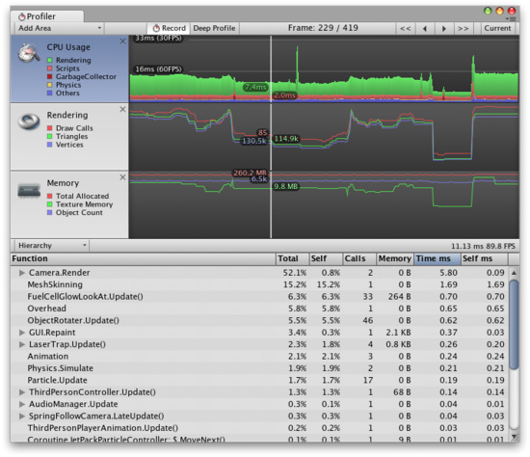
Profiler window 分析器窗口

Profiler Controls 分析器控制
Profiler controls are in the toolbar at the top of the window. Use these to turn profiling on and off, navigate through profiled frames and so on. The transport controls are at the far right end of the toolbar. Note that when the game is running and the profiler is collecting data clicking on any of these transport controls will pause the game. The controls go to the first recorded frame, step one frame back, step one frame forward and go to the last frame respectively. The profiler does not keep all recorded frames, so the notion of the first frame should really be though of as the oldest frame that is still kept in memory. The "current" transport button causes the profile statistics window to display data collected in real-time.
分析器控制在工具栏在窗口的顶部。使用这些分析打开和关闭，浏览分析框架等。传输控制在工具栏的最右侧。请注意，当游戏运行和分析器正在收集数据，点击任何这些传输控制将暂停游戏。这些控制转到第一个记录的框架，一步一帧回来，一步一帧前进到各自的最后一帧。分析器并没有记录全部的帧，所以第一帧的概念真正应该作为最原始的框架仍然保存在内存中。 “当前”传输按钮导致统计分析窗口去显示的实时收集的数据。

Deep Profiling 深度分析
When you turn on Deep Profile, all your script code is profiled - that is, all function calls are recorded. This is useful to know where exactly time is spent in your game code.
当你打开深度分析，所有的脚本代码被分析--也就是说，所有的函数调用记录。这用于去了解准确时间应用到何处在你的游戏代码里。
Note that Deep Profiling incurs a very large overhead and uses a lot of memory, and as a result your game will run significantly slower while profiling. If you are using complex script code, Deep Profiling might not be possible at all. Deep profiling should work fast enough for small games with simple scripting. If you find that Deep Profiling for your entire game causes the frame rate to drop so much that the game barely runs, you should consider not using this approach, and instead use the approach described below. You may find deep profiling more helpful as you are designing your game and deciding how to best implement key features. Note that for large games deep profiling may cause Unity to run out of memory and so for this reason deep profiling may not be possible.
请注意，深度分析导致一个非常大的开销，使用了大量的内存，因此你的游戏运行显著降低在分析过程中。如果你正在使用复杂的脚本代码，深度分析可能无法分析所有。深度分析应工作足够快对于简单的脚本小游戏。如果你发现为你的整整个游戏深度分析导致刚刚运行的游戏帧速率下降很多，你应该考虑不使用这种方法，而是使用如下介绍的方法。你可能会发现深度的分析提供更多帮助在你设计你的游戏时，并决定如何最好地实现主要功能。请注意，对于大型游戏的深度分析可能导致Unity的运行内存不足，为此深度分析可能无法接受。
Manually profiling blocks of your script code will have a smaller overhead than using Deep Profiling. Use Profiler.BeginSample and Profiler.EndSample scripting functions to enable and disable profiling around sections of code.
手工分析你的脚本代码块将有一个使用小的开销与使用深度分析相比。使用Profiler.BeginSample和Profiler.EndSample脚本函数启用或禁止分析代码段。

Profiler Timeline 时间线分析器
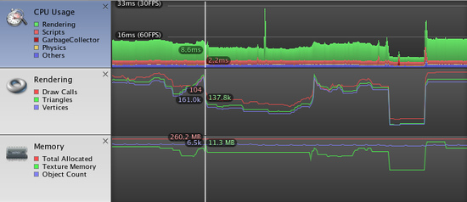
The upper part of the Profiler window displays performance data over time. When you run a game, data is recorded each frame, and the history of the last several hundred frames is displayed. Clicking on a particular frame will display it's details in the lower part of the window. Different details are displayed depending on which timeline area is currently selected.
在分析器窗口的上部中显示随着时间的推移性能数据。当你运行一个游戏，数据记录每一帧，并显示过去几百帧的历史。点击某一帧将在窗口的下半部分显示它的细节。不同细节的显示取决于时间区的当前选择。
The vertical scale of the timeline is managed automatically and will attempt to fill the vertical space of the window. Note that to get more detail in say the CPU Usage area you can remove the Memory and Rendering areas. Also, the splitter between the timeline and the statistics area can be selected and dragged downward to increase the screen area used for the timeline chart.
时间线的纵坐标是自动管理并尝试填补窗口的垂直空间。请注意，要获得更详细地在你可以删除内存和渲染领域的CPU使用率区域中说明。此外，在时间线和统计领域之间的分析器可以被选择和向下拖动以增加屏幕面积的时间表图表的使用。
The timeline consists of several areas: CPU Usage, Rendering and Memory. These areas can be removed by clicking the close button in the panel, and re-added again using the Add Area drop down in the Profile Controls bar.
时间线包括几个方面：CPU使用率，渲染和内存。这些领域可以移除通过单击面板关闭按钮，并重新添加再次使用新增面积下降在分析控制栏里。

CPU Usage Area CPU利用率
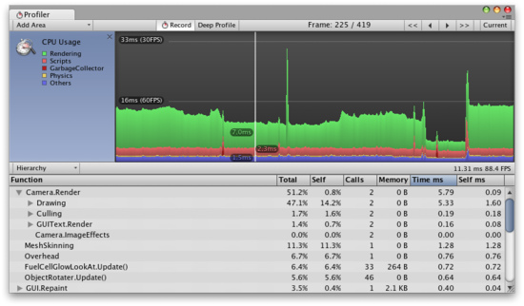
The CPU Usage area displays where time is spent in your game. When it is selected, the lower pane displays hierarchical time data for the selected frame.
CPU使用率区域显示在你的游戏哪里的时间是被用过的。当它被选中，下部窗格显示分层的实时数据。
- Hierarchy mode - displays hierarchical time data. 层次模式—显示层次时间数据
- Group Hierarchy mode - groups time data into logical groups (Rendering, Physics, Scripts etc.).
- 层次群模式—逻辑组里的群时间数据（渲染、物理、脚本等）。
Because children of any group can be in different group (e.g. some script might call rendering functions), the percentages of group times often add up to more than 100%. (This is not a bug.)
因为任何组的可在不同的组里（例如：一些脚本也许调用渲染函数），组时间的百分比常常总计超过100%（这是一个BUG）。
The way the CPU chart is stacked can be reordered by simply dragging chart labels up & down.
在CPU的图表方法是堆积可以通过简单的拖动图表标签升降排序。
When an item it selected in the lower pane, it's contribution to the CPU chart is highlighted (and the rest are dimmed). Clicking on an item again de-selects it.
当一个项目是在较低的窗格中选中，它的贡献是突出的CPU图表（并变灰）。在一个项目再次点击取消选择它。
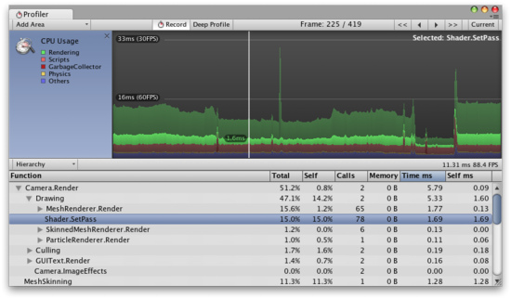
Shader.SetPass is selected and it's contribution is highlighted in the chart.
Shader.SetPass被选中，它的贡献是在图表中突出显示。
In the hierarchical time data the self time refers to the amount of time spent in a particular function not including the time spent calling sub-functions. In the screenshot above, for example 51.2% of time is spent in the Camera.Render function. This function does a lot of work and calls the various drawing and culling functions. Excluding all these functions only 0.8% of time is spent actually in the Camera.Render function.
在分层时间数据的自我时间是指在某一特定功能所用的时间不包括调用子功能所花费的时间。在上面的截图里，例如51.2％的时间，花费在Camera.Render函数上。这个函数做了大量工作并调用若干绘画函数和精选函数。除去所有这些只有0.8％的时间花费在Camera.Render函数实际功能上。

Rendering Area 渲染区域
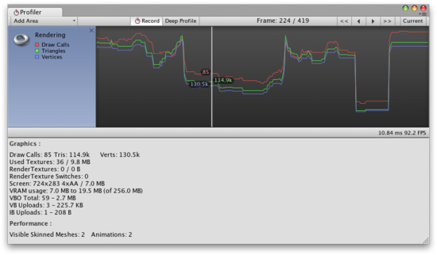
The Rendering area displays rendering statistics. The Number of Draw Calls, Triangles and Vertices rendered is displayed graphical in the timeline. The Lower pane displays more rendering statistics and these more closely match the ones shown in the GameView Rendering Statistics window.
渲染区域显示的渲染统计。绘制调用的数量，三角形和顶点渲染是在时间线中显示图形。下部窗格显示更多的渲染统计而这些更紧密的配合显示在GameView的渲染统计窗口。

Memory Area 内存区域
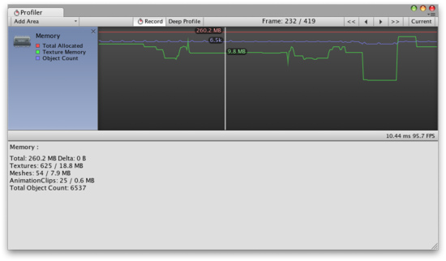
The Memory area displays some memory usage data: 内存区域显示内存使用的一些数据：
Total Allocated is the total RAM used by the application. Note that in the Unity Editor this is memory used by everything in the editor; game builds will use much less.
总分配内存是应用程序使用内存的合计。请注意，在Unity的编辑器，这是在编辑器中所使用的一切内存;游戏编译使用较少。
Texture Memory is the about of video memory used by the textures in the current frame.
纹理内存是关于纹理使用的显存在当前游戏里。
Object Count is the total number of Objects that are created. If this number rises over time then it means your game is creating some objects that are never destroyed.
对象计数是创建的对象总数。如果这个数字随着时间的推移上升那么这意味着你的游戏的创建的一些对象从未释放过。

See Also参见
- Optimizing Graphics Performance page.优化的图形性能页。

