Unity Manual > Advanced > Shadows in Unity > Directional Shadow Details
Unity手册->高级->Unity中的阴影->方向阴影细节

Directional Shadow Details方向阴影细节
This page explains shadows from Directional lights in detail. 本从定向光源细节解释阴影。
Directional lights are mostly used as a key light - sunlight or moonlight - in an outdoor game. Viewing distances can be huge, especially in first and third person games, and shadows often require some tuning to get the best quality vs. performance balance for your situation. 定向光源大多是用来作为主光源-阳光或月光-在室外游戏里。视距可以是巨大的，尤其是在第一和第三人称游戏，以及阴影往往需要一些调整，以获得与性能的平衡状况最好的质量。
Let's start out with a good looking shadow setup for a 3rd person game: 让我们开始一个漂亮的阴影设置的第三人称游戏：
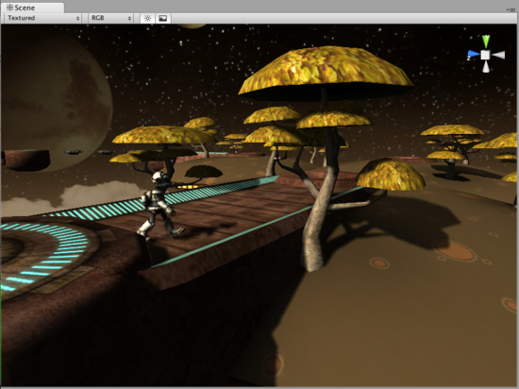
Shadows here look pretty good! 阴影这里看来相当不错！
Here, visible distance is about 50 game units, so Shadow Distance was set to 50 in Quality Settings. Also, Shadow Cascades was set to 4, Shadow Resolution to High, and the light uses Soft Shadows. 在这里，可视距离约50游戏单位，因此在质量设置里设置影子距离为50。此外，阴影级联被设置为4，阴影的分辨率设置为高，而灯光使用软阴影。
Chapters below dissect each aspect of directional light shadows: 以下各章解剖定向光阴影每个方面：
- Hard versus Soft shadows 硬阴影与软阴影
- Shadow Cascade count 阴影级联数
- Shadow Distance is Important! 阴影距离很重要！

Hard versus Soft shadows硬阴影与软阴影
Using the same light setup, if we switch Shadow Type to Hard Shadows, then the transition from lit to shadowed regions is "hard" - either something is 100% in shadow, or 100% lit. Hard shadows are faster to render but often they look less realistic. 使用相同的光源设置，如果我们改用阴影类型的硬阴影，然后从照亮阴影区的过渡转换到“硬” -无论事情是100%的阴影，或100％照亮。硬阴影被快速渲染但往往它们看起来不太现实。
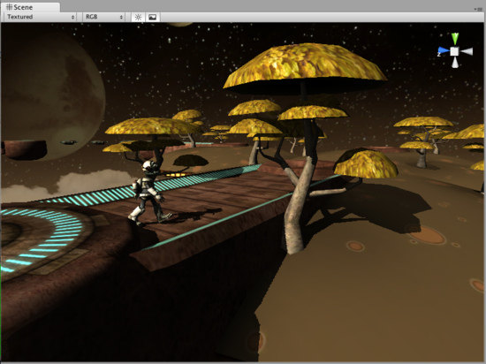
Hard shadows with distance of 50 and four cascades. 50个硬阴影和4个级联距离。

Shadow Cascade count 阴影级联数量
For Directional lights Unity can use so called Cascaded Shadow Maps (alternatively called "Parallel Split Shadow Maps") which give very good shadow quality, especially for long viewing distances. Cascaded shadows work by dividing viewing area into progressively larger portions and using the same size shadow map on each. The result is that objects close to the viewer get more shadow map pixels than objects far away.
Unity定向光源可以使用所谓的级联阴影地图（也称“平行拆分阴影地图”），提供很好的阴影质量，特别是长视距。级联分成逐步较大的部分，并在每个使用同样大小的阴影图可视面积阴影工作。其结果是，物体接近观众得到更多的阴影映射像素超过更远的物体。
In the images below we'll use Hard shadows because shadow pixels are better visible there. 在以下图片，我们将使用硬阴影，因为在那里阴影像素更好可见。
If no cascaded shadow maps were used, the entire shadow distance (still 50 units in our case) must be covered by the shadow texture uniformly. Hard shadows would look like this with no cascades: 如果没有级联阴影地图使用，整个阴影的距离（仍旧50个单位在我们的方案里）必须由阴影纹理均匀覆盖。硬阴影看起来像这样的，没有瀑布：
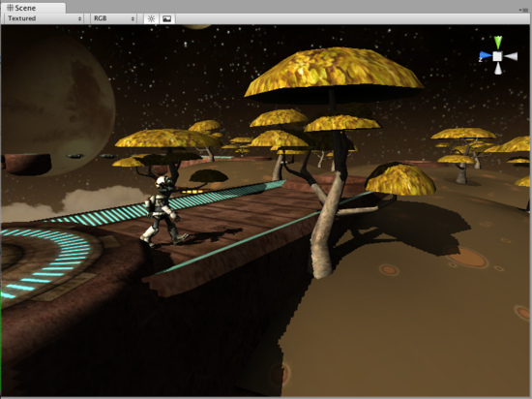
Hard shadows with distance of 50 and no cascades. 50距离的硬阴影而没有级联。
The pixels of the shadow texture are the same size everywhere, and while they look good in distance, the quality is not stellar up close. The shadow texture covers the entire viewing area, and if visualized it would look like this: 阴影纹理像素的大小相同随处可见，而在距离里他们看起来良好，质量是没有星体的近距离。阴影纹理覆盖整个显示区域，如果直观的它将看起来像这样：
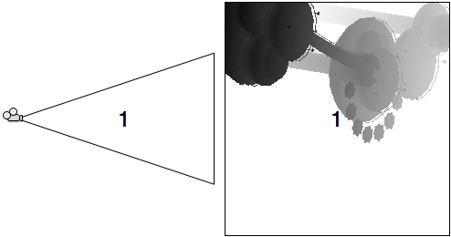
With no cascades, shadow texture covers viewing area uniformly. 没有级联，阴影纹理平均的覆盖。
When two shadow cascades are used, the entire shadow distance is divided into a smaller chunk near the viewer and a larger chunk far away. Hard shadows would look like this with two cascades: 当两个阴影级联使用，整个阴影距离分为接近的观众一小块和远处的一大块。硬阴影是这样的两个级联：
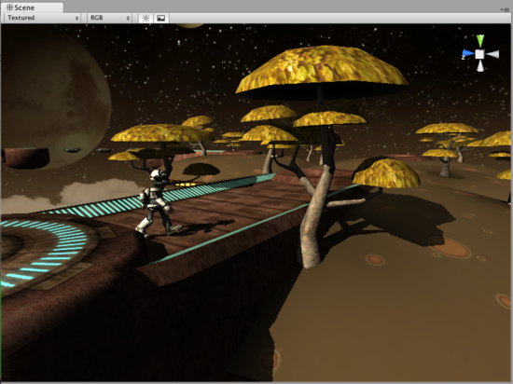
Hard shadows with distance of 50 and two cascades. 50的距离的硬阴影和两个级联。
In exchange for some performance, we get better shadow resolution up close. 调整一些性能，我们获得更好的阴影的近距离的清晰度。
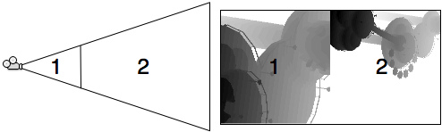
With two cascades, two shadow textures cover different sized portions of viewing area.
利用2个级联，2个阴影纹理覆盖不同大小视图区域的位置。
And finally when four shadow cascades are used, the shadow distance is divided into four progressively larger portions. Hard shadows would look like this with four cascades: 最后，当4级联阴影使用，阴影的距离分为四个大的部分逐渐分化。硬阴影是这样的四个级联：
Hard shadows with distance of 50 and four cascades. Hey, we've seen this already! 50距离的硬阴影和4个级联。
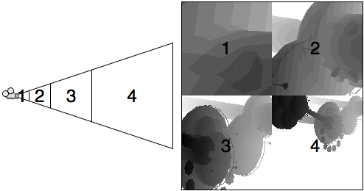
With four cascades, four shadow textures cover different sized portions of viewing area. 利用4个级联，四个阴影纹理覆盖不同大小视图区域位置。

Shadow Distance is Important! 阴影距离很重要！
Shadow Distance is extremely important for both quality and performance of directional light shadows. Just like shadow cascade count, shadow distance can be set in Quality Settings and allows an easy way to scale shadows down on less performant hardware. 阴影距离是非常重要的对质量和阴影的定向光性能而言。就像阴影级联计数，在质量设置里可以设定阴影距离，并允许一个简单的方法来伸缩阴影向下在少高性能的硬件上。
Shadows fade out at the end of shadow distance, and further than that objects are not shadowed. In most situations shadows further than some distance in the game would not be noticeable anyway! 阴影淡出在阴影距离的末尾，并进一步比物体不带阴影。在大多数情况下的阴影比一些距离在游戏中明显不会失去！
With no shadow cascades, hard shadows and shadow distance set to 20 units our shadows look like picture below. Note that shadows do fade out in the distance, but at the same time shadow quality is much better than it was with no cascades and a distance of 50 units. 由于没有影子级联，硬阴影和阴影距离设置为20个单位的阴影看起来像下面的图片。请注意，阴影不消失在远方，但同时阴影质量明显优于它没有级联和50个单位的距离。
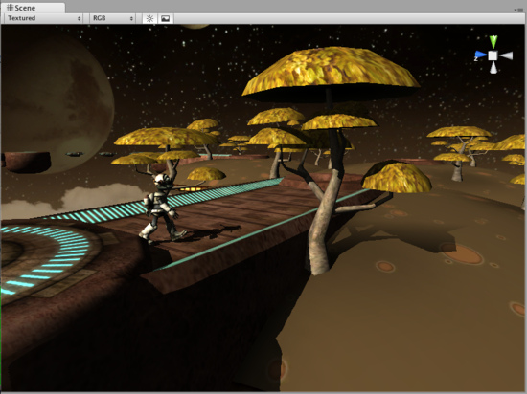
Hard shadows with distance of 20 and no cascades. 20的距离硬阴影而没有级联。
If on the other hand we set shadow distance too high, shadows won't look good at all. Setting distance to 100 here only decreases both performance and quality and does not make much sense - no objects in the scene are further than about 50 meters anyway! 如果在另一方面，我们设置阴影距离过高，阴影根本不会好看。这里设置距离只有100，既降低性能和质量而没有太大意义-在场景里无路如何没有对象进一步超过50米！
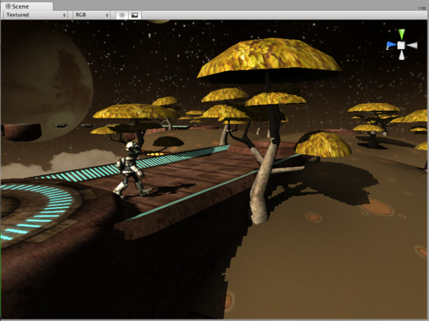
Hard shadows with distance of 100 and no cascades. Ouch! 100距离的硬阴影和没有级联。唉哟！
Shadow maps with cascades scale with distance much better. For example, four cascade soft shadows with covering 300 units in front of the camera look like picture below. It's somewhat worse than the picture at the top of this page, but not very bad either for a 6x increase in shadowing distance (of course in this scene that high shadow distance does not make much sense). 与级联的距离伸缩更好的阴影地图。例如，在覆盖300个单位的4级联柔阴影在摄像机前面看起来像下面的图像。这有点不如在此页顶部图片，但不是非常糟糕，在阴影的距离增加6倍（当然，在这个场景里，高阴影距离并没有多大意义）。
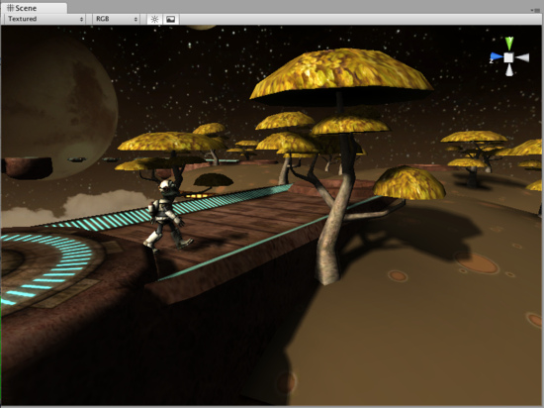
Soft shadows with distance of 300 and four cascades. 300距离的软阴影和4个级联

