Unity Manual > Advanced > Optimizing Graphics Performance > Rendering Statistics Window
Unity手册->高级->优化图形性能->渲染统计窗口

Rendering Statistics Window 渲染统计窗口
The Game View has a Stats button top right. When this Stats button is pressed, an overlay window is displayed with realtime rendering statistics. This is very useful for Optimizing Graphics Performance. Additionally, Profiler shows some rendering statistics.
游戏视图有一个统计按钮在右上角。当这个按钮被按下统计，一个重叠窗口与实时渲染的统计数字显示。这是非常有用的优化的图形性能。此外，分析器显示了一些渲染的统计数字。
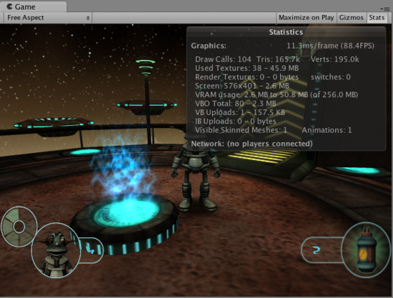
Rendering Statistics Window 渲染统计窗口
Statistics window contains the following information: 通体窗口包含如下的信息：
Time per frame and FPS  每帧时间和FPS | How much time it takes to process and render one game frame (and resulting FPS). Note that this number only includes frame update and rendering of the game view; and does not include time taken in the editor to draw the scene view, inspector and other editor-only processing.  花费多少的时间去处理进程和渲染一个游戏的帧（以及FPS结果）。请注意，这个数字只包括帧更新和游戏图像生成;，不包括在编辑器中绘制场景视图，检视器和其它编辑器只处理时间。
Draw Calls  绘制调用 | How many objects are drawn in total. This accumulates objects that are drawn multiple times as well, for example some object that is affected by pixel lights will add several draw calls.  总共有多少对象被绘制。这种积累的对象也被绘制多次，例如一些受影响对象通过像素光源绘制将添加几个绘制调用。
Tris and Verts  三角形和顶点 | Number of triangles and vertices drawn. This is mostly important when optimizing for low-end hardware  三角形和顶点数目绘制。这主要是重要的当优化低端硬件时。
Used Textures  使用纹理 | Count and memory size of textures used when drawing this frame.  纹理的数量和内存大小使用当绘制这个帧时。
Render Textures  渲染纹理 | Count and memory size of Render Textures that are created. Also displays how many times active Render Texture was switched during this frame.  所创建的纹理渲染的数量和内存大小。也显示有多少次激活的渲染纹理被在这个帧期间交换。
Screen  屏幕 | Size, anti-aliasing level and memory taken by the screen itself.  大小，图形保真水平和内存携带通过屏幕它自身。
VRAM usage  显存使用率 | Approximate bounds of current video memory (VRAM) usage. Also shows how much video memory your graphics card has.  当前视频内存（显存）使用近似边界。也显示你显卡有多少视频内存。
VBO total  VBO总计 | Number of unique meshes (vertex buffers) that are uploaded to the graphics card. Each different model will cause new VBO to be created. In some cases scaled objects will cause additional VBOs to be created.  独特网格的数量（顶点缓冲器）上传至显卡。每一个不同的模型将导致新的VBO被创建。在某些情况下伸缩对象将造成额外VBOS被创建。
VB uploads  VB 上载 | Count and size of vertex data changed this frame. Dynamic geometry, like particles or skinned meshes, will contribute to this, as well as terrain LOD changing, etc.  这个帧的顶点数据更改的数量和大小。动态几何结构、像粒子和皮肤网格，将有助于这一点，以及地形LOD的变化等。
IB uploads  IB 上载 | Count and size of triangle data changed this frame. Dynamic geometry, like particles or skinned meshes, will contribute to this, as well as terrain LOD changing, etc.  这个帧的三角形数据更改的数量和大小。动态几何结构，像粒子和皮肤网格，将有助于这一点，以及地形LOD的变化等。
Visible Skinned Meshes  可视皮肤网格 | How many skinned meshes are rendered.  多少皮肤网格被渲染。
Animations  动画 | How many animations are playing.  多少动画 被播放。

