Unity Manual > Advanced > Graphics Emulation

Graphics Emulation
You can choose to emulate graphics hardware with less capabilities when working in Unity editor. This is very handy when writing custom shaders and rendering effects, and is a quick way to test how your game will look on that eight year old graphics card that someone might have.
To enable Graphics emulation, go to Edit->Graphics Emulation, and choose your desired emulation level.
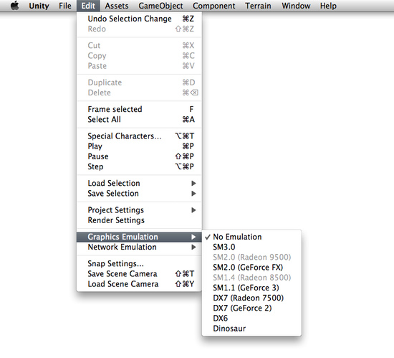
Enabling Graphics Emulation

Technical Details
Graphics emulation limits the graphics capabilities that are supported, but it does not emulate the performance of graphics hardware. Your game in the editor will still be rendered by your graphics card; just more and more features will be disabled as you choose further emulation levels.
While emulation is a quick way to check out graphics capabilities, you should still test your game on actual hardware. This will reveal real performance, and any peculiarities of the specific graphics card, operating system or driver version.

Emulation Levels
Graphics emulation levels are the following:
No Emulation
No emulation is performed.
SM3.0
Emulates graphics card with Shader Model 3.0 level capabilities. Long vertex & fragment shader programs and support for built-in shadows.
SM2.0 (Radeon 9500)
Shader Model 2.0 capabilities, ATI Radeon style. Vertex & fragment programs, support for built-in shadows, ATI text fragment shader extension, 8 texture units.
SM2.0 (GeForce FX)
Shader Model 2.0 capabilities, NVIDIA GeForce style. Vertex & fragment programs, support for built-in shadows, 4 texture units.
SM1.4 (Radeon 8500)
Shader Model 1.4 capabilities. Vertex programs, ATI text fragment shader extension, 6 texture units. Not supported: fragment programs, built-in shadows.
SM1.1 (GeForce 3)
Shader Model 1.1 capabilities. Vertex programs, 4 texture units. Not supported: fragment programs, built-in shadows.
DX7 (Radeon 7500)
DirectX 7 level capabilities. Vertex programs (usually in software mode), 3 texture units. Not supported: fragment programs, built-in shadows.
DX7 (GeForce 2)
DirectX 7 level capabilities. Vertex programs (usually in software mode), 2 texture units, texture size limited to 2048, cubemap size limited to 512. Not supported: fragment programs, built-in shadows, volume textures, some complex texture combine modes.
DX6
DirectX 6 level capabilities. 2 texture units, texture size limited to 1024. Not supported: vertex & fragment programs, built-in shadows, cubemaps, volume textures, rectangle textures, three argument texture combine modes, DOT3 texture combine modes, projected textures.
Dinosaur
Emulates graphics cards everyone already forgot about! One texture unit, texture size limited to 512, vertex light count limited to 4. Not supported: vertex & fragment programs, built-in shadows, cubemaps, RenderTextures, volume textures, rectangle textures, three argument texture combine modes, DOT3 texture combine modes, projected textures.
When your graphics card does not support all capabilities of some emulation level, that level will be disabled. For example, Intel GMA950 (Intel 915/945/3000) card does not support Shader Model 3.0, so there's no way to emulate that level.

