By: Goh Kun Ming
Admin Number: P2415691
Class: DAAA/FT/2B/02
Lecturer: Senior Lecturer Peter Wai Tong Lee
DAta VISUALISATION (ST1502) CA1

Chart Specifications

Charts Specifications

1.1 Chart 1: Treemap (TO BE MARKED)
Purpose
This treemap visual is designed to benchmark the cost efficiency of every HDB flat model by using the user-selected metric (e.g., Average Price per Sqm, Median Price, etc.). By encoding each flat model as a proportional tile, the visual strategically highlights which models deliver higher or lower cost efficiency at a glance, enabling users to rapidly compare the relative “value” of each model without digging through raw numbers.
From a decision-making perspective, this chart empowers potential buyers to:
- Identify premium or high-cost flat models that may stretch their budget.
- Spot more cost-efficient models that offer better price-to-space value.
- Understand market segmentation across all flat models.
- Interactively switch metrics via the parameter to evaluate cost efficiency from multiple angles.
In short, this visual operationalises a high-level “cost efficiency scan” across the ecosystem of HDB flat models, giving the user a strategic, data-driven baseline before drilling into more detailed dashboards.
Table 1: Treemap Specifications
Sheet Name | Attributes Use | Calculated Field Use | Filter or Parameter Use
Chart 1: Treemap - Cost Efficiency Across HDB Flat Models | Columns:  NIL  Rows:  NIL  Marks (Size):  AGG(Selected Metric)  Marks (Colour):  AGG(Selected Metric)  Marks (Text):  Flat Model  AGG(Selected Metric)  Marks (Tooltip):  FlatType_Selected  AGG(Selected Metric)  PCT10(Resale Price)  PCT90(Resale Price)  Metric Selector  CNT(Resale Price)  AVG(Resale Price)  MEDIAN(Resale Price) | Filter by Flat Type  IF [FlatType_Selection] = 0 THEN  TRUE  ELSE  [FlatType_Code] = [FlatType_Selection]  END  *FlatType_Selection is a parameter  Selected Metric  CASE [Metric Selector]  WHEN "Average Resale Price" THEN AVG([Resale Price])  WHEN "Median Resale Price" THEN MEDIAN([Resale Price])  WHEN "Average Price per Sqm" THEN AVG([Price Per Sqm])  WHEN "Median Price per Sqm" THEN MEDIAN([Price Per Sqm])  END  *Metric Selector is a parameter | Filter  Filter by Flat Type  Parameter  Metric Selector  FlatType_Selection]

Chart 1: Treemap - Cost Efficiency Across HDB Flat Models
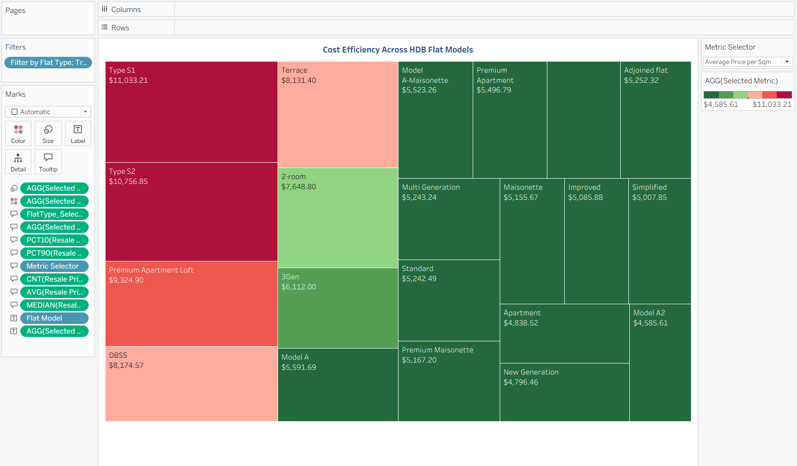

1.2 Chart 2: Map (TO BE MARKED)
*Contains Additional Data
Purpose
This geospatial visual provides a macro-level market scan across Singapore by layering two key elements:
- URA Planning Area polygons, shaded according to the selected pricing metric (e.g., Average Resale Price, Average Price per Sqm).
- Individual HDB resale transactions, plotted as point data and colour-encoded by flat type.
This dual-layer design enables users to contextualise micro transactions within macro regional trends, supporting more strategic, location-based decision-making.
Specifically, the chart helps users to:
- Identify high-price and low-price clusters across planning areas through intuitive choropleth shading.
- Observe the distribution of different flat types across the island, revealing supply patterns and neighbourhood specialisation.
- Benchmark price disparities between central and non-central regions at a glance.
- Understand how individual resale points sit within broader regional price dynamics, especially for town-level comparison.
- Use filters (Flat Type, Planning Area, Town, Flat Model) to drill down and derive more personalised insights.
From a decision-support standpoint, this map functions as a strategic first touchpoint to help potential buyers anchor their expectations geographically before exploring more granular dashboards.
Table 2: Layered Map Specifications
Sheet Name | Attributes Use | Calculated Field Use | Filter or Parameter Use
Chart 2: Map - HDB Market Landscape Across Singapore | Columns:  Longitude (generated)  Rows:  Latitude (generated)  Filled Map’s Marks (Colour):  AGG(Selected Metric)  Filled Map’s Marks (Text):  Planning Area Ura  Filled Map’s Marks (Detail):  Planning Area Ura  Filled Map’s Marks (Tooltip):  Metric Selector  CNT(Resale Price)  PCT10(Resale Price)  PCT90(Resale Price)  MEDIAN(Resale Price)  FlatType_Selected  ATTR(Planning Area Ura)  ATTR(Region Ura)  AVG(Resale Price)  HDB Location’s Marks (Colour):  Flat Type  HDB Location’s Marks (Detail):  Longitude  Latitude  Town  Flat Model  Block  HDB Location’s Marks (Tooltip):  AVG(Floor Area Sqm)  AVG(Price Per Sqm)  AVG(Resale Price)  ATTR(Lease Commence Date)  ATTR(Remaining Lease) | Price Per Sqm  [Resale Price] / NULLIF([Floor Area Sqm], 0)  Filter by Flat Type  IF [FlatType_Selection] = 0 THEN  TRUE  ELSE  [FlatType_Code] = [FlatType_Selection]  END  *FlatType_Selection is a parameter  Selected Metric  CASE [Metric Selector]  WHEN "Average Resale Price" THEN AVG([Resale Price])  WHEN "Median Resale Price" THEN MEDIAN([Resale Price])  WHEN "Average Price per Sqm" THEN AVG([Price Per Sqm])  WHEN "Median Price per Sqm" THEN MEDIAN([Price Per Sqm])  END  *Metric Selector is a parameter | Filter  Filter by Flat Type  Action(Planning Area Ura)  Action(Town)  Action(Flat Model)  Parameter  Metric Selector  FlatType_Selection]

Chart 2: Map - HDB Market Landscape Across Singapore
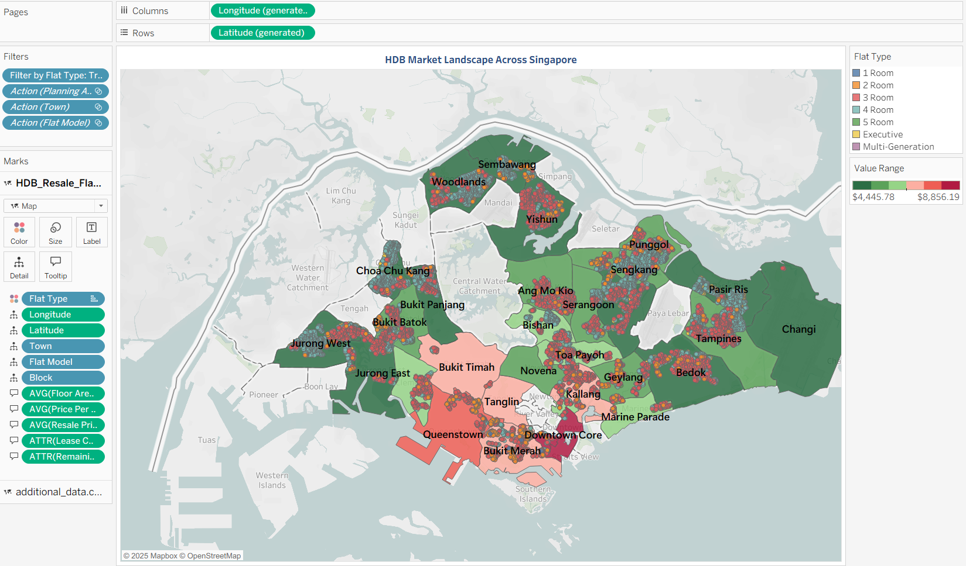

1.3 Chart 3: Time Series (TO BE MARKED)
Purpose
This line chart provides a multi-year perspective on how HDB prices have evolved over time, enabling users to evaluate both historical behaviour and forward-looking projections. By plotting the selected metric (e.g., Average Price per Sqm) against year and overlaying Tableau’s forecasting model, the chart helps users establish a realistic expectation of future resale price movements.
Key objectives of this visual include:
- Highlighting long-term pricing trajectories, showing whether prices have been trending upward, stable, or volatile.
- Quantifying year-on-year changes, giving users contextual clarity on market acceleration or slowdown.
- Providing forecasted price ranges, allowing buyers to budget more strategically for upcoming years.
- Supporting scenario planning, especially for users intending to purchase within the next 1 to 3 years.
- Enabling deeper segmentation through filters (Flat Type, Town, Flat Model), allowing users to see how different market segments move differently over time.
Overall, this chart establishes a data-driven outlook on future affordability, helping users anticipate increasing price pressure and plan financial commitments with greater confidence.

Table 3: Line Chart (Time Series) Specifications
Sheet Name | Attributes Use | Calculated Field Use | Filter or Parameter Use
Chart 3: Line - Long-Term Trend Analysis of HDB Prices | Columns:  YEAR(Month)  Rows:  AGG(Selected Metric)  Marks (Colour):  Forecast indicator  Marks (Text):  AGG(Selected Metric)  Marks (Tooltip):  AGG(Selected Metric)  CNT(Resale Price) | Filter by Flat Type  IF [FlatType_Selection] = 0 THEN  TRUE  ELSE  [FlatType_Code] = [FlatType_Selection]  END  *FlatType_Selection is a parameter  Selected Metric  CASE [Metric Selector]  WHEN "Average Resale Price" THEN AVG([Resale Price])  WHEN "Median Resale Price" THEN MEDIAN([Resale Price])  WHEN "Average Price per Sqm" THEN AVG([Price Per Sqm])  WHEN "Median Price per Sqm" THEN MEDIAN([Price Per Sqm])  END  *Metric Selector is a parameter | Filter  Filter by Flat Type  Action(Planning Area Ura)  Action(Town)  Action(Flat Model)  Parameter  Metric Selector  FlatType_Selection]

Chart 3: Line - Long-Term Trend Analysis of HDB Prices
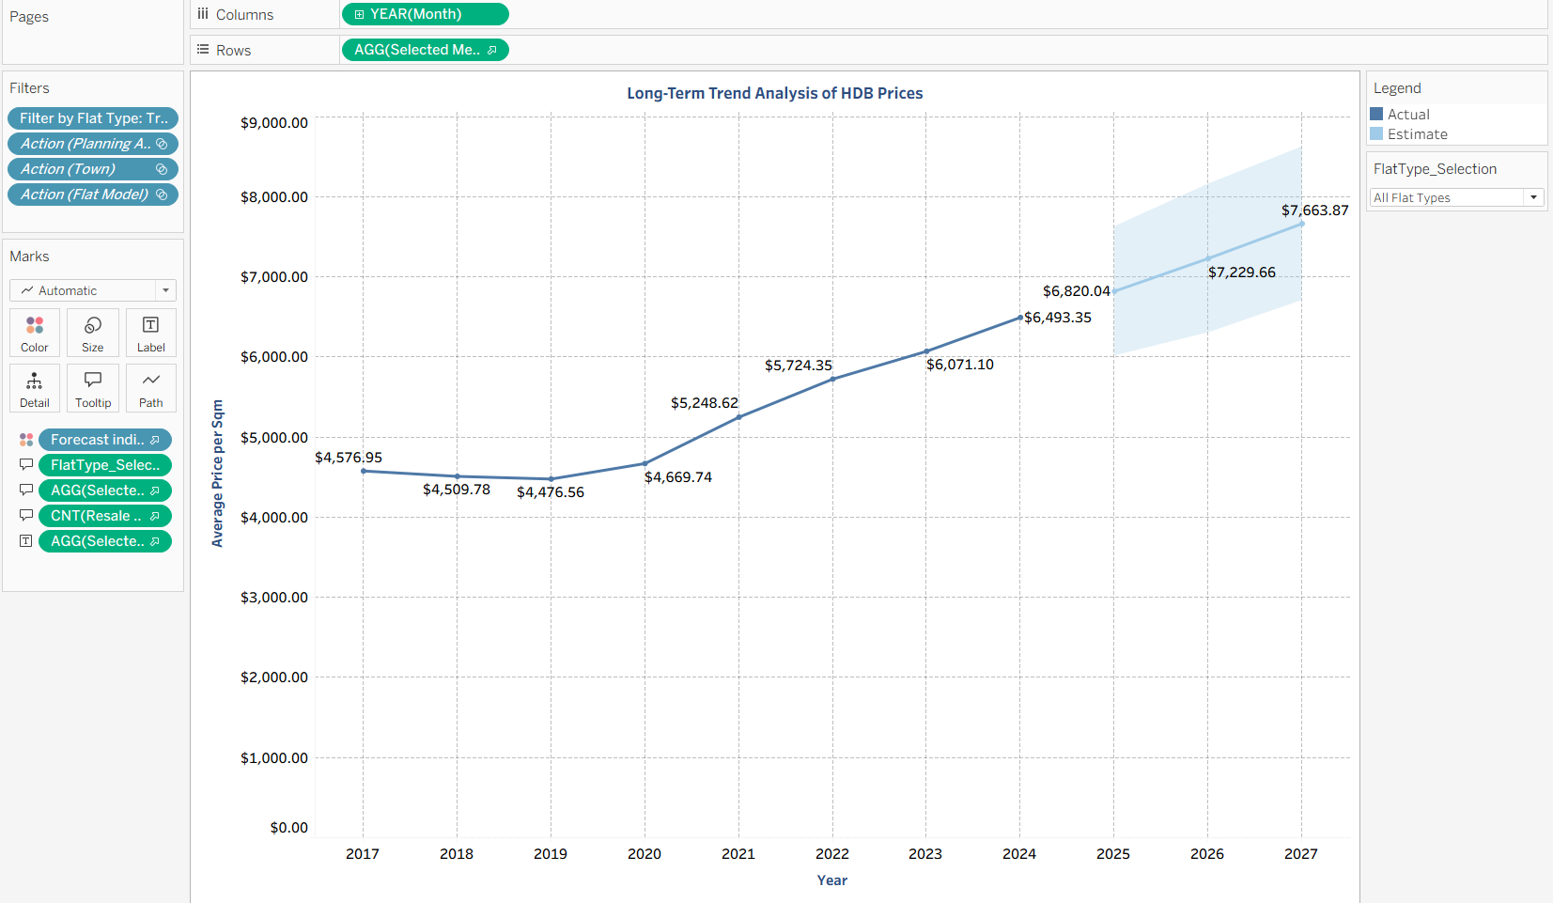

1.4 Chart 4: Heatmap (TO BE MARKED)
Purpose
This heatmap provides a matrix-style affordability benchmark across every town and flat type combination in Singapore. By calculating the percentage of flats within each segment that fall below the user’s affordability threshold, the chart operationalises a highly actionable view of where buyers can realistically purchase and where they may face financial constraints.
Key functions of this visual:
- Enables immediate comparison of affordability levels across towns and flat types through colour intensity (green = high affordability, red = low).
- Highlights structural gaps in the market where certain flat types (e.g., 5-Room, Executive, Multi-Generation) are priced out of reach in many towns.
- Reveals strong affordability pockets, especially for smaller flat types, helping users quickly shortlist feasible areas.
- Supports filtering by flat type, making it possible to isolate affordability only for the category a user is considering.
- Shows supply realism, clarifying that even if a town shows strong affordability on average, individual flat-type segments may be significantly more constrained.
Overall, this chart acts as a decision-support heatmap, allowing users to strategically align their housing expectations with realistic affordability outcomes before diving deeper into location or unit-level analysis.

Table 4: Heatmap Specifications
Sheet Name | Attributes Use | Calculated Field Use | Filter or Parameter Use
Chart 4: Heatmap - Town vs Flat Type: Affordability Status | Columns:  Flat Type  Rows:  Town  Marks (Colour):  AVG(% Affordable)  Marks (Text):  AVG(% Affordable)  Marks (Tooltip):  ATTR(% Affordable)  ATTR(% Stretch Budget)  ATTR(% Not Affordable)  ATTR(Total_Transactions_Affordability)  ATTR(Town)  ATTR(Flat Type)  MEDIAN(Affordability_Gap)  AVG(Affordability_Gap)  ATTR(Affordable_Total)  ATTR(Stretch_Total)  ATTR(Not_Affordable_Total) | Filter by Flat Type  IF [FlatType_Selection] = 0 THEN  TRUE  ELSE  [FlatType_Code] = [FlatType_Selection]  END  *FlatType_Selection is a parameter  % Affordable  [Affordable_Total] / [Total_Transactions_Affordability]  Total_Transactions_Affordability  { FIXED [Town], [Flat Type] : COUNT([Resale Price]) }  Affordable_Total  { FIXED [Town], [Flat Type] : SUM([Affordable_Count]) }  Affordable_Count  IF [Affordability_Status] = "Affordable" THEN 1 ELSE 0 END  Affordability_Status  IF [Affordability_Gap] >= 0 THEN  "Affordable"  ELSEIF [Affordability_Gap] >= -50000 THEN  "Stretch Budget"  ELSE  "Not Affordable"  END  Affordability_Gap  [Loan_Affordability] - [Resale Price]  Loan_Affordability  [Monthly_Repayment_Budget] * [Loan_Constant]  *Monthly_Repayment_Budget is a parameter  Loan_Constant  (  (1 + 0.026/12) ^ (25 * 12) - 1  )  /  (  (0.026/12) * ( (1 + 0.026/12) ^ (25 * 12) )  )  *The loan constant converts the HDB concessionary loan rate of 2.6% which is a fixed rate pegged to CPF OA interest +1% and a typical 25-year tenure into a single multiplier that tells you the monthly instalment payable per dollar borrowed.  % Not Affordable  [Not_Affordable_Total] / [Total_Transactions_Affordability]  Not_Affordable_Total  { FIXED [Town], [Flat Type] : SUM([Not_Affordable_Count]) }  Not_Affordable_Count  IF [Affordability_Status] = "Not Affordable" THEN 1 ELSE 0 END  % Stretch Budget  [Stretch_Total] / [Total_Transactions_Affordability]  Stretch_Total  { FIXED [Town], [Flat Type] : SUM([Stretch_Count]) }  Stretch_Count  IF [Affordability_Status] = "Stretch Budget" THEN 1 ELSE 0 END | Filter  Filter by Flat Type  Action(Town)  Action(Flat Model)  Parameter  Monthly_replayment_budget  FlatType_Selection]

Chart 4: Heatmap - Town vs Flat Type: Affordability Status
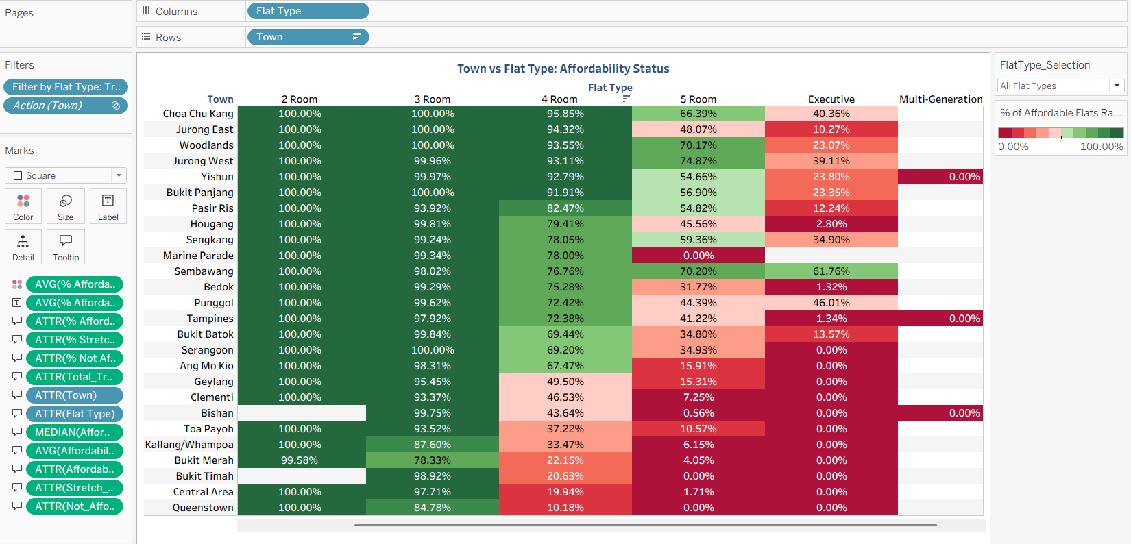

1.5 Chart 5: Lollipop Chart (TO BE MARKED)
Purpose
This lollipop chart compares each town’s value-for-money score against the national average resale price per square metre, allowing users to identify which towns offer better, fair, or poorer value relative to the overall market. By calculating the difference between each town’s average price and the national benchmark, the chart provides a clear indicator of market positioning and cost efficiency across locations.
Key objectives of this visual include:
• Highlighting towns that deliver strong value-for-money by being priced significantly below the national benchmark.
• Identifying premium-priced towns that command higher-than-average prices despite offering similar flat types.
• Categorising each town into High Value, Fair Value, or Low Value to support clearer decision-making for buyers.
• Allowing users to quickly shortlist budget-friendly towns based on quantifiable metrics rather than assumptions.
• Supporting deeper segmentation through filters, enabling analysis based on specific flat types or user-selected conditions.
Overall, this chart helps users understand how each town performs relative to national pricing norms, enabling more informed location-based decisions and supporting a transparent evaluation of market value.

Table 5: Lollipop Chart Specifications
Sheet Name | Attributes Use | Calculated Field Use | Filter or Parameter Use
Chart 5: Lollipop - Town-Level Value-For-Money (National Price Per SQM Benchmark) | Columns:  AVG(VFM_National) + AVG(VFM_National)  *Dual Axis is used  Rows:  Town  ALL Marks (Colour):  AGG(VFM_Category)  Marks (Tooltip):  ATTR(Town)  AVG(VFM_National)  ATTR(VFM_Category)  AVG(National PPSM)  AVG(Town PPSM)  FlatType_Selection  CNT(Resale Price)  Bar Marks (Label):  AVG(VFM_National) | Filter by Flat Type  IF [FlatType_Selection] = 0 THEN  TRUE  ELSE  [FlatType_Code] = [FlatType_Selection]  END  *FlatType_Selection is a parameter  VFM_Category  IF AVG([VFM_National]) > 200 THEN  "High Value"  ELSEIF AVG([VFM_National]) < -200 THEN  "Low Value"  ELSE  "Fair Value"  END  VFM_National  { FIXED [Town] : SUM([National_PPSM]) - SUM([Town_PPSM]) }  National_PPSM  { EXCLUDE [Town] : AVG([Price Per Sqm]) }  Town_PPSM  { FIXED [Town] : AVG([Price Per Sqm]) } | Filter  Filter by Flat Type  Action(Town)  Parameter  FlatType_Selection

Chart 5: Lollipop - Town-Level Value-For-Money (National Price Per SQM Benchmark)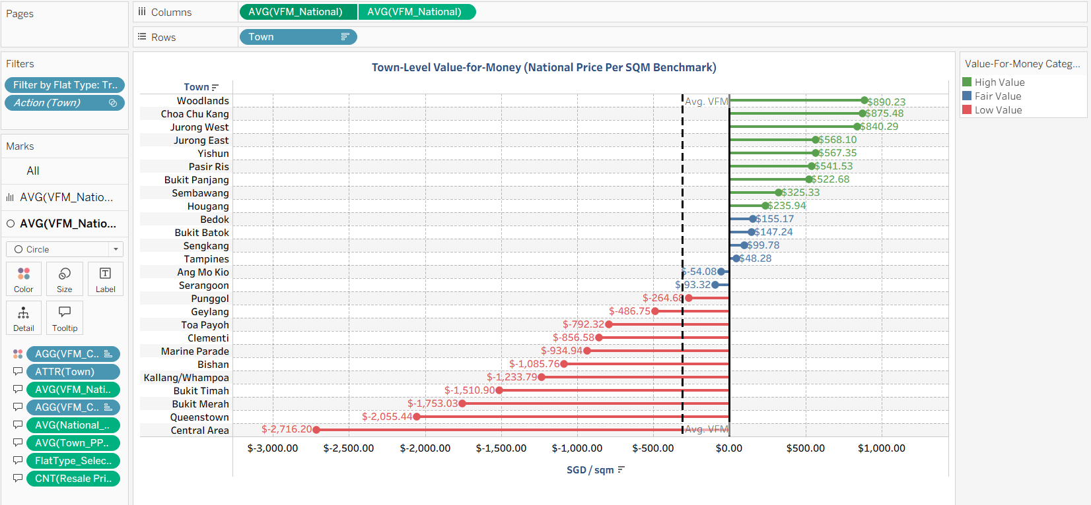

1.6 Chart 6: Ideal Housing Index Bar Chart (TO BE MARKED)
*Contains Additional Data
Purpose
This bar chart presents the Ideal Housing Index for each town, allowing users to evaluate how well different locations align with key lifestyle and liveability factors. By aggregating weighted components such as distance to the CBD, school accessibility, MRT proximity, floor area, and remaining lease, the chart highlights which towns provide a more desirable living environment and which towns may present lifestyle challenges.
Key objectives of this visual include:
• Identifying towns that offer excellent lifestyle suitability based on a balanced combination of accessibility, space, convenience, and long-term lease value.
• Highlighting average-performing towns that provide reasonable living conditions without strong advantages or disadvantages.
• Flagging towns that may present lifestyle limitations due to factors such as distance from amenities or smaller available flat sizes.
• Supporting clearer decision-making for buyers who prioritise lifestyle needs rather than only affordability or pricing metrics.
• Allowing deeper segmentation through filters such as flat type, enabling a more personalised evaluation based on the user’s housing preferences.
Overall, this chart helps users understand which towns best meet their lifestyle expectations, enabling them to make more holistic decisions that balance both financial and quality-of-life considerations.

Table 6: Ideal Housing Index (IHI) Bar Chart Specifications
Sheet Name | Attributes Use | Calculated Field Use | Filter or Parameter Use
Chart 6: Bar Chart - Ideal Housing Index (IHI) by Town | Columns:  AVG(Ideal_Housing_Index)  Rows:  Town  Marks (Colour):  AGG(IHI_Category)  Marks (Label):  AVG(Ideal_Housing_Index)  Marks (Tooltip):  ATTR(Town)  W_CBD  W_FloorArea  W_Lease  W_MRT  W_School  FlatType_Selection  CNT(Resale Price) | Filter by Flat Type  IF [FlatType_Selection] = 0 THEN  TRUE  ELSE  [FlatType_Code] = [FlatType_Selection]  END  *FlatType_Selection is a parameter  IHI_Category  IF AVG([Ideal_Housing_Index]) >= 0.25 THEN  "Excellent Lifestyle"  ELSEIF AVG([Ideal_Housing_Index]) <= -0.25 THEN  "Lifestyle Challenges"  ELSE  "Average Lifestyle"  END  Ideal_Housing_Index  [Normalised MRT Weight] * [MRT_Z] +  [Normalised School Weight] * [School_Z] +  [Normalised CBD Weight] * [CBD_Z] +  [Normalised Lease Weight] * [Lease_Z] +  [Normalised FloorArea Weight] * [Floor_Z]  Normalised MRT Weight  IF [Total Weight Raw] = 0 THEN  1.0/5  ELSE  [W_MRT] / [Total Weight Raw]  END  *W_MRT is a parameter  Total Weight Raw  [W_MRT] + [W_School] + [W_CBD] + [W_Lease] + [W_FloorArea]  *W_MRT, W_School, W_CBD, W_Lease, W_FloorArea are parameters  MRT_Z  IF {STDEV([MRT_Raw])} = 0 THEN 0  ELSE ([MRT_Raw] - {AVG([MRT_Raw])}) / {STDEV([MRT_Raw])}  END  MRT_Raw  -[Distance To Mrt Meters]  Normalised School Weight  IF [Total Weight Raw] = 0 THEN  1.0/5  ELSE  [W_School] / [Total Weight Raw]  END  *W_School is a parameter  School_Z  IF {STDEV([School_Raw])} = 0 THEN 0  ELSE ([School_Raw] - {AVG([School_Raw])}) / {STDEV([School_Raw])}  END  School_Raw  -[Distance To Pri School Meters]  Normalised CBD Weight  IF [Total Weight Raw] = 0 THEN  1.0/5  ELSE  [W_CBD] / [Total Weight Raw]  END  *W_CBD is a parameter  CBD_Z  IF {STDEV([CBD_Raw])} = 0 THEN 0  ELSE ([CBD_Raw] - {AVG([CBD_Raw])}) / {STDEV([CBD_Raw])}  END  CBD_Raw  -[Distance To Cbd]  Normalised Lease Weight  IF [Total Weight Raw] = 0 THEN  1.0/5  ELSE  [W_Lease] / [Total Weight Raw]  END  *W_Lease is a parameter  Lease_Z  IF {STDEV([Remaining Lease Months])} = 0 THEN 0  ELSE ([Remaining Lease Months] - {AVG([Remaining Lease Months])}) / {STDEV([Remaining Lease Months])}  END  Normalised FloorArea Weight  IF [Total Weight Raw] = 0 THEN  1.0/5  ELSE  [W_FloorArea] / [Total Weight Raw]  END  *W_FloorArea is a parameter  Floor_Z  IF {STDEV([Floor Area Sqm])} = 0 THEN 0  ELSE ([Floor Area Sqm] - {AVG([Floor Area Sqm])}) / {STDEV([Floor Area Sqm])}  END | Filter  Filter by Flat Type  Action(Town)  Parameter  FlatType_Selection  W_CBD  W_FloorArea  W_Lease  W_MRT  W_Lease

Chart 6: Bar Chart - Ideal Housing Index (IHI) by Town
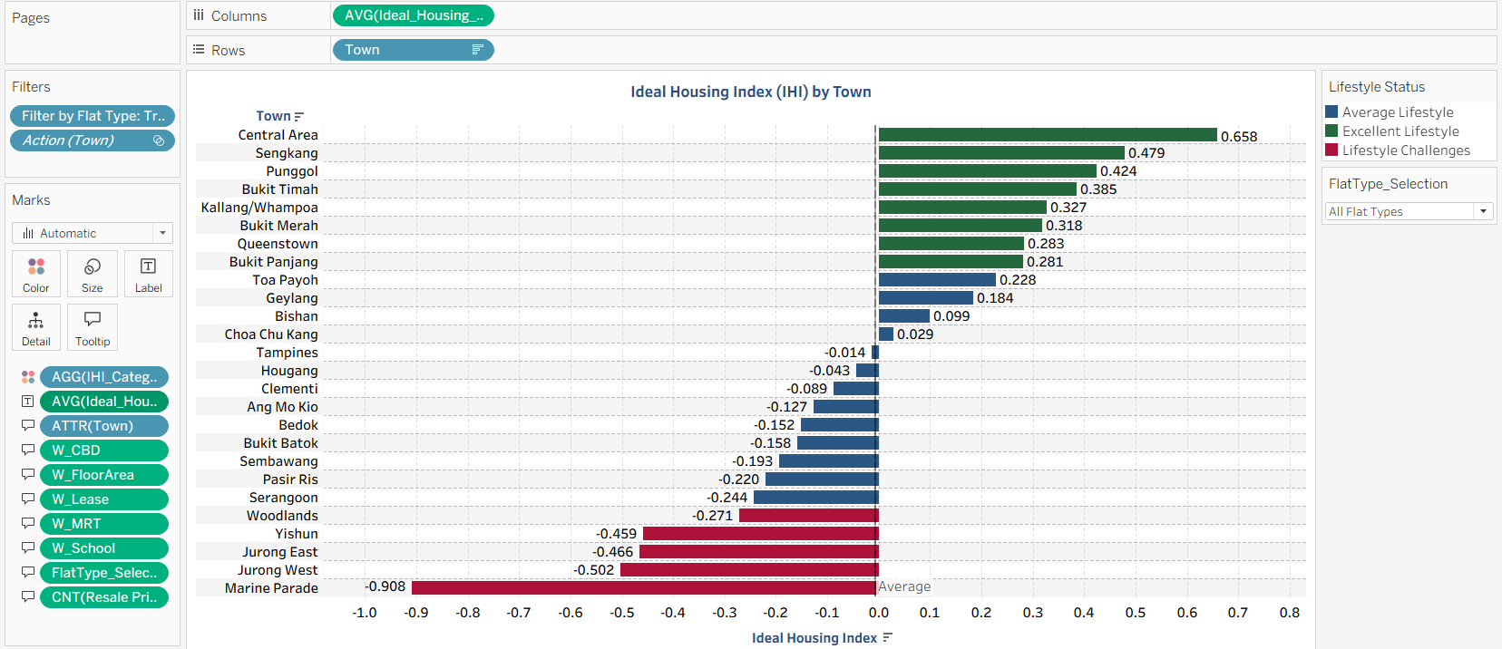

1.7 Chart 7: Best Town Bar Chart (NO MARKING)
*Contains Additional Data
Purpose
This bar chart presents the overall best town score by combining multiple key metrics into a single weighted index, allowing users to evaluate which towns perform most strongly when considering value-for-money, lifestyle suitability, affordability, and resale price competitiveness together. By aggregating these components into a unified score, the chart highlights towns that offer a balanced and attractive housing proposition based on data rather than intuition.
Key objectives of this visual include:
• Identifying top-performing towns that consistently rank well across multiple housing metrics, making them strong overall choices for potential buyers.
• Highlighting towns that are reasonable options with moderate performance, helping users recognise balanced alternatives that may still fit their preferences.
• Flagging towns with lower composite scores, allowing users to understand where trade-offs or limitations may exist.
• Providing a holistic assessment that goes beyond a single metric, supporting buyers who want a more comprehensive decision-making framework.
• Allowing deeper segmentation through filters such as flat type, enabling a personalised evaluation based on the user’s preferences or constraints.
Overall, this chart helps users identify the towns that offer the most well-rounded housing experience, supporting a data-driven decision on where to live based on both practical and lifestyle factors.

Table 6: Best Town Bar Chart Specifications
Sheet Name | Attributes Use | Calculated Field Use | Filter or Parameter Use
Chart 7: Bar Chart - Overall Best Town: Weighted Comparison Across Metrics | Columns:  AGG(Best_Town_Score)  Rows:  Town  Marks (Colour):  Best_Town_Colour  Marks (Label):  AVG(Best_Town_Score)  Marks (Tooltip):  ATTR(Town)  AVG(Ideal_Housing_Index)  AVG(VFM_National)  AVG(% Affordable)  CNT(Resale Price)  AGG(Best_Town_Score) | Filter by Flat Type  IF [FlatType_Selection] = 0 THEN  TRUE  ELSE  [FlatType_Code] = [FlatType_Selection]  END  *FlatType_Selection is a parameter  Best_Town_Colour  IF [Z_Best_Town_Score] >= 0.5 THEN  "Top Choice"  ELSEIF [Z_Best_Town_Score] <= -0.5 THEN  "Less Ideal"  ELSE  "Considerable Option"  END  Z_Best_Town_Score  IF WINDOW_STDEV([Best_Town_Score]) = 0 THEN  0  ELSE  (  [Best_Town_Score]  - WINDOW_AVG([Best_Town_Score])  )  / WINDOW_STDEV([Best_Town_Score])  END  Best_Town_Score  AVG([Ideal_Housing_Index]) * [Normalised_Weight_IHI]  + [Z_VFM] * [Normalised_Weight_VFM]  + [Z_Affordability] * [Normalised_Weight_Affordability]  Normalised_Weight_IHI  [Weight_IHI] / ([Weight_IHI] + [Weight_VFM] + [Weight_Affordability])  * Weight_IHI, Weight_VFM, Weight_Affordability are parameters  Ideal_Housing_Index  [Normalised MRT Weight] * [MRT_Z] +  [Normalised School Weight] * [School_Z] +  [Normalised CBD Weight] * [CBD_Z] +  [Normalised Lease Weight] * [Lease_Z] +  [Normalised FloorArea Weight] * [Floor_Z]  Normalised MRT Weight  IF [Total Weight Raw] = 0 THEN  1.0/5  ELSE  [W_MRT] / [Total Weight Raw]  END  *W_MRT is a parameter  Total Weight Raw  [W_MRT] + [W_School] + [W_CBD] + [W_Lease] + [W_FloorArea]  *W_MRT, W_School, W_CBD, W_Lease, W_FloorArea are parameters  MRT_Z  IF {STDEV([MRT_Raw])} = 0 THEN 0  ELSE ([MRT_Raw] - {AVG([MRT_Raw])}) / {STDEV([MRT_Raw])}  END  MRT_Raw  -[Distance To Mrt Meters]  Normalised School Weight  IF [Total Weight Raw] = 0 THEN  1.0/5  ELSE  [W_School] / [Total Weight Raw]  END  *W_School is a parameter  School_Z  IF {STDEV([School_Raw])} = 0 THEN 0  ELSE ([School_Raw] - {AVG([School_Raw])}) / {STDEV([School_Raw])}  END  School_Raw  -[Distance To Pri School Meters]  Normalised CBD Weight  IF [Total Weight Raw] = 0 THEN  1.0/5  ELSE  [W_CBD] / [Total Weight Raw]  END  *W_CBD is a parameter  CBD_Z  IF {STDEV([CBD_Raw])} = 0 THEN 0  ELSE ([CBD_Raw] - {AVG([CBD_Raw])}) / {STDEV([CBD_Raw])}  END  CBD_Raw  -[Distance To Cbd]  Normalised Lease Weight  IF [Total Weight Raw] = 0 THEN  1.0/5  ELSE  [W_Lease] / [Total Weight Raw]  END  *W_Lease is a parameter  Lease_Z  IF {STDEV([Remaining Lease Months])} = 0 THEN 0  ELSE ([Remaining Lease Months] - {AVG([Remaining Lease Months])}) / {STDEV([Remaining Lease Months])}  END  Normalised FloorArea Weight  IF [Total Weight Raw] = 0 THEN  1.0/5  ELSE  [W_FloorArea] / [Total Weight Raw]  END  *W_FloorArea is a parameter  Floor_Z  IF {STDEV([Floor Area Sqm])} = 0 THEN 0  ELSE ([Floor Area Sqm] - {AVG([Floor Area Sqm])}) / {STDEV([Floor Area Sqm])}  END  Z_VFM  IF AVG([VFM_SD]) = 0 THEN 0  ELSE  ( AVG([VFM_National]) - AVG([VFM_Mean]) )  / AVG([VFM_SD])  END  VFM_SD  { FIXED : STDEV([VFM_National]) }  VFM_Mean  { FIXED : AVG([VFM_National]) }  VFM_National  { FIXED [Town] : SUM([National_PPSM]) - SUM([Town_PPSM]) }  National_PPSM  { EXCLUDE [Town] : AVG([Price Per Sqm]) }  Town_PPSM  { FIXED [Town] : AVG([Price Per Sqm]) }  Normalised_Weight_VFM  [Weight_VFM] / ([Weight_IHI] + [Weight_VFM] + [Weight_Affordability])  * Weight_IHI, Weight_VFM, Weight_Affordability are parameters  Z_Affordability  IF AVG([Aff_SD]) = 0 THEN 0  ELSE  ( AVG([Affordability_Gap]) - AVG([Aff_Mean]) )  / AVG([Aff_SD])  END  Aff_SD  { FIXED : STDEV([Affordability_Gap]) }  Aff_Mean  { FIXED : AVG([Affordability_Gap]) }  Affordability_Gap  [Loan_Affordability] - [Resale Price]  Loan_Affordability  [Monthly_Repayment_Budget] * [Loan_Constant]  *Monthly_Repayment_Budget is a parameter  Loan_Constant  (  (1 + 0.026/12) ^ (25 * 12) - 1  )  /  (  (0.026/12) * ( (1 + 0.026/12) ^ (25 * 12) )  )  *The loan constant converts the HDB concessionary loan rate of 2.6% which is a fixed rate pegged to CPF OA interest +1% and a typical 25-year tenure into a single multiplier that tells you the monthly instalment payable per dollar borrowed.  Normalised_Weight_Affordability  [Weight_Affordability] / ([Weight_IHI] + [Weight_VFM] + [Weight_Affordability])  * Weight_IHI, Weight_VFM, Weight_Affordability are parameters | Filter  Filter by Flat Type  Action(Town)  Parameter  FlatType_Selection  Weight_IHI  Weight_VFM  Weight_Affordability  W_CBD  W_FloorArea  W_Lease  W_MRT  W_Lease

Chart 6: Bar Chart - Ideal Housing Index (IHI) by Town

1.8 Chart 8: Scatter Plot (NO MARKING)
*Contains Additional Data
Purpose
This scatter plot examines the relationship between lifestyle amenities and housing prices by comparing each unit’s Ideal Housing Index score against its price per square metre. By plotting thousands of transactions and colouring them according to lifestyle category, the chart helps users understand how lifestyle quality influences housing value across the entire market.
Key objectives of this visual include:
• Identifying whether higher lifestyle quality is associated with higher housing prices across towns and flat types.
• Highlighting how units categorised under excellent lifestyle, average lifestyle, or lifestyle challenges cluster differently along the price spectrum.
• Providing a clear view of the market distribution to show where most units lie relative to the median IHI and median price.
• Supporting interpretation through a trend line that reflects the general direction of the relationship between lifestyle factors and pricing.
• Helping users compare lifestyle-based housing preferences against their budget and affordability constraints.
Overall, this chart helps users evaluate the trade-off between lifestyle amenities and pricing, enabling more informed decisions about whether to prioritise convenience and liveability or cost savings when selecting a town or flat.
Table 8: Scatter Plot Chart Specifications
Sheet Name | Attributes Use | Calculated Field Use | Filter or Parameter Use
Chart 6: Bar Chart - Ideal Housing Index (IHI) by Town | Columns:  Ideal_Housing_Index  Rows:  Price Per Sqm  Marks (Colour):  AGG(IHI_Category)  Marks (Detail):  Town  Marks (Tooltip):  ATTR(Ideal_Housing Index)  FlatType_Selection | Filter by Flat Type  IF [FlatType_Selection] = 0 THEN  TRUE  ELSE  [FlatType_Code] = [FlatType_Selection]  END  *FlatType_Selection is a parameter  IHI_Category  IF AVG([Ideal_Housing_Index]) >= 0.25 THEN  "Excellent Lifestyle"  ELSEIF AVG([Ideal_Housing_Index]) <= -0.25 THEN  "Lifestyle Challenges"  ELSE  "Average Lifestyle"  END  Ideal_Housing_Index  [Normalised MRT Weight] * [MRT_Z] +  [Normalised School Weight] * [School_Z] +  [Normalised CBD Weight] * [CBD_Z] +  [Normalised Lease Weight] * [Lease_Z] +  [Normalised FloorArea Weight] * [Floor_Z]  Normalised MRT Weight  IF [Total Weight Raw] = 0 THEN  1.0/5  ELSE  [W_MRT] / [Total Weight Raw]  END  *W_MRT is a parameter  Total Weight Raw  [W_MRT] + [W_School] + [W_CBD] + [W_Lease] + [W_FloorArea]  *W_MRT, W_School, W_CBD, W_Lease, W_FloorArea are parameters  MRT_Z  IF {STDEV([MRT_Raw])} = 0 THEN 0  ELSE ([MRT_Raw] - {AVG([MRT_Raw])}) / {STDEV([MRT_Raw])}  END  MRT_Raw  -[Distance To Mrt Meters]  Normalised School Weight  IF [Total Weight Raw] = 0 THEN  1.0/5  ELSE  [W_School] / [Total Weight Raw]  END  *W_School is a parameter  School_Z  IF {STDEV([School_Raw])} = 0 THEN 0  ELSE ([School_Raw] - {AVG([School_Raw])}) / {STDEV([School_Raw])}  END  School_Raw  -[Distance To Pri School Meters]  Normalised CBD Weight  IF [Total Weight Raw] = 0 THEN  1.0/5  ELSE  [W_CBD] / [Total Weight Raw]  END  *W_CBD is a parameter  CBD_Z  IF {STDEV([CBD_Raw])} = 0 THEN 0  ELSE ([CBD_Raw] - {AVG([CBD_Raw])}) / {STDEV([CBD_Raw])}  END  CBD_Raw  -[Distance To Cbd]  Normalised Lease Weight  IF [Total Weight Raw] = 0 THEN  1.0/5  ELSE  [W_Lease] / [Total Weight Raw]  END  *W_Lease is a parameter  Lease_Z  IF {STDEV([Remaining Lease Months])} = 0 THEN 0  ELSE ([Remaining Lease Months] - {AVG([Remaining Lease Months])}) / {STDEV([Remaining Lease Months])}  END  Normalised FloorArea Weight  IF [Total Weight Raw] = 0 THEN  1.0/5  ELSE  [W_FloorArea] / [Total Weight Raw]  END  *W_FloorArea is a parameter  Floor_Z  IF {STDEV([Floor Area Sqm])} = 0 THEN 0  ELSE ([Floor Area Sqm] - {AVG([Floor Area Sqm])}) / {STDEV([Floor Area Sqm])}  END | Filter  Filter by Flat Type  Action(Town)  Parameter  FlatType_Selection  W_CBD  W_FloorArea  W_Lease  W_MRT  W_Lease

Chart 8: Scatter Plot - Impact of Lifestyle Amenities on Price Per SQM
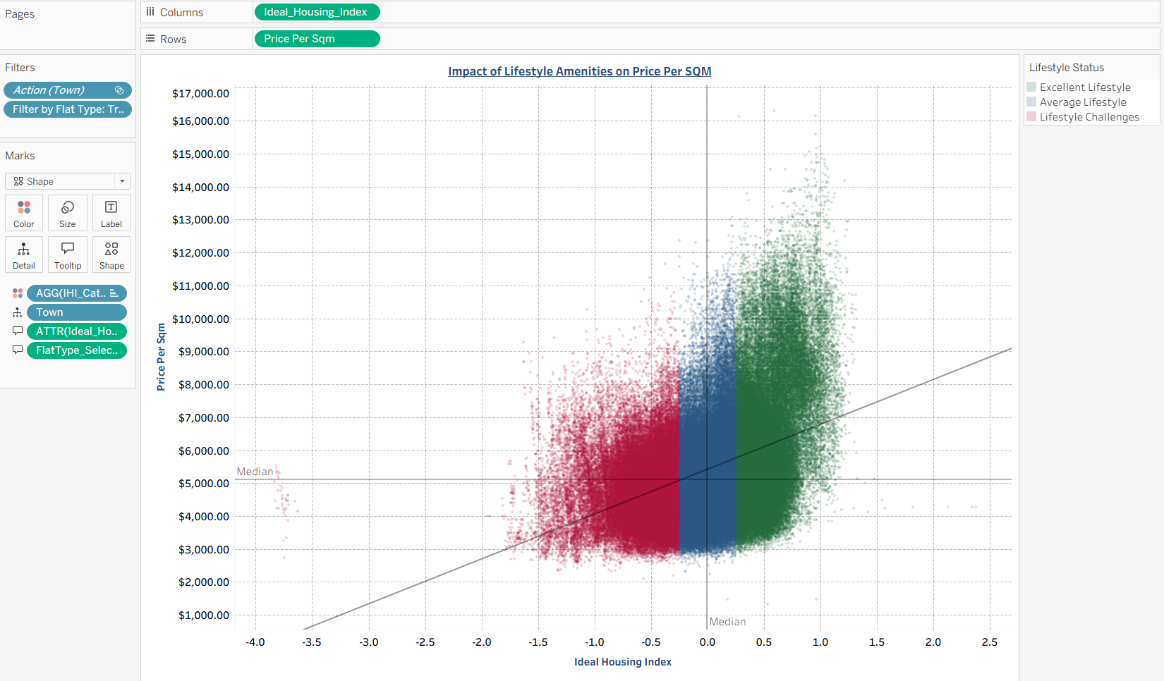

2. KPI Arrow Specifications

2.1 1 Room Resale KPI (NO MARKING)
Purpose
This KPI indicator displays the year-on-year price movement for the selected flat type, allowing users to quickly understand how resale prices have changed compared to the previous year. By presenting the percentage change together with an increase or decrease arrow, the visual provides an immediate and intuitive snapshot of price momentum in the market.
Key objectives of this visual include:
• Highlighting whether prices for the selected flat type have risen or fallen over the past year.
• Providing a simple and direct performance indicator that supports quick decision-making.
• Allowing users to track short-term market movements without needing to interpret full trend lines or detailed charts.
• Supporting interactive analysis through filters such as town and flat model, enabling users to see how year-on-year changes differ across locations and unit types.
• Helping buyers understand the current price climate before moving into deeper affordability or trend analysis.
Overall, this KPI helps users stay aware of short-term resale price dynamics and serves as an effective entry point into understanding broader market performance.
Table 9: 1 Room Resale KPI Specifications
Sheet Name | Attributes Use | Calculated Field Use | Filter or Parameter Use
Resale KPI 1: 1 Room | Columns:  NIL  Rows:  NIL  Marks (Colour):  AGG(YoY Colour)  Marks (Label):  AGG(YoY Display) | YoY Colour  IF [YoY % Change] > 0 THEN "Increase"  ELSEIF [YoY % Change] < 0 THEN "Decrease"  ELSE "Neutral"  END  YoY Display  IF [YoY % Change] > 0 THEN  "▲ " + STR(ROUND([YoY % Change] * 100, 2)) + "%"  ELSEIF [YoY % Change] < 0 THEN  "▼ " + STR(ROUND(ABS([YoY % Change] * 100), 2)) + "%"  ELSE  "0%"  END  YoY % Change  IF AVG([Avg Price 2024]) = 0 THEN  NULL  ELSE  (AVG([Avg Price 2025]) - AVG([Avg Price 2024]))  / AVG([Avg Price 2024])  END  Avg Price 2024  IF YEAR([Month]) = 2024 THEN [Resale Price] END  Avg Price 2025  IF YEAR([Month]) = 2025 THEN [Resale Price] END | Filter  Flat Type: 1 Room  Action(Town)  Action (Flat Model)

Resale KPI 1: 1 Room
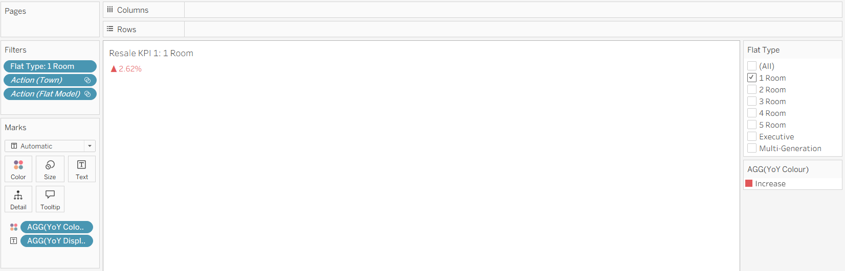

2.2 2 Room Resale KPI (NO MARKING)
Purpose
This KPI indicator displays the year-on-year price movement for the selected flat type, allowing users to quickly understand how resale prices have changed compared to the previous year. By presenting the percentage change together with an increase or decrease arrow, the visual provides an immediate and intuitive snapshot of price momentum in the market.
Key objectives of this visual include:
• Highlighting whether prices for the selected flat type have risen or fallen over the past year.
• Providing a simple and direct performance indicator that supports quick decision-making.
• Allowing users to track short-term market movements without needing to interpret full trend lines or detailed charts.
• Supporting interactive analysis through filters such as town and flat model, enabling users to see how year-on-year changes differ across locations and unit types.
• Helping buyers understand the current price climate before moving into deeper affordability or trend analysis.
Overall, this KPI helps users stay aware of short-term resale price dynamics and serves as an effective entry point into understanding broader market performance.
Table 10: 2 Room Resale KPI Specifications
Sheet Name | Attributes Use | Calculated Field Use | Filter or Parameter Use
Resale KPI 2: 2 Room | Columns:  NIL  Rows:  NIL  Marks (Colour):  AGG(YoY Colour)  Marks (Label):  AGG(YoY Display) | YoY Colour  IF [YoY % Change] > 0 THEN "Increase"  ELSEIF [YoY % Change] < 0 THEN "Decrease"  ELSE "Neutral"  END  YoY Display  IF [YoY % Change] > 0 THEN  "▲ " + STR(ROUND([YoY % Change] * 100, 2)) + "%"  ELSEIF [YoY % Change] < 0 THEN  "▼ " + STR(ROUND(ABS([YoY % Change] * 100), 2)) + "%"  ELSE  "0%"  END  YoY % Change  IF AVG([Avg Price 2024]) = 0 THEN  NULL  ELSE  (AVG([Avg Price 2025]) - AVG([Avg Price 2024]))  / AVG([Avg Price 2024])  END  Avg Price 2024  IF YEAR([Month]) = 2024 THEN [Resale Price] END  Avg Price 2025  IF YEAR([Month]) = 2025 THEN [Resale Price] END | Filter  Flat Type: 2 Room  Action(Town)  Action (Flat Model)

Resale KPI 2: 2 Room
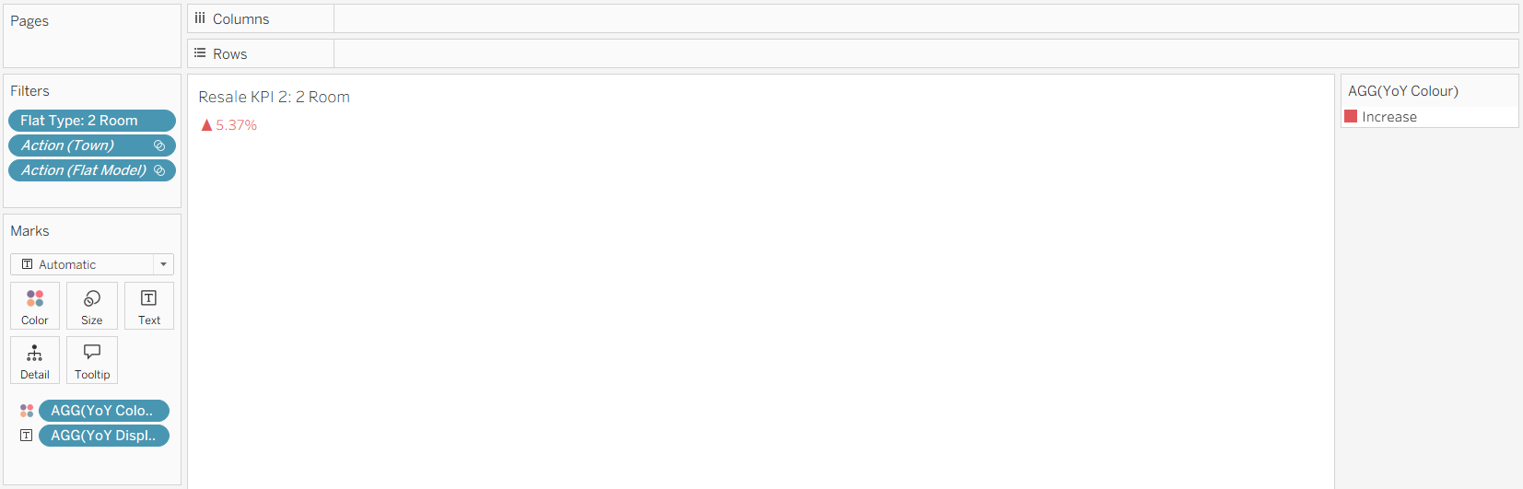

2.3 3 Room Resale KPI (NO MARKING)
Purpose
This KPI indicator displays the year-on-year price movement for the selected flat type, allowing users to quickly understand how resale prices have changed compared to the previous year. By presenting the percentage change together with an increase or decrease arrow, the visual provides an immediate and intuitive snapshot of price momentum in the market.
Key objectives of this visual include:
• Highlighting whether prices for the selected flat type have risen or fallen over the past year.
• Providing a simple and direct performance indicator that supports quick decision-making.
• Allowing users to track short-term market movements without needing to interpret full trend lines or detailed charts.
• Supporting interactive analysis through filters such as town and flat model, enabling users to see how year-on-year changes differ across locations and unit types.
• Helping buyers understand the current price climate before moving into deeper affordability or trend analysis.
Overall, this KPI helps users stay aware of short-term resale price dynamics and serves as an effective entry point into understanding broader market performance.
Table 11: 3 Room Resale KPI Specifications
Sheet Name | Attributes Use | Calculated Field Use | Filter or Parameter Use
Resale KPI 3: 3 Room | Columns:  NIL  Rows:  NIL  Marks (Colour):  AGG(YoY Colour)  Marks (Label):  AGG(YoY Display) | YoY Colour  IF [YoY % Change] > 0 THEN "Increase"  ELSEIF [YoY % Change] < 0 THEN "Decrease"  ELSE "Neutral"  END  YoY Display  IF [YoY % Change] > 0 THEN  "▲ " + STR(ROUND([YoY % Change] * 100, 2)) + "%"  ELSEIF [YoY % Change] < 0 THEN  "▼ " + STR(ROUND(ABS([YoY % Change] * 100), 2)) + "%"  ELSE  "0%"  END  YoY % Change  IF AVG([Avg Price 2024]) = 0 THEN  NULL  ELSE  (AVG([Avg Price 2025]) - AVG([Avg Price 2024]))  / AVG([Avg Price 2024])  END  Avg Price 2024  IF YEAR([Month]) = 2024 THEN [Resale Price] END  Avg Price 2025  IF YEAR([Month]) = 2025 THEN [Resale Price] END | Filter  Flat Type: 3 Room  Action(Town)  Action (Flat Model)

Resale KPI 3: 3 Room
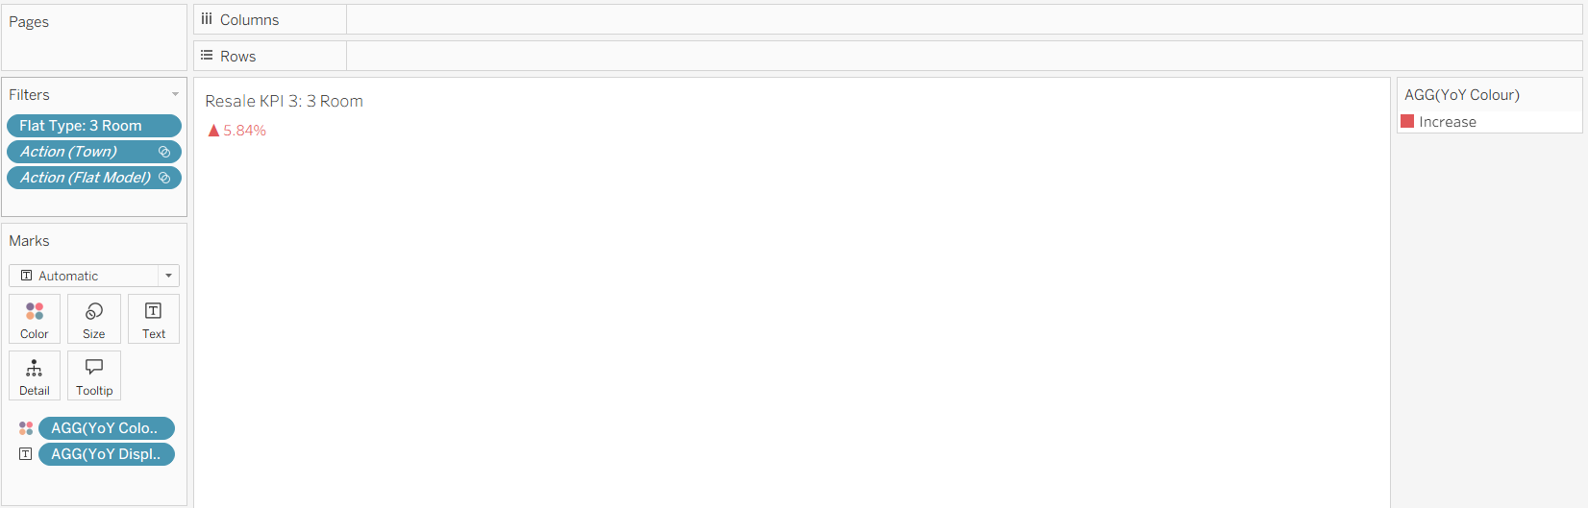

2.4 4 Room Resale KPI (NO MARKING)
Purpose
This KPI indicator displays the year-on-year price movement for the selected flat type, allowing users to quickly understand how resale prices have changed compared to the previous year. By presenting the percentage change together with an increase or decrease arrow, the visual provides an immediate and intuitive snapshot of price momentum in the market.
Key objectives of this visual include:
• Highlighting whether prices for the selected flat type have risen or fallen over the past year.
• Providing a simple and direct performance indicator that supports quick decision-making.
• Allowing users to track short-term market movements without needing to interpret full trend lines or detailed charts.
• Supporting interactive analysis through filters such as town and flat model, enabling users to see how year-on-year changes differ across locations and unit types.
• Helping buyers understand the current price climate before moving into deeper affordability or trend analysis.
Overall, this KPI helps users stay aware of short-term resale price dynamics and serves as an effective entry point into understanding broader market performance.
Table 12: 4 Room Resale KPI Specifications
Sheet Name | Attributes Use | Calculated Field Use | Filter or Parameter Use
Resale KPI 4: 4 Room | Columns:  NIL  Rows:  NIL  Marks (Colour):  AGG(YoY Colour)  Marks (Label):  AGG(YoY Display) | YoY Colour  IF [YoY % Change] > 0 THEN "Increase"  ELSEIF [YoY % Change] < 0 THEN "Decrease"  ELSE "Neutral"  END  YoY Display  IF [YoY % Change] > 0 THEN  "▲ " + STR(ROUND([YoY % Change] * 100, 2)) + "%"  ELSEIF [YoY % Change] < 0 THEN  "▼ " + STR(ROUND(ABS([YoY % Change] * 100), 2)) + "%"  ELSE  "0%"  END  YoY % Change  IF AVG([Avg Price 2024]) = 0 THEN  NULL  ELSE  (AVG([Avg Price 2025]) - AVG([Avg Price 2024]))  / AVG([Avg Price 2024])  END  Avg Price 2024  IF YEAR([Month]) = 2024 THEN [Resale Price] END  Avg Price 2025  IF YEAR([Month]) = 2025 THEN [Resale Price] END | Filter  Flat Type: 4 Room  Action(Town)  Action (Flat Model)

Resale KPI 4: 4 Room
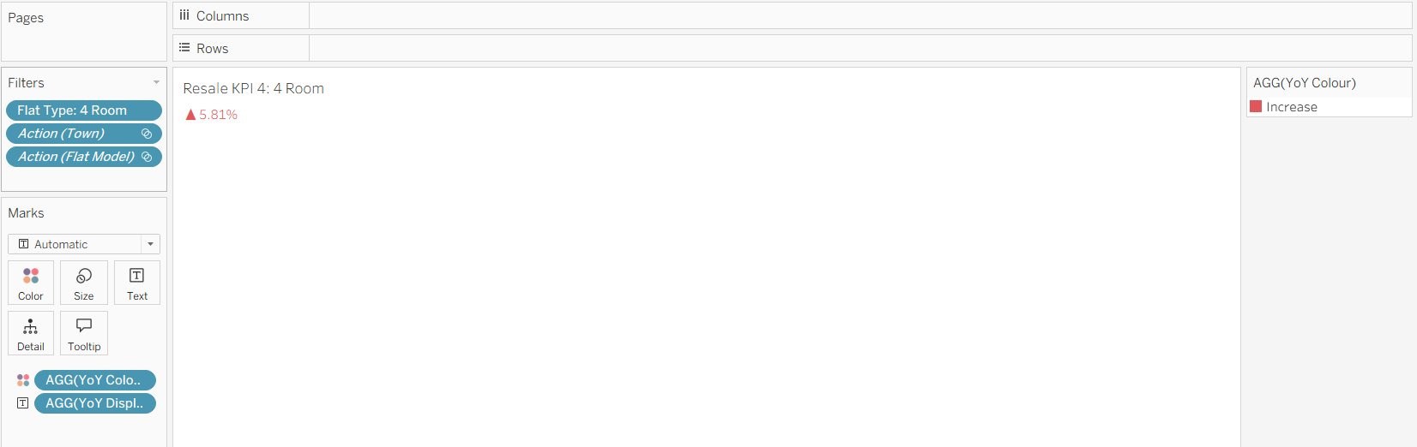

2.5 5 Room Resale KPI (NO MARKING)
Purpose
This KPI indicator displays the year-on-year price movement for the selected flat type, allowing users to quickly understand how resale prices have changed compared to the previous year. By presenting the percentage change together with an increase or decrease arrow, the visual provides an immediate and intuitive snapshot of price momentum in the market.
Key objectives of this visual include:
• Highlighting whether prices for the selected flat type have risen or fallen over the past year.
• Providing a simple and direct performance indicator that supports quick decision-making.
• Allowing users to track short-term market movements without needing to interpret full trend lines or detailed charts.
• Supporting interactive analysis through filters such as town and flat model, enabling users to see how year-on-year changes differ across locations and unit types.
• Helping buyers understand the current price climate before moving into deeper affordability or trend analysis.
Overall, this KPI helps users stay aware of short-term resale price dynamics and serves as an effective entry point into understanding broader market performance.
Table 13: 5 Room Resale KPI Specifications
Sheet Name | Attributes Use | Calculated Field Use | Filter or Parameter Use
Resale KPI 5: 5 Room | Columns:  NIL  Rows:  NIL  Marks (Colour):  AGG(YoY Colour)  Marks (Label):  AGG(YoY Display) | YoY Colour  IF [YoY % Change] > 0 THEN "Increase"  ELSEIF [YoY % Change] < 0 THEN "Decrease"  ELSE "Neutral"  END  YoY Display  IF [YoY % Change] > 0 THEN  "▲ " + STR(ROUND([YoY % Change] * 100, 2)) + "%"  ELSEIF [YoY % Change] < 0 THEN  "▼ " + STR(ROUND(ABS([YoY % Change] * 100), 2)) + "%"  ELSE  "0%"  END  YoY % Change  IF AVG([Avg Price 2024]) = 0 THEN  NULL  ELSE  (AVG([Avg Price 2025]) - AVG([Avg Price 2024]))  / AVG([Avg Price 2024])  END  Avg Price 2024  IF YEAR([Month]) = 2024 THEN [Resale Price] END  Avg Price 2025  IF YEAR([Month]) = 2025 THEN [Resale Price] END | Filter  Flat Type: 5 Room  Action(Town)  Action (Flat Model)

Resale KPI 5: 5 Room
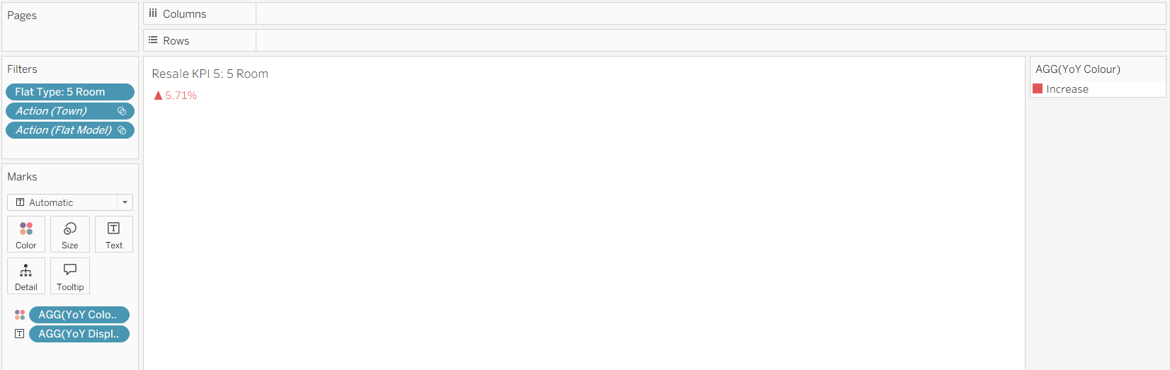

2.6 Executive Resale KPI (NO MARKING)
Purpose
This KPI indicator displays the year-on-year price movement for the selected flat type, allowing users to quickly understand how resale prices have changed compared to the previous year. By presenting the percentage change together with an increase or decrease arrow, the visual provides an immediate and intuitive snapshot of price momentum in the market.
Key objectives of this visual include:
• Highlighting whether prices for the selected flat type have risen or fallen over the past year.
• Providing a simple and direct performance indicator that supports quick decision-making.
• Allowing users to track short-term market movements without needing to interpret full trend lines or detailed charts.
• Supporting interactive analysis through filters such as town and flat model, enabling users to see how year-on-year changes differ across locations and unit types.
• Helping buyers understand the current price climate before moving into deeper affordability or trend analysis.
Overall, this KPI helps users stay aware of short-term resale price dynamics and serves as an effective entry point into understanding broader market performance.
Table 14: Executive Resale KPI Specifications
Sheet Name | Attributes Use | Calculated Field Use | Filter or Parameter Use
Resale KPI 5: Executive | Columns:  NIL  Rows:  NIL  Marks (Colour):  AGG(YoY Colour)  Marks (Label):  AGG(YoY Display) | YoY Colour  IF [YoY % Change] > 0 THEN "Increase"  ELSEIF [YoY % Change] < 0 THEN "Decrease"  ELSE "Neutral"  END  YoY Display  IF [YoY % Change] > 0 THEN  "▲ " + STR(ROUND([YoY % Change] * 100, 2)) + "%"  ELSEIF [YoY % Change] < 0 THEN  "▼ " + STR(ROUND(ABS([YoY % Change] * 100), 2)) + "%"  ELSE  "0%"  END  YoY % Change  IF AVG([Avg Price 2024]) = 0 THEN  NULL  ELSE  (AVG([Avg Price 2025]) - AVG([Avg Price 2024]))  / AVG([Avg Price 2024])  END  Avg Price 2024  IF YEAR([Month]) = 2024 THEN [Resale Price] END  Avg Price 2025  IF YEAR([Month]) = 2025 THEN [Resale Price] END | Filter  Flat Type: Executive  Action(Town)  Action (Flat Model)

Resale KPI 6: Executive
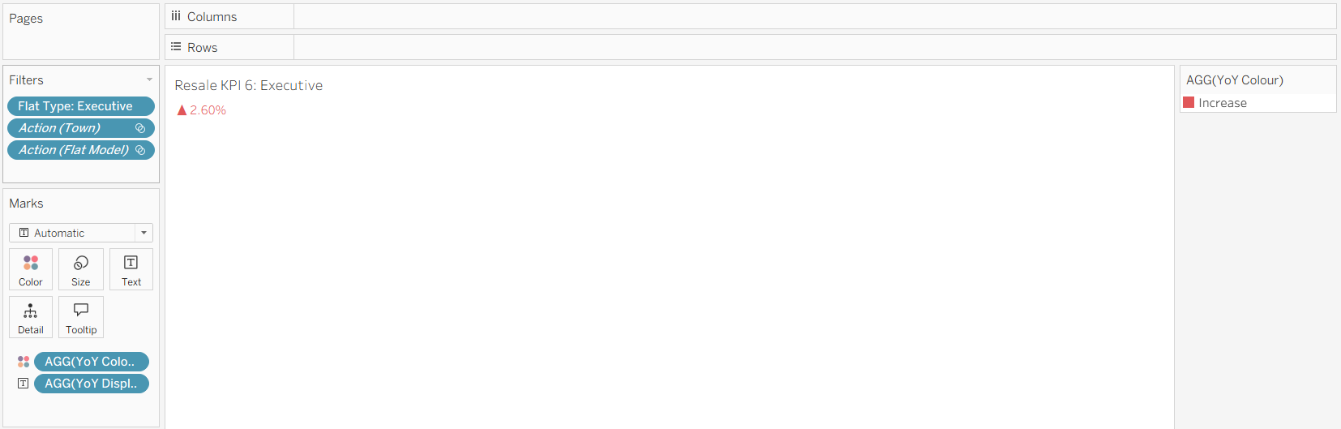

2.7 Multi-Generation Resale KPI (NO MARKING)
Purpose
This KPI indicator displays the year-on-year price movement for the selected flat type, allowing users to quickly understand how resale prices have changed compared to the previous year. By presenting the percentage change together with an increase or decrease arrow, the visual provides an immediate and intuitive snapshot of price momentum in the market.
Key objectives of this visual include:
• Highlighting whether prices for the selected flat type have risen or fallen over the past year.
• Providing a simple and direct performance indicator that supports quick decision-making.
• Allowing users to track short-term market movements without needing to interpret full trend lines or detailed charts.
• Supporting interactive analysis through filters such as town and flat model, enabling users to see how year-on-year changes differ across locations and unit types.
• Helping buyers understand the current price climate before moving into deeper affordability or trend analysis.
Overall, this KPI helps users stay aware of short-term resale price dynamics and serves as an effective entry point into understanding broader market performance.
Table 15: Multi-Generation Resale KPI Specifications
Sheet Name | Attributes Use | Calculated Field Use | Filter or Parameter Use
Resale KPI 7: Multi-Generation | Columns:  NIL  Rows:  NIL  Marks (Colour):  AGG(YoY Colour)  Marks (Label):  AGG(YoY Display) | YoY Colour  IF [YoY % Change] > 0 THEN "Increase"  ELSEIF [YoY % Change] < 0 THEN "Decrease"  ELSE "Neutral"  END  YoY Display  IF [YoY % Change] > 0 THEN  "▲ " + STR(ROUND([YoY % Change] * 100, 2)) + "%"  ELSEIF [YoY % Change] < 0 THEN  "▼ " + STR(ROUND(ABS([YoY % Change] * 100), 2)) + "%"  ELSE  "0%"  END  YoY % Change  IF AVG([Avg Price 2024]) = 0 THEN  NULL  ELSE  (AVG([Avg Price 2025]) - AVG([Avg Price 2024]))  / AVG([Avg Price 2024])  END  Avg Price 2024  IF YEAR([Month]) = 2024 THEN [Resale Price] END  Avg Price 2025  IF YEAR([Month]) = 2025 THEN [Resale Price] END | Filter  Flat Type: Multi-Generation  Action(Town)  Action (Flat Model)

Resale KPI 7: Multi-Generation
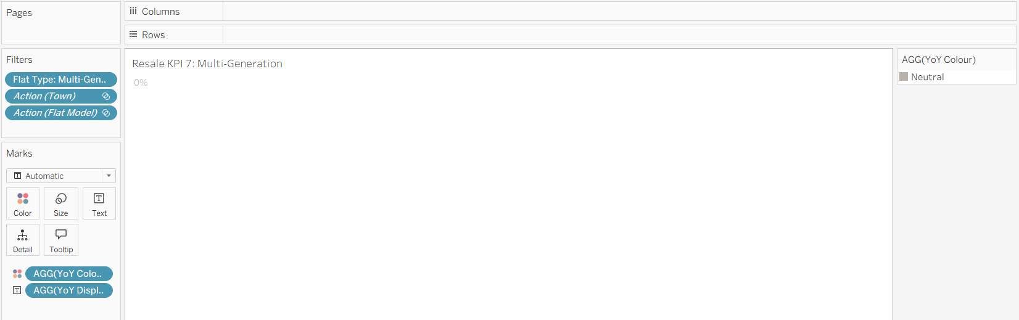

2.8 1 Room Price Per SQM KPI (NO MARKING)
Purpose
This KPI indicator shows the year-on-year percentage change in price per square metre for the selected flat type, allowing users to quickly understand how unit-level value has shifted relative to the previous year. By displaying the change with a clear increase or decrease arrow, the visual provides an immediate snapshot of pricing pressure on a per-sqm basis.
Key objectives of this visual include:
• Highlighting whether price per square metre has risen or fallen for the selected flat type over the past year.
• Offering a simple and concise indicator that helps users track short-term changes in unit value.
• Allowing users to detect shifts in price intensity that may not be visible through overall resale price alone.
• Supporting interactive exploration through filters such as town and flat model, enabling targeted analysis of localised PPSM movements.
• Helping buyers understand how efficiently space is being priced before evaluating broader affordability metrics.
Overall, this KPI gives users a quick and direct understanding of per-sqm price trends and serves as a useful complement to the resale price KPI in assessing current market conditions.
Table 16 1 Room Price Per SQM KPI Specifications
Sheet Name | Attributes Use | Calculated Field Use | Filter or Parameter Use
PSQM KPI 1: 1 Room | Columns:  NIL  Rows:  NIL  Marks (Colour):  AGG(PPSM YoY Colour)  Marks (Label):  AGG(PPSM YoY Display) | PPSM YoY Colour  IF [PPSM YoY %] > 0 THEN  "Increase"  ELSEIF [PPSM YoY %] < 0 THEN  "Decrease"  ELSE  "Neutral"  END  PPSM YoY Display  IF [PPSM YoY %] > 0 THEN  "▲ " + STR(ROUND([PPSM YoY %] * 100, 2)) + "%"  ELSEIF [PPSM YoY %] < 0 THEN  "▼ " + STR(ROUND(ABS([PPSM YoY %] * 100), 2)) + "%"  ELSE  "0%"  END  PPSM YoY %  IF AVG([PPSM 2024]) = 0 THEN  NULL  ELSE  (AVG([PPSM 2025]) - AVG([PPSM 2024]))  / AVG([PPSM 2024])  END  PPSM 2024  IF YEAR([Month]) = 2024 THEN [Price Per Sqm] END  PPSM 2025  IF YEAR([Month]) = 2025 THEN [Price Per Sqm] END | Filter  Flat Type: 1 Room  Action(Town)  Action (Flat Model)

PSQM KPI 1: 1 Room
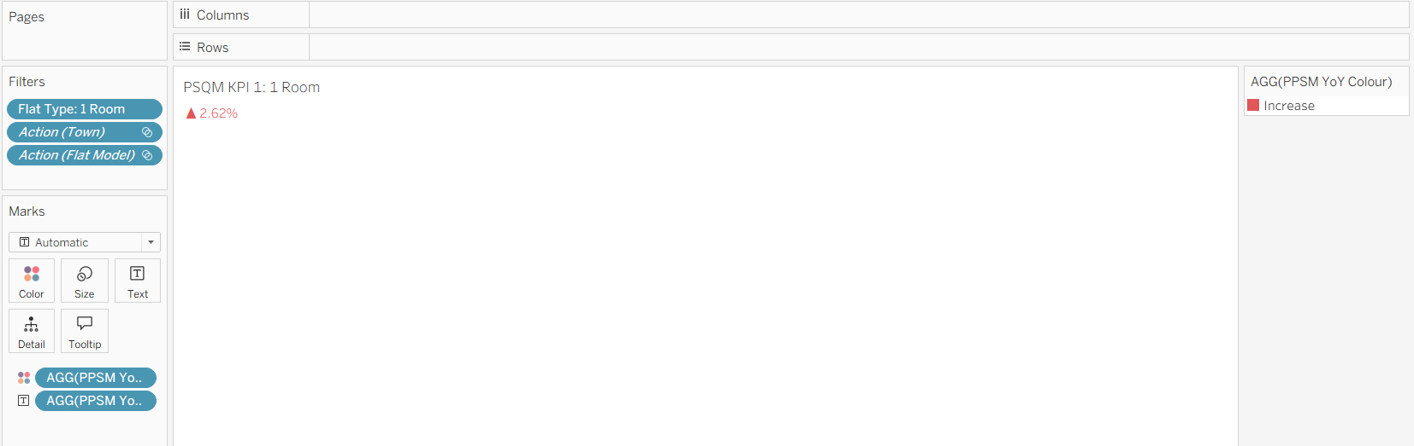

2.9 2 Room Price Per SQM KPI (NO MARKING)
Purpose
This KPI indicator shows the year-on-year percentage change in price per square metre for the selected flat type, allowing users to quickly understand how unit-level value has shifted relative to the previous year. By displaying the change with a clear increase or decrease arrow, the visual provides an immediate snapshot of pricing pressure on a per-sqm basis.
Key objectives of this visual include:
• Highlighting whether price per square metre has risen or fallen for the selected flat type over the past year.
• Offering a simple and concise indicator that helps users track short-term changes in unit value.
• Allowing users to detect shifts in price intensity that may not be visible through overall resale price alone.
• Supporting interactive exploration through filters such as town and flat model, enabling targeted analysis of localised PPSM movements.
• Helping buyers understand how efficiently space is being priced before evaluating broader affordability metrics.
Overall, this KPI gives users a quick and direct understanding of per-sqm price trends and serves as a useful complement to the resale price KPI in assessing current market conditions.
Table 17: 2 Room Price Per SQM KPI Specifications
Sheet Name | Attributes Use | Calculated Field Use | Filter or Parameter Use
PSQM KPI 2: 2 Room | Columns:  NIL  Rows:  NIL  Marks (Colour):  AGG(PPSM YoY Colour)  Marks (Label):  AGG(PPSM YoY Display) | PPSM YoY Colour  IF [PPSM YoY %] > 0 THEN  "Increase"  ELSEIF [PPSM YoY %] < 0 THEN  "Decrease"  ELSE  "Neutral"  END  PPSM YoY Display  IF [PPSM YoY %] > 0 THEN  "▲ " + STR(ROUND([PPSM YoY %] * 100, 2)) + "%"  ELSEIF [PPSM YoY %] < 0 THEN  "▼ " + STR(ROUND(ABS([PPSM YoY %] * 100), 2)) + "%"  ELSE  "0%"  END  PPSM YoY %  IF AVG([PPSM 2024]) = 0 THEN  NULL  ELSE  (AVG([PPSM 2025]) - AVG([PPSM 2024]))  / AVG([PPSM 2024])  END  PPSM 2024  IF YEAR([Month]) = 2024 THEN [Price Per Sqm] END  PPSM 2025  IF YEAR([Month]) = 2025 THEN [Price Per Sqm] END | Filter  Flat Type: 2 Room  Action(Town)  Action (Flat Model)

PSQM KPI 2: 2 Room
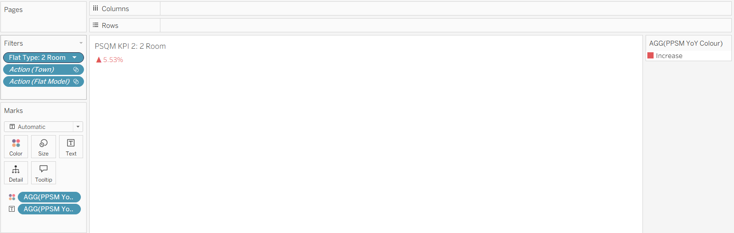

2.10 3 Room Price Per SQM KPI (NO MARKING)
Purpose
This KPI indicator shows the year-on-year percentage change in price per square metre for the selected flat type, allowing users to quickly understand how unit-level value has shifted relative to the previous year. By displaying the change with a clear increase or decrease arrow, the visual provides an immediate snapshot of pricing pressure on a per-sqm basis.
Key objectives of this visual include:
• Highlighting whether price per square metre has risen or fallen for the selected flat type over the past year.
• Offering a simple and concise indicator that helps users track short-term changes in unit value.
• Allowing users to detect shifts in price intensity that may not be visible through overall resale price alone.
• Supporting interactive exploration through filters such as town and flat model, enabling targeted analysis of localised PPSM movements.
• Helping buyers understand how efficiently space is being priced before evaluating broader affordability metrics.
Overall, this KPI gives users a quick and direct understanding of per-sqm price trends and serves as a useful complement to the resale price KPI in assessing current market conditions.
Table 18: 3 Room Price Per SQM KPI Specifications
Sheet Name | Attributes Use | Calculated Field Use | Filter or Parameter Use
PSQM KPI 3: 3 Room | Columns:  NIL  Rows:  NIL  Marks (Colour):  AGG(PPSM YoY Colour)  Marks (Label):  AGG(PPSM YoY Display) | PPSM YoY Colour  IF [PPSM YoY %] > 0 THEN  "Increase"  ELSEIF [PPSM YoY %] < 0 THEN  "Decrease"  ELSE  "Neutral"  END  PPSM YoY Display  IF [PPSM YoY %] > 0 THEN  "▲ " + STR(ROUND([PPSM YoY %] * 100, 2)) + "%"  ELSEIF [PPSM YoY %] < 0 THEN  "▼ " + STR(ROUND(ABS([PPSM YoY %] * 100), 2)) + "%"  ELSE  "0%"  END  PPSM YoY %  IF AVG([PPSM 2024]) = 0 THEN  NULL  ELSE  (AVG([PPSM 2025]) - AVG([PPSM 2024]))  / AVG([PPSM 2024])  END  PPSM 2024  IF YEAR([Month]) = 2024 THEN [Price Per Sqm] END  PPSM 2025  IF YEAR([Month]) = 2025 THEN [Price Per Sqm] END | Filter  Flat Type: 3 Room  Action(Town)  Action (Flat Model)

PSQM KPI 3: 3 Room
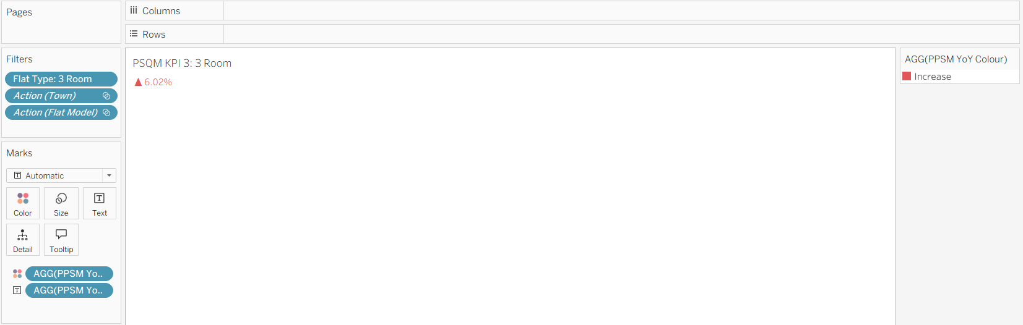

2.11 4 Room Price Per SQM KPI (NO MARKING)
Purpose
This KPI indicator shows the year-on-year percentage change in price per square metre for the selected flat type, allowing users to quickly understand how unit-level value has shifted relative to the previous year. By displaying the change with a clear increase or decrease arrow, the visual provides an immediate snapshot of pricing pressure on a per-sqm basis.
Key objectives of this visual include:
• Highlighting whether price per square metre has risen or fallen for the selected flat type over the past year.
• Offering a simple and concise indicator that helps users track short-term changes in unit value.
• Allowing users to detect shifts in price intensity that may not be visible through overall resale price alone.
• Supporting interactive exploration through filters such as town and flat model, enabling targeted analysis of localised PPSM movements.
• Helping buyers understand how efficiently space is being priced before evaluating broader affordability metrics.
Overall, this KPI gives users a quick and direct understanding of per-sqm price trends and serves as a useful complement to the resale price KPI in assessing current market conditions.
Table 19: 4 Room Price Per SQM KPI Specifications
Sheet Name | Attributes Use | Calculated Field Use | Filter or Parameter Use
PSQM KPI 4: 4 Room | Columns:  NIL  Rows:  NIL  Marks (Colour):  AGG(PPSM YoY Colour)  Marks (Label):  AGG(PPSM YoY Display) | PPSM YoY Colour  IF [PPSM YoY %] > 0 THEN  "Increase"  ELSEIF [PPSM YoY %] < 0 THEN  "Decrease"  ELSE  "Neutral"  END  PPSM YoY Display  IF [PPSM YoY %] > 0 THEN  "▲ " + STR(ROUND([PPSM YoY %] * 100, 2)) + "%"  ELSEIF [PPSM YoY %] < 0 THEN  "▼ " + STR(ROUND(ABS([PPSM YoY %] * 100), 2)) + "%"  ELSE  "0%"  END  PPSM YoY %  IF AVG([PPSM 2024]) = 0 THEN  NULL  ELSE  (AVG([PPSM 2025]) - AVG([PPSM 2024]))  / AVG([PPSM 2024])  END  PPSM 2024  IF YEAR([Month]) = 2024 THEN [Price Per Sqm] END  PPSM 2025  IF YEAR([Month]) = 2025 THEN [Price Per Sqm] END | Filter  Flat Type: 4 Room  Action(Town)  Action (Flat Model)

PSQM KPI 4: 4 Room
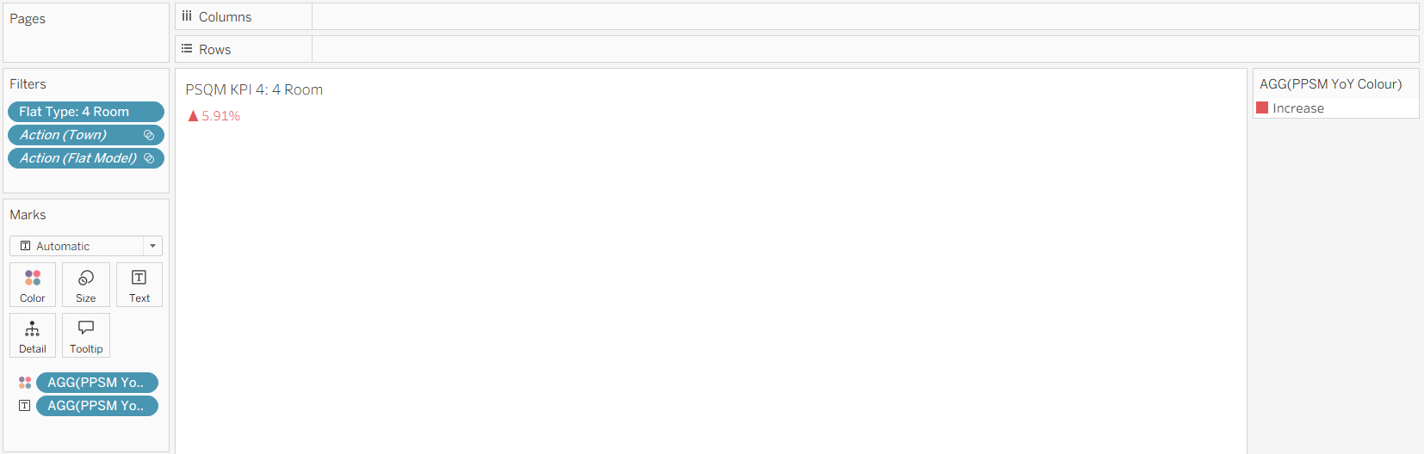

2.12 5 Room Price Per SQM KPI (NO MARKING)
Purpose
This KPI indicator shows the year-on-year percentage change in price per square metre for the selected flat type, allowing users to quickly understand how unit-level value has shifted relative to the previous year. By displaying the change with a clear increase or decrease arrow, the visual provides an immediate snapshot of pricing pressure on a per-sqm basis.
Key objectives of this visual include:
• Highlighting whether price per square metre has risen or fallen for the selected flat type over the past year.
• Offering a simple and concise indicator that helps users track short-term changes in unit value.
• Allowing users to detect shifts in price intensity that may not be visible through overall resale price alone.
• Supporting interactive exploration through filters such as town and flat model, enabling targeted analysis of localised PPSM movements.
• Helping buyers understand how efficiently space is being priced before evaluating broader affordability metrics.
Overall, this KPI gives users a quick and direct understanding of per-sqm price trends and serves as a useful complement to the resale price KPI in assessing current market conditions.
Table 20: 5 Room Price Per SQM KPI Specifications
Sheet Name | Attributes Use | Calculated Field Use | Filter or Parameter Use
PSQM KPI 5: 5 Room | Columns:  NIL  Rows:  NIL  Marks (Colour):  AGG(PPSM YoY Colour)  Marks (Label):  AGG(PPSM YoY Display) | PPSM YoY Colour  IF [PPSM YoY %] > 0 THEN  "Increase"  ELSEIF [PPSM YoY %] < 0 THEN  "Decrease"  ELSE  "Neutral"  END  PPSM YoY Display  IF [PPSM YoY %] > 0 THEN  "▲ " + STR(ROUND([PPSM YoY %] * 100, 2)) + "%"  ELSEIF [PPSM YoY %] < 0 THEN  "▼ " + STR(ROUND(ABS([PPSM YoY %] * 100), 2)) + "%"  ELSE  "0%"  END  PPSM YoY %  IF AVG([PPSM 2024]) = 0 THEN  NULL  ELSE  (AVG([PPSM 2025]) - AVG([PPSM 2024]))  / AVG([PPSM 2024])  END  PPSM 2024  IF YEAR([Month]) = 2024 THEN [Price Per Sqm] END  PPSM 2025  IF YEAR([Month]) = 2025 THEN [Price Per Sqm] END | Filter  Flat Type: 5 Room  Action(Town)  Action (Flat Model)

PSQM KPI 5: 5 Room
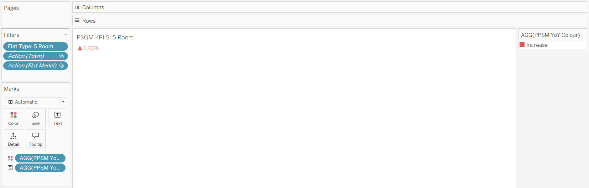

2.13 Executive Price Per SQM KPI (NO MARKING)
Purpose
This KPI indicator shows the year-on-year percentage change in price per square metre for the selected flat type, allowing users to quickly understand how unit-level value has shifted relative to the previous year. By displaying the change with a clear increase or decrease arrow, the visual provides an immediate snapshot of pricing pressure on a per-sqm basis.
Key objectives of this visual include:
• Highlighting whether price per square metre has risen or fallen for the selected flat type over the past year.
• Offering a simple and concise indicator that helps users track short-term changes in unit value.
• Allowing users to detect shifts in price intensity that may not be visible through overall resale price alone.
• Supporting interactive exploration through filters such as town and flat model, enabling targeted analysis of localised PPSM movements.
• Helping buyers understand how efficiently space is being priced before evaluating broader affordability metrics.
Overall, this KPI gives users a quick and direct understanding of per-sqm price trends and serves as a useful complement to the resale price KPI in assessing current market conditions.
Table 21: Executive Price Per SQM KPI Specifications
Sheet Name | Attributes Use | Calculated Field Use | Filter or Parameter Use
PSQM KPI 6: Executive | Columns:  NIL  Rows:  NIL  Marks (Colour):  AGG(PPSM YoY Colour)  Marks (Label):  AGG(PPSM YoY Display) | PPSM YoY Colour  IF [PPSM YoY %] > 0 THEN  "Increase"  ELSEIF [PPSM YoY %] < 0 THEN  "Decrease"  ELSE  "Neutral"  END  PPSM YoY Display  IF [PPSM YoY %] > 0 THEN  "▲ " + STR(ROUND([PPSM YoY %] * 100, 2)) + "%"  ELSEIF [PPSM YoY %] < 0 THEN  "▼ " + STR(ROUND(ABS([PPSM YoY %] * 100), 2)) + "%"  ELSE  "0%"  END  PPSM YoY %  IF AVG([PPSM 2024]) = 0 THEN  NULL  ELSE  (AVG([PPSM 2025]) - AVG([PPSM 2024]))  / AVG([PPSM 2024])  END  PPSM 2024  IF YEAR([Month]) = 2024 THEN [Price Per Sqm] END  PPSM 2025  IF YEAR([Month]) = 2025 THEN [Price Per Sqm] END | Filter  Flat Type: Executive  Action(Town)  Action (Flat Model)

PSQM KPI 6: Executive
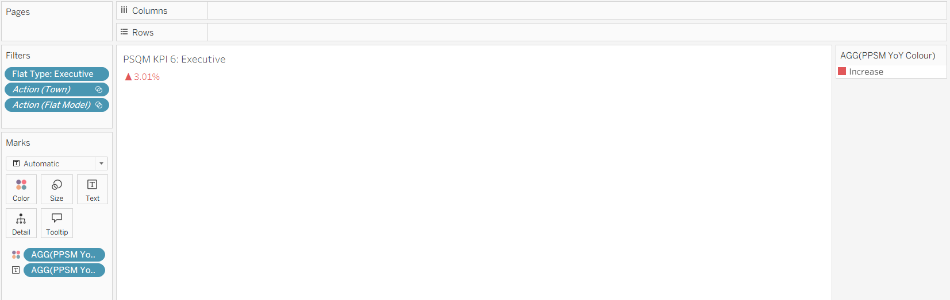

2.14 Multi-Generation Price Per SQM KPI (NO MARKING)
Purpose
This KPI indicator shows the year-on-year percentage change in price per square metre for the selected flat type, allowing users to quickly understand how unit-level value has shifted relative to the previous year. By displaying the change with a clear increase or decrease arrow, the visual provides an immediate snapshot of pricing pressure on a per-sqm basis.
Key objectives of this visual include:
• Highlighting whether price per square metre has risen or fallen for the selected flat type over the past year.
• Offering a simple and concise indicator that helps users track short-term changes in unit value.
• Allowing users to detect shifts in price intensity that may not be visible through overall resale price alone.
• Supporting interactive exploration through filters such as town and flat model, enabling targeted analysis of localised PPSM movements.
• Helping buyers understand how efficiently space is being priced before evaluating broader affordability metrics.
Overall, this KPI gives users a quick and direct understanding of per-sqm price trends and serves as a useful complement to the resale price KPI in assessing current market conditions.
Table 22: Multi-Generation Price Per SQM KPI Specifications
Sheet Name | Attributes Use | Calculated Field Use | Filter or Parameter Use
PSQM KPI 7: Multi-Generation | Columns:  NIL  Rows:  NIL  Marks (Colour):  AGG(PPSM YoY Colour)  Marks (Label):  AGG(PPSM YoY Display) | PPSM YoY Colour  IF [PPSM YoY %] > 0 THEN  "Increase"  ELSEIF [PPSM YoY %] < 0 THEN  "Decrease"  ELSE  "Neutral"  END  PPSM YoY Display  IF [PPSM YoY %] > 0 THEN  "▲ " + STR(ROUND([PPSM YoY %] * 100, 2)) + "%"  ELSEIF [PPSM YoY %] < 0 THEN  "▼ " + STR(ROUND(ABS([PPSM YoY %] * 100), 2)) + "%"  ELSE  "0%"  END  PPSM YoY %  IF AVG([PPSM 2024]) = 0 THEN  NULL  ELSE  (AVG([PPSM 2025]) - AVG([PPSM 2024]))  / AVG([PPSM 2024])  END  PPSM 2024  IF YEAR([Month]) = 2024 THEN [Price Per Sqm] END  PPSM 2025  IF YEAR([Month]) = 2025 THEN [Price Per Sqm] END | Filter  Flat Type: Multi-Generation  Action(Town)  Action (Flat Model)

PSQM KPI 7: Multi-Generation
