Declaration of Academic Integrity
Academic Integrity is a central tenet of Singapore Polytechnic. The polytechnic rules state that "Cheating in examinations and other assessed work is a very serious offence. This includes copying and using plagiarised material. Any student who cheats, attempts to cheat or breaches any rules for examinations and tests will face disciplinary action. The student is liable to be expelled."
Check only one of the two options below:
☐ I affirm that the work I submit is my own, produced without help from any AI tool(s) and/or other source(s).
☒ I affirm that the work I submit has been produced with the use of AI tool(s) and/or other source(s) which I have acknowledged fully in the following section.
By signing this form, I declare that the above affirmation made is true, and that I have read and understood the rules stated in Students Handbook on “Plagiarism” and “Breach of Examination/Assessment Rules”.

Name:  Goh Kun Ming | Student ID:  P2415691 | Class:  DAAA/FT/2B/02
Signature:  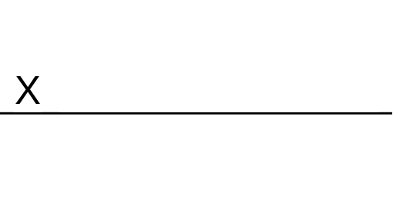 | Date:  15/2/2026

Acknowledgement of use of AI tool(s) and/or other source(s) (where applicable)

AI tool(s)
Name of AI tool | ChatGPT, Bolt.new
Input prompt | -
Date generated | -
Output generated | -
Impact on submission | -

Other source(s)
Source | Impact on submission
https://universe.roboflow.com/vegetables-zdlas/vegetable-cihx0 | Live Object Detection Model

