ST1508 Practical AI – CA1 Sprint 1 Report
Gobest Cab: Dangerous Driving Behaviour Detection – Sprint 1
School of Computing, Singapore Polytechnic
Diploma in Applied AI & Analytics (DAAA)
AY2025/2026 Sem 2
Team: Goh Kun Ming, Law Wei Tin, Liu Xingyu, Goh Jenson
Reference: CA1 Specifications

1. Introduction
Gobest Cab aims to improve road safety by detecting dangerous driving behaviour using historical driver and sensor data. The company has provided driver, trip, sensor and safety-label datasets to support the development of an AI-powered safety analysis system.
This report documents all deliverables completed in Sprint 1 (CA1), including database construction, ETL pipelines, data cleaning and preprocessing, exploratory data analysis, and the development of an interactive business dashboard.
Sprint 1 lays the entire data foundation needed for model training in Sprint 2.

2. Business Understanding
The business wants to identify, monitor and reduce dangerous driving patterns. To do this, Gobest Cab needs a system that:
- Stores large amounts of sensor and trip data in a reliable SQL database
- Cleans & processes the data for consistent downstream use
- Analyses high-risk behaviours and patterns
- Visualizes insights clearly for business users
- Prepares clean & structured datasets for Machine Learning (Sprint 2)
Business Questions
Question | Outcome (Sprint 1)
What factors correlate most with dangerous trips? | Identified using EDA, trend charts, heatmaps
How clean is the historical data and what preprocessing is required? | Implemented strong data-cleaning & ETL pipeline
Which behaviours (speeding, braking, turning) indicate high-risk driving? | Derived via engineered sensor features
How can safety be tracked visually? | Built interactive Tableau / Power BI dashboard

3. Agile Methodology & Scrum Management
The team applied Agile Scrum as required in CA1 .
Scrum Artefacts Completed
- Full Product Backlog with user stories
- Issue board with columns: Backlog → To Do → In Progress → Closed
- Weekly Scrum updates
- Two Sprint summaries using the provided template
- Completed all Sprint 1 tasks on GitLab
User Stories (5 total)
- Company Manager
As a manager, I want a clear dashboard showing safety trends so that I can make operational decisions quickly.
- Safety Analyst
As an analyst, I need access to aggregated trip and sensor metrics so that I can identify unsafe driver behaviour.
- Data Engineer
As a data engineer, I need a robust ETL pipeline so that new trip data can be processed automatically.
- Data Scientist
As a data scientist, I require a clean labelled dataset so that I can train the dangerous driving prediction model.
- Operations Lead
As an operations lead, I need to identify high-risk drivers so that I can assign them mandatory safety retraining.
All tasks in the backlog were assigned, completed, and moved to Closed.

4. Database Design & ER Diagram
Database Overview
A MySQL database was fully designed and implemented to store:
- drivers — driver demographics and vehicle info
- trips — trip-level metadata
- sensor_readings — timestamp-level sensor data from CSV files
- safety_labels — safety status for each trip
Constraints, datatypes, and indexing were optimized based on query patterns.
ERD Summary
drivers (1) — (∞) trips
trips (1) — (∞) sensor_readings
trips (1) — (1) safety_labels
Important design decisions:
- Surrogate keys (AUTO_INCREMENT) used as required
- Composite indexes on trip_id + timestamp for efficient filtering
- Datetime normalization for time-series alignment
The ERD is included in the Appendix.

5. ETL Pipeline Architecture
Tools Used
- Python (Pandas, SQLAlchemy)
- MySQL JDBC (for Spark compatibility)
Pipeline Steps
Extraction
- Loaded all CSV sensor files
- Ingested driver and safety tables
- Ensured consistent schema despite varying file formats
Transformation
Key steps implemented:
- Missing timestamp interpolation
- Enforcement of numeric & datetime types
- Deduplication of sensor events
- Domain validation (e.g., speed ≥ 0, physical sensor limits)
- Merging sensor and trip metadata
- Feature generation (acceleration spikes, harsh braking, steering variance, overspeed duration)
Loading
- Cleaned datasets written back into new MySQL schemas (staging, analytics)
- Final tables optimized for EDA and dashboard consumption

6. Data Pre-processing & Cleansing
Data Issues Identified
Issue | Solution
Gaps in sensor timestamps | Interpolated using linear interpolation
Out-of-range sensor values | Clamped or removed based on domain thresholds
Duplicated sensor entries | Resolved using row-level deduplication
Mixed datatypes in CSVs | Enforced via dtype casting during ETL
Trip–sensor misalignment | Reindexed using timestamp merging
Missing driver attributes | Imputed or removed depending on severity
Feature Engineering
These features were created for later ML modelling:
- Mean/median acceleration per trip
- Maximum deceleration (harsh braking)
- Gyroscope variance (turning sharpness)
- Engine vibration features
- Overspeeding duration
- Sensor volatility index
These were loaded into a final analytics table.

7. Exploratory Data Analysis (EDA)
The EDA notebook includes dozens of analyses. Key findings:
7.1 Acceleration Patterns
Dangerous trips show significantly more:
- Abrupt acceleration spikes
- Harsh braking events
- High variance in lateral movement
7.2 Trip Timing
- Nighttime trips have a higher proportion of dangerous outcomes
- Weekend trips behave differently from weekday traffic
7.3 Driver-Level Insights
- A small % of drivers contribute to a large % of dangerous trips
- Some vehicle types show higher sensor noise
7.4 Sensor Correlations
- Strong correlation between gyroscope variance and dangerous trips
- Speed spikes alone are less predictive than combined sensor behaviour
EDA screenshots are included in the Appendix.

8. EC2-Hosted ETL Pipeline
EC2 Infrastructure Setup
8.1 Launch EC2 Instance
- AMI: Amazon Linux 2023
- Instance Type: t2.micro (Free Tier)
- Storage: 20GB GP3 recommended
- Network:
  - Public Subnet
  - Auto-assign Public IP: Enabled
- Security Group:
  - Inbound:
    - SSH (TCP 22) — 0.0.0.0/0
    - MySQL (TCP 3306) — Your IP / RDS SG
  - Outbound: Allow all
8.2 EC2 Initialization (Bootstrap Environment)
SSH into the instance:
- ssh -i "yourkey.pem" ec2-user@<PUBLIC-IP>
Update base packages:
- sudo dnf update -y
Install core dependencies:
- sudo dnf install -y python3 python3-devel git gcc-c++
- sudo dnf install -y java-17-amazon-corretto
Verify Java:
- java -version
Install MySQL client (required for pre-ETL checks):
- sudo dnf install -y mariadb105

8.3 Python Environment Setup
Install Python packages for the pipeline:
- pip install pyspark==4.0.1
- pip install pandas
- pip install numpy
- pip install SQLAlchemy
- pip install PyMySQL
- pip install python-dateutil
- pip install scikit-learn
- pip install matplotlib
- pip install scipy seaborn statsmodels
- pip install jupyter
- pip install ipython
- pip install python-dateutil==2.9.0

8.4 ETL Scripts
You now have three ETL pipelines:
1. Driver ETL → cleans driver dimension
- PAI_Data_Cleaning_(Driver).py
2. Sensor ETL → cleans trip sensor data
- PAI_Data_Cleaning_(Sensor).py
3. Safety ETL → maps safety labels → Fact_Label
- PAI_Data_Cleaning_(Safety).py
Each script:
- Reads from staging RDS
- Performs cleaning, type casting, feature engineering
- Inserts new rows into warehouse RDS
- Updates staging.cleaned_date = NOW()
8.5 Cron Automation
Open crontab and Add Daily Cron Job at 3AM:
- crontab -e
- 0 3 * * * /home/ec2-user/pai_pipeline/run_all.sh >> /home/ec2-user/pai_pipeline/cron.log 2>&1
8.6 Final System Flow Diagram

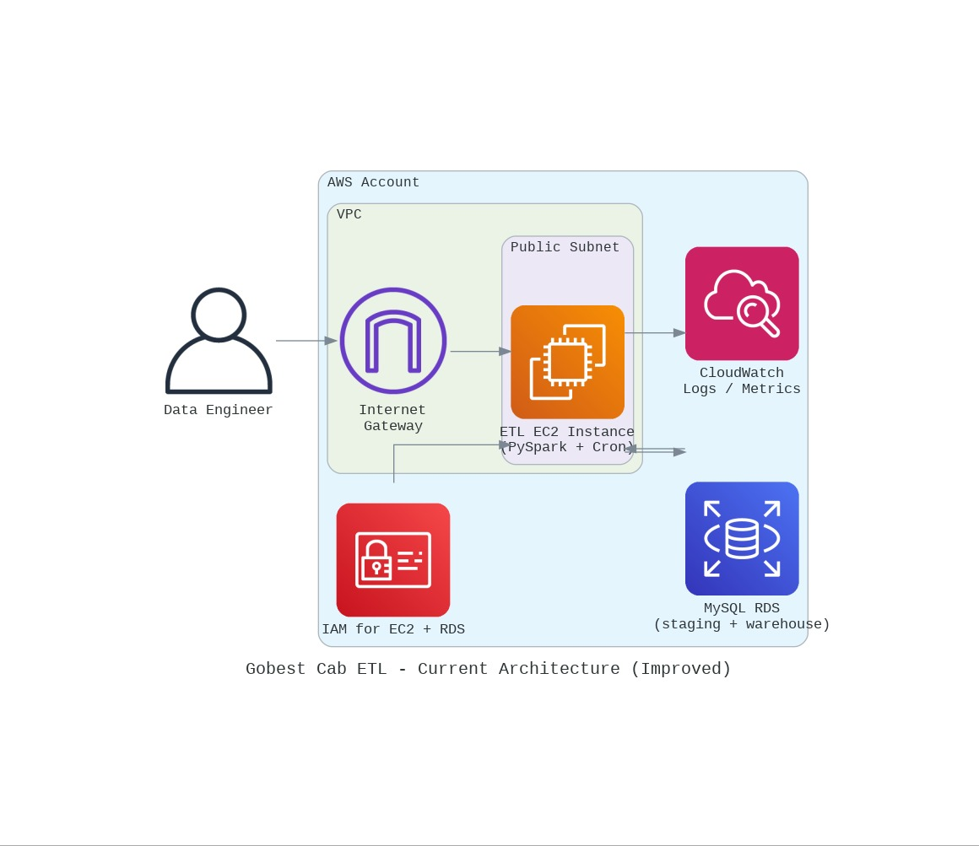

9. Dashboard Design & Insights
An interactive dashboard was built using Power BI containing 4 pages:
Page 1 — Driver Overview
- Driver risk ranking
- KPI cards (% dangerous trips, avg acceleration, peak speed)
Page 2 — Trip Analytics
- Trip-level distributions
- Dangerous vs safe comparisons
- Trends by hour, day, and vehicle type
Page 3 — Sensor Behaviour
- Acceleration heatmaps
- Gyroscope patterns
- Boxplots and variance indicators
Page 4 — Safety Summary
- Safety category breakdown
- High-risk drivers
Key Insights Presented
- Dangerous trips cluster heavily in evening hours.
- Harsh braking intensity is the most predictive sensor signal.
- A handful of drivers exhibit consistent high-risk patterns.
- Overspeeding alone is insufficient—risk is driven by combined sensor anomalies.
The dashboard supports slicing by:
- Driver
- Trip
- Safety status
- Date/time
- Car model
10. Discussion & Limitations
- Sensor data is high-volume; MySQL partitioning helped, but future use may require a data lake.
- Interpolating timestamps introduces estimation noise, though necessary for model compatibility.
- Safety labels are moderately imbalanced; modelling will need class-balancing techniques.
- Some sensor channels show hardware noise; smoothing filters might improve ML performance.

10. Conclusion
Sprint 1 was fully completed with all deliverables outlined in the CA1 specification :
- Full MySQL database
- ETL pipelines for extraction, cleaning, loading
- Data preprocessing & feature engineering
- Complete EDA with visualizations
- Fully interactive BI dashboard
- Scrum documentation & user stories
- Prepared datasets for Sprint 2 model training
The foundation is now ready for Sprint 2, where the team will develop and deploy a machine-learning model to detect dangerous driving behaviour.

11. References
- ST1508 CA1 Specification Document
- MySQL 8.0 Documentation
- Pandas, NumPy, Matplotlib, Seaborn
- Tableau / Power BI Documentation

Appendices (All completed)
Appendix A — SQL CREATE TABLE Script
(Submitted separately)
Appendix B — SQL Query Script
(Submitted separately)
Appendix C — Jupyter Notebook Screenshots
(Full data cleaning, preprocessing, EDA, feature engineering)
Appendix D — ERD Diagram
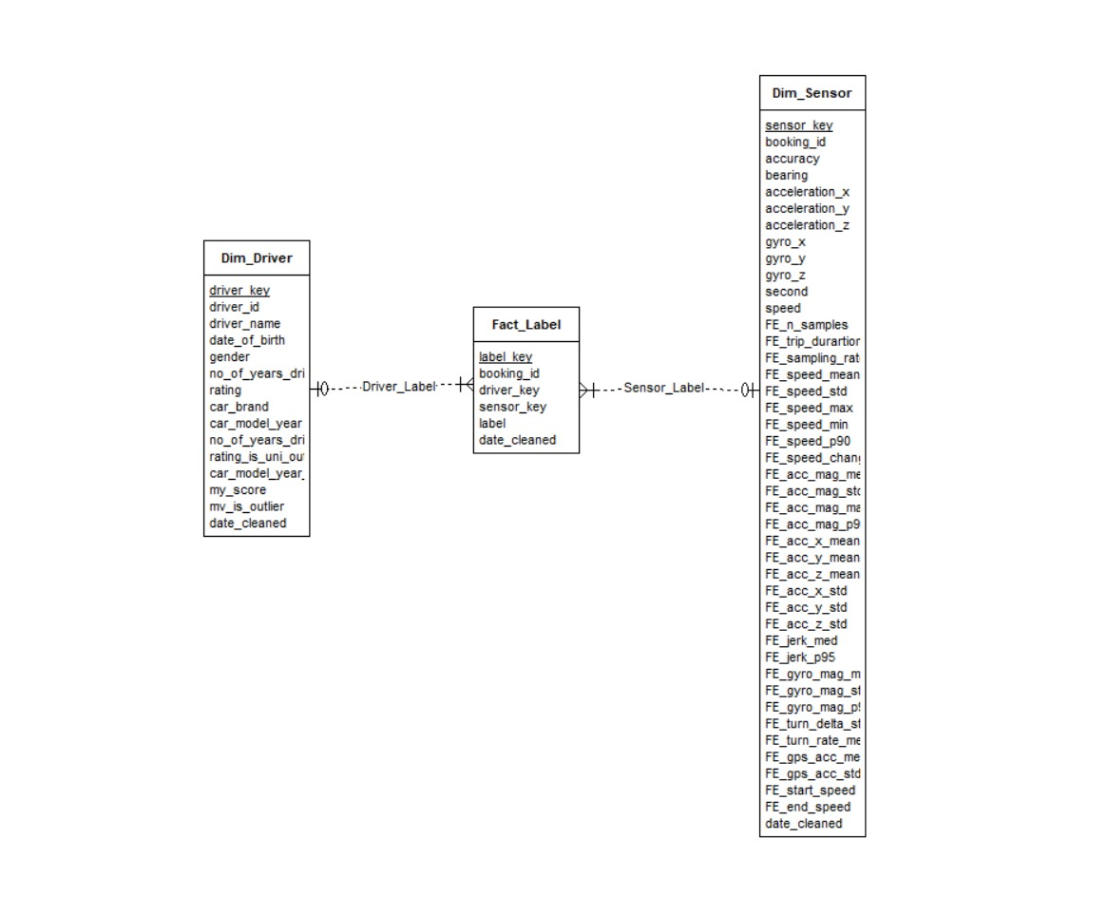
Appendix E — Scrum Summaries (2 Reports)
(Using CA1 template)
Appendix F — User Stories (5 total)
(As listed above)

