SCRUM DOCUMENT (ST1508 CA1 – Sprint 1)

Product Backlog (User Stories)
Given User Story
As a manager, I need an intuitive application with a user interface so that I can visualize, analyse, and compare fraud activities from various angles so that I can initiate new platform features to prevent fraud actions.
User Story 1 — View Safety Trends & Risky Drivers (Manager)
As a manager, I want to view overall safety performance trends and risky driver statistics so that I can monitor safety KPIs and plan targeted safety campaigns.

User Story 2 — View Aggregated Safety Statistics by Region (Manager)
As a manager, I want to view aggregated statistics by region and time of day so that I can identify high-risk areas or peak accident periods.

User Story 3 — Real-time Fleet Safety Summary (Manager)
As a manager, I want a summary page that provides real-time updates on overall fleet safety so that I can make fast decisions when issues arise.

User Story 4 — Trace Unsafe Behaviour by Trip (Operations Supervisor)
As an operations supervisor, I want to view trip-level data linked to each driver so that I can trace unsafe behaviour to individual drivers.

User Story 5 — Compare Sensor Readings Across Trips (Operations Supervisor)
As an operations supervisor, I want to compare sensor readings across trips so that I can identify patterns that lead to unsafe outcomes.

User Story 6 — Generate Driver Performance Report (Operations Supervisor)
As an operations supervisor, I want to generate driver performance reports so that I can give feedback and plan retraining programmes.

User Story 7 — Design Normalised SQL Schema (Data Scientist)
As a data scientist, I want to design a normalised SQL schema so that I can maintain data consistency and integrity across datasets.

User Story 8 — Build Automated ETL Pipeline (Data Scientist)
As a data scientist, I want to build an automated ETL pipeline that extracts and loads data efficiently so that the data can be used in Jupyter for analysis.

User Story 9 — Perform EDA on Driver and Sensor Data (Data Scientist)
As a data scientist, I want to perform EDA to understand feature distributions and correlations so that I can identify predictors for Sprint 2.

User Story 10 — Ensure Modular and Reusable ETL Codebase (Software Developer)
As a software developer, I want to ensure the ETL codebase is modular and reusable so that it can be integrated easily into future AI applications.

User Story 11 — Design SQL Query Scripts for Dashboard (Software Developer)
As a software developer, I want to design SQL query scripts to retrieve analytical data so that the dashboard can access key metrics.

User Story 12 — Visualise Correlations Between Sensor Metrics and Safety (Safety Analyst)
As a safety analyst, I want to visualise correlations between sensor metrics and trip safety so that I can interpret behavioural risk factors.

Weekly Scrum Summary – Gantt Chart

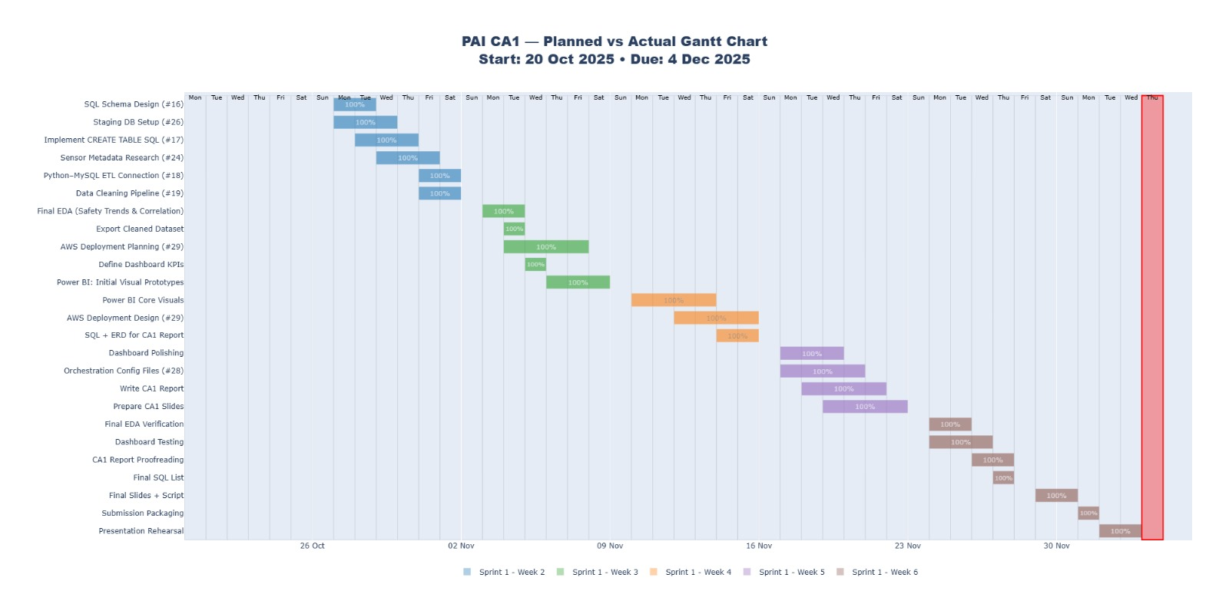

Weekly Scrum Summary
✅ Weekly Scrum Summary – Week 2

1. Tasks completed (per person + estimated time spent)
Goh Jenson
- Completed Research on Sensor Data Metadata (#24) – ~1.5 hours
- Completed Implement SQL Schema CREATE TABLE SQL Script - ~1.5 hours
Goh Kun Ming
- Started Develop Python–MySQL ETL Connection (#18) – ~2 hours
- Started Implement Data Cleaning Pipeline (#19) – ~2 hours
Law Wei Tin
- Completed Create Staging Database in MySQL (#26) – ~4 hours
- Completed Implement CREATE TABLE SQL Script (#17) – ~2 hours
Liu Xingyu
- Designed SQL Schema for Drivers & Trips (#16) – ~3 hours

2. Scrum Board Status
Tasks completed this week:
- #25 Research Tableau Best Practices
- #16 SQL Schema Design
- #26 Staging DB Setup
- #17 Create Table SQL
- #24 Sensor Metadata Research

Tasks still in progress / backlog:
- In Progress:
- #19 Data Cleaning Pipeline
- #18 Python–MySQL ETL Connection
- To Do / Backlog:
- #20 EDA Notebook
- #21 Build Dashboard
- #23 Compile CA1 Report
- #22 Prepare Sprint 1 Presentation
New tasks added this week:
None newly added the team is still clearing the initial backlog created at Sprint Planning.

3. Reflection on Delays / Challenges
- ETL pipeline (#18, #19) is taking longer because:
- Large sensor data files required testing chunked loading.
- Multiple table dependencies created debugging needs.
Team plans to complete ETL fully next week before moving to EDA.

✅ Weekly Scrum Summary – Week 4

1. Tasks completed (per person + estimated time spent)
Goh Jenson
- Started EDA Notebook (#20) with early visualisation tests – ~2.5 hours
Goh Kun Ming
- Completed Python–MySQL ETL Connection (#18) – ~3 hours
- Finalised Data Cleaning Pipeline logic (#19) – ~3 hours
Law Wei Tin
- Completed Trip-Level Feature Engineering Pipeline (#27) – ~4 hours
- Reviewed ETL outputs with Kun Ming – ~1 hour

Liu Xingyu
- Completed Research on Tableau Capabilities & Best Practices (#25) – ~2.5 hours
- Supported dashboard field planning after Tableau research – ~1 hour

2. Scrum Board Status
Tasks completed this week:
- #27 Trip-Level Feature Engineering Pipeline
- #18 Python–MySQL ETL
- #19 Data Cleaning Pipeline

Tasks currently in progress:
- #20 EDA Notebook (Jenson)
- #21 Dashboard Development (Wei Tin)

Tasks still in backlog:
- #23 Compile CA1 Report
- #22 Sprint 1 Presentation

New tasks added this week:
None added however, existing tasks (#20, #21) were expanded with subtasks (e.g., safety trend visualisation, sensor correlation charts) because EDA revealed additional insights that would be useful for dashboarding.

3. Reflection on Delays / Challenges
- EDA (#20) took longer due to:
- Needing to merge driver, sensor, and safety labels tables properly.
- Some sensor files contained missing timestamps requiring interpolation.

- Dashboard (#21) development is slightly delayed because:
-Team is still finalising which metrics best support business users (e.g., high-risk drivers, unsafe trips by time, sensor anomalies).
- Additional SQL queries needed to be written to support aggregated metrics.
- Team agreed to focus next week on finishing EDA → building Tableau dashboard → preparing CA1 report and slides.

✅ Weekly Scrum Summary – Week 6

1. Tasks completed (per person + estimated time spent)
Goh Jenson
- Completed verification of EDA results + ensured all figures aligned with dashboard metrics – ~1.5 hours
- Assisted in proofreading the CA1 report (EDA + Insights sections) – ~1 hour
Goh Kun Ming
- Reviewed ETL and feature engineering code to ensure reproducibility – ~2 hours
- Helped finalise SQL query list for report appendix – ~1 hour
Law Wei Tin
- Final polishing of Power BI dashboard (layout alignment, slicer optimisation) – ~2 hours
- Conducted functional testing on dashboard interactivity for presentation – ~1 hour
Liu Xingyu
- Integrated all remaining parts of CA1 report (ERD diagrams, references, appendix) – ~2 hours
- Finalised Sprint 1 presentation script and rehearsal flow – ~1.5 hours

2. Scrum Board Status
Tasks completed this week:
- Power BI dashboard fully completed and tested
- CA1 report fully assembled and formatted
- All SQL queries + ERD finalised
- Sprint 1 presentation slides and script completed

Tasks currently in progress:
- Final pre-submission checks (file naming, packaging)
- Rehearsing Sprint 1 presentation as a team

Tasks still in backlog:
- None — all Sprint 1 tasks have been completed for CA1 submission

New tasks added this week:
None

3. Reflection on Delays / Challenges
- The largest challenge was aligning EDA results with dashboard KPIs, which required the team to adjust several SQL queries and re-export cleaned datasets.
- Final dashboard polish took additional time because field formatting, tooltips, and cross-filtering behaviour had to be consistent across all visuals.
- Overall, the team completed all Sprint 1 tasks on time and resolved all blockers through weekly check-ins and collaborative debugging.

