task1：
开启ufw后禁用23端口
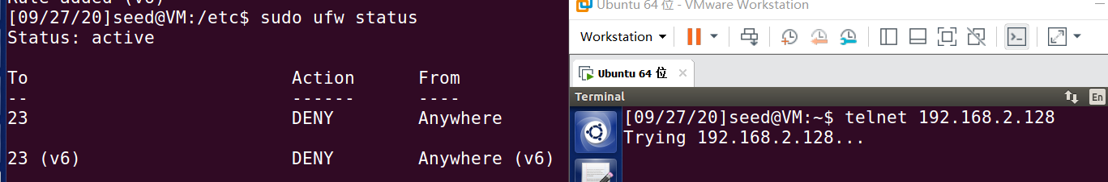
则外部无法telnet到目的主机
task2:
模块的源文件如下
#include <linux/module.h>
#include <linux/kernel.h>
#include <linux/skbuff.h>
#include <linux/ip.h>
#include <linux/tcp.h>
#include <linux/netfilter.h>
#include <linux/netfilter_ipv4.h>

static struct nf_hook_ops telnetFilterHook;

unsigned int telnetFilter(void *priv,struct sk_buff *skb,const struct nf_hook_state *state)
{
struct iphdr *iph;
struct tcphdr *tcph;
iph=ip_hdr(skb);
tcph=(void*)iph+iph->ihl*4;
if(iph->protocol == IPPROTO_TCP && tcph->dest == htons(23))
{
printk(KERN_INFO "Dropping telnet packet to %d.%d.%d.%d\n",
((unsigned char *)&iph->daddr)[0],
((unsigned char *)&iph->daddr)[1],
((unsigned char *)&iph->daddr)[2],
((unsigned char *)&iph->daddr)[0]);
return NF_DROP;
}
else
{
return NF_ACCEPT;
}
}

int setUpFilter(void)
{
printk(KERN_INFO "Registering a Telnet filter.\n");
telnetFilterHook.hook = telnetFilter;
telnetFilterHook.hooknum = NF_INET_POST_ROUTING;
telnetFilterHook.pf = PF_INET;
telnetFilterHook.priority = NF_IP_PRI_FIRST;
nf_register_hook(&telnetFilterHook);
return 0;
}

void removeFilter(void)
{
printk(KERN_INFO "Telnet filter is being remove.\n");
nf_unregister_hook(&telnetFilterHook);
}

module_init(setUpFilter);
module_exit(removeFilter);
编译完成后加入现有系统内核
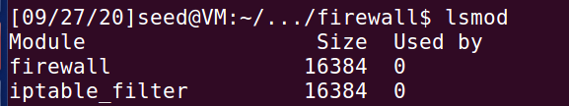
当主机向外发送telnet报文，使用dmesg查看输出信息
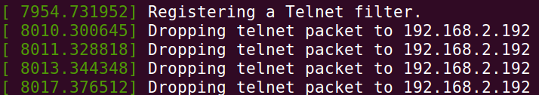
task3a：
在task2中创建了过滤23端口报文的防火墙，建立ssh隧道telnet到目标主机
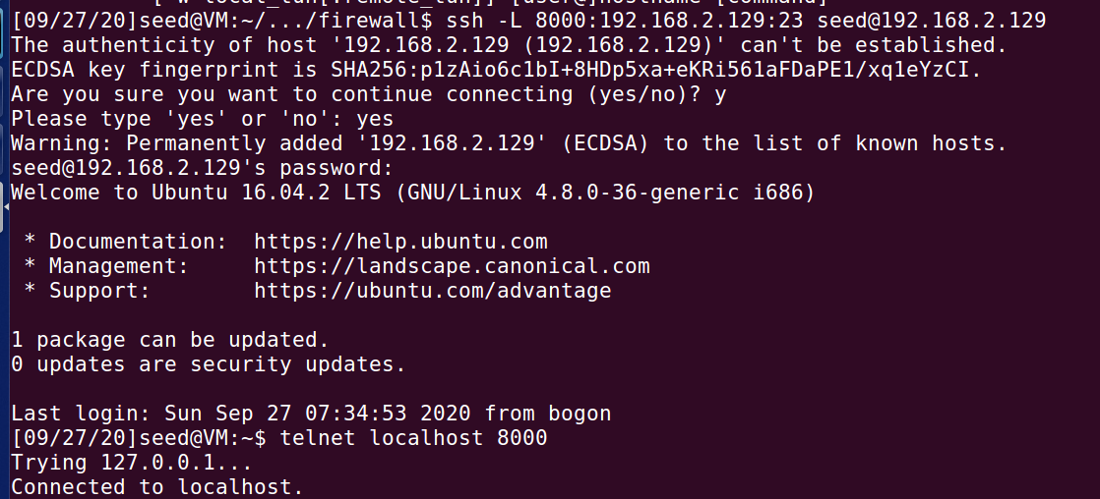
task3b：
利用ufw过滤到指定IP地址的报文
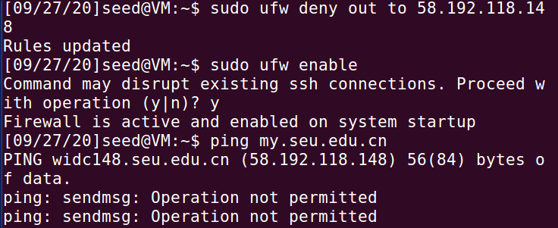
当与192.168.2.128建立ssh隧道后，主机ping 58.192.118.148时与192.168.2.128建立连接并转发请求，由后者向外发送ping报文
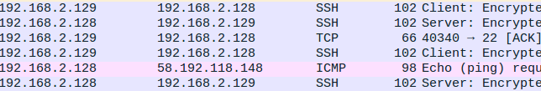
task4：
首先在内网主机上执行ufw deny+端口禁止外部主机的telnet、ssh、http等
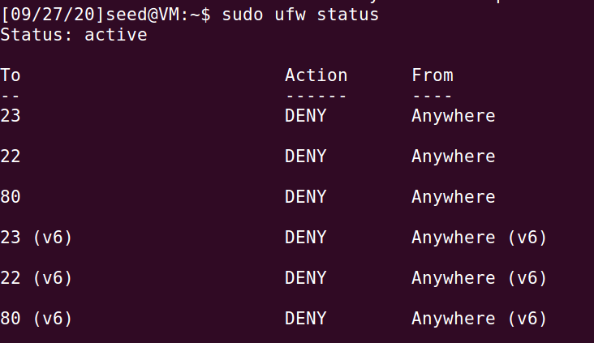
在内网主机上建立reverse ssh隧道到外网主机
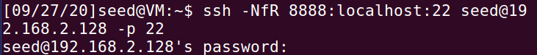
外网主机访问内网主机的8888端口作为ssh端口
