PSet 4 – Final Deliverable

Ryan Fish

Trajectories using Circle Controller

NT

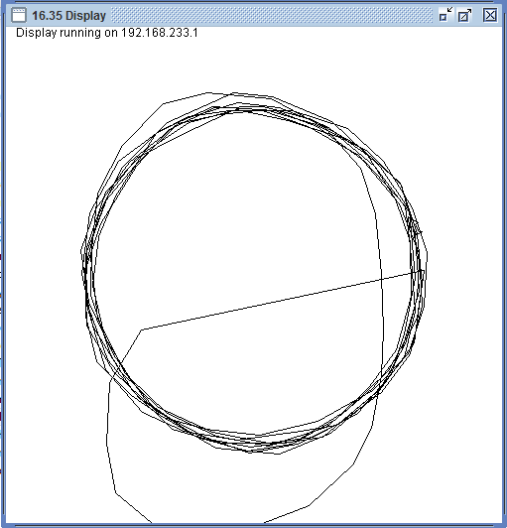

RT

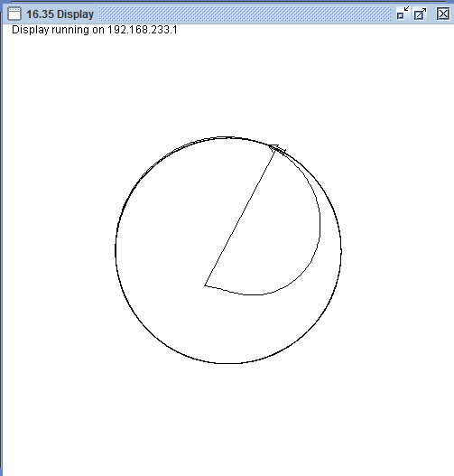

Cost Estimates:

Vehicle: <1 millisecond

Simulator: 8 milliseconds

CircleController: 2-3 milliseconds

FollowController: 4 milliseconds

LeadingController: 4 milliseconds

Misses:

