**ROBERT H. OSBORNE**

7950 CAMFIELD CIRCLE

COLORADO SPRINGS, CO 80920

(719) 246-3467

**Objective:** Seeking position working as an IT Helpdesk Technician, Network Administrator, or Systems Administrator

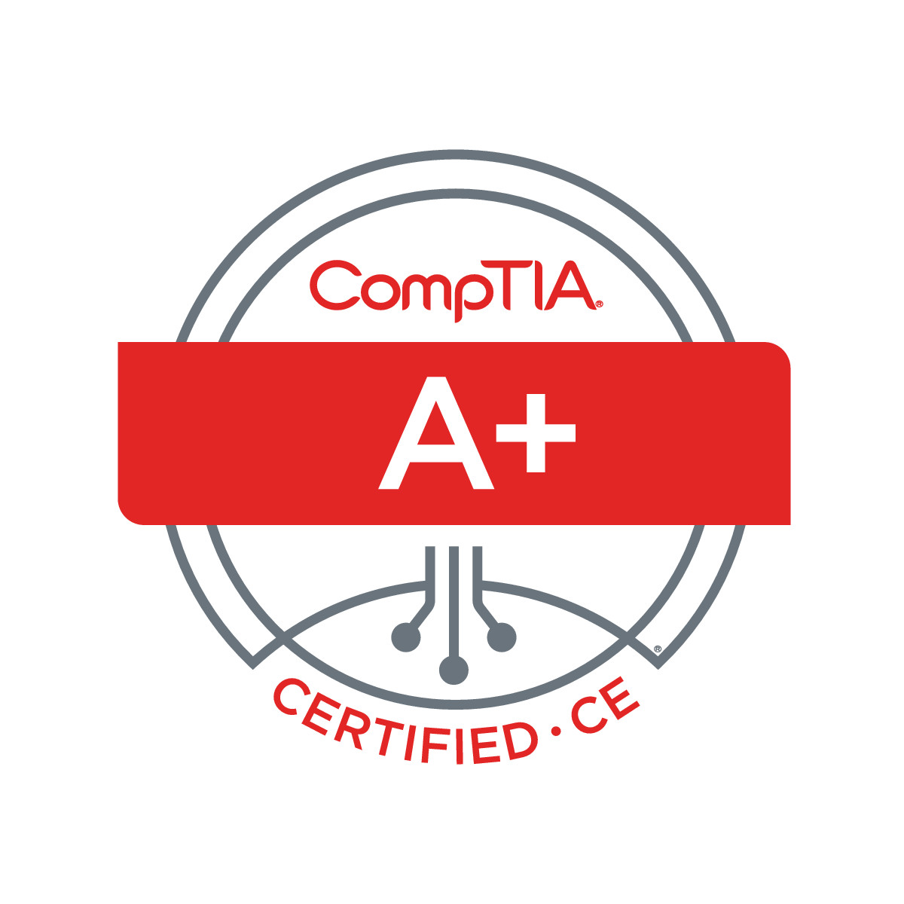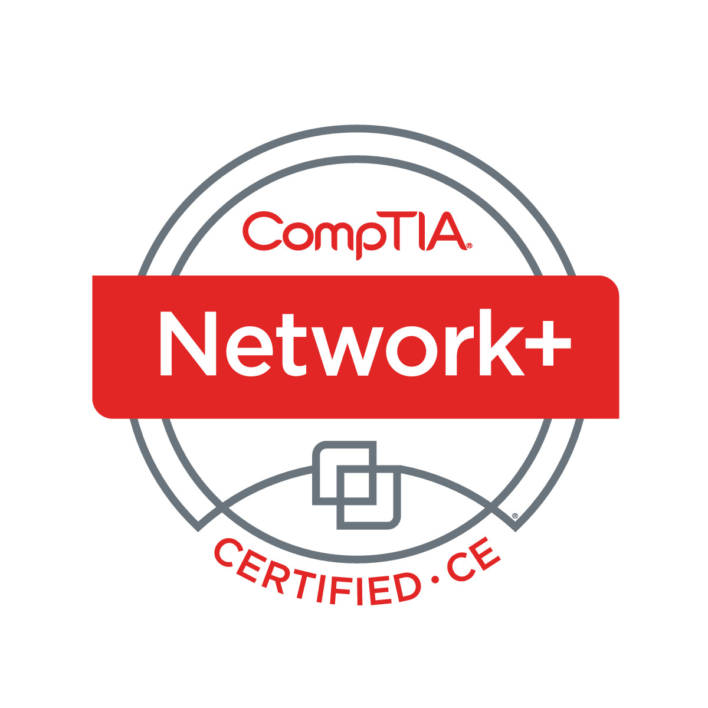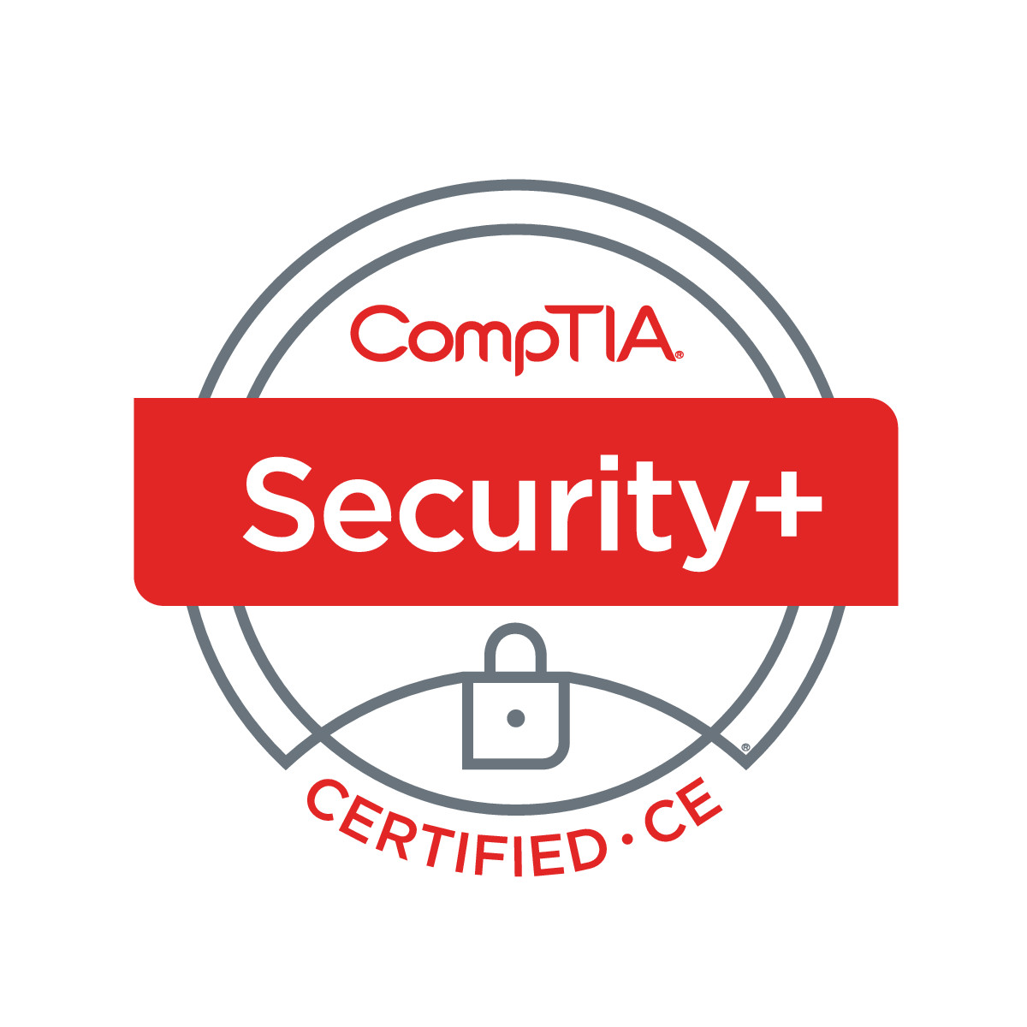

**Certifications:**

[**CCENT**](https://ciscocertificates.com/verify.cfm)

Cred ID: 430164169737DOWM

Expires 6/7/2022

[**CCNA Wireless**](https://www.youracclaim.com/badges/7d350240-778e-47fb-8b8e-b0895fc9d410/linked_in_profile)

CSCO13217585

Cred ID: 436538259019HRZG

Expires 6/7/2022

[**CompTIA Security+**](https://www.youracclaim.com/badges/739e0646-8570-4b56-a9f5-5a4bb0506b72/linked_in_profile)

COMP0010212134443

Expires 12/15/2017

[**CompTIA Network+**](https://www.youracclaim.com/badges/f9dcf172-9169-411a-983d-4b2e1c7f570b/linked_in_profile)

COMP0010212134443

Expires 11/17/2020

[**CompTIA A+:**](https://www.youracclaim.com/badges/8ca891c0-c92a-444a-8477-e511778c1fc9/linked_in_profile)

COMP0010212134443

Expires 1/10/21

[**CompTIA IT Fundamentals:**](https://www.youracclaim.com/badges/bfa0e395-3f9a-4520-a380-2ccaf5bcc2ca/linked_in_profile)

COMP0010212134443

Issued Jan 2018

[**MCSA Windows 10 Exam 70-697:**](https://www.youracclaim.com/badges/84034589-9ab2-48b1-b6dc-0ecba415fe40/linked_in_profile)

Cred ID: H022-2870

Issued Jan 2019

**[MCSA Windows 10 Exam 70-698:](https://www.youracclaim.com/badges/8d735f24-7aef-4317-a3c4-02064f2772fb/linked_in_profile)**

Cred ID: G751-7772

Issued March 2018

[**MCSA Windows 10 Exam**](https://www.youracclaim.com/badges/573235e3-bfee-4e8b-88ea-f92f9a50aa48/linked_in_profile)

Issued Jan 2019

[**ITIL Foundation**](https://www.youracclaim.com/badges/e8a08619-5de2-4508-b62e-35af3b4ec63d/linked_in_profile)

Cred ID: GR750515955RO

Issued Dec 2018

**Skills:**

* Programs: Windows 7/8/10, Mac OS X, Kali, Ubuntu, IT Glue, Active Directory, Google Apps, DropBox, Citrix ShareFile, CLI, Command Prompt, Terminal, nmap, Dirbuster, Metasploit, Wire Shark, Antivirus Software, Snort IDS/IPS, Microsoft Office 365, Pro Tools 12, Auto CAD, Adobe Photoshop, xCode, GPG Keychain, Adobe Dreamweaver, Lenel, Symmetry, C-CURE, Sony Video Editing Software, Skype, Mac OS Server, Windows Server 2016
* Type 71 wpm
* Customer Service, Adaptable in high stress situations
* HTML, CSS, JavaScript, Swift 4, C# .NET Framework (PowerShell), Python, PHP, Ruby

**Professional Experience:**

**USA Volleyball**

February 2018 – Present

Technology Coordinator

4065 Sinton Road

Colorado Springs, CO 80907

* Keep Change Management records and Threat/Incident Reports
* Maintain up to date information on all devices
* Create Shells to perform custom needed functions
* Implement effective real time alerts for suspicious network activity
* Review logs and data for suspicious activity
* Fix issues with Office 365 Products
* Fix Windows 10 issues and build computers
* Network and Systems Administration
* Helpdesk Customer Service

**Securitas Security Services Inc.**

December 2011 – February 2018

Shift Supervisor Security Officer

2790 N. Academy Blvd Suite 130

Colorado Springs, CO 80917

Telephone: (719) 591-6522

* Use Lenel and Symmetry to monitor alarms and cameras
* Use MS Word to keep daily log of events and writing training materials
* Prepare Incident Reports and Injury Reports on Windows 7 computer

**Boat Dome LLC.**

March 2015 - October 2017

IT Specialist

Mario Sottile (719) 358-3321

Peyton, CO 80831

* SEO Marketing, Meta Tags and Analytics
* Maintain Website and Social Media
* Correct any computer issues on Windows 10
* Set up Guest Internet for seamstresses
* Use Google SaaS for 3 users to communicate and schedule events
* Spoke with people on social media for feedback on product
* Created Product show video using iMovie and MacBook Pro OS X

**Berea Records LLC.**

December 2013 – January 2016

CEO Founder

Robert Osborne (Myself) & Lance Singson

Colorado Springs, CO 80910

* Use Pro Tools 12 to produce music and Sony Video Editor to edit video
* Used Windows Vista and Windows 7 on computers
* Used Microsoft Office to create agreements and keep records
* Used Dropbox and Google Drive to send music to Music Supervisors
* Used Google SaaS to schedule appointments. Watched over 8 employees
* Maintained Website, Social Media, and SEO for company

**Wall-nut Installations**

December 2010 – January 2012

Carpenter’s Helper

Telephone: (719) 358-3321

Peyton, CO 80831

* Built decks
* Remodeled Kitchens
* Installed water heaters, windows and door

**Barnes Ace Hardware**

May 2010 – December 2010

Hardware Salesman

3640 Austin Bluffs Parkway

Colorado Springs CO 80918

Telephone (719) 266-4367

* Assisted customers with items they required to complete projects
* Fixed appliances, made keys, and re pinned locks

**The Sports Authority**

November 2007 to April 2010

Footwear Team Lead

Colorado Springs, CO 80920

* Made Schedule; trained employees on product knowledge and selling
* Ensured all sales quotas were met individually and departmentally

**Deluxe Corporation**

June 2007 to August 2007

Call Center Representative

Colorado Springs, CO 80920

* Answer inbound calls to take orders for business and personal checks
* Provide Excellent Customer Service
* Used Vista on Computers and a program containing PII.

**Education:**

**Pikes Peak Community College** (Some College)

11195 Highway 83

Colorado Springs, CO 80920.

**Newton High School (Graduated 2006)**

44 Ryerson Avenue

Newton, NJ 07860

Telephone 973-383-7573.

**Volunteer:**

**Dixon Trail Construction**

Volunteers for Outdoor Colorado

May 2017

Volunteered for a day to learn how to fix a trail on Cheyenne Mountain

**Feeding the Homeless**

Gary Snipes on his Private Accord

August 2008 – July 2009

Gary was a former band mate. We’d bring food to Dorchester Park to feed the homeless. Sport’s Authority donated coats and hand warmers to give out.

**References:**

Tracy Ellis

(719) 419-2268

Security Site Lead at United States Olympic Training Center

Mario Sotteli

(719) 358-3321

I was his carpenter’s helper. Did research and online marketing for Boat Dome LLC.

Horacio Flores

(719) 491-6668

Helping him set up a website

Lance Singson

(719) 323-9134

Berea Records Business Partner

LINKEDIN: <https://www.linkedin.com/in/roberthosborne/>

WEBSITE: <https://roberthosborne.com>

<http://www.osbornepro.com>