**Ling (*Molva molva*) in Division 5.a (Iceland grounds)**

ICES stock advice

ICES advises that when the Icelandic management plan is applied, catches in the fishing year 1 September 2017 to 31 August 2018 should be no more than 8598 tonnes. All catches are assumed to be landed.

**Stock development over time**

Recruitment was high from 2004 to 2010, but has since declined to the levels of the 1980s and 1990s. The spawning-stock biomass (SSB) and the reference biomass (ling longer than 75 cm) in 2017 are among the highest in the time-series. The harvest rate (HR) has decreased since 2008 and is now the lowest in the time-series, below HRMSY.

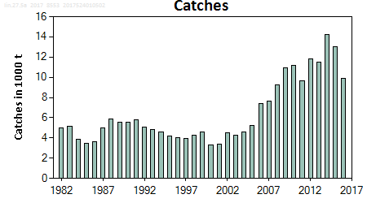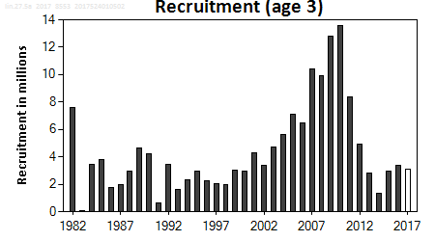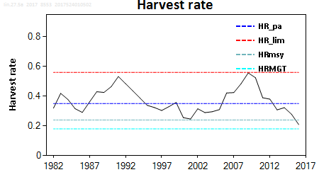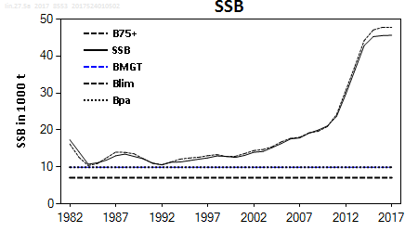

**Figure 1** Ling in Division 5.a. Summary of the stock assessment. In the lower right panel (SSB), the B75+ line represents the trend in the biomass of ling at 75 cm and greater that is used in the harvest control rule.

**Stock and exploitation status**

**Table 1** Ling in Division 5.a. State of the stock and fishery relative to reference points.

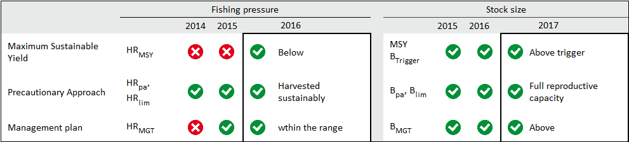

Catch options

The basis of the catch options for this stock is the management plan. A catch option is provided for the fishery year from September 2017 to end August 2018, based on the estimated reference biomass at the end of quarter 1 in 2017. A short-term forecast to the end of 2018 is provided to evaluate the impact of the catch on the SSB.

**Table 2** Ling in Division 5.a. The basis for the catch options.

| Variable | Value | Source | Notes |
| --- | --- | --- | --- |
| HRMGT | 0.18 | ICES (2017a) |  |
| Reference biomass 2017 | 47765 | ICES (2017a) | Biomass of fish at 75 cm and greater (75+) at the end of quarter 1; in tonnes. |
| R age 3 (2018) | 3906 | ICES (2017a) | In thousands. |

**Table 3** Ling in Division 5.a. Annual catch options. All weights are in tonnes.

|  |  |  |  |  |  |
| --- | --- | --- | --- | --- | --- |
| Basis | Total catch (2017/2018) | HR (2018) | SSB (2019) | % SSB change ** | % TAC change *** |
| Management plan | 8598 | 0.189 | 42247 | −5% | 0% |

* SSB in 2019 relative to SSB in 2018.

** Catches in 2018 relative to the TAC in 2017.

Basis of the advice

**Table 4** Ling in Division 5.a. The basis of the advice.

|  |  |
| --- | --- |
| Advice basis | Management plan. |
| Management plan | The Icelandic Ministry of Industries and Innovation’s fisheries management plan for Icelandic ling has been evaluated by ICES (ICES, 2017a). It is considered to be precautionary and conforms to the ICES MSY approach. According to the management plan the TAC for the fishing year Y/Y+1 (1 September of year Y to 31 August of year Y+1) is calculated as follows:  *When SSBY is equal or above MGT Btrigger:*  *TACY/y+1 = HRMGT*BRef,y*  *When SSBY is below MGT Btrigger:*  *TACY/y+1 = HRMGT* (SSBy/MGT Btrigger) * Bref,y*  *The spawning stock biomass trigger (MGT Btrigger) is defined as 9.93 kt, the reference biomass is defined as the biomass of ling 75+ cm and the target harvest rate (HRMGT) is set to 0.18.* |

Quality of the assessment

This stock was benchmarked in 2017 (ICES, 2017a); therefore, the present assessment is not fully comparable with previous assessments of this stock. Fishing pressure is defined in terms of harvest rate of biomass of ling at 75 cm and larger, but in the assessments prior to 2017 it was defined in terms of fishing mortality for ages 15–19.

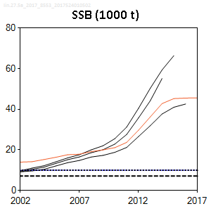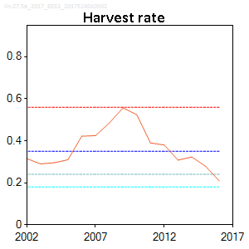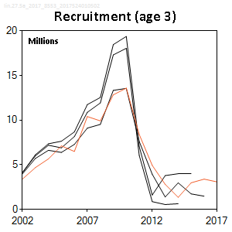

**Figure 2** Ling in Division 5.a. Historical assessment results. The harvest rate graph shows only the current assessment as fishing pressure in the historic assessments was estimated as fishing mortality.

Issues relevant for the advice

There is no information to present for this stock.

Reference points

**Table 5** Ling in Division 5.a. Reference points, values, and their technical basis.

|  |  |  |  |  |
| --- | --- | --- | --- | --- |
| Framework | Reference point | Value | Technical basis | Source |
| MSY approach | MSY Btrigger | 9930 | Bpa (tonnes) | ICES (2017a) |
| FMSY | 0.284 | Stochastic simulations | ICES (2017a) |
| HRMSY | 0.24 | Stochastic simulations | ICES (2017a) |
| Precautionary approach | Blim | 7090 | Bpa/1.4 (tonnes) | ICES (2017a) |
| Bpa | 9930 | Bloss (tonnes) | ICES (2017a) |
| Flim | 0.7 | Equilibrium F that will maintain the stock above Blim with a 50% probability. | ICES (2017a) |
| Fpa | 0.41 | 5% probability that the true F has been above Flim. | ICES (2017a) |
| HRlim | 0.56 | Equilibrium HR that will maintain the stock above Blim with a 50% probability. | ICES (2017a) |
| HRpa | 0.35 | 5% probability that the true HR has been above HRlim. | ICES (2017a) |
| Management plan | SSBmgt | 9930 | Bpa (tonnes) | ICES (2017a) |
| HRmgt | 0.18 | Percentage of biomass 75+ cm. Leads to long-term MSY. Realized HR can range from 0.12 to 0.28. | ICES (2017a) |

Basis of the assessment

**Table 6** Ling in Division 5.a. Basis of the assessment and advice.

|  |  |
| --- | --- |
| ICES stock data category | 1 ([ICES, 2016](http://www.ices.dk/sites/pub/Publication%20Reports/Advice/2016/2016/Introduction_to_advice_2016.pdf)). |
| Assessment type | Analytical length-based assessment (Gadget model) that uses catches in the model and in the forecast (ICES, 2017b). |
| Input data | March Icelandic groundfish survey and data from commercial catches. |
| Discards and bycatch | Not included, discarding is considered negligible. |
| Indicators | None. |
| Other information | Last benchmark in 2017 (ICES, 2017a). |
| Working group | Working Group on the Biology and Assessment of Deep-Sea Fisheries Resources ([WGDEEP](http://www.ices.dk/community/groups/Pages/WGDEEP.aspx)) |

Information from stakeholders

There is no available information.

**History of the advice, catch, and management**

**Table 7** Ling in Division 5.a. ICES advice and official landings. All weights are in tonnes.

| Year* | ICES advice* | Predicted catch corresp. to advice** | ICES catches Division 5.a** | TAC Icelandic Division 5.a* | ICES catches Division 5.a* |
| --- | --- | --- | --- | --- | --- |
| 2003/2004 | 30% reduction on fishing effort^ | - | 4621 | 3000 | 4608 |
| 2004/2005 | Biennial^ | - | 5195 | 3000 | 5238 |
| 2005/2006 | 30% reduction on fishing effort^ | - | 7431 | 4000 | 6961 |
| 2006/2007 | Biennial^ | - | 7619 | 5000 | 7617 |
| 2007/2008 | Maintain catches at 2001–2004 level | 3800 | 9279 | 5000 | 8560 |
| 2008/2009 | Biennial | 3800 | 10948 | 7000 | 10489 |
| 2009/2010 | Constrain catches to 2006–2007 average | 7500 | 11150 | 7000 | 10713 |
| 2010/2011 | Biennial | 7500 | 9650 | 7500 | 10095 |
| 2011/2012 | Same advice as previously | 7500 | 11829 | 9000 | 11133 |
| 2012/2013 | Fproxy target | 12000 | 11536 | 12000 | 12445 |
| 2013/2014 | No new advice, same as 2013 | 12000 | 14246 | 14000 | 14983 |
| 2014/2015 | Fishing at FMSY | 14362 | 13036 | 14300 | 13166 |
| 2015/2016 | Fishing at FMSY | ≤ 16156 | 9884 | 16200 | 9769 |
| 2016/2017 | Fishing at FMSY | ≤ 9343 |  |  |  |
| 2017/2018 | Management plan | ≤ 8598 |  |  |  |

* Icelandic fishing year ending on 31 August.

** Calendar year (refers to the second year in the fishing year period).

^ Prior to 2007/2008, the advice for ling was for the whole Northeast Atlantic area.

**History of the catch and landings**

This stock is distributed primarily in Icelandic waters and does not extend to the NEAFC regulatory area.

**Table 8** Ling in Division 5.a. Catch distribution by fleet in 2016 as estimated by ICES.

|  |  |  |  |  |
| --- | --- | --- | --- | --- |
| Catch (2016) | Landings | | | Discards |
| 9766 tonnes | longlines 66% | trawl 26% | other 8% | Negligible |
| 9766 tonnes | | |

**Table 9** Ling in Division 5.a. History of ICES estimated landings for each country participating in the fishery. All weights are in tonnes.

| Year | Belgium | Faroes | France | Germany | Iceland | Norway | UK | Total |
| --- | --- | --- | --- | --- | --- | --- | --- | --- |
| 1973 | 1080 | 984 | 0 | 586 | 3564 | 418 | 829 | 7461 |
| 1974 | 681 | 890 | 0 | 486 | 3868 | 318 | 532 | 6775 |
| 1975 | 736 | 732 | 23 | 375 | 3748 | 522 | 562 | 6698 |
| 1976 | 431 | 498 | 0 | 404 | 4538 | 502 | 268 | 6641 |
| 1977 | 442 | 613 | 0 | 254 | 3433 | 506 | 0 | 5248 |
| 1978 | 541 | 534 | 0 | 0 | 3439 | 484 | 0 | 4998 |
| 1979 | 508 | 536 | 0 | 0 | 3759 | 399 | 0 | 5202 |
| 1980 | 445 | 607 | 0 | 0 | 3149 | 423 | 0 | 4624 |
| 1981 | 196 | 489 | 0 | 0 | 3348 | 415 | 0 | 4448 |
| 1982 | 116 | 524 | 0 | 0 | 3738 | 612 | 0 | 4990 |
| 1983 | 128 | 644 | 0 | 0 | 4236 | 115 | 0 | 5123 |
| 1984 | 103 | 450 | 0 | 0 | 3306 | 21 | 0 | 3880 |
| 1985 | 59 | 384 | 0 | 0 | 2989 | 17 | 0 | 3449 |
| 1986 | 88 | 556 | 0 | 0 | 2948 | 4 | 0 | 3596 |
| 1987 | 157 | 657 | 0 | 0 | 4154 | 6 | 0 | 4974 |
| 1988 | 134 | 619 | 0 | 0 | 5083 | 10 | 0 | 5846 |
| 1989 | 95 | 614 | 0 | 0 | 4833 | 5 | 0 | 5547 |
| 1990 | 42 | 399 | 0 | 0 | 5121 | 0 | 0 | 5562 |
| 1991 | 69 | 530 | 0 | 0 | 5187 | 0 | 0 | 5786 |
| 1992 | 34 | 526 | 0 | 0 | 4529 | 0 | 0 | 5089 |
| 1993 | 20 | 501 | 0 | 0 | 4322 | 0 | 0 | 4843 |
| 1994 | 3 | 548 | 0 | 0 | 4054 | 0 | 0 | 4605 |
| 1995 | 0 | 463 | 0 | 0 | 3733 | 0 | 0 | 4196 |
| 1996 | 0 | 358 | 0 | 0 | 3671 | 20 | 0 | 4049 |
| 1997 | 0 | 299 | 0 | 0 | 3635 | 0 | 0 | 3934 |
| 1998 | 0 | 699 | 0 | 0 | 3604 | 0 | 0 | 4303 |
| 1999 | 0 | 500 | 0 | 0 | 3972 | 120 | 1 | 4593 |
| 2000 | 0 | 0 | 0 | 0 | 3218 | 67 | 3 | 3288 |
| 2001 | 0 | 362 | 0 | 2 | 2870 | 116 | 1 | 3351 |
| 2002 | 0 | 1629 | 0 | 0 | 2840 | 45 | 0 | 4514 |
| 2003 | 0 | 565 | 0 | 2 | 3599 | 108 | 5 | 4279 |
| 2004 | 0 | 739 | 0 | 1 | 3742 | 139 | 0 | 4621 |
| 2005 | 0 | 682 | 0 | 1 | 4312 | 180 | 20 | 5195 |
| 2006 | 0 | 960 | 0 | 1 | 6312 | 158 | 0 | 7431 |
| 2007 | 0 | 807 | 0 | 0 | 6627 | 185 | 0 | 7619 |
| 2008 | 0 | 1366 | 0 | 0 | 7737 | 176 | 0 | 9279 |
| 2009 | 0 | 1157 | 0 | 0 | 9619 | 172 | 0 | 10948 |
| 2010 | 0 | 1095 | 0 | 0 | 9887 | 168 | 0 | 11150 |
| 2011 | 0 | 588 | 0 | 0 | 8813 | 249 | 0 | 9650 |
| 2012 | 0 | 875 | 0 | 0 | 10706 | 248 | 0 | 11829 |
| 2013 | 0 | 1030 | 0 | 0 | 10212 | 294 | 0 | 11536 |
| 2014 | 0 | 1738 | 0 | 0 | 12450 | 158 | 0 | 14246 |
| 2015 | 0 | 1233 | 0 | 0 | 11553 | 250 | 0 | 13036 |
| 2016* | 0 | 1072 | 0 | 0 | 8582 | 230 | 0 | 9884 |

* Preliminary.

**Summary of the assessment**

**Table 10** Ling in Division 5.a. Assessment summary. Catches in the assessments are based on landings from the Icelandic Directorate of Fisheries to make splitting of catches by quarters possible. Weights are in tonnes.

| Year | Recruitment (thousands) | SSB (tonnes) | Total catch (tonnes) | Harvest rate | Biomass of 75+ cm (tonnes) |
| --- | --- | --- | --- | --- | --- |
| 1982 | 7592 | 17377 | 4990 | 0.319 | 16219 |
| 1983 | 70 | 14070 | 5123 | 0.419 | 12602 |
| 1984 | 3426 | 10754 | 3880 | 0.378 | 10394 |
| 1985 | 3810 | 11123 | 3449 | 0.316 | 10926 |
| 1986 | 1755 | 11870 | 3596 | 0.291 | 12478 |
| 1987 | 1957 | 13027 | 4974 | 0.361 | 14022 |
| 1988 | 2930 | 13480 | 5846 | 0.43 | 13957 |
| 1989 | 4633 | 12837 | 5547 | 0.425 | 13553 |
| 1990 | 4222 | 12212 | 5562 | 0.464 | 12184 |
| 1991 | 657 | 11006 | 5786 | 0.533 | 11047 |
| 1992 | 3467 | 10569 | 5089 | 0.484 | 10613 |
| 1993 | 1617 | 11282 | 4843 | 0.436 | 11326 |
| 1994 | 2334 | 11341 | 4605 | 0.387 | 12122 |
| 1995 | 2963 | 11725 | 4196 | 0.339 | 12423 |
| 1996 | 2269 | 12099 | 4049 | 0.323 | 12619 |
| 1997 | 2067 | 12449 | 3934 | 0.304 | 13048 |
| 1998 | 1954 | 12982 | 4303 | 0.329 | 13343 |
| 1999 | 3019 | 12873 | 4593 | 0.358 | 12818 |
| 2000 | 2959 | 12582 | 3288 | 0.256 | 12889 |
| 2001 | 4313 | 13115 | 3351 | 0.246 | 13621 |
| 2002 | 3396 | 13964 | 4514 | 0.315 | 14433 |
| 2003 | 4684 | 14184 | 4279 | 0.29 | 14714 |
| 2004 | 5654 | 15241 | 4621 | 0.295 | 15465 |
| 2005 | 7120 | 16338 | 5195 | 0.31 | 16803 |
| 2006 | 6490 | 17591 | 7433 | 0.422 | 17738 |
| 2007 | 10403 | 17859 | 7619 | 0.425 | 18025 |
| 2008 | 9919 | 19133 | 9279 | 0.484 | 19224 |
| 2009 | 12831 | 19970 | 10948 | 0.557 | 19652 |
| 2010 | 13591 | 21093 | 11150 | 0.524 | 20937 |
| 2011 | 8384 | 23660 | 9650 | 0.39 | 24169 |
| 2012 | 4933 | 29655 | 11829 | 0.38 | 30682 |
| 2013 | 2803 | 36236 | 11536 | 0.308 | 37268 |
| 2014 | 1350 | 42796 | 14246 | 0.323 | 44158 |
| 2015 | 2980 | 45254 | 13036 | 0.279 | 47065 |
| 2016 | 3391 | 45531 | 9884 | 0.209 | 47782 |
| 2017 | 3075 | 45631 |  |  | 47765 |

**Sources and references**

ICES. 2016. Advice basis. *In* Report of the ICES Advisory Committee, 2016. ICES Advice 2016, Book 1, Section 1.2.

ICES. 2017a. Iceland request to evaluate the harvest control rule for ling in Division 5.a. *In* Report of the ICES Advisory Committee, 2017. ICES Advice 2017, sr.2017.09.

ICES. 2017b. Report of the Working Group on the Biology and Assessment of Deep-sea Fisheries Resources (WGDEEP), 24 April–1 May 2017, Copenhagen, Denmark. ICES CM 2017/ACOM:14. 702 pp.