COMP 8500SEF Software Engineering
User Requirements Specification (URS) — DRAFT
Project: Election Management and Voting System

1. Introduction

1.1 Purpose
This document defines the user requirements for the Election Management and Voting System (EMVS), a software system that supports the end-to-end administration of an election, from voter registration through result publication. It serves as a baseline for requirement engineering, system design, implementation, and testing as required by the COMP 8500SEF group project.

1.2 Scope
The system will allow eligible voters to register, verify their identity, and cast a single vote per election. Candidates may submit nominations for approval. Election administrators configure elections, manage candidates, and monitor the voting process. The system automatically tabulates and publishes results, and maintains an audit trail for accountability.

1.3 Definitions and Acronyms
- EMVS — Election Management and Voting System
- Voter — An eligible individual authorized to cast a vote
- Candidate — An individual nominated to stand for election
- Admin — Election Administrator, responsible for configuring and overseeing the election
- Auditor — System Auditor, responsible for reviewing audit logs

2. Overall Description

2.1 Product Perspective
EMVS is a new, standalone web-based (and optionally mobile) system. It is composed of a client layer (voter/admin interfaces), an application layer (authentication, voting, candidate management, tabulation, and audit services), and a data layer (voter, election, and audit databases).

2.2 User Classes and Characteristics
User Class | Description
Voter | Registers, verifies identity, casts one vote, and views published results.
Candidate | Submits nomination and tracks its approval status.
Election Administrator | Configures elections, approves/rejects nominations, monitors voting, publishes results.
System Auditor | Reviews audit logs and generates audit reports for compliance/verification.

2.3 Assumptions and Dependencies
- Voters possess a valid, verifiable form of identification.
- Voters and administrators have access to the internet and a supported device/browser.
- An authoritative voter roll (eligible voter list) is available to the system.
- The project team is not building a legally-binding national election system; the scope is a course project demonstrating software engineering practice on this domain.

3. System Models

3.1 Use Case Diagram
The diagram below identifies the four actors and their interactions with the system.
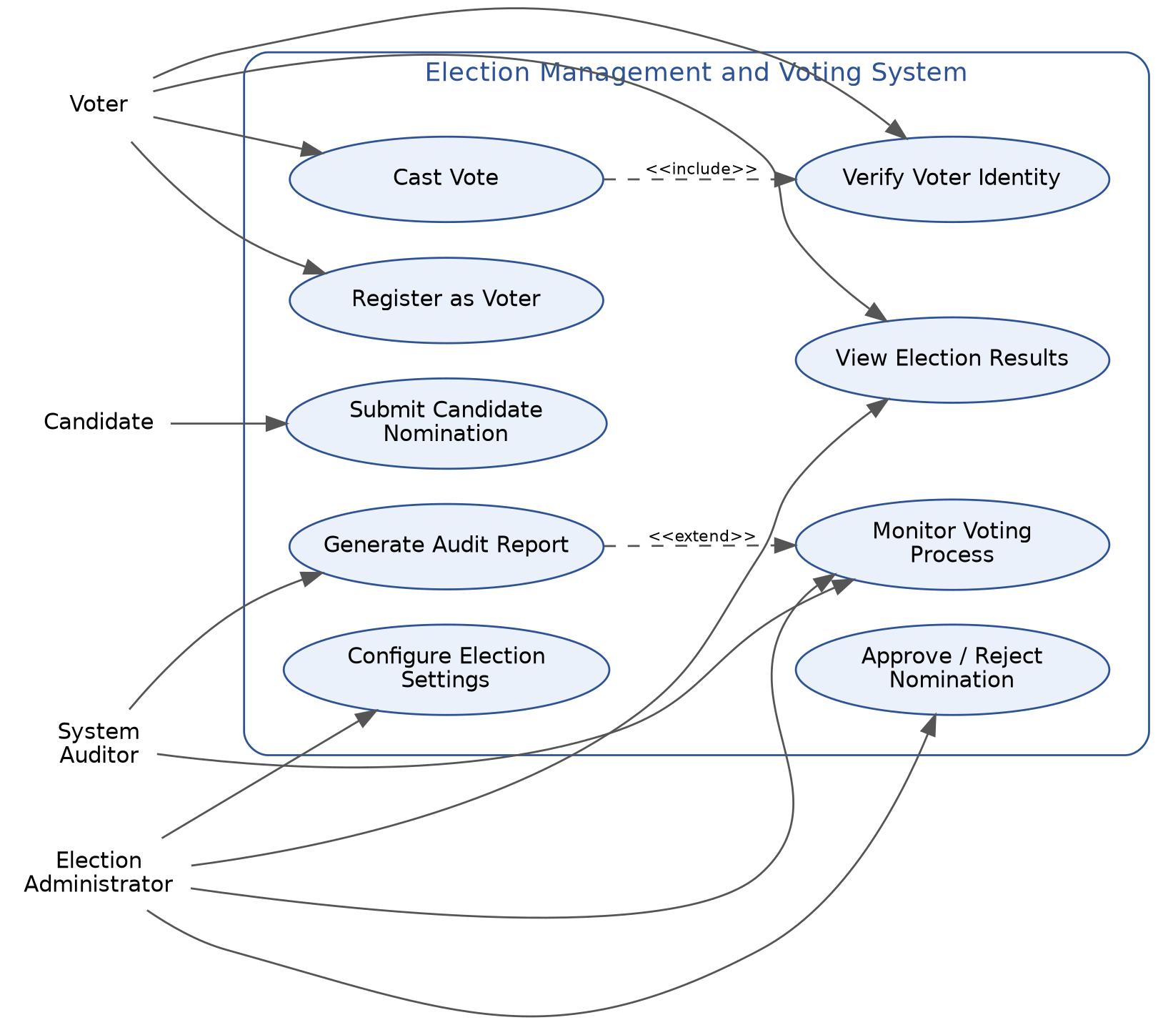

3.2 System Architecture Diagram
The system follows a layered architecture: client, application (services), and data layer.
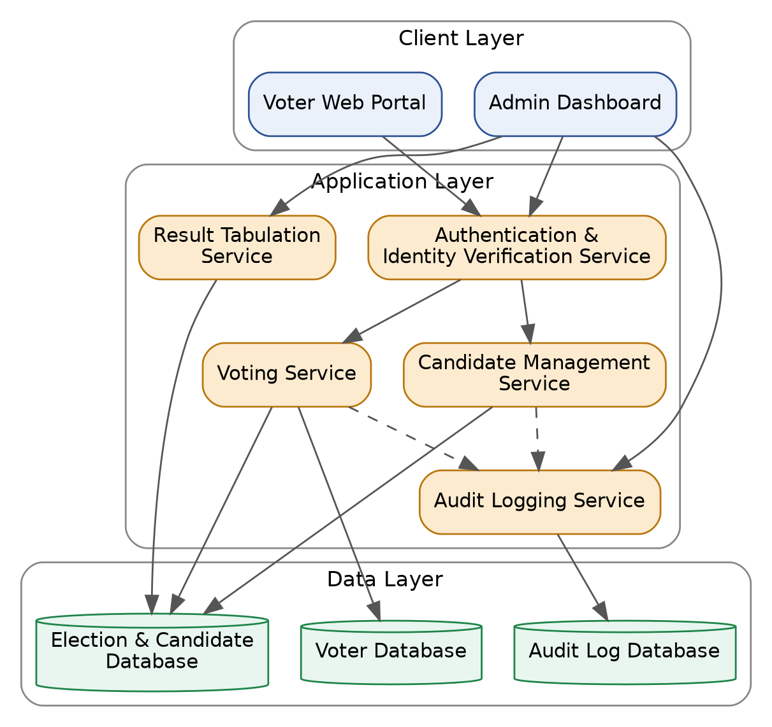

4. Functional Requirements
The following functional requirements are derived from the use case diagram (Section 3.1). Priority: H = High (must-have for MVP), M = Medium, L = Low (stretch goal).
ID | Requirement Description | Priority | Related Actor(s)
FR-1 | The system shall allow an eligible individual to register as a voter by submitting required identification details. | H | Voter
FR-2 | The system shall verify a voter's identity (e.g. ID number and one-time passcode) before permitting access to voting. | H | Voter
FR-3 | The system shall allow a verified voter to cast exactly one vote per election. | H | Voter
FR-4 | The system shall prevent a voter from casting more than one vote in the same election. | H | Voter
FR-5 | The system shall issue a confirmation receipt after a vote is submitted, without disclosing the voter's choice. | M | Voter
FR-6 | The system shall allow a candidate to submit a nomination application with supporting documents. | H | Candidate
FR-7 | The system shall allow an administrator to review and approve or reject candidate nominations. | H | Admin
FR-8 | The system shall allow an administrator to configure election parameters, including voting period and eligible constituency. | H | Admin
FR-9 | The system shall allow an administrator or auditor to monitor voting turnout and system status in real time. | M | Admin, Auditor
FR-10 | The system shall automatically tabulate votes and generate results once the voting period closes. | H | Admin
FR-11 | The system shall publish official results to voters upon administrator confirmation. | H | Voter, Admin
FR-12 | The system shall record an audit trail of all critical actions (e.g. login attempts, vote submission, admin changes). | H | Auditor
FR-13 | The system shall allow an auditor to generate an audit report for a given election. | M | Auditor

5. Non-Functional Requirements
Category | Requirement
Security | Votes must be encrypted in transit and at rest; vote content must remain anonymous and unlinkable to the voter's identity.
Data Integrity | Once cast, a vote record shall be immutable and tamper-evident.
Availability | The system shall maintain at least 99.9% uptime during an active voting period.
Performance | The system shall respond to a vote submission within 2 seconds under expected peak concurrent load.
Scalability | The system shall support a surge in concurrent users during peak voting hours (e.g. near the close of polls).
Usability | The voter interface shall be usable by individuals with varying levels of digital literacy, following basic accessibility guidelines.
Auditability | All critical system actions shall be traceable via logs without compromising vote secrecy.
Compliance | The system design shall follow generally accepted e-voting principles (verifiability, secrecy, one-voter-one-vote).

6. Constraints
- The system is a course project prototype; it will not undergo legal certification for a binding public election.
- Development timeline is bounded by the COMP 8500SEF semester schedule (project report due Dec 8, 2026).
- The team's domain knowledge of election law/process is limited; requirements are based on commonly understood e-voting practices, to be refined with the teaching team's feedback.

Note: This is a first draft for internal group discussion. Requirements should be reviewed, prioritized, and refined with the full team before being finalized in the Project Report.

