Bellabeat Smart Device Analysis
How consumers use smart wellness devices — and what it means for Bellabeat Leaf

Prepared by: Peter Francis Muthukkalai
Programme: Google Data Analytics Professional Certificate — Capstone
Dataset: FitBit Fitness Tracker Data (Kaggle, CC0) — 33 users, April–May 2016
Tools: BigQuery (SQL), Tableau Public

1. Executive Summary
This analysis examines FitBit usage data from 33 users collected over a 31-day period (April–May 2016) to uncover how consumers engage with smart wellness devices. The findings are applied to Bellabeat's Leaf tracker to identify product and marketing opportunities.
Users average 8,329 daily steps — 17% below the WHO 10,000-step goal — and spend 15.9 hours per day sedentary. Sleep quantity is adequate at 7.0 hours but quality is poor, with users lying awake an average of 39 minutes nightly. Activity follows clear temporal patterns: three peaks (morning, lunch, evening) with a consistent 3pm dip and a Saturday leisure peak.
Three strategic recommendations are proposed for the Bellabeat Leaf: smart movement reminders targeting the 3pm dip and Monday sedentary spike; a Sunday wind-down programme addressing anticipatory work stress; and personalised step goals calibrated to each of four user activity segments.

2. Background and Business Task

2.1 About Bellabeat
Bellabeat is a high-growth wellness technology company specialising in health-focused smart devices for women. Its product range includes the Leaf (a wellness tracker worn as a bracelet, necklace, or clip), the Time watch, and the Spring smart water bottle — all connected via the Bellabeat app, which provides users with data on activity, sleep, stress, and reproductive health.

2.2 Business Task
The business task is defined as: analyse smart device usage data to gain insight into how consumers use non-Bellabeat smart devices, then apply those insights to one Bellabeat product to inform future marketing strategy.
This report focuses on the Bellabeat Leaf and addresses the following questions:
- How do FitBit users engage with their device across activity, sleep, and health tracking?
- What patterns suggest unmet needs that Bellabeat Leaf could address?
- Which user segments represent the highest conversion opportunity?

3. Data Source and Limitations

3.1 Data Source
The dataset used is the FitBit Fitness Tracker Data (Kaggle, CC0 Public Domain licence), which contains personal fitness tracker data from 33 consenting Fitbit users collected between 12 April and 12 May 2016. Five tables were used in this analysis:
- daily_activity — step counts, distance, activity minutes, calories (940 rows pre-cleaning)
- sleep_day — total time in bed, time asleep, wake minutes (413 rows pre-cleaning)
- hourly_steps — step counts per hour of day
- hourly_intensities — activity intensities per hour
- weight_log — body weight entries, BMI, manual vs. automatic logging

3.2 Limitations
The following limitations must be considered when interpreting findings:
- Small sample size: 33 users is not statistically representative of the broader Bellabeat market.
- Outdated data: collected in 2016; smart device usage behaviour has evolved significantly.
- No demographics: age, gender, location, and health conditions are unknown, limiting segmentation depth.
- Incomplete coverage: only 24 of 33 users tracked sleep; only 8 tracked weight.
- Sedentary minutes include sleep: the daily_activity table counts all inactive time including time asleep. Analysis focuses on relative differences between segments rather than absolute values.
- Mixed date formats: hourly tables contained inconsistent timestamp formats, standardised using CASE/PARSE_TIMESTAMP in BigQuery.

4. Tools Used
The following tools were used across data preparation, analysis, and output:

Tool | Purpose
BigQuery (SQL) | Data exploration, cleaning, and all analysis queries
Tableau Public | visualisations

5. Data Cleaning and Preparation
Data cleaning was performed entirely in BigQuery SQL. All decisions are documented below.

5.1 Duplicate Records
Three duplicate rows were identified in the sleep_day table and these were removed, reducing the table from 413 to 410 rows. No duplicates were found in daily_activity or the hourly tables.

5.2 Invalid Activity Days
84 rows in daily_activity were identified where TotalSteps = 0 AND SedentaryMinutes = 1440 (a full 24-hour day of inactivity with zero steps recorded). These represent days when the device was not worn and were removed to avoid distorting averages. The table was reduced from 940 to 856 rows.

5.3 Null Values
The weight_log table's Fat column contained 65 nulls (97% of entries), indicating that fat percentage measurement requires a smart scale not widely available to participants. This column was excluded from all weight analysis.

5.4 Date Format Standardisation
Hourly tables (hourly_steps, hourly_intensities) contained mixed timestamp formats across rows. A CASE statement using PARSE_TIMESTAMP was applied to standardise all timestamps to a consistent UTC format before joining tables.

5.5 Sedentary Minutes and Sleep Overlap
The SedentaryMinutes field in daily_activity includes time spent asleep, as the Fitbit device does not distinguish between sleep and passive inactivity. This is noted in the analysis. All comparisons of sedentary behaviour are made on a relative basis between segments rather than as absolute daily inactive hours.

6. Analysis
Analysis was conducted across six themes, each corresponding to a BigQuery query phase. Key findings are summarised below with supporting charts.

6.1 Activity by Day of Week
Average daily steps were calculated across all users and days and grouped by day of week. Saturday recorded the highest average (8,979 steps), driven by leisure activity. Sunday and Friday recorded the lowest, at 7,669 and 7,821 steps respectively. Monday recorded the highest sedentary time (16.4 hours), suggesting a work-week onset effect.
Across all days, users averaged 8,329 steps — 17% below the WHO 10,000-step recommendation.
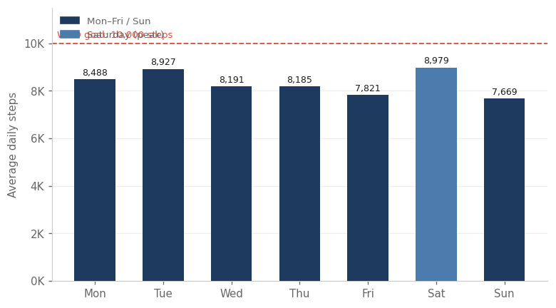
Figure 1 — Average daily steps by day of week. Saturday highlighted. Dashed line = WHO 10,000-step goal.

6.2 Hourly Activity Patterns
Average step counts were calculated for each hour of the day across all users and dates. Three clear activity peaks emerge: a morning peak between 8–10am, a lunch peak between 12–2pm, and an evening peak between 5–7pm peaking at 6pm (599 average steps per hour).
A consistent dip occurs at 3pm (hour 15), with steps falling to 406 — the lowest point of the active day. This represents an optimal window for a Leaf movement reminder.
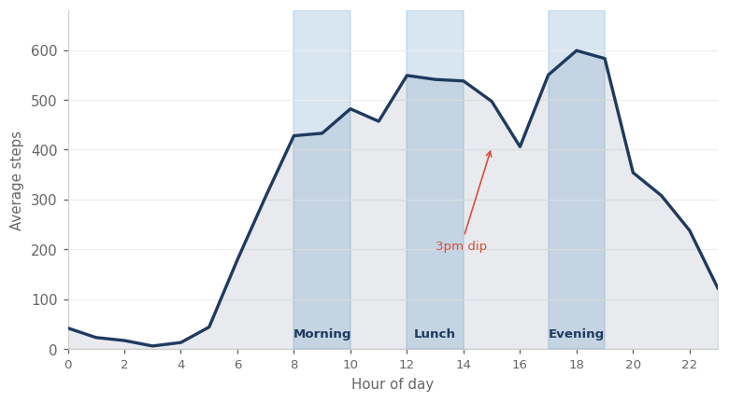
Figure 2 — Average steps by hour of day. Shaded bands = three daily activity peaks. Arrow marks 3pm dip.

6.3 Sleep Patterns
Sleep analysis was limited to 24 of 33 users who recorded at least one sleep entry. Average sleep duration was 7.0 hours — meeting the minimum recommended threshold but with significant night-to-night variability. Users spent an average of 39 minutes awake in bed per night, indicating disrupted sleep quality.
The Sunday paradox is notable: Sunday recorded the most time in bed (8.4 hours) yet the worst sleep quality (50.8 minutes awake). This is consistent with anticipatory work-week stress impairing sleep onset despite extended time in bed.
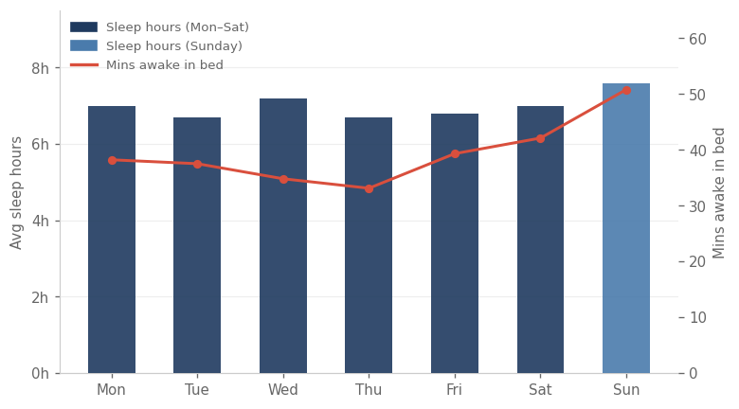
Figure 3 — Average sleep hours (bars) and minutes awake in bed (line) by day of week. Sunday highlighted.

6.4 User Activity Segmentation
Users were segmented into four activity tiers based on average daily step count: Active (≥10,000 steps, 21.2%), Moderately Active (7,500–9,999, 33.3%), Lightly Active (5,000–7,499, 24.2%), and Sedentary (<5,000, 21.2%). Moderately Active represents the largest single group and sits closest to the Active threshold, making it the highest-priority conversion target.
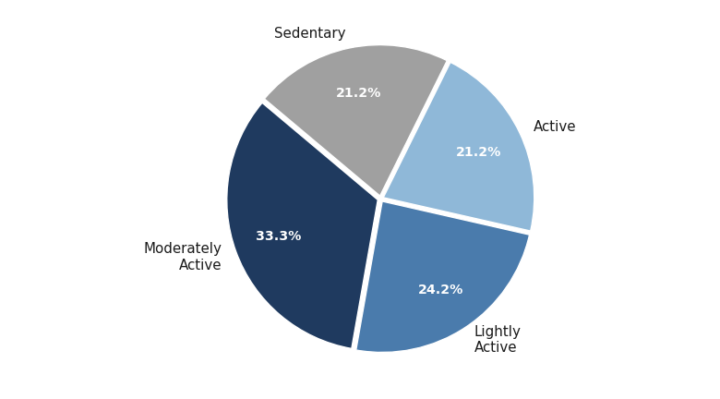
Figure 4 — Distribution of users across four activity segments. n = 33 users.

6.5 Sedentary Behaviour by Segment
Sedentary time was averaged by activity segment. Even the Active segment averages 16.2 sedentary hours per day, demonstrating that high step counts do not prevent prolonged inactivity. The Sedentary segment averages 18.2 hours. Paradoxically, the Lightly Active segment (17.7h) records more sedentary time than the Active segment (16.2h) despite moderate activity levels.
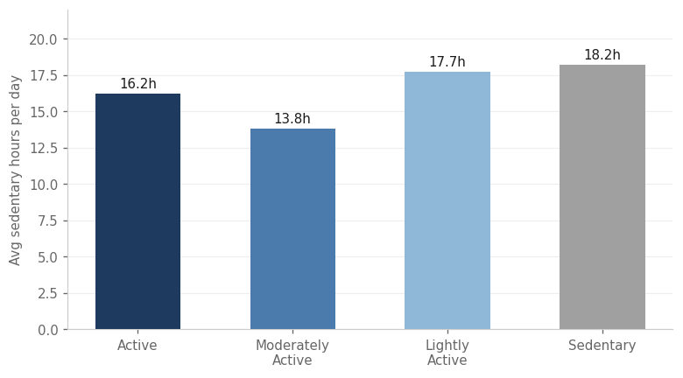
Figure 5 — Average sedentary hours per day by user activity segment.

6.6 Active Minutes Breakdown
Daily minutes were broken down into four activity intensity types. Sedentary time dominates at 951.8 minutes per day (15.9 hours — 66% of a 24-hour day). Lightly Active minutes account for 211.7. Fairly Active and Very Active minutes are minimal at 14.9 and 23.2 respectively — suggesting users approach but do not consistently achieve the recommended 20–30 minutes of vigorous daily exercise.
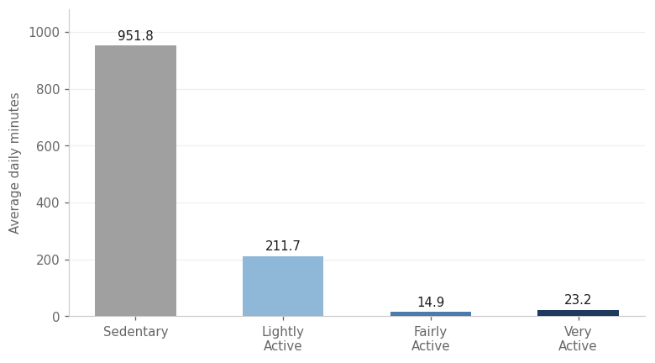
Figure 6 — Average daily minutes by activity intensity type.

6.7 Key Findings Summary

Metric | Finding | Implication
Avg daily steps | 8,329 steps/day | 17% below WHO 10,000 goal
Sedentary time | 15.9 hrs/day | Affects all activity segments
Average sleep | 7.0 hrs/night | At minimum recommended threshold
Sleep quality | 39 mins awake/night | Poor wind-down / restless nights
Peak activity day | Saturday (8,979 steps) | Leisure-driven, not habitual
Lowest activity day | Sunday (7,669 steps) | Rest / anticipatory work stress
Peak activity hour | 6pm (599 avg steps/hr) | Post-work exercise window
3pm activity dip | Hour 15 — lowest daytime | Optimal reminder trigger point
Weight tracking | 8 of 33 users (24%) | Low engagement with health metrics
Manual weight logs | 61% of all entries | Engagement present but high friction

7. Recommendations for Bellabeat Leaf
Three strategic recommendations are proposed, each grounded in specific data findings and directly applicable to Bellabeat Leaf product and marketing decisions.

Recommendation | Rationale | Implementation
01 — Smart movement reminders | Activity dips at 3pm daily and spikes in Monday sedentary hours. Targeted nudges convert passive time into movement. | Leaf sends haptic reminder at 3pm. Monday morning prompt triggers a step challenge. Goals personalised per activity segment.
02 — Sunday wind-down programme | Sunday paradox: most time in bed (8.4h) but worst sleep quality (50.8 mins awake). Anticipatory work stress is the likely cause. | Leaf delivers a Sunday evening wind-down sequence. App tracks pre-sleep restlessness and offers breathing exercises.
03 — Personalised segment goals | Moderately Active users (33.3%) sit closest to the Active threshold. Small step increases could convert the largest segment. | Onboarding assigns goals by segment. Moderately Active users receive progressive weekly step targets with in-app coaching.

These recommendations are prioritised by implementation complexity. Recommendation 01 (movement reminders) requires only a firmware and app update. Recommendation 02 (Sunday wind-down) requires content development. Recommendation 03 (personalised goals) requires backend user segmentation infrastructure.

8. Next Steps
The following actions are recommended to build on this analysis:
- Collect Bellabeat-specific usage data. FitBit data is a proxy; first-party Leaf user data would provide more accurate and directly applicable insights.
- A/B test the movement reminder timing. The 3pm dip is identified from aggregate data; user-level testing would confirm whether personalised reminder timing outperforms a fixed time.
- Investigate the Sunday sleep problem. Bellabeat should confirm whether its own user base exhibits the Sunday paradox before building the wind-down programme.
- Build segment-aware onboarding. Classifying users into activity segments at onboarding and immediately personalising goals and reminders could drive early retention.
- Expand data scope. A larger, more recent, and demographically diverse dataset would increase the confidence and generalisability of all findings in this report.

Google Data Analytics Professional Certificate — Capstone Project 2 | Bellabeat Smart Device Analysis

