## **Lab Assignment 2 – Manual Executions**

### **Manual Execution 1**

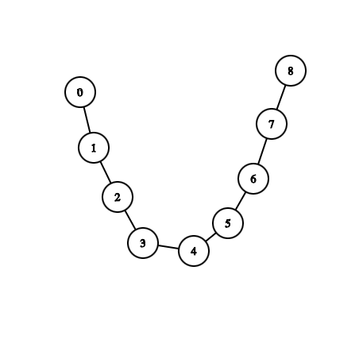

Manual execution 1 was performed by running the program with the following instructions:

read ../data/undir1.txt undirected

search bfs connComps

After this, the program will ask you if you want to save the connected components as graphs somewhere. The answer was yes, and we save with this pattern:

yes

../data/undir1/undir

The complete output log:

read ../data/undir1.txt undirected

Successfully opened file in 0.000368s.

search bfs connComps

Save resulting connected components (yes/no)? yes

Filenames structure to save at (e.g. 'components' => components1.txt etc.): ../data/undir1/undir

Component #1 [ 0 1 2 3 4 5 6 7 8 ]

Printed all connected components.

Operation done in 0.001454s.

The resulting component file:

9 8

0 1 100

1 2 200

2 3 300

3 4 400

4 5 500

5 6 600

6 7 700

7 8 800

### 

### **Manual Execution 2**

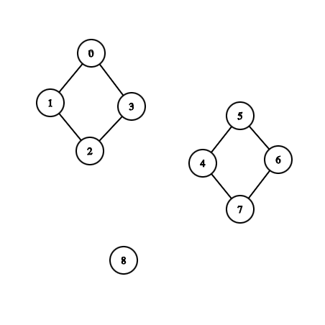

Manual execution 2 was performed by running the program with the following instructions:

read ../data/undir2.txt undirected

search bfs connComps

After this, the program will ask you if you want to save the connected components as graphs somewhere. The answer was yes, and we save with this pattern:

yes

../data/undir2/undir

The complete output log:

read ../data/undir2.txt undirected

Successfully opened file in 0.000378s.

search bfs connComps

Save resulting connected components (yes/no)? yes

Filenames structure to save at (e.g. 'components' => components1.txt etc.): ../data/undir2/undir

Component #1 [ 0 1 2 3 ]

Component #2 [ 4 5 6 7 ]

Component #3 [ 8 ]

Printed all connected components.

Operation done in 0.001717s.

The resulting 3 component files:

4 8

0 1 10

0 3 30

1 2 12

2 3 23

4 8

4 5 45

4 7 74

5 6 56

6 7 67

1 0

8 -1