c233ks

c351ks

c26 1ks 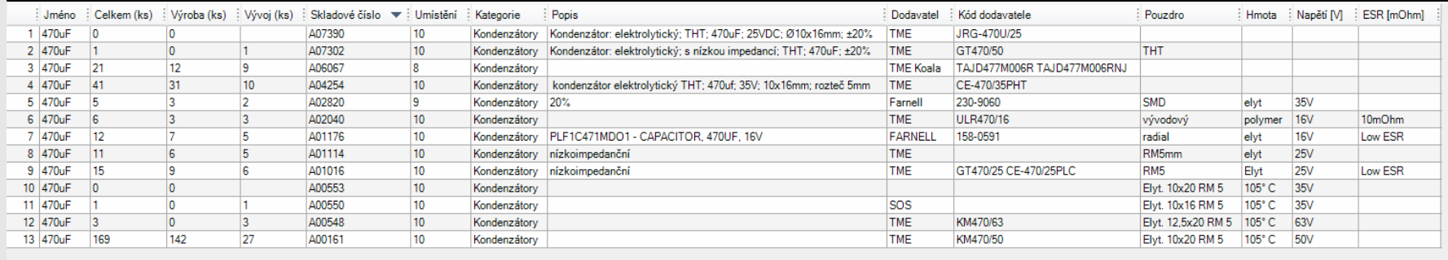

3ks BSS138

d23ks

1ks IRLML0030TRPBF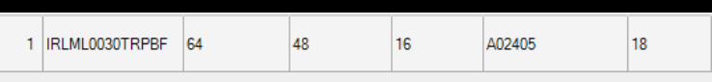,

půjčit si programator