CDS - Customer Deliverable Specification

Ziraat Bank Kosova

Software modification

Të Drejtat e Pronës Intelektuale
Ky dokument është hartuar dhe përpiluar nga Asseco SEE, pra, të gjitha kopje e saj dhe të drejtat e pronës janë pronë e grupit Asseco SEE. Ky dokument është klasifikuar si sekret tregtar dhe si i tillë është e ndaluar që të kopjohet apo t’i shpërndahet partive të paautorizuara, individëve jashtë grupit Asseco SEE, si dhe keqpërdorimit të saj nga punonjësit e Asseco SEE dhe / ose nga subjektet që nuk janë të punësuar nga Asseco SEE.

Solution Specification

Number of task | 595748 | Priority | High
Payment Status | RPLLB
Short name | Raportim per llogari bankare
Description of Proposed Solution* | RPLLB (Raportim për Llogari Bankare) is a report system that shows all bank accounts opened during a chosen time and reports to BQK(Banka qendrore e Kosoves). It includes basic details and helps with rules and checks.
Requestor | Amir Hyseni
Short Description of Proposed Solution* | The RPLLB module is designed to dynamically generate XML reports of bank accounts opened within a specific time period which report to BQK. It works based on a stored procedure and an associated XSD schema, which is first used to validate the structure before generating the XML file. This ensures that the output XML fully complies with the required format before it is submitted.  A dedicated settings table is used to store key parameters, including the start datetime and end datetime, values required by the stored procedure. These parameters are read dynamically to fetch the relevant data for each report.  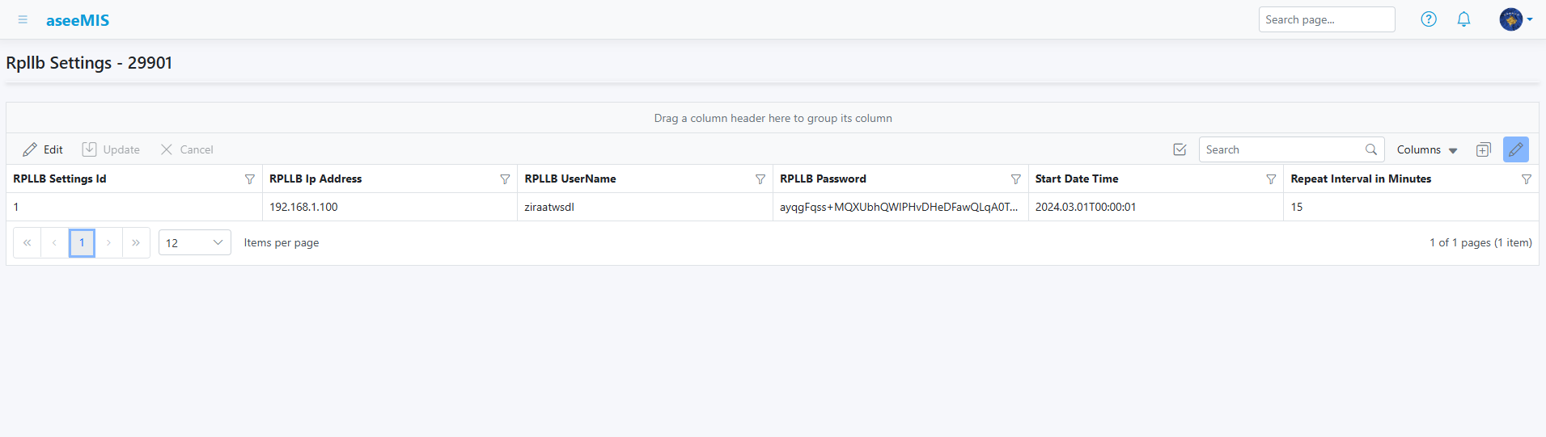  For SOAP communication, the same settings table holds the IP address, username, and password needed to connect to the SOAP protocol. These credentials are securely hashed when stored in database and decrypted when accessed via the web interface.  All uploads to the SOAP service are logged in a separate table called RpllbUploads, which tracks the full history of each submission. Before sending data to the live SOAP endpoint, an internal API validates the XML using the XSD schema to ensure it meets the correct structure and requirements.  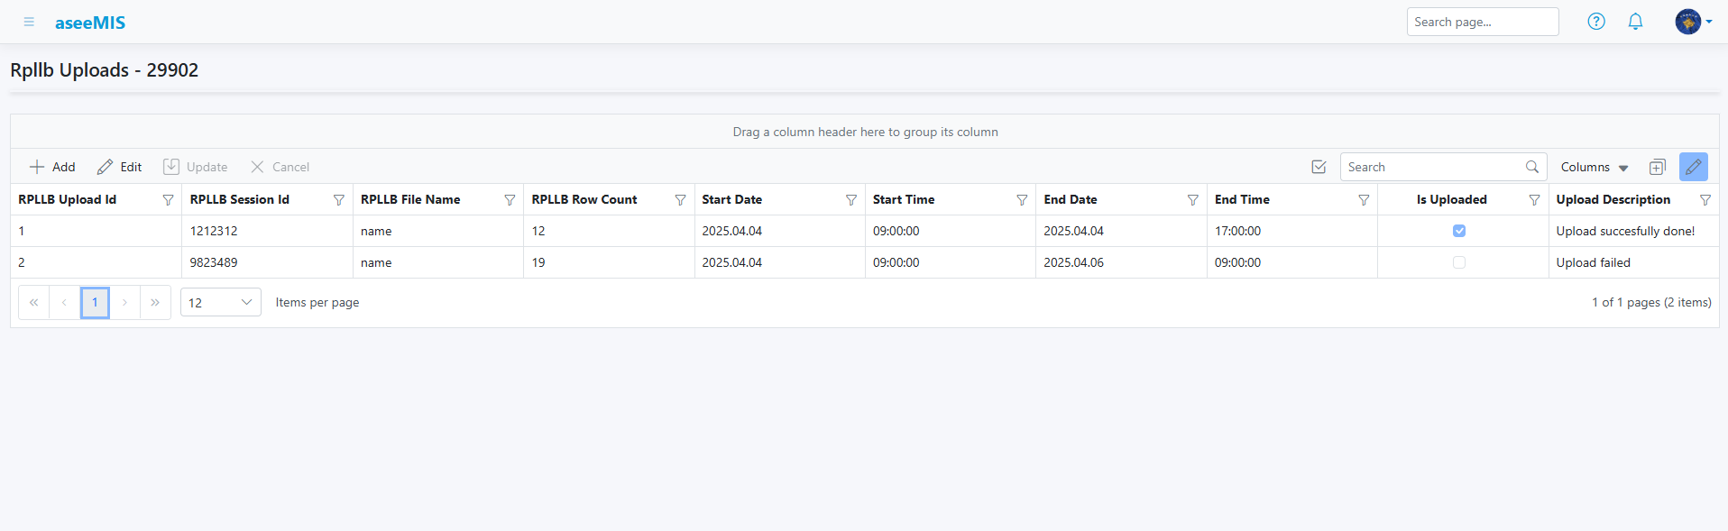  Additionally, the solution includes Start Scheduler and Stop Scheduler functionality. When the scheduler is started, it reads the RpllbSettings table to retrieve the configured repeat interval in minutes, and based on that interval, it periodically executes the SOAP protocol to submit reports to BQK. The scheduler can be stopped at any time through the provided Stop option, halting the automated submissions.  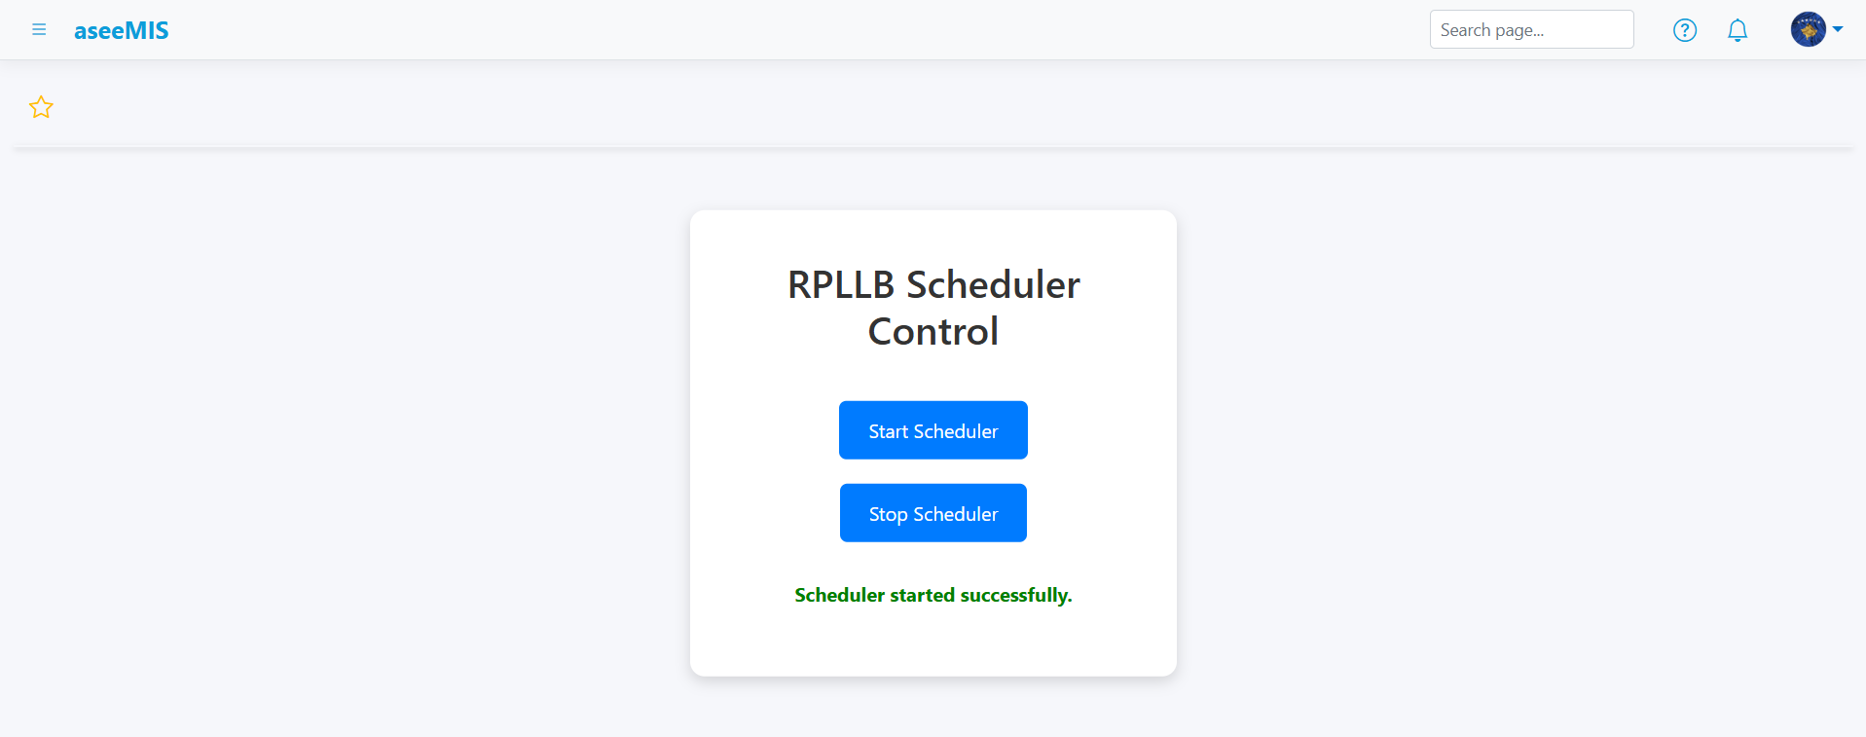  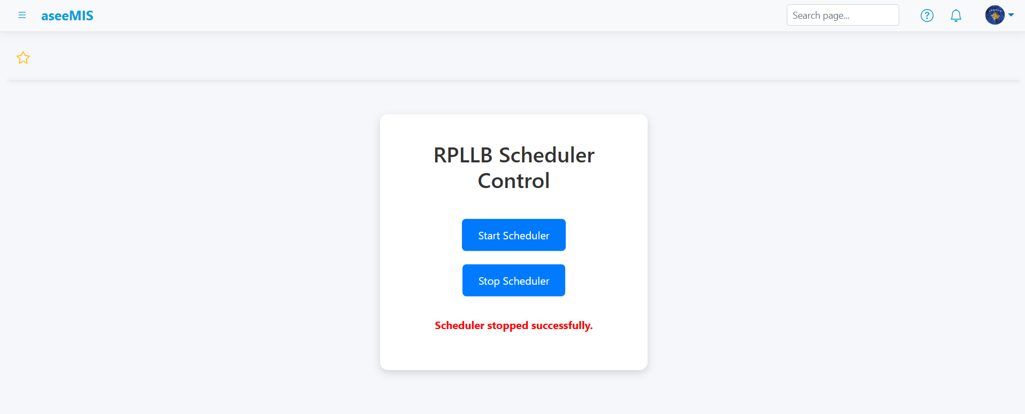  This solution offers a secure, flexible, and fully traceable process for generating, validating, and sending RPLLB reports through SOAP.
Responsible person for Asseco | Jon Kutllovci
Hours | Total:88
Delivery Due Date* | 16.05.2025
Deadline for accepting the solution | 28.04.2025

________________________________ __/__/____
Nenshkrimi/Signature Data/Date
Note:
The development of the solution starts after receiving formal (via e-mail) acceptance of the proposed solution, sent by the customer (Bank). The Bank is expected to respond to the CDS to deadline for acceptance specified in this document. After this period the reservations of the Asseco resources are cancelled. In case of a delayed acceptance of the CDS, the delivery date is estimated again.
In case of changes of the initial request, a new CDS is prepared and sent to the customer, after which this CDS is no longer valid.

