Pagesat
Permbajtja
Between own accounts 2
Between bank accounts 3
National 4
International 5
Invoices 6
Komune 6
Burgjet 7
Komisioneret dhe Zyret Rregullative 8
Ministrite dhe Agjensionet 9
Gjobat 10
Pagesat e studenteve per Universitetin 11
Keshilli Gjyqesor I Kosoves 12
Prokuroria Shteterore 13
Prepaid Services 14
TV 14
Internet 15
DuoTv 16
Top Up 17
IPKO 17
VALA 18
Currency Exchange 19

Between own accounts
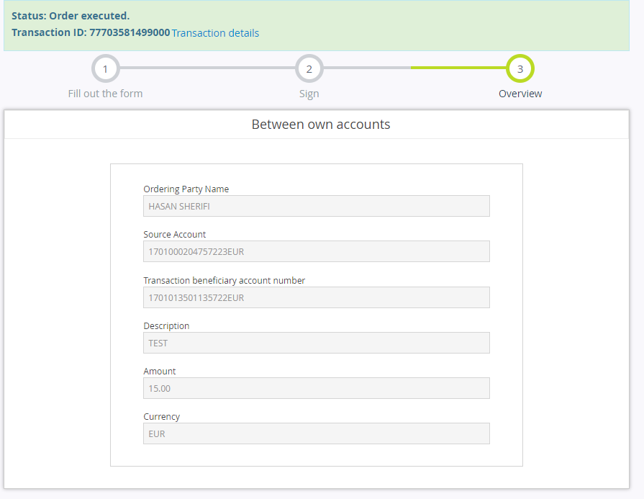

declare @p24 int
set @p24=0
declare @p25 nvarchar(2000)
set @p25=N'Success'
declare @p26 nvarchar(2000)
set @p26=N'77703581499000'
declare @p27 int
set @p27=NULL
declare @p28 nvarchar(2000)
set @p28=N'Transfer i'
declare @p29 nvarchar(2000)
set @p29=N'TEST'
declare @p30 nvarchar(2000)
set @p30=N'GENAR SHERIFI'
declare @p31 nvarchar(2000)
set @p31=N'GJILAN'
declare @p32 nvarchar(2000)
set @p32=N'1701013501135722 '
declare @p33 nvarchar(2000)
set @p33=N'Transferi në kuadër të bankës'
declare @p34 nvarchar(2000)
set @p34=NULL
exec ibank4_retail_pmtorderrq_internaltr @SourceAccount=N'1701000204757223'
,@DestinationAccount=N'1701013501135722',@SourceCurrency=N'978',@Currency=N'978',
@Amount=15.00,@Description=N'TEST',@CurrencyDate=N'2021.06.16',@BookingDate=N'2021.06.16',@PersonalID=N'1005038509',@TransCode=21,@FeeType=1,@PurposeCode=0,@PurposeDesc=default,@FiscalNo=N'',
@Uniref=N'',@ForPeriod=N'',@TaxPayerName=N'',@ContactName=N'',@PackageID=N'',@SourceAccountType=N'DDA',@destinationPersonalId=N'',@cardtype=default,@Salter=N'777',@ErrCode=@p24 output,@ErrMessage=@p25 output,@TransactionID=@p26 output,@Fee=@p27 output,@TrnType=@p28 output,@TransactionDescription=@p29 output,@OtherPartyInfoName=@p30 output,@OtherPartyInfoCity=@p31 output,@OtherPartyAccountAcctid=@p32 output,@Purpose=@p33 output,@StatusCode=@p34 outputselect @p24, @p25, @p26, @p27, @p28, @p29, @p30, @p31, @p32, @p33, @p34

Between bank accounts
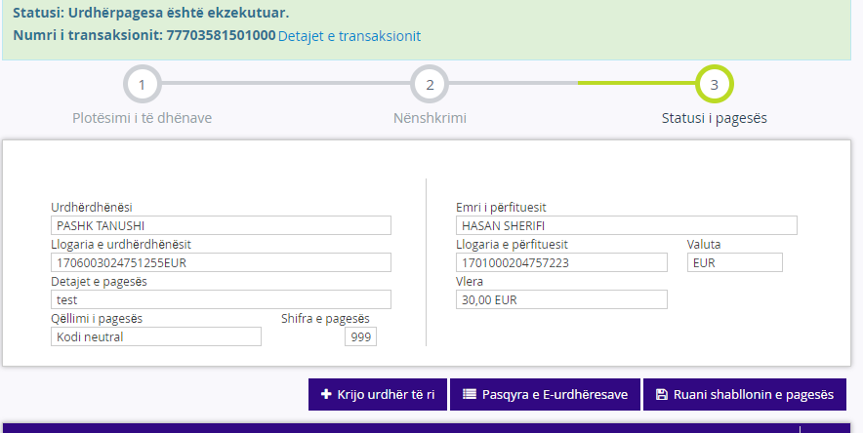
declare @p24 int
set @p24=0
declare @p25 nvarchar(2000)
set @p25=N'Success'
declare @p26 nvarchar(2000)
set @p26=N'77703581501000'
declare @p27 int
set @p27=NULL
declare @p28 nvarchar(2000)
set @p28=N'Transfer i'
declare @p29 nvarchar(2000)
set @p29=N'test'
declare @p30 nvarchar(2000)
set @p30=N'HASAN SHERIFI'
declare @p31 nvarchar(2000)
set @p31=N'GJILAN'
declare @p32 nvarchar(2000)
set @p32=N'1701000204757223 '
declare @p33 nvarchar(2000)
set @p33=N'Transferi në kuadër të bankës'
declare @p34 nvarchar(2000)
set @p34=NULL
exec ibank4_retail_pmtorderrq_internaltr @SourceAccount=N'1706003024751255',
@DestinationAccount=N'1701000204757223',@SourceCurrency=N'978',@Currency=N'978',
@Amount=30.00,@Description=N'test',@CurrencyDate=N'2021.06.16',@BookingDate=N'2021.06.16',
@PersonalID=N'1170559076',@TransCode=21,@FeeType=1,@PurposeCode=999,@PurposeDesc=N'Kodi neutral',@FiscalNo=N'',@Uniref=N'',@ForPeriod=N'',@TaxPayerName=N'',@ContactName=N'',@PackageID=N'',
@SourceAccountType=N'DDA',@destinationPersonalId=N'',@cardtype=default,@Salter=N'777',
@ErrCode=@p24 output,@ErrMessage=@p25 output,@TransactionID=@p26 output,@Fee=@p27 output,
@TrnType=@p28 output,@TransactionDescription=@p29 output,@OtherPartyInfoName=@p30 output,
@OtherPartyInfoCity=@p31 output,@OtherPartyAccountAcctid=@p32 output,@Purpose=@p33 output,
@StatusCode=@p34 outputselect @p24, @p25, @p26, @p27, @p28, @p29, @p30, @p31, @p32, @p33, @p34

National

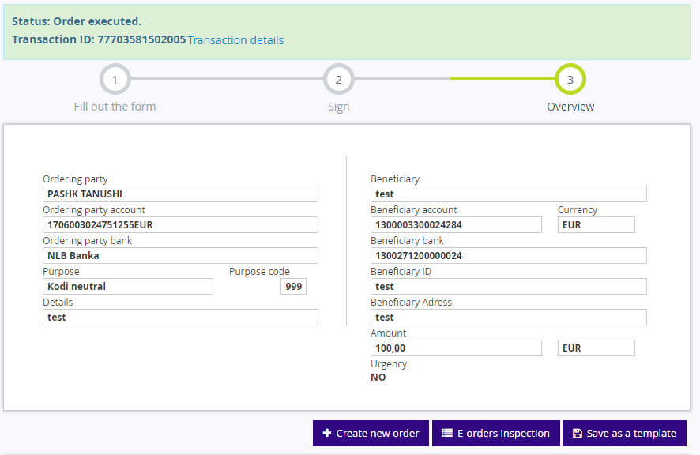
declare @p20 int
set @p20=0
declare @p21 nvarchar(2000)
set @p21=N'Success'
declare @p22 nvarchar(2000)
set @p22=N'77703581502005'
declare @p23 int
set @p23=0
declare @p24 nvarchar(2000)
set @p24=N'77703581502'
declare @p25 nvarchar(2000)
set @p25=N'Pagesa ne '
declare @p26 nvarchar(2000)
set @p26=N'Provizioni per pagese'
declare @p27 nvarchar(2000)
set @p27=N'test'
declare @p28 nvarchar(2000)
set @p28=N'Kosova'
declare @p29 nvarchar(2000)
set @p29=N'1300003300024284'
declare @p30 nvarchar(2000)
set @p30=N'Transfertat dërguese'
declare @p31 nvarchar(2000)
set @p31=NULL
exec ibank4_retail_pmtorderrq_outgoingtrans @SourceAccount=N'1706003024751255',
@Currency=N'978',@RecBankAccount=N'1300271200000024',@RecCustName=N'test',
@RecCustNameAddress=N'',@RecCustAccount=N'1300003300024284',@Amount=100.00,
@Details=N'test',@TransType=0,@FeeType=1,@purposecode=999,
@purposedesc=N'Kodi neutral',@TransCode=22,@CurrencyDate=N'2021.06.16',
@BookingDate=N'2021.06.16',@PersonalID=N'1170559076',@sourceCurrency=N'978',@PackageID=N'',
@Salter=N'777',@ErrCode=@p20 output,@ErrMessage=@p21 output,@TransactionID=@p22 output,
@Fee=@p23 output,@ControlNumber=@p24 output,@TrnType=@p25 output,
@TransactionDescription=@p26 output,@OtherPartyInfoName=@p27 output,
@OtherPartyInfoCity=@p28 output,@OtherPartyAccountAcctid=@p29 output,
@Purpose=@p30 output,@StatusCode=@p31 output
select @p20, @p21, @p22, @p23, @p24, @p25, @p26, @p27, @p28, @p29, @p30, @p31

International
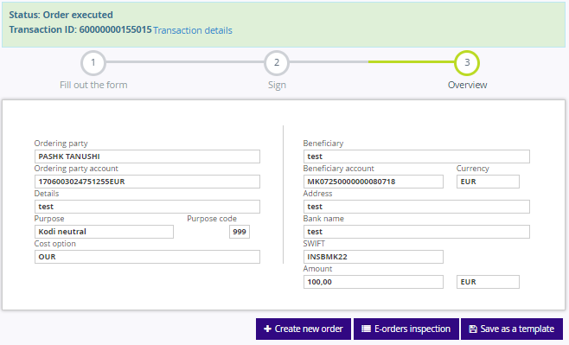
declare @p23 int
set @p23=0
declare @p24 nvarchar(2000)
set @p24=N'Success'
declare @p25 nvarchar(2000)
set @p25=N'60000000155015'
declare @p26 nvarchar(2000)
set @p26=NULL
exec ibank4_retail_pmtorderrq_fpspayments @Acctid=N'1706003024751255EUR',
@Name=N'PASHK TANUSHI',@Address=N' ',@BankName=N'NLB Banka',
@BankCode=N'INSBMK22',@BankAddress=N' ',@BenAcctid=N'MK07250000000080718',
@BenName=N'test',@BenAddress=N'test ',@Currency=N'978',@CurrencyDate=N'2021.06.17',
@Amount=100.00,@CorSWIFT=N'',@TransType=0,@PayType=N'ORDERING',@Trnuid=N'',
@Description=N'test',@PurposeCode=0,@PurposeDesc=N'',@Salter=N'777',
@PersonalID=N'1170559076',@ABA=0,@ErrCode=@p23 output,@ErrMessage=@p24 output,
@TransactionID=@p25 output,@StatusCode=@p26 output
select @p23, @p24, @p25, @p26

Invoices

Komune
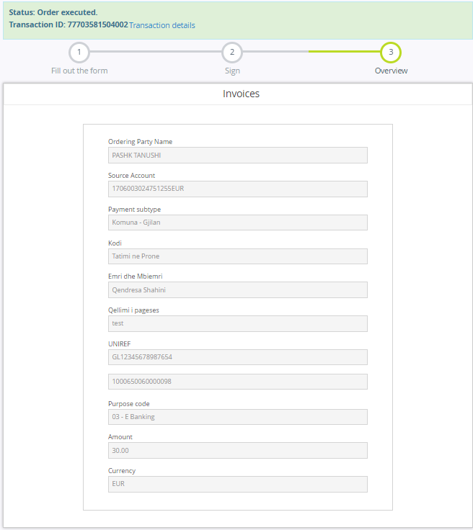
declare @p24 int
set @p24=0
declare @p25 nvarchar(2000)
set @p25=N'Success'
declare @p26 nvarchar(2000)
set @p26=N'77703581504002'
declare @p27 int
set @p27=0
declare @p28 nvarchar(2000)
set @p28=N'Pagesa Mas'
declare @p29 nvarchar(2000)
set @p29=N'Komuna - Gjilan-test GL12345678987654'
declare @p30 nvarchar(2000)
set @p30=N'Komuna - Gjilan'
declare @p31 nvarchar(2000)
set @p31=N'N/A'
declare @p32 nvarchar(2000)
set @p32=N'1000650060000098 '
declare @p33 nvarchar(2000)
set @p33=N'Pagesë Massive nga llogaria'
declare @p34 nvarchar(2000)
set @p34=NULL
exec ibank4_retail_pmtorderrq_diffpayments @TransType=N'865',@Text1=N'',
@Text2=N'',@Text3=N'10',@Text4=N'Qendresa Shahini',@Text5=N'test',
@Text6=N'GL12345678987654',@SourceAccount=N'1706003024751255',@Currency=N'978',
@Amount=N'30.00',@Description=N'',@DestinationAccount=N'',@purposecode=3,
@purposedesc=N'.',@purposeGiro=N'.',@CurrencyDate=N'2021.06.16',
@BookingDate=N'2021.06.16',@PersonalID=N'1170559076',@TransCode=2,
@FeeType=1,@PaymentCode=865,@SourceAccountType=N'DDA',@Salter=N'777',
@ErrCode=@p24 output,@ErrMessage=@p25 output,@TransactionID=@p26 output,
@Fee=@p27 output,@TrnType=@p28 output,@TransactionDescription=@p29 output,
@OtherPartyInfoName=@p30 output,@OtherPartyInfoCity=@p31 output,
@OtherPartyAccountAcctid=@p32 output,@Purpose=@p33 output,@StatusCode=@p34 output
select @p24, @p25, @p26, @p27, @p28, @p29, @p30, @p31, @p32, @p33, @p34

Burgjet

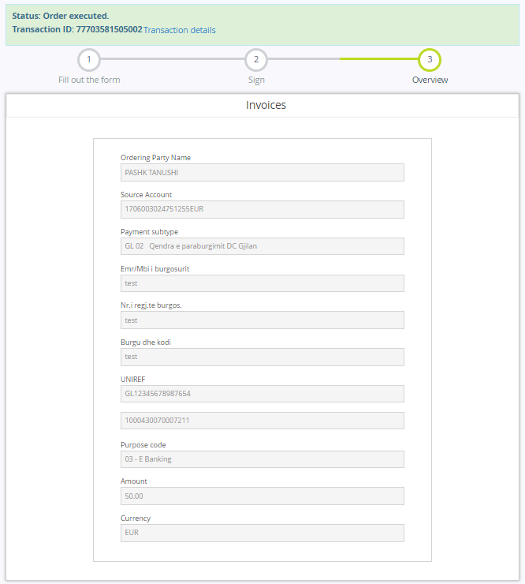
declare @p24 int
set @p24=0
declare @p25 nvarchar(2000)
set @p25=N'Success'
declare @p26 nvarchar(2000)
set @p26=N'77703581505002'
declare @p27 int
set @p27=0
declare @p28 nvarchar(2000)
set @p28=N'Pagesa Mas'
declare @p29 nvarchar(2000)
set @p29=N'GL 02 Qendra e paraburgimit DC Gjilan-test GL12345678987654'
declare @p30 nvarchar(2000)
set @p30=N'GL 02 Qendra e paraburgimit DC Gjilan'
declare @p31 nvarchar(2000)
set @p31=N'N/A'
declare @p32 nvarchar(2000)
set @p32=N'1000430070007211 '
declare @p33 nvarchar(2000)
set @p33=N'Pagesë Massive nga llogaria'
declare @p34 nvarchar(2000)
set @p34=NULL
exec ibank4_retail_pmtorderrq_diffpayments @TransType=N'852',@Text1=N'test',
@Text2=N'test',@Text3=N'test',@Text4=N'',@Text5=N'',@Text6=N'GL12345678987654',
@SourceAccount=N'1706003024751255',@Currency=N'978',@Amount=N'50.00',@Description=N'',
@DestinationAccount=N'',@purposecode=3,@purposedesc=N'.',@purposeGiro=N'.',
@CurrencyDate=N'2021.06.16',@BookingDate=N'2021.06.16',@PersonalID=N'1170559076',
@TransCode=2,@FeeType=1,@PaymentCode=852,@SourceAccountType=N'DDA',@Salter=N'777',
@ErrCode=@p24 output,@ErrMessage=@p25 output,@TransactionID=@p26 output,
@Fee=@p27 output,@TrnType=@p28 output,@TransactionDescription=@p29 output,
@OtherPartyInfoName=@p30 output,@OtherPartyInfoCity=@p31 output,
@OtherPartyAccountAcctid=@p32 output,@Purpose=@p33 output,@StatusCode=@p34 output
select @p24, @p25, @p26, @p27, @p28, @p29, @p30, @p31, @p32, @p33, @p34

Komisioneret dhe Zyret Rregullative

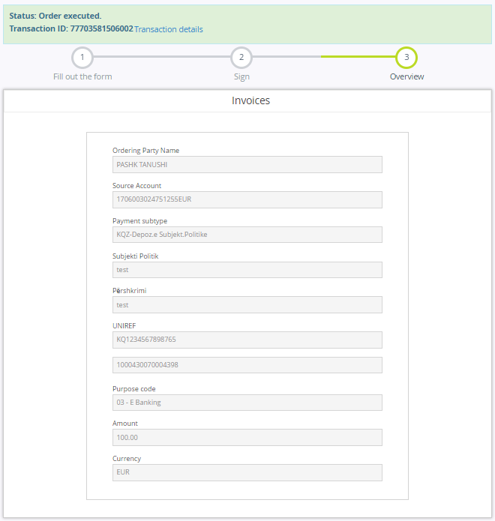
declare @p24 int
set @p24=0
declare @p25 nvarchar(2000)
set @p25=N'Success'
declare @p26 nvarchar(2000)
set @p26=N'77703581506002'
declare @p27 int
set @p27=0
declare @p28 nvarchar(2000)
set @p28=N'Pagesa Mas'
declare @p29 nvarchar(2000)
set @p29=N'KQZ-Depoz.e Subjekt.Politike-test KQ1234567898765'
declare @p30 nvarchar(2000)
set @p30=N'KQZ-Depoz.e Subjekt.Politike'
declare @p31 nvarchar(2000)
set @p31=N'N/A'
declare @p32 nvarchar(2000)
set @p32=N'1000430070004398 '
declare @p33 nvarchar(2000)
set @p33=N'Pagesë Massive nga llogaria'
declare @p34 nvarchar(2000)
set @p34=NULL
exec ibank4_retail_pmtorderrq_diffpayments @TransType=N'918',@Text1=N'test',
@Text2=N'test',@Text3=N'',@Text4=N'',@Text5=N'',@Text6=N'KQ1234567898765',
@SourceAccount=N'1706003024751255',@Currency=N'978',@Amount=N'100.00',
@Description=N'',@DestinationAccount=N'',@purposecode=3,@purposedesc=N'.',
@purposeGiro=N'.',@CurrencyDate=N'2021.06.17',@BookingDate=N'2021.06.17',
@PersonalID=N'1170559076',@TransCode=2,@FeeType=1,@PaymentCode=918,
@SourceAccountType=N'DDA',@Salter=N'777',@ErrCode=@p24 output,
@ErrMessage=@p25 output,@TransactionID=@p26 output,@Fee=@p27 output,
@TrnType=@p28 output,@TransactionDescription=@p29 output,
@OtherPartyInfoName=@p30 output,@OtherPartyInfoCity=@p31 output,
@OtherPartyAccountAcctid=@p32 output,@Purpose=@p33 output,@StatusCode=@p34 output
select @p24, @p25, @p26, @p27, @p28, @p29, @p30, @p31, @p32, @p33, @p34

Ministrite dhe Agjensionet

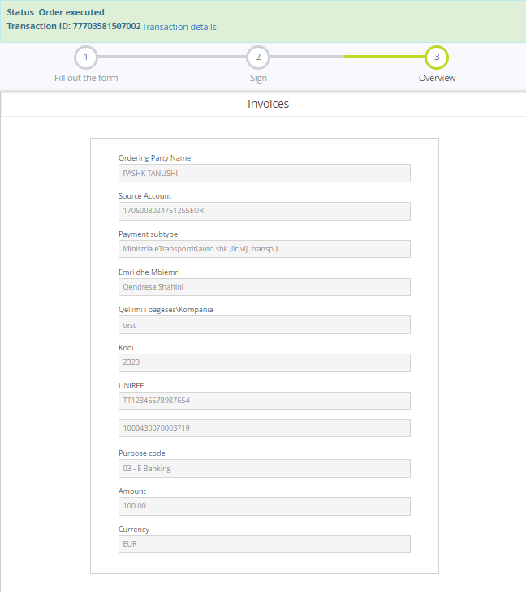
declare @p24 int
set @p24=0
declare @p25 nvarchar(2000)
set @p25=N'Success'
declare @p26 nvarchar(2000)
set @p26=N'77703581507002'
declare @p27 int
set @p27=0
declare @p28 nvarchar(2000)
set @p28=N'Pagesa Mas'
declare @p29 nvarchar(2000)
set @p29=N'Ministria eTransportit(auto shk.,lic.vij. transp.)-test TT12345678987654'
declare @p30 nvarchar(2000)
set @p30=N'Ministria eTransportit(auto shk.,lic.vij. transp.)'
declare @p31 nvarchar(2000)
set @p31=N'N/A'
declare @p32 nvarchar(2000)
set @p32=N'1000430070003719 '
declare @p33 nvarchar(2000)
set @p33=N'Pagesë Massive nga llogaria'
declare @p34 nvarchar(2000)
set @p34=NULL
exec ibank4_retail_pmtorderrq_diffpayments @TransType=N'715',@Text1=N'Qendresa Shahini',
@Text2=N'test ',@Text3=N'2323',@Text4=N'',@Text5=N'',@Text6=N'TT12345678987654',
@SourceAccount=N'1706003024751255',@Currency=N'978',@Amount=N'100.00',@Description=N'',
@DestinationAccount=N'',@purposecode=3,@purposedesc=N'.',@purposeGiro=N'.',
@CurrencyDate=N'2021.06.17',@BookingDate=N'2021.06.17',@PersonalID=N'1170559076',
@TransCode=2,@FeeType=1,@PaymentCode=715,@SourceAccountType=N'DDA',@Salter=N'777',
@ErrCode=@p24 output,@ErrMessage=@p25 output,@TransactionID=@p26 output,@Fee=@p27 output,
@TrnType=@p28 output,@TransactionDescription=@p29 output,@OtherPartyInfoName=@p30 output,
@OtherPartyInfoCity=@p31 output,@OtherPartyAccountAcctid=@p32 output,@Purpose=@p33 output,
@StatusCode=@p34 output
select @p24, @p25, @p26, @p27, @p28, @p29, @p30, @p31, @p32, @p33, @p34

Gjobat
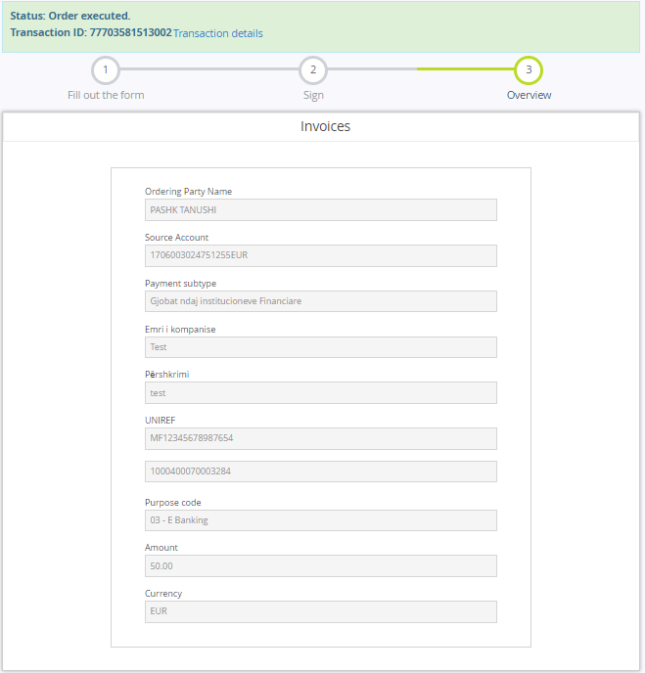
declare @p24 int
set @p24=0
declare @p25 nvarchar(2000)
set @p25=N'Success'
declare @p26 nvarchar(2000)
set @p26=N'77703581513002'
declare @p27 int
set @p27=0
declare @p28 nvarchar(2000)
set @p28=N'Pagesa Mas'
declare @p29 nvarchar(2000)
set @p29=N'Gjobat ndaj institucioneve Financiare-test MF12345678987654'
declare @p30 nvarchar(2000)
set @p30=N'Gjobat ndaj institucioneve Financiare'
declare @p31 nvarchar(2000)
set @p31=N'N/A'
declare @p32 nvarchar(2000)
set @p32=N'1000400070003284 '
declare @p33 nvarchar(2000)
set @p33=N'Pagesë Massive nga llogaria'
declare @p34 nvarchar(2000)
set @p34=NULL
exec ibank4_retail_pmtorderrq_diffpayments @TransType=N'936',@Text1=N'Test',
@Text2=N'test',@Text3=N'',@Text4=N'',@Text5=N'',@Text6=N'MF12345678987654',
@SourceAccount=N'1706003024751255',@Currency=N'978',@Amount=N'50.00',
@Description=N'',@DestinationAccount=N'',@purposecode=3,@purposedesc=N'.',
@purposeGiro=N'.',@CurrencyDate=N'2021.06.17',@BookingDate=N'2021.06.17',
@PersonalID=N'1170559076',@TransCode=2,@FeeType=1,@PaymentCode=936,
@SourceAccountType=N'DDA',@Salter=N'777',@ErrCode=@p24 output,
@ErrMessage=@p25 output,@TransactionID=@p26 output,@Fee=@p27 output,
@TrnType=@p28 output,@TransactionDescription=@p29 output,@OtherPartyInfoName=@p30 output,@OtherPartyInfoCity=@p31 output,@OtherPartyAccountAcctid=@p32 output,@Purpose=@p33 output,@StatusCode=@p34 output select @p24, @p25, @p26, @p27, @p28, @p29, @p30, @p31, @p32, @p33, @p34

Pagesat e studenteve per Universitetin
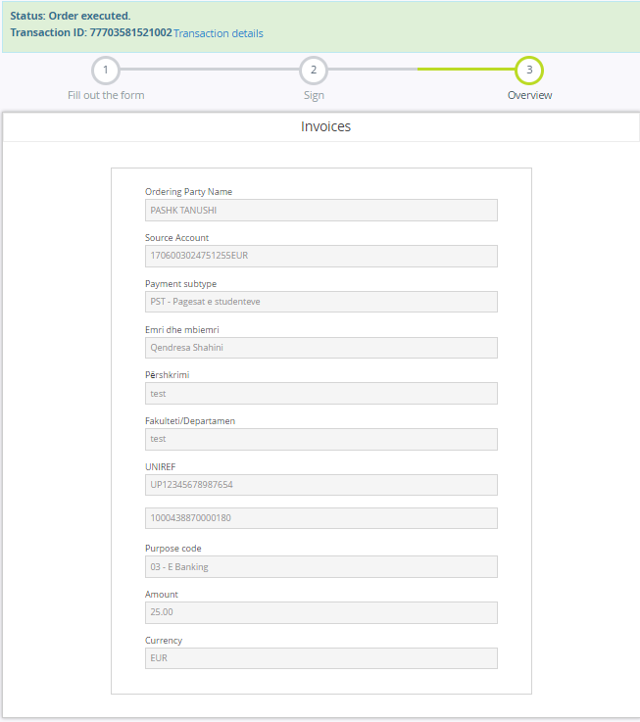
declare @p24 int
set @p24=0
declare @p25 nvarchar(2000)
set @p25=N'Success'
declare @p26 nvarchar(2000)
set @p26=N'77703581521002'
declare @p27 int
set @p27=0
declare @p28 nvarchar(2000)
set @p28=N'Pagesa Mas'
declare @p29 nvarchar(2000)
set @p29=N'PST - Pagesat e studenteve-test UP12345678987654'
declare @p30 nvarchar(2000)
set @p30=N'PST - Pagesat e studenteve'
declare @p31 nvarchar(2000)
set @p31=N'N/A'
declare @p32 nvarchar(2000)
set @p32=N'1000438870000180 '
declare @p33 nvarchar(2000)
set @p33=N'Pagesë Massive nga llogaria'
declare @p34 nvarchar(2000)
set @p34=NULL
exec ibank4_retail_pmtorderrq_diffpayments @TransType=N'708',
@Text1=N'Qendresa Shahini',@Text2=N'test',@Text3=N'test',
@Text4=N'',@Text5=N'',@Text6=N'UP12345678987654',
@SourceAccount=N'1706003024751255',@Currency=N'978',
@Amount=N'25.00',@Description=N'',@DestinationAccount=N'',
@purposecode=3,@purposedesc=N'.',@purposeGiro=N'.',
@CurrencyDate=N'2021.06.17',@BookingDate=N'2021.06.17',
@PersonalID=N'1170559076',@TransCode=2,@FeeType=1,
@PaymentCode=708,@SourceAccountType=N'DDA',@Salter=N'777',
@ErrCode=@p24 output,@ErrMessage=@p25 output,@TransactionID=@p26 output,
@Fee=@p27 output,@TrnType=@p28 output,@TransactionDescription=@p29 output,
@OtherPartyInfoName=@p30 output,@OtherPartyInfoCity=@p31 output,
@OtherPartyAccountAcctid=@p32 output,@Purpose=@p33 output,@StatusCode=@p34 output
select @p24, @p25, @p26, @p27, @p28, @p29, @p30, @p31, @p32, @p33, @p34

Keshilli Gjyqesor I Kosoves
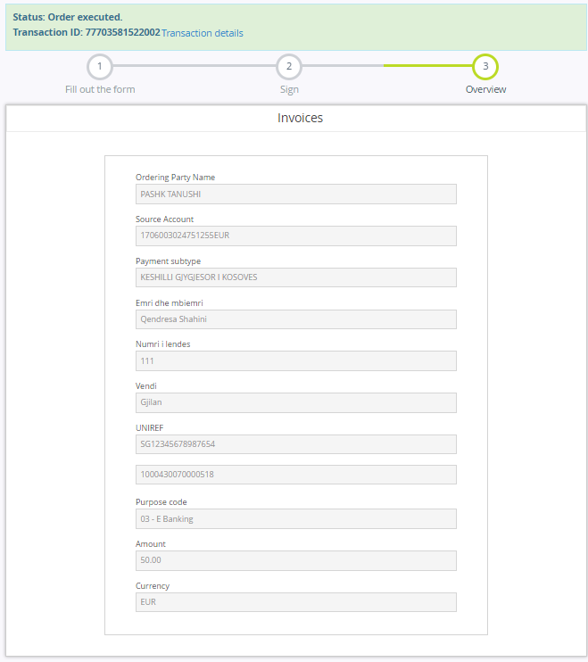
declare @p24 int
set @p24=0
declare @p25 nvarchar(2000)
set @p25=N'Success'
declare @p26 nvarchar(2000)
set @p26=N'77703581522002'
declare @p27 int
set @p27=0
declare @p28 nvarchar(2000)
set @p28=N'Pagesa Mas'
declare @p29 nvarchar(2000)
set @p29=N'KESHILLI GJYGJESOR I KOSOVES-111 SG12345678987654'
declare @p30 nvarchar(2000)
set @p30=N'KESHILLI GJYGJESOR I KOSOVES'
declare @p31 nvarchar(2000)
set @p31=N'N/A'
declare @p32 nvarchar(2000)
set @p32=N'1000430070000518 '
declare @p33 nvarchar(2000)
set @p33=N'Pagesë Massive nga llogaria'
declare @p34 nvarchar(2000)
set @p34=NULL
exec ibank4_retail_pmtorderrq_diffpayments @TransType=N'705',
@Text1=N'Qendresa Shahini',@Text2=N'111',@Text3=N'Gjilan',
@Text4=N'',@Text5=N'',@Text6=N'SG12345678987654',
@SourceAccount=N'1706003024751255',@Currency=N'978',
@Amount=N'50.00',@Description=N'',@DestinationAccount=N'',
@purposecode=3,@purposedesc=N'.',@purposeGiro=N'.',
@CurrencyDate=N'2021.06.17',@BookingDate=N'2021.06.17',
@PersonalID=N'1170559076',@TransCode=2,@FeeType=1,
@PaymentCode=705,@SourceAccountType=N'DDA',@Salter=N'777',
@ErrCode=@p24 output,@ErrMessage=@p25 output,@TransactionID=@p26 output,
@Fee=@p27 output,@TrnType=@p28 output,@TransactionDescription=@p29 output,
@OtherPartyInfoName=@p30 output,@OtherPartyInfoCity=@p31 output,
@OtherPartyAccountAcctid=@p32 output,@Purpose=@p33 output,@StatusCode=@p34 output
select @p24, @p25, @p26, @p27, @p28, @p29, @p30, @p31, @p32, @p33, @p34

Prokuroria Shteterore
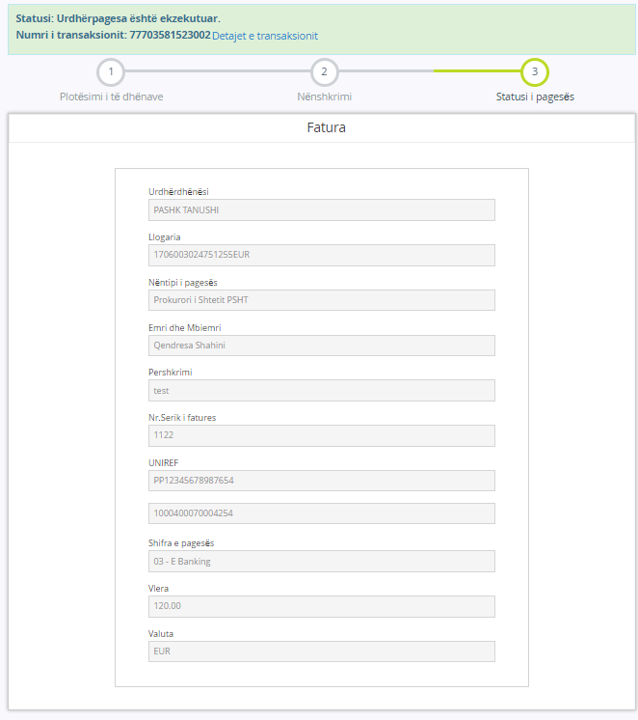
declare @p24 int
set @p24=0
declare @p25 nvarchar(2000)
set @p25=N'Success'
declare @p26 nvarchar(2000)
set @p26=N'77703581523002'
declare @p27 int
set @p27=0
declare @p28 nvarchar(2000)
set @p28=N'Pagesa Mas'
declare @p29 nvarchar(2000)
set @p29=N'Prokurori i Shtetit PSHT-test PP12345678987654'
declare @p30 nvarchar(2000)
set @p30=N'Prokurori i Shtetit PSHT'
declare @p31 nvarchar(2000)
set @p31=N'N/A'
declare @p32 nvarchar(2000)
set @p32=N'1000400070004254 '
declare @p33 nvarchar(2000)
set @p33=N'Pagesë Massive nga llogaria'
declare @p34 nvarchar(2000)
set @p34=NULL
exec ibank4_retail_pmtorderrq_diffpayments @TransType=N'947',
@Text1=N'Qendresa Shahini',@Text2=N'test',@Text3=N'1122',
@Text4=N'',@Text5=N'',@Text6=N'PP12345678987654',
@SourceAccount=N'1706003024751255',@Currency=N'978',
@Amount=N'120.00',@Description=N'',@DestinationAccount=N'',
@purposecode=3,@purposedesc=N'.',@purposeGiro=N'.',
@CurrencyDate=N'2021.06.17',@BookingDate=N'2021.06.17',
@PersonalID=N'1170559076',@TransCode=2,@FeeType=1,@PaymentCode=947,
@SourceAccountType=N'DDA',@Salter=N'777',@ErrCode=@p24 output,
@ErrMessage=@p25 output,@TransactionID=@p26 output,@Fee=@p27 output,
@TrnType=@p28 output,@TransactionDescription=@p29 output,
@OtherPartyInfoName=@p30 output,@OtherPartyInfoCity=@p31 output,
@OtherPartyAccountAcctid=@p32 output,@Purpose=@p33 output,@StatusCode=@p34 output
select @p24, @p25, @p26, @p27, @p28, @p29, @p30, @p31, @p32, @p33, @p34

Prepaid Services

TV
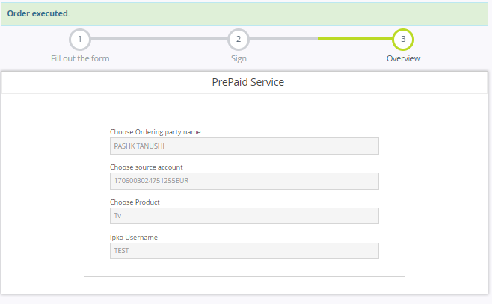
declare @p24 int
set @p24=0
declare @p25 nvarchar(2000)
set @p25=N'Success'
declare @p26 nvarchar(2000)
set @p26=N' '
declare @p27 int
set @p27=NULL
declare @p28 nvarchar(2000)
set @p28=NULL
declare @p29 nvarchar(2000)
set @p29=NULL
declare @p30 nvarchar(2000)
set @p30=NULL
declare @p31 nvarchar(2000)
set @p31=NULL
declare @p32 nvarchar(2000)
set @p32=NULL
declare @p33 nvarchar(2000)
set @p33=NULL
declare @p34 nvarchar(2000)
set @p34=NULL
exec ibank4_retail_pmtorderrq_internaltr @SourceAccount=N'1706003024751255',
@DestinationAccount=N'PrePaidServ',@SourceCurrency=N'978',@Currency=N'978',
@Amount=0,@Description=N'PrePaid Services',@CurrencyDate=N'2021.06.17',
@BookingDate=N'2021.06.17',@PersonalID=N'1170559076',@TransCode=21,
@FeeType=1,@PurposeCode=2,@PurposeDesc=N'TEST',@FiscalNo=N'',@Uniref=N'',
@ForPeriod=N'',@TaxPayerName=N'',@ContactName=N'',@PackageID=N'',
@SourceAccountType=N'DDA',@destinationPersonalId=N'',@cardtype=default,
@Salter=N'777',@ErrCode=@p24 output,@ErrMessage=@p25 output,
@TransactionID=@p26 output,@Fee=@p27 output,@TrnType=@p28 output,
@TransactionDescription=@p29 output,@OtherPartyInfoName=@p30 output,@OtherPartyInfoCity=@p31 output,@OtherPartyAccountAcctid=@p32 output,@Purpose=@p33 output,@StatusCode=@p34 output select @p24, @p25, @p26, @p27, @p28, @p29, @p30, @p31, @p32, @p33, @p34

Internet
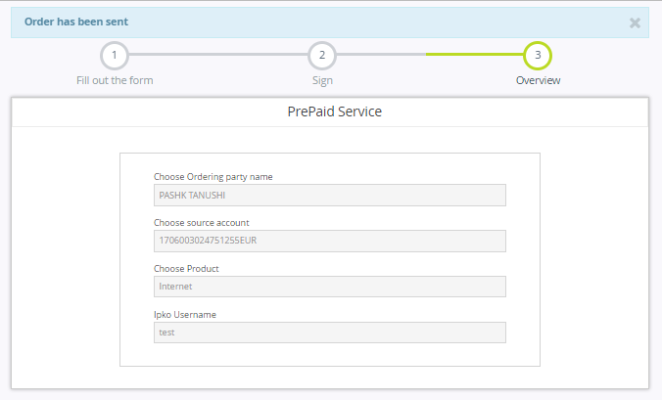
declare @p24 int
set @p24=0
declare @p25 nvarchar(2000)
set @p25=N'Success'
declare @p26 nvarchar(2000)
set @p26=N' '
declare @p27 int
set @p27=NULL
declare @p28 nvarchar(2000)
set @p28=NULL
declare @p29 nvarchar(2000)
set @p29=NULL
declare @p30 nvarchar(2000)
set @p30=NULL
declare @p31 nvarchar(2000)
set @p31=NULL
declare @p32 nvarchar(2000)
set @p32=NULL
declare @p33 nvarchar(2000)
set @p33=NULL
declare @p34 nvarchar(2000)
set @p34=NULL
exec ibank4_retail_pmtorderrq_internaltr @SourceAccount=N'1706003024751255',
@DestinationAccount=N'PrePaidServ',@SourceCurrency=N'978',@Currency=N'978',
@Amount=0,@Description=N'PrePaid Services',@CurrencyDate=N'2021.06.17',
@BookingDate=N'2021.06.17',@PersonalID=N'1170559076',@TransCode=21,@FeeType=1,
@PurposeCode=3,@PurposeDesc=N'test',@FiscalNo=N'',@Uniref=N'',@ForPeriod=N'',
@TaxPayerName=N'',@ContactName=N'',@PackageID=N'',@SourceAccountType=N'DDA',
@destinationPersonalId=N'',@cardtype=default,@Salter=N'777',@ErrCode=@p24 output,
@ErrMessage=@p25 output,@TransactionID=@p26 output,@Fee=@p27 output,
@TrnType=@p28 output,@TransactionDescription=@p29 output,@OtherPartyInfoName=@p30 output,@OtherPartyInfoCity=@p31 output,@OtherPartyAccountAcctid=@p32 output,@Purpose=@p33 output,@StatusCode=@p34 outputselect @p24, @p25, @p26, @p27, @p28, @p29, @p30, @p31, @p32, @p33, @p34

DuoTv
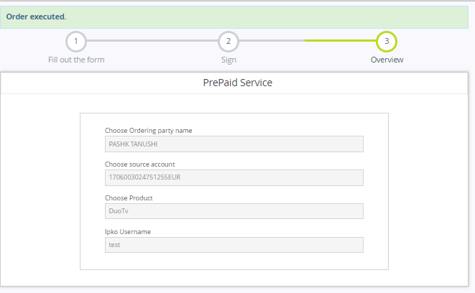
declare @p24 int
set @p24=0
declare @p25 nvarchar(2000)
set @p25=N'Success'
declare @p26 nvarchar(2000)
set @p26=N' '
declare @p27 int
set @p27=NULL
declare @p28 nvarchar(2000)
set @p28=NULL
declare @p29 nvarchar(2000)
set @p29=NULL
declare @p30 nvarchar(2000)
set @p30=NULL
declare @p31 nvarchar(2000)
set @p31=NULL
declare @p32 nvarchar(2000)
set @p32=NULL
declare @p33 nvarchar(2000)
set @p33=NULL
declare @p34 nvarchar(2000)
set @p34=NULL
exec ibank4_retail_pmtorderrq_internaltr @SourceAccount=N'1706003024751255',
@DestinationAccount=N'PrePaidServ',@SourceCurrency=N'978',@Currency=N'978',
@Amount=0,@Description=N'PrePaid Services',@CurrencyDate=N'2021.06.17',
@BookingDate=N'2021.06.17',@PersonalID=N'1170559076',@TransCode=21,
@FeeType=1,@PurposeCode=4,@PurposeDesc=N'test',@FiscalNo=N'',@Uniref=N'',
@ForPeriod=N'',@TaxPayerName=N'',@ContactName=N'',@PackageID=N'',
@SourceAccountType=N'DDA',@destinationPersonalId=N'',@cardtype=default,
@Salter=N'777',@ErrCode=@p24 output,@ErrMessage=@p25 output,@TransactionID=@p26 output,@Fee=@p27 output,@TrnType=@p28 output,@TransactionDescription=@p29 output,@OtherPartyInfoName=@p30 output,@OtherPartyInfoCity=@p31 output,@OtherPartyAccountAcctid=@p32 output,
@Purpose=@p33 output,@StatusCode=@p34 output select @p24, @p25, @p26, @p27, @p28, @p29, @p30, @p31, @p32, @p33, @p34

Top Up

IPKO
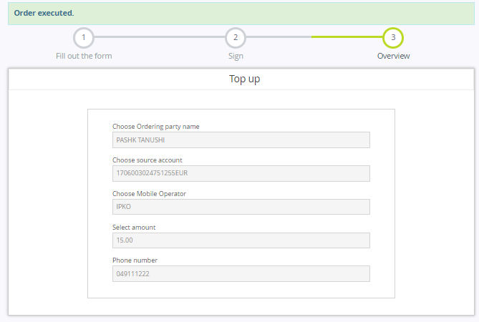
declare @p24 int
set @p24=0
declare @p25 nvarchar(2000)
set @p25=N'Success'
declare @p26 nvarchar(2000)
set @p26=N' '
declare @p27 int
set @p27=NULL
declare @p28 nvarchar(2000)
set @p28=NULL
declare @p29 nvarchar(2000)
set @p29=NULL
declare @p30 nvarchar(2000)
set @p30=NULL
declare @p31 nvarchar(2000)
set @p31=NULL
declare @p32 nvarchar(2000)
set @p32=NULL
declare @p33 nvarchar(2000)
set @p33=NULL
declare @p34 nvarchar(2000)
set @p34=NULL
exec ibank4_retail_pmtorderrq_internaltr @SourceAccount=N'1706003024751255',
@DestinationAccount=N'IPKO',@SourceCurrency=N'978',@Currency=N'978',
@Amount=15.00,@Description=N'TopUpMobilePhone',@CurrencyDate=N'2021.06.17',
@BookingDate=N'2021.06.17',@PersonalID=N'1170559076',@TransCode=21,@FeeType=1,
@PurposeCode=1,@PurposeDesc=N'049111222',@FiscalNo=N'',@Uniref=N'',@ForPeriod=N'',
@TaxPayerName=N'',@ContactName=N'',@PackageID=N'',@SourceAccountType=N'DDA',
@destinationPersonalId=N'',@cardtype=default,@Salter=N'777',@ErrCode=@p24 output,
@ErrMessage=@p25 output,@TransactionID=@p26 output,@Fee=@p27 output,
@TrnType=@p28 output,@TransactionDescription=@p29 output,
@OtherPartyInfoName=@p30 output,@OtherPartyInfoCity=@p31 output,
@OtherPartyAccountAcctid=@p32 output,@Purpose=@p33 output,@StatusCode=@p34 output
select @p24, @p25, @p26, @p27, @p28, @p29, @p30, @p31, @p32, @p33, @p34

VALA
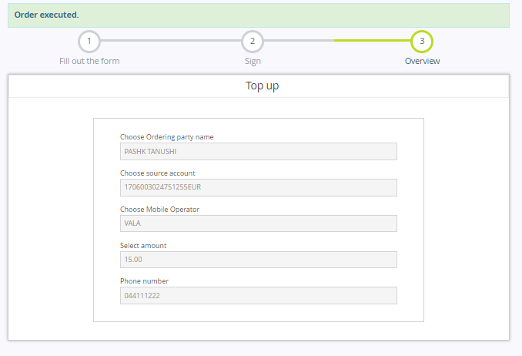
declare @p24 int
set @p24=0
declare @p25 nvarchar(2000)
set @p25=N'Success'
declare @p26 nvarchar(2000)
set @p26=N' '
declare @p27 int
set @p27=NULL
declare @p28 nvarchar(2000)
set @p28=NULL
declare @p29 nvarchar(2000)
set @p29=NULL
declare @p30 nvarchar(2000)
set @p30=NULL
declare @p31 nvarchar(2000)
set @p31=NULL
declare @p32 nvarchar(2000)
set @p32=NULL
declare @p33 nvarchar(2000)
set @p33=NULL
declare @p34 nvarchar(2000)
set @p34=NULL
exec ibank4_retail_pmtorderrq_internaltr @SourceAccount=N'1706003024751255',
@DestinationAccount=N'VALA',@SourceCurrency=N'978',@Currency=N'978',
@Amount=15.00,@Description=N'TopUpMobilePhone',@CurrencyDate=N'2021.06.17',
@BookingDate=N'2021.06.17',@PersonalID=N'1170559076',@TransCode=21,@FeeType=1,
@PurposeCode=1,@PurposeDesc=N'044111222',@FiscalNo=N'',@Uniref=N'',@ForPeriod=N'',
@TaxPayerName=N'',@ContactName=N'',@PackageID=N'',@SourceAccountType=N'DDA',
@destinationPersonalId=N'',@cardtype=default,@Salter=N'777',@ErrCode=@p24 output,
@ErrMessage=@p25 output,@TransactionID=@p26 output,@Fee=@p27 output,
@TrnType=@p28 output,@TransactionDescription=@p29 output,
@OtherPartyInfoName=@p30 output,@OtherPartyInfoCity=@p31 output,
@OtherPartyAccountAcctid=@p32 output,@Purpose=@p33 output,@StatusCode=@p34 output
select @p24, @p25, @p26, @p27, @p28, @p29, @p30, @p31, @p32, @p33, @p34

Currency Exchange
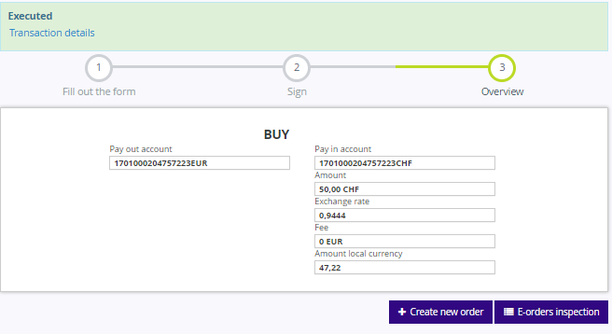
declare @p15 int
set @p15=0
declare @p16 nvarchar(2000)
set @p16=N'Success'
declare @p17 nvarchar(2000)
set @p17=N'77703581525000'
declare @p18 int
set @p18=0
declare @p19 nvarchar(2000)
set @p19=N'Transfer i'
declare @p20 nvarchar(2000)
set @p20=N'Konvertim ndërmjet llogarive'
declare @p21 nvarchar(2000)
set @p21=N'HASAN SHERIFI'
declare @p22 nvarchar(2000)
set @p22=N'GJILAN'
declare @p23 nvarchar(2000)
set @p23=N'1701000204757223 '
declare @p24 nvarchar(2000)
set @p24=N'Transferi në kuadër të bankës'
declare @p25 nvarchar(2000)
set @p25=NULL
exec ibank4_retail_pmtorderrq_internaltr_excange @SourceAccount=N'1701000204757223',
@DestinationAccount=N'1701000204757223',@SourceCurrency=N'978',@Currency=N'756',
@Amount=50.00,@Description=N'',@CurrencyDate=N'2021.06.17',@BookingDate=N'2021.06.17',
@PersonalID=N'1005038509',@TransCode=21,@FeeType=1,@PurposeCode=0,@PurposeDesc=N'',
@Salter=N'777',@ErrCode=@p15 output,@ErrMessage=@p16 output,@TransactionID=@p17 output,
@Fee=@p18 output,@TrnType=@p19 output,@TransactionDescription=@p20 output,
@OtherPartyInfoName=@p21 output,@OtherPartyInfoCity=@p22 output,
@OtherPartyAccountAcctid=@p23 output,@Purpose=@p24 output,@StatusCode=@p25 output
select @p15, @p16, @p17, @p18, @p19, @p20, @p21, @p22, @p23, @p24, @p25

