

Assignment # 2
Course Title: Parallel and Distributed Computing Lab(CS-426L)
SUBMITTED BY: SUBMITTED TO:
Name: Fissha Fatima Instructor Name: Mr. Qaiser Ali
Student ID: 247108
Semester: 5th
Section: BSCYS-F-24 B
Date of Submission: 25/10/2026

AIR UNIVERSITY, KHARIAN CAMPUS
DEPARTMENT OF CYBER SECURITY

Question 1: Polymorphic Trade Event Dispatching (Inheritance and Method Overriding)
Screenshots of Code:
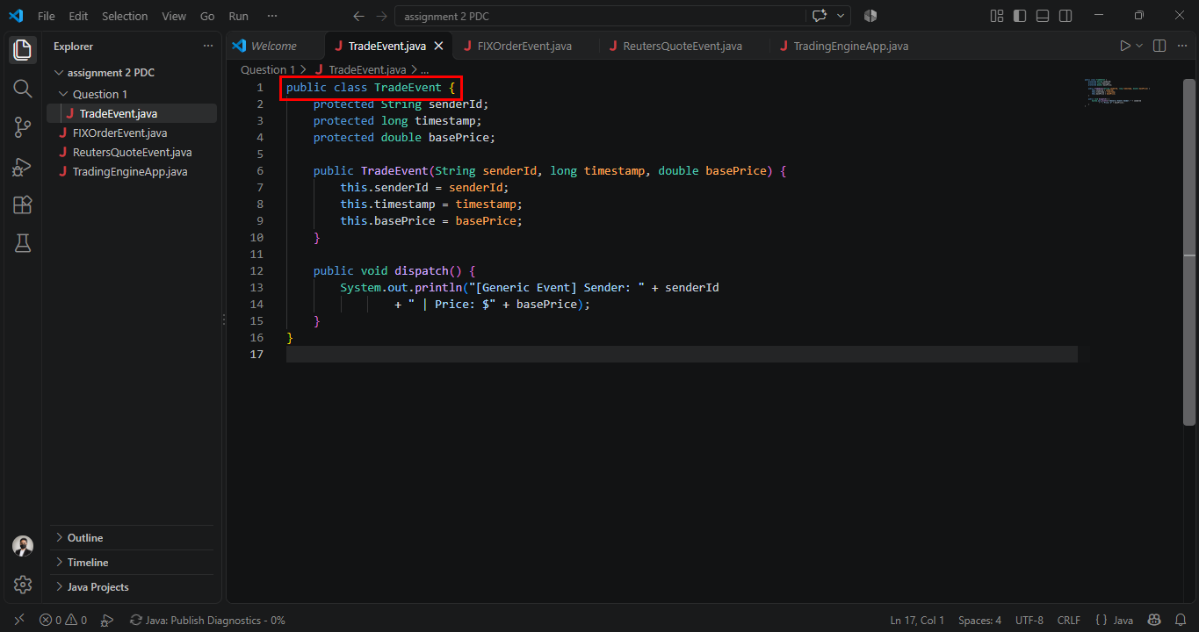
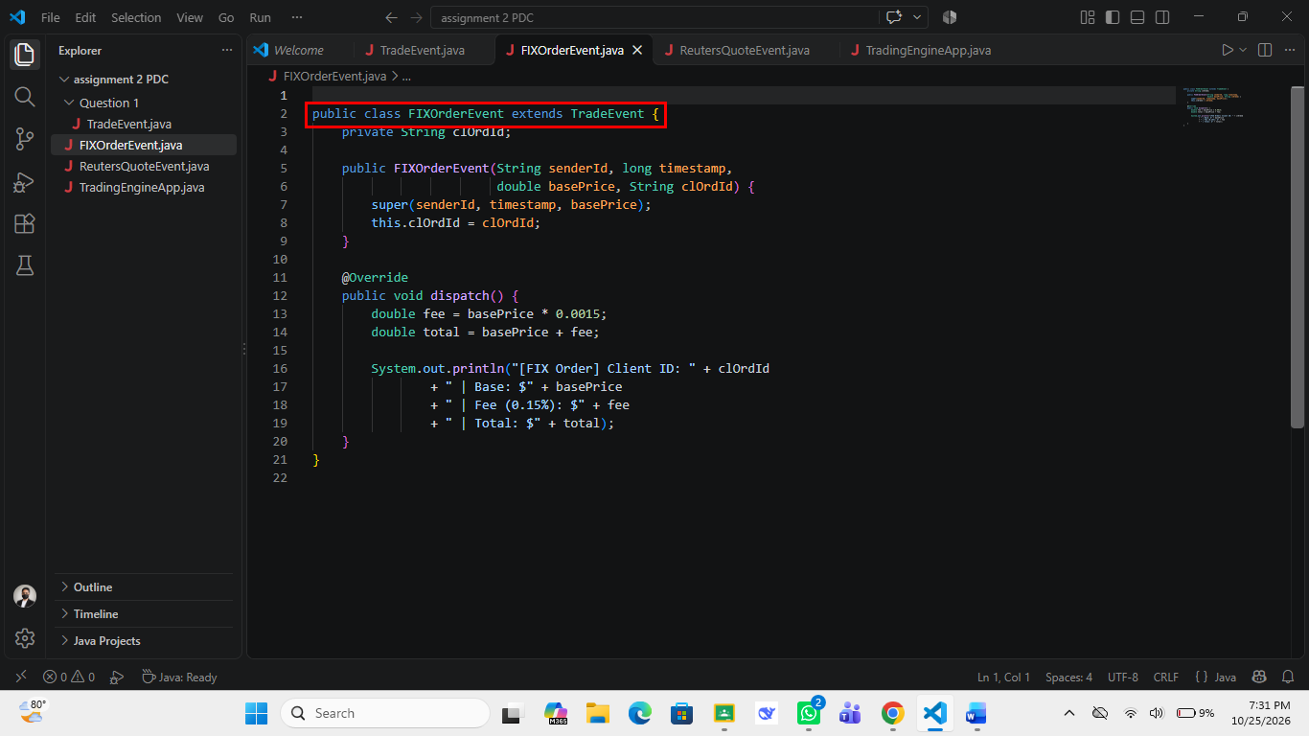
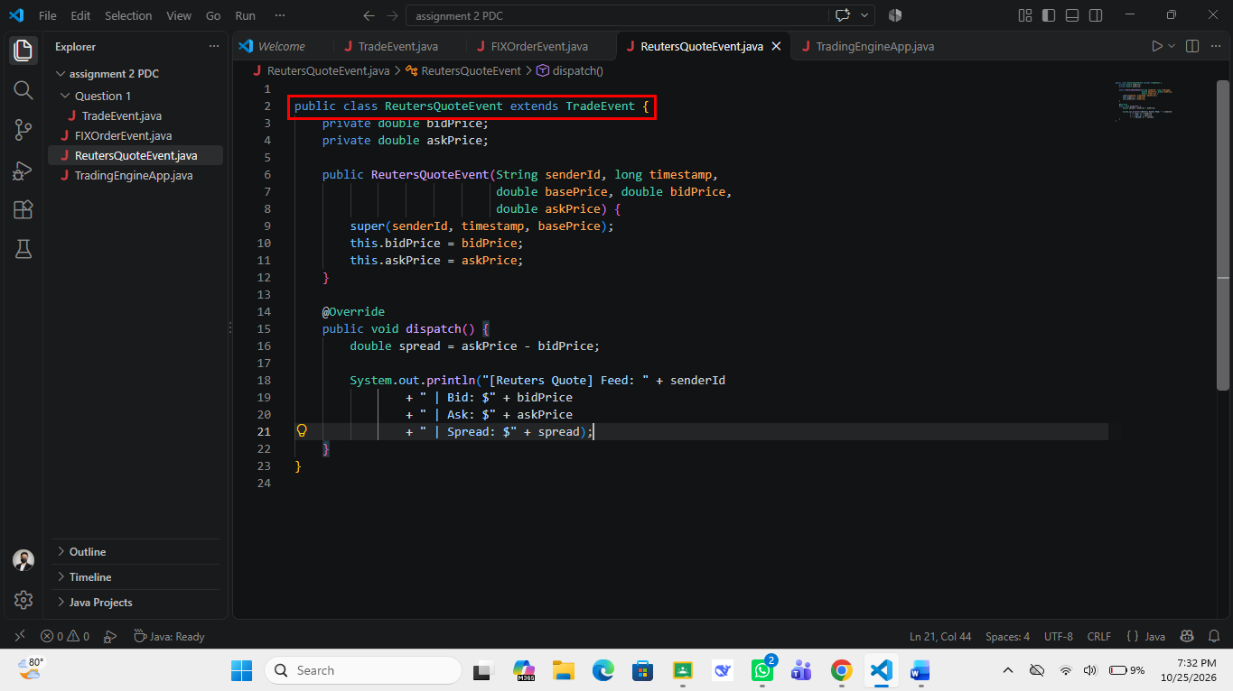
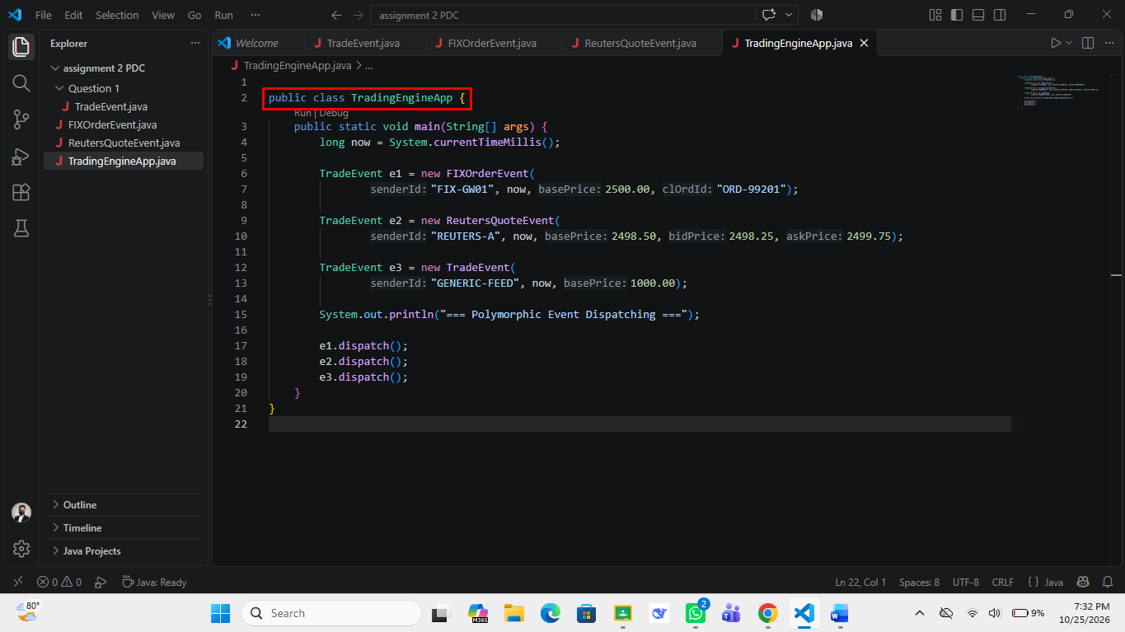
Output:
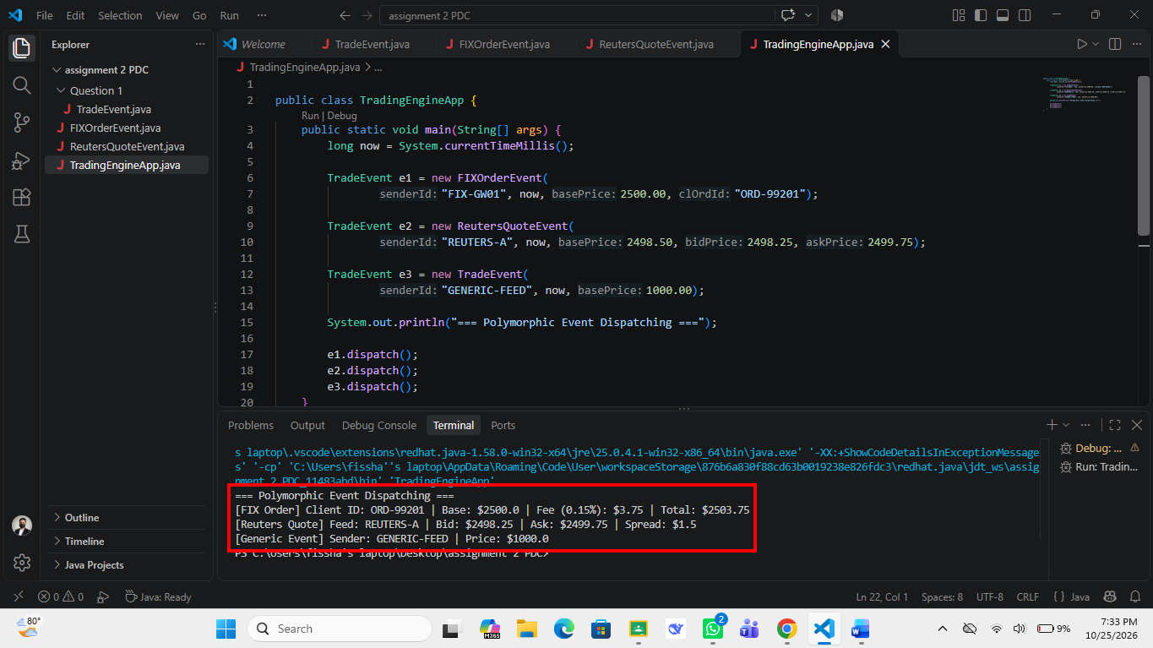
Approach:
To solve Question 1, I built a small class hierarchy for a trading engine, with each class written in its own .java file. I started with the parent class TradeEvent, which keeps senderId, timestamp and basePrice as protected instance variables, initializes them in its constructor, and defines a generic dispatch() method that prints the sender and the price. I then created FIXOrderEvent and ReutersQuoteEvent using the extends keyword; each constructor passes the shared fields upward with super(senderId, timestamp, basePrice) and then initializes its own fields (clOrdId for the FIX order, and bidPrice and askPrice for the Reuters quote). Both subclasses override dispatch() with @Override: FIXOrderEvent calculates a 0.15% fee (basePrice * 0.0015) and prints the base, fee and total, while ReutersQuoteEvent prints the spread calculated as askPrice - bidPrice. In TradingEngineApp I created one object of each type but stored all three in variables of the parent type TradeEvent, so the calls e1.dispatch(), e2.dispatch() and e3.dispatch() are resolved at runtime to the version belonging to the real object, which is runtime polymorphism. The terminal output verifies this: the FIX order shows a base of $2500.0, a fee of $3.75 and a total of $2503.75, the Reuters quote shows a spread of $1.5 (2499.75 - 2498.25), and the plain TradeEvent prints the generic message with a price of $1000.0.
Question 2: Microservice Packet Symmetry Auditor (Array-Based Stack and Queue)
Screenshots of Code:
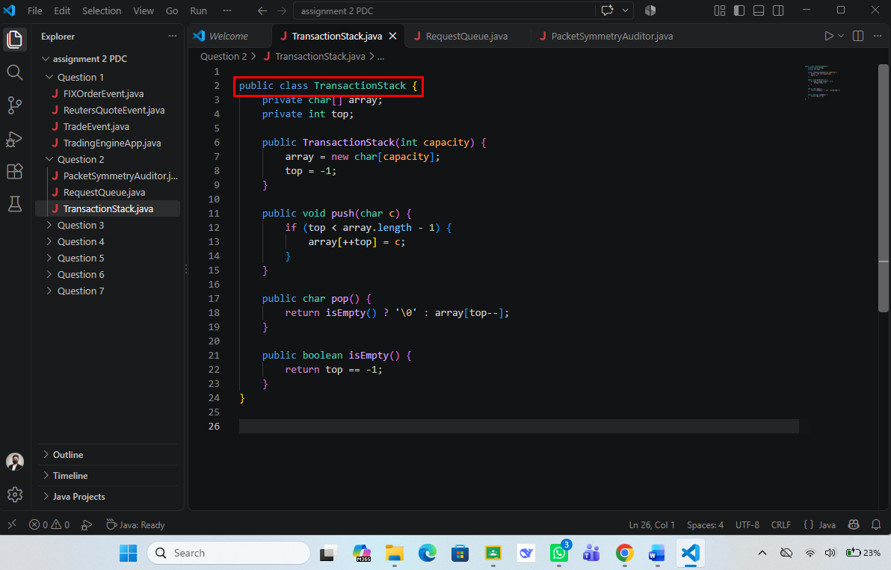
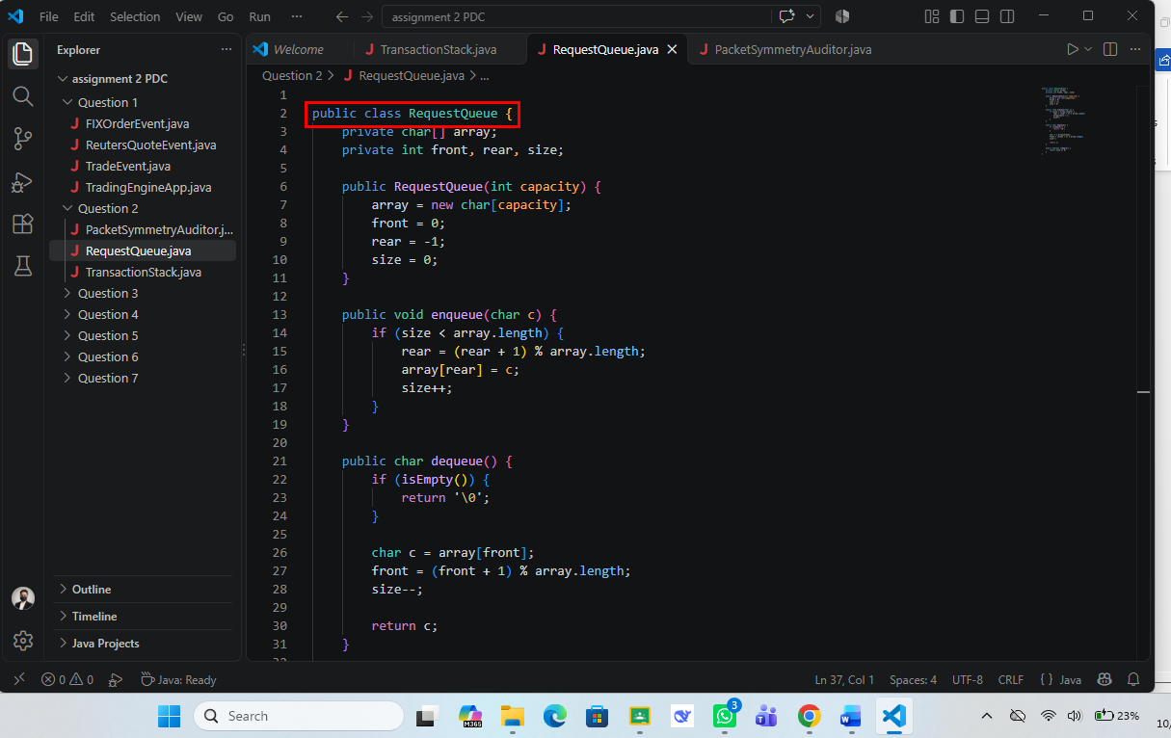
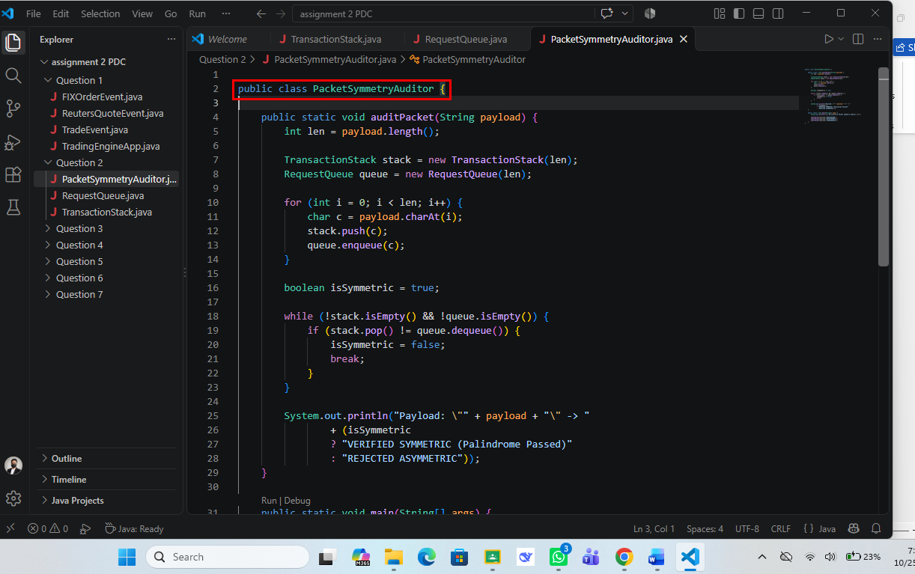
Output:
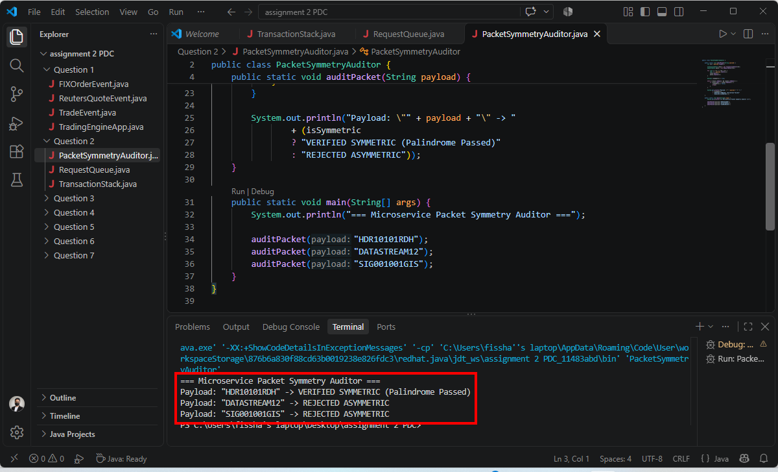
Approach:
For Question 2, I implemented my own array-based data structures instead of using the built-in collections, and used them to check whether a packet payload is a palindrome. TransactionStack stores characters in a char[] array with an integer top that starts at -1; push() increments top only while there is space, pop() returns the top character (or '\0' when empty) and isEmpty() checks top == -1. RequestQueue uses a circular char[] array with front, rear and size variables, where enqueue() moves rear forward with (rear + 1) % array.length and dequeue() moves front the same way, so no space is wasted. In PacketSymmetryAuditor.auditPacket(), I create a stack and a queue whose capacity equals the payload length, loop over every character with charAt(i) and push it into the stack and enqueue it into the queue at the same time. Because the stack returns the characters in reverse order and the queue returns them in the original order, a while loop that runs while neither structure is empty compares stack.pop() with queue.dequeue(), and a single mismatch sets isSymmetric to false and breaks out. The output confirms the logic: HDR10101RDH is printed as VERIFIED SYMMETRIC because it reads the same backwards, while DATASTREAM12 and SIG001001GIS are printed as REJECTED ASYMMETRIC because their reverse strings are different.
Question 3: Asynchronous Web Engine (Thread and Runnable)
Screenshots of Code:
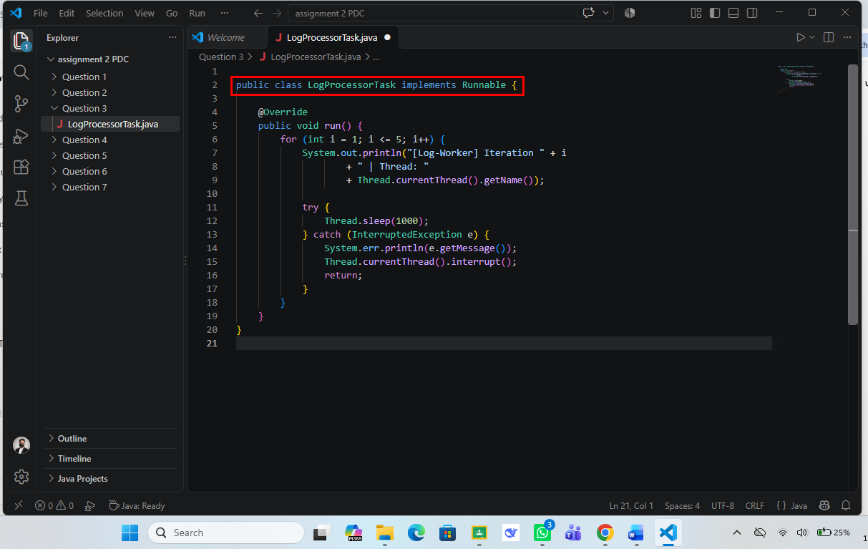
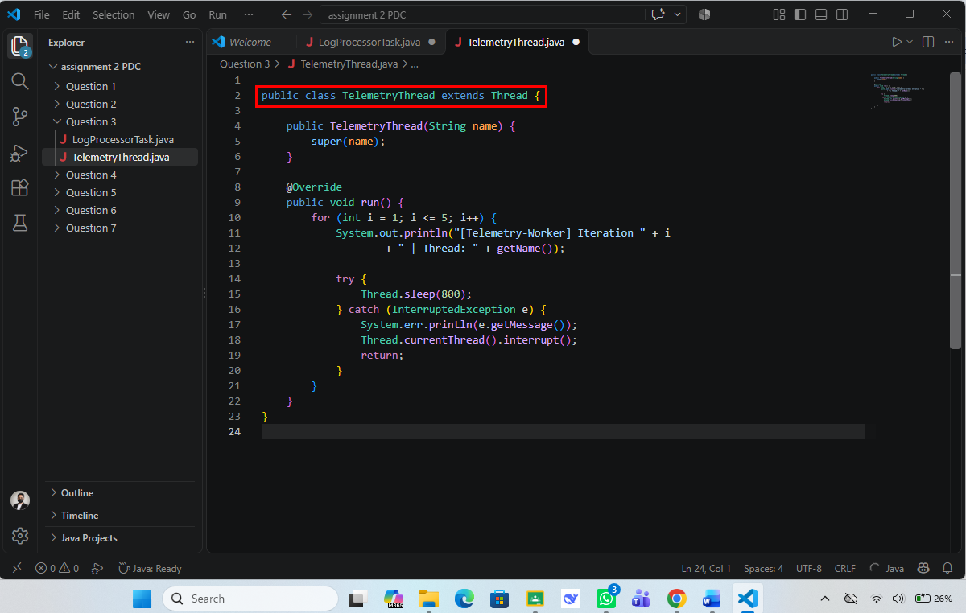
Output:
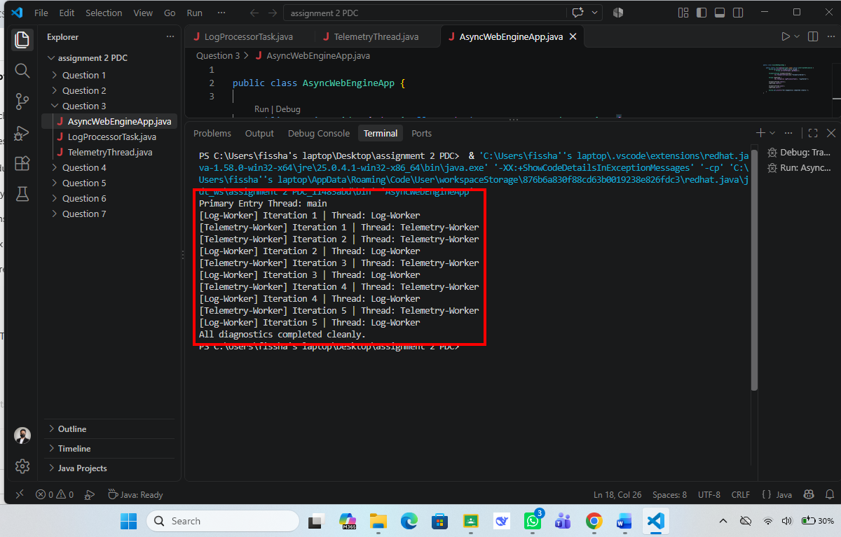
Approach:
In Question 3, I used two different ways of creating threads so that two background tasks could run at the same time as the main thread. TelemetryThread is a class that extends Thread, passes its name to the parent constructor with super(name), and overrides run() to print five iterations with getName() and to sleep for 800 milliseconds between them. LogProcessorTask implements the Runnable interface and its run() method does the same for five iterations but sleeps for 1000 milliseconds, using Thread.currentThread().getName() to print the thread name; it is wrapped inside a new Thread object named Log-Worker. In AsyncWebEngineApp.main(), I first print the name of the primary thread (main), then create both threads, call start() on each so they run concurrently, and finally call join() on both so that the main thread waits until they finish before printing the closing message. Each Thread.sleep() call is surrounded by a try-catch block that handles InterruptedException by printing the message, restoring the interrupt flag and returning. The terminal output shows the Telemetry-Worker and Log-Worker lines interleaved because they sleep for different intervals, each thread prints iterations 1 to 5 with its own name, and the line All diagnostics completed cleanly. appears only after both threads are finished, which proves that join() worked.
Question 4: Parallel Portfolio Risk Analysis (Fork/Join Framework)
Screenshots of Code:
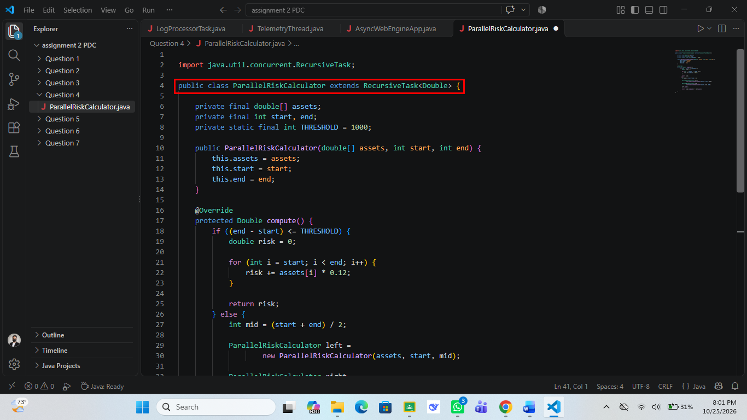
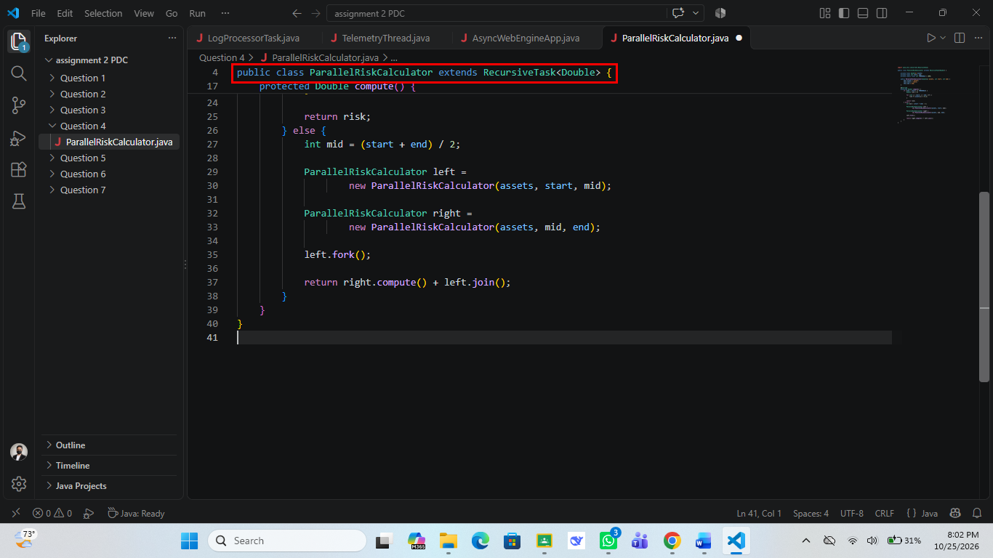
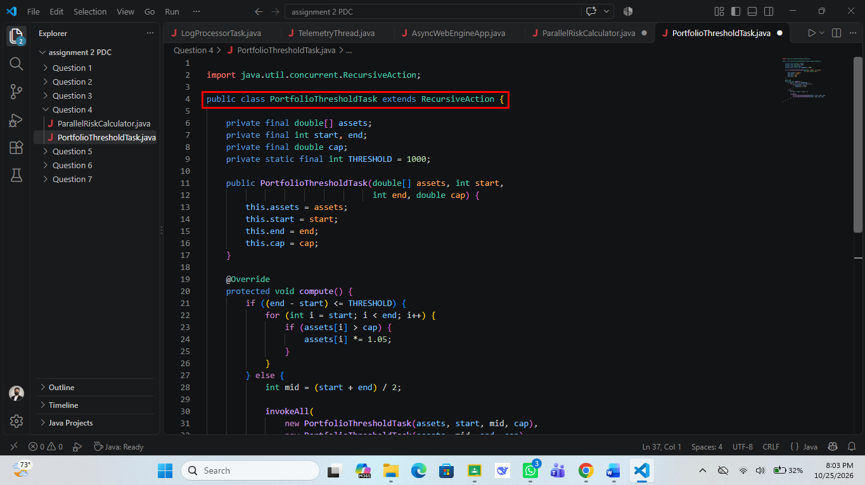
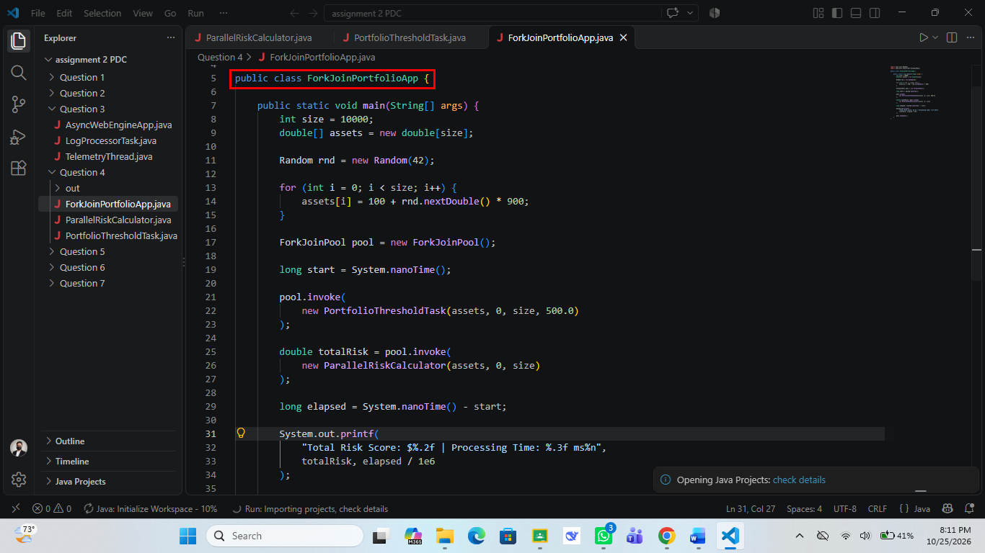
Output:
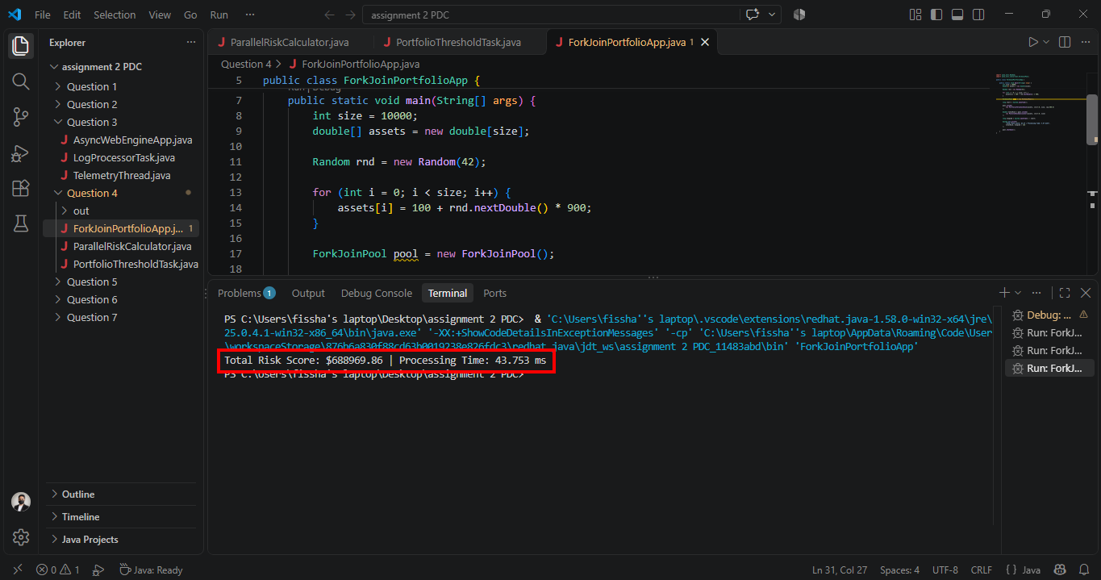
Approach:
For Question 4, I used the Fork/Join framework to process a portfolio of 10,000 asset values in parallel. In ForkJoinPortfolioApp, I fill a double[] array with values between 100 and 1000 using new Random(42) (a fixed seed so the result can be repeated), create a ForkJoinPool, and measure the running time with System.nanoTime(). PortfolioThresholdTask extends RecursiveAction, so it returns nothing; its compute() method checks whether the range is at most the THRESHOLD of 1000 elements, and if so it loops through the range and multiplies every asset above the cap of 500.0 by 1.05, otherwise it finds the midpoint and calls invokeAll() on two smaller tasks. ParallelRiskCalculator extends RecursiveTask<Double>, so it returns a value; for ranges within the threshold it adds assets[i] * 0.12 to a running risk total, and for larger ranges it splits at the midpoint, calls left.fork() to run the left half in another worker, computes the right half directly with right.compute(), and returns right.compute() + left.join(). The application invokes the threshold task first and then the risk calculator through pool.invoke(), so the risk is calculated on the already adjusted values, and finally it shuts the pool down. The terminal output prints Total Risk Score: $688969.86 and a processing time of 43.753 ms, showing that the divide-and-conquer approach produced one combined result.
Question 5: Sensor Grid Monitor (Abstract Class and Multithreaded Min/Max Search)
Screenshots of Code:
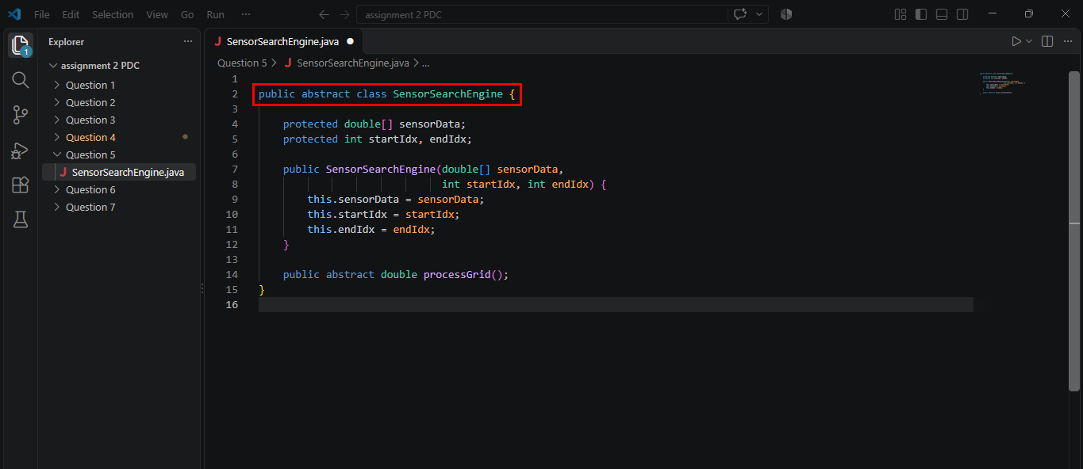
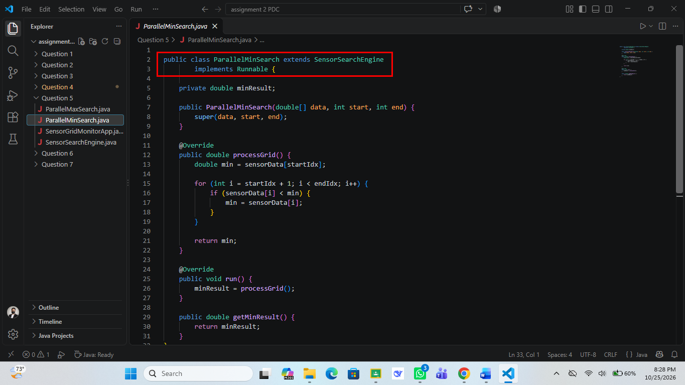
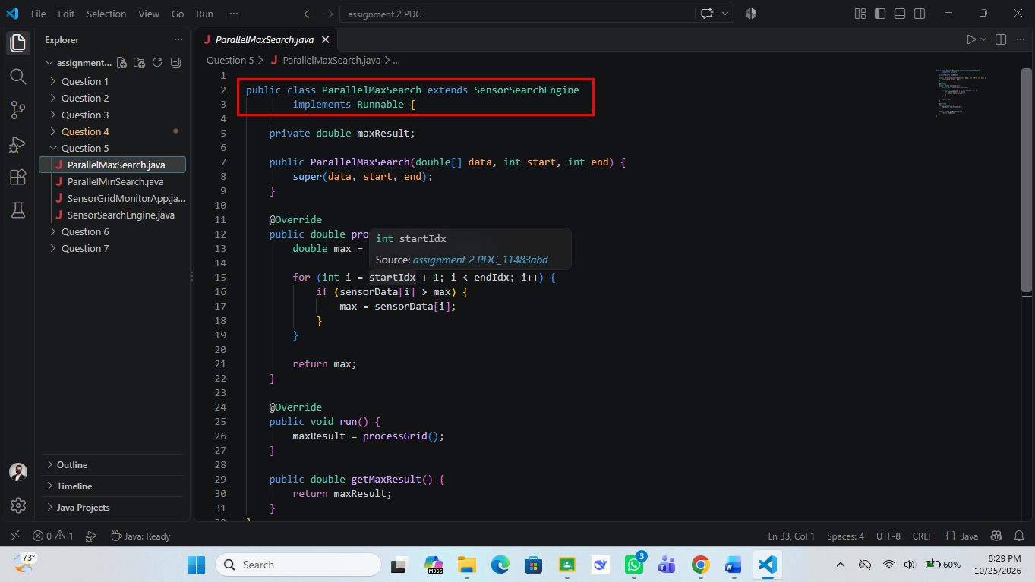
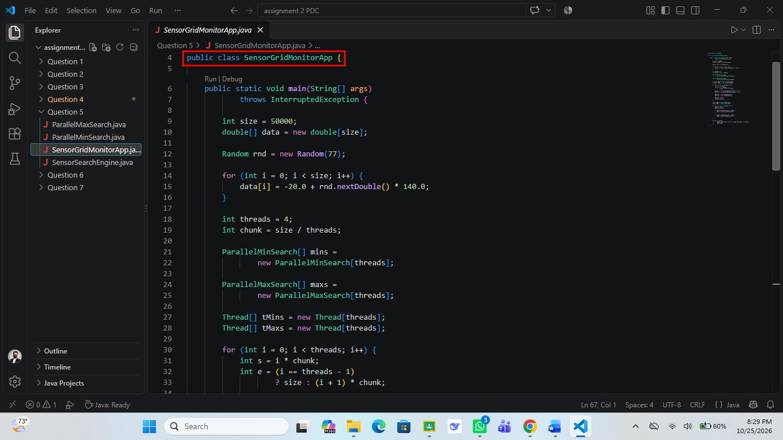
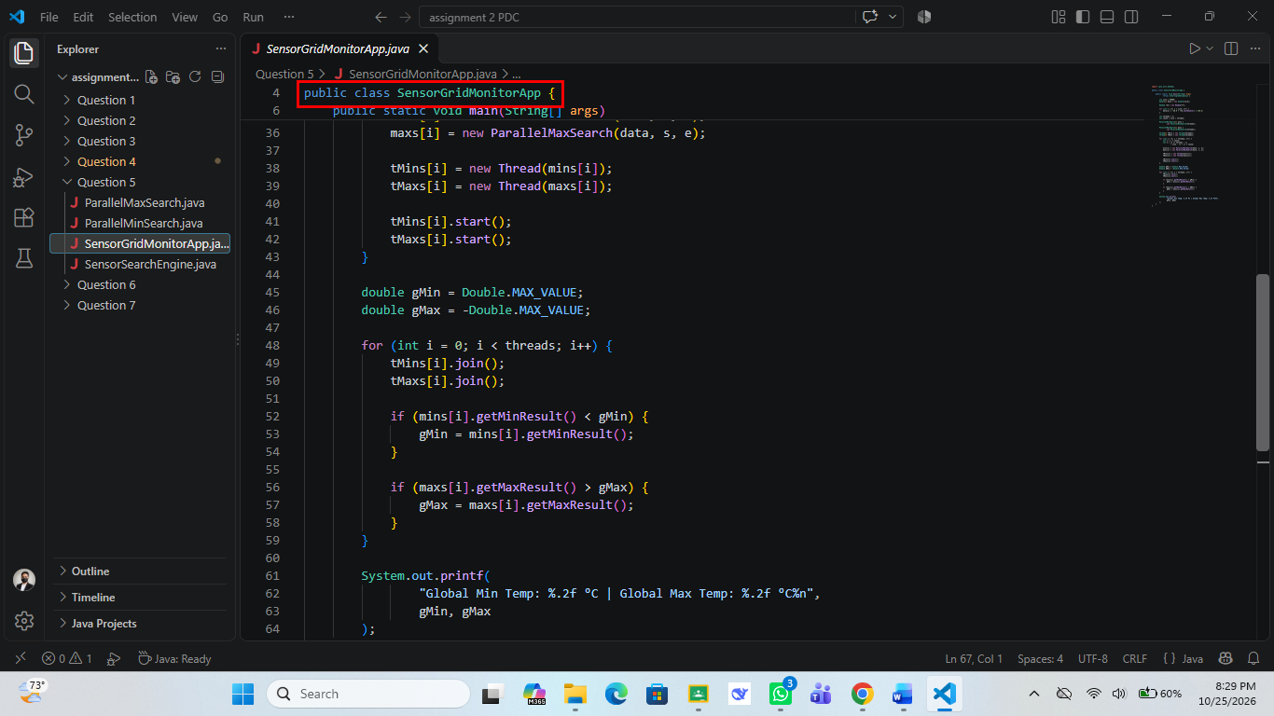
Output:
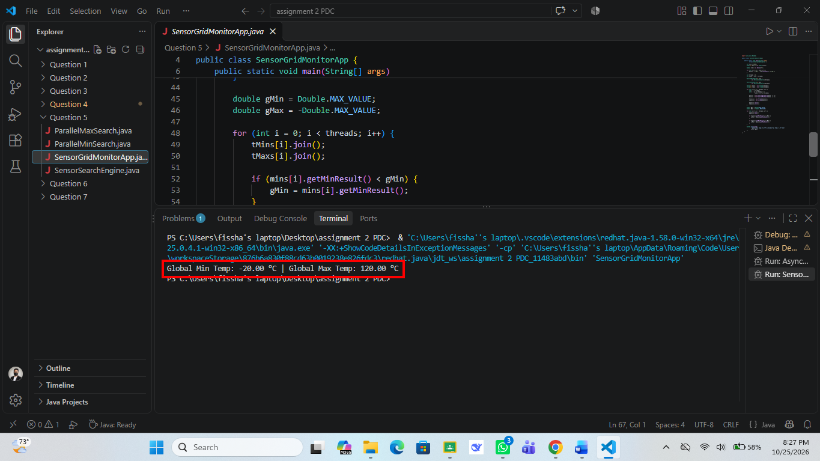
Approach:
In Question 5, I combined inheritance with manual threading to find the minimum and maximum temperature in a large sensor grid. SensorSearchEngine is an abstract class that holds the shared protected fields sensorData, startIdx and endIdx, initializes them in its constructor, and declares the abstract method processGrid(). ParallelMinSearch and ParallelMaxSearch both extend it and also implement Runnable: each overrides processGrid() to scan its own part of the array from startIdx to endIdx, and each run() method stores that answer in a result field that is read later through getMinResult() or getMaxResult(). In SensorGridMonitorApp, I generate 50,000 readings between -20 and 120 using new Random(77), divide the array into 4 chunks of size / threads elements (the last chunk takes any remainder), create one min object and one max object per chunk, wrap each in a Thread and start all eight threads. A loop then calls join() on every thread and compares each partial result with the global minimum and global maximum, which started at Double.MAX_VALUE and -Double.MAX_VALUE. The terminal output, Global Min Temp: -20.00 °C | Global Max Temp: 120.00 °C, verifies that the partial results from all threads were merged correctly and matches the range used to generate the data.
Question 6: E-Commerce Inventory Benchmark (Synchronized Map vs ConcurrentHashMap)
Screenshots of Code:
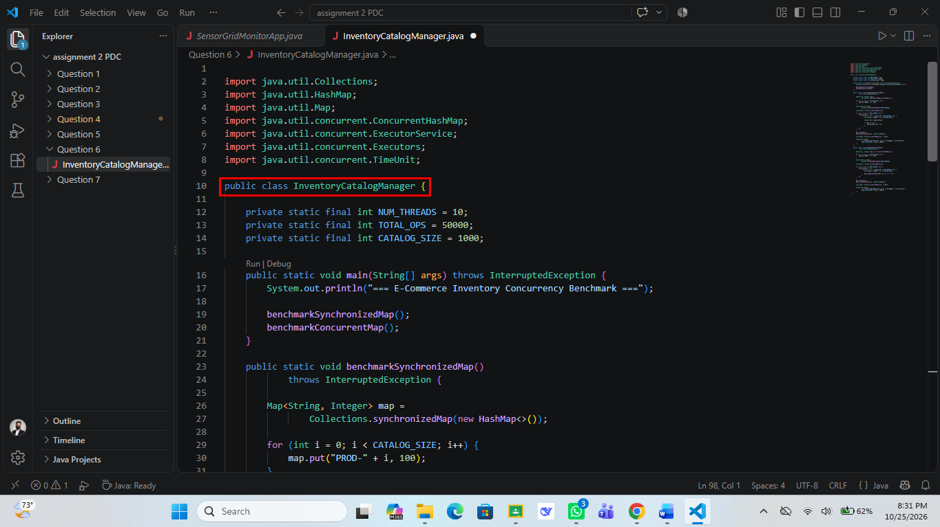
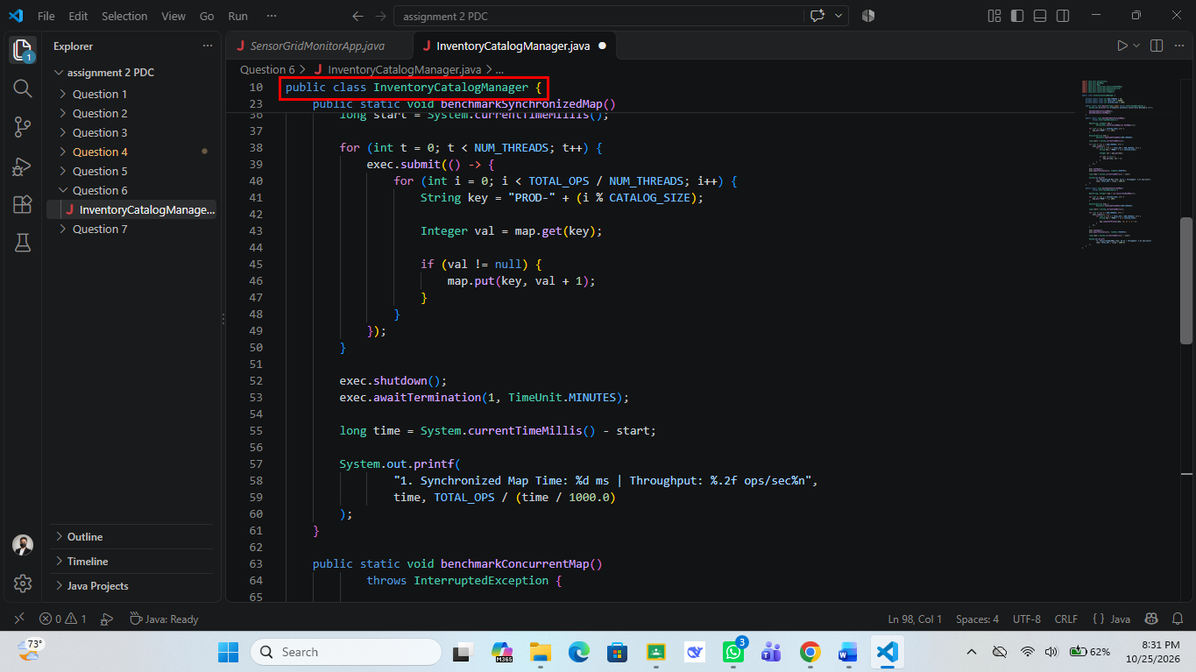
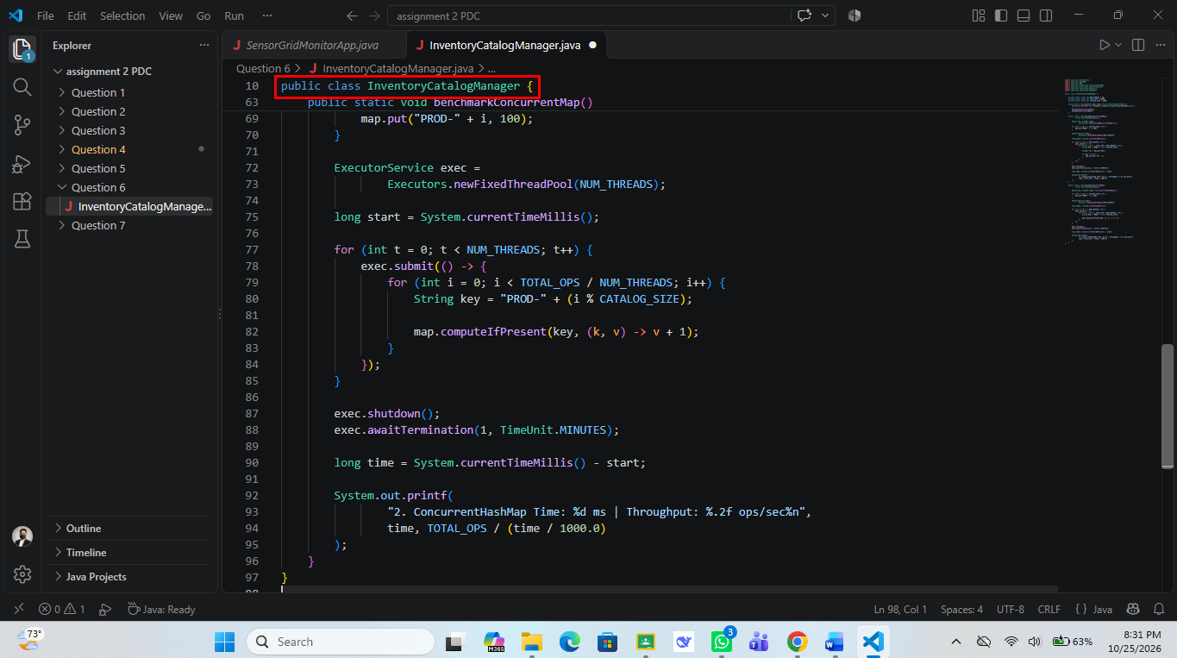
Output:
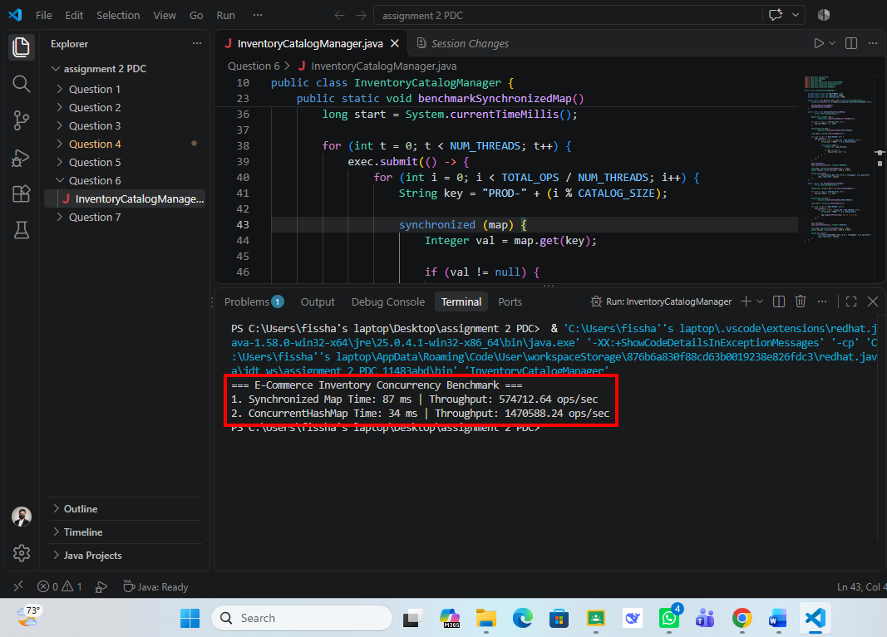
Approach:
For Question 6, I compared a synchronized HashMap with a ConcurrentHashMap under heavy multi-threaded updates for an e-commerce inventory. InventoryCatalogManager defines the constants NUM_THREADS = 10, TOTAL_OPS = 50000 and CATALOG_SIZE = 1000, and each benchmark method first fills a map with 1,000 products (PROD-0 to PROD-999) having stock 100. I then create an ExecutorService with Executors.newFixedThreadPool(10) and submit 10 lambda tasks, each doing 5,000 updates (TOTAL_OPS / NUM_THREADS) on keys chosen with i % CATALOG_SIZE. In benchmarkSynchronizedMap(), the map is created with Collections.synchronizedMap(new HashMap<>()) and the read-then-write sequence map.get() and map.put() is placed inside a synchronized (map) block so the whole update is atomic. In benchmarkConcurrentMap(), the map is a ConcurrentHashMap and each update is done with the atomic computeIfPresent(key, (k, v) -> v + 1), so no explicit lock is needed. After submitting the tasks, I call exec.shutdown() and exec.awaitTermination(1, TimeUnit.MINUTES), measure the time with System.currentTimeMillis() and calculate throughput as TOTAL_OPS divided by the seconds taken (with Math.max to avoid dividing by zero). The output shows the synchronized map taking 87 ms with 574712.64 ops/sec, while the ConcurrentHashMap took 34 ms with 1470588.24 ops/sec, so the concurrent map was about 2.5 times faster because threads do not all wait on one single lock.
Question 7: CPU Cache Locality Benchmark (Row-Major vs Column-Major Traversal)
Screenshots of Code:
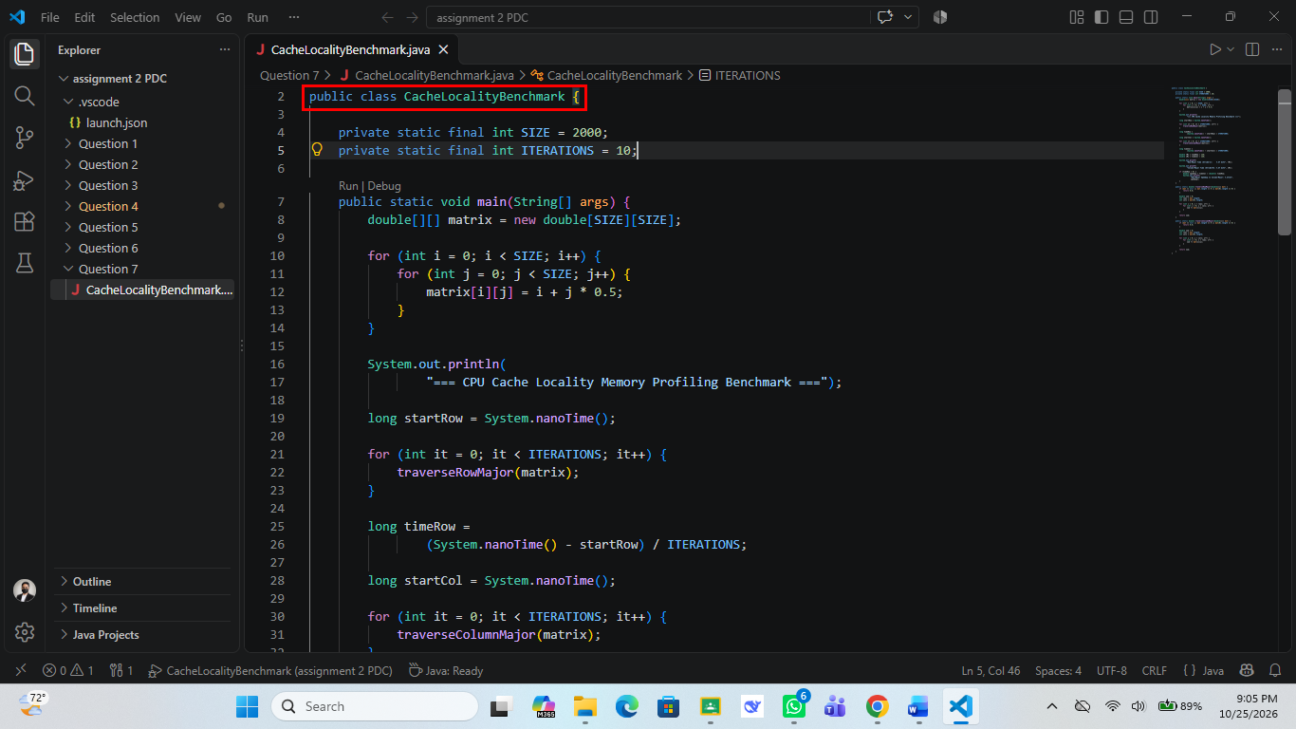
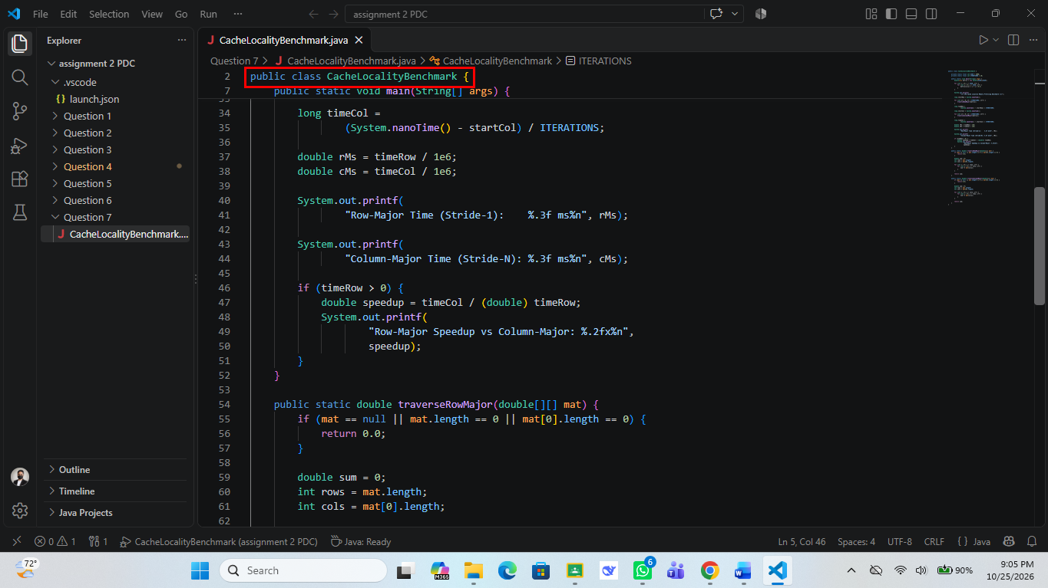
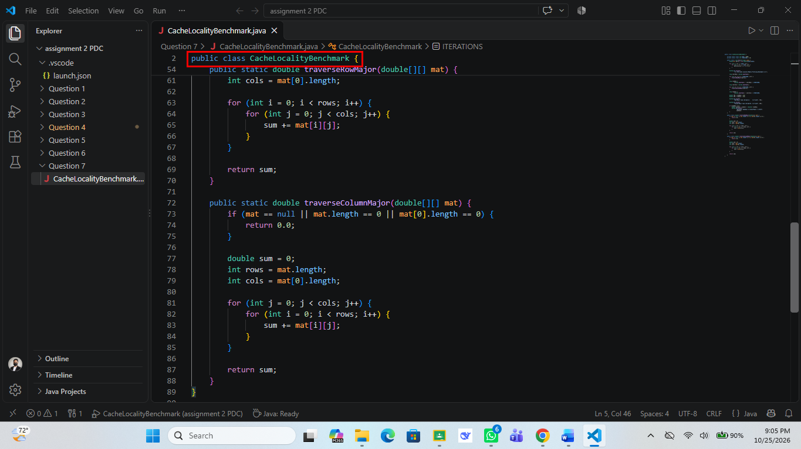
Output:
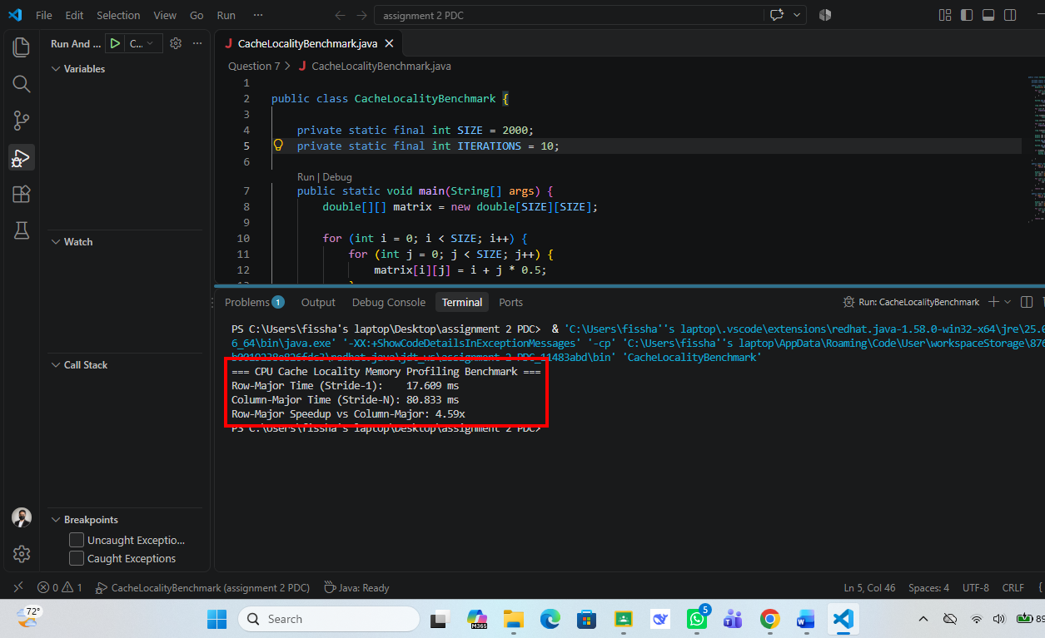
Approach:
In Question 7, I measured how the order of memory access affects CPU cache performance by traversing the same 2000 x 2000 double matrix in two different ways. In main(), the matrix is filled with matrix[i][j] = i + j * 0.5, and the constants SIZE = 2000 and ITERATIONS = 10 control the size and the number of repeated runs. traverseRowMajor() uses the row index i in the outer loop and the column index j in the inner loop, so it reads neighbouring elements one after another (stride-1) from the same row array, whereas traverseColumnMajor() swaps the loops so every step of the inner loop jumps to a different row (stride-N). Both methods first return 0.0 if the matrix is null or empty, and both return the sum so that the JVM cannot remove the loops as unused code. Each traversal is repeated 10 times inside a System.nanoTime() timer and the total is divided by ITERATIONS to get an average, then converted to milliseconds, and the speedup is calculated as timeCol / timeRow. The terminal output shows Row-Major at 17.609 ms and Column-Major at 80.833 ms, a speedup of 4.59x for row-major access, because row-major reading uses every value in each cache line that is loaded from memory while column-major reading causes many more cache misses.

