1. Which one is not a characteristic of well-designed naming convention in key-value  
database?  
a. Use meaningful and unambiguous naming components, such as 'cust' for customer or 'inv'  
for inventory.  
b. Use range-based components when you would like to retrieve ranges of values. Ranges  
include dates or integer counters.  
c. Use a common delimiter when appending components to make a key. The ‘:’ is a  
commonly used delimiter, but any character that will not otherwise appear in the key will  
work.  
d**. Keep keys as long as possible.**  
2. Which design pattern provides some of features of relational database transactions in  
RDBMS  
a. Time to live (TTL)  
b. Aggregates.  
**c. Atomic aggregates.**  
d. Enumerable keys  
3. What are enumerable keys  
a. is a pattern that supports different attributes for different subtypes of an entity  
b. are keys that use counters or sequences to generate new keys

4. Which is NOT a characteristic of key-value database  
a. Simplicity  
b. Speed  
c. Scalability  
**d. Searchable value**  
e. All of the above characteristics are correct  
5. Which of the following rules are NOT belongs to JSON Object in Document database  
a. Documents consist of key-value pairs separated by commas  
b. Values can be numbers, strings, Booleans (true or false), arrays, objects, or the NULL value  
c. The values of objects are listed as key-value pairs within curly brackets, that is, { and }  
**d. Keys can be any types (number, string, float, etc.)**  
6. NoSQL databases is used mainly for handling large volumes of _____ data.  
**a. unstructured**  
b. structured  
c. semi-structured  
d. all of the mentioned  
7. Which of the following is correct statement of Google BigTable ?  
a. Developers have dynamic control over columns  
b. Data values are indexed by row identifier, column name, and a timestamp  
c. Reads and writes of a row are atomic  
d. Rows are maintained in a sorted order  
**e. All of features above are correct**f. None is correct.  
8. In Column-family database, Primary key in a keyspace is a ____.  
a. Column family  
b. Row  
c. are sets of key-value pairs that allow for looking up keys or values by other attribute  
values of the same entity

**c. Column**  
d. Data  
9. In Column-family database, Keyspace is similar to _____ in RDBMS  
a. Table  
b. Fields  
c. Primary key  
**d. Schema**  
10. Vertex represents relationships between nodes in graph database? True | **False**  
11. A bipartite graph is is a graph with two distinct sets of vertices where each vertex in  
one set is only connected to vertices in the other set. (**True** | False)  
12. Which of the following is not a Neo4J CQL command?  
a. CREATE  
b. MATCH  
c. DELETE  
**d. EXIT**  
13. Joins in graph database are represented as  
a. constraint  
b. Nodes  
c. Relationships  
**d. Traversal**  
14. The Elasticsearch default communication port is  
**a. 9200/tcp**  
b. 3000/ip  
c. 9200/udp  
d. 3000/tcp  
15. In URI Search in ES, which of the following parameter denotes the number of hits  
to return in each request

A. from  
B. terminate_after  
**C. size**  
D. timeout  
16. A __________ breakdown fields values of a document into a stream, and inverted  
indexes are created and updates using these values, and these stream of values are stored  
in the document.  
A. analyzer  
B. shard  
C. filter  
**D. tokenizer**

**Part B. SHORT ANSWER**

1.

a. Unions

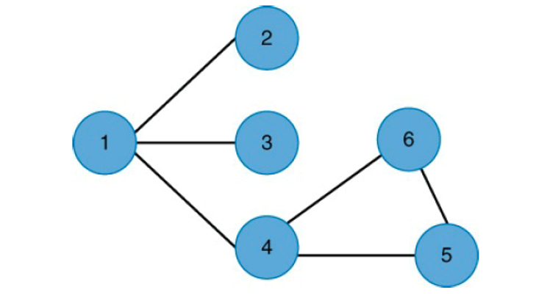

b.Intersection

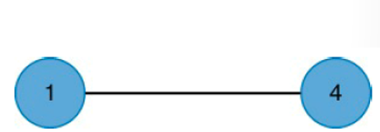

2.

-Search “Like” : to search exact word or a part of word

-Elastic Search accrording the exact order or the reverse order. You may choose which one must be or must not be in the search result. You may choose the prefered word in the search result

3.

POST : id will be generated automatically

PUST : You can specify wanted id

**Part C. PROBLEM SOLVING**

**1.**

Denormalization:

db.publisher.insertOne({"p_id": "p1","name": "Kim Dong", "founder": 2001, "address": "Ha Noi", books: [ {"b_id": "b1","tittle": "book1", "total_page": 100, "language": "VN", author:{"first_author": "Camnh",

"second_author": "congnv" }}, {"b_id":"b2","tittle":"book2", "total_page":200, "language":"EN", author: {"first_author": "camnh", "second_author": "congnv"}}]})

Normalization:

db.book.insertOne({“b_id”: “1”, “tittle”: “book1”, “total_page: 100”, “language”: “VN”, author:{“first_author”: “camnh”, “second_author”: “congnv”} })

db.book.insertOne({“b_id”: “2”, “tittle”: “book2”, “total_page: 200”, “language”: “VN”, author:{“first_author”: “camnh”, “second_author”: “congnv”} })

db.publisher.insertOne({"p_id":"p1","name": "Kim Dong", "founder": 2001, "address": "Ha Noi", books: [1, 2]})

**2.**

a.db.employee_info.insertOne({“empno”:1, “fname”: “charlie”, “lname”: “rodgers”, “role”: “manager”, departments: [“sales”, “marketing”] })

db.employee_info.insertOne({“empno”:7, “fname”: “mahesh”, “lname”: “iyer”, “role”: “manager”})

b.

db.employee_info.aggregate(

{

$group: {

_id: {

role:"$role"

},

count: {

$sum : 1

}

}

}