|  | **Faculty of Information Technology**  **HUMAN COMPUTER INTERACTION**  **Spring 2022** |
| --- | --- |

**Part I. Answer the question**

1. What is interaction design?

It is responsible for the creation of interactive digital products and services. The terms "interaction design" and "user experience design" are sometimes used interchangeably. This is understandable given the significant overlap between interaction and UX design.

The main distinction between UX and interaction design is how we approach user interactions. Interaction designers are concerned with the point at which a user interacts with a product, and their purpose is to improve that interaction. The moment of engagement is merely one component of a user's journey while interacting with a product, according to UX designers. All parts of a product or system that are visible to users are considered in user experience design. **The goal of interaction design is to create products that allow users to achieve their goal(s) in the best possible way.**

Example: Tiktok: when users use a phone, they want to use 1 hand to surf. Users can double-tap to drop the heart emoji to that video or scroll up to change to another video. etc

2. What are usability and user experience goals?

Usability is a measure of how well a certain user in a specific setting can utilize a product/design to accomplish a stated objective in an effective, efficient, and satisfactory manner. Through guarantee optimal usability, designers typically test a design's usability throughout the development process—from wireframes to the final delivery.

A user experience objective is a decision made by your product team about how you want your consumers to interact with your product or service. These options are used to gauge and drive the design of your product. Goals tell us when we've completed a task and can move on to the next one. They help us focus our energy on the major things instead of stressing over the minor issues. Goals tell us what to measure, and what can be ignored.

For example Chat function: Message-sending or File-sharing function of Facebook and Zalo. Both have video and audio meetings for free

| Zalo | FB (messenger) |
| --- | --- |
| Video: 100Mb | Video: 50Mb |
| Image and video Not compressed | Image and video Compressed |
| File: < 1GB (everything is allowed) | Cannot send file jar and zip |
| More function (pin, format text, alarm, assign tasks, appointment, priority messages) | Secret massage |
| Have ‘my cloud’ | Doesn’t have |
| More appropriate for work, sending file | More appropriate for entertainment, chatting (more friends use) – in relation with Facebook |

3. What is user-centered approach?

This method necessitates a design that is informed by a clear knowledge of people, tasks, and surroundings, is guided and modified by user-centered assessment, and considers the entire user experience. The iterative method incorporates users throughout the design and development process. Finally, the team possesses a diverse set of abilities and viewpoints.

User-centered design (UCD) is an iterative design method in which designers pay close attention to users and their demands at every stage of the process. UCD design teams employ a combination of research and design methodologies to incorporate customers throughout the design process, resulting in highly useable and accessible products for them.

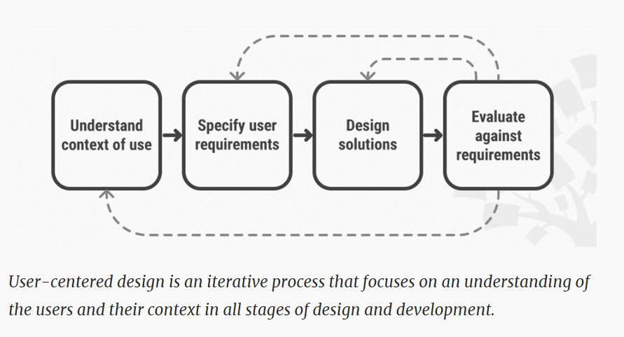

**4. Four basic activities of interaction design?**

Establishing requirements – a requirement is a need that a particular interactive product must be able to satisfy. Establishing what is required of the product is essential to ensure that the interaction is the best possible fit for the user, both in terms of what the user needs to do with the product and how they experience the interaction. Requirements will depend on the characteristics of the user, the activities the user will perform using the product, and the environment in which the user interacts with the product. In the example of a phone or remote control, requirements are shaped by the need to use the device (e.g. mobile phone) to do certain activities (to make phone calls), given the size and mobility of the user’s hands (bigger than standard or fingerless) and the user’s physical environment (ski slope).

Designing alternatives – coming up with alternative designs enables designers to explore different ways of interpreting and satisfying the requirements for a particular interactive product. This is an essential and highly creative part of the process. In the phone and remote control example, this activity began when you started jotting down alternatives for the controls. Design ideas should be informed by fundamental design principles that derive from what we know about how our minds and bodies work.

Prototyping designs – once interaction designers have identified a number of possible ideas, they need to figure out which ones have the potential to work best for the users, their activities and their environment. To do this, designers need to prototype the most promising design ideas to make a first, often rough, model so that they can try them out. In the example of the phone or remote control, as you thought of different designs, you were also prototyping them by drawing the alternative interfaces you thought of. Prototyping can also be used to explore different aspects of a design.

Evaluating prototypes – evaluation enables designers to assess the limitations of a particular design, to find out to what extent a prototype meets requirements that have already been identified, to identify requirements that have not already emerged, and to establish what changes need to be made so that requirements are met.

**These are permeated with three principles:**

1. Involve users early in the design process and evaluation of the artifact

2. Define quantifiable & measurable usability criteria

3. Iteration is inevitable

Key characteristics of the interaction design process are explicit incorporation of user involvement, iteration, and specific usability criteria.

Before you can begin to establish requirements, you must understand who the users are and what their goals are in using the device.

Looking at others' designs provides useful inspiration and encourages designers to consider alternative design solutions, which is key to effective design.

Usability criteria, technical feasibility, and users' feedback on prototypes can all be used to choose among alternatives.

Prototyping is a useful technique for facilitating user feedback on designs at all stages.

Lifecycle models show how development activities relate to one another.

The interaction design process is complementary to lifecycle models from other fields.