|  |  |
| --- | --- |
|  | Faculty of Information Technology  **SYSTEM ANALYSIS AND DESIGN**  **Fall 2021** |

**Chapter 6. Designing database**

***Exercise 1***: Give examples about some of entity and attributes in real-life

***Answer:***

* Book: **ISBN**, title, publisher, version, genre
* Product: **ID**, name, category, color, model

***Exercise 2***: Given following context. Define entities and attributes only

A university has a large number of courses in its catalog. Attributes of COURSE include Course_Number (identifier), Course_Name, and Units. Each course may have one or more different courses as prerequisites, or may have no prerequisites. Similarly, a particular course may be a prerequisite for any number of courses, or may not be prerequisite for any other course.

***Answer:***

* Course: course_number, course_name, units, prerequisite

***Exercise 3***: Define the following relationships (one-to-one, one-to-many and many-to-many relationship) between entities and transform into 3NF relationship entities

* A user login has only one user information. User login includes id, username, email and password. User information includes first name, last name, address, dob, phone number
* A student can enroll in several course and a course have many students enrolled. Information of course includes id, course name, course description. Information of student includes id, student name, student dob, phone number. Each student enrolment between student and course contain: enrolment date – which is the date student enrolls in specific course and mark given for that student.
* A phone brand has several phones. A phone brand has the following property: id, name - such as Apple, Samsung, Huawei, date established. A phone is also has the following properties: id, phone name (Apple Iphone 13, Samsung Galaxy S20), description and date announced.

***Answer:***

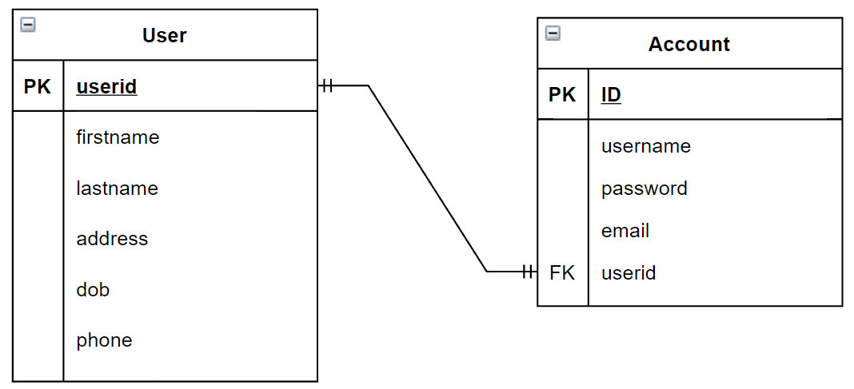

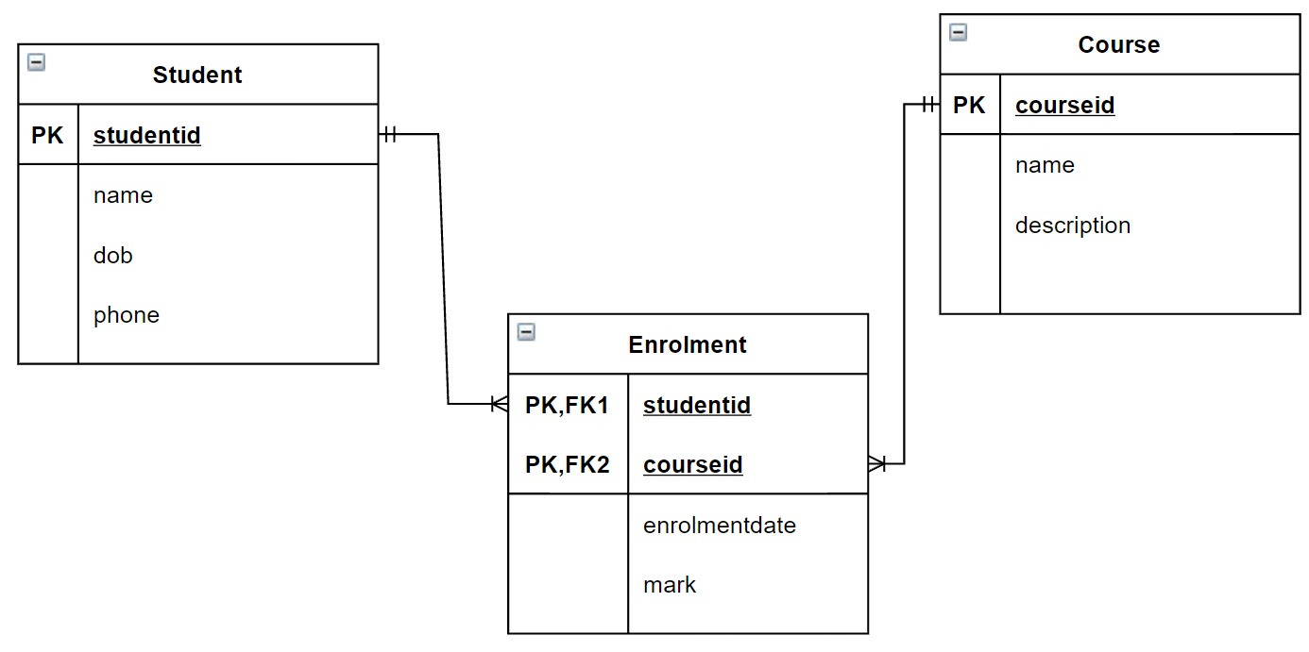

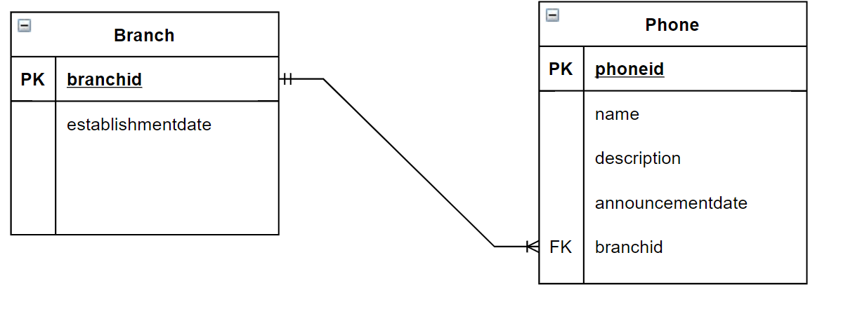

Exercise 4: Define entity, relationships and transform into 3NF between entities in the following context

• Each student has an id (sid), a name (sname), a major study direction (major) and an date of birth(dob).

• Each course has a name (cname) and description (cdesc).

• Each faculty has an id (fid) and a name (fname).

• Students can be enrolled in several courses and for each course there exists at least one student who is enrolled in that course.

• Each course belongs to one faculty and for each faculty exists at least one course which belongs to this faculty.

