|  |  |
| --- | --- |
|  | Faculty of Information Technology  **SYSTEM ANALYSIS AND DESIGN**  **Fall 2021** |

# Chapter 6. Designing database

***Exercise 1***: Give examples about some of entity and attributes in real-life

***Answer:***

* Book: **ISBN**, title, publisher, version, genre
* Product: **ID**, name, category, color, model

***Exercise 2***: Given following context. Define entities and attributes only

A university has a large number of courses in its catalog. Attributes of COURSE include Course_Number (identifier), Course_Name, and Units. Each course may have one or more different courses as prerequisites, or may have no prerequisites. Similarly, a particular course may be a prerequisite for any number of courses, or may not be prerequisite for any other course.

***Answer:***

* Course: course_number, course_name, units, prerequisite

***Exercise 3***: Define the following relationships (one-to-one, one-to-many and many-to-many relationship) between entities and transform into 3NF relationship entities

* A user login has only one user information. User login includes id, username, email and password. User information includes first name, last name, address, dob, phone number
* A student can enroll in several course and a course have many students enrolled. Information of course includes id, course name, course description. Information of student includes id, student name, student dob, phone number. Each student enrolment between student and course contain: enrolment date – which is the date student enrolls in specific course and mark given for that student.
* A phone brand has several phones. A phone brand has the following property: id, name - such as Apple, Samsung, Huawei, date established. A phone is also has the following properties: id, phone name (Apple Iphone 13, Samsung Galaxy S20), description and date announced.

***Answer:***

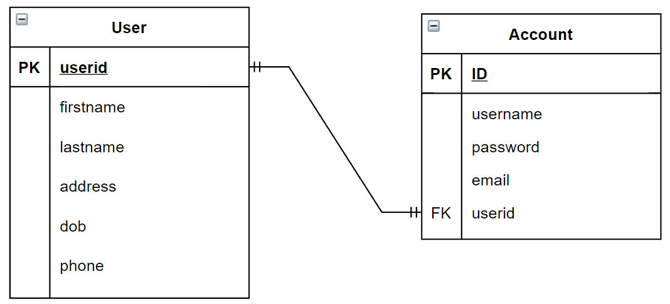

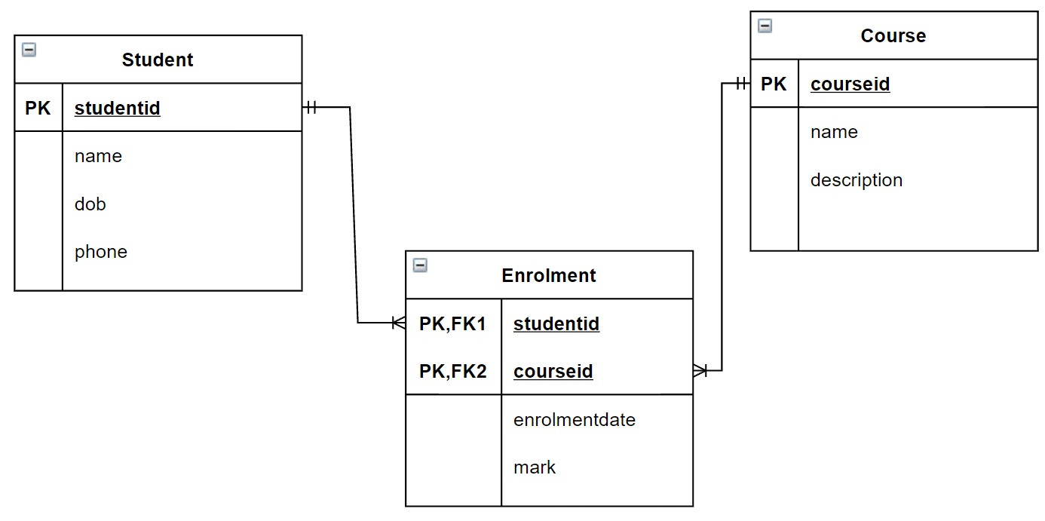

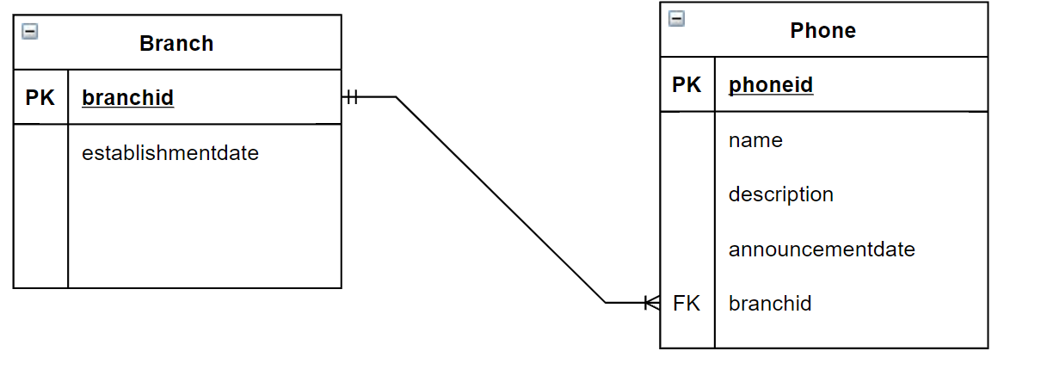

Exercise 4: Define entity, relationships and transform into 3NF between entities in the following context

• Each student has an id (sid), a name (sname), a major study direction (major) and an date of birth(dob).

• Each course has a name (cname) and description (cdesc).

• Each faculty has an id (fid) and a name (fname).

• Students can be enrolled in several courses and for each course there exists at least one student who is enrolled in that course.

• Each course belongs to one faculty and for each faculty exists at least one course which belongs to this faculty.

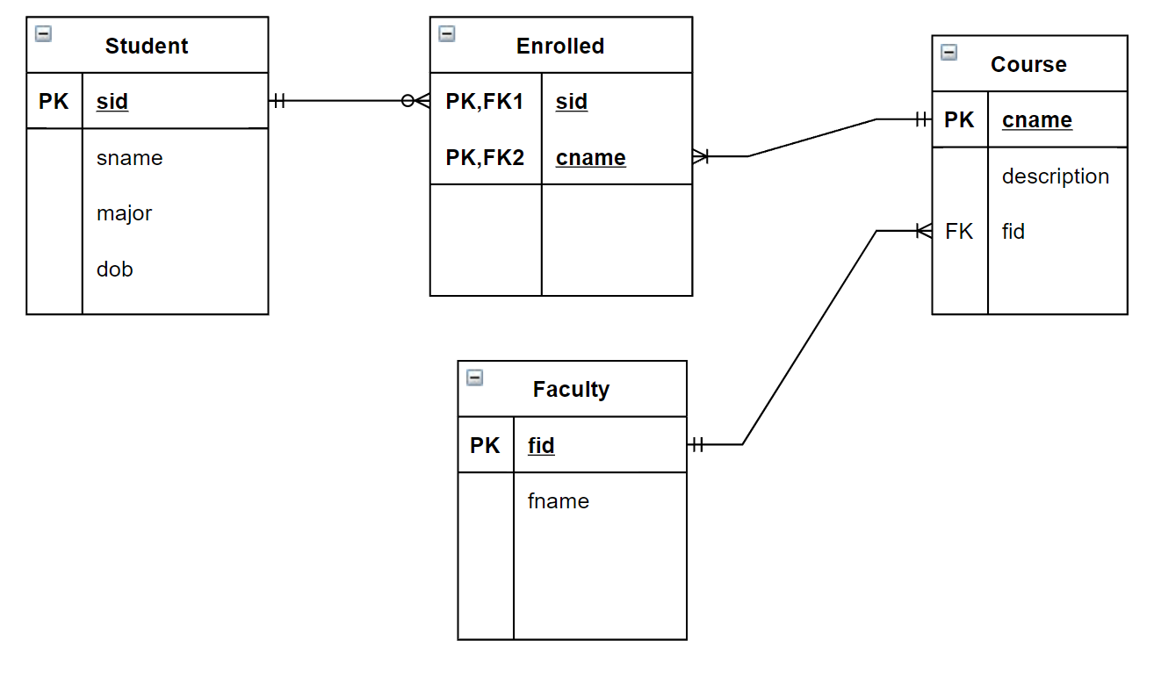

SAD

Part 1:

|  |  |  |  |  |  |  |  |  |  |  |  |  |  |  |  |  |  |  |  |  |  |  |  |  |  |  |  |  |  |
| --- | --- | --- | --- | --- | --- | --- | --- | --- | --- | --- | --- | --- | --- | --- | --- | --- | --- | --- | --- | --- | --- | --- | --- | --- | --- | --- | --- | --- | --- |
|  |  |  |  |  |  |  |  |  |  | 1  A | V | A | I | L | A | B | I | L | I | T | Y |  |  |  |  |  |  |  |  |
|  |  |  |  |  |  |  |  |  |  |  |  |  |  |  |  |  |  |  |  |  |  |  |  |  |  |  |  |  |  |
|  |  |  |  |  |  |  |  |  |  |  | 2  S |  |  |  |  |  |  | 3  P |  |  |  |  |  |  |  |  |  |  |  |
|  |  |  |  |  |  |  |  |  |  |  | E |  |  |  |  |  | 4  C | U | S | T | O | M | I | Z | A | T | I | O | N |
|  |  |  |  |  |  |  |  |  |  |  | R |  |  |  |  |  |  | B |  |  |  |  |  |  |  |  |  |  |  |
|  |  |  |  |  | 5  D |  |  |  |  |  | V |  |  |  |  | 6  D |  | L |  | 7  S |  |  |  |  |  |  |  |  |  |
|  |  |  |  |  | A |  |  |  |  | 8  P | E | R | S | O | N | A | L | I | Z | A | T | I | O | N |  |  |  |  |  |
|  |  |  |  |  | T |  |  |  |  |  | R |  |  |  |  | T |  | C |  | A |  |  |  |  |  |  |  |  |  |
|  |  |  |  |  | A |  |  |  |  |  |  |  |  | 9  S | A | A | S |  | 10  C | S | S |  |  |  |  |  |  |  |  |
|  |  |  |  |  | B |  | 11  M |  |  |  |  |  |  |  |  | M |  | 12  C |  |  |  |  |  | 13  S |  |  |  |  |  |
|  |  |  |  |  | A |  | I |  |  |  | 14  X |  |  |  |  | A |  | L |  |  |  | 15  V |  | I |  |  |  | 16  P |  |
|  |  |  | 17  C | M | S |  | D |  | 18  C | O | M | P | O | 19  N | E | N | T | I | Z | 20  A | T | I | O | N |  |  |  | R |  |
|  |  |  |  |  | E |  | D |  |  |  | L |  |  | E |  | A |  | E |  | P |  | R |  | G |  |  |  | I |  |
|  |  |  |  |  | E |  | L |  |  |  |  |  |  | T |  | G |  | N |  | I |  | T |  | L |  |  |  | V |  |
|  |  |  | 21  C | O | N | T | E | N | T |  | 22  L |  |  | W |  | E |  | T |  |  |  | U |  | E |  |  |  | A |  |
|  |  |  |  |  | G |  | W |  |  |  | A |  |  | O |  | M |  |  |  |  |  | A |  |  |  |  |  | T |  |
|  | 23  A | P | P | L | I | C | A | T | I | O | N | S | E | R | V | E | R |  |  | 24  F | I | L | E | S | E | R | V | E | R |
|  |  |  |  |  | N |  | R |  |  |  |  |  |  | K |  | N |  |  |  |  |  | M |  |  |  |  |  |  |  |
|  |  |  |  |  | E |  | E |  |  |  |  |  |  |  | 25  H | T | T | 26  P |  | 27  P | A | A | S |  |  |  |  |  |  |
|  |  |  |  |  |  |  |  |  |  |  |  |  |  |  |  |  |  | C |  |  |  | C |  |  |  |  |  |  |  |
|  |  |  |  |  |  |  |  |  |  |  |  |  |  |  |  | 28  P |  |  |  |  |  | H |  |  |  |  |  |  |  |
|  |  |  |  |  |  |  |  |  |  |  |  | 29  D | A | T | A | A | N | A | L | Y | S | I | S |  |  |  |  |  |  |
|  |  |  |  |  |  |  |  |  |  |  |  |  |  |  |  | A |  |  |  |  |  | N |  |  |  |  |  |  |  |
|  |  |  |  |  |  |  |  |  |  |  |  |  |  |  | 30  X | S | L |  |  |  |  | E |  |  |  |  |  |  |  |

|  |  |
| --- | --- |
| **Across**  **1.** A primary concern for most organizations when dealing with the cloud is ________.  **4.** ________ refers to sites that allow a user to customize the content and look of a site based on their personal preferences.  **8.** ________ means providing Internet content to a user based upon knowledge of that customer.  **9.** In the ________ model, the customer uses only applications provided via a cloud infrastructure. Typically, such applications include Web-based e-mail services and Web-based productivity suites.  **10.** ________ is a set of style rules that tells a Web browser how to present a document.  **17.** A(n) ________ is a special type of software application for collecting, organizing, and publishing Web site content.  **18.** According to the ________ service principle, a service should be simple and modular.  **21.** To make sure Websites contain the most accurate and up-to-date information, often from multiple sources, many organizations have turned to using a ________ management system.  **23.** A(n) ________ is a computing server where data analysis functions primarily reside.  **24.** A ________ is a device that manages file operations and is shared by each client PC attached to a LAN.  **25.** ________ is a communication protocol for exchanging information on the Internet.  **27.** In the ________ model, the user has control over the applications but has limited or no control over the underlying infrastructure  **29.** The ________ functions of an IS transform inputs into outputs, including simple summarization to complex mathematical modeling such as regression analysis.  **30.** ________ is a specification for separating style from content when generating XML pages. | **Down**  **2.** A thin client is a client device designed so that most processing and data storage occur on the ________.  **3.** Services in a(n) ________ cloud can be used by any interested party on a pay-per-use basis; hence, they are often used for applications that need rapid scalability  **5.** A ________ is the (back-end) portion of the client/server database system running on the server that provides database processing and shared access functions  **6.** The ________ functions of an IS manage all interaction between software and files and databases, including data retrieval/querying, updating, security, concurrency control, and recovery.  **7.** Applications under the ________ model are typically easiest to deploy, because the customer does not have to worry about maintaining or updating the software, the underlying platform, or the hardware infrastructure  **11.** ________ is a combination of hardware, software and communication technology that brings data management, presentation, and analysis together into a three-tiered (or n-tiered) client/server environment.  **12.** File servers transfer files when data are requested from a ________.  **13.** Designing distributed and Internet systems is much like designing ________ location systems.  **14.** ________ is an Internet authoring language that allows designers to create customized tags, enabling the definition, transmission, validation, and interpretation of data between applications.  **15.** A(n) ________ is a software emulation of a physical computer system, both hardware and operating system, that allows more efficient sharing of physical hardware resources.  **16.** A(n) ________ cloud does not free an organization from the issues associated with managing the cloud infrastructure, but it does give the organization a high degree of customizability, flexibility, and control over their data and applications.  **19.** A Web service is a method of communication between two electronic devices over a ________.  **20.** A(n) ________ refers to the software building blocks that are used to ensure that common system capabilities, such as user interfaces and printing, as well as modules are standardized to facilitate data exchange between clients and servers.  **22.** ________ is the cabling, hardware, and software used to connect workstations, computers and file servers located in a confined geographical area.  **26.** In a file server configuration, each file server acts as an additional hard disk for each client ________.  **28.** In the ________ model, customers can run their own applications, which are typically designed using tools provided by the service provider. |

**Part 2:**

List some advantages and disadvantages of Layered architecture and Client–server architecture

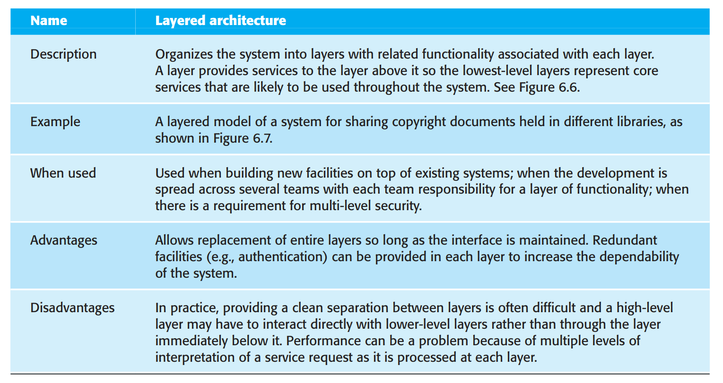

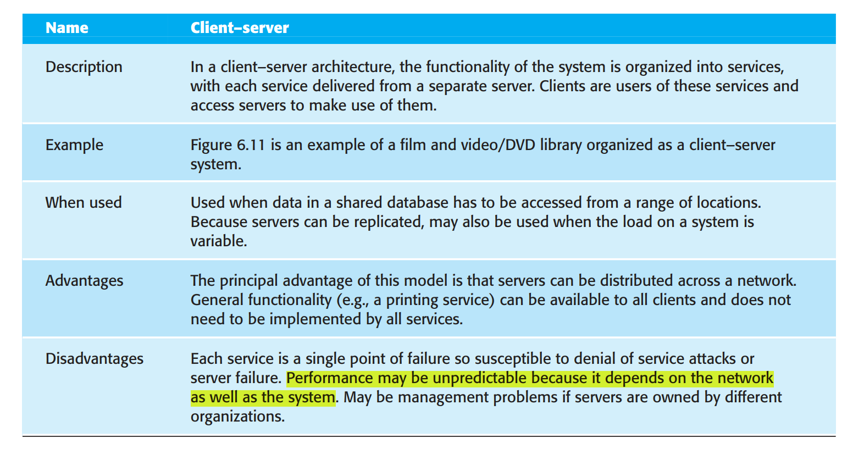

2. How to choose software architecture based on non-functional requirements

Answer:

Because of the close relationship between non-functional requirements and software architecture, the particular architectural style and structure that you choose for a system should depend on the non-functional system requirements:

1. Performance If performance is a critical requirement, the architecture should be designed to localize critical operations within a small number of components, with these components all deployed on the same computer rather than distributed across the network. This may mean using a few relatively large components rather than small, fine-grain components, which reduces the number of component communications. You may also consider run-time system organizations that allow the system to be replicated and executed on different processors.

2. Security If security is a critical requirement, a layered structure for the architecture should be used, with the most critical assets protected in the innermost layers, with a high level of security validation applied to these layers.

3. Safety If safety is a critical requirement, the architecture should be designed so that safety-related operations are all located in either a single component or in a small number of components. This reduces the costs and problems of safety validation and makes it possible to provide related protection systems that can safely shut down the system in the event of failure.

4. Availability If availability is a critical requirement, the architecture should be designed to include redundant components so that it is possible to replace and update components without stopping the system. I describe two fault-tolerant system architectures for high-availability systems in Chapter 13.

5. Maintainability If maintainability is a critical requirement, the system architecture should be designed using fine-grain, self-contained components that may readily be changed. Producers of data should be separated from consumers and shared data structures should be avoided.

|  |  |
| --- | --- |
|  | **Faculty of Information Technology**  **SYSTEM ANALYSIS AND DESIGN**  **Fall 2021** |



**Chapter 3 Determining Software Requirement**

**Part I. Requirement gathering**

1) You are developing a Human Resource Management software for your customer. You have to Interview groups of people with diverse needs to find synergies and contrasts among system requirements. Plan the interview for gather requirement with the following artifacts: Agenda, Checklist, Questions.

**Difficulty**: Difficult

**Learning objectives**: (i) 3.1 Describe options for designing and conducting interviews and developing a plan for conducting an interview to determine system requirements, (ii) 3.2 Explain the advantages and pitfalls of observing workers and analyzing business documents to determine system requirements (iii) 3.4 Participate in and help plan a Joint Application Design session

**Teaching activity**: Students have 20 mins to answer, teacher-student interaction to share & discuss

**Sample answer**:

|  |  |
| --- | --- |
| **Interview outline** | |
| Interviewee: | Interviewer: |
| Location: | Appointment: |
| Objectives |  |
| Agenda:  Intro  Background on project  Overview of the interview   * Topic to be covered * Permission to record   Topic 1 questions  Topic 2 questions  Summary  Closing | Estimated time:  1 min  2-3 mins  2 mins  1 min  3 mins  3 mins  3 mins  1 min |
| General observation: |  |
| Topic not covered: |  |
| Questions | Notes |
| * Question 1: What are your expected functionalities of the system? | Answer: *I want it to manage employee information and their payment*  Observation: *Seem not confident with the answer* |
| * Question 2: How many departments are there? | Answer: 3 departments: human resource department, accounting department, sales  Observation: |
| * Question 3: Could you please tell me about job positions in each department? | Answer: ….  Observation:…. |
| * Question 4: How to calculate salary for each position? | Answer:…  Observation:…. |

2) Write a requirement specification for a function: Manage employee in organization.

**Difficulty**: Medium

**Learning objectives**: 3.3 Explain how computing can provide support for requirements determination

**Teaching activity**: Students have 20 mins to work in pair, teacher-student interaction to share & discuss

**Answer**:

1. A purpose

This document captures the complete requirements for employee management function in A company.

1. An overall description

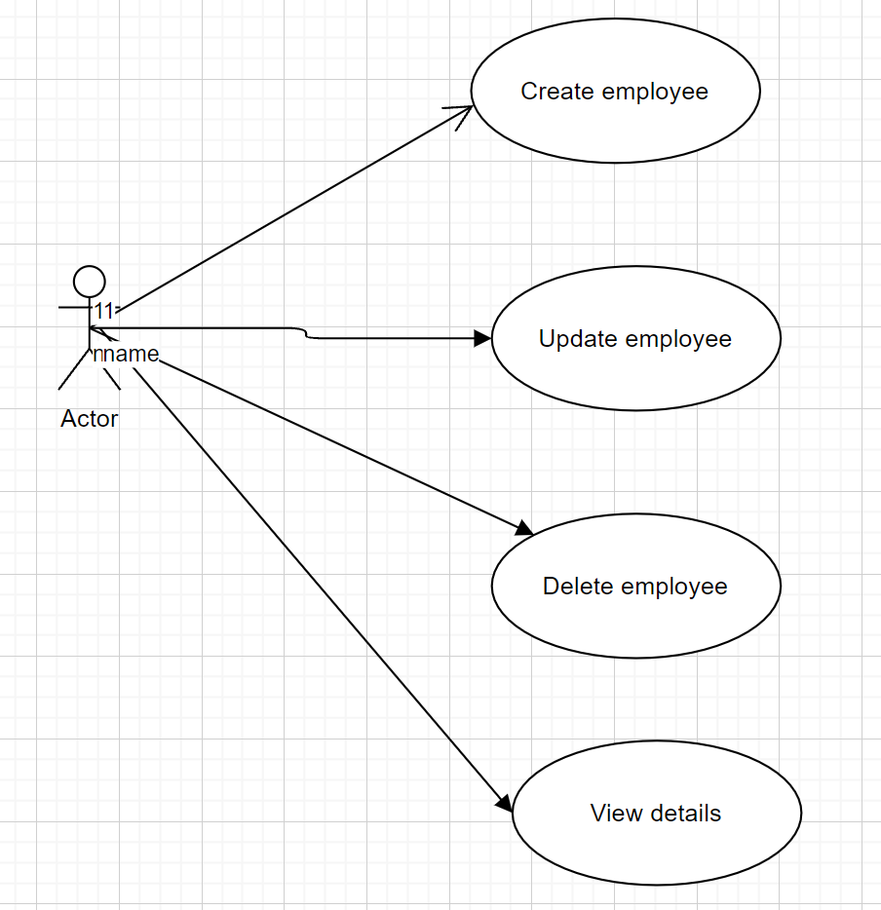

1. Specific requirement
   1. Functional requirement
      1. **Create employee**

This function allows an authenticated user to create a new employee. In order to create a new employee, the user needs to provide the following information:

* Employee id: the unique identity number of an employee
* Employee fullname:… full name of the employee
* Date of birth
* Place of birth (city name only
* Address(full address)
* Phone number (10 digit number)
* Email (can be blank)
  + 1. Update employee:

This function allows an authenticated user to update an existed employee based on the ID. In order to update a new employee, the user needs to select an employee based on ID and provide suitable information to change.

* + 1. Delete employee:

This function allows an authenticated user to delete an existed employee based on the ID. If an employee is deleted, alll the information of the employee must be remove from the db

* 1. Non functional requirement
* The system should be accessible 24/7
* Each request should be processed within 10 seconds.
* The site should load in 3 seconds when the number of simultaneous users are > 10000

**Part 2. Prototyping**

1) Use any tool (Word, Excel, Paint, Visio, Free online mockup / prototyping tools, etc.) to create prototype for above function: Manage employee.

**Difficulty**: Medium

**Learning objectives**: 3.3 Explain how computing can provide support for requirements determination

**Teaching activity**: Students have 30 mins to answer, teacher-student interaction to share & discuss

**Answer**:

Based on Manage employee in organization spec. above. After gathering requirements, the development team decides to have the following functionality:

* Manage Employee List: Employee table includes: ID (1,2, …), Employee Identification Number (1901040005 – for example), name, DOB, gender, address
* Manage Employee includes:
  + Allow user to enter new employee information
  + Allow user to view employee list
  + Allow user to edit existing employee information
  + Allow user to remove employee out of company.

<https://balsamiq.cloud/sdguf54/puh3jj6/r2278>

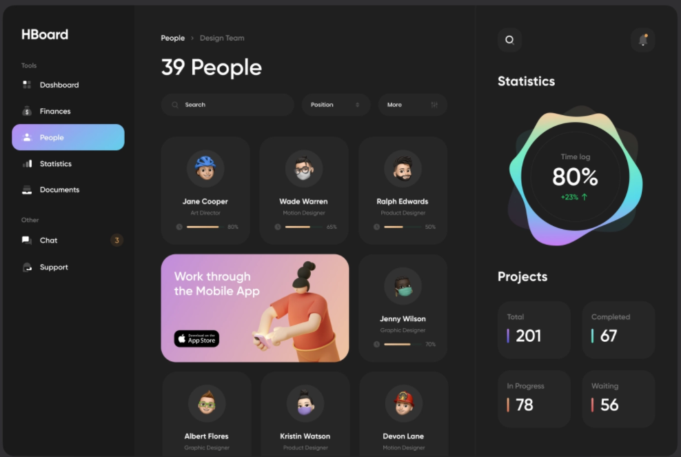

|  |  |
| --- | --- |
|  | Faculty of Information Technology  **SYSTEM ANALYSIS AND DESIGN**  **Fall 2021** |

**Chapter 1 Fundamental of Systems Development**

**Part I. Multiple choice questions**

1) ________ would be classified as software designed to support the payroll function.

A) System software

B) Design software

C) Analysis software

D) Application software

Answer: D

Difficulty: Easy

AACSB: Information Technology

L.O.: 1.1 Define information systems analysis and design

Classification: Concept

2) ________ is designed to support organizational functions or processes.

A) Application software

B) Design software

C) Analysis software

D) Testing software

Answer: A

Difficulty: Easy

AACSB: Information Technology

L.O.: 1.1 Define information systems analysis and design

Classification: Concept

3) What are computer programs that make it easy to use and benefit from techniques and to faithfully follow the guidelines of the overall development methodology?

A) Tools

B) Techniques

C) Data flow

D) Methodologies

Answer: A

Difficulty: Moderate

AACSB: Information Technology

L.O.: 1.1 Define information systems analysis and design

Classification: Concept

4) Who has the primary responsibility for the design and analysis of information systems?

A) Systems analyst

B) Software engineer

C) Employees

D) Applications developer

Answer: A

Difficulty: Easy

AACSB: Information Technology

L.O.: 1.1 Define information systems analysis and design

Classification: Concept

5) ________ is/are the process(es) that an analyst will follow to help ensure that his work is complete, well-done, and understood by project team members.

A) Tools

B) Techniques

C) Data flow

D) Methodologies

Answer: B

Difficulty: Moderate

AACSB: Information Technology

L.O.: 1.1 Define information systems analysis and design

Classification: Concept

6) The first procedural, or third-generation, computer programming languages did not become available until the beginning of the ________.

A) 1950s

B) 1960s

C) 1970s

D) 1980s

Answer: B

Difficulty: Difficult

AACSB: Information Technology

L.O.: 1.1 Define information systems analysis and design

Classification: Concept

7) Because computers were so expensive, computer memory was also at a premium, so system developers conserved as much memory as possible for ________.

A) System design

B) System analysis

C) Data analysis

D) Data storage

Answer: D

Difficulty: Easy

AACSB: Information Technology

L.O.: 1.1 Define information systems analysis and design

Classification: Concept

8) ________ are large, complex systems that consist of a series of independent system modules.

A) Supply chain management systems

B) Enterprise-wide systems

C) Customer relationship management systems

D) Transaction processing systems

Answer: B

Difficulty: Moderate

AACSB: Information Technology

L.O.: 1.1 Define information systems analysis and design

Classification: Concept

9) ________ were developed to make systems developers' work easier and more consistent.

A) Data analysis tools

B) Computer-aided software engineering (CASE) tools

C) Software designing tools

D) Modeling tools

Answer: B

Difficulty: Difficult

AACSB: Information Technology

L.O.: 1.1 Define information systems analysis and design

Classification: Concept

10) Most organizations find it beneficial to use a standard set of steps, called ________, to develop and support their information systems.

A) Systems development methodology

B) Supply chain management systems

C) Analytical processing systems

D) Customer relationship management systems

Answer: A

Difficulty: Difficult

AACSB: Information Technology

L.O.: 1.1 Define information systems analysis and design

Classification: Concept

11) Which of the below is a traditional methodology used to develop, maintain, and replace information systems?

A) Prototyping

B) OOAD

C) RAD

D) SDLC

Answer: D

Difficulty: Easy

AACSB: Information Technology

L.O.: 1.1 Define information systems analysis and design

Classification: Concept

12) Information systems analysis and design is a process to develop and maintain computer-based information systems.

Answer: TRUE

Difficulty: Easy

AACSB: Information Technology

L.O.: 1.1 Define information systems analysis and design

Classification: Concept

13) Ninety-four percent of companies report that they practice agile in their systems development efforts.

Answer: TRUE

Difficulty: Easy

AACSB: Information Technology

L.O.: 1.1 Define information systems analysis and design

Classification: Concept

14) To be effective, techniques and tools must both be consistent with an organization's systems development methodology.

Answer: TRUE

Difficulty: Moderate

AACSB: Information Technology

L.O.: 1.1 Define information systems analysis and design

Classification: Concept

15) Techniques and tools must make it difficult for system developers to conduct the steps called for in the methodology.

Answer: FALSE

Difficulty: Moderate

AACSB: Information Technology

L.O.: 1.1 Define information systems analysis and design

Classification: Concept

16) An organizational approach to systems analysis and design is not driven by methodologies.

Answer: FALSE

Difficulty: Moderate

AACSB: Information Technology

L.O.: 1.1 Define information systems analysis and design

Classification: Concept

17) The analysis and design of computer-based information systems began in the 1950s.

Answer: TRUE

Difficulty: Difficult

AACSB: Information Technology

L.O.: 1.1 Define information systems analysis and design

Classification: Concept

18) Most organizations never developed their applications from scratch using their in-house development staff.

Answer: FALSE

Difficulty: Moderate

AACSB: Information Technology

L.O.: 1.1 Define information systems analysis and design

Classification: Concept

19) Which of the following is correct with respect to the logical design?

A) All functional features of the system chosen for development in analysis are described independently of any computer platform.

B) Logical design does not concentrate on the business aspects of the system.

C) Logical design is tied to a specific hardware and software platform.

D) Technical specifications are developed.

Answer: A

Difficulty: Moderate

AACSB: Information Technology

L.O.: 1.2 Describe the information systems development life cycle (SDLC)

Classification: Concept

20) In which phase of the SDLC is an information system systematically repaired and improved?

A) Implementation

B) Analysis

C) Design

D) Maintenance

Answer: D

Difficulty: Easy

AACSB: Information Technology

L.O.: 1.2 Describe the information systems development life cycle (SDLC)

Classification: Concept

21) Which of the following are delivered after the completion of analysis phase?

A) Functional, detailed specifications of all system elements

B) Priorities for systems and projects; an architecture for data, networks, and selection hardware, and IS management are the result of associated systems

C) Code, documentation, training procedures, and support capabilities

D) Description of current system and where problems and opportunities are with a general recommendation on how to fix, enhance, or replace current system

Answer: D

Difficulty: Moderate

AACSB: Information Technology

L.O.: 1.2 Describe the information systems development life cycle (SDLC)

Classification: Concept

22) Systems development methodologies and techniques which are based on objects rather than data or processes are known as ________.

A) Inheritance

B) Objects

C) Participatory design

D) Object-oriented analysis and design

Answer: D

Difficulty: Moderate

AACSB: Information Technology

L.O.: 1.3 Describe the agile methodologies, eXtreme Programming, and Scrum

Classification: Concept

**Part 2. Short answer**

1) Who is a systems analyst and what are the duties of a systems analyst?

Answer: Many people in organizations are responsible for systems analysis and design; in most organizations the systems analyst has the primary responsibility. When you begin your career in systems development, you will most likely begin as a systems analyst or as a programmer with some systems analysis responsibilities. The primary role of a systems analyst is to study the problems and needs of an organization in order to determine how people, methods, and information technology can best be combined to bring about improvements in the organization. A systems analyst helps system users and other business managers define their requirements for new or enhanced information services. As such, a systems analyst is an agent of change and innovation.

Difficulty: Moderate

AACSB: Information Technology

L.O.: 1.1 Define information systems analysis and design

Classification: Synthesis

2) What is an application software and its importance?

Answer: An important (but not the only) result of systems analysis and design is application software, software designed to support a specific organizational function or process, such as inventory management, payroll, or market analysis. In addition to application software, the total information system includes the hardware and systems software on which the application software runs, documentation and training materials, the specific job roles associated with the overall system, controls, and the people who use the software along with their work methods.

Difficulty: Easy

AACSB: Information Technology

L.O.: 1.1 Define information systems analysis and design

Classification: Synthesis

3) What is meant by system methodologies, techniques, and tools?

Answer: Methodologies are comprehensive, multiple-step approaches to systems development. Techniques are particular processes that you follow to help ensure that your work is complete, well done, and understood by others. Tools are typically computer programs that make it easier to use and benefit from techniques and to follow faithfully the guidelines of the overall development methodology. The techniques and tools should support the chosen methodology. Methodologies, techniques, and tools work together to form an organizational approach to systems analysis and design.

Difficulty: Easy

AACSB: Information Technology

L.O.: 1.1 Define information systems analysis and design

Classification: Synthesis

4) What is a system development methodology?

Answer: Most organizations find it beneficial to use a standard set of steps, called a systems development methodology, to develop and support their information systems. Like many processes, the development of information systems often follows a life cycle. For example, a commercial product follows a life cycle in that it is created, tested, and introduced to the market. Its sales increase, peak, and decline. Finally, the product is removed from the market and replaced by something else.

Difficulty: Easy

AACSB: Information Technology

L.O.: 1.1 Define information systems analysis and design

Classification: Synthesis

5) What are the five major phases of the SDLC?

Answer: The major SDLC phases include planning, analysis, design, implementation, and maintenance. Planning is the first phase of the SDLC in which an organization's total information system needs are identified, analyzed, prioritized, and arranged. Analysis is the second phase of the SDLC in which system requirements are studied and structured. During the third phase, the design phase, a description of the recommended solution is converted into logical and then physical system specifications. Implementation is the fourth phase of the SDLC in which the information system is coded, tested, installed, and supported in the organization. Maintenance is the fifth and final phase of the SDLC in which an information system is systematically repaired and improved.

Difficulty: Moderate

AACSB: Information Technology

L.O.: 1.1 Define information systems analysis and design

Classification: Synthesis

6) Which of the below is a true statement regarding the systems development life cycle?

A) The SDLC is not iterative.

B) It is not possible to complete some activities in one phase in parallel with those of another phase.

C) The life cycle can be thought of as a circular process in which the end of the useful life of one system leads to the beginning of another project to develop a new version of or replace an existing system.

D) The life cycle can be thought of as a linear process in which the end of the useful life of one system leads to the beginning of another project to develop a new version of or replace an existing system.

Answer: C

Difficulty: Difficult

AACSB: Information Technology

L.O.: 1.2 Describe the information systems development life cycle (SDLC)

Classification: Concept

Faculty of Information Technology

SYSTEM ANALYSIS AND DESIGN

**Fall 2021**

# Chapter 2 Software Development Life Cycle

**Part I. Multiple choice questions**

1. Which of the following is NOT a part of the Evolutionary model of the SDLC process?
   1. Analysis
   2. Design
   3. Planning
   4. **Procedure**
2. Which of the following activities happens during the SDLC planning phase?
   1. **A presentation of why the system should or should not be developed by the organization is given.**
   2. New system requirements are identified.
   3. The high level design is prepared.
   4. User acceptance testing is performed.
3. In which phase of the SDLC are the system requirements studied and structured?
   1. Implementation
   2. **Analysis**
   3. Design
   4. Planning
4. Which SDLC phase focuses on the needs of the entire organization?
   1. Design
   2. Planning
   3. **Logical**
   4. Analysis
5. In which phase of the SDLC is the description of the recommended solution converted into logical and then physical system specifications?
   1. Implementation
   2. Analysis
   3. **Design**
   4. Planning
6. In which phase of the SDLC is the information system coded, tested, installed, and supported in the organization?
   1. **Implementation**
   2. Analysis
   3. Design
   4. Planning
7. is/are the final output from the analysis phase.
   1. Physical system specifications
   2. Work plan for the project
   3. Priorities for systems and projects proposal
   4. **A description of the alternative solution**
8. Which of the following are delivered after the completion of the implementation phase?
   1. **Code, documentation, training procedures, and support capabilities**
   2. Functional, detailed specifications of all system elements
   3. Description of current system and where problems and opportunities are with a general recommendation on how to fix, enhance, or replace current system
   4. Priorities for systems and projects; an architecture for data, networks, and selection hardware, and IS management are the result of associated systems
9. Which of the following are delivered after the completion of analysis phase?
   1. Functional, detailed specifications of all system elements
   2. Priorities for systems and projects; an architecture for data, networks, and selection hardware, and IS management are the result of associated systems
   3. Code, documentation, training procedures, and support capabilities
   4. **Description of current system and where problems and opportunities are with a general recommendation on how to fix, enhance, or replace current system**
10. Which of the below is NOT a true statement regarding the SDLC?
    1. It is a highly linked set of phases whose products feed the activities in subsequent phases.
    2. The different phases are clearly defined.
    3. The relationships between phases are well specified.
    4. **It is a rapid method to prototype and develop an application.**
11. Which of the following are delivered after the completion of the Maintenance phase of the SDLC?
    1. **New versions or releases of software with associated updates to documentation, training, and support**
    2. Functional, detailed specifications of all system elements
    3. Priorities for systems and projects; an architecture for data, networks, and selection hardware, and IS management are the result of associated systems
    4. Code, documentation, training procedures, and support capabilities
12. All of these are reasons to begin designing a system replacement except .
    1. when the information system is no longer performing as desired.
    2. when maintenance costs become prohibitive.
    3. when the organization needs have substantially changed.
    4. when the system has reached the time limit of seven years.
13. Which of the following is a drawback of the traditional waterfall SDLC approach?
    1. **Users are locked into requirements.**
    2. There are no criticisms.
    3. The process is too chaotic.
    4. It is too short of a process.
14. Which of the following is NOT a criticism of the traditional waterfall SDLC approach?
    1. **Prototypes do not work properly.**
    2. Users are locked into requirements.
    3. The role of customers is narrowly defined.
    4. Intangible processes are given hard and fast dates.
15. Which of the following is one of three key principles shared by the Agile Methodologies?
    1. **A focus on self-adaptive processes**
    2. A focus on roles
    3. A focus on predictive methodologies
    4. A focus on passive processes
16. The third phase in the SDLC is planning and in this phase the analyst thoroughly studies the organization's current procedures and the information systems used to perform organizational tasks? **F**
17. The part of the design process that is independent of any specific hardware or software platform is referred to as logical design? **T**
18. Which of the following is NOT true regarding iterative development?
    1. It is a mechanism for dealing with a lack of predictability.
    2. It focuses on the frequent production of working versions of a system.
    3. It provides feedback to customers.
    4. **Feedback is not provided to developers and customers.**
19. Which of the following is NOT valued according to the Agile Manifesto for software development?
    1. Responding to change over following a plan
    2. Working software over comprehensive documentation
    3. **Prioritizing the plan over the change required**
    4. Individuals and interactions over processes and tools
20. is/are often called the third approach to systems development, after the process-oriented and data-oriented approaches.
    1. **Inheritance**
    2. Objects
    3. Participatory design
    4. Object-oriented analysis and design
21. One of the most popular realizations of the iterative approach for object-oriented development is the .
    1. JAD
    2. RAD
    3. **RUP**
    4. eXtreme Programming
22. Which of the following is NOT a phase in the Rational Unified Process?
    1. Inception
    2. Elaboration
    3. Construction
    4. **Calculation**
23. Which of the following is an iterative approach to programming in the object-oriented design process?
    1. **Rational Unified Process (RUP)**
    2. Software Development Life Cycle (SDLC)
    3. eXtreme Programming
    4. The Construction Process

# Part 2. Short answer

1. List the outputs delivered from each of the SDLC phases.

**Requirement Analysis: Description of current system and where problems and opportunities are with a general recommendation on how to fix, enhance, or replace current system**

The requirements of the software are determined at this stage. Discussions are held between the various stake holders, managers, and users to find out what the particular software will be used for. Who will use it and how will they be using it. Information regarding what kind of input is required and what output is expected is collected during this stage. Once the information is collected, it is analysed to see if the requirements can be incorporated into the software that is to be developed. After which, a ‘Requirement Specification’ document is developed to be used as a guide for the next stage.

**Design: Functional, detailed specifications of all system elements**

Here, the software and system design is developed according to the instructions provided in the ‘Requirement Specification’ document. The design stage establishes what hardware and what system requirements are needed as well as the entire system architecture. The results from this stage are used as input for the next one.

**Implementation & Coding: Code, documentation, training procedures, and support capabilities**

In this stage, the actual coding is done and the code is produced based on the design specifications. This is the most critical and also the longest stage in the SDLC.

**Testing: Defects, Issues, Test Plan,Test Cases, Results, Test Reports.**

After the development of the code, it is tested to see if it meets all the requirements that were determined in the first stage. Various kinds of testing such as system testing, unit testing, acceptance testing, and integration testing are carried out.

**Maintenance: New versions or releases of software with associated updates to documentation, training, and support**

This is the final stage, where the finished software is delivered to the customer. The real problems are identified once the customer begins use. These problems are addressed from time to time as they crop up.

1. **What happens during testing and installation of the new systems during the implementation phase of the software development life cycle?**

first to install the software in the production environment and to bring it into operation; and second, to ensure that the software, as developed:

* Satisfies the functional requirements
* Satisfies the business needs;
* Adheres to all mandates, physical constraints and service level agreements; and
* Operates as described in the User and Operator Manuals

This phase is initiated after the system has been tested and accepted by the user. In this phase, the system is installed to support the intended business functions. System performance is compared to performance objectives established during the planning phase. Implementation includes user notification, user training, installation of hardware, installation of software onto production computers, and integration of the system into daily work processes. This phase continues until the system is operating in production in accordance with the defined user requirements.

The purpose of the Implementation Phase is to deploy and enable operations of the new information system in the production environment.

1. **Describe the criticism of traditional waterfall SDLC process.**

There are several criticisms of the traditional life-cycle approach to systems development. One relates to the way the life cycle is organized. Note how the flow of the project begins in the planning phase and from there runs "downhill" to each subsequent phase, just like a stream that runs off a cliff. It became too tempting to ignore the need for feedback and to treat each phase as complete unto itself, never to be revisited once finished. Another criticism of the traditional waterfall SDLC is that the role of system users or customers was narrowly defined. User roles were often relegated to the requirements determination or analysis phases of the project, where it was assumed that all of the requirements could be specified in advance. Such an assumption, coupled with limited user involvement, reinforced the tendency of the waterfall model to lock in requirements too early, even after business conditions had changed.

1. **Explain object-oriented analysis and design.**

Object Oriented Analysis (OOA) is the first technical activity performed as part of object oriented software engineering. OOA introduces new concepts to investigate a problem. It is based in a set of basic principles, which are as follows-

The information domain is modeled.

Behavior is represented.

Function is described.

Data, functional, and behavioral models are divided to uncover greater detail.

Early models represent the essence of the problem, while later ones provide implementation details.

Software and computer application systems are incredibly complex concepts since there are few material restrictions and a lot of possible arbitrary reconstructions. Software does not enjoy the same restrictions, and the room for complexity to grow is very large. This is where object-oriented analysis and design comes into play. It uses abstraction as a tool to encapsulate complexity, and the more abstractions are introduced, the greater is the reduction in complexity. These acts of abstraction and encapsulation allow for certain problems to be highlighted and subsequently suppressed.

1. **Describe the Rational Unified Process (RUP) and its phases.**

tands for "Rational Unified Process." RUP is a software development process from Rational, a division of IBM. It divides the development process into four distinct phases that each involve business modeling, analysis and design, implementation, testing, and deployment. The four phases are:

1. Inception - The idea for the project is stated. The development team determines if the project is worth pursuing and what resources will be needed.
2. Elaboration - The project's architecture and required resources are further evaluated. Developers consider possible applications of the software and costs associated with the development.
3. Construction - The project is developed and completed. The software is designed, written, and tested.
4. Transition - The software is released to the public. Final adjustments or updates are made based on feedback from end users.

The RUP development methodology provides a structured way for companies to envision create software programs. Since it provides a specific plan for each step of the development process, it helps prevent resources from being wasted and reduces unexpected development costs.