SAD

Part 1:

|  |  |  |  |  |  |  |  |  |  |  |  |  |  |  |  |  |  |  |  |  |  |  |  |  |  |  |  |  |  |
| --- | --- | --- | --- | --- | --- | --- | --- | --- | --- | --- | --- | --- | --- | --- | --- | --- | --- | --- | --- | --- | --- | --- | --- | --- | --- | --- | --- | --- | --- |
|  |  |  |  |  |  |  |  |  |  | 1  A | V | A | I | L | A | B | I | L | I | T | Y |  |  |  |  |  |  |  |  |
|  |  |  |  |  |  |  |  |  |  |  |  |  |  |  |  |  |  |  |  |  |  |  |  |  |  |  |  |  |  |
|  |  |  |  |  |  |  |  |  |  |  | 2  S |  |  |  |  |  |  | 3  P |  |  |  |  |  |  |  |  |  |  |  |
|  |  |  |  |  |  |  |  |  |  |  | E |  |  |  |  |  | 4  C | U | S | T | O | M | I | Z | A | T | I | O | N |
|  |  |  |  |  |  |  |  |  |  |  | R |  |  |  |  |  |  | B |  |  |  |  |  |  |  |  |  |  |  |
|  |  |  |  |  | 5  D |  |  |  |  |  | V |  |  |  |  | 6  D |  | L |  | 7  S |  |  |  |  |  |  |  |  |  |
|  |  |  |  |  | A |  |  |  |  | 8  P | E | R | S | O | N | A | L | I | Z | A | T | I | O | N |  |  |  |  |  |
|  |  |  |  |  | T |  |  |  |  |  | R |  |  |  |  | T |  | C |  | A |  |  |  |  |  |  |  |  |  |
|  |  |  |  |  | A |  |  |  |  |  |  |  |  | 9  S | A | A | S |  | 10  C | S | S |  |  |  |  |  |  |  |  |
|  |  |  |  |  | B |  | 11  M |  |  |  |  |  |  |  |  | M |  | 12  C |  |  |  |  |  | 13  S |  |  |  |  |  |
|  |  |  |  |  | A |  | I |  |  |  | 14  X |  |  |  |  | A |  | L |  |  |  | 15  V |  | I |  |  |  | 16  P |  |
|  |  |  | 17  C | M | S |  | D |  | 18  C | O | M | P | O | 19  N | E | N | T | I | Z | 20  A | T | I | O | N |  |  |  | R |  |
|  |  |  |  |  | E |  | D |  |  |  | L |  |  | E |  | A |  | E |  | P |  | R |  | G |  |  |  | I |  |
|  |  |  |  |  | E |  | L |  |  |  |  |  |  | T |  | G |  | N |  | I |  | T |  | L |  |  |  | V |  |
|  |  |  | 21  C | O | N | T | E | N | T |  | 22  L |  |  | W |  | E |  | T |  |  |  | U |  | E |  |  |  | A |  |
|  |  |  |  |  | G |  | W |  |  |  | A |  |  | O |  | M |  |  |  |  |  | A |  |  |  |  |  | T |  |
|  | 23  A | P | P | L | I | C | A | T | I | O | N | S | E | R | V | E | R |  |  | 24  F | I | L | E | S | E | R | V | E | R |
|  |  |  |  |  | N |  | R |  |  |  |  |  |  | K |  | N |  |  |  |  |  | M |  |  |  |  |  |  |  |
|  |  |  |  |  | E |  | E |  |  |  |  |  |  |  | 25  H | T | T | 26  P |  | 27  P | A | A | S |  |  |  |  |  |  |
|  |  |  |  |  |  |  |  |  |  |  |  |  |  |  |  |  |  | C |  |  |  | C |  |  |  |  |  |  |  |
|  |  |  |  |  |  |  |  |  |  |  |  |  |  |  |  | 28  P |  |  |  |  |  | H |  |  |  |  |  |  |  |
|  |  |  |  |  |  |  |  |  |  |  |  | 29  D | A | T | A | A | N | A | L | Y | S | I | S |  |  |  |  |  |  |
|  |  |  |  |  |  |  |  |  |  |  |  |  |  |  |  | A |  |  |  |  |  | N |  |  |  |  |  |  |  |
|  |  |  |  |  |  |  |  |  |  |  |  |  |  |  | 30  X | S | L |  |  |  |  | E |  |  |  |  |  |  |  |

|  |  |
| --- | --- |
| **Across**  **1.** A primary concern for most organizations when dealing with the cloud is ________.  **4.** ________ refers to sites that allow a user to customize the content and look of a site based on their personal preferences.  **8.** ________ means providing Internet content to a user based upon knowledge of that customer.  **9.** In the ________ model, the customer uses only applications provided via a cloud infrastructure. Typically, such applications include Web-based e-mail services and Web-based productivity suites.  **10.** ________ is a set of style rules that tells a Web browser how to present a document.  **17.** A(n) ________ is a special type of software application for collecting, organizing, and publishing Web site content.  **18.** According to the ________ service principle, a service should be simple and modular.  **21.** To make sure Websites contain the most accurate and up-to-date information, often from multiple sources, many organizations have turned to using a ________ management system.  **23.** A(n) ________ is a computing server where data analysis functions primarily reside.  **24.** A ________ is a device that manages file operations and is shared by each client PC attached to a LAN.  **25.** ________ is a communication protocol for exchanging information on the Internet.  **27.** In the ________ model, the user has control over the applications but has limited or no control over the underlying infrastructure  **29.** The ________ functions of an IS transform inputs into outputs, including simple summarization to complex mathematical modeling such as regression analysis.  **30.** ________ is a specification for separating style from content when generating XML pages. | **Down**  **2.** A thin client is a client device designed so that most processing and data storage occur on the ________.  **3.** Services in a(n) ________ cloud can be used by any interested party on a pay-per-use basis; hence, they are often used for applications that need rapid scalability  **5.** A ________ is the (back-end) portion of the client/server database system running on the server that provides database processing and shared access functions  **6.** The ________ functions of an IS manage all interaction between software and files and databases, including data retrieval/querying, updating, security, concurrency control, and recovery.  **7.** Applications under the ________ model are typically easiest to deploy, because the customer does not have to worry about maintaining or updating the software, the underlying platform, or the hardware infrastructure  **11.** ________ is a combination of hardware, software and communication technology that brings data management, presentation, and analysis together into a three-tiered (or n-tiered) client/server environment.  **12.** File servers transfer files when data are requested from a ________.  **13.** Designing distributed and Internet systems is much like designing ________ location systems.  **14.** ________ is an Internet authoring language that allows designers to create customized tags, enabling the definition, transmission, validation, and interpretation of data between applications.  **15.** A(n) ________ is a software emulation of a physical computer system, both hardware and operating system, that allows more efficient sharing of physical hardware resources.  **16.** A(n) ________ cloud does not free an organization from the issues associated with managing the cloud infrastructure, but it does give the organization a high degree of customizability, flexibility, and control over their data and applications.  **19.** A Web service is a method of communication between two electronic devices over a ________.  **20.** A(n) ________ refers to the software building blocks that are used to ensure that common system capabilities, such as user interfaces and printing, as well as modules are standardized to facilitate data exchange between clients and servers.  **22.** ________ is the cabling, hardware, and software used to connect workstations, computers and file servers located in a confined geographical area.  **26.** In a file server configuration, each file server acts as an additional hard disk for each client ________.  **28.** In the ________ model, customers can run their own applications, which are typically designed using tools provided by the service provider. |

**Part 2:**

List some advantages and disadvantages of Layered architecture and Client–server architecture

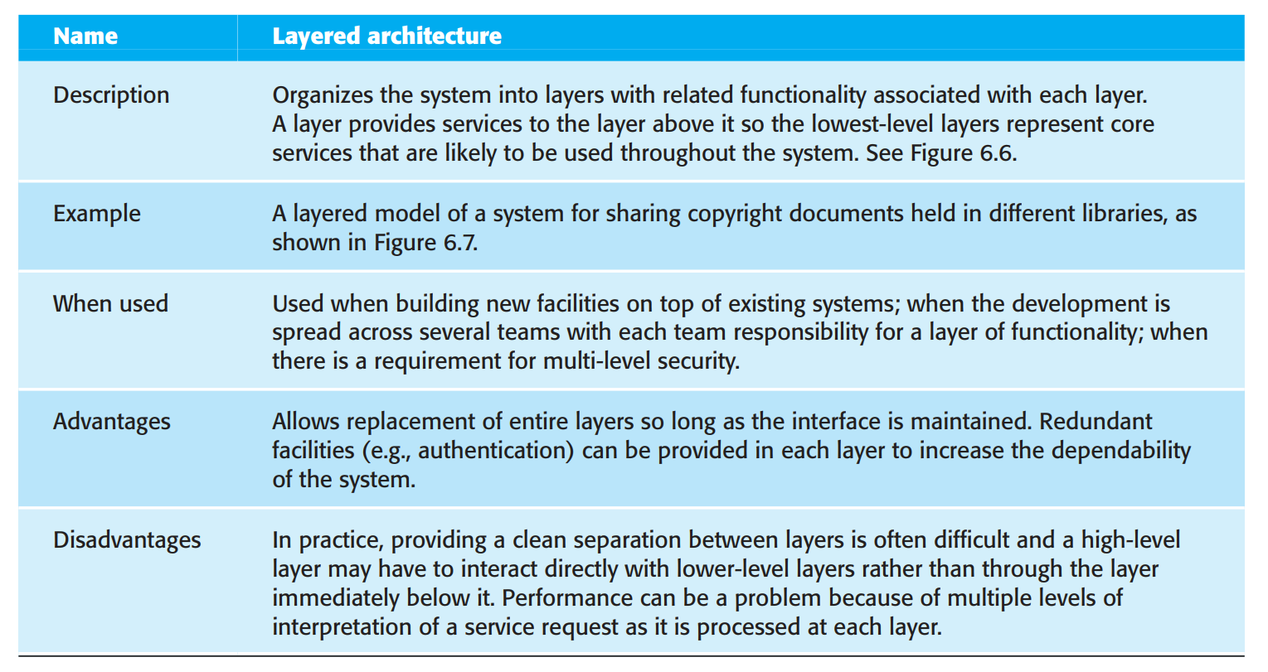

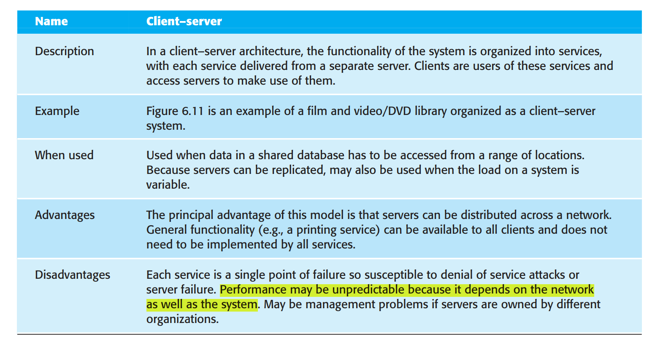

2. How to choose software architecture based on non-functional requirements

Answer:

Because of the close relationship between non-functional requirements and software architecture, the particular architectural style and structure that you choose for a system should depend on the non-functional system requirements:

1. Performance If performance is a critical requirement, the architecture should be designed to localize critical operations within a small number of components, with these components all deployed on the same computer rather than distributed across the network. This may mean using a few relatively large components rather than small, fine-grain components, which reduces the number of component communications. You may also consider run-time system organizations that allow the system to be replicated and executed on different processors.

2. Security If security is a critical requirement, a layered structure for the architecture should be used, with the most critical assets protected in the innermost layers, with a high level of security validation applied to these layers.

3. Safety If safety is a critical requirement, the architecture should be designed so that safety-related operations are all located in either a single component or in a small number of components. This reduces the costs and problems of safety validation and makes it possible to provide related protection systems that can safely shut down the system in the event of failure.

4. Availability If availability is a critical requirement, the architecture should be designed to include redundant components so that it is possible to replace and update components without stopping the system. I describe two fault-tolerant system architectures for high-availability systems in Chapter 13.

5. Maintainability If maintainability is a critical requirement, the system architecture should be designed using fine-grain, self-contained components that may readily be changed. Producers of data should be separated from consumers and shared data structures should be avoided.