Faculty of Information Technology

SYSTEM ANALYSIS AND DESIGN
Fall 2021


Chapter 3 Determining Software Requirement

Part I. Requirement gathering

1) You are developing a Human Resource Management software for your customer. You have to Interview groups of people with diverse needs to find synergies and contrasts among system requirements. Plan the interview for gather requirement with the following artifacts: Agenda, Checklist, Questions.

Difficulty: Difficult
Learning objectives: (i) 3.1 Describe options for designing and conducting interviews and developing a plan for conducting an interview to determine system requirements, (ii) 3.2 Explain the advantages and pitfalls of observing workers and analyzing business documents to determine system requirements (iii) 3.4 Participate in and help plan a Joint Application Design session
Teaching activity: Students have 20 mins to answer, teacher-student interaction to share & discuss
Sample answer:
Interview outline
Interviewee: | Interviewer:
Location: | Appointment:
Objectives
Agenda:  Intro  Background on project  Overview of the interview  - Topic to be covered  - Permission to record  Topic 1 questions  Topic 2 questions  Summary  Closing | Estimated time:  1 min  2-3 mins  2 mins  1 min  3 mins  3 mins  3 mins  1 min
General observation:
Topic not covered:
Questions | Notes
- Question 1: What are your expected functionalities of the system? | Answer: I want it to manage employee information and their payment  Observation: Seem not confident with the answer
- Question 2: How many departments are there? | Answer: 3 departments: human resource department, accounting department, sales  Observation:
- Question 3: Could you please tell me about job positions in each department? | Answer: ….  Observation:….
- Question 4: How to calculate salary for each position? | Answer:…  Observation:….

2) Write a requirement specification for a function: Manage employee in organization.

Difficulty: Medium
Learning objectives: 3.3 Explain how computing can provide support for requirements determination
Teaching activity: Students have 20 mins to work in pair, teacher-student interaction to share & discuss
Answer:
- A purpose
This document captures the complete requirements for employee management function in A company.
- An overall description

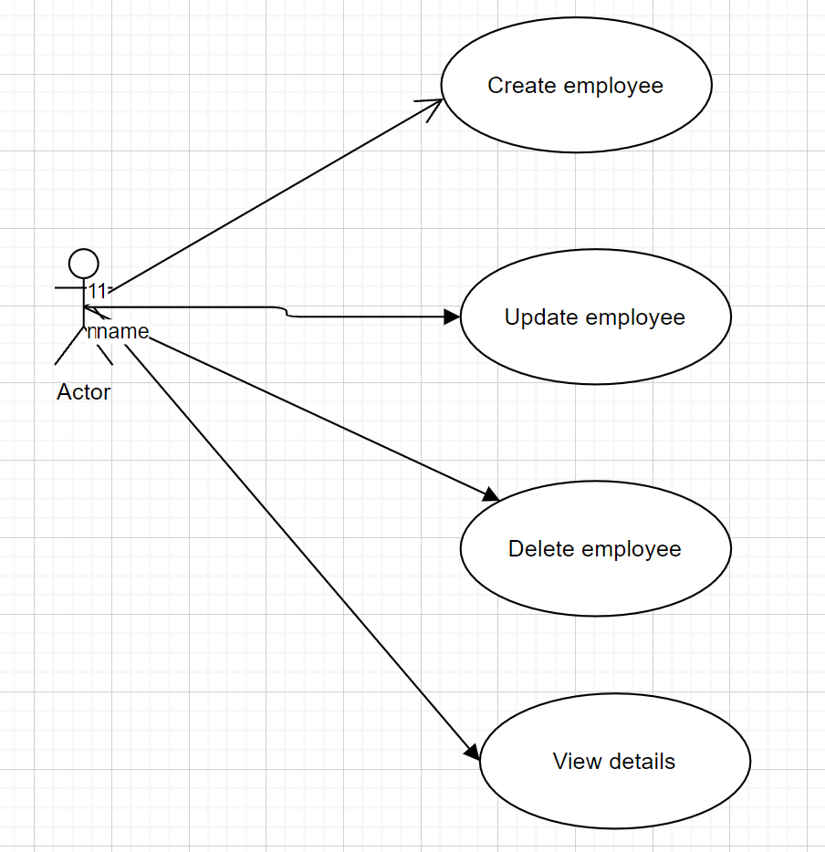
- Specific requirement
  - Functional requirement
    - Create employee
This function allows an authenticated user to create a new employee. In order to create a new employee, the user needs to provide the following information:
- Employee id: the unique identity number of an employee
- Employee fullname:… full name of the employee
- Date of birth
- Place of birth (city name only
- Address(full address)
- Phone number (10 digit number)
- Email (can be blank)
    - Update employee:
This function allows an authenticated user to update an existed employee based on the ID. In order to update a new employee, the user needs to select an employee based on ID and provide suitable information to change.

    - Delete employee:
This function allows an authenticated user to delete an existed employee based on the ID. If an employee is deleted, alll the information of the employee must be remove from the db

  - Non functional requirement
- The system should be accessible 24/7
- Each request should be processed within 10 seconds.
- The site should load in 3 seconds when the number of simultaneous users are > 10000

Part 2. Prototyping

1) Use any tool (Word, Excel, Paint, Visio, Free online mockup / prototyping tools, etc.) to create prototype for above function: Manage employee.

Difficulty: Medium
Learning objectives: 3.3 Explain how computing can provide support for requirements determination
Teaching activity: Students have 30 mins to answer, teacher-student interaction to share & discuss
Answer:

Based on Manage employee in organization spec. above. After gathering requirements, the development team decides to have the following functionality:
- Manage Employee List: Employee table includes: ID (1,2, …), Employee Identification Number (1901040005 – for example), name, DOB, gender, address
- Manage Employee includes:
  - Allow user to enter new employee information
  - Allow user to view employee list
  - Allow user to edit existing employee information
  - Allow user to remove employee out of company.

https://balsamiq.cloud/sdguf54/puh3jj6/r2278

