WISHWAVE

Use-Case-Realization Specification: Earn Coins

Version 1.0

Revision History
Date | Version | Description | Author
26/11/2024 | 1.0 | Complete the final version | Tran Thi Giang

Table of Contents
1. Introduction 4
1.1 Purpose 4
1.2 Scope 4
1.3 Definitions, Acronyms, and Abbreviations 4
1.4 References 4
1.5 Overview 4
2. Flow of Events 5
3. Derived Requirements 8

Use-Case-Realization Specification: Earn Coins

Introduction

Purpose
This document outlines the implementation details of the Earn Coins use case in WishWave application, focusing on the sequence and class diagrams that illustrate system interactions.

Scope
This document applies to earning, tracking, redeeming, and updating coin-related activities in the WishWave application.

Definitions, Acronyms, and Abbreviations
User: The player using the app to interact with the game, manage trees, complete tasks, and earn rewards.
StartUI: The main screen where the user taps the "Play" button to begin the game.
TreeListUI: The screen where the user selects a tree to plant from a list of available options.
FarmUI: The interface where the user manages and interacts with their farm, including seeing and maintaining the planted tree.
Water icon: The button in FarmUI that the user taps to water their tree.
Task icon: The button in FarmUI that the user taps to access and complete tasks for rewards.
TasksListUI: The screen where the user views available tasks and their statuses.
TaskDetailedUI: The detailed interface where users complete more complex tasks or leave them unfinished.
CollectCoins button: The button that appears when the tree matures, allowing the user to collect coins and bonuses from the harvested tree.
Item icon: The button in FarmUI that the user taps to manage or purchase items for the game.
ItemShopUI: The interface where users can purchase new items for their farm.
ItemStorageUI: The interface where users can view and manage items they already own.
EventList popup: A pop-up that displays current in-game events and challenges available for the user to engage with.
NotifListUI: The interface where users can view notifications related to tasks, events, or updates in the game.
changeIcon: The button the user taps to change their current tree by selecting a new one from the TreeListUI.

References
NA.

Overview
The use-case realization specification for the Earn Coins feature in the WishWave application is designed to facilitate understanding and guide implementation. Additionally, the derived requirements section identifies further needs, including non-functional requirements, that extend beyond the design model and are necessary for successful implementation.

Flow of Events

Sequence diagram
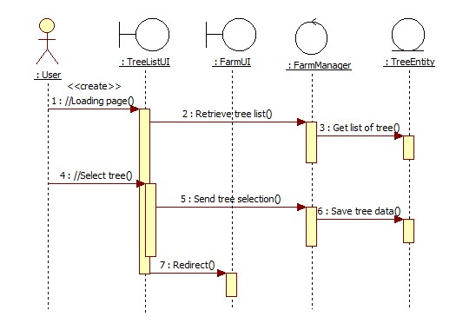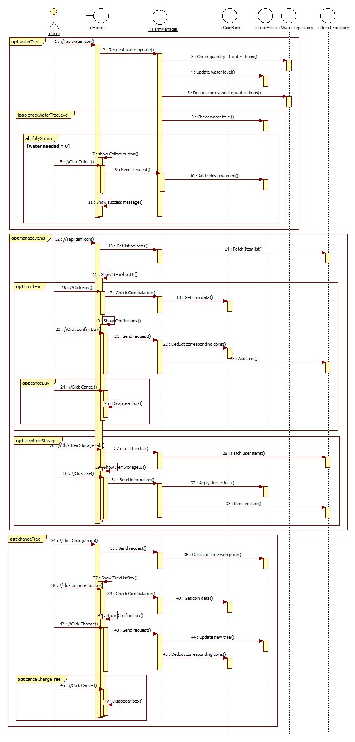
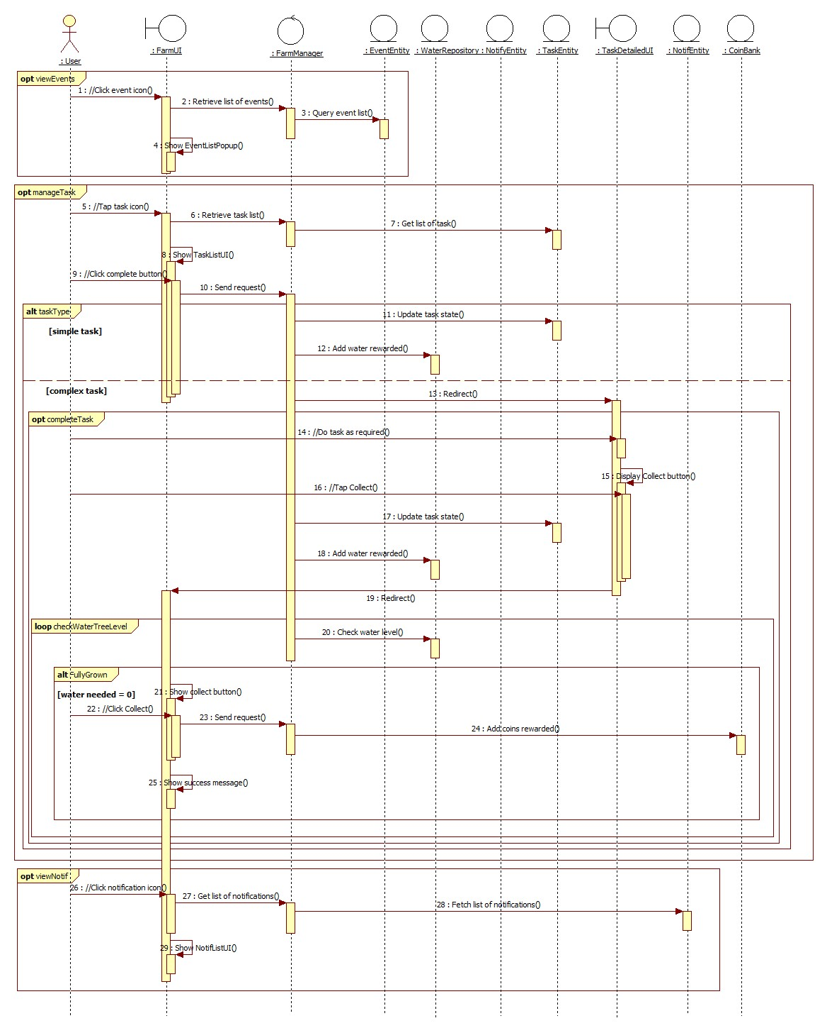

Class Diagram
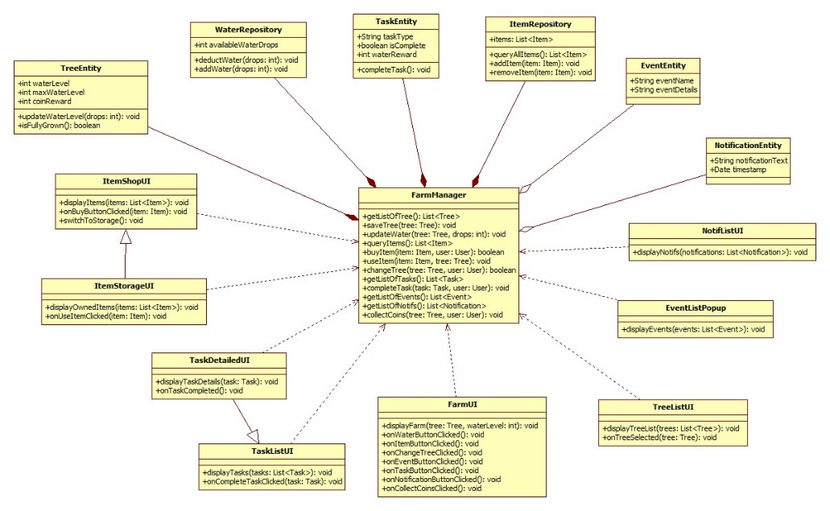

Derived Requirements

Functional Requirements

- Intuitive access to Earn Coins with clear feedback and prominent key features.
- Offline earning with auto-sync when online.
- Users can customize privacy settings for social interactions.

Non-Functional Requirements

- Quick UI updates with minimal latency (<2 seconds).
- Strong encryption for data storage and transmission.
- Scalable modular design for future enhancements.

