WISHWAVE

Use-Case-Realization Specification: Earn Coins

Version 1.0

Revision History
Date | Version | Description | Author
26/11/2024 | 1.0 | Complete the final version | Tran Thi Giang

Table of Contents
1. Introduction 2
1.1 Purpose 2
1.2 Scope 2
1.3 Definitions, Acronyms, and Abbreviations 2
1.4 References 2
1.5 Overview 2
2. Flow of Events—Design 2
3. Derived Requirements 2

Use-Case-Realization Specification: Earn Coins

Introduction

Purpose
This document outlines the implementation details of the Earn Coins use case in WishWave application, focusing on the sequence and class diagrams that illustrate system interactions.

Scope
This document applies to earning, tracking, redeeming, and updating coin-related activities in the WishWave application.

Definitions, Acronyms, and Abbreviations
User: The player using the WishWave app to earn coins by interacting with the game elements.
StartUI: The main screen of the app, where the "Play" button is displayed to start the game.
TreeListUI: Displays a list of available trees that the user can choose to plant.
TreeEntity: A class that manages the state of the tree, including its growth and water levels.
FarmUI: Displays the user's farm, showing planted trees, their status, and options like watering or harvesting.
WaterRepository: Stores the available water quantity, used to check if the user has enough water to water trees.
TaskListUI: Displays a list of tasks the user can complete for rewards, including simple and complex tasks.
TaskEntity: Contains data about tasks, including task status and whether it’s completed or not.
FarmManager: Manages tree growth, maturity, and coin collection processes.
ItemShopUI: Displays items available for purchase, such as tools or boosts for the farm.
ItemStorageUI: Displays a list of items the user owns, which can be used on the trees to improve growth or provide other benefits.
ItemRepository: Stores the items the user has purchased or collected.
CoinBank: Tracks the user's current coin balance for transactions.
EventListPopup: Displays current in-game events, such as special challenges or time-limited offers.

References
N/A.

Overview
The use-case realization specification for the Earn Coins feature in the WishWave application is designed to facilitate understanding and guide implementation. This document includes a comprehensive description of the use case, along with sequence and class diagrams that illustrate its operation. Additionally, the derived requirements section identifies further needs, including non-functional requirements, that extend beyond the design model and are necessary for successful implementation.

Flow of Events—Design

Sequence Diagram
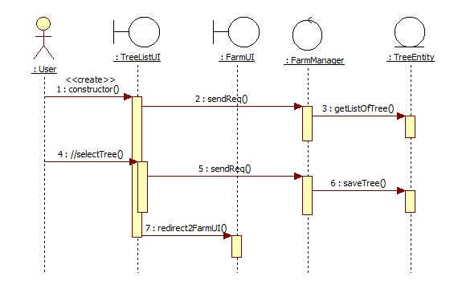
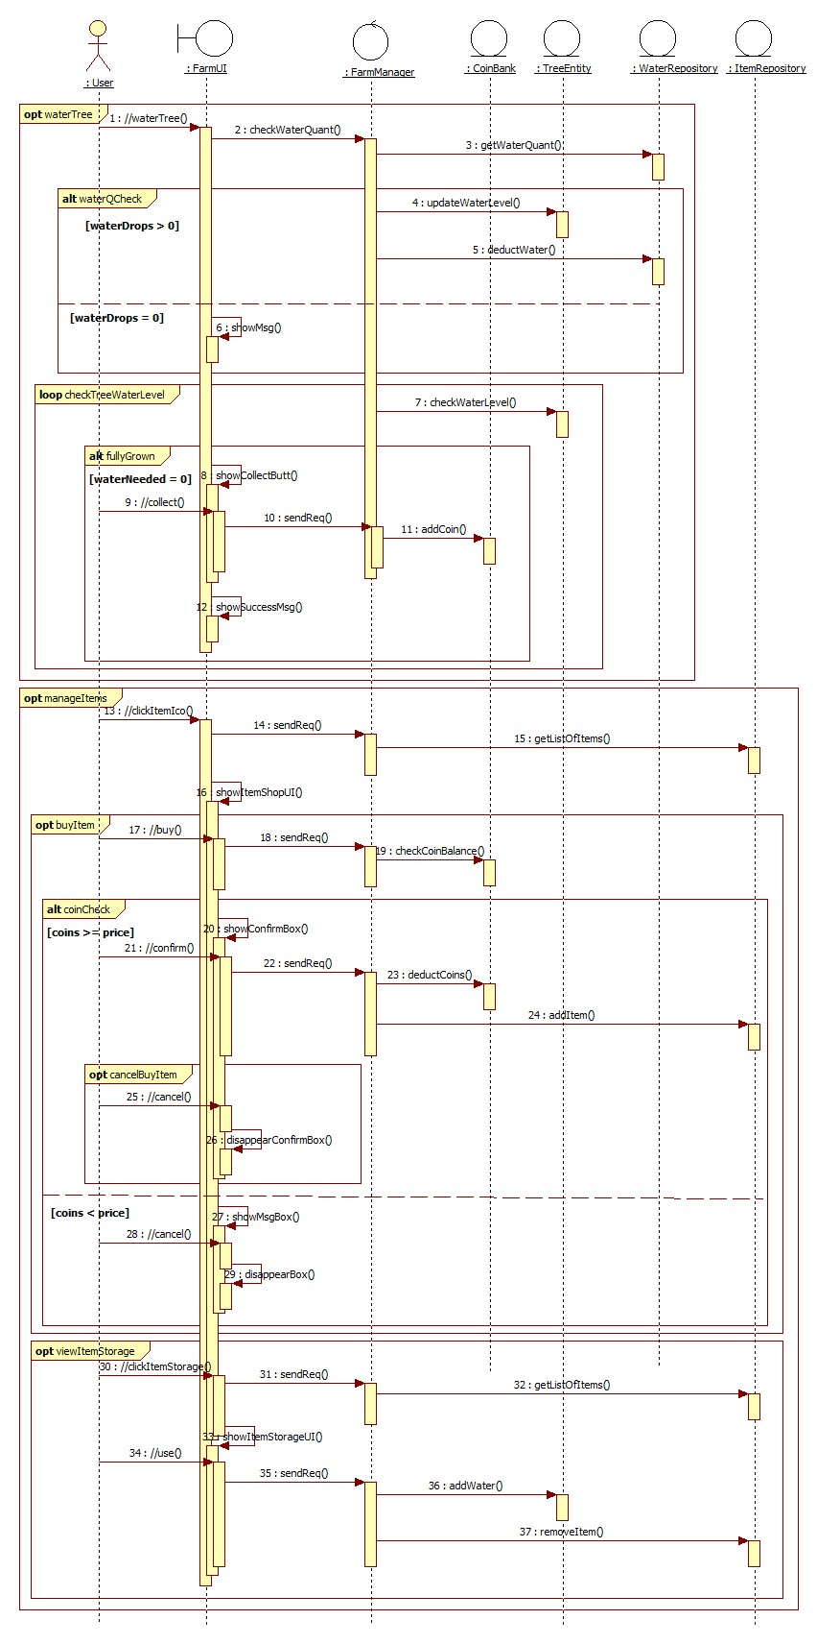
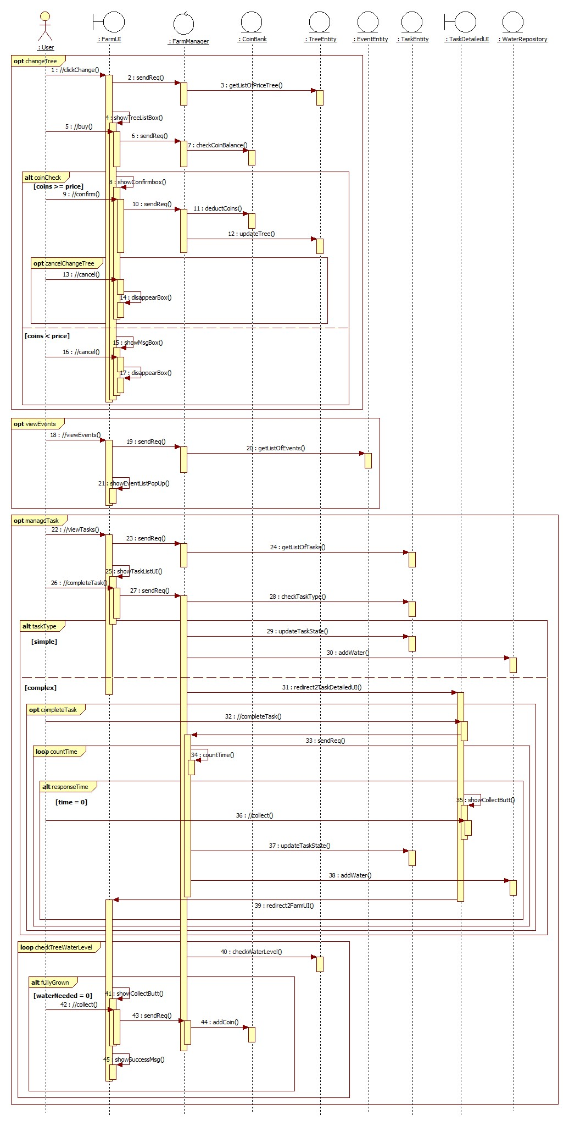
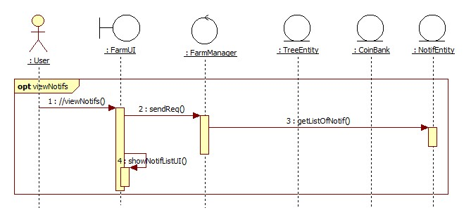

2.2 Class Diagram
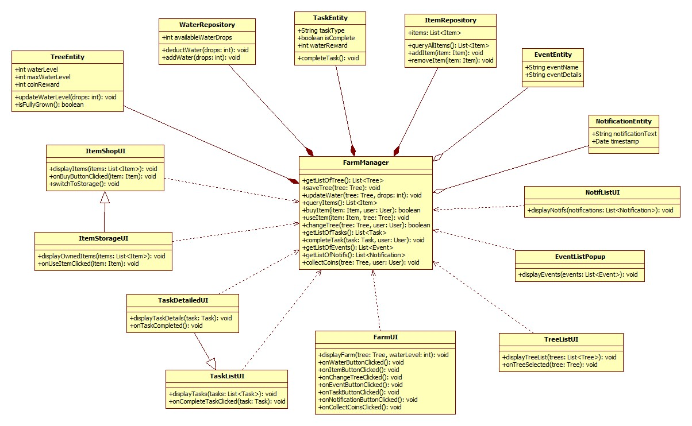

Derived Requirements

Functional Requirements
- Intuitive access to Earn Coins with clear feedback and prominent key features.
- Offline earning with auto-sync when online.
- Users can customize privacy settings for social interactions.

Non-Functional Requirements
- Quick UI updates with minimal latency (<2 seconds).
- Strong encryption for data storage and transmission.
- Scalable modular design for future enhancements.

