WishWave

Use-Case Specification: Book Hotel

Version 1.0

Revision History
Date | Version | Description | Author
26/11/2024 | 1.0 | Complete the final version | Tran Thi Giang

Table of Contents
1. Use-Case Name 4
1.1 Brief Description 4
2. Flow of Events 4
2.1 Basic Flow 4
2.2 Alternative Flows 6
3. Special Requirements 6
4. Preconditions 7
4.1. The user must have a registered account and logged into the WishWave app. 7
4.2. The user must have access to a stable internet connection for syncing game progress. 7
5. Postconditions 7
5.1 The tree state is updated (e.g., water level or growth status). 7
5.2 The user's coin balance in CoinBank reflects any transactions. 7
6. Extension Points 7
7. Prototype 7

Use-Case Specification: Earn Coins

Use-Case Name

Brief Description
The purpose of this use case is to describe the process through which a user earns coins in the WishWave application.

Flow of Events

Basic Flow
The use case begins on the TreeListUI, where a carousel-style layout presents six trees, including Bonsai, Pine, and Coconut. Each tree card has a clean white background with subtle shadows, displaying the tree name in bold (font size: 18px) at the top, followed by details about the required water drops and earned coins in a smaller font (12px). Users can navigate the tree list using slider arrows with a gray background that darkens on hover and turns green (#4CAF50) when clicked.

When a user clicks on a tree, the selected card is highlighted with a light green border (2px solid #4CAF50), and the "Plant" button becomes active, changing its color from gray (#d3d3d3) to dark red (#8B0000). Clicking the "Plant" button sends a request to the FarmManager to save the selected tree using the TreeEntity. The tree data, including its initial water level (set to 0), is saved successfully, and the user is redirected to the FarmUI. The FarmUI features a horizontal navigation bar at the top with circular icon buttons for Coins, Items, Change, Events, Tasks, and Notifications, each accompanied by a small text label below to depict its function. The main screen presents a serene beach environment with a growing sapling centered, representing the user’s progress. At the bottom of the screen, a progress bar stretches across, with a watering can icon on the left and a final tree icon on the right, visually indicating the growth progress of the sapling. Below the watering can icon, a display shows the total water drop count available to the user, which includes 1000 drops provided at the start of the game, combined with any additional drops earned or accumulated by the user.

When users click the water icon (a circular green watering can with a white border at the bottom-left), the system interacts with FarmManager, which checks the water drops available in WaterRepository. If the count is 0, FarmUI displays a modal box in the center of the screen, showing the message "Out of water now, please do task to earn water drop" and a "Cancel" button, which closes the box when the user clicks. If the count is greater than 0, FarmManager deducts 50 drops from WaterRepository and updates the TreeEntity water level. The progress bar updates, displaying "1580 bear fruit" in white text. Simultaneously, the WaterRepository counter in the bottom-left decreases by 50.

When the user clicks the "Items" icon in the navigation bar, a request is sent to the FarmManager. The FarmManager retrieves a list of 4 available items from the ItemRepository and displays them in the ItemShopUI. The shop interface is laid out with tabs at the top, where the "Item Shop" tab is active, and the "Item Storage" tab is also available. Below, four item cards are displayed. Each card contains the item's name, a brief description of its function, the price in coins, and a "Buy" button. The item cards are styled with a white background, rounded corners, and a shadow effect, while the text is dark gray, with the price displayed at the bottom of the card in bold.

When the user clicks the "Buy" button on an item, a request is sent to the FarmManager to check if the user has enough coins in their CoinBank. If the user has insufficient coins, a modal will appear in the center of the screen displaying a message that says "Not enough coins" with a "Cancel" button. The modal is styled with a white background, rounded corners, and a shadow, while the "Cancel" button has a simple border and a hover effect. If the user has enough coins, a confirmation modal will appear asking, "Use X coins to buy [Item Name]?" This modal contains two buttons: "Cancel" and "Confirm Buy". If the user clicks "Confirm Buy", the FarmManager deducts the required coins from the CoinBank, the item is added to the user's ItemRepository, and a success message, such as "Purchase Successful!", is displayed. If the user clicks "Cancel", the screen will return to the shop.

If the user switches to the "Item Storage" tab, the FarmManager queries the ItemRepository to retrieve the user's current items. The ItemStorageUI displays each item as a card. These cards show the item’s name, a brief description, and the quantity available, with the count displayed in the top-right corner of the card. Each card also features a "Use" button that allows the user to use the item. The cards are styled similarly to the shop cards, with small, bold text for the quantity and a blue "Use" button.
When the user clicks the "Use" button, a request is sent to the FarmManager to update the TreeEntity with the appropriate water level based on the item used on FarmUI. The components of the progress bar update dynamically. The used item is then removed from the ItemRepository.

When a user clicks the Change Icon button, the system initiates the process of updating the tree on their farm, contingent on their coin balance. Upon clicking, the FarmUI sends a request to the FarmManager, which retrieves the list of trees via the TreeEntity component and displays the TreeListBox interface. This interface, designed for tree replacement, features a horizontally scrollable carousel showcasing six trees in a card layout. Each card mirrors the style of the TreeListUI, but adds a button that displays the price of the tree, as changing a tree requires coins, unlike planting a new tree, which is free. When a user selects a tree by clicking that button, the system checks the user’s coin balance, interacting with the CoinBank. If the user has sufficient coins, a confirmation dialog appears, asking: "Spend X coins to switch from <current tree> to <chosen tree>?". The dialog includes Confirm and Cancel buttons styled with hover effects. Confirming the action triggers the FarmManager to execute the updateTree() function, updating the tree in the TreeEntity and reflecting changes in the FarmUI. The tree icon updates with a fade-in effect, the progress bar resets to zero, and the coin balance reflects the deduction. If the user lacks sufficient coins, a dialog appears stating: "Not have enough coins hic :(((" with Cancel button below. Clicking Cancel returns the user to the TreeListBox interface.

When the user clicks on the "Events" icon in the application, a request is sent to the FarmManager, which retrieves the list of available events from the EventEntity. Once the list is fetched, the EventListUI is displayed in the FarmUI, allowing the user to see all the current and upcoming events. The EventListUI is displayed in a soft yellow box with rounded corners. The header features a bold green background with white, centered text indicating "EVENTS." Each event appears as a separate item with a white background, light gray borders, and rounded edges. On the left is a small icon (e.g., water droplet or watering can), while the right side shows the event title in bold dark gray text and a short description in lighter gray. The list is static and purely informational, highlighting bonuses like "GET X2 WATER" and "WATER REFILL SPEED X2."

When the user clicks the Tasks icon in the FarmUI, a request is sent to the FarmManager, which retrieves a list of four tasks from TaskEntity. The type of each task is stored in the taskType field within TaskEntity but is not displayed on the UI. At the start of each new day, the state of these four tasks is updated to reflect their reset or refreshed status, ensuring users have a new set of tasks to complete daily.
The tasks are presented in the TaskListUI as bar list, each showing the task name, reward (e.g., “16660 💧”), and a "Complete" button for actionable tasks. Completed tasks are visually updated with a green-highlighted status message, such as "You completed this task and got 10 💧."
For simple tasks, clicking "Complete" sends a request to the FarmManager to update the task state and add the reward to the WaterRepository. The TaskListUI then reflects the completed status.
For complex tasks, clicking the task redirects the user to the TaskDetailedUI, which includes a timer and task description. The timer counts down 30 seconds as the user engages with the task. Once the countdown is complete, the timer disappears, and a blue "Collect" button appears. Clicking "Collect" sends a request to the FarmManager to update the task state, add the reward to the WaterRepository, and return the user to the TaskListUI, where the task is marked as completed.

When the user clicks on the notification icon, a request is sent to the FarmManager, which retrieves a list of notifications from the NotifEntity. The FarmUI then displays the NotifListUI, showing the five most recent notifications in a bar list format. Each notification bar contains a picture icon, the notification name (in bold and larger font), the time of the notification (in gray), and a brief description of the notification details. The notifications are presented in a white background, with the entire NotifListUI wrapped in a light green box. The list simply informs the user of important updates without interactive elements.

When the water level of the tree reaches its maximum (indicating that the required amount of water has been provided), the progress bar is fully filled, and a "Collect" button appears in place of the progress bar. This button, displayed in green with a rounded border (18px), shows the corresponding number of coins that the user will collect. At the same time, the tree in the FarmUI is updated to reflect its mature state. When the user clicks the "Collect" button, a request is sent to the FarmManager, which updates the user's coin balance. Afterward, the FarmUI is refreshed, removing the tree image and the progress/collect button. Instead, a success message appears in the center of the screen in a white box with black text, confirming that the collection was successful.

Alternative Flows
NA.

Special Requirements
NA.

Preconditions

The user must have a registered account and logged into the WishWave app.

The user must have access to a stable internet connection for syncing game progress.

Postconditions

The tree state is updated (e.g., water level or growth status).

The user's coin balance in CoinBank reflects any transactions.

Extension Points
6.1 Event Participation
Allows users to earn coins through limited-time in-game events.

Prototype

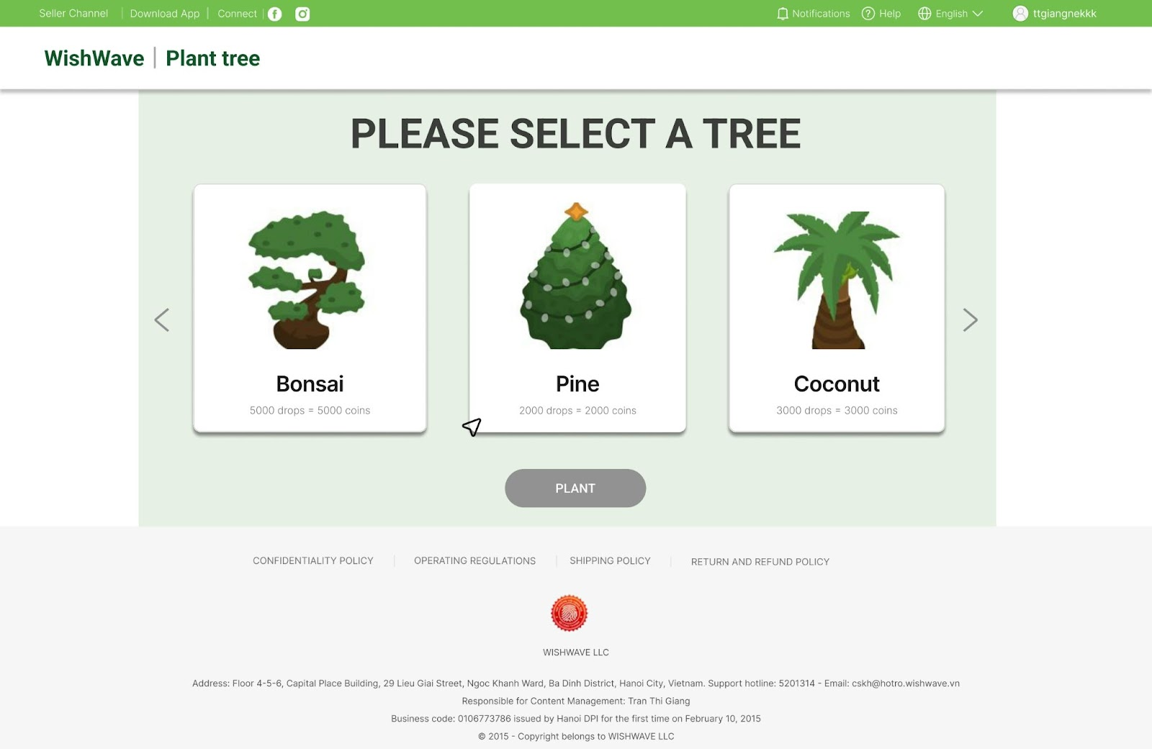

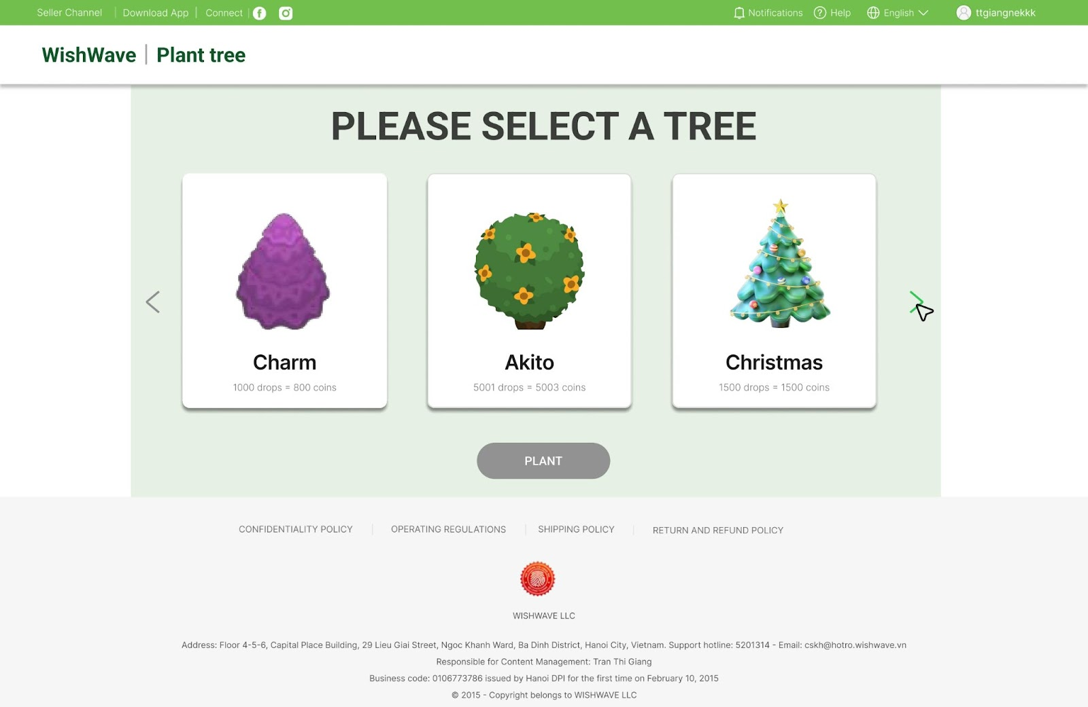

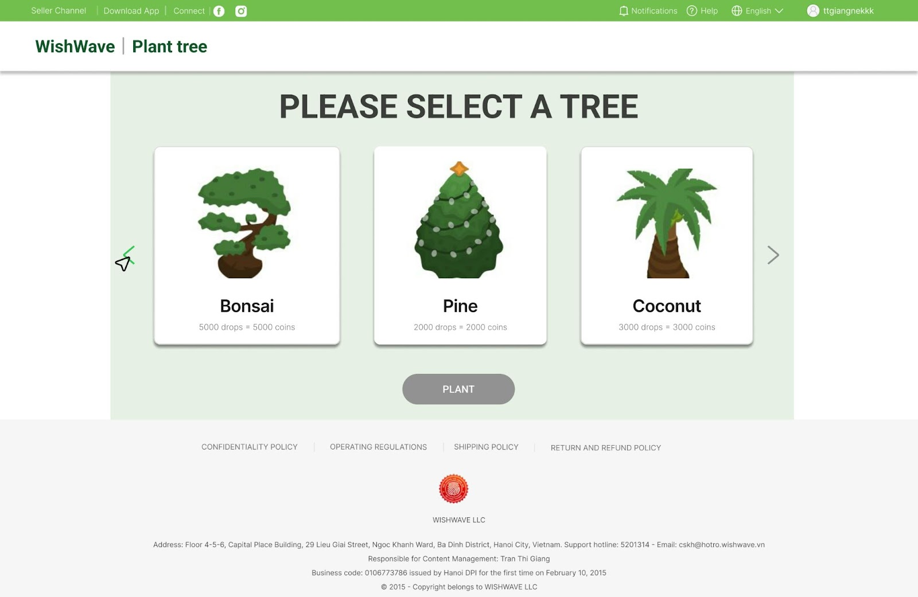

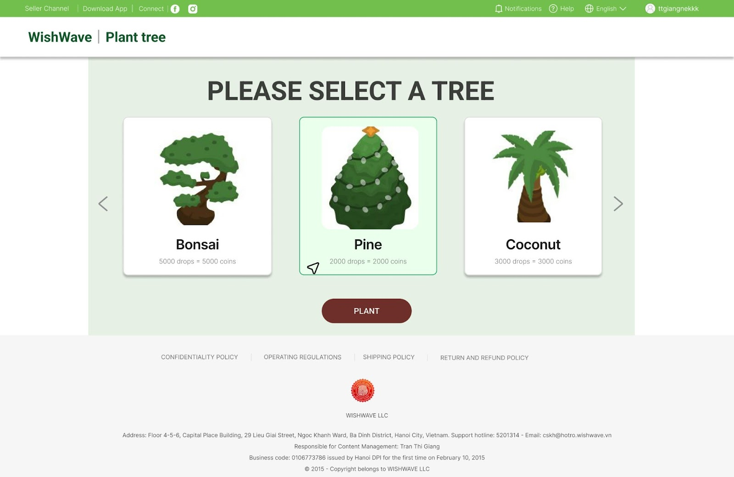
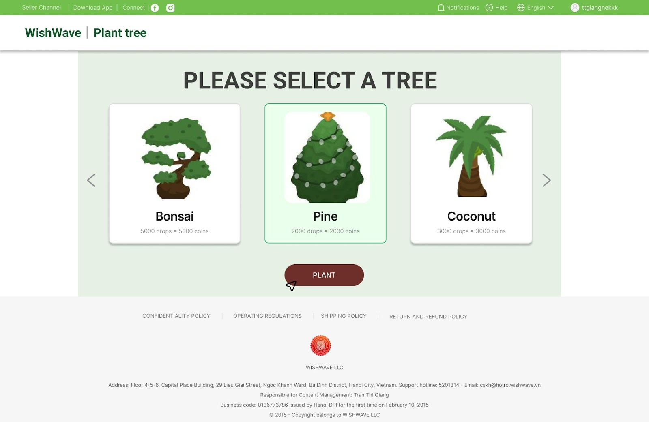
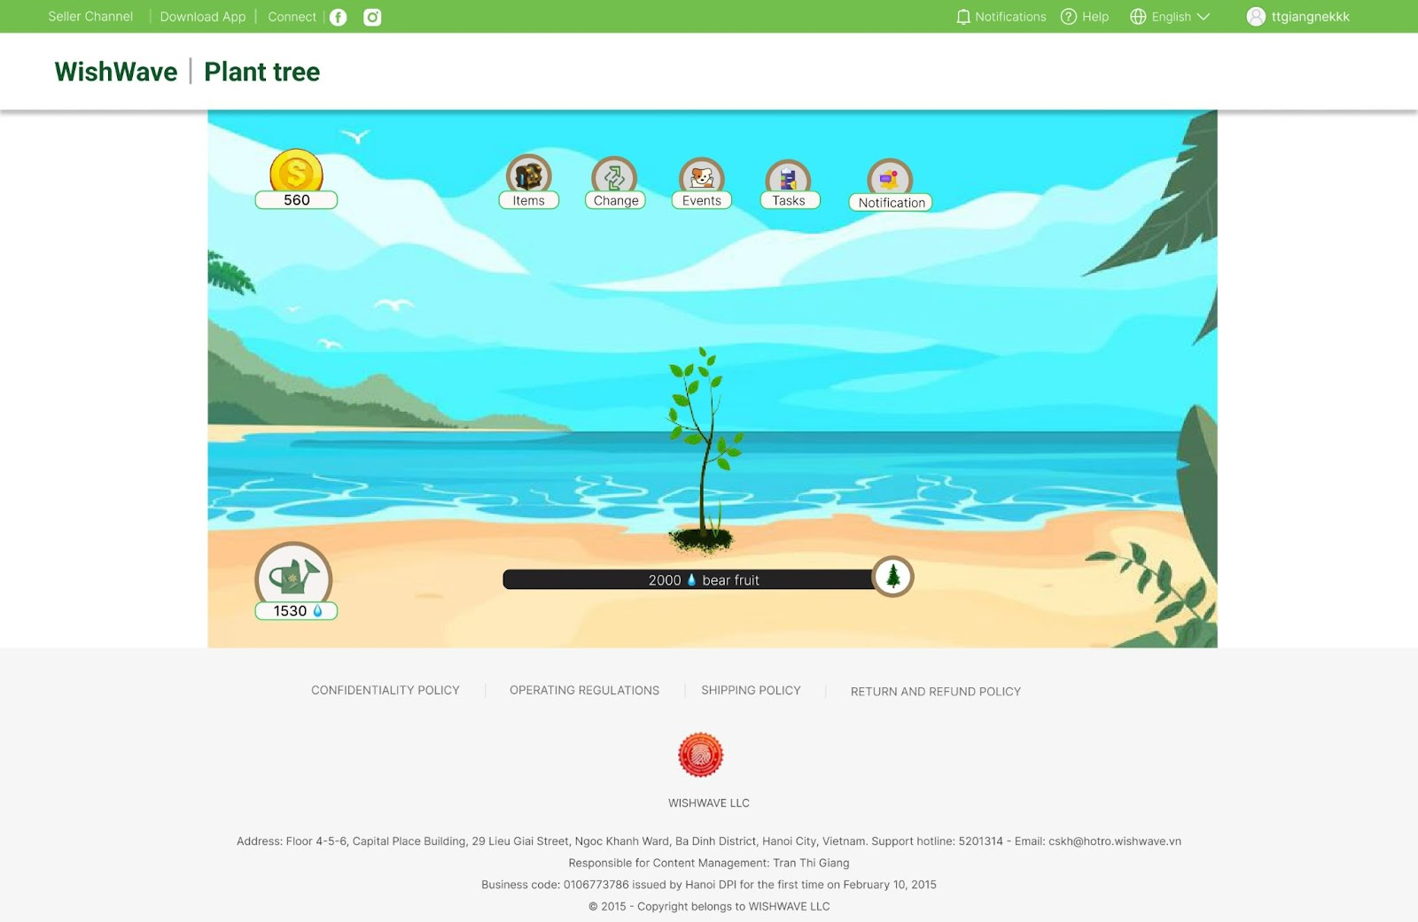
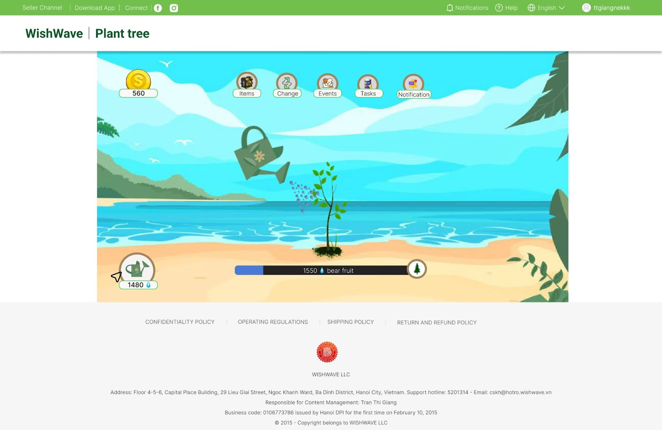
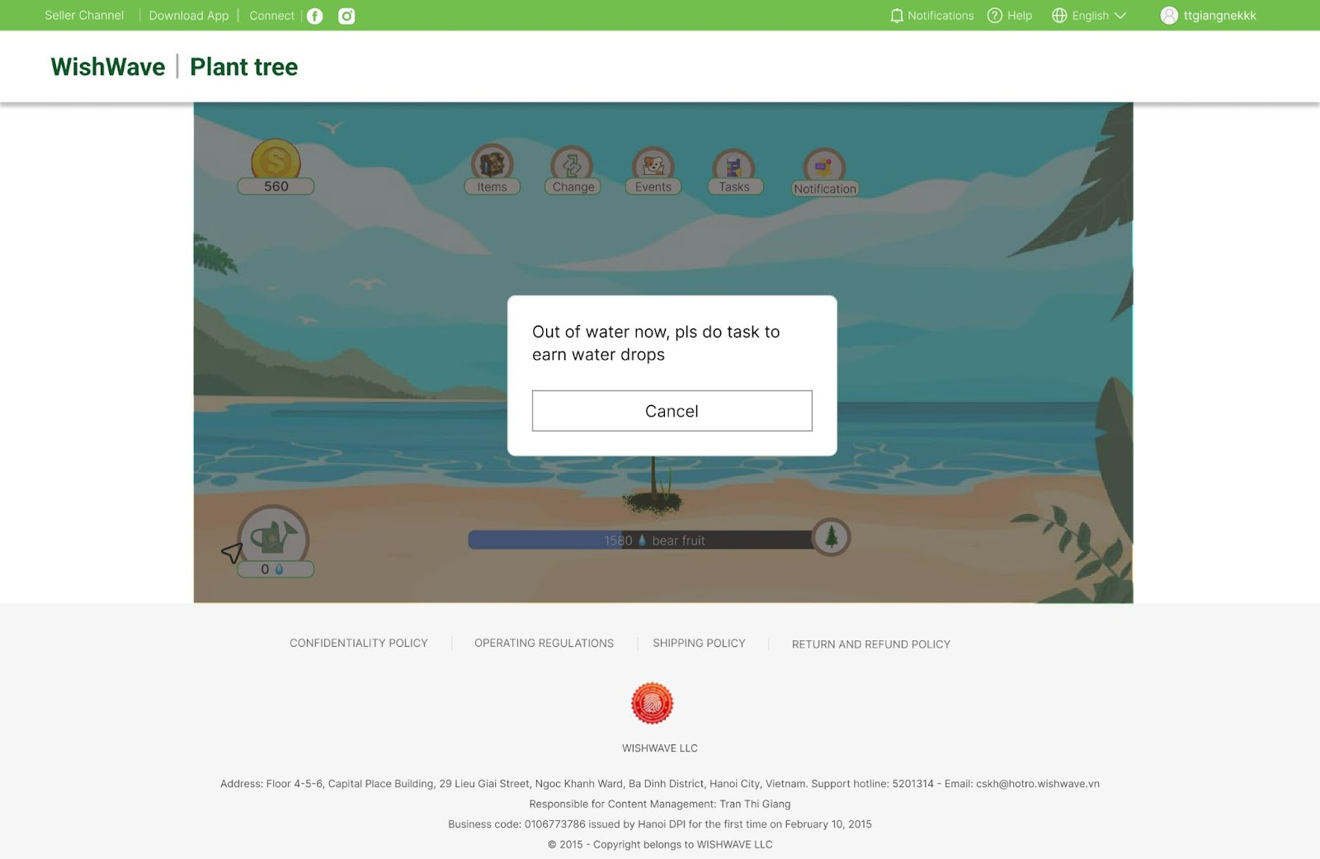

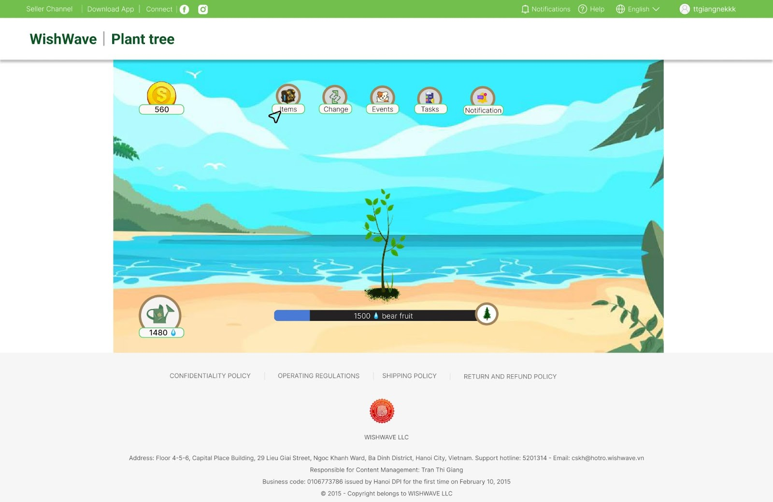

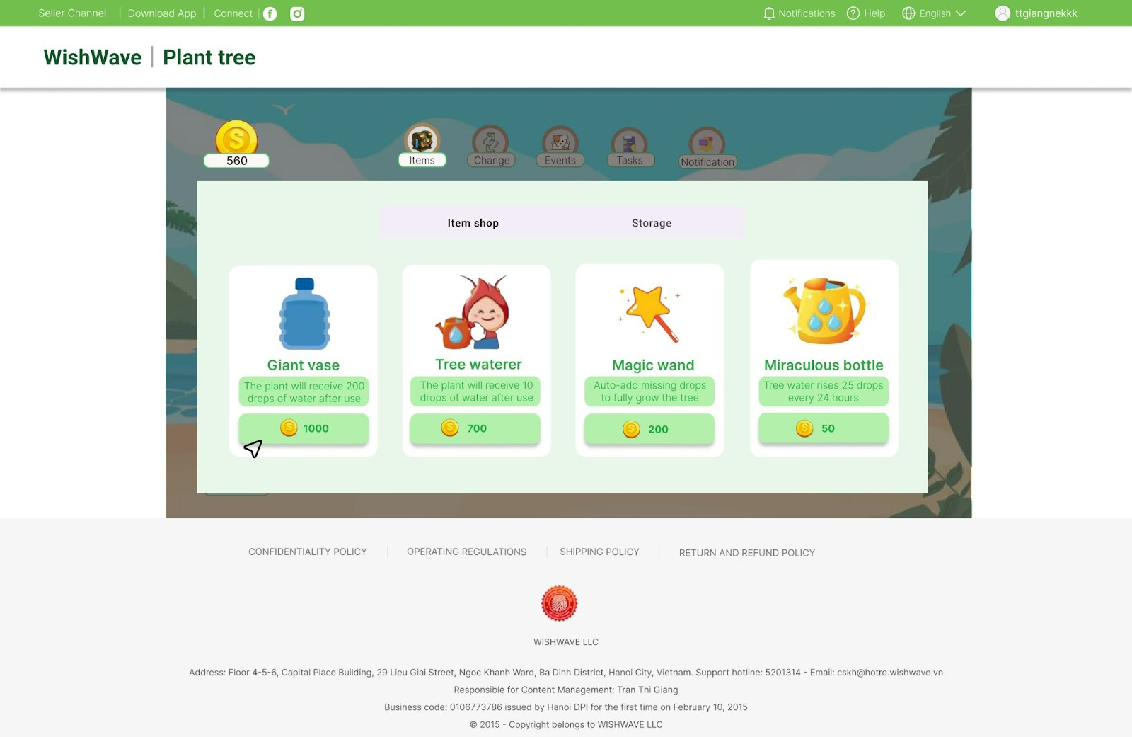

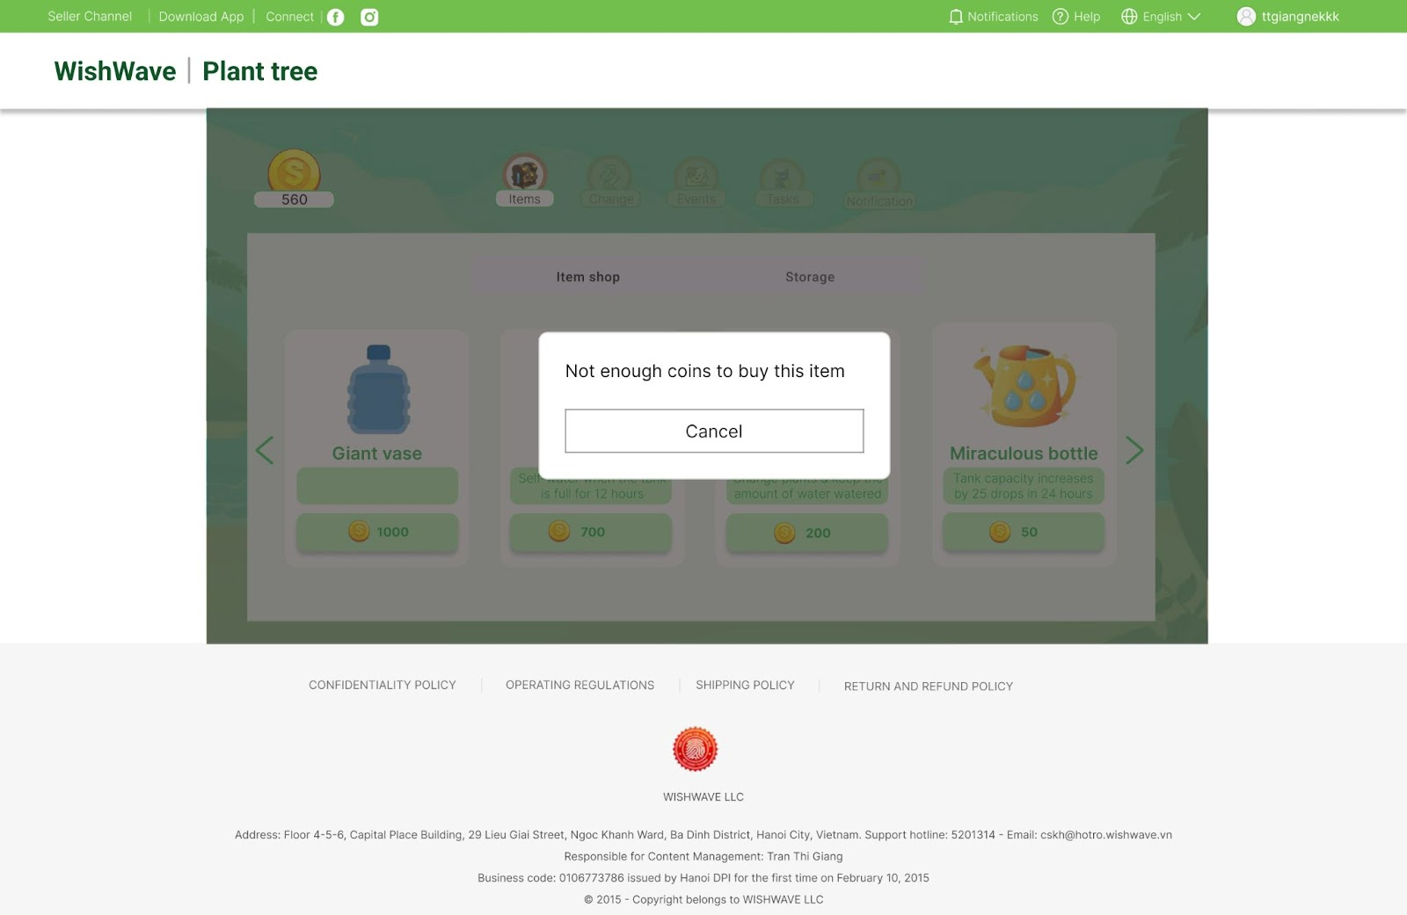
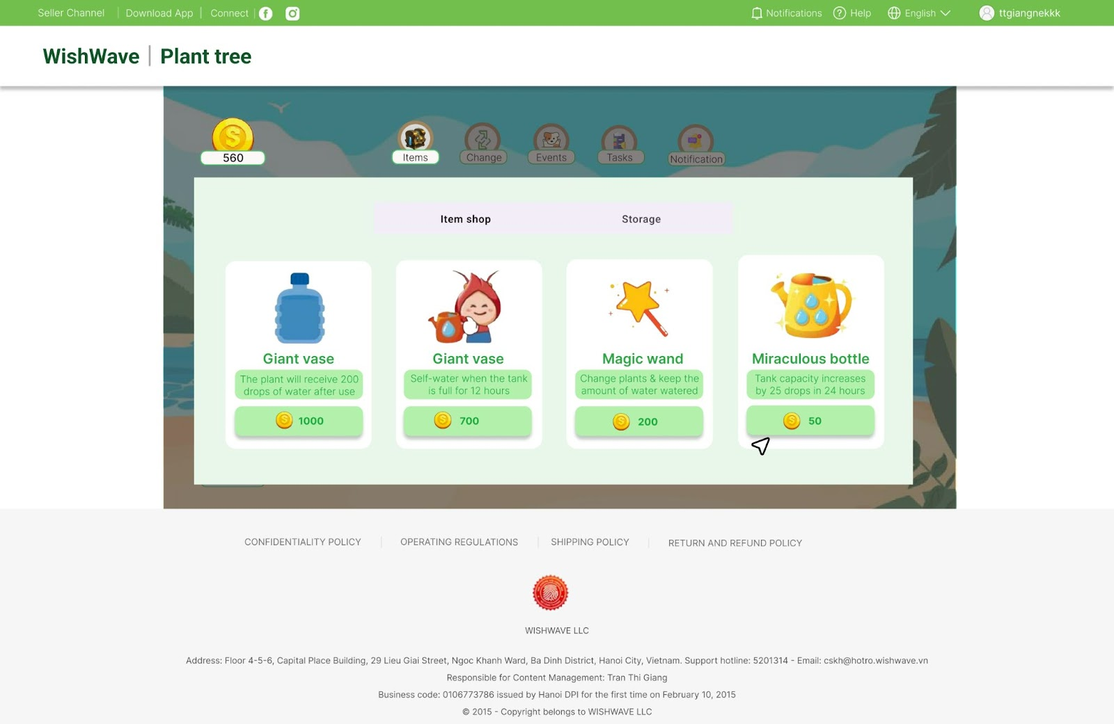
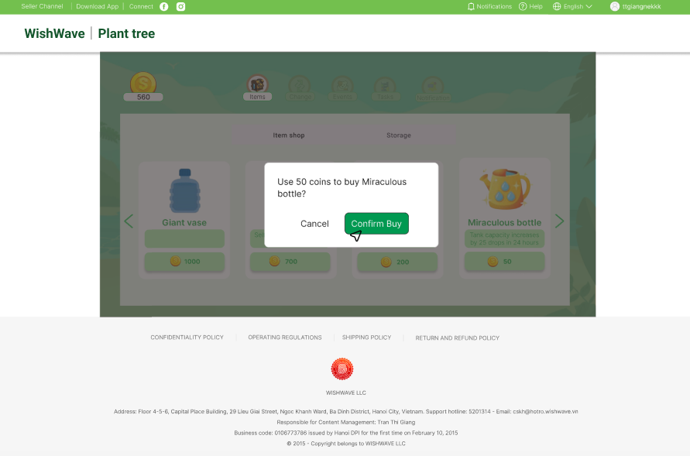
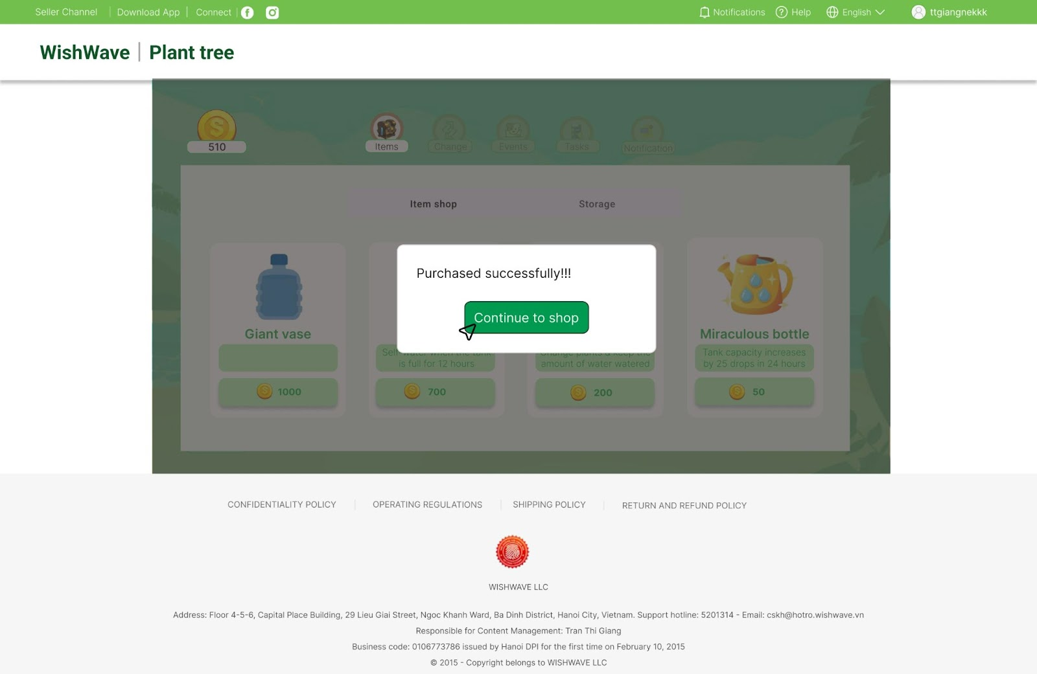

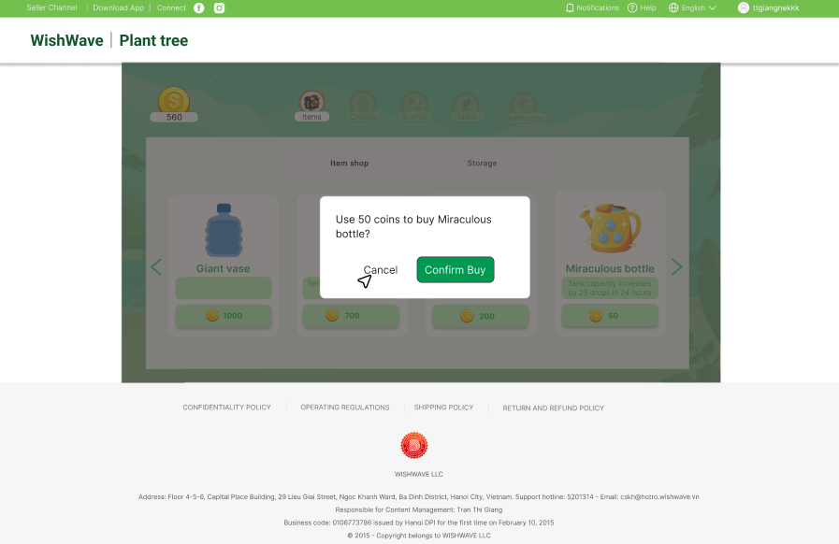
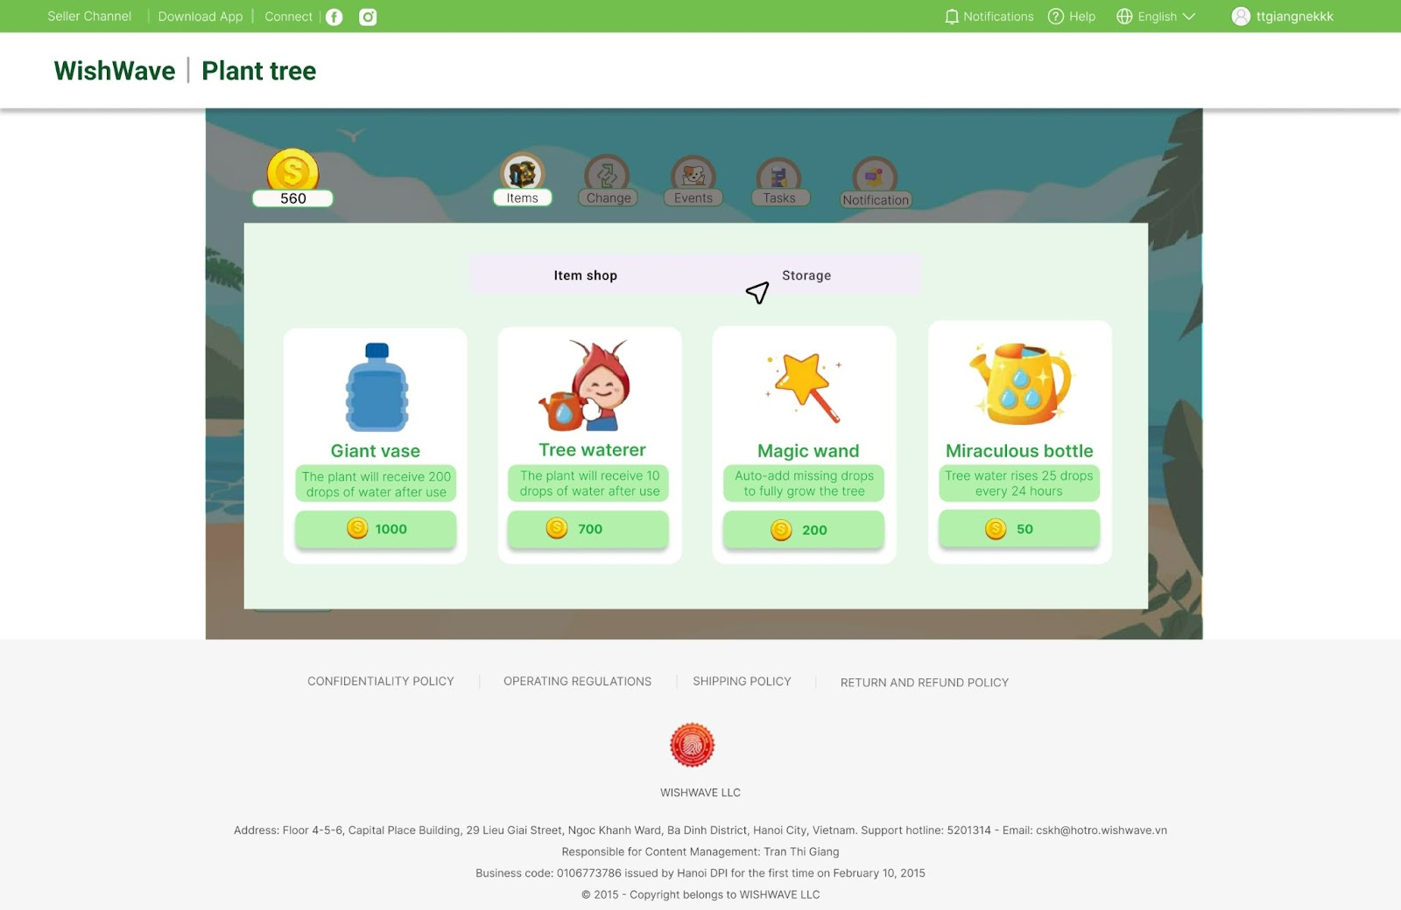

ItemStorageUI before buying Giant Vase:
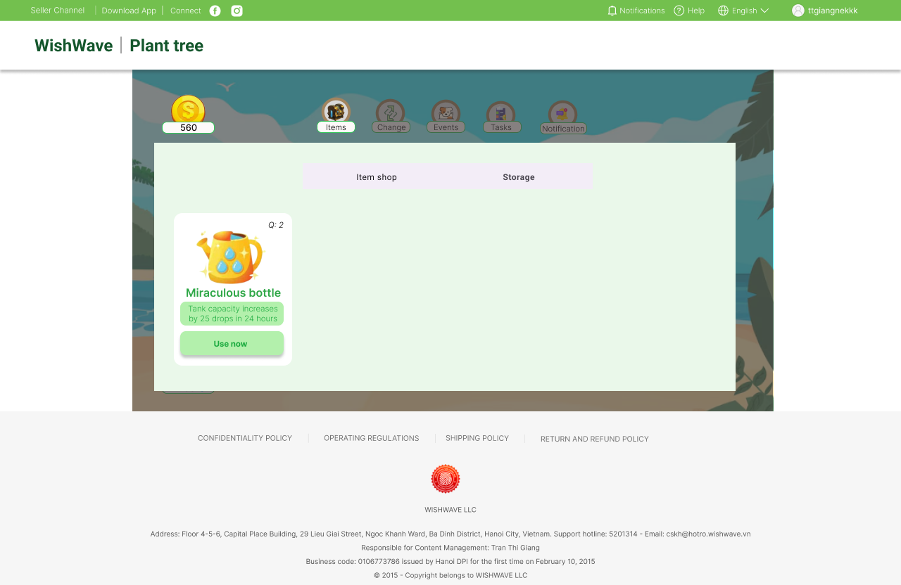

ItemStorageUI before buying Giant Vase:
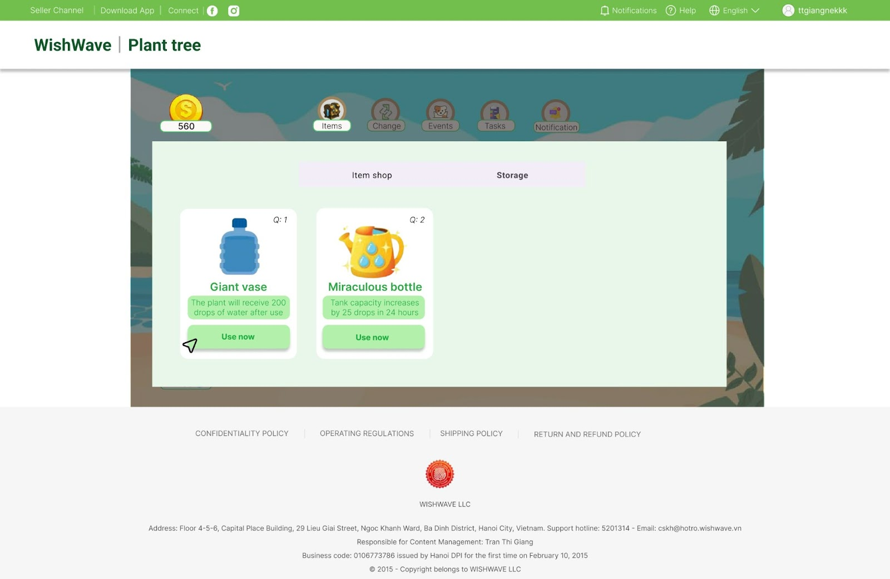
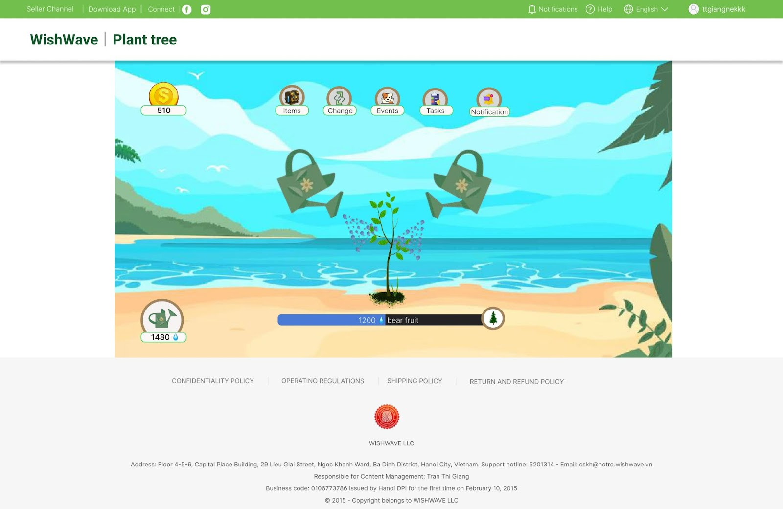
ItemStorageUI after using Giant Vase:


