FIT3140 – Assignment 2 (Traffic Analyzer App)
Team 28 – Kevin Tang (26918218) & Ken Chung (24767689)

Introduction
Analysing the number of people who enter or exit a particular area is something that could have a myriad of uses and applications in the real world – it can be used as a security feature to detect intruders, for logistical purposes to count crowds for events, to analyse the efficiency for architectural or design improvement – these are all simply examples of what such a seemingly simple concept can yield if applied in innovative ways.

Direction
In this initial leg of the project, the team aimed to create a basic working prototype of a simple traffic analyser with limited functionality. With a minimised scope that incorporated the scenario of a simple corridor or hallway, the app was created to detect the presence of a ‘person’ (more accurately, the concept of one) and to turn on a light accordingly. Both of the motion-sensor and the light is controlled through a webpage, which also displays how many people have passed through. It is not a large stretch to see the logical extension of this app into a personal intruder detector/alarm that could be installed into one’s home or business.

Of course, the product developed by the team is no way near refined or polished enough to consider a commercial release. The motion sensor used is extremely inaccurate and prone to imprecise readings, and all the code is optimised for the small scale of the project. But as a simple demontration of concepts and functionality the team considers it more than satisfactory.

Design
At a high level viewpoint, the whole ensemble consists of several components. There is tbasically three main pieces- the webpage client, which is where the user controls the app and sees the results, the server that communicates with the client, and is connected to the IoT kit, and the backend realtime database, which stores all the data that the sensor receives and retrieves it if asked by the client.
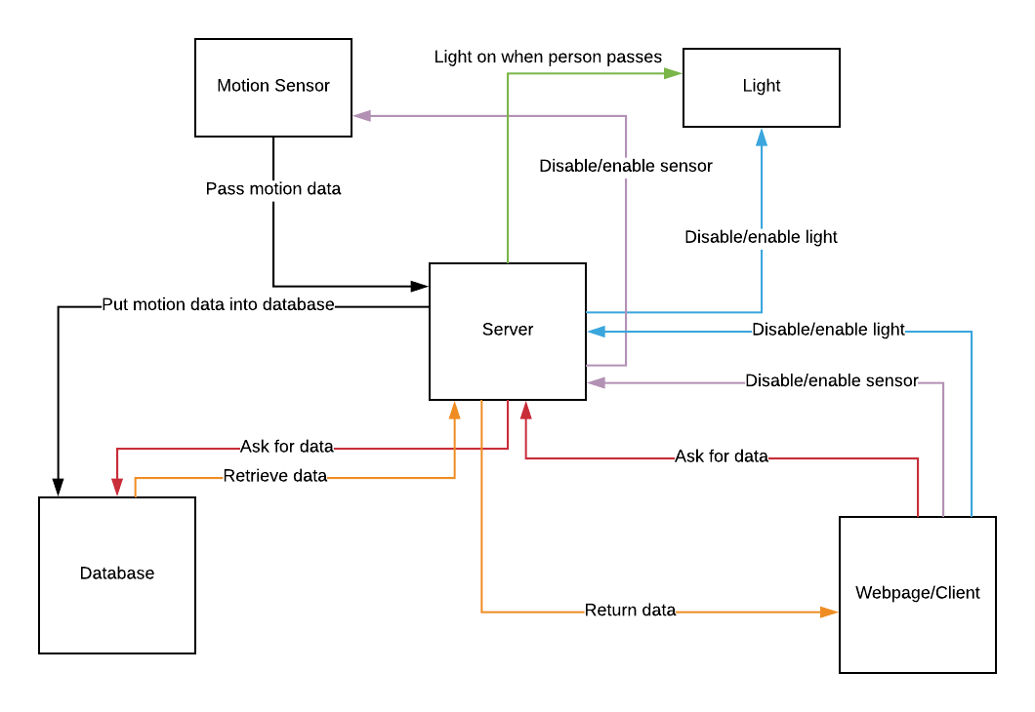

This above diagram should accurately give an indication of the basic functionality of the setup.
As you can see, the server is integral to the entire application, and is responsible for communication between the major components.

A more detailed explanation of the setup follows.

Webpage

The webpage is how the user interacts with the system – currently it looks as such:
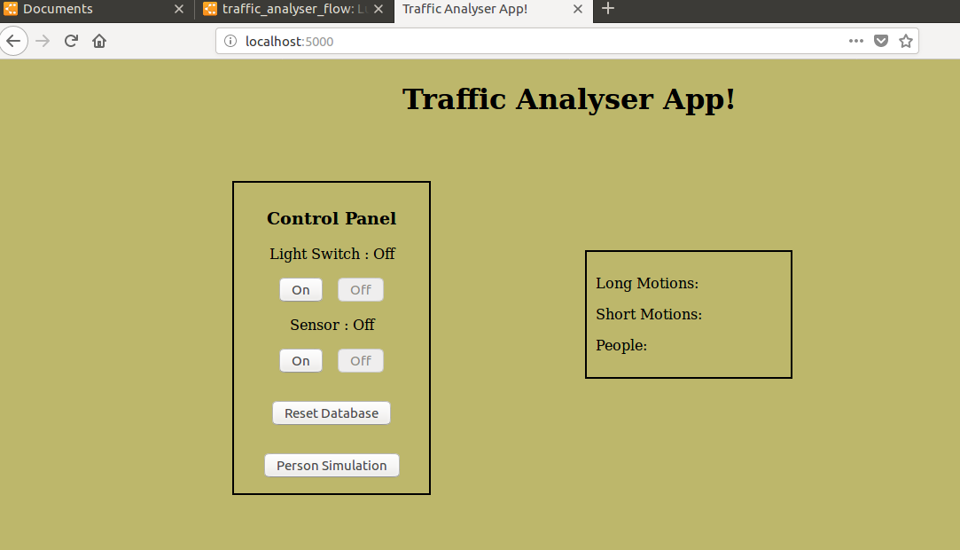

As this project is, again, more of a demonstration of concept rather than a finished commercial product, the design and aesthetic appeal of the webpage is noticeably lacking. It was decided that functionality, clarity and ease of use was of a higher priority than a slick and design and cool, novel features.

The webpage is pretty self-explanatory- on the left is a control panel where the user can use the supplied buttons to control the traffic analyser, and on the right is the stats panel which displays the current data from the database.

The statistics are updated on this webpage upon addition to the database itself, so it is always current and updates itself in realtime for as long as the server is running.

On the control panel, the two sets of button are rather intuitive- the ‘light switch’ enables and disables the light on the ‘on’ and ‘off’ buttons, respectively; if this is not enabled, even if a ‘person’ is detected by the motion sensor, the light will not turn on. Similarly, with ‘sensor’, if it is not enabled with the ‘on’ button, the server will refuse to take any readings from the motion sensor.

The ‘reset database’ button will, upon press, clear all the data from the database. It will not reset the settings of the sensor or light switch or anything else – it merely does as its name suggests.

Finally, the last button, ‘person simulation’, is mostly for testing purposes. It adds a ‘virtual person’ to the server, bypassing the normal requirements that the server needs to read from the database to classify a series of motions as a ‘person’. It is only temporary, and does not affect the database in any way- it was designed to test the light function, which turns on upon detection of a person, or, in this case, a virtual one.

This was necessitated because the server classifies anything shorter than eight seconds as a ‘short’ motion, and anything longer as ‘long’. This is due to the imprecise nature of the motion sensor used, which is slow to register even the briefest of movements. The threshold was placed at eight seconds as it was, upon initial testing, the most consistent upper limit of a very short movement (such as the jerk of an arm or a small wave). Thus, the shortest possible time that the server registers a person as (in this project, a person is classified as a sequence of long-short-long-long motions), is 8-0-8-8 seconds, or twenty-four seconds total.

The light is supposed to turn on for fifteen seconds upon detection of a single person, and if subsequent people are detected within that timeframe, to extend the illumination by five seconds per extra person. As it is plain to see, if the shortest possible time for a person is twenty-four seconds and the light is only on for fifteen, it is literally impossibe to naturally test the light’s function to extend the illumination for extra people. Thus, this extra button was implemented.

Database

All the motion data is stored on the database in separate entries. The database keeps track of what order they were pushed on in, and distinguishes entries through a unique identifying key which it assigns as it is pushed on. Each entry, which represents a separate motion, contains four values – the length of the motion in milliseconds, the type of the motion (whether it is ‘long’ or ‘short’, which is defined by being longer or shorter than eight seconds (eight thousand milliseconds), respectively), the sequence of the previous four motion types in the database starting from itself, and finally, whether or not it is a ‘person’ or not (which is characterised by having a sequence of long-short-long-long exactly).
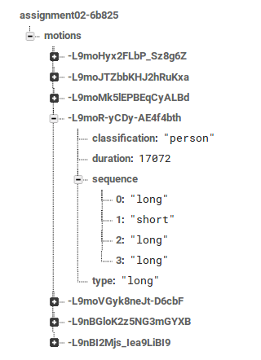

Server

The server is responsible for communication between every part of the application, and is vitally important. It is where all the important logic is hosted, and makes all the decisions and calls when given input, from either the user (through the webpage client) or the motion sensor.

The statistics box on the webpage is updated through the server, which queries the relevant information from the database and passes it back to the webpage. Similarly with resetting the database and the person simulation, the server is also responsible for taking the input of the button press, and telling the database to clear itself or to process a virtual person, respectively.

It also keeps track of the enabled/disabled status of the light switch and sensor, and is responsible for refusing to turn the light on when a person is detected and refusing to accept motion data from the sensor respectively if they are disabled.

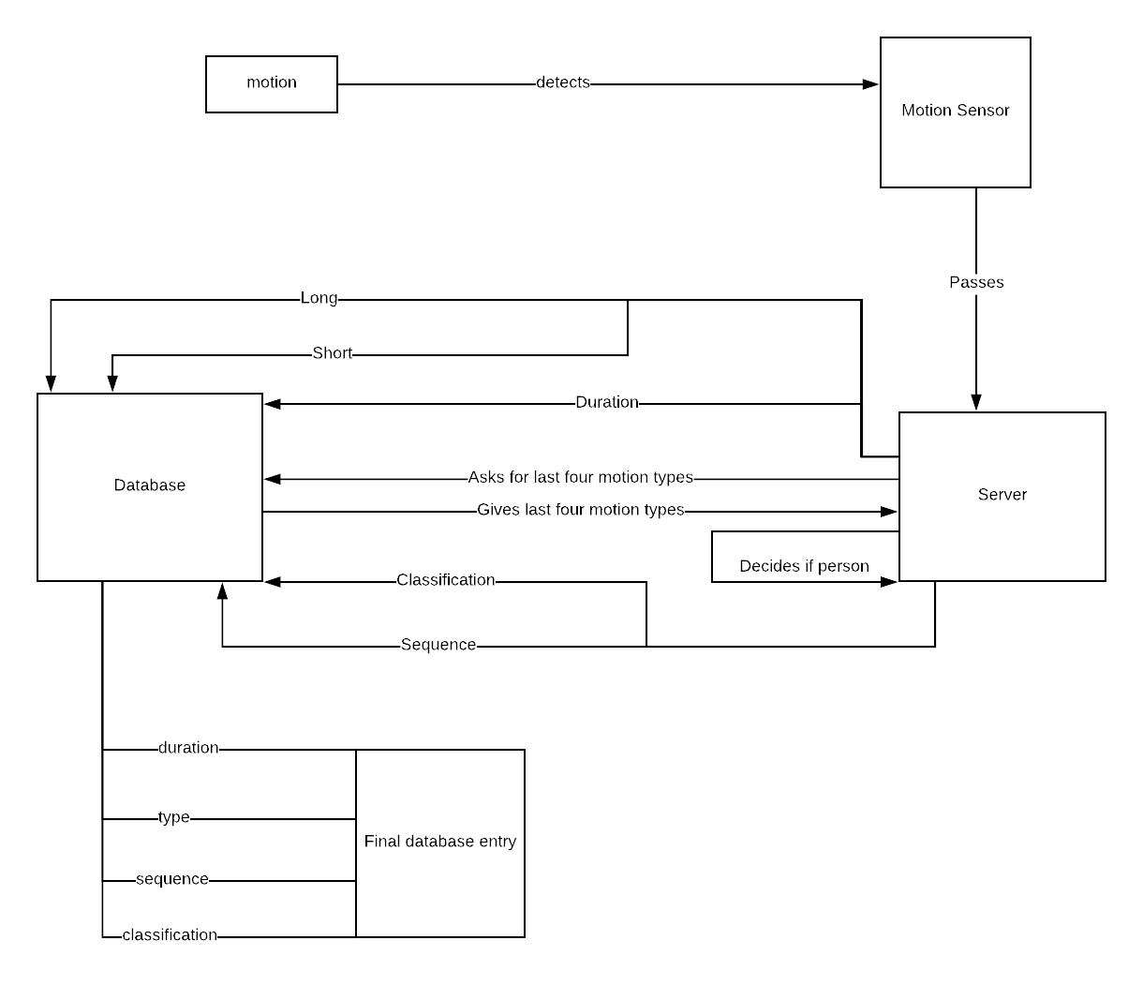
When the motion sensor detects any sort of motion, it will pass this information onto the server, which pushes it into the database. Importantly, it is only the duration and type that is initially pushed- the sequence and classification are values which cannot be determined by the server alone, as it needs information from the database (of the last three entries). The latest motion data also needs to be pushed because the last entry of the sequence needs to be itself. Only then can the server get all four motion types to create the sequence for the entry and determine whether it is a person or not.

Specifications

Along with the attached files, it is important to set up the necessary procedures before the application can be run.

First of all, node.js and npm must be installed on your machine.

Next, the external modules that the code uses must be installed.

In the directory with the files, assuming linux, the following four commands should be run from the command line:

npm install express - -save
npm install socket.io - -save
npm install johnny-five - -save
npm install firebase-admin - -save

This should create a folder called node_modules that has all the modules you need to run the code.
The code is run by the command:

node app.js

An arduino that has been configured for johnny-five must be connected (StandardFirmataPlus should have been uploaded through the IDE application). A motion sensor and LED need to be correctly plugged in.

It is imperative that there be no motion while the application is starting up as the motion sensor is calibrating and activity during this period will throw off what it considers to be movement.

The webpage will open at the following address:

http://localhost:5000

which can be opened on any browser.

The terminal window is useful to keep open as it will display a lot of pertinent information as the application runs such as when the motion sensor is calibrated, when a motion is completed, when the database is cleared, when the light switch/sensor is enabled/disabled, etc.

Tools

A brief background on everything used:

Arduino: arduinos are single-board microcontrollers that can be used to connect computers and code to robotics and other electronics paraphernalia such as LEDs, motion sensors, and many more.

Johnny-five: a platform to run Javascript code on arduinos.

Firebase: a Google driven cloud computing realtime database service, in comparison to traditional entity-relation databases like SQL-built ones, instead of storing data as a table, individual entries are left separate with all their data that can be retrieved using ‘keys’.

Node.js: an web server framework that uses Javascript, which is useful for its asynchronous, non-blocking method of handling requests and connections, which reduces time and memory spent.

Express: an external module for node that is convenient for hosting html and css files. It is used in our project to serve the webpage that serves as the client.

Socket.io: a Javascript library that allows communication between server and client through the use of web-sockets, allowing realtime bidirectional call-and-response events.

Risks

Risk: Faulty motion detector/broken light
Likelihood: Quite likely 7/10
Consequence: The motion detectors we are using are particularly inaccurate, but the problem can be generalised to faulty hardware in general resulting in false or misleading data.
Mitigation: In a general sense, the hardware could be checked and tested at regular intervals to make sure it is always working to an acceptable standard.
Response: If a faulty hardware is detected (which may be an issue in itself) repair of the hardware is paramount, or outright replacement if not possible.

Risk: Security violation
Likelihood: Unlikely 4/10
Consequence: Because the database is not stored on personal servers as a traditional database is, it is possible that your data is not secure and could be accessed or changed/deleted by other entities.
Mitigation: Most cloud storage providers will have protocols in place to prevent this. Care should be taken to choose a trusted and reputable source to handle your data. Maybe consider encrypting your data for more security.
Response: Sue the company that allowed your data to be breached. Try and recover the data and take more precautions next time.

Risk: Outage/no access to data
Likelihood: Unlikely 2/10
Consequence: Again, the data is in the hands of another company, and if your cloud storage service experiences an outage, this could mean your data is not able to be accessed until they fix the problem.
Mitigation: Choose a trusted company that has no history of outages.
Response: Consider changing to another service that has a smaller chance of such a thing happening.

Risk: Cyber crime
Likelihood: Depends on how valuable your data is
Consequence: If your data is stored on the internet, hackers may try to access your data. If they succeed they could gain access to valuable/confidential information, or perhaps wreak havoc on your business/application.
Mitigation: Choose a company who has good defence against cyber attacks. Try encrypting the data for more security.
Response: Maybe choose another company with better cyber defence, or take more precautions with your data (encryption).

