MODEL REFERENCE SHEET  Artificial Analysis + CursorBench 3.2 snapshot | 18 JUL 2026  13 supplied charts + live leaderboard

GENERAL INTELLIGENCE  Claude Fable 5  60 | AGENTIC  GPT-5.6 Sol max  54.0 | CODING  GPT-5.6 Sol xhigh  78.3
OUTPUT SPEED  GPT-5.6 Luna max  185 tok/s | FIRST TOKEN  Luna NR / Terra NR  0.7 s | 500-TOKEN E2E  GPT-5.6 Luna NR  3.5 s
LOWEST COST  GPT-5.6 Luna low  $0.04/task | EARLY WRITING  Claude Fable 5 max  ~2,810 Elo | CURSORBENCH 3.2  Claude Fable 5 max  70.5%

Quick routing guide
Use case | Primary pick | Why
Maximum overall quality / writing | Claude Fable 5 max | CursorBench leader (70.5%); Fable also leads AA intelligence (60) and early writing (~2,810 Elo). Highest quality, highest cost.
Maximum GPT agentic quality | GPT-5.6 Sol max | AA Agentic leader (54.0) and best GPT on CursorBench (67.2%, rank 3) at about one-third of Fable max's CursorBench cost.
Best daily coding quality | GPT-5.6 Sol xhigh | AA Coding leader (78.3); CursorBench 64.5%. Faster than max in AA latency data, while max adds 2.7 CursorBench points.
Fast coding value | GPT-5.6 Sol medium | 76.3 AA coding at $0.31 and 14.3 s E2E; CursorBench 60.0% shows a real quality trade-off versus max, not near-parity.
High-throughput reasoning | GPT-5.6 Luna max | 185 tok/s and 51 AA intelligence; CursorBench 61.1% but 87,973 tokens and 61 steps per task.
Interactive balanced default | GPT-5.6 Terra high | 49 AA intelligence, 119 tok/s and 6.1 s E2E; CursorBench 54.2% at $0.89/task.
Lowest-cost strong reasoning | GPT-5.6 Luna xhigh | 49 AA intelligence at $0.14/task; CursorBench 57.7% at $1.14/task and 48 steps.
Fast simple-task mode | GPT-5.6 Luna non-reasoning | 0.7 s TTFT and 3.5 s AA E2E. CursorBench does not list a non-reasoning Luna route; use only for bounded work.
Fast economical delegation | Grok 4.5 high | 66.7% at $1.51/task on CursorBench; 88 tok/s and 16.3 s AA E2E. Discount the exact rank, not the speed/value signal.
NR = non-reasoning. “Best value” and routing labels are derived judgments from the supplied metrics, not source-chart categories. Values marked ~ elsewhere are estimates from cropped or unlabeled chart elements.

Full visible index rankings
Compact names: Sol/Terra/Luna imply GPT-5.6; “5.5” implies GPT-5.5; NR = non-reasoning. Ties retain the left-to-right order shown in the screenshots.
# | Agentic model | Score | # | Coding model | Score | # | Intelligence model | Score
1 | Sol max | 54.0 | 1 | Sol xhigh | 78.3 | 1 | Fable 5 fallback | 60
2 | Fable 5 fallback | 52.8 | 2 | Sol max | 77.4 | 2 | Sol max | 59
3 | Sol xhigh | 51.8 | 3 | Sol high | 77.2 | 3 | Sol xhigh | 58
4 | Sol high | 48.5 | 4 | Terra max | 76.7 | 4 | Sol high | 56
5 | Terra max | 47.4 | 5 | Fable 5 fallback | 76.5 | 5 | Opus 4.8 max | 56
6 | Opus 4.8 max | 47.2 | 6 | Sol medium | 76.3 | 6 | Terra max | 55
7 | Sonnet 5 max | 46.7 | 7 | 5.5 xhigh | 74.9 | 7 | 5.5 xhigh | 55
8 | Grok 4.5 high | 45.7 | 8 | Opus 4.8 max | 74.3 | 8 | Grok 4.5 high | 54
9 | Luna max | 45.6 | 9 | Grok 4.5 high | 72.4 | 9 | Sol medium | 54
10 | 5.5 xhigh | 44.9 | 10 | 5.5 high | 71.6 | 10 | Sonnet 5 max | 53
11 | Terra xhigh | 44.7 | 11 | Sonnet 5 max | 71.5 | 11 | 5.5 high | 53
12 | Sol medium | 44.5 | 12 | 5.5 medium | 71.5 | 12 | Terra xhigh | 52
13 | 5.5 high | 43.5 | 13 | Luna max | 71.4 | 13 | Luna max | 51
14 | Luna xhigh | 42.9 | 14 | Terra xhigh | 70.6 | 14 | 5.5 medium | 50
15 | Terra high | 41.3 | 15 | Sol low | 69.7 | 15 | Sol low | 49
16 | Luna high | 40.1 | 16 | Luna xhigh | 68.6 | 16 | Luna xhigh | 49
17 | Sol low | 40.0 | 17 | Terra high | 67.1 | 17 | Terra high | 49
18 | 5.5 medium | 37.8 | 18 | Sonnet 5 NR | 66.4 | 18 | Luna high | 46
19 | Terra medium | 37.0 | 19 | Sol NR | 65.1 | 19 | Terra medium | 46
20 | Sol NR | 34.9 | 20 | Terra medium | 64.7 | 20 | 5.5 low | 43
21 | Sonnet 5 NR | 33.7 | 21 | Luna high | 63.3 | 21 | Sonnet 5 NR | 42
22 | Luna medium | 31.0 | 22 | 5.5 low | 60.9 | 22 | Sol NR | 41
23 | Terra low | 30.6 | 23 | Terra low | 58.1 | 23 | Terra low | 40
24 | 5.5 low | 30.4 | 24 | 5.5 NR | 56.5 | 24 | Luna medium | 38
25 | Terra NR | 29.3 | 25 | Terra NR | 52.3 | 25 | 5.5 NR | 35
26 | 5.5 NR | 25.8 | 26 | Luna medium | 50.7 | 26 | Terra NR | 34
27 | Luna NR | ~22.0 | 27 | Luna NR | ~39.0 | 27 | Luna NR | 27
The screenshots show 27 ranked entries in each index. The rightmost Luna non-reasoning Agentic and Coding labels were cropped; they are recorded as approximately 22 and 39.

Model matrix - GPT-5.6 Luna and Terra
Luna maximizes decode throughput; Terra generally provides the stronger interactive quality/latency balance.
Model / mode | Intel | Agent | Code | Cost/task | tok/s | TTFT s | E2E 500 s | Reference note
GPT-5.6 Luna (Non-reasoning) | 27 | ~22.0 | ~39.0 | $0.05 | 178 | 0.7 | 3.5 | Fastest E2E; lowest quality tier.
GPT-5.6 Luna (low) | 33 | — | — | $0.04 | — | — | — | Cheapest 2D frontier point; perf not shown.
GPT-5.6 Luna (medium) | 38 | 31.0 | 50.7 | $0.05 | 177 | 1.7 | 4.5 | Very low cost; 177 tok/s; 4.5 s E2E.
GPT-5.6 Luna (high) | 46 | 40.1 | 63.3 | $0.09 | 176 | 6.6 | 9.5 | Good low-cost quality step-up.
GPT-5.6 Luna (xhigh) | 49 | 42.9 | 68.6 | $0.14 | 174 | 29.7 | 32.6 | 49 intel at $0.14; long thinking delay.
GPT-5.6 Luna (max) | 51 | 45.6 | 71.4 | $0.21 | 185 | 79.5 | 82.2 | Fastest decode; speed-quality quadrant.
GPT-5.6 Terra (Non-reasoning) | 34 | 29.3 | 52.3 | — | 123 | 0.7 | 4.8 | 0.7 s TTFT; cost not visible.
GPT-5.6 Terra (low) | 40 | 30.6 | 58.1 | $0.10 | 115 | 1.3 | 5.7 | Cheap, interactive baseline.
GPT-5.6 Terra (medium) | 46 | 37.0 | 64.7 | $0.13 | 120 | 1.3 | 5.5 | 46 intel with 5.5 s E2E.
GPT-5.6 Terra (high) | 49 | 41.3 | 67.1 | $0.24 | 119 | 1.8 | 6.1 | Interactive sweet spot at 49 intel.
GPT-5.6 Terra (xhigh) | 52 | 44.7 | 70.6 | $0.33 | 121 | 16.9 | 21.1 | 52 intel; speed-quality quadrant.
GPT-5.6 Terra (max) | 55 | 47.4 | 76.7 | $0.55 | 136 | 133.9 | 137.6 | Strong indexes; 134 s thinking delay.
~ = visually estimated from a clipped chart label. — = the metric was not visible in the supplied screenshots. Cost/task is the Artificial Analysis weighted Intelligence Index task cost, not a token-list price.
Within-family step-up economics
Upgrade | Quality gain | Cost / time multiplier | Interpretation
Luna xhigh -> max | +2 intel; +2.7 agent; +2.8 code | 1.50x cost; 2.52x E2E | Max mainly buys a small quality lift; xhigh is the stronger cost point.
Terra xhigh -> max | +3 intel; +2.7 agent; +6.1 code | 1.67x cost; 6.52x E2E | Max meaningfully helps coding, but thinking time explodes from 16.9 s to 133.9 s.
Terra NR -> medium | +12 intel; +7.7 agent; +12.4 code | E2E only 4.8 -> 5.5 s | Medium is a compelling interactive reasoning step-up when cost permits.

Model matrix - GPT-5.6 Sol and GPT-5.5
Sol dominates the top agentic/coding ranks. Medium is the practical coding default; max is an agentic-quality mode with extreme thinking latency.
Model / mode | Intel | Agent | Code | Cost/task | tok/s | TTFT s | E2E 500 s | Reference note
GPT-5.6 Sol (Non-reasoning) | 41 | 34.9 | 65.1 | $0.20 | 56 | 1.0 | 9.9 | Simple tasks; same cost as Sol low.
GPT-5.6 Sol (low) | 49 | 40.0 | 69.7 | $0.20 | 51 | 3.3 | 13.0 | +8 intel vs NR for same $0.20 cost.
GPT-5.6 Sol (medium) | 54 | 44.5 | 76.3 | $0.31 | 53 | 4.7 | 14.3 | Coding/value sweet spot.
GPT-5.6 Sol (high) | 56 | 48.5 | 77.2 | $0.45 | ~49 | 12.1 | 22.3 | High quality; moderate E2E.
GPT-5.6 Sol (xhigh) | 58 | 51.8 | 78.3 | $0.68 | 53 | 41.6 | 51.1 | Highest Coding Index.
GPT-5.6 Sol (max) | 59 | 54.0 | 77.4 | $1.04 | 54 | 129.3 | 138.6 | Highest Agentic Index.
GPT-5.5 (Non-reasoning) | 35 | 25.8 | 56.5 | $0.17 | 66 | 0.9 | 8.4 | Low latency; low index scores.
GPT-5.5 (low) | 43 | 30.4 | 60.9 | $0.21 | 66 | 1.8 | 9.4 | Small cost/latency step from NR.
GPT-5.5 (medium) | 50 | 37.8 | 71.5 | $0.41 | 68 | 7.4 | 14.8 | 50 intel; eclipsed by Sol medium on value.
GPT-5.5 (high) | 53 | 43.5 | 71.6 | $0.67 | 70 | 22.3 | 29.4 | 53 intel; 29.4 s E2E.
GPT-5.5 (xhigh) | 55 | 44.9 | 74.9 | $0.99 | 68 | 61.6 | 69.0 | 55 intel; $0.99; 69 s E2E.
~ = visually estimated from a clipped chart label. — = the metric was not visible in the supplied screenshots. Cost/task is the Artificial Analysis weighted Intelligence Index task cost, not a token-list price.
Sol scale-up: coding saturates before agentic capability
Mode | Intel | Agentic | Coding | Cost / E2E | Decision cue
low | 49 | 40.0 | 69.7 | $0.20 / 13.0 s | Same $0.20 cost as NR, but +8 intelligence.
medium | 54 | 44.5 | 76.3 | $0.31 / 14.3 s | 76.3 coding at $0.31 and 14.3 s: best coding value.
high | 56 | 48.5 | 77.2 | $0.45 / 22.3 s | Adds general quality with tolerable 22.3 s E2E.
xhigh | 58 | 51.8 | 78.3 | $0.68 / 51.1 s | Absolute coding leader; 51.1 s E2E.
max | 59 | 54.0 | 77.4 | $1.04 / 138.6 s | Agentic leader; only +1.1 coding vs medium at 3.35x cost.

Model matrix - Anthropic and xAI
The Sonnet effort variants are fully visible for speed/latency, but only max and non-reasoning are visible in the index/cost screenshots.
Model / mode | Intel | Agent | Code | Cost/task | tok/s | TTFT s | E2E 500 s | Reference note
Claude Sonnet 5 (Non-reasoning) | 42 | 33.7 | 66.4 | $0.37 | 63 | 1.3 | 9.2 | Fast; much lower scores than max.
Claude Sonnet 5 (low) | — | — | — | — | 60 | 1.6 | 9.8 | Latency/speed only in supplied views.
Claude Sonnet 5 (medium) | — | — | — | — | 64 | 2.5 | 10.3 | Latency/speed only in supplied views.
Claude Sonnet 5 (high) | — | — | — | — | 65 | 8.5 | 16.2 | Latency/speed only in supplied views.
Claude Sonnet 5 (xhigh) | — | — | — | — | 68 | 22.7 | 30.0 | Latency/speed only in supplied views.
Claude Sonnet 5 (max) | 53 | 46.7 | 71.5 | $1.53 | 83 | ~193.7 | ~199.7 | 53 intel; about 200 s E2E.
Claude Opus 4.8 (max) | 56 | 47.2 | 74.3 | $1.80 | 57 | 34.5 | 43.2 | Premium quality; $1.80/task.
Claude Fable 5 (with fallback) | 60 | 52.8 | 76.5 | ~$2.70 | 61 | 116.2 | 124.5 | Top intelligence/writing; highest cost.
Grok 4.5 (high) | 54 | 45.7 | 72.4 | $0.31 | 88 | 10.6 | 16.3 | 54 intel at $0.31; 88 tok/s.
~ = visually estimated from a clipped chart label. — = the metric was not visible in the supplied screenshots. Cost/task is the Artificial Analysis weighted Intelligence Index task cost, not a token-list price.
Performance and cost leaderboards
# | Output speed | tok/s | # | E2E 500 tokens | seconds | # | Lowest cost / task
1 | Luna max | 185 | 1 | Luna NR | 3.5 | 1 | Luna low $0.04
2 | Luna NR | 178 | 2 | Luna medium | 4.5 | 2 | Luna NR $0.05
3 | Luna medium | 177 | 3 | Terra NR | 4.8 | 3 | Luna medium $0.05
4 | Luna high | 176 | 4 | Terra medium | 5.5 | 4 | Luna high $0.09
5 | Luna xhigh | 174 | 5 | Terra low | 5.7 | 5 | Terra low $0.10
6 | Terra max | 136 | 6 | Terra high | 6.1 | 6 | Terra medium $0.13
Output speed measures decode throughput after answering begins. It does not remove reasoning delay: Luna max leads at 185 tok/s yet takes 79.5 s to the first answer token.

Cost-intelligence frontier and the third dimension: time
The supplied synthesis chart treats bubble area as approximate weighted task time. The dashed line is the 2D cost-intelligence efficient frontier.
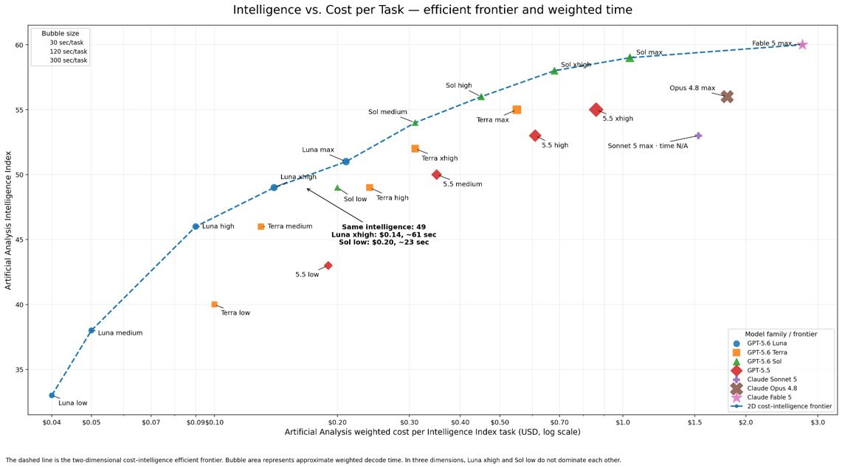  Supplied frontier synthesis (source image) | 2D frontier points  Model Cost Intel  Luna low $0.04 33  Luna medium $0.05 38  Luna high $0.09 46  Luna xhigh $0.14 49  Luna max $0.21 51  Sol medium $0.31 54  Sol high $0.45 56  Sol xhigh $0.68 58  Sol max $1.04 59  Fable 5 fallback $2.70 60
What the frontier leaves out
Comparison | Numbers | Routing implication
Same intelligence: Luna xhigh vs Sol low | Both 49 intel. Luna: $0.14, ~61 s weighted task time. Sol: $0.20, ~23 s. | Luna wins cost and decode speed; Sol wins time-to-completion and coding by 1.1 points.
Interactive alternative: Terra high | 49 intel, $0.24, 119 tok/s, 1.8 s TTFT, 6.1 s E2E. | Not on the 2D frontier, but often the best user-facing choice when responsiveness matters.
Same cost/intel: Grok vs Sol medium | Both $0.31 and 54 intel. Grok: 88 tok/s, 45.7 agentic. Sol: 76.3 coding, 14.3 s E2E. | Choose Grok for faster streaming/agentic score; Sol for coding and slightly faster full 500-token completion.
Same intelligence: Terra max vs 5.5 xhigh | Both 55 intel. Terra: $0.55, 76.7 coding, 137.6 s E2E. 5.5: $0.99, 74.9 coding, 69.0 s. | Terra wins price and benchmark scores; GPT-5.5 xhigh completes much sooner.

Early writing benchmark: approximate ranking
The source labels this benchmark as “early results.” Elo and API cost points below are visually read from the axes and rounded; they are not final benchmark values.
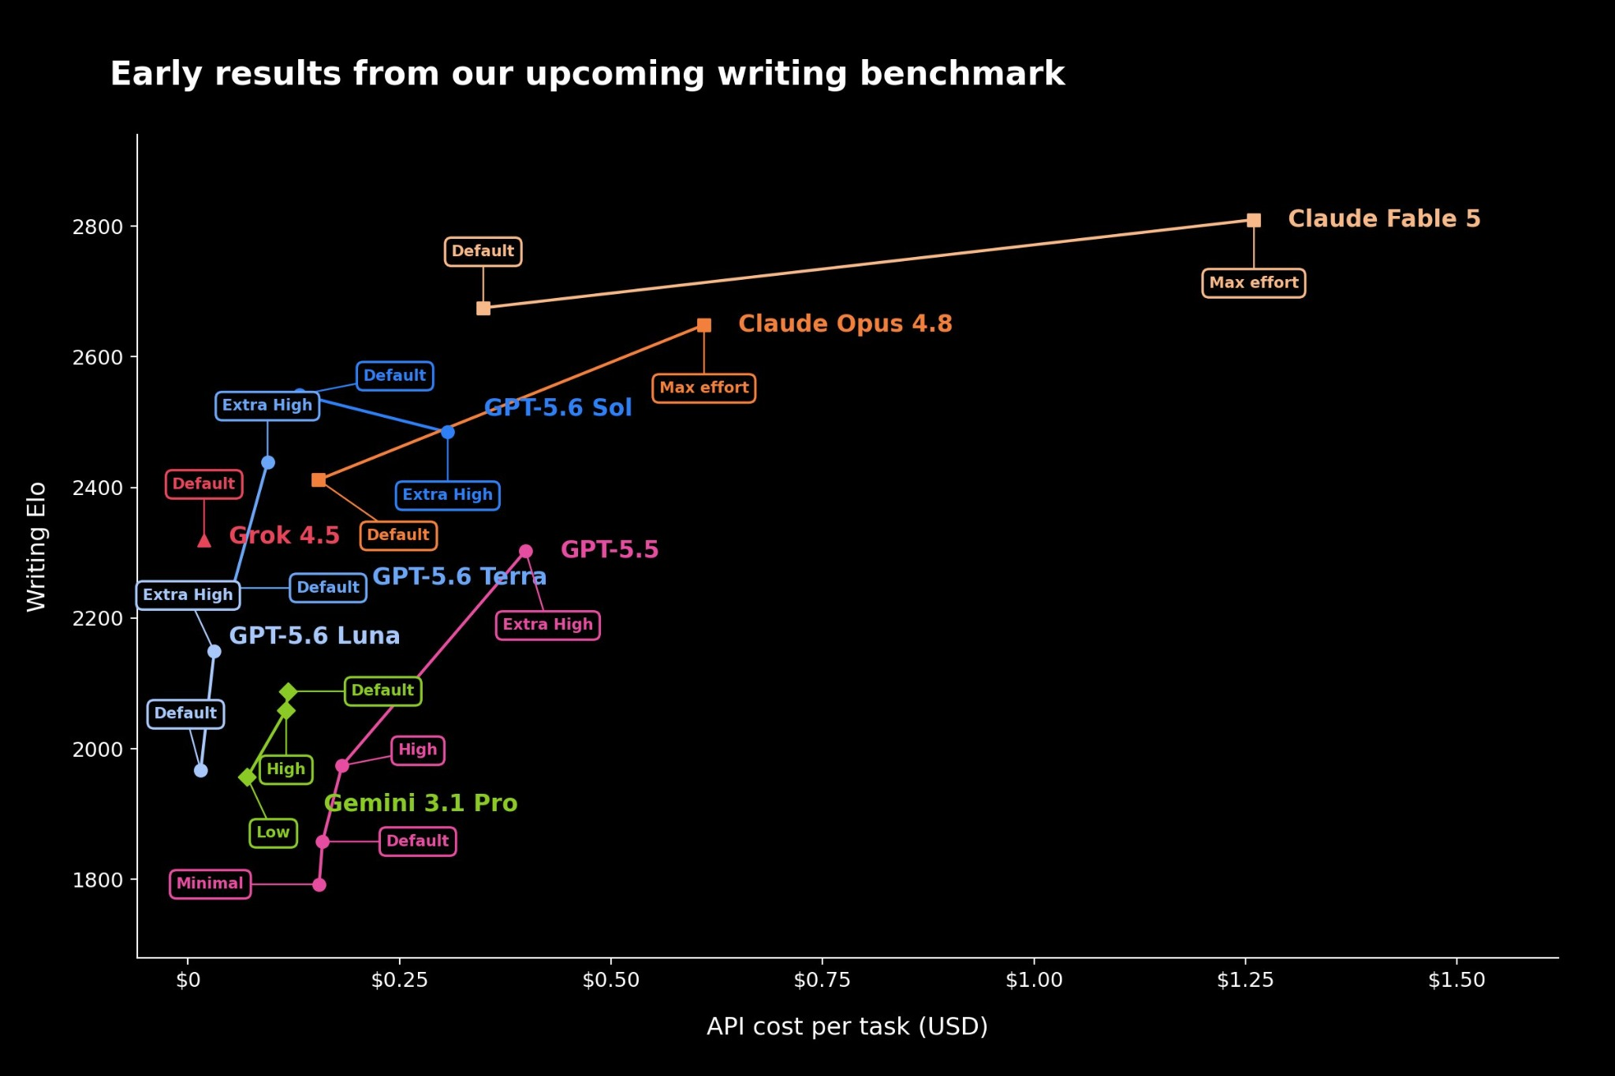  Supplied early writing benchmark (source image) | Approximate top results  # Setting Cost Elo  1 Claude Fable 5 - max effort ~$1.26 ~2,810  2 Claude Fable 5 - default ~$0.35 ~2,675  3 Claude Opus 4.8 - max effort ~$0.61 ~2,650  4 GPT-5.6 Sol - default ~$0.17 ~2,550  5 GPT-5.6 Sol - extra high ~$0.31 ~2,485  6 GPT-5.6 Terra - extra high ~$0.10 ~2,440  7 Claude Opus 4.8 - default ~$0.16 ~2,410  8 Grok 4.5 - default ~$0.02 ~2,315  9 GPT-5.5 - extra high ~$0.40 ~2,300  10 GPT-5.6 Luna - extra high ~$0.03 ~2,150
Writing-specific takeaways
- Claude Fable 5 leads: max effort is about 2,810 Elo; default is about 2,675.  - Fable max costs about 3.6x default for roughly +135 Elo.  - Claude Opus 4.8 max reaches about 2,650 Elo at about $0.61/task.  - Grok 4.5 default is unusually inexpensive (~$0.02) for roughly 2,315 Elo. | - GPT-5.6 Sol default appears to beat its extra-high setting while costing less; treat this non-monotonic result as provisional.  - GPT-5.6 Terra extra high reaches roughly 2,440 Elo at about $0.10/task.  - Writing effort labels do not necessarily map one-to-one to the index-chart effort labels.  - Writing API cost/task is a different workload from Intelligence Index cost/task; do not compare the dollar values directly.

Metric definitions, cost anatomy, and transcription notes
Use this page when applying the sheet to routing, procurement, or benchmark interpretation.
Definitions  Intelligence Index v4.1: Composite of 9 evaluations: GDPval-AA v2, tau^3-Banking, Terminal-Bench v2.1, SciCode, Humanity’s Last Exam, GPQA Diamond, CritPt, AA-Omniscience, and AA-LCR.  Agentic Index: Average of agentic-capability benchmarks in the source: GDPval-AA v2 and tau^3-Banking.  Coding Index: Weighted average of Terminal-Bench v2.1 and SciCode.  Output speed: Output tokens per second after generation begins; higher is better.  TTFT: Seconds to first answer token, including reasoning-model thinking time; lower is better.  E2E 500: Seconds to produce 500 output tokens, including thinking and input processing; lower is better.  Cost/task: Weighted average USD per Artificial Analysis Intelligence Index task; lower is better.  Writing Elo: Separate early writing benchmark rating plotted against API cost per writing task.  CursorBench 3.2: Correctness score for ambiguous, multi-file tasks sourced from real Cursor sessions. The suite includes instruction-following and advanced tool-use problems; higher is better.  CursorBench cost/task: Published input, cache-read, cache-write, and output prices applied to each task's token use, then averaged with the score weights. It is not comparable to AA cost/task because the workloads differ. | Cost anatomy in the supplied charts  - Token-type stack: answer, reasoning, cache write, cache hit, and input.  - Evaluation stack: GDPval-AA v2, tau^3-Banking, Terminal-Bench v2.1, SciCode, Humanity’s Last Exam, GPQA Diamond, CritPt, AA-Omniscience, and AA-LCR.  - At the high-cost end, GDPval-AA v2 is visibly a major contributor; Terminal-Bench is also material for Claude Opus/Fable.  - Use the total bar labels as the primary comparable number. Several segment labels are not visible in the screenshot.  Interpretation cautions  - Index values are aggregate scores, not percentages or guaranteed task success rates.  - The UI screenshots are horizontally scrollable; some selected models may be outside the captured viewport.  - Latency is environment- and provider-dependent. Treat it as the measured snapshot, not a service-level guarantee.  - Fable is “with fallback” in index charts, while the writing chart uses default/max effort labels; these may not be identical routes.  - Reasoning modes are indicated by a lightbulb in the source charts. Non-reasoning rows are explicitly labeled NR here.  - The weighted task-time bubbles in the frontier chart are not the same measure as the 500-token E2E bars.  CursorBench caution: Results are subject to variance and small score differences may not be statistically meaningful. Grok 4.5 has a disclosed training-data advantage on this suite, so its exact rank is discounted; independent AA speed, cost, agentic, and coding results still support a fast/value role.
Source image coverage
Supplied image | What was extracted
Artificial Analysis Agentic Index | Full 27-entry agentic ranking and scores.
Artificial Analysis Coding Index | Full 27-entry coding ranking and scores.
Artificial Analysis Intelligence Index | Full 27-entry intelligence ranking and benchmark composition.
Intelligence vs. Output Speed | Speed-quality quadrant and model trade-offs.
End-to-End Response Time | 500-token completion times and thinking/output decomposition.
Latency - Time To First Answer Token | First-token latency including reasoning time.
Output Speed | Decode throughput in output tokens per second.
Evaluation Breakdown | Cost contribution by each Intelligence Index evaluation.
Cost per Intelligence Index Task | Total cost and token-type cost stack.
Intelligence vs. Cost per Intelligence Index Task | Cross-vendor cost-quality quadrant.
HM8OUrWWMAAkIO1.jpeg | Early writing Elo versus API task cost.
HM6BgeuaMAA6XR8.jpeg | OpenAI family cost-intelligence curves and attractive quadrant.
bench.jpeg | 2D efficient frontier plus weighted task-time bubbles.
Transcription rule: exact Artificial Analysis labels were copied from the supplied images; values prefixed with ~ were estimated from chart geometry or cropped labels. CursorBench 3.2 values were copied from the live leaderboard on 18 July 2026. Sources: https://cursor.com/cursorbench and https://cursor.com/blog/cursorbench.

CursorBench 3.2 - full leaderboard (1-21)
Cursor evaluates agents on ambiguous, multi-file tasks from real Cursor sessions. Version 3.2 added instruction-following and advanced tool-use problems. The live table was accessed 18 July 2026; its Sol/Terra/Luna costs include the 9 July cache-write-cost correction.
# | Model / effort | Score | Cost / task | Tokens / task | Steps / task
1 | Fable 5 Max | 70.5% | $17.32 | 103,525 | 72
2 | Fable 5 Extra High | 68.4% | $11.73 | 64,971 | 56
3 | GPT-5.6 Sol Max | 67.2% | $5.69 | 28,320 | 48
4 | Grok 4.5 High* | 66.7% | $1.51 | 19,521 | 33
5 | Fable 5 High | 66.5% | $8.77 | 43,747 | 48
6 | Grok 4.5 Medium* | 65.4% | $1.54 | 18,914 | 34
7 | Fable 5 Medium | 65.2% | $6.80 | 30,366 | 41
8 | GPT-5.6 Terra Max | 64.9% | $2.89 | 32,969 | 47
9 | GPT-5.6 Sol Extra High | 64.5% | $3.88 | 19,699 | 38
10 | Grok 4.5 Low* | 63.5% | $1.22 | 15,841 | 31
11 | GPT-5.6 Sol High | 63.5% | $2.79 | 13,867 | 32
12 | Opus 4.8 Max | 62.3% | $5.77 | 71,411 | 44
13 | Fable 5 Low | 62.1% | $4.46 | 18,182 | 31
14 | Sonnet 5 Max | 61.5% | $6.45 | 92,882 | 86
15 | GPT-5.6 Luna Max | 61.1% | $1.97 | 87,973 | 61
16 | GPT-5.6 Sol Medium | 60.0% | $1.95 | 9,747 | 27
17 | Opus 4.8 Extra High | 59.4% | $4.50 | 51,121 | 40
18 | GPT-5.6 Terra Extra High | 59.2% | $1.44 | 16,089 | 29
19 | Sonnet 5 Extra High | 58.7% | $4.16 | 52,871 | 67
20 | GPT-5.5 High | 58.4% | $2.05 | 12,183 | 28
21 | GPT-5.5 Extra High | 58.4% | $2.85 | 17,534 | 32
Top-line result: Fable 5 max leads at 70.5%. Sol max is third at 67.2% and costs $5.69/task versus $17.32 for Fable max. Fable extra high is second at 68.4% and $11.73/task.

CursorBench 3.2 - full leaderboard (22-42)
# | Model / effort | Score | Cost / task | Tokens / task | Steps / task
22 | Opus 4.8 High | 58.0% | $3.15 | 33,548 | 33
23 | GPT-5.6 Luna Extra High | 57.7% | $1.14 | 22,480 | 48
24 | Sonnet 5 High | 56.9% | $3.19 | 39,483 | 57
25 | GPT-5.6 Luna High | 56.8% | $0.82 | 15,141 | 40
26 | Opus 4.8 Medium | 56.1% | $2.81 | 28,384 | 32
27 | Composer 2.5 | 56.1% | $0.44 | 14,286 | 33
28 | GLM 5.2 Max | 55.0% | $1.76 | 35,946 | 58
29 | GPT-5.6 Terra High | 54.2% | $0.89 | 9,468 | 23
30 | GPT-5.5 Medium | 53.8% | $1.51 | 8,522 | 25
31 | Opus 4.8 Low | 53.1% | $2.02 | 19,624 | 27
32 | GPT-5.6 Sol Low | 52.6% | $1.01 | 5,104 | 19
33 | Sonnet 5 Medium | 52.4% | $2.16 | 26,200 | 46
34 | GLM 5.2 High | 51.5% | $1.19 | 21,829 | 49
35 | GPT-5.6 Terra Medium | 50.3% | $0.61 | 6,222 | 20
36 | Kimi K2.7 Code | 49.7% | $1.43 | 31,247 | 58
37 | Gemini 3.5 Flash | 48.8% | $2.20 | 46,702 | 77
38 | GPT-5.6 Luna Medium | 47.7% | $0.39 | 7,095 | 28
39 | Sonnet 5 Low | 47.7% | $1.30 | 16,269 | 33
40 | GPT-5.6 Terra Low | 46.9% | $0.53 | 5,312 | 19
41 | GPT-5.5 Low | 46.6% | $0.98 | 5,168 | 20
42 | GPT-5.6 Luna Low | 37.6% | $0.16 | 3,209 | 17
* Cursor discloses that Grok 4.5 benefited because an earlier Cursor codebase snapshot was unintentionally present in training. The impact is unknown, so treat its exact 66.7% score cautiously. The separate AA results still establish its speed, low cost, and competitive general capability.
Cost/task uses published token prices and this benchmark's task weights. Results are subject to variance; small score differences may not be statistically meaningful. Compare models within CursorBench 3.2, not against percentages from another suite.

Cross-benchmark synthesis and revised routing
Artificial Analysis and CursorBench answer different questions. AA separates general intelligence, agentic capability, coding, latency, decode speed, and cost. CursorBench is narrower but more directly aligned with ambiguous repository work. No combined score is calculated because the scales and workloads are not commensurate.
Model | AA Intel / Agent / Code | CursorBench score / cost | Interpretation
Fable 5 max / fallback† | 60 / 52.8 / 76.5 | 70.5% / $17.32 | Absolute CursorBench and AA general-quality leader; premium route.
Fable 5 extra high | Not separately visible | 68.4% / $11.73 | Beats Sol max by 1.2 points at about 2.1x cost.
GPT-5.6 Sol max | 59 / 54.0 / 77.4 | 67.2% / $5.69 | Best GPT and AA agentic leader; strongest one-model compromise.
GPT-5.6 Sol xhigh | 58 / 51.8 / 78.3 | 64.5% / $3.88 | AA coding leader and responsive daily high-effort choice.
GPT-5.6 Sol high | 56 / 48.5 / 77.2 | 63.5% / $2.79 | Only 1.0 CursorBench point below xhigh at lower cost.
GPT-5.6 Sol medium | 54 / 44.5 / 76.3 | 60.0% / $1.95 | Fast AA coding value, but 7.2 points below Sol max on CursorBench.
Claude Opus 4.8 max | 56 / 47.2 / 74.3 | 62.3% / $5.77 | No longer a primary quality/value recommendation.
Grok 4.5 high* | 54 / 45.7 / 72.4 | 66.7% / $1.51 | Fast/value specialist; exact CursorBench rank discounted, AA evidence retained.
† AA reports a Fable 5 with-fallback route, while CursorBench reports explicit effort levels. Treat the cross-suite row as family-level evidence, not a controlled effort comparison.
Recommendation changes
Use case | Recommendation | Change and rationale
Absolute maximum quality | Claude Fable 5 max | Changed. CursorBench rank 1 plus AA intelligence/writing leadership outweighs cost when quality is the first priority.
Maximum GPT / one-model default | GPT-5.6 Sol max | Still best GPT and the best quality-cost compromise across both suites.
Daily responsive coding | GPT-5.6 Sol xhigh | Unchanged. It retains the AA coding lead and avoids max's extreme AA thinking latency.
Fast economical delegation | Grok 4.5 high | Changed. Use for scouting, context building, and bounded fixes; AA corroborates the speed/value signal independently.
Bounded quality-first implementation | GPT-5.6 Sol medium/high | Unchanged. Prefer Sol when coding quality matters more than Grok's latency and cost advantage.
Independent review / writing | Claude Fable 5 | Unchanged. CursorBench strengthens the existing cross-model reviewer and writer assignment.
Highest-stakes final pass | Fable max, then Sol max if needed | New escalation path. Do not promote all routine agents to max from one aggregate benchmark.
Practical conclusion: use Fable 5 max when a few quality points dominate cost, Sol xhigh for daily quality-first coding, and Grok 4.5 high for fast economical scouting, context building, and bounded fixes. Keep final implementation and review gates on Sol or Fable.

