**Industrial ventilator tube cleaner**



Author: Fitim Halimi

FIM, University of Prishtina / e-mail: fitimhalimi777@gmail.com

Professor: Arbnor Pajaziti

Course: Final Project in Mechatronics

**Abstract**

Industrial ventilators or any sort of ventilation system in: Shops, Industries, Schools, Hospitals, function to cleanse the air in those buildings, due to intensive working or malfunctions while working on certain times can cause the dust condensed through the tubes to get stuck and remain inside the tubes. That way the main ventilator won’t be able to get that dust outside the ventilation system. To fix this problem, as a student in the Technical University of Prishtina, I started to develop a project, which can be put inside the ventilation tubes with rectangular shape, and vacuum the dust in the bottom part of the tubes. The head which will be collecting the dust inside, will be easily replaced to other shapes configured to particular tube shape or design, that way the usage of the project will be of a wider range. The project is remotely controlled with a self-made transmitter and receiver to communicate but also with easy replacement opportunities to switch into Bluetooth controlling mode.

**Keywords:** keyword 1, keyword 2, keyword 3

Table of Contents

1. Introduction 2

2. Design of the project 2

2.1 Base model 3

2.2 Steering system 4

2.3 Vacuum section with filtering system 5

2.4 Linear actuator and suction attachment 6

3. Electric components, diagnosis and overall cost 8

3.1 Running Diagnosis 8

3.2 All the components and Overall Cost 8

4. Remote controlling 9

4.1 Transmitter 9

4.2 Source Code 9

4.3 Receiver 10

4.4 Source code 10

5. Final look of the project 10

# Introduction

As mentioned above, the functionality of the project is cleaning the ventilation tubes, particularly the section below. Knowing there are different varieties for these tubes, the head which will be used to accumulate the dust which will be cleaned, can be used with a different size or shape with an easy replacement possibility. Depending the client’s request, it can also be designed specifically and delivered to the client. The project will contain 2 sections, the first section will contain the steering system and the base of the project which will be on four wheels, and that will be the base for section 2, which along with the electronics will also contain one main motor which will be creating vacuum to clean the dust, it will have its own power supply (**6 volts, 4.5 Ah**), the electronics along with the microcontroller used will use a different power supply (**2 x 18650 connected in series with a 2S BMS**). Both of the power supplies will have protection boards to protect from overcharge or discharge to extend the lifespan of the batteries. The main battery will be powered with 220V and then converted into **6 Volts** to charge the battery, and the electronics power supply will be recharged with **7.2 Volts** adapter with maximum output of **8.4 Volts**, through the BMS connected. The project will contain one linear servo actuator to position the suction head lower or higher depending on the tube shape. The suction heads are designed specially, but still knowing that these tubes will be of a rectangular shape, the most appropriate shape would be a wide rectangular one. The connector between the suction head and the linear actuator can easily be removed. Each suction head will contain one connector for easy and fast replacement. This project could find a wide range of use in every company or factory that uses industrial ventilators, that due to the long periods of the working time, can get dirty and full of dust.

# Design of the project

The project has been designed all in AutoCAD 2016, all the components designed are exported as STL files and will be uploaded online in a personal website or websites such as: Thingiverse.com, where a license can be obtained and every sort of use of this work should cite the name of the author with the rights given. All the components have been printed using a 3D Printer model: __________, material used: PLA. Some of the parts have been printed using snap fit models because of the size restrictions from the printer, as its maximum capacity is 20cm x 20cm x 20cm. Knowing the project has different sections they will be divided in order to be explained properly.

Sections are enlisted below:

1. Base Model.
2. Steering system.
3. Vacuum suction and filtering system.
4. Linear actuator and suction attachment.
5. Casing.

## Base model

The designing of the project started with the base, which had to be separated in two parts as the 3D printer used for printing the parts has a working area of 20cm x 20cm x 20cm   
(X-Y-Z). The base model was separated with a snap-fit pattern. It contains the holes for assembling the steering system which helps the project operate Left/Right/Forward. In the back of the base, the casing of two TT motors is positioned **fig.1**, where the motors should be placed and the wheels get connected afterwards. The thickness of the base is **5mm** and due to the help of the snap fit pattern its connected with the other part with no other necessary materials needed.

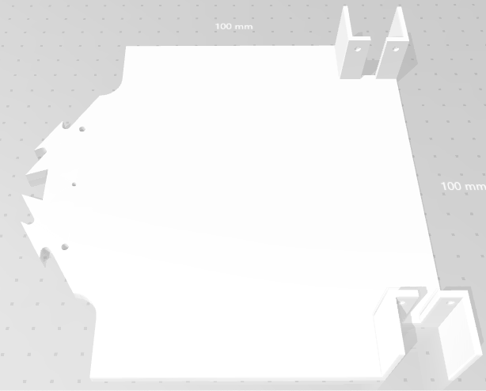

Figure 1: Base model

The front side of the base consists of the assembly place for the steering system inits own and also has the place where the servo motor will be placed. After all the components will be in place, an additional extension will be added to theservo motor which will connect it with the steering system. As mentioned earlier the models are sepperated with a snap fit pattern, which allows the base model to be connect the both sections without any additional material and the connection will be powerful enough to hold the weight of the components placed on.

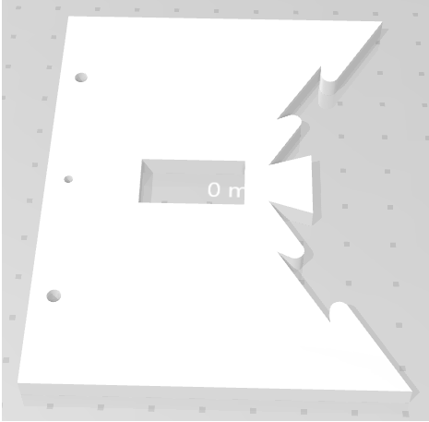

Figure 2: Base model front side

## Steering system

The steering system consist of:

1. Bearing holder x2
2. Holder joint connectors x2
3. Servo-join connector

The bearing holder, holds in place 2 bearings model **627** with dimensions as shown in the **fig.3**. The bearing holder is printed with PLA, and it has a wall thickness of **3 mm**. Inside the bearings, special designed pins are inserted that will connect the bearings with the wheels in the steering system.

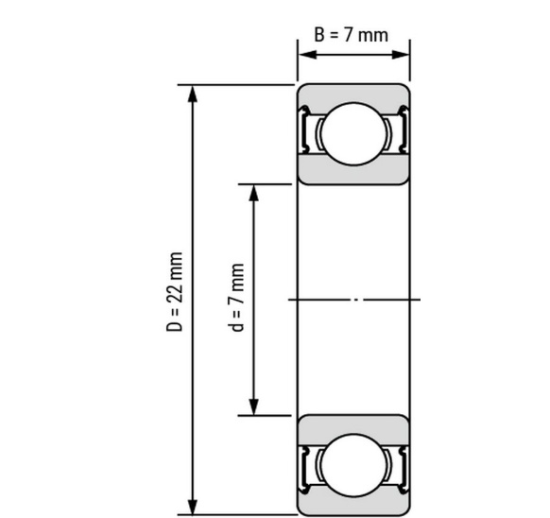

Figure 3: Bearing dimensions

Before placing the bearings inside the casing, the pins should be inserted, then they are placed properly inside the casing. The casing has sides with 2 holes, one in each, as shown in **fig.4**, they are used to connect the steering system, they are straight shaped objects that have pins in both sides that get inside the holes in the casing. That way the steering system can stay stable. Apart from these, how will the system turn? The servo motor is connected to one of the casing connectors in the middle, through an extension printed specificaly for the MicroServo 9G.

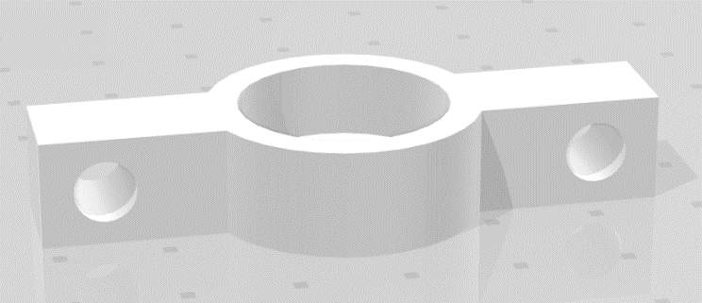

Figure 4: Bearing Holder

The connector between the bearing holders is left with a tolerance so there won’t be too much pressure needed to put them in place, **fig.5**. After they are connected and everythins is in place, the ending sides of the pins can be heated up so the steering system won’t get loose.

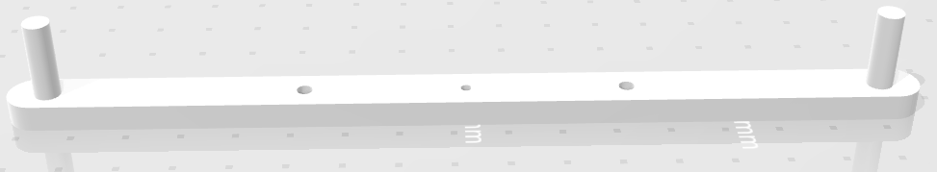

Figure 5: Bearing holder connector

The connector between the wheels and the bearings is designed due to the inner section of the wheels and the inner dimension of the bearings. The bearing model **627** has an inner diameter of **7 mm.** That way the pins are designed and printed. One of the problems that has appeared while funcitioning and assemblying the parts is that these pins are constantly in high pressure and they need to be of a good quality.

In order to prevent the pins from breaking make sure:

1. Printing these at 100% infill.
2. Use a metal version of them.

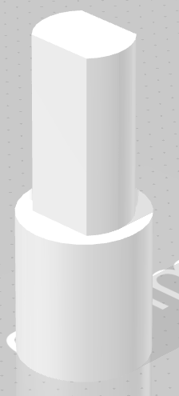

Figure 6: Bearing and wheel connector

## Vacuum section with filtering system

The vacuum section is the one which create the suction power, it also has its own filtering system and an easy way to detach the filter to clean it after use, or in between the process due to longer periods of work.

The vacuum section consists of these parts:

1. The vacuum motor and its casing.
2. The extension tube from the motor.
3. The adapter for filter connection.
4. The holder of this section.
5. The connectors.

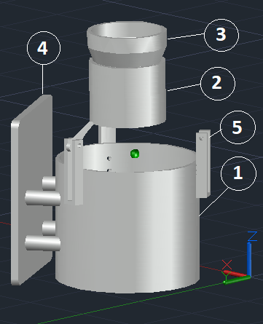

Figure 7:The vacuum section

Changes made to the design:

1. The motor casing needs an opening to release the the air that in gets inside, in order to do that, two holes were drilled in the casing proportionally and mesh filters were placed so if any unwanted smell or small particules were not stopped from the filter they get stuck in the mesh filters.

The connectors are used to connect the extension tube and the motor casing, in which one end is placed in the motor and it gets a secure connection from the connectors. Then the adapter gets inserted inside the extension tube and in the other end it has a wider diameter in which the filter gets connected. The holder of this section gets connected to the motor casing through 4 extensions, and the holder itself gets connected with the base of the project to hold everything in place. This section also contains the filtering system which is the filter and its casing.

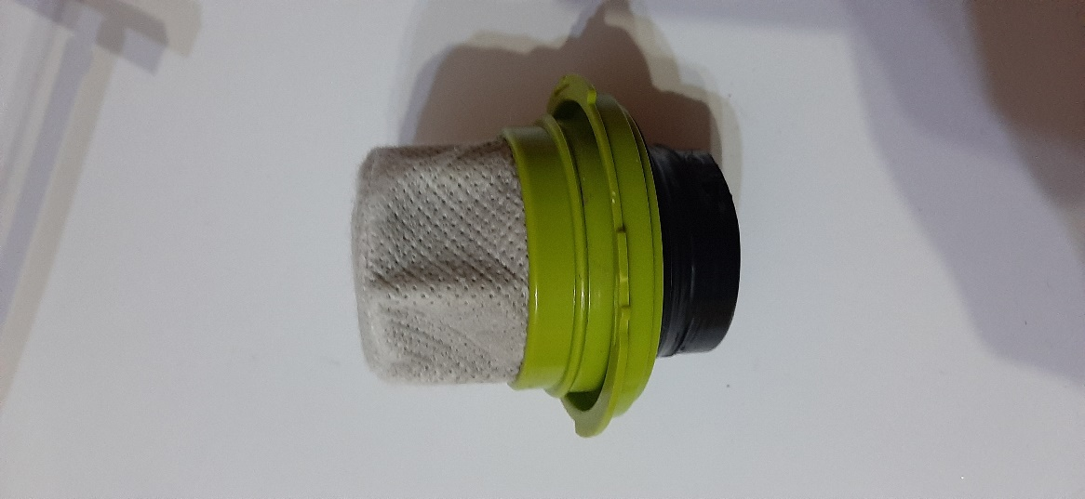

Figure 8: Filter

## Linear actuator and suction attachment

During movement or working process in general, the project might come into some areas where the suction head might not be able to work properly. Keeping that in mind, a system of a linear actuator, which will position the suction head lower/higher, has been designed. That way, during the time where the project doesn’t need to operate (create vacuum), the suction head can be lifted to avoid any obstacle during return.

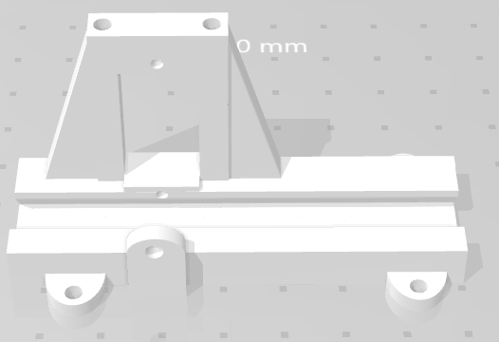

Figure 9: Linear actuator

The linear actuator where the servo motor is connected had the geared extension, which allows the servo motor to move it lower/higher for user adjustment. That wat the suction head can be positioned as needed. Its length is determined from the amount of lift calculated.



Figure 10: Geared extension

The geared extension is connected with the suction head with a connector, to make it easier for the user, each suction head has one connector already connected so that way the user can easily remove it and connect it with the other suction head depending on the usage. The geared extension fits to the inner part of the connector and needs no additional connectors, if the connection is loose, the sides of the connector have openings where the user can insert screws to strengthen the connection.



Figure 11: Linear actuator and suction head connector

The suction head that is presented below, has the length of: **20cm**. It has four pipes above so that the pipes from the filter casing can be connected to it. Four pipes are used to spread the vacuum that the motor creates equally in all the suction head’s surface. That way the vacuum can be appropriate and the dust can be cleaned better.

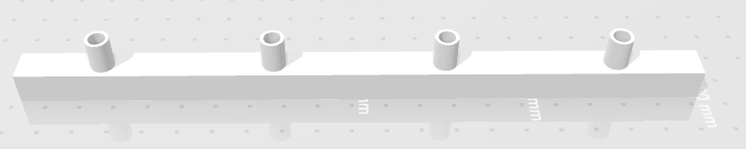

Figure 12: Suction Head

The width of the suction head presented above is: **1cm**. The rubber tubes that are extended from the filter casing are connected to it. The rubber tubes in the filter casing are glued so there will be no air escaping from them. Also, they have one more connector to strengthen their position so they cannot move from the filter casing.

# Electric components, diagnosis and overall cost

One of the most important parts of the project is the electronics, basically this is what brings the project to life. All the components are soldered in proper perf boards, the schemes are created also, in the near future the electronic boards will be replaced with a more professional version of them, PCB’s will be created for both the transmitter and receiver. In order to keep everything safe and to make all the components attach easily in the board, output pins have been placed in the receiver board, so all the motors and the power supply will be connected.

## Running Diagnosis

The battery type used for powering the vacuum motor is Lead Acid Battery, which after calculations depending on specific rates it has to be multiplied by 0.75 to obtain the total running time of the motor.

Table 1. Running time calculation for the vacuum motor

|  |  |  |  |
| --- | --- | --- | --- |
| Capacity (Amp hours) | Discharge rate (Amps) | Running time (hours) | Battery type comments |
| 4.5 | 1 | 4.5 | Lead Acid Battery x0.75 |
| Total running time: 3.375 hours (3 hours, 22.5 minutes) | | | |

The Servo motors also the DC motors will be powered with 2 x 18650 Lithium Ion Batteries that are connected in series. The LM7805 voltage regulator converts the 8.2 Volts from the batteries into 5 Volts for the servo motors. The DC motors have the ground connected from the batteries and the positive charge from the Arduino Nano pins. The overall usage of current from the DC motors and Servo motors won’t be constant and also won’t be high, that way the 2S batteries will fulfil the requirements. The higher usage of current is from the suction motor which is powered with Lead Acid Battery 4.5 Ah, and that is enough to keep it running for an estimated 3.375 hours

## All the components and Overall Cost

Table 2: List of componets and cost

|  |  |  |
| --- | --- | --- |
| **Component** | **Description-Functionality** | **Cost** |
| Arduino NANO | Microcontroller | 19.0 € x2 |
| NR24L01 | Wireless Transmission | 4.00 € x2 |
| L7805 | Voltage Regulator (5 Volt) | 1.00 € x1 |
| LM1117 3.3 V | Voltage, Current Regulator | 2.50 € x2 |
| 2N2222 | Transistor for driving DC motors | 0.10 € x2 |
| DC motor with wheel | TT geared motor 200/rpm | 3.00 € x4 |
| Lithium Ion Battery 18650 | Power supply for Receiver | 6.00 € x2 |
| Battery (6V, 4.5Ah) | Power supply for vacuum motor | 15.0 € x1 |
| 540VH-6926NF DC-12V | Vacuum Motor | 20.0 € x1 |
| Micro Servo 9G | Steering System Control | 14.5 € x2 |
| JoyStick Module | Controlling the Project Movement | 8.00 € x2 |
| Resistors () | Electric Circuit | 0.50 € x1 |
| Capacitors (10,100) | Electric Circuit | 0.50 € x1 |
| Switch 8x8mm Blue Cap | Electric Circuit | 0.90 € x2 |
| Perf Board | For Soldering all the Components | 1.00 € x2 |
| Filament PLA (Black, 0.75mm) | For Printing all the Components | 25.0 € x1 |
| **Total cost: 186 €** | | |

Prices taken from the local store “**SmartTronik**” in Kosovo/Prishtina

# Remote controlling

The project is remotely controlled through the wireless NRF24L01 modules, both the transmitter and receiver have one implemented in the electronic boards. The transmitter will be used for transmitting the signal to control the project, it will be used to move it left/right/forward, also for adjusting the height of the linear actuator, which will position the suction heads lower/higher. The receiver drives the DC motors also the servo motors, they are connected through the pins in the board, specified for each motor.

## Transmitter

The transmitter electronic circuit consists of these components:

1. Arduino NANO x1
2. NRF24L01 x1
3. Potentiometer 10 **KΩ**
4. JoyStick x2
5. Battery **9V**

Sample text, sample text, sample text, sample text, sample text, sample text, sample text, sample text, sample text, sample text, sample text, sample text, sample text, sample text, sample text, sample text, sample text, sample text, sample text, sample text, sample text, sample text, sample text, sample text, sample text, sample text, sample text, sample text, sample text, sample text, sample text, sample text, sample text, sample text, sample text, sample text, sample text, sample text, sample text, sample text,

## Source Code

The receiver electronic circuit consist of these components:

1. Arduino Nano x1
2. NRF24L01 x1
3. L7805 Voltage Regulator x1
4. 10 **μF** Capacitor x2, 100 **μF** Capacitor x1
5. Transistor 2N2222 x2
6. Resistor ___**Ω** x2
7. LM1117 3.3 V Regulator

Sample text, sample text, sample text, sample text, sample text, sample text, sample text, sample text, sample text, sample text, sample text, sample text, sample text, sample text, sample text, sample text, sample text, sample text, sample text, sample text, sample text, sample text, sample text, sample text, sample text, sample text, sample text, sample text, sample text, sample text, sample text, sample text, sample text, sample text, sample text, sample text, sample text, sample text, sample text, sample text,

## Receiver

The receiver electronic circuit consist of these components:

1. Arduino Nano x1
2. NRF24L01 x1
3. L7805 Voltage Regulator x1
4. 10 **μF** Capacitor x2, 100 **μF** Capacitor x1
5. Transistor 2N2222 x2
6. Resistor ___**Ω** x2
7. LM1117 3.3 V Regulator

Sample text, sample text, sample text, sample text, sample text, sample text, sample text, sample text, sample text, sample text, sample text, sample text, sample text, sample text, sample text, sample text, sample text, sample text, sample text, sample text, sample text, sample text, sample text, sample text, sample text, sample text, sample text, sample text, sample text, sample text, sample text, sample text, sample text, sample text, sample text, sample text, sample text, sample text, sample text, sample text,

## Source code

Sample text, sample text, sample text, sample text, sample text, sample text, sample text, sample text, sample text, sample text, sample text, sample text, sample text, sample text, sample text, sample text, sample text, sample text, sample text, sample text, sample text, sample text, sample text, sample text, sample text, sample text, sample text, sample text, sample text, sample text, sample text, sample text, sample text, sample text, sample text, sample text, sample text, sample text, sample text, sample text, sample text, sample text,. Sample text, sample text, sample text, sample text, sample text, sample text, sample text, sample text, sample text, sample text, sample text, sample text, sample text, sample text, sample text, sample text, sample text, sample text, sample text, sample text, sample text, sample text, sample text, sample text, sample text, sample text, Sample text, sample text, sample text,

# Final look of the project