**Project Report on**

**NoPanik**

**An Android Application for Emergencies**

Mentored By – Dr. Suruchi Chawla

Submitted By

Akansha Jain (2019304)

B.Sc. (H) Computer Science 1st Year

Batch 2019-2022

**Shaheed Rajguru College of Applied Sciences for Women**

**University Of Delhi**

**CERTIFICATE**

This is to certify that Project Report entitled “**NoPanik – An Android Application for Emergencies**” submitted by Akansha Jain (2019304, Batch 2019-2022) under a summer internship project carried out by her from July 01, 2020 - July 30,2020 under my supervision.

**Dr. Suruchi Chawla**

Project Mentor

Head of the Department

Department of Computer Science

SRCASW, University of Delhi

**DECLARATION**

I hereby declare that this project work entitled "**NoPanik – An Android Application for Emergencies**" which is being submitted to Shaheed Rajguru College of Applied Sciences for Women, University of Delhi for the purpose of Summer Internship Program, is a bona fide report of the project carried out by me.

**Akansha Jain** (2019304)

B.Sc. (H) Computer Science 1st Year

Batch 2019-2022

**ACKNOWLEDGEMENT**

The confidence one attains while performing a task that has great importance of its own comes not only through one's own constant efforts but rather is a result of ceaseless cooperation, constant guidance and ever motivating tips of various experienced people. I express my sincere gratitude to Dr. Suruchi Chawla for her guidance and especially for her emphasis on systematic approach, details and rigor in the process of research.

I cherish the discussions I had with her and thank her for her advice and all the support throughout my research work. I am grateful to her for her guidance and especially, for her constant encouragement for developing a deep passion towards research and emphasis on hard work and rigorous experimentation. I would also like to thank the faculty members of my institute with whom I had fruitful interactions.

**ABSTRACT**

The aim of the project is to develop an Android application that lets its users to send notifications in case of an emergency or a panic situation. Emergency mobile application will work like an emergency pocket assistant to help people during the urgent situation. The idea for this application is easy and effective.

The basic concept of this mobile application is, when the user fall into the emergency situation, he or she can just can send text message on the press of a single button. The emergency function will send emergency message and GPS location in the form of a url through SMS to particular contact. The phone numbers can be set from within the application. The text message sent, along with the content, also have the last known location of the user(in the form of a url). This is very helpful in tracking the whereabouts of the person.

**TABLE OF CONTENTS**

Table of Contents

**Certificate1**

**Declaration2**

**Acknowledgement3**

**Abstract4**

**Ch 1: Introduction6**

1.1 Introduction6

1.2 Motivation7

1.3 Project Scope8

1.4 Project Objectives9

1.5 Impact, Significance and Contribution10

**Ch 2: Literature Review11**

2.1 Article Review11

2.2 Fact Finding16

2.3 Data Collection17

**Ch 3: Software Requirements23**

**Ch 4: Architecture and Design24**

4.1 System Architecture24

4.2 Design Diagram25

4.3 Methodology27

**Ch 5: Implementation29**

5.1 Tools and Languages Used29

5.2 The Device specification that used in this project development30

5.3 Implementation Issues and Challenges31

5.4 Results32

**Ch 6: Future Work38**

**Ch 7: Conclusion39**

**Ch 8: Supplementary Material40**

**Ch 9: References and Bibliography47**

**INTRODUCTION**

**“**Emergency never comes with prior intimation and in real world scenarios, detecting such emergencies & reporting them is real challenge.**”**

**Chapter 1: Introduction**

* 1. Introduction

Emergency mobile application is a system that use to help people when they are in urgent situation. For example when a person is kidnapped by a kidnapper, during the extreme situation, he/she can just click one button from the mobile phone and an emergency message will be sent through SMS to three important persons or even some government official that is set by the user. The coordinate of the user’s current location and the emergency message will attach together in SMS and sent. So, this is how the application operate to help people.

Moreover, the idea of the emergency mobile application that i develop in this project is quick, easy and effective. Therefore, i decide to set only one button to let user to click. For example the user want to operate the app, they just need to press one button in order to activate all the function in the app. This will make the user feel easy, effective and less burden when they need to operate the app, because fast and quick is the most important things during emergency situation. The basic concept of the mobile application that i develop in this project will be the app will need some emergency contact number from user. The contact number can be the relative of the user or even the friend of the user. The user needs to save three important contact numbers that he/she think will help in such kind of situations using the add emergency contacts button. The app use Alert image button to send the emergency message with location URL during the emergency situation. To trigger the emergency function the user needs to just click the Alert image button.

* 1. Motivation

Presently, smartphone become a common use electronic device that people will have nowadays. The mobile application inside the smartphone can be used to help people finish their task. But if the mobile application can be used to rescue or provide help for people when they are in emergency situation, this will become a huge benefit for people. For example if he or she are kidnapped by someone, at that time the victim might not have enough time or energy to type some message to send to someone this will waste a lot of time, but if the smartphone inside have a mobile application that can automatically send emergency message by trigger one button in the phone, then the victim can be easily look for help at the short period of time. The reason that i develop this type of mobile application is because i want to provide an easy, fast and effective way to look for help for all people when they are in trouble, the app will act like a little emergency assistant in the smartphone.

Moreover, there are few existing emergency mobile apps in the current market, but there are few way that can be improve such as the way to active the app, the way to spread the emergency message. By solving or improving the function in the mobile apps in order to let user have a good and effective emergency assistant to help them when they are in trouble. The main motive of this project is to improve the function of the emergency mobile application and to improve the helpfulness of the app to the people during emergency situation.

* 1. Project scope

This project is to develop an emergency mobile application that can be help people rescue themselves when they are in emergency situation. This mobile app is to target on all the users that are using smartphone. In order to deliver a reliable and good system, iterative and incremental model have been chosen to become a software methodology of this project. This software methodology allow the developer to add or improve the functionality of the system using the way of incremental. There are seven phases cover in this model, which is initial planning, planning and requirement, analysis and design, testing, implementation, evaluation and deployment. But we will not cover all the task that perform in each phase, each phase only cover specific scope for this project.

**The scope for each phase will be:**

|  |  |
| --- | --- |
| Phase | Scope |
| 1. Initial planning | The basic and rough plan will be covered in this stage in order to form a basic concept of the system. |
| 2. Planning and requirement | The requirement gathering will be covered to collect the user’s needs and wants, besides, the actually work plan will be made in order to have a guide for the process of the project. |
| 3. Analysis and design | Analysing the user’s requirements will be covered to create a standard of the system and a system design will be included to form the layout of the system. |
| 4. Testing | System testing and acceptance testing will be covered and carried out in the phase, to test the working system and learn the problem. |
| 5. Implementation | System working confirmation will be cover to ensure the fully working system. |
| 6. Evaluation | Cover system benchmarking to evaluate performance of the system. |
| 7. Deployment | Cover transformation of the system. |

**Table 1-1: Scope of Methodology**

* 1. Project objectives

In this project, the emergency based mobile application is developed to help people to act quickly when they are in emergency situation. The system will send an emergency message including the location, to the emergency contacts that the user has already set in the system. The information will be sent when the user trigger the system.

**Goal to achieve in this project:**

1. To apply button active function to trigger the system. User can activate all the function by pressing one Alert image button.
2. To develop a simple, effective and user friendly emergency mobile application. Provide user a straight forward interface and friendly mobile application environment.
3. To send an emergency message along with location URL that helps the emergency contacts to know the whereabouts of the user.
   1. Impact, significance and contribution

**1. Impact**

This emergency mobile application will provide user a fast way to look for help. Besides, because of the complete information that set in the app by the user, the emergency contact or police official will be easy to know who and what exactly is happening in that emergency situation. The rescue process will be performed quickly and accurately according to the user’s complete information.

**2. Significance**

Because of the busy and dangerous world today, we need easy and fast way to get help when we are in trouble. For example an invisible emergency assistant that will help people during some stressful situation. Emergency mobile application will be an invisible assistant. People just need to install this mobile application in their smartphone, it will act like an emergency assistant. User can trigger it anytime anywhere as long as emergency is happen. After the user trigger the apps, an emergency message will be send to specific contact person to look for help. The user no need to type message or search contact in order to look for help.

**3. Contribution**

By using this emergency mobile application people can react fast or look for help in a short period of time when they are in trouble. The emergency mobile application could reduce the possibility of people kidnapped by someone or increase the chance of people get rescue. Other than this, the emergency mobile application will improve the efficiency of police or the friend and family to look for the user that are in trouble. For example when the person who installed this app, suddenly some emergency situation is happen, the user will trigger the apps in order to look for help in quickly without suffering.

**LITERATURE REVIEW**

**Chapter 2: Literature Review**

2.1 Article Review

The main topic that use to review the literature is emergency based mobile application. There are many literature theories that are related to this kind of topic, but in this review we will only focus on three groups, which are the emergency based handling system, the mobile emergency response technology by using geolocation and safety triggering system. These three groups will be mainly focus and review, in order to improve the understanding of emergency based mobile application.

**1.Emergency based handling system**

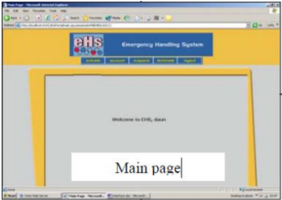 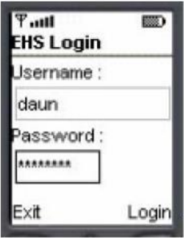

**Figure 2-1: EHS system portal Figure 2-2: EHS Mobile Application**

Firstly, the meaning of emergency based handling system group is when people have any incident or emergency, people will use the system to get help and the system will handle this every critical situation to provide help and response to the people. Maznah Kamat, Anazida Zainal & Rashidah Kadir conducted a research and development regarding the emergency handling system. They developed the system call emergency handling system (EHS),

they applied location based technologies to this system, in order to detect the caller or the user location and connect to a database server. This kind of system they enable user to send a emergency message to a police station, rescue team, hospital etc. The receiver will check and ensure the location when they login in to the system portal and check the message of the sender to estimate the location (Maznah Kamat, Anazida Zainal & Rashidah Kadir 2003).

**Strength:**

• Provide a user friendly interface in order to let user more easy to function.

• Able to suggest the user nearest emergency service station and let user report to the nearby station.

**Weakness:**

• User need to login in to the application before they request for help, if in the stressful situation this might be affect the effectiveness of the request

• Did not provide a message resending function for the user, in order to let the user resending the message in the specific interval of time without pressing a button.

**2. Emergency response technology by using geolocation**

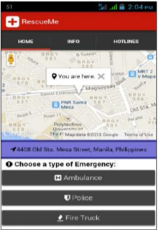 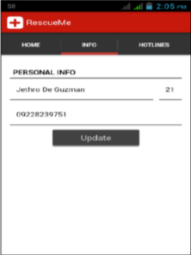

**Figure 2-3: RescueMe Apps Figure 2-4: RescueMe Apps**

Following the first group, the second group is the mobile emergency response technology by using geolocation. The meaning of this group is using the location service in smart phone such as GPS and A-GPS to keep track user location when the user are in urgent. Jethro, Ritz and Engr conducted a research or a development regarding the mobile emergency response technology by using geolocation. They develop a mobile application can RescueMe, which using this technologic and the mobile application will work together with the web application command center. The command center will read the user information when the user request certain emergency unit.

The application will have three type of emergency unit, for example ambulance, police and fire truck. After the command center get the user information from the mobile application, the command center will immediately plot the information on google map ( Jethro, Ritz & Engr 2014).

**Strength:**

• The mobile application have a clear and simple user interface.

• The mobile application can detect user location and plot it in google maps in real time.

**Weakness:**

• The mobile application did not provide a setting for the user to sending emergency message to their friend or related , the apps just provide several hotline for user to call.

• The apps will became ineffective if the user don’t have stable network connection.

**3. Safety triggering system**

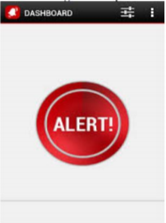

**Figure 2-5: Safety triggering system**

The last group is safety triggering system. Safety triggering system is when a person who fall in to a stressful situation, in that situation they feel trouble to doing anything, the safety triggering system will help the user handle everything when the user trigger the system. Kalyanchakravarthy, Lakshmi, Rupavathi & Lakshmankumar conducted a research and development about safety triggering system. They develop an android based safety triggering mobile application, the main purpose of them to create this app is woman’s safety, to provide a quick react when the user are in emergency situation. This application will operate when the user press the power button of the phone, after pressed the power button, the phone will popup an alert screen and the screen will show user a button, when the pressed the triggering button to active the apps and the apps will starting perform the emergency function at the background. The application will detect the current location of the user and append with the message together and send it to the user family and friend, the user can stop application continue sending message by using the personal password (Kalyanchakravarthy, Lakshmi, Rupavathi & Lakshmankumar 2014).

**Strength:**

• Provide a quick ways for user activate the application by one click.

• The apps can resending the emergency message without pressing any button.

**Weakness:**

• The application do not provide sound recording or video recording function, in order to record down everything during the emergency situation and append together with the message together.

• The apps did not provide a phone call function, in order to let user send the message at the same time they can also call the emergency contact by one click.

***In conclusion, by going through all the three groups which is emergency based handling system, the mobile emergency response technology by using geolocation and safety triggering system in this literature review. The group of safety triggering system will be more suitable for the world today and it is more related to my project, this is because my project will be more on safety triggering emergency mobile application such as pressed an image alert button to send all information of the user in order to get help. In this whole process of literature review, I learnt different functions and purpose of different groups and my understanding regarding the emergency based system become stronger. In order for me to create a useful emergency system, the review and also the comparison that I made in this review helped me a lot and gave me an idea on how to make my system more useful.***

2.2 Fact Finding

In order to collect a complete and accurate data in this project. We will only focus on the people who are using smart phone. Then, the range of the people that we target is the people who age above 16 years old and below 50 years old. By carrying the feasibility analysis the method that we choose to collect data for the analysis is questionnaire.

The reason that we choose questionnaire as the dataset collection method is because, questionnaire can target large amount of people in order to collect large amount of information. For example we create some question that relate to the emergency mobile application and distribute to particular amount of people in order to receive different opinion or information from the same amount of people. Besides, questionnaire method are more objective, the way of the response that get from the audience are more standardized.

In addition, questionnaire is a cost-effective method in compare to other method, such as interview method. For instance, if the project needs to collect large amount of information or data from different geographical area then for interview this might not be a good idea because there is no point to interview large amount of people, the expense for travelling will be horrible and also time consuming. Therefore, questionnaire will be good choice.

Moreover, the format that we choose to set the survey question is closed ended questions and multiple choice questions. There were three sections in the questionnaire. The first section contained some questions to get basic personal information from the audience. For example, the age of the audience, the education level of the audience, the specialization of the audience etc. The second section contained questions about the functions and features. This section contained close-ended questions, the audience can choose only one response out of five, the response will be very useful, useful, neutral, not useful and useless. The question will be regarding the usefulness of the functions and features that will be set in the emergency mobile app. The third section contained multiple choice questions. This section was created basically to understand how people understand about emergency mobile apps.

2.3 Data Collection

For this project, I performed the analysis of the questionnaire. I prepared 30 copies of the questionnaire and distributed to specific target audience. My target audience lies under the age between 16 to 50 who are smartphone users. The purpose to carry this analysis is that i wanted to know how much people understand towards emergency mobile apps and how people actually behave during emergency situations.

1. **Analysis of multiple choice questions**

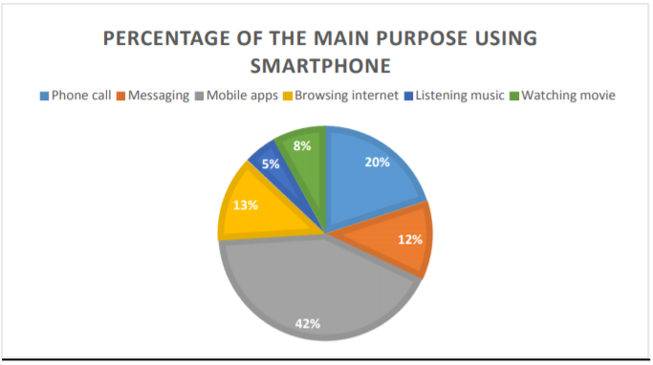

**Figure 2-6: Analysis MCQ question 1**

Figure 2-6, shows the data that people think towards the main purpose of using smartphone. As we can see that, Mobile apps have the highest percentage which is 42% by comparing to other choices. which means people think that mobile apps are the main purpose of using a smartphone. We assume that the reason that the audience choose ‘mobile apps’ as their main purpose, is because of the trend and the technology nowadays. For example, now people use and buy phone is not because of the phone call, the main thing they want is the specification of the phone, the higher the specification the more mobile apps they can install and more smooth the mobile applications will run.

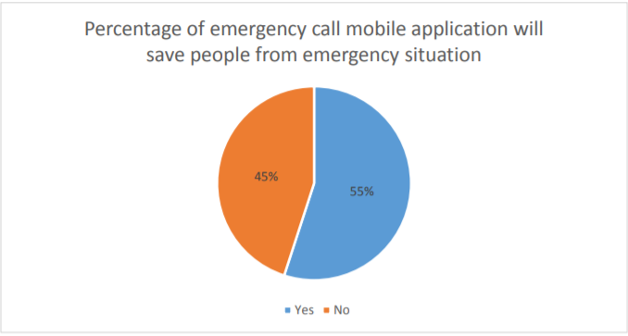

**Figure 2-7: Analysis MCQ question 2**

The pie chart in figure 2-7, shows the percentage of people think emergency mobile application will save people during emergencies. There are 55% of people think the mobile apps can save people from trouble, but the other side of people think that it cannot save people from trouble which is 45%. The percentage of between this choice is very close. There are some reasons that people choose ‘NO’ as the response, such as, some people think that mobile apps are not effective, some people also think that smartphone will easily run out of battery therefore no use for the mobile apps if no battery for the smartphone etc. But there are still more than half of the people think that emergency mobile application can save people in emergency situations**.**

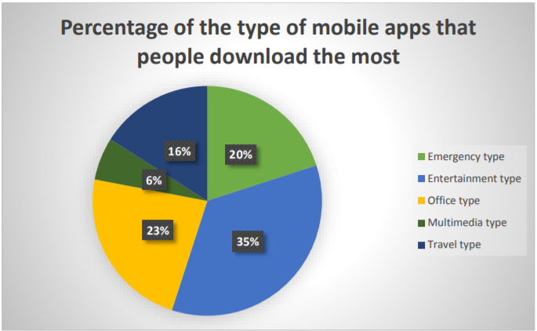

**Figure 2-8: Analysis MCQ question 3**

The pie chart above represents the data about the type of mobile application people download the most.

Entertainment type of mobile apps have the high percentage as compare to other type which is 35%, the type that relate to this project which is the emergency type have 20% and slightly lower than office type which is 23%, the travel type mobile apps get 16% from the audience. The lowest will be the multimedia apps.

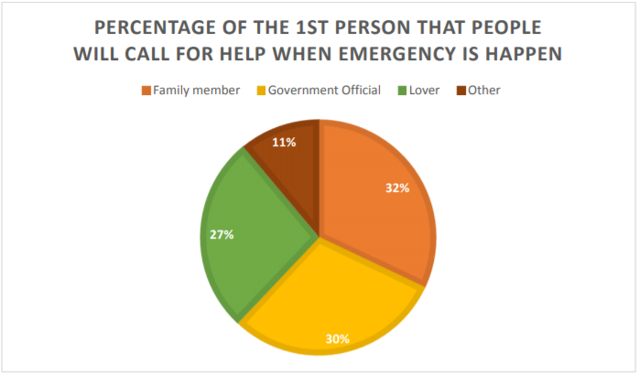

**Figure 2-9: Analysis MCQ question 4**

Based on figure 2-9, the pie chart shows the percentage of the first person that people will actually call for help when emergency happens.

Family member have the highest percentage which is 32%, the second highest will be the 30% Government officer. Lover are 27% a little lower compare to the first and second. The lowest percentage is other which is 11%. The people who choose other means that they have their own different people they want to call during emergency.

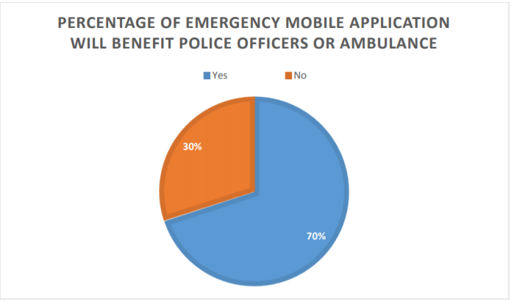

**Figure 2-10: Analysis MCQ question 5**

Based on figure 2-10, I collected the data about the people who think that emergency mobile application will benefit police officers or ambulance.

There are 70% of people that say yes, it is benefit for police officers and ambulance. But there are 30% of people think that it is no. The reason for people choose no might be the officers will think that the information send to them are not real or they think this is just someone playing to them or so on.

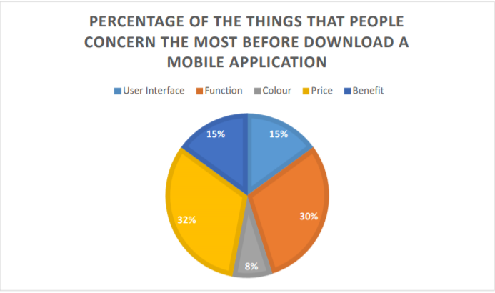

**Figure 2-11: Analysis MCQ question 6**

Based on figure 2-11, the data collected resulted in the percentage of the things that people concern the most before download a mobile apps.

Price and function have a very close percentage which is 32% and 30% respectively which means most of the people will be more concerned about the price and function of the apps before download. User interface and benefit have the same percentage. The lowest will be colour which is 8%.

**REQUIREMENT SPECIFICATIONS**

**Chapter 3: Software Requirements**

These requirements are separated based on whether you are developing the app or running the app on a device.

**For development:**

Operating System: Windows XP or higher/Mac OS X 15.8 or later/Linux Platform: Android SDK Framework 10 or Higher Tools: Android Studio 4.0

Technologies used: Java, Android, Google maps v2 API Debugger: Android Dalvik Debug Monitor Service (DDMS) Android Emulator: API level 25 or higher 6

**For running on a device:**

Operating System: Android 3.0 or higher Cellular capabilities for SMS messages

**Hardware Requirements:**

For development:

Processor: Intel Pentium IV or higher RAM:256MB

Space on disk: 250 MB (at the least)

For running on a device:

Device: Phone or tablet running Android 4.0 or higher Disk space: 6 MB (at the least 7)

**ARCHITECTURE AND DESIGN**

**Chapter 4: Architecture and Design**

4.1 System Architecture

**GOOGLE MAPS ENGINE**

**ANDROID**

**APP**

**LOGIC (CLASS FILES)**

**FRONT END**

**USER**

**Figure 4-1 System Architecture Diagram**

The different components in the architecture are –

1. User – This is the person who installs the application on his/her Android device. The user provides inputs contact numbers and triggers various events on the application.
2. Front End – This is the part of the application that is visible to the user. A screen presented to the user is usually an Activity, Fragment or a Dialog Box. They contain various elements like text box or buttons to take inputs from and provide outputs to the user.
3. Logic – These are the java files that contain the logic of the application. They contain various methods and classes that meet the functional requirements of the application. These files also contain code to communicate with other components in the application. For example, a file called Map.java will make use of Google maps Android API v2 to connect the Android app with Google Maps Engine to render map and markers of them.
4. Services – This is the component of the application that is typically used to perform long background tasks that do not have a user interface. For example – a service is used to track the location of the device.
5. Receivers – This is the component of the application that typically listens for some events or responses from other services. For example – A receiver is used to fetch the location co-ordinates from the location service and then add this location to the database for future references**.**
6. Google Maps Engine – This app uses google maps Android API v2 to work with maps. When this API is used, calls are made to the google maps engine to fetch the map or place various markers on it.

4.2 Design Diagram

4.2.1 Use Case Diagram

A use case diagram at its simplest is a representation of a user's interaction with the system that shows the relationship between the user and the different use cases in which the user is involved.

CONTACT NUMBER OF FAMILY MEMBER

CONTACT NUMBER OF FRIEND(S)

**ADD CONTACTS BUTTON**

USER

GOVT. OFFICIAL OR ANY OTHER PERSON THE USER TRUSTS

**Figure 4-2 Use Case Diagram 1**

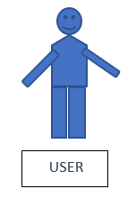

**Sends text message with location URL to the Emergency cotacts saved**



**CLICK**

**Figure 4-3 Use Case Diagram 2**

*As the user open the app the user first needs to Add 3 Emergency Contacts using the ADD EMERGENCY CONTACTS Button and save them. Then the user will be directed to the Main Activity Page where an image button will be present with Alert Sign as shown in the User Case Diagram. As soon as the user clicks the Alert Image Button there will be a pop up or toast that make sure the user that the details has been sent to the saved contacts as a text message. The details contain an Emergency Message with URL of the location.*

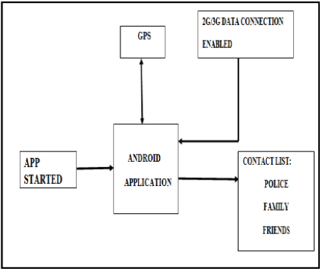

**Figure 4-4 Block Diagram for the Proposed System**

4.3 Methodology

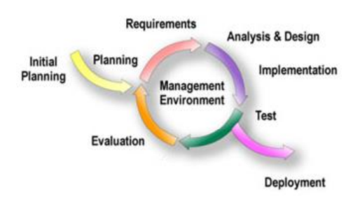

**Fig. 4-5 Iterative and Incremental Development Model**

The software methodology that are used for this project is Iterative and incremental development. Iterative and incremental development is the method that use to produce a good quality and reliable system. This model allow the developer to increase the functionality of the system in the increment way. Basically, this method has divided into two approach which is iterative and incremental approach. In iterative approach the author can choose to review or redesign part of the system and improve some of the feature in order to make the system become better. For instance every times the developer review or revisit the system, some modification or improvement will be made in that iteration. By the way, the developer can get user feedback in order to make quality improvement for the system. In incremental approach the developer are develop and analyse the system many times at different portion, each times the new feature of the system will be add incrementally until the whole system is finish developed. Besides, the system design, testing and implement also will perform incrementally until the system is done. In the end of the development the author will check the system completion and make sure it is fulfil the user requirement.

**Stages:**

1. Initial Planning

• Rough work plan for this project had been carry out, for instance decide the function and the feature that should have in the apps.

1. Planning and requirement

• Carried out analysis to analyse user requirement, the method have been choose to collect data for the analysis is questionnaire.

• The project work plan was made during this stage.

1. Analysis and design

• The data was collected to analyse in this stage.

• The standard of the system or apps will be based on the analysis result.

• System design was carried out in this stage, the system design will be use case diagram.

• Simple layout of the system was constructed in this stage.

1. Testing

• In this phase system testing and acceptance testing was carried out.

• The system will test with test plan in order check each functionality in the mobile application and check the bugs contain inside the app.

1. Implementation

• Test the bug in the system.

• The system will be fully integrated and constructed.

1. Evaluation

• Benchmarking the system to know the standard of the system.

• To check whether the system match the user requirements.

1. Deployment

• Transform the system to fully working system.

• Deploying the complete function system to the user.

**IMPLEMENTATION**

**Chapter 5: Implementation**

5.1 Tools and Languages Used

**1. Platform used**

Android

The proposed system is a mobile application. Therefore the android platform was chosen to become the system platform that I used in this system. Android is a famous mobile platform people well known about it. It is a linux kernel based mobile platform, the reason to choose android is because android mobile apps can fit in many type of smart phone.

**2. Languages used**

JAVA

The proposed system is in android platform. Therefore, Java will be used in its development. Java is an object-oriented programming language that is used to develop various types of systems. Nowadays, most of the systems are using Java programming language to develop. The reasons to use Java to develop the system is because most of the android application are developed using Java and using its object-oriented features.

XML

Android application requires xml language to design the layout and graphic user interface of the mobile application. The layout size, text, color, background and so on is required to use xml language in order to make change.

**3. Software Used**

Android Studio

Android Studio is the official integrated development environment for Google's Android operating system, built on JetBrains' IntelliJ IDEA software and designed specifically for Android development.

5.2 The Device specification that used in this project development

This is the computer specification that used to develop the apps throughout this project.

|  |  |
| --- | --- |
| Processor | Intel i5 8265U@1.6Ghz-1.80Ghz |
| RAM | 8GB |
| OS | Windows 10 Pro 64 bit |
| Video Card or memory | Nvidia Geforce GT 630M, 2GB RAM |

**Table 5-1: Specification of computer**

This is the smartphone that used to debug and test the functionality of the mobile application.

|  |  |
| --- | --- |
| Processor | Quad-core 2.0Ghz |
| RAM | 16GB |
| OS | Android Version 7.1.1 Nougat |

**Table 5-2: Specification of smartphone**

5.3 Implementation Issues and Challenges

*During the project development, I faced some challenge and issues also. The first challenge and issue was the xml language, it is a programming language that I was not so familiar. But xml was included in the development, this is because most of the IDE’s in android development use xml to develop different kind of apps. So in order to use it, I needed to learn this language in order to design a good user interface.*

*Besides, the second will be mobile app “bug” problem. If we find a bug during the development of apps, we need to spend almost two or three hours to look for the solution to solve the bug. Sometimes a day, still cannot find any solution. So, this might be one of the reasons to slow down my project’s progress. In addition, the virtual machine of android that use to display outcome is slow. For example, when i finished developing the apps then i wanted to test the apps, after running the apps i need to wait some time to get the output.*

5.4 Results

The following figures are the screen shots of Abhaya

application initially from the starting of it.

The following figures are the screen shots of Abhaya

application initially from the starting of it.

The following figures are the screen shots of Abhaya

application initially from the starting of it.

*The following figures are the screen shots of “NoPanik” application initially from the starting of it.*

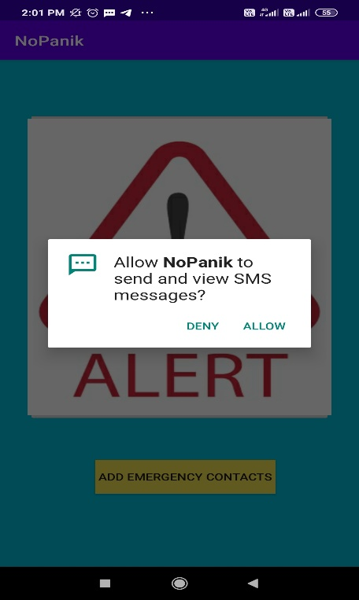

**When you open the Application, it will ask you for the permission to send and view SMS messages.**

**Fig. 5-1 Permission message**

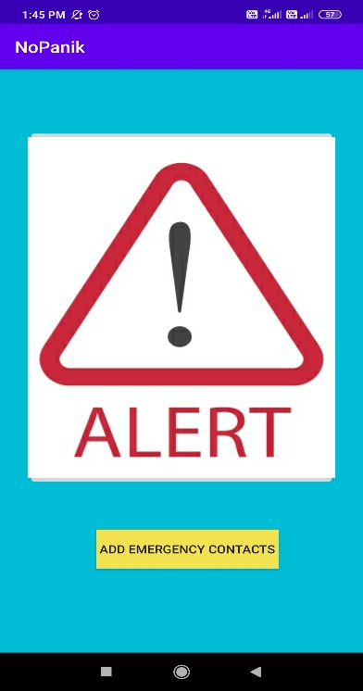

***This is the Home Screen where the user first needs to click on the ADD EMERGENCY CONTACTS Button to save contacts.***

**Fig. 5-2 Home Screen**

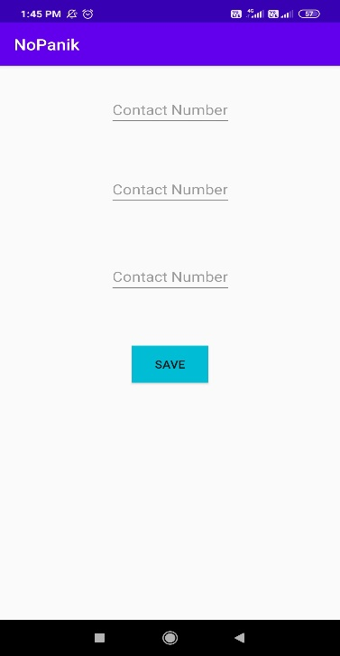

**This is the page the user gets after clicking on the ADD EMERGENCY CONTACTS BUTTON to save contacts of the three important people the user thinks that he/she can trust in the time of emergency.**

**Fig. 5-3 Contacts Page**

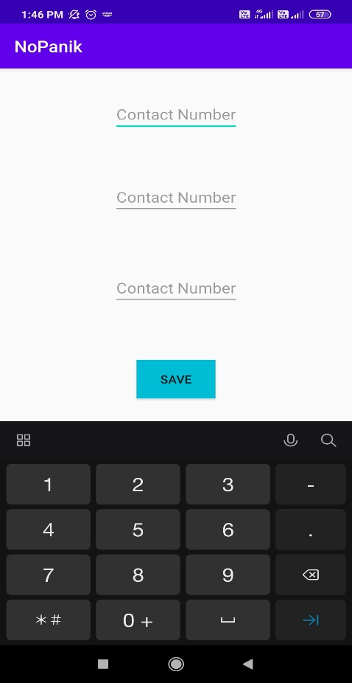

**This is the interface the user will receive when he/she try to save contact numbers. Only number keypad will be present to add contact numbers.**

**Fig. 5-4 Saving Contacts**

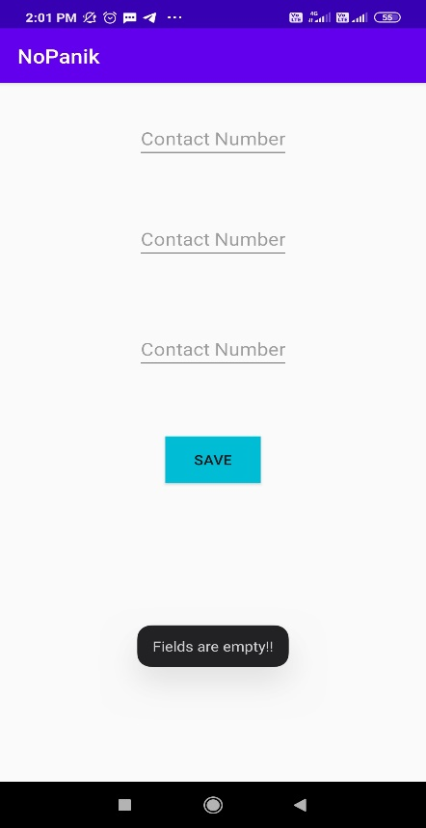

**If the user tries to click the save button without adding any contacts he/she will receive a toast stating “*Fields are empty!!”*.**

**Fig. 5-5 Receiving of Toast**

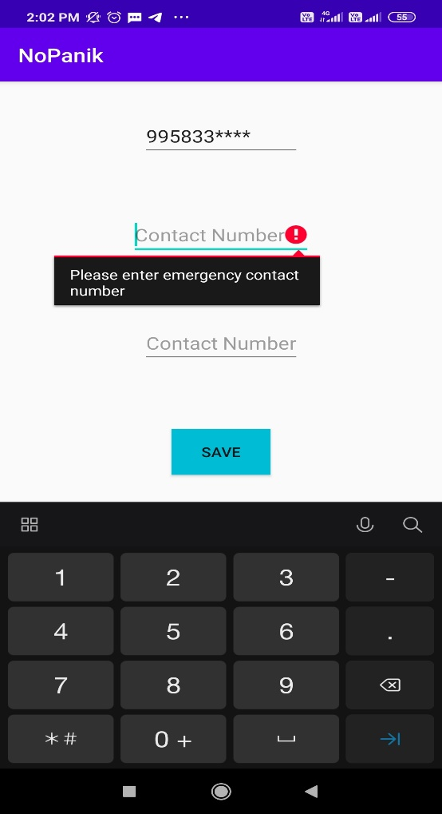

**The application won’t run until the user adds all three contact numbers. If the user tries to SAVE by adding only one/two contact numbers, he/she will receive a message stating “*Please enter emergency contact number*”.**

**Fig. 5-6 Saving of three Contact Numbers**

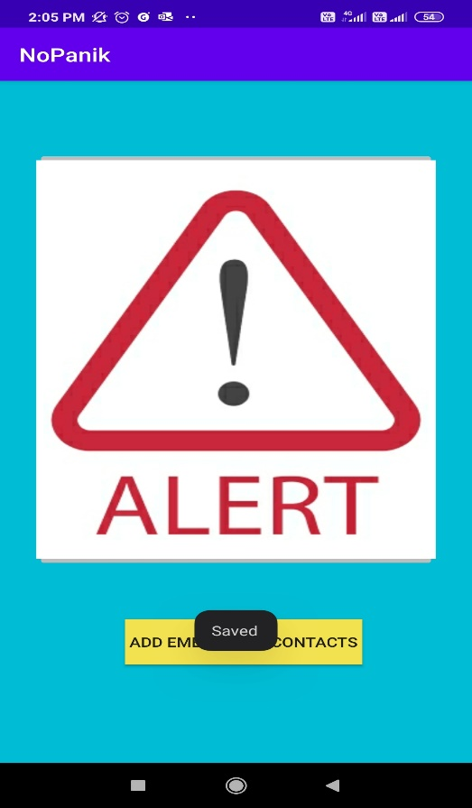

**As soon as the user saves all the three contacts, he/she will receive a toast “*Saved!*” for confirming that the contacts has been saved.**

**Fig. 5-7 Confirmation for saving of contacts**

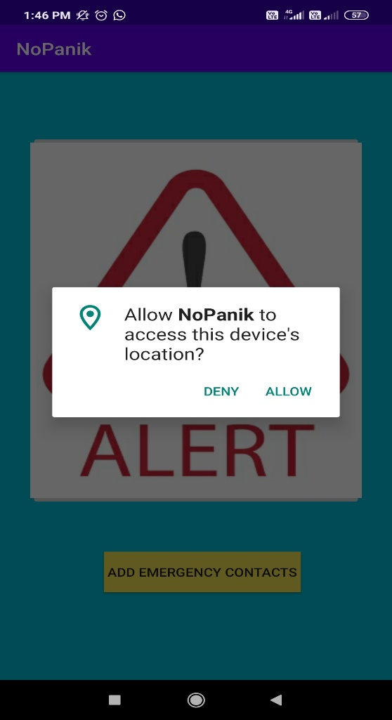

**When the user clicks on the Alert image button the application asks permission to access device’s location so that the concerned person gets the current location of the user and save him/her in any kind of emergency situation.**

**Fig. 5-8 Permission to access device’s location**

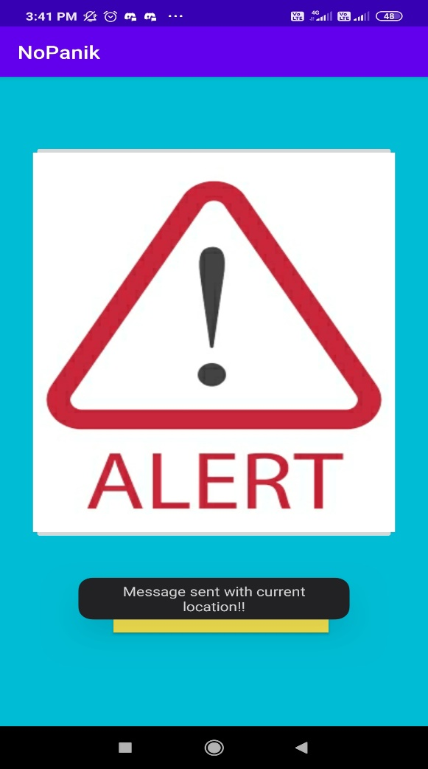

**After asking for the permission the application sends message with location URL of the user to the three saved contacts. For the confirmation, the application gives a toast stating “*Message sent with current location!!”*.**

**Fig. 5-9 Confirmation of the sent message** 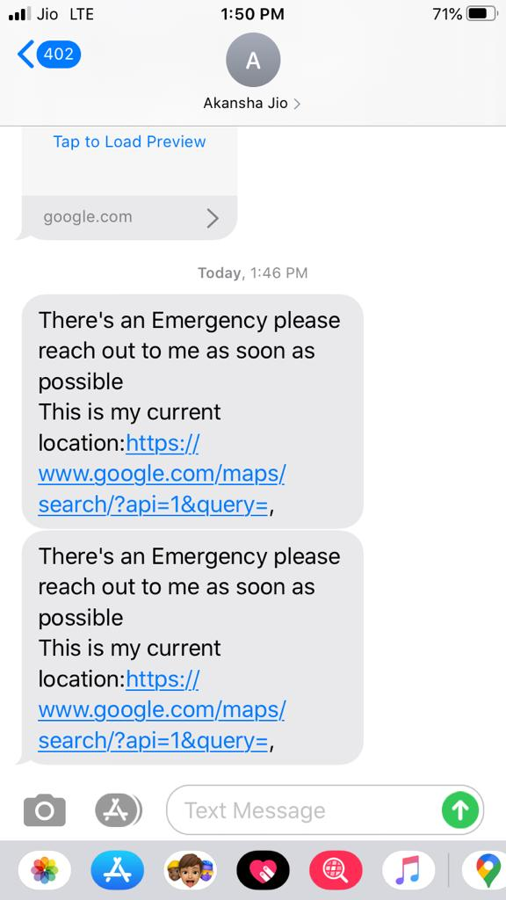

**The concerned person receives an emergency message with current location of the user.**

**Fig. 5-10 Message with Location URL**

**received by the concerned person**

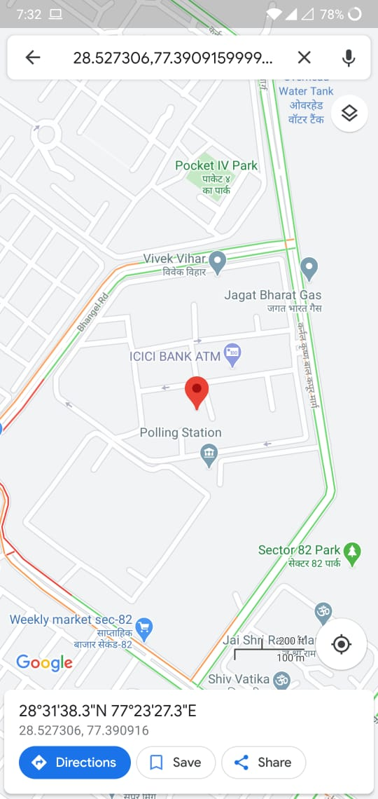

**As the concerned person opens the URL he/she is directed to the user’s current location in Google Maps.**

**Fig. 5-11 User’s Current Location**

**FUTURE WORK**

**Chapter 6: Future Work**

The current work on the NoPanik app has a lot of essential features that would be used in case of an emergency situation like sending text messages with current location from within the app on tap of a single button. An app for such a purpose has a lot of scope for enhancement.

In the future, the app may include features like –

1. A home screen widget that can be used as a triggering point to send panic notifications. The user would then not have to open the app every-time to send these panic notifications.
2. Initiating a call to a number set from within the application when the user presses the panic button.
3. The app can also listen to incoming messages from the set contacts. If these messages have a pre-defined text like “UPDATE LOCATION” the app can reply with a text message containing the current location or for some other text like “AUDIO” in which case the app can record a short audio and send it as an email to the person. This is very helpful as you may have already pressed the panic button and may be in some trouble where you cannot reply. This way the person can track you constantly and can also understand something about the nature of the emergency from the audio clip.
4. Point no. 3. can also be achieved by developing a voice bot inside the app which will perform all the functions listed above.

**CONCLUSION**

**Chapter 7: Conclusion**

In the end of this project, an emergency type mobile application will be delivered. This mobile app will work like an invisible assistant to help user look for help during the stressful situation. The idea for this mobile app is quick, easy and effective. So, there is only one button to let user trigger the app.

The proposed system : *As the user open the app the user first needs to Add 3 Emergency Contacts using the ADD EMERGENCY CONTACTS Button and save them. Then the user will be directed to the Main Activity Page where an image button will be present with Alert Sign as shown in the User Case Diagram. As soon as the user clicks the Alert Image Button there will be a pop up or toast that make sure the user that the details has been sent to the saved contacts as a text message. The details contain an Emergency Message with URL of the location.*

The reason that motivated us to improve the function of this mobile app is because we want all the people have an efficient and powerful mobile apps to help people from urgent situation. This will become a huge benefit for people. The proposed solution that will use to solve the existing problem will change the way to active the app so that the user can be quick and fast to activate the app.

**SUPPLEMENTARY MATERIAL**

**Chapter 8: Supplementary Material**

Code Snapshots :

1. MainActivity.java

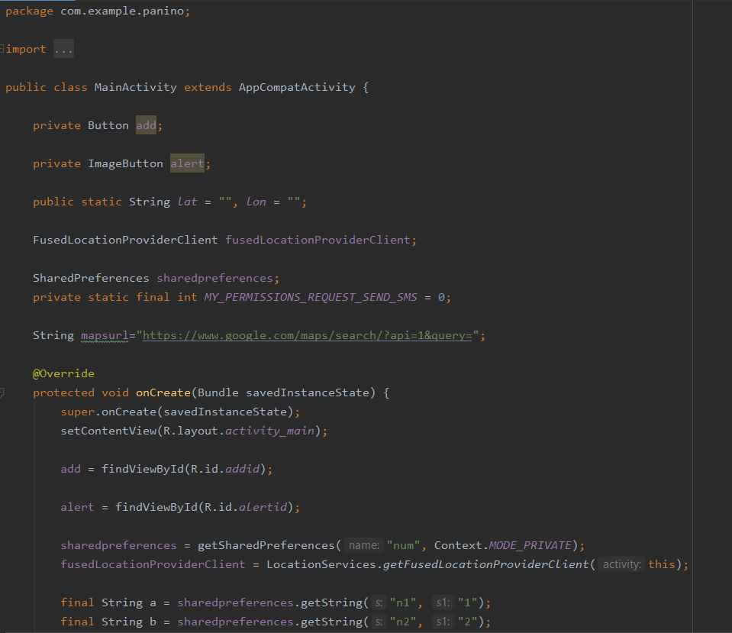

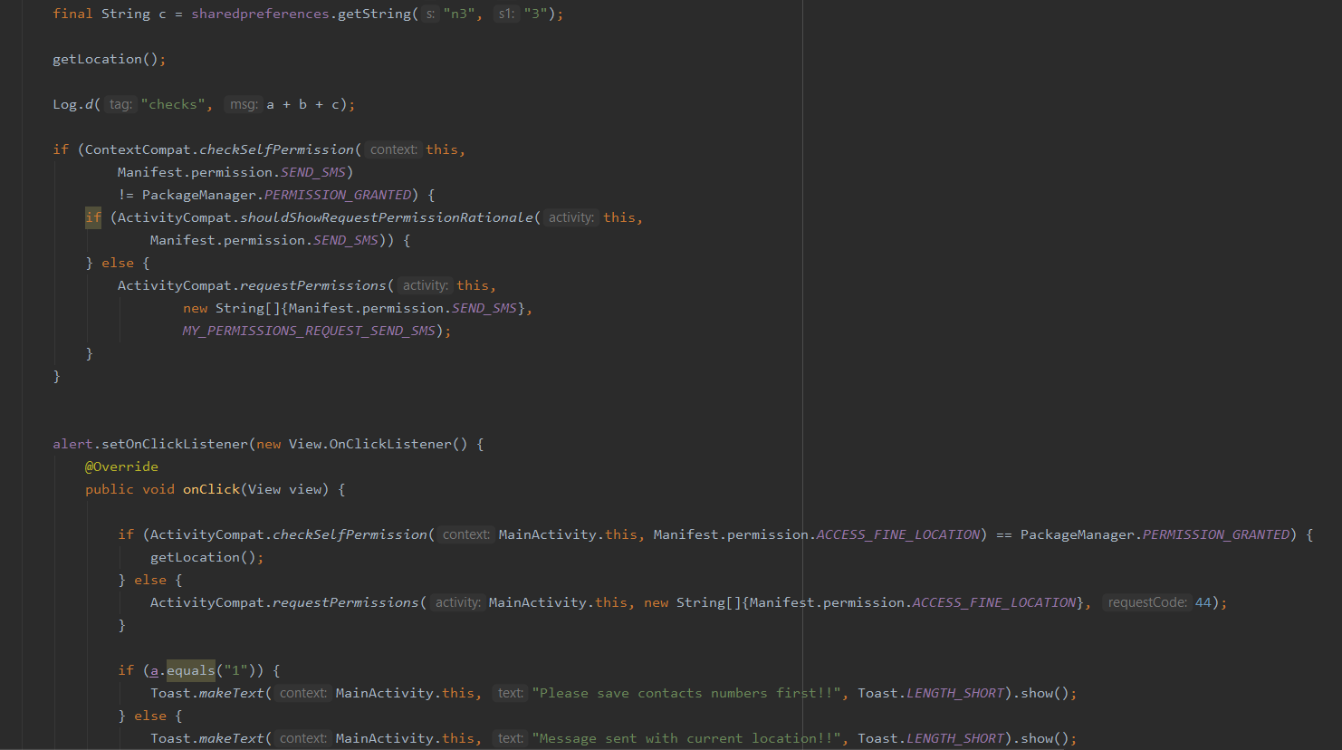

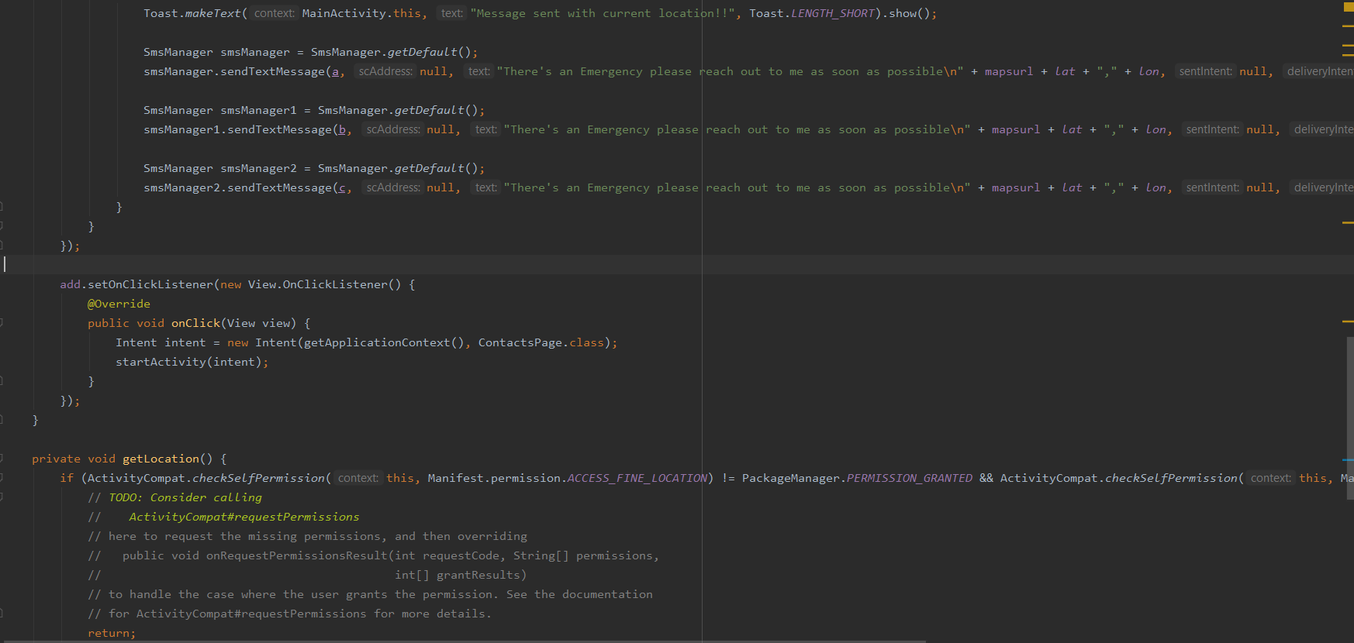

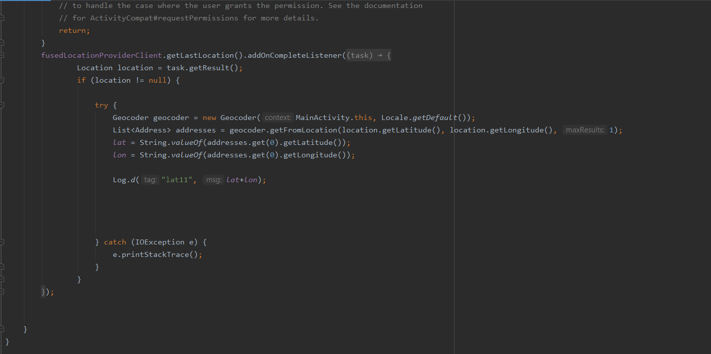

1. ContactsPage.java

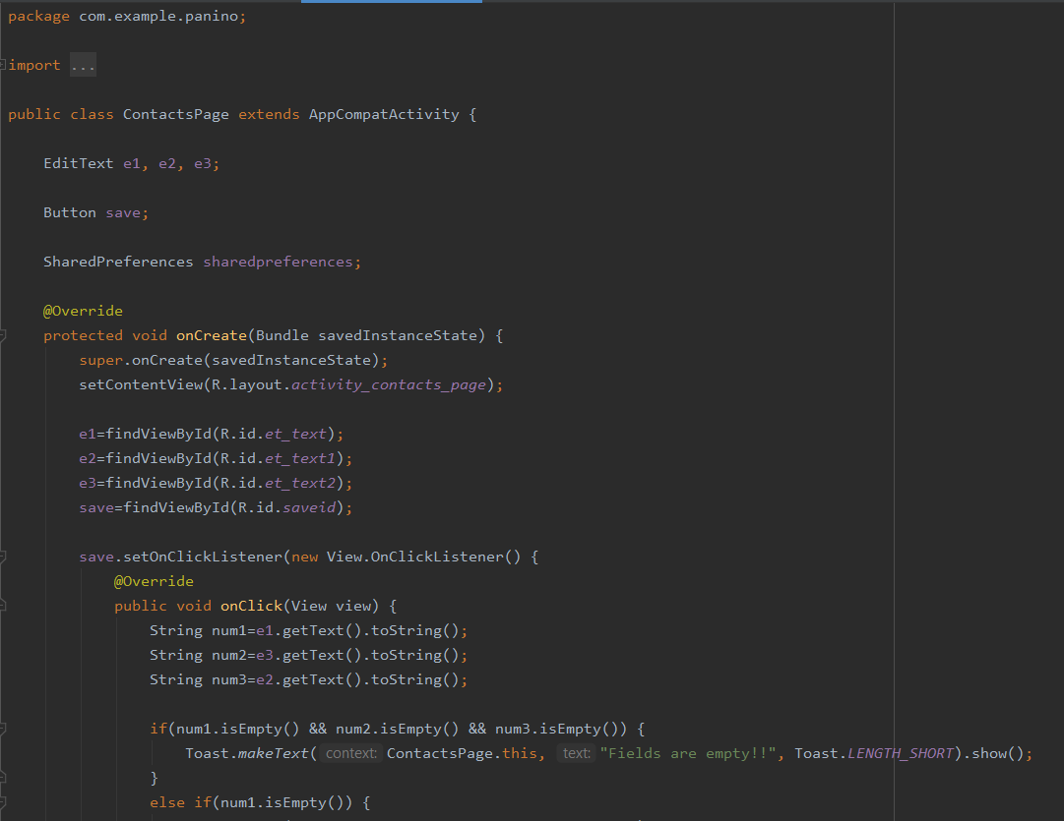

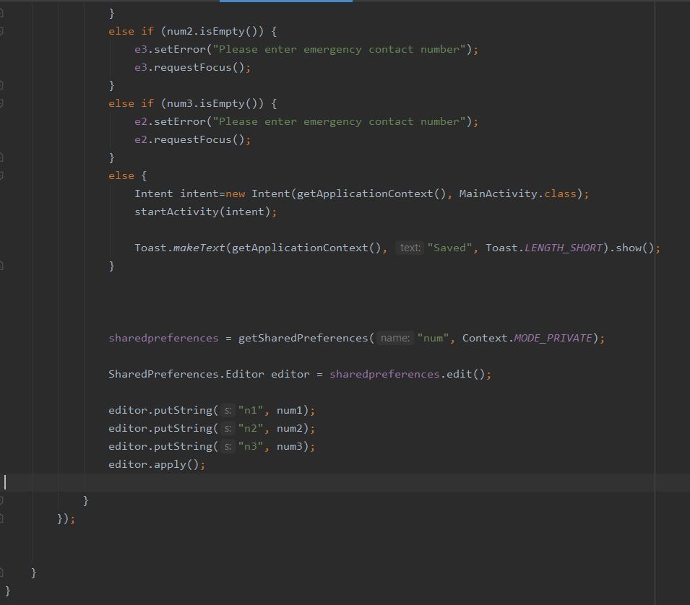

1. activity_main.xml

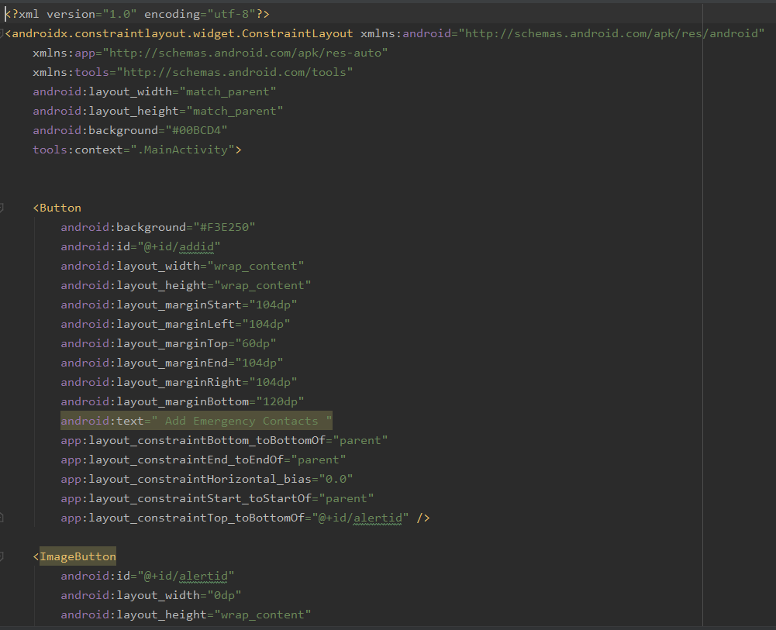

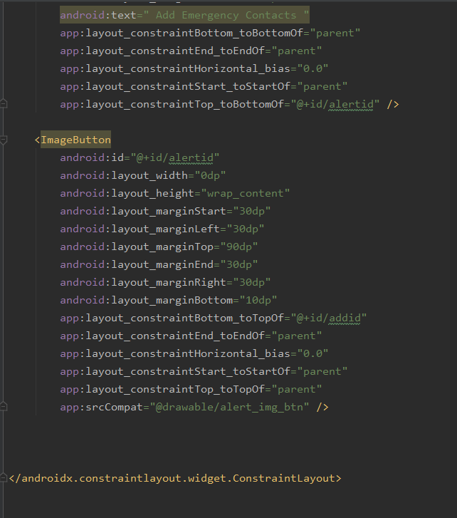

1. activity_contacts_page.xml

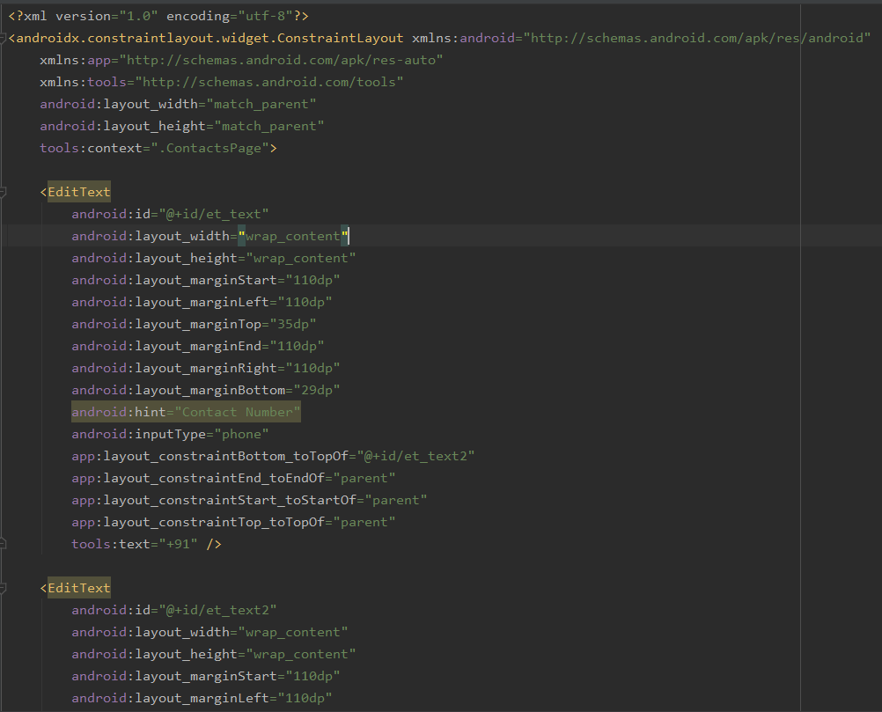

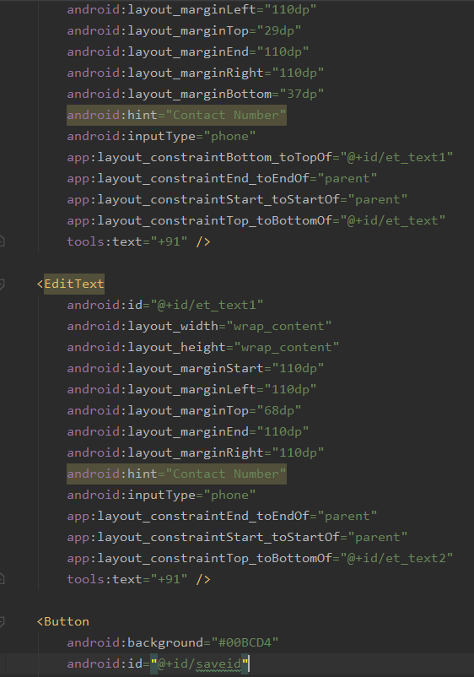

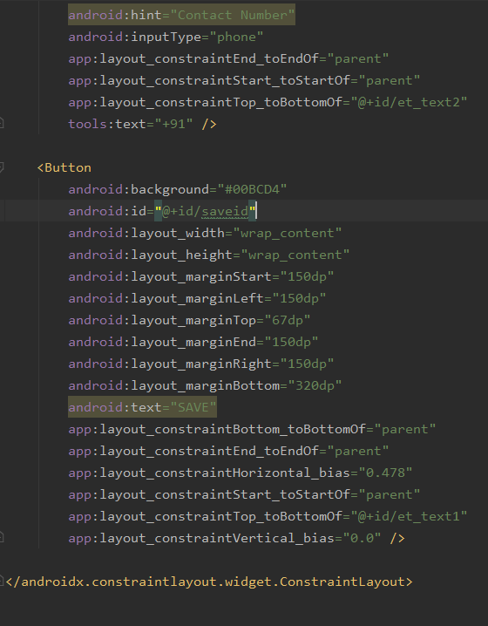

1. AndroidManifest.xml

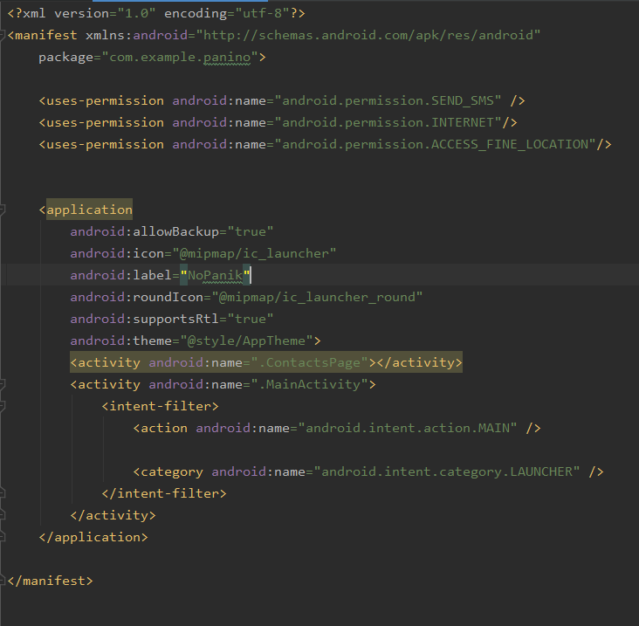

**REFERENCES AND BIBLIOGRAPHY**

**Ch 9: References and Bibliography**

* [www.wampserver.com](http://www.wampserver.com)
* [www.w3schools.com](http://www.w3schools.com)
* [www.stackoverflow.com](http://www.stackoverflow.com)
* [www.getbootstrap.com](http://www.getbootstrap.com)
* For graphics and images : [www.canva.com](http://www.canva.com/)
* [www.medium.com](http://www.medium.com)
* www.freecodecamp.com