free_fall
of a digital body

fito_segrera

They say laws of physics are universal; predefined rules that govern nature. Newtonian physics state that these conditions are fixed, non-mutable, but is that really the case?
A similar case applies to the idea of gravity vs zero gravity. We often are told that astronauts in space stations float around because of the effects of absolute zero gravity; but in fact there is no such conditions in space. Every single corner in this universe is affected by gravity, micro-gravities, macro-gravities, it varies from body to body, from mass to mass. In theory everything in the universe is affected by gravity; it is a primordial force that keeps order in chaos. Everything in the universe is falling; all matter is being attracted by bigger bodies off mass. Eventually any object in space will hit a ground.

Besides quantum mechanics, digital space the other universe that defies natural laws. Actually we, as creators of cyberspace, determine the rules that govern these spaces. Physics engines are an example of methods developed to simulate real physical spaces within digital environments. We create and program spaces to mimic our universe; we assign mass, acceleration, speed, dimensions, etc. to digital bodies and spaces expecting them to behave in a “realistic” way.

This project proposes an installation that takes the idea of gravity and physics in general and questions its validity in digital environments. It problematizes and rises questions on the subject; can the idea of “everything in the universe is falling and eventually will hit ground” be applied in digital environments? What happens to a digital body that freely falls into cyberspace?

The installation is comprised of a computer monitor hanging on a wall, a thermal printer and some custom software running on a raspberry-pi.
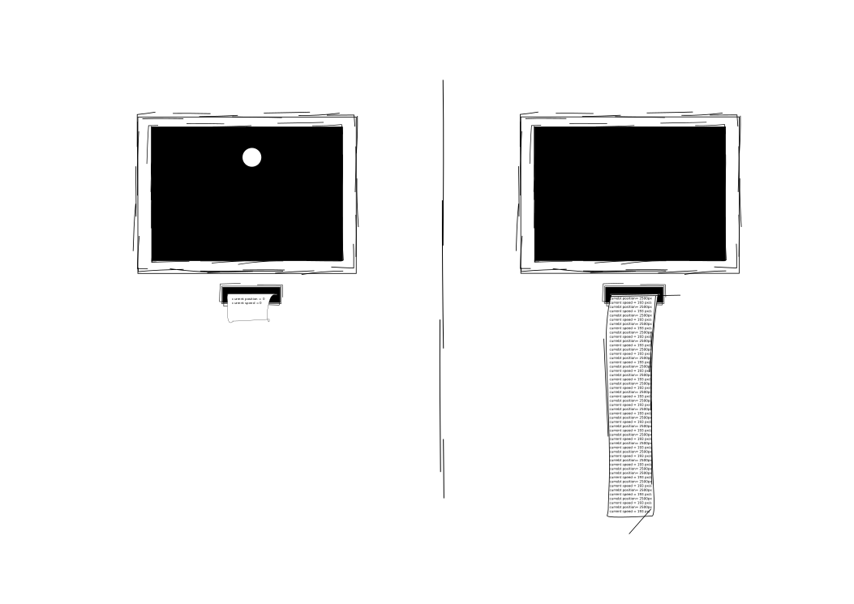

The image above shows the dynamics of the piece. At first, the observer contemplates a static digital body; a simple plane circle at rest. After a moment, the body starts falling freely into empty space, affected by gravity. A thermal printer turns immediately after the object starts falling; it prints, every second, the current status of the free falling body; current position, speed, mass and acceleration. After a few seconds the observer sees how the objects leaves the visible window (monitor) through the bottom edge. From now on there is no more visual reference of the object; but it is still falling, and it will continue doing so as long as the system is running. From this point onwards, the only reference we have from the object is that which is being printed every second. We don't see; but we know. Opposed to our physical universe, this free falling digital body will never hit ground, the only thing ahead of it is absolute emptiness.

